**PACMAN GAME USING FINITE AUTOMATA**

A PROJECT REPORT

***Submitted by***

BL.EN.U4AIE19007 APOORVA.M

BL.EN.U4AIE19041 TANUJ.M

BL.EN.U4AIE19068 AISHWARYA.V

***for the course***

***19AIE301- Formal Language and Automata***

***Guided and Evaluated by***

***DR. SUPRIYA M***

IN

ARTIFICIAL INTELLIGENCE ENGINEERING



AMRITA SCHOOL OF ENGINEERING, BANGALORE

**BANGALORE 560 035**

**ABSTRACT OF THE PROJECT**

Pac-Man is an action maze-chase video game. The player controls the eponymous character through an enclosed maze. The objective of the game is to eat all of the dots placed in the maze while avoiding few coloured ghosts that pursue him. When Pac-Man eats all of the dots, the player advances to the next level. If Pac-Man makes contact with a ghost, he will lose a life; the game ends when all lives are lost. Each of the ghosts have their own unique, distinct personalities.

This is a multi-level game. The game increases in difficulty as the player progresses to further levels. We are developing this game using finite automata in both JFLAP and with GUI in ‘SCRATCH’.

[**INTRODUCTION**](bookmark://_Toc55647445)

Pac-Man is an arcade game that was first release in 1980. The player navigates Pac-Man through a maze and has to collect all the dots (Pac-Dots) in order to complete the stage. Pac-Man is being chased by four ghosts in the game whose main objective is to kill him. The four ghosts, Blinky, Pinky, Inky and Clyde, each has different behaviour depending on the mode of the ghosts. The ghosts change mode during game play from scattering to the corners of the maze, to chasing Pac-Man and also to being frightened when Pac-Man picks up a Power-Pellet.

In this project we are discussing the different movements and behaviour of the ghosts in Pac-Man and how it relates to implementing Reusable Object-Oriented software also known as Design Patterns.

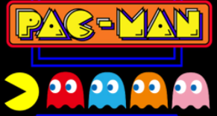

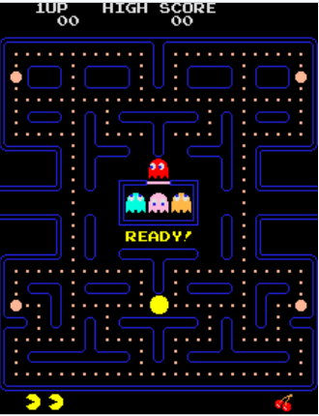

**CHASE**

In “Chase” mode, the ghosts are trying to find and capture Pac-Man. Each of the four ghosts has a unique behaviour while chasing Pac-Man. Blinky the red ghost is very aggressive in its approach while chasing Pac-Man and will follow Pac-Man once located. Pinky the pink ghost will attempt to ambush Pac-Man by trying to get in front of him and cut him off. Inky the cyan ghost will patrol an area and is not very predictable in this mode. Clyde the orange ghost is moving in a random fashion and seems to stay out of the way of Pac-Man.

[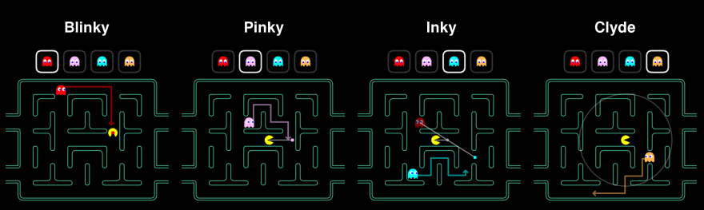](https://res.cloudinary.com/practicaldev/image/fetch/s--tMDeCSH4--/c_limit%2Cf_auto%2Cfl_progressive%2Cq_auto%2Cw_880/https:/cdn-images-1.medium.com/proxy/0%2ACoMAiBNHxshA7HIw.png)

**SCATTER**

In “Scatter” mode, the ghosts will stop chasing Pac-Man and each will move into its respective corners for a few seconds. Blinky the red ghost moves towards the top right corner, while Pink - the pink ghost moves towards the top left corner. Inky the cyan ghost moves towards the bottom left corner and Clyde the orange ghost moves towards the bottom left corner. This mode lasts only for a few seconds and then changes back to the “Chase” mode.

[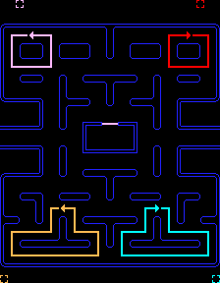](https://res.cloudinary.com/practicaldev/image/fetch/s--Rvtrl2Gc--/c_limit%2Cf_auto%2Cfl_progressive%2Cq_auto%2Cw_880/https:/cdn-images-1.medium.com/proxy/0%2AzNDnbLILf0WwS3co.png)

**FRIGHTENED**

[](https://res.cloudinary.com/practicaldev/image/fetch/s--AY3cmOy1--/c_limit%2Cf_auto%2Cfl_progressive%2Cq_auto%2Cw_880/https:/cdn-images-1.medium.com/proxy/0%2AXDKqZ9aXMYhUmXxc.png)The “Frightened” mode occurs when Pac-Man eats an energizer within the maze. There are four energizers located in the maze and all four ghosts change mode. The ghosts turn dark blue and wander around in the maze being vulnerable. They will flash moments before they return to either the Scatter or Chase mode.

So, to sum up the movement requirements of the ghosts, the following table illustrates the types of movement and also how the individual ghosts behave during those types of movement.

Ghost Name Chase Scatter Frightened Blinky (Red) Aggressive Top Right Corner Wandering Pinky (Pink) Ambush Top Left Corner Wandering Inky (Cyan) Patrol Bottom Right Corner Wandering Clyde (Orange) Random Bottom Left Corner Wandering.

**POWER PELLETS**

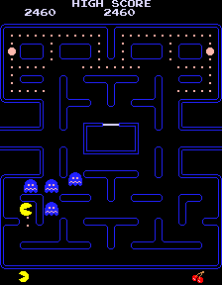Placed at the four corners of the maze are large flashing "energizers", or "power pellets". Eating these will cause the ghosts to turn blue with a dizzied expression and reverse direction. Pac-Man can eat blue ghosts for bonus points; when eaten, their eyes make their way back to the centre box in the maze, where the ghosts "regenerate" and resume their normal activity. Eating multiple blue ghosts in succession increases their point value. After a certain amount of time, blue-coloured ghosts will flash white before turning back into their normal, lethal form. Eating a certain number of dots in a level will cause a bonus item - usually in the form of a fruit – to appear underneath the centre box, which can be eaten for bonus points. One thing to be noted is that the power pellets are time bound and will disappear if pacman fails to catch it within a certain time

**AUTOMATA DESIGN**

**GAME_START**

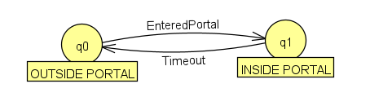

This model summarizes the game start and end. So as we can see the game starts from the outside portal and as soon as the space bar is hit, we enter the game.

**GHOST AI**

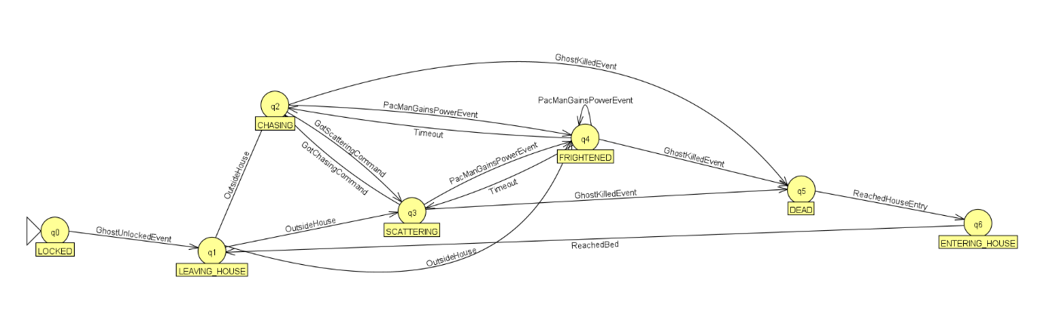

This Automata has been designed for the movement of the ghosts. Initially the ghosts are locked in the house, and as soon as the gate is unlocked, they’ll be able to come outside and roam. The ghosts’ primary movements are to chase the pacman and scatter. Whenever the pacman acquires a special power , the ghosts get frightened until timeout. In case the Pac-Man kills one of the ghosts during the power event, the ghost starts once again from the house.

**GHOST MADNESS**

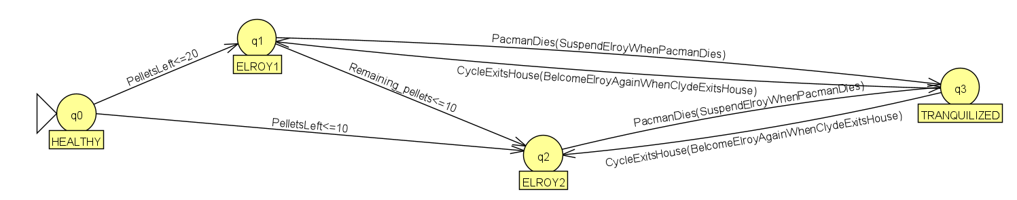

Blinky madness signifies the agitated state of the ghosts when the Pac-Man is done with consuming almost all the pellets. So, when the number of pellets is less than 20, the ghosts start accelerating and chasing the pacman by taking the shortest routes. ELROY1 and ELROY2 are similar but the intensity with which the ghost chases the pacman differs. This is when the number pellets are less than 10, the ghost chases the pacman more vigorously. When the ghost catches the pacman, pacman dies and revives using the next life. When the pacman revives, the ghosts move slowly for some seconds, this is the tranquilized state. And again after sometime the ghosts start chasing the pacman with the same vigour.

**PACMAN**

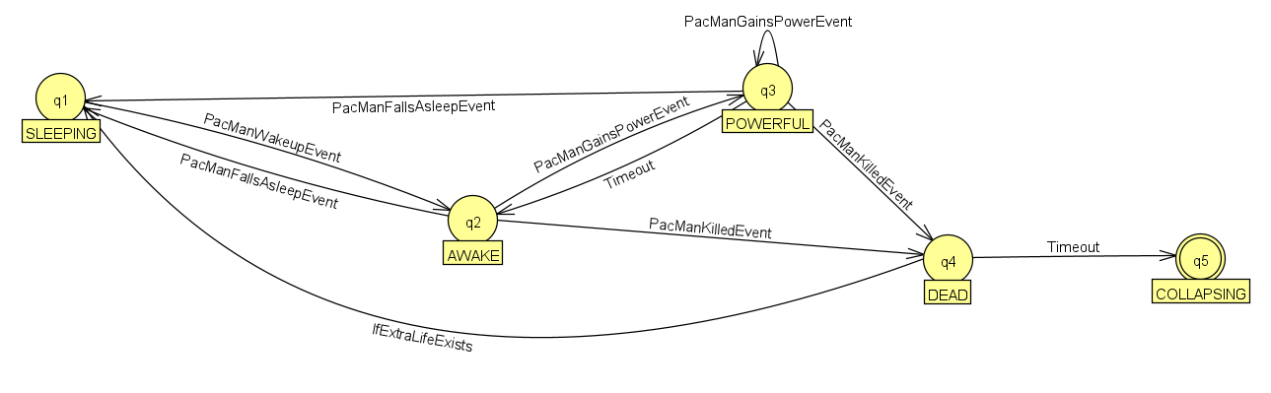

This Automata describes the Pac-Man’s overall movement and participation in the game. So initially the pacman is in the sleep state and that’s why we observe a halt and later the pacman starts moving, this state is the awake state. Whenever pacman acquires special power, it will get the ability to kill the ghosts. Also, this power state will only last for a certain amount of time , so after that, the pacman will return to its normal awake. When pacman gets killed, if it doesn’t have any extra lives left, the game collapses and starts from level 1 again. But if the pacman has an extra life, it will go back to the starting position and continue the level.

**BONUS FOOD CONTROLLER**

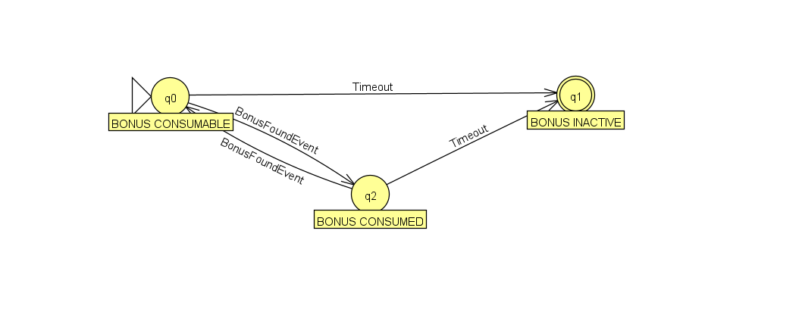

This automata describes the special power/bonus acquisition. So the pacman first encounters the bonus and then tries to consumes it. As already mentioned, the power will only last for some time, so the bonus become inactive after some time. Also, if the pacman fails to consume the bonus within a particular time, the bonus becomes inactive.

**GHOST ATTACK CONTROLLER**

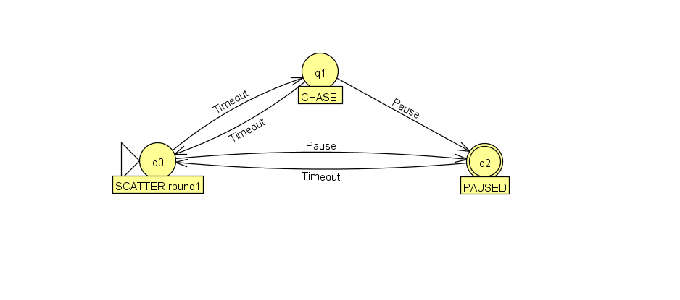

This automata represents the ghost attack controller design. The ghost starts off with scattering but when it encounters pacman in its line of sight, it starts chasing pacman and again when pacman disappears from its line of sight, the ghosts get back to scattering movement. The pacman acquires various kinds of special power during the game. One such special power is to pause the ghosts from moving and after timeout all get back to their natural state.

**GAME CONTROLLER**

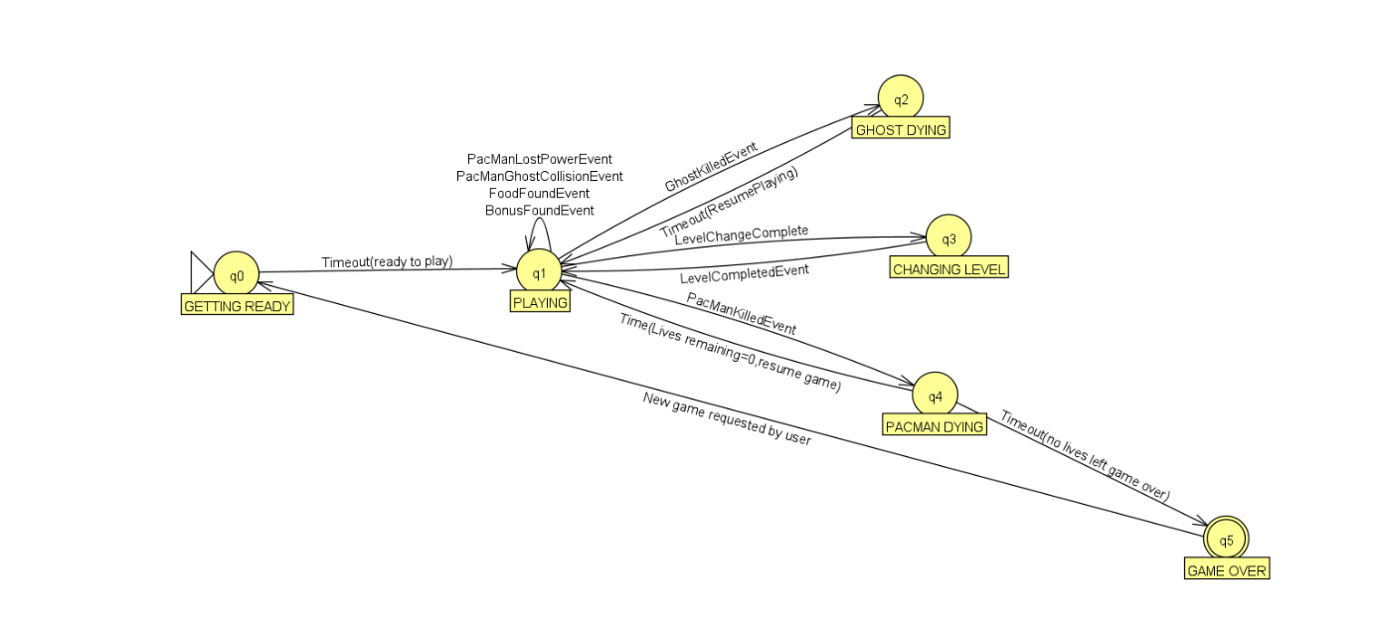

This automata represents the overall working of the game. Before game starts ,the characters take their respective positions in the maze and get ready. After this the game starts.

While playing, when a ghost gets killed , game timeouts and we’ll be able to resume. Pacman levels up when it complete eating all the pellets. When pacman gets killed by the ghost, it'll be able to resume the game if it has extra lives, or else the game times out and game over will be displayed. After game over, the game restarts from level 1.

**WORKING AUTOMATA IMPLEMENTATION IN JFLAP**

So when we start the game, when we click on space, it enables the user to play game, initially the player will be given 3 lives and he has the game controls: up, left, right, down, when the pacman gets special food – P, he is enabled to kill the ghost for a little time and he again comes back to the previous node, in that game if he completes all food platelets i.e.; 0, he wins that level, and goes to next level, and this process repeats if he again eats all the food pellets in that level, if pacman encounters a ghost, he’ll lose a life, if he loses all the 3 lives, the player loses the game, and score is then displayed and option to start a new game or exit the game is shown.

**GUI - IMPLEMENTATION IN SCRATCH**

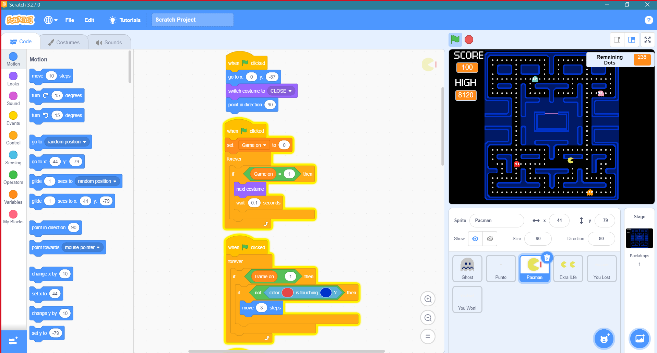

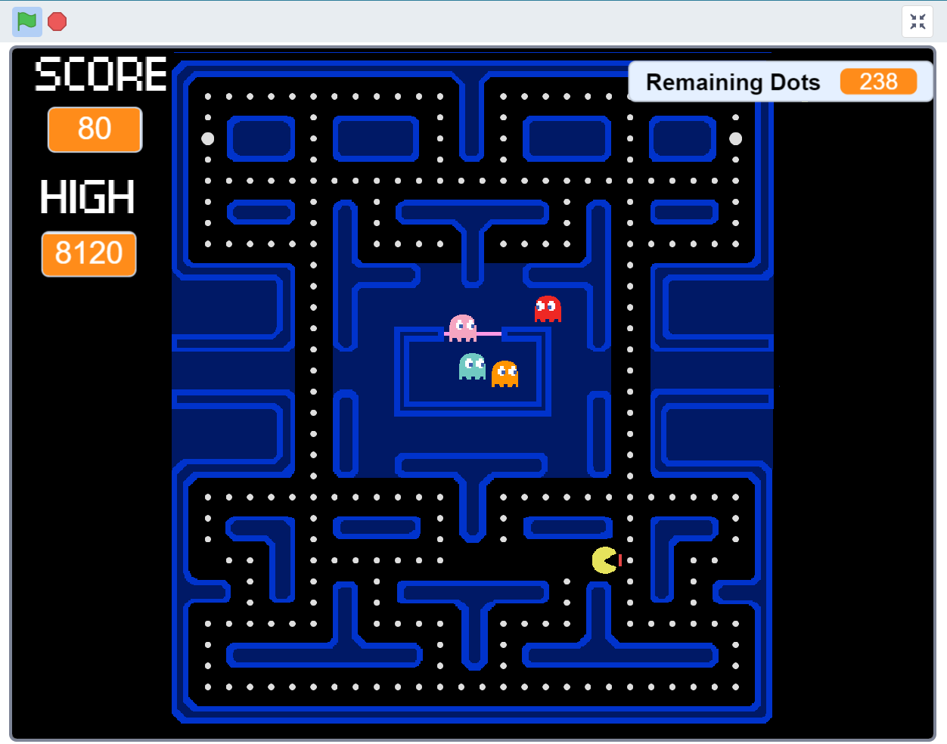

**CONCLUSION**

Pac-man designer Toru Iwatani had no training as a designer or programmer. That’s why it is more apt for this particular project. It was one of the most successful arcade games of all time. Pac-Man was a massive hit, and its grip on pop culture is still strong today. The game was introduced in 1980s and it's insidiously addictive even for this generation gamers.

The proposed design of the Pacman game has been implemented by utilizing finite-state machines and GUI has been implemented using SCRATCH. It is shown that there is consistency between the inputs and the expected outputs. Furthermore, we found that designing a game using Automata is the best practice by which a game director without having any background in programming can design a game with visualization. Therefore, it is a helping tool to explain the story and business process of a game. Moreover, finite machines help the coding process to be more systematic and organized. In further work, we are planning to incorporate more special powers for both the ghosts and the Pacman in order to increase the complexity of the game, thereby enhancing the gaming experience for the players.