**TRAFFIC VIOLATION DETECTION SYSTEM**

A PROJECT REPORT

***Submitted by***

BL.EN.U4AIE19007 APOORVA.M

BL.EN.U4AIE19041 TANUJ.M

BL.EN.U4AIE19068 AISHWARYA.V

***in partial fulfilment for the award of the degree***

***0f***

**BACHELOR OF TECHNOLOGY**

IN

ARTIFICIAL INTELLIGENCE ENGINEERING



AMRITA SCHOOL OF ENGINEERING, BANGALORE

AMRITA VISHWA VIDYAPEETHAM

**BANGALORE 560 035**

#### **TABLE OF CONTENTS**

**CHAPTER 1:** INTRODUCTION **.….……………….………….…3**

**CHAPTER 2:** SYSTEM DESIGN **…………………….….……….4**

**CHAPTER 3:** IMPLEMENTATION**………………………………5**

**CHAPTER 4:** RESULTS**………………………………………….10**

**CHAPTER 5:** CONCLUSIONANDFUTURE SCOPE**.…………15**

**CHAPTER 6:** REFERENCES**………………………...…………...16**

**CHAPTER 1: INTRODUCTION**

The increasing number of cars in cities can cause high volume of traffic, and implies that traffic violations become more critical nowadays in metropolitan cities and also around the world. This causes severe destruction of property and more accidents that may endanger the lives of the people. To solve the alarming problem and prevent such unfathomable consequences, traffic violation detection systems are needed. For which the system enforces proper traffic regulations at all times, and apprehend those who does not comply. The trafﬁc accidents can be reduced by penalizing violators. Different countries have addressed the is-sue by installing surveillance systems to monitor trafﬁc violation at every intersection. However, such systems are expensive and require well installed infrastructure. It is convenient in developed countries due to existing infrastructure; whereas, in underdeveloped countries, the lack of budget and weak infrastructure makes it unfeasible. The deployment of extensive number of trafﬁc constables to monitor violations is not viable either.

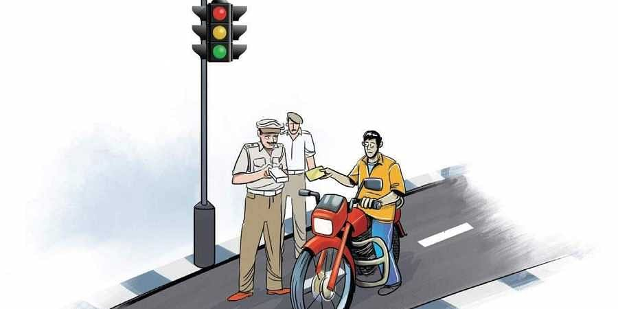

**Figure 1 : A person being fined for violating traffic rules**

A traffic violation detection system must be realized in real-time as the authorities track the roads all the time. Hence, traffic enforcers will not only be at ease in implementing safe roads accurately, but also efficiently; as the traffic detection system detects violations faster than humans. The goal of the project is to automate the traffic signal violation detection system and make it easy for the traffic police department to monitor the traffic and take action against the violated vehicle owner in a fast and efficient way. Detecting and tracking the vehicle and their activities accurately is the main priority of the system. In this project, Speed detection, Licence plate detection, Helmet detection, and Signal violation detection systems have been implemented.

**CHAPTER 2: SYSTEM DESIGN**

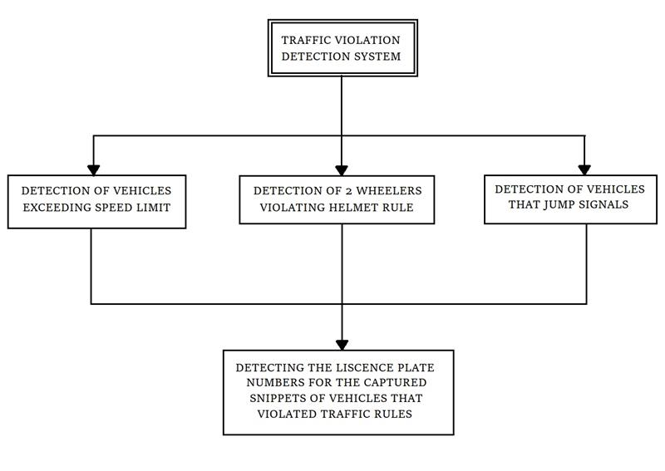

**Figure 2: System Design of our model**

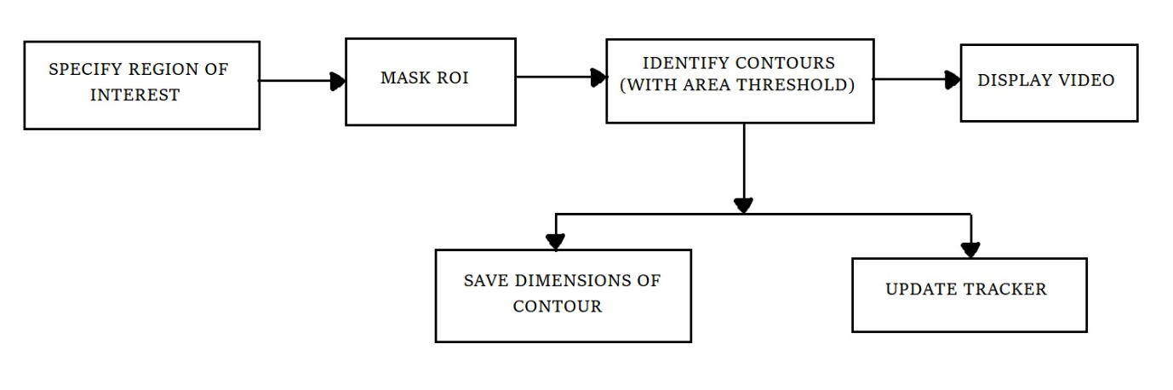

**Figure 3: Flowchart describing vehicle detection**

**CHAPTER 3: IMPLEMENTATION**

1. **SPEED VIOLATION DETECTOR**

The video used in this project is a street view in Abu Dhabi. The number plates of the vehicle in the video are however not clearly visible.

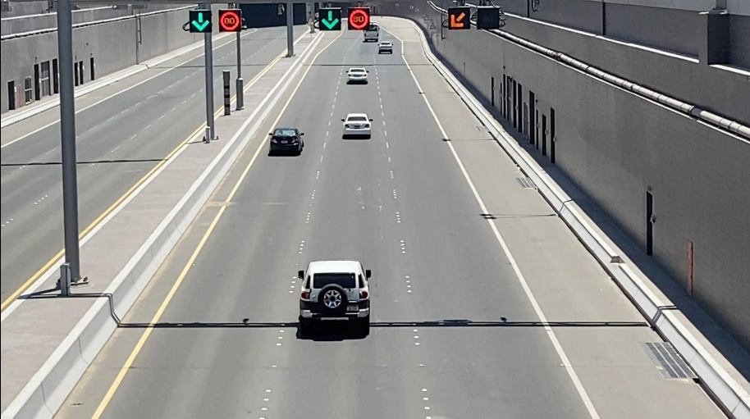

**Figure 4 : Sample Video Screenshot**

Region of Interest (ROI) takes a smaller portion of the original video. On this ROI, Image subtraction is performed to detect a moving vehicle. (Image Subtraction helps find the difference between two frames). Masking is performed to make the moving vehicles appear white and the rest of the image black.

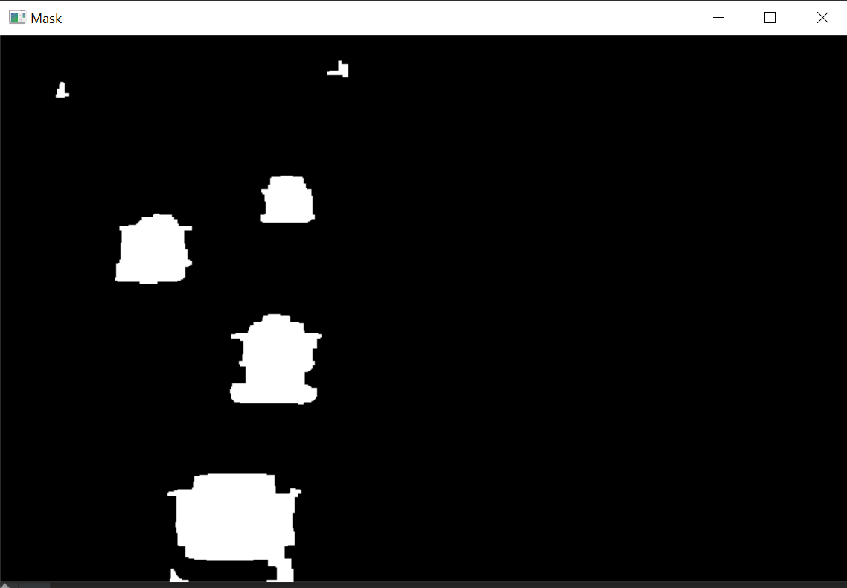

**Figure 5 : Masked Image**

Based on the area threshold of number of pixels, the contours are detected. The threshold is used to avoid detecting contours of smaller moving objects that are not vehicles. The object is tracked based on the distance between two contours between frames. An ID is assigned to each contour.

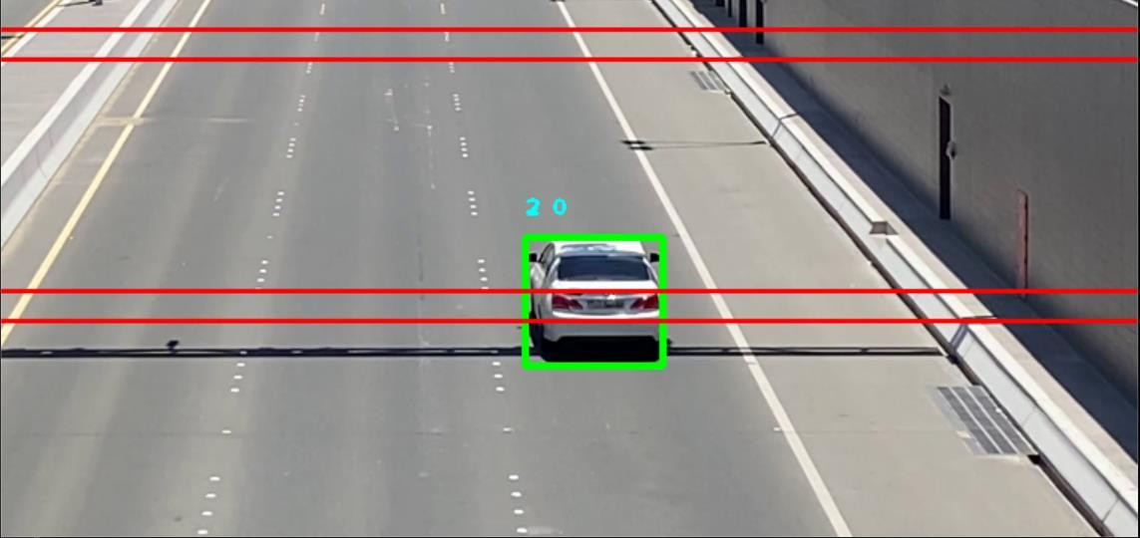

**Figure 6 : Contour Detection**

Time difference between the position of a vehicle is calculated and the speed is estimated based on a formula. The timer starts when the vehicle crosses the first line, and the timer ends when the vehicle crosses the second line. The speed is displayed on top of the bounding box only when the vehicle crosses both the lines.

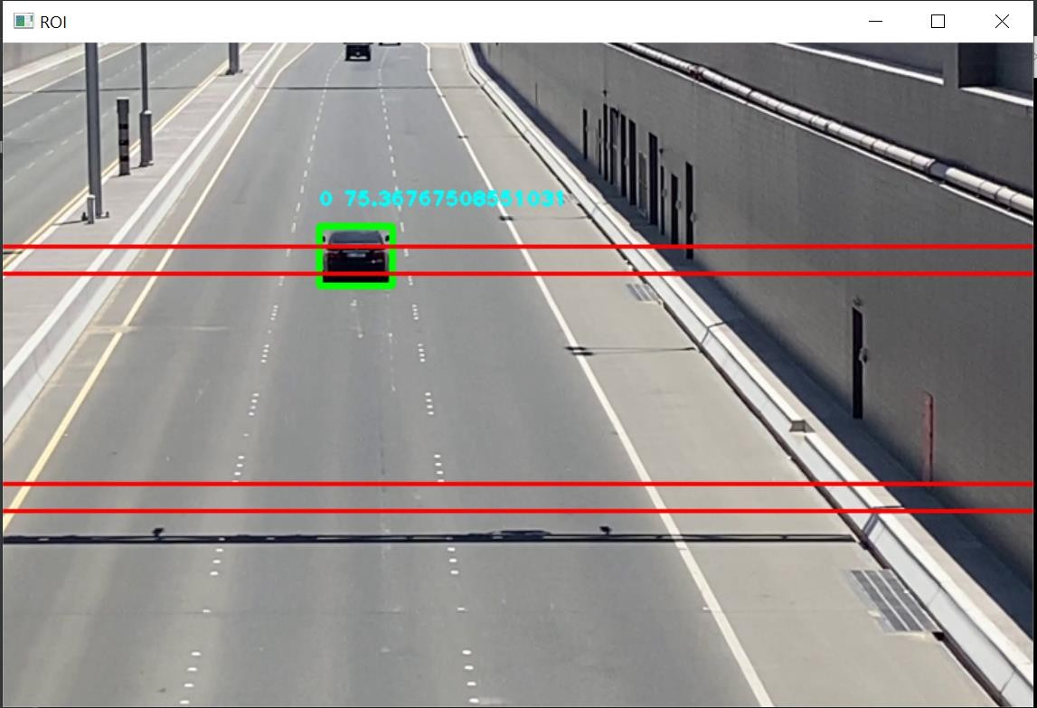

**Figure 7 : Speed Estimation**

1. **SIGNAL VIOLATION DETECTOR**

The video used in this project is a street view. The number plates of the vehicle in the video are however not clearly visible.

In this implementation , signal colors such as green , yellow and red are detected. Users are required to draw a region or interest to keep a check of the vehicles that pass through it.

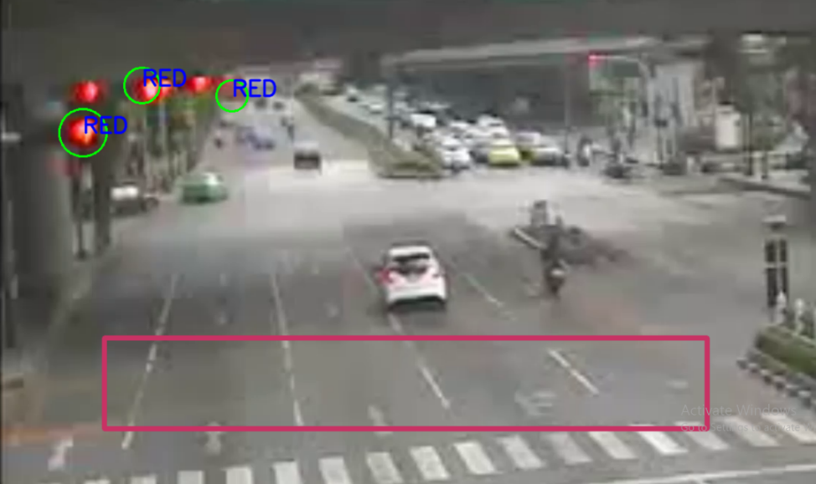

**Figure 8: Region of Interest**

Whenever a vehicle passes through the region of interest during when a red light is detected, the vehicle is subjected to have violated the signal and the snippet of the vehicle is stored in a separate directory.

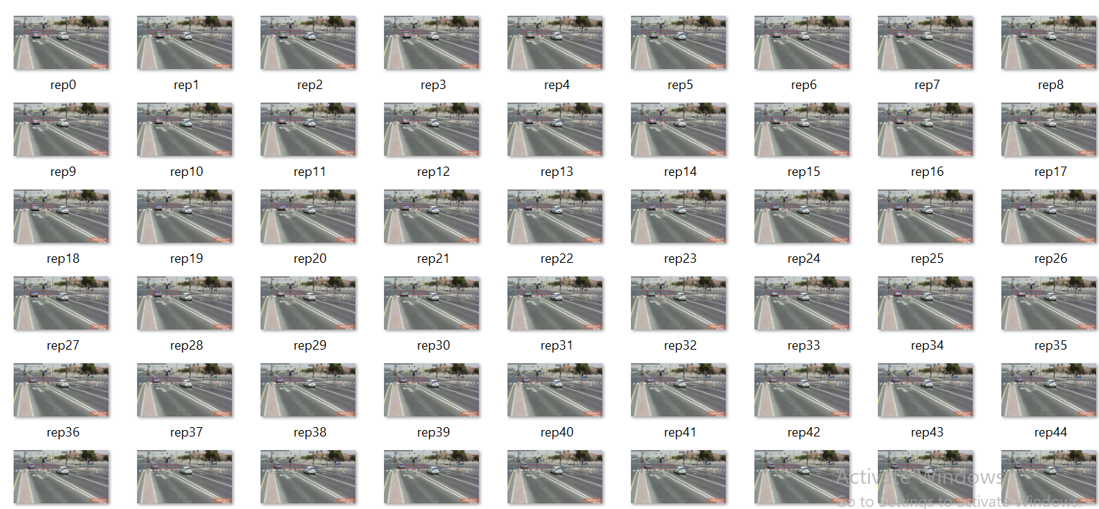

**Figure 9 :**

1. **HELMET DETECTOR**

From the video, the model can differentiate riders with helmet and without helmet using YOLO-Dark Net. And using Opencv we draw a bounding box over the person’s face and labels it as with or without helmet.

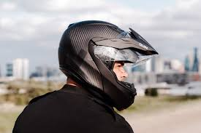

**Figure 10 : Person with head gear**

1. **NUMBER PLATE DETECTOR**

The model takes input vehicle image and identifies the number plate and crops it and then identifies the characters and prints them.



**Figure 11 : Vehicle with number plate**



**Figure 12 : Cropped Number Plate**



**Figure 13: Obtained number plate**

**CHAPTER 4: RESULTS**

1. **SPEED VIOLATION DETECTOR**

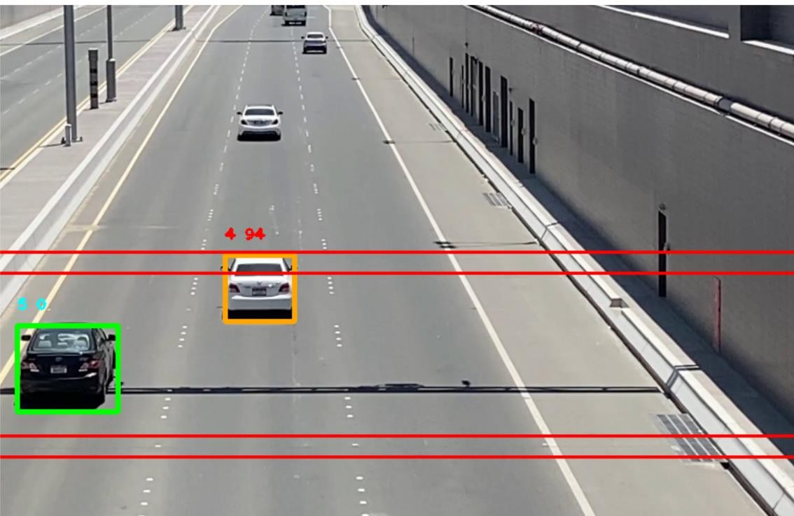

**Figure 14 : Speed Radar Main Output**

The picture of the bounding box (the vehicle) is saved into a file along with the speed. Vehicles crossing the speed limit is segregated into a separate folder.

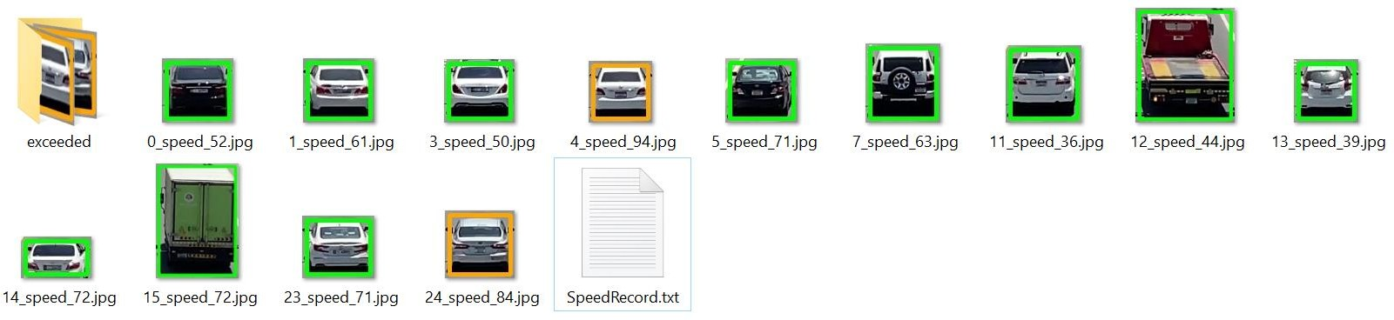

**Figure 15: Saved Vehicle Images**

The vehicle data is saved in a text file. The vehicles that exceeded the speed limit are pointed. A summary of number of vehicles and the speed violators are displayed.

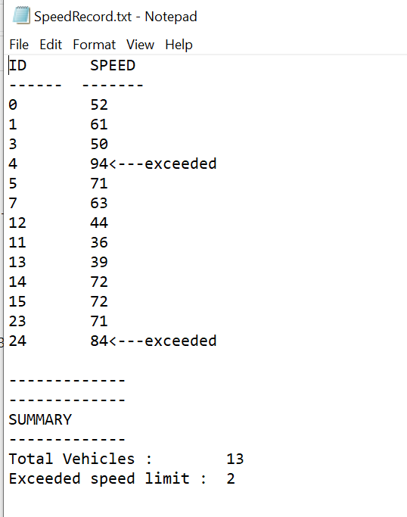

**Figure 16 : Summary of Vehicles**

1. **SIGNAL VIOLATION DETECTOR**

In the below image, the vehicle violated signal when it’s red. So, when the vehicle crosses the region of interest, the number plate is highlighted with a bounding box and a snippet of that particular frame is taken.

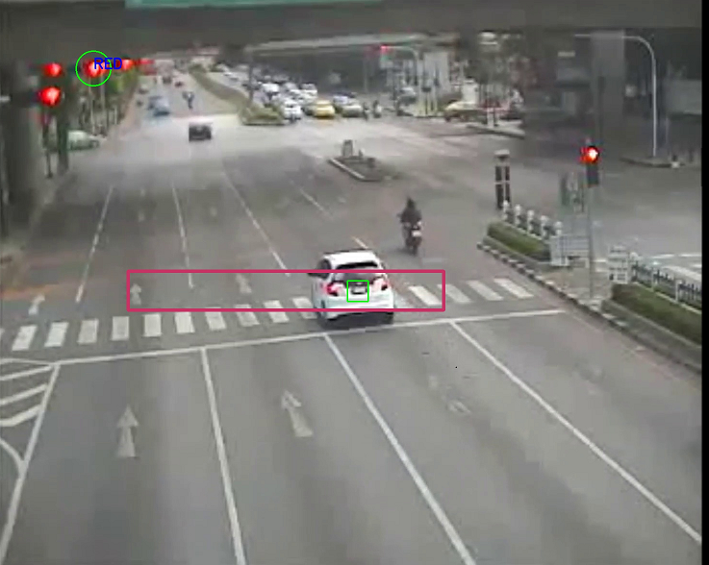

**Figure 17: Vehicle violating signal**

1. **HELMET DETECTOR**

In the below image, two riders are identified by the model with and without helmet.

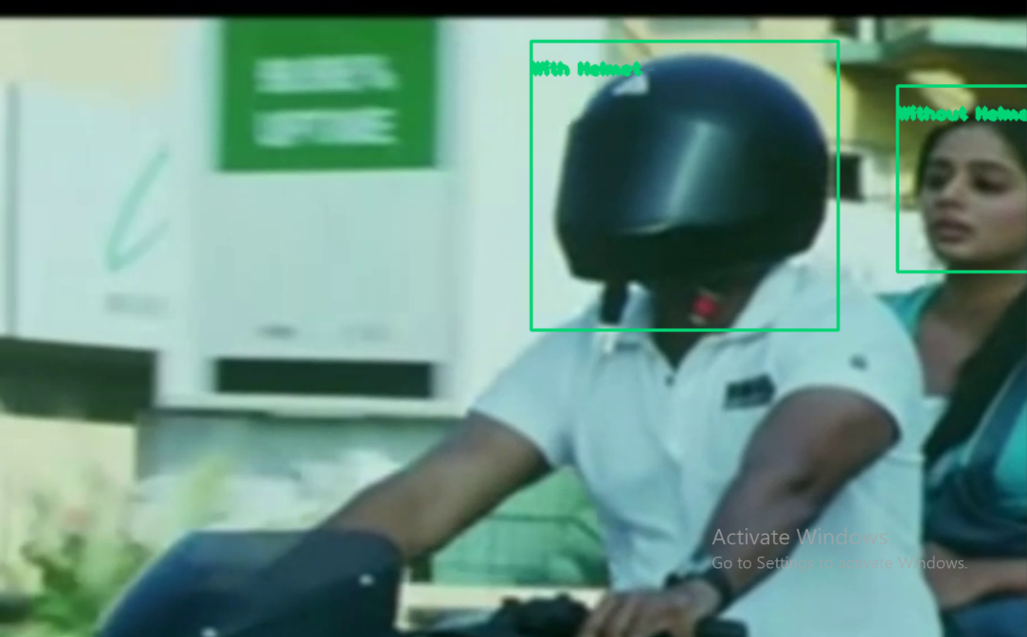

**Figure 18: Helmet Detection**

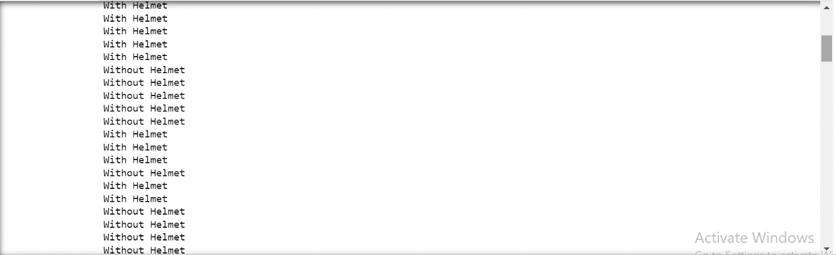

**Figure 19: Terminal Result of Helmet Detection**

1. **NUMBER PLATE DETECTOR**

From the snippets of the violated cars, the region of the number plate is cropped, and using the model the number plate characters are extracted.

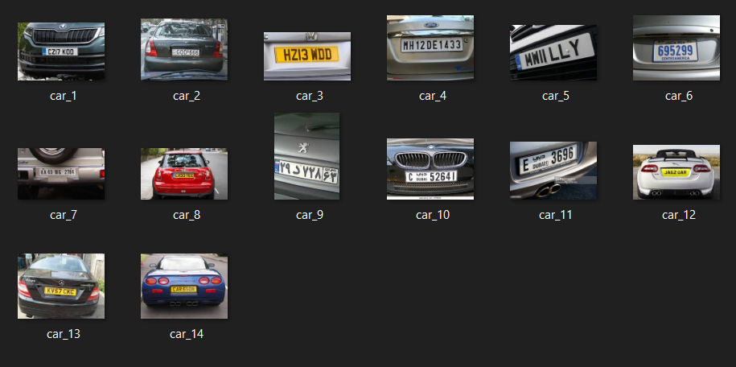

**Figure 20 : Violated car images**

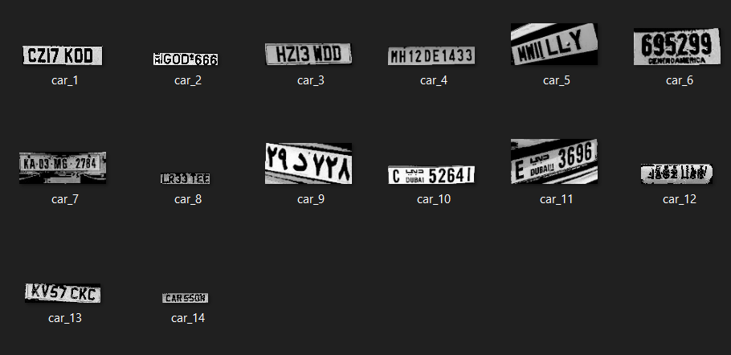

**Figure 21 : Cropped images of number plates**



**Figure 22: Extracted characters from number plates**

**CHAPTER 5: CONCLUSION AND FUTURE SCOPE**

Most traffic accidents are caused by driver inattention to safety rules, distraction due to in-vehicle activities and fatigue. The idea behind this project was to successfully implement detection systems for keeping check of specific road safety rules being followed. Some of the main causes of road accidents such as vehicles exceeding speed limit, helmet rule and jumping signal were planned to taken care off.

Further, a way for extracting the number plate details of the vehicles violating the rules has also been added. The designed algorithms were able effectively detect the type of violations and has proved to be efficient.

Furthermore, we are planning to extend our project by detecting the other traffic violations like wrong lane, wrong parking, etc.

**CHAPTER 6: REFERENCES**

1. G. Ou, Y. Gao and Y. Liu, "Real Time Vehicular Traffic Violation Detectionin Traffic Monitoring System", in IEEE/WIC/ACM, Beijing, China , 2012.
2. X. Wang, L.-M. Meng, B. Zhang, J. Lu and K.-L.Du, "A Video-based Traffic Violation Detection System", in MEC, Shenyang, China, 2013.
3. Joseph Redmon and Ali Farhadi, "YOLOv3: An Incremental Improvement".
4. Shreya Asoba, Shreya Supekar, Tushar Tonde, " Advanced Traffic Violation Control and Penalty System using IoT and Image Processing Techniques", in ICIMIA 2020
5. Dr.S.Raj Anand, Dr.Naveen Kilari, Dr.D.Udaya Suriya Raj Kumar, "TRAFFIC SIGNAL VIOLATION DETECTION USING ARTIFICIAL INTELLIGENCE AND DEEP LEARNING", in IAEME, International Journal of Advanced Research in Engineering and Technology (IJARET) 2021
6. Kailasam Selvaraj, Kartheeban Kamatchi, Jegadeeshwaran G, Surya B, Vajithraguman M, Robin Samuel R. (2020). Traffic Violation Detection. International Journal of Advanced Science and Technology, 29(12s), 239 - 249.