**PROJECT _1:** CREATION OF WIONDOWS AMI AND LAUNCH WITH RDP.

Instance creation is successful and running.

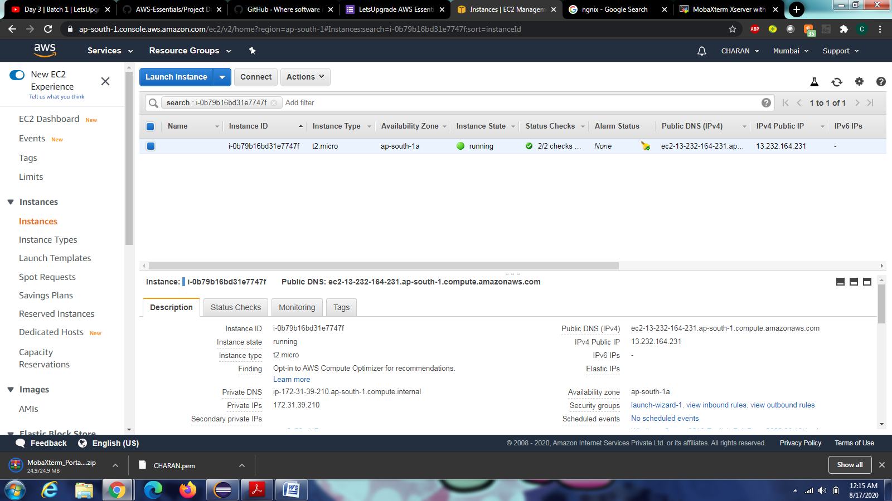

Creation of password is completed

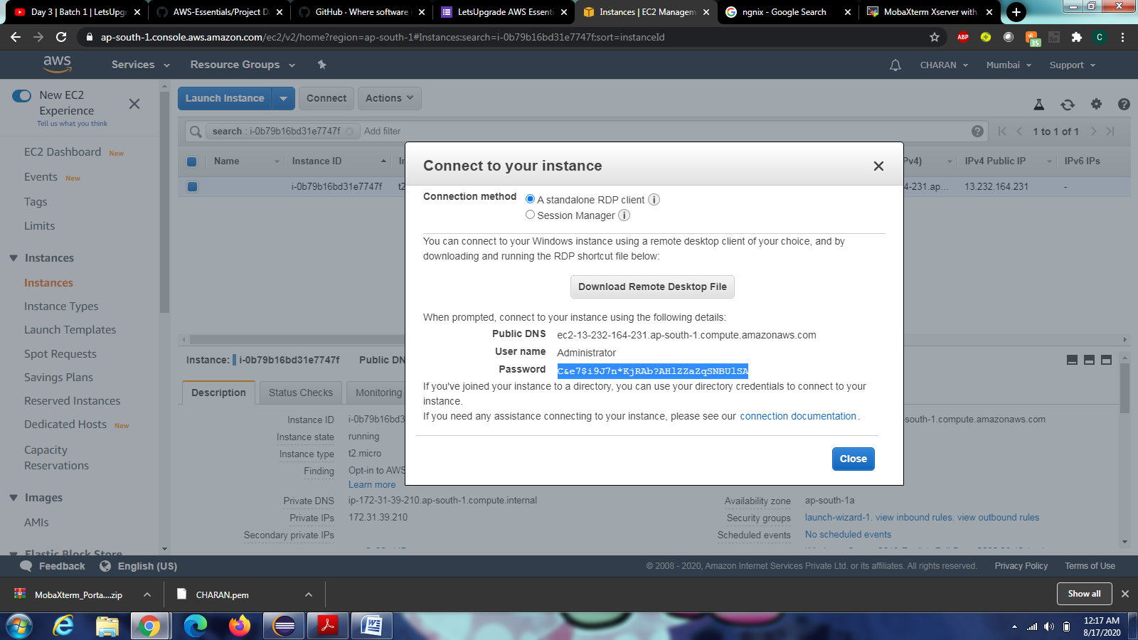

Connecting rdp.

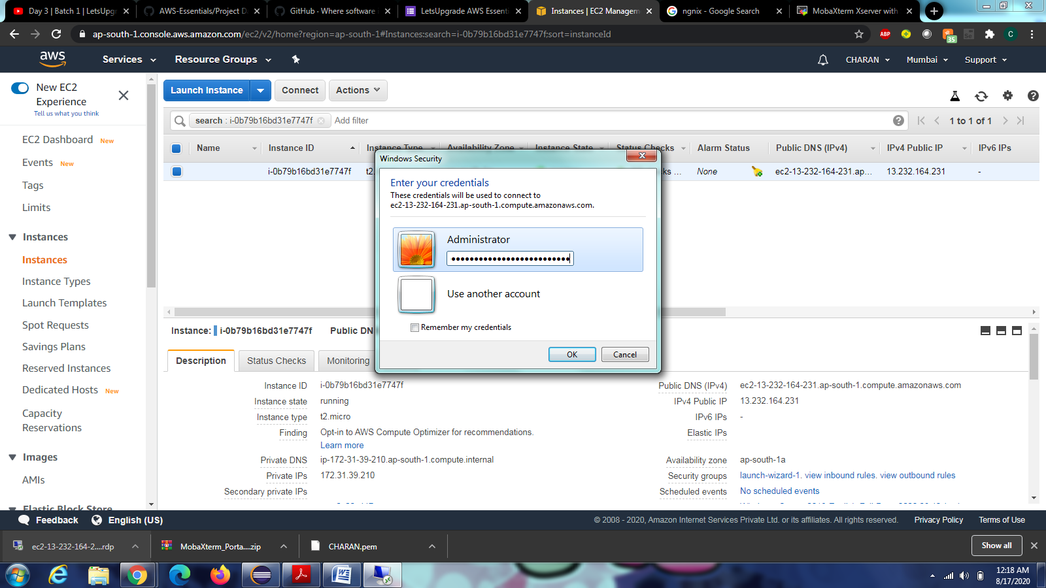

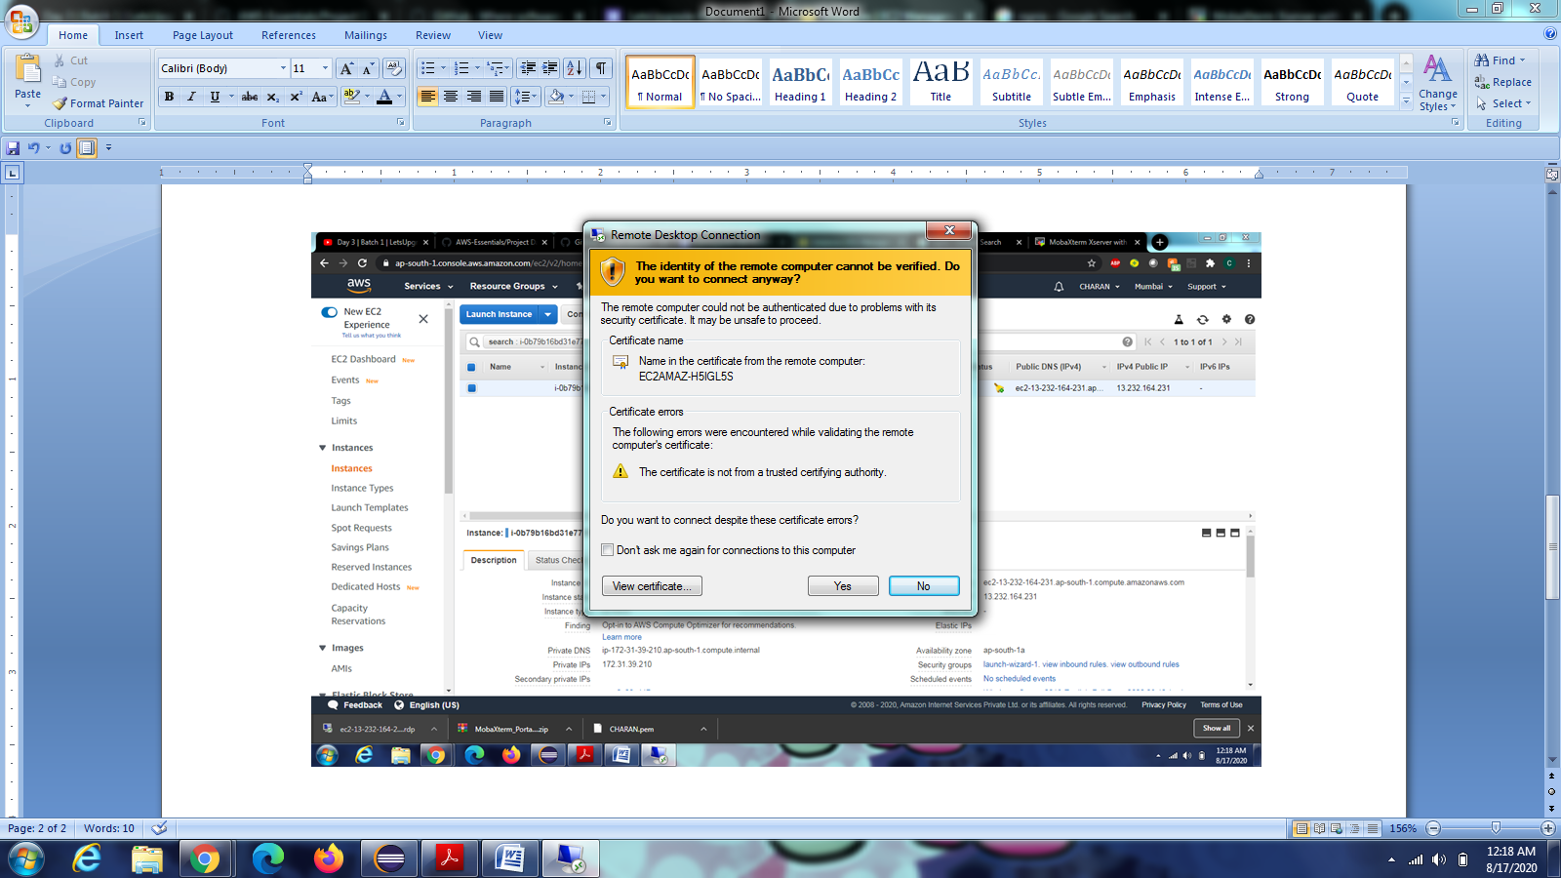

Successfully connected to remote desktop

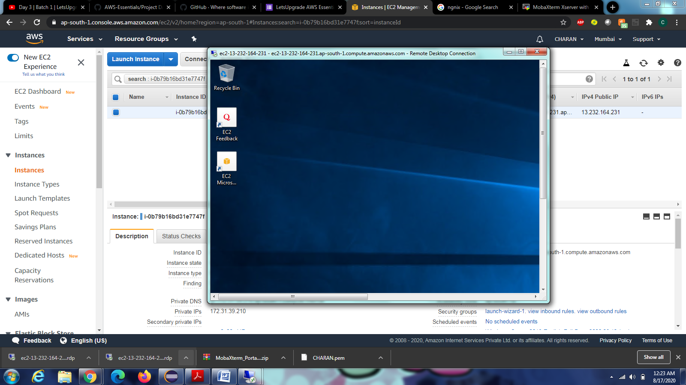

Successfully installed the IIS server.

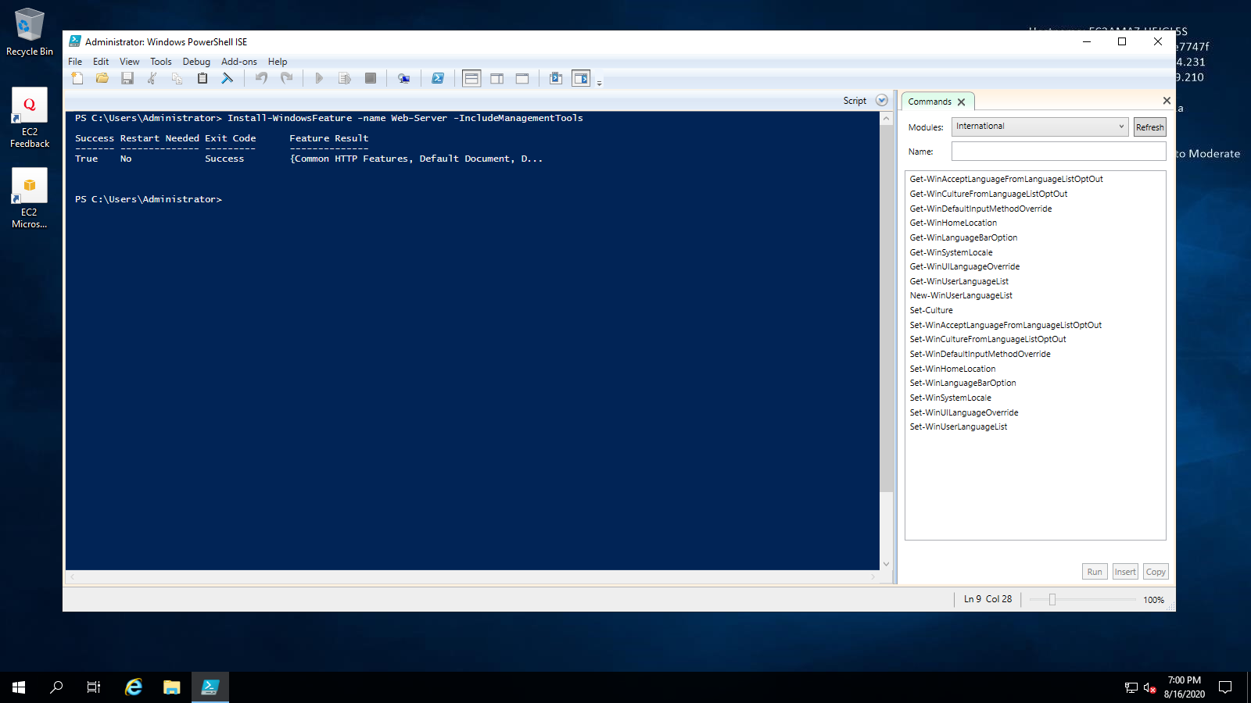

MY IP is 13.232.164.231 is up and running.

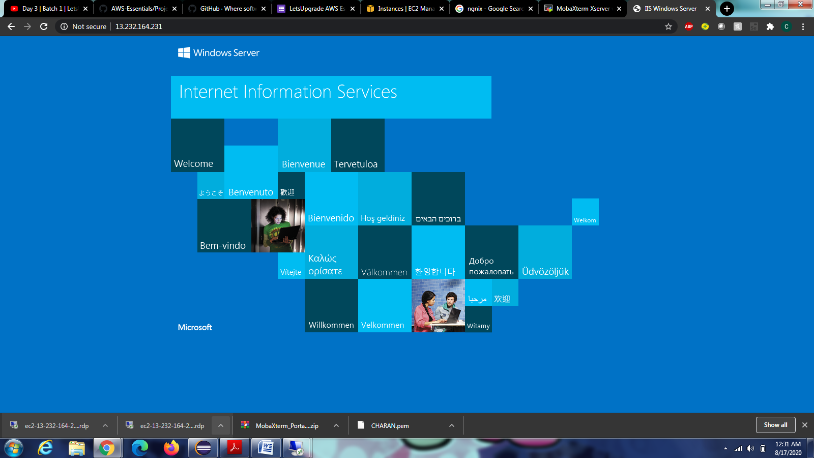

**PROJECT 2: CREATION OF UBUNTU AND INSTALLATION NGNIX SERVER.**

Creation of ubuntu ami image is successful

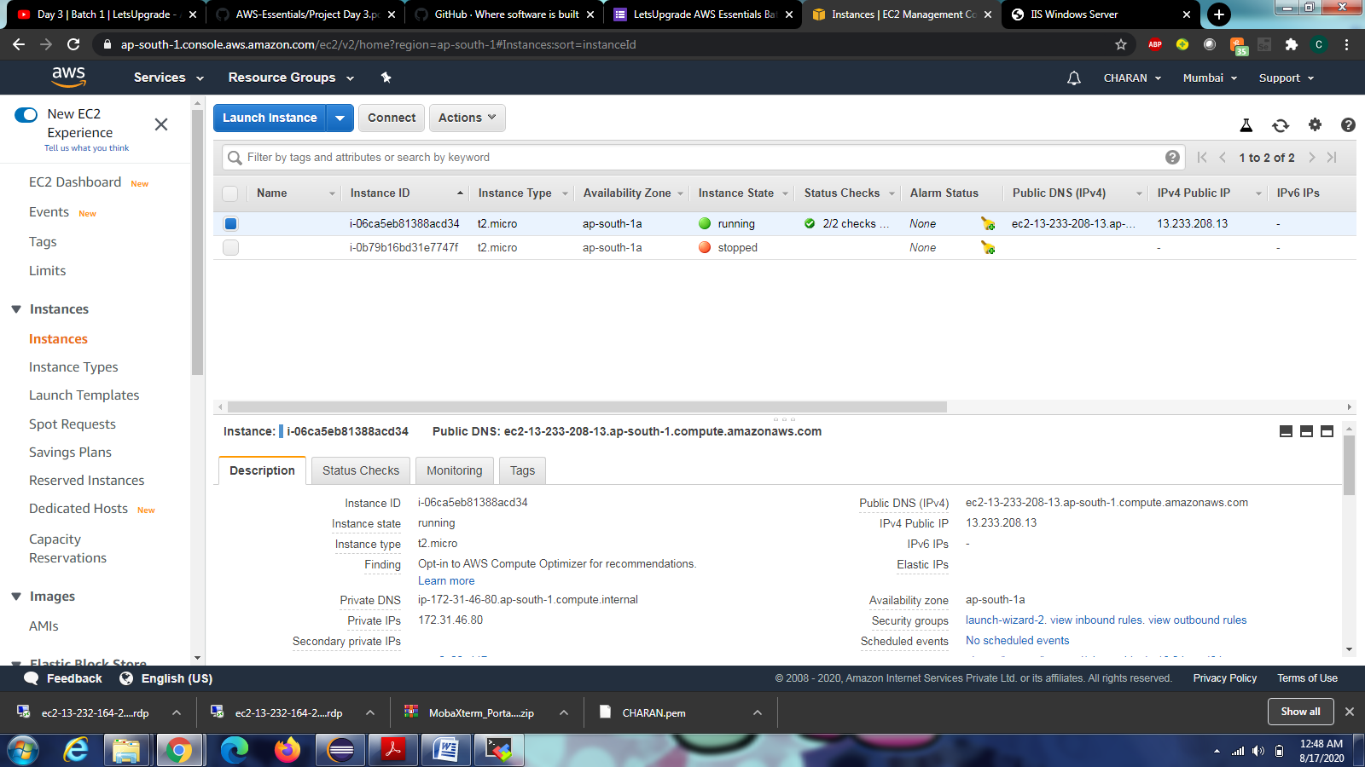

Installation and run of mobaxterm is successful.

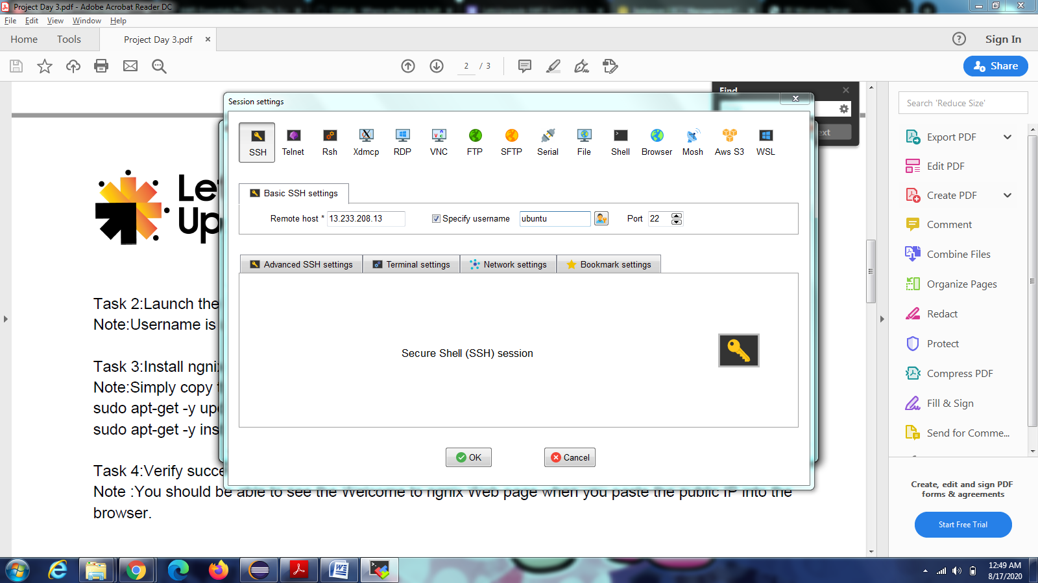

Ubuntu connection is successful and installation of ngnix server.

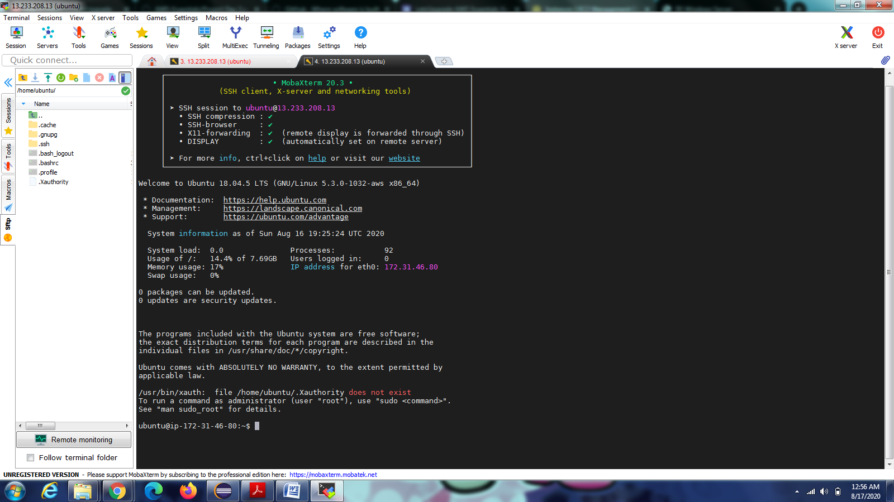

Ngnix server set is successful and my ip is: **13.233.208.13**

