ASSIGNMENT 2: hosting a load balancer:

Instances running

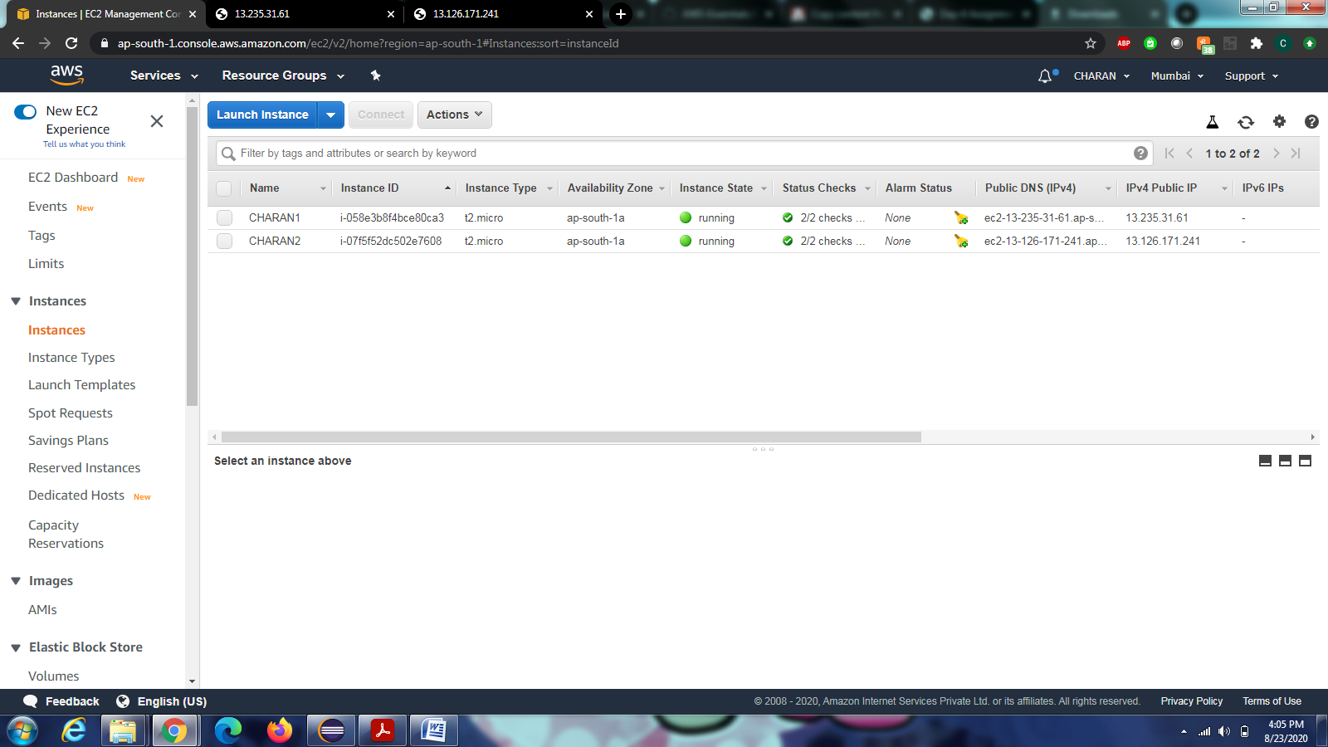

Instance 1: 13.235.31.61 ipv4 address

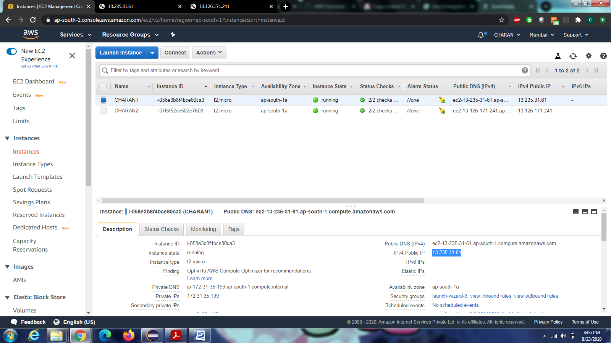

Instance 2: 13.126.171.241 ipv4 address

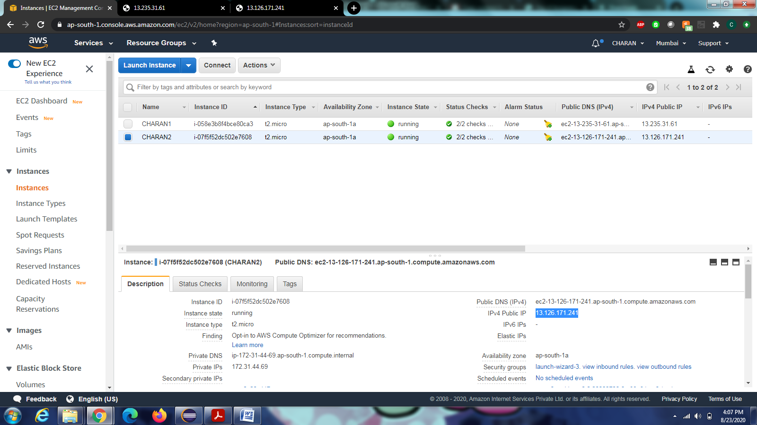

Website running in instance 1:

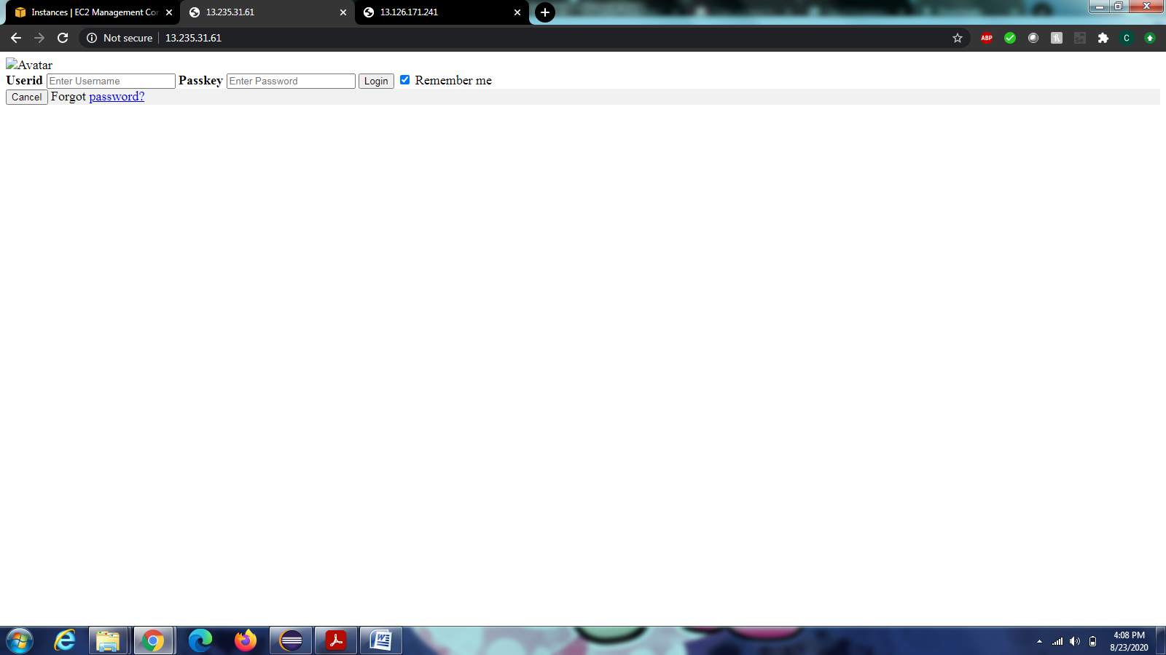

Website running in instance 2:

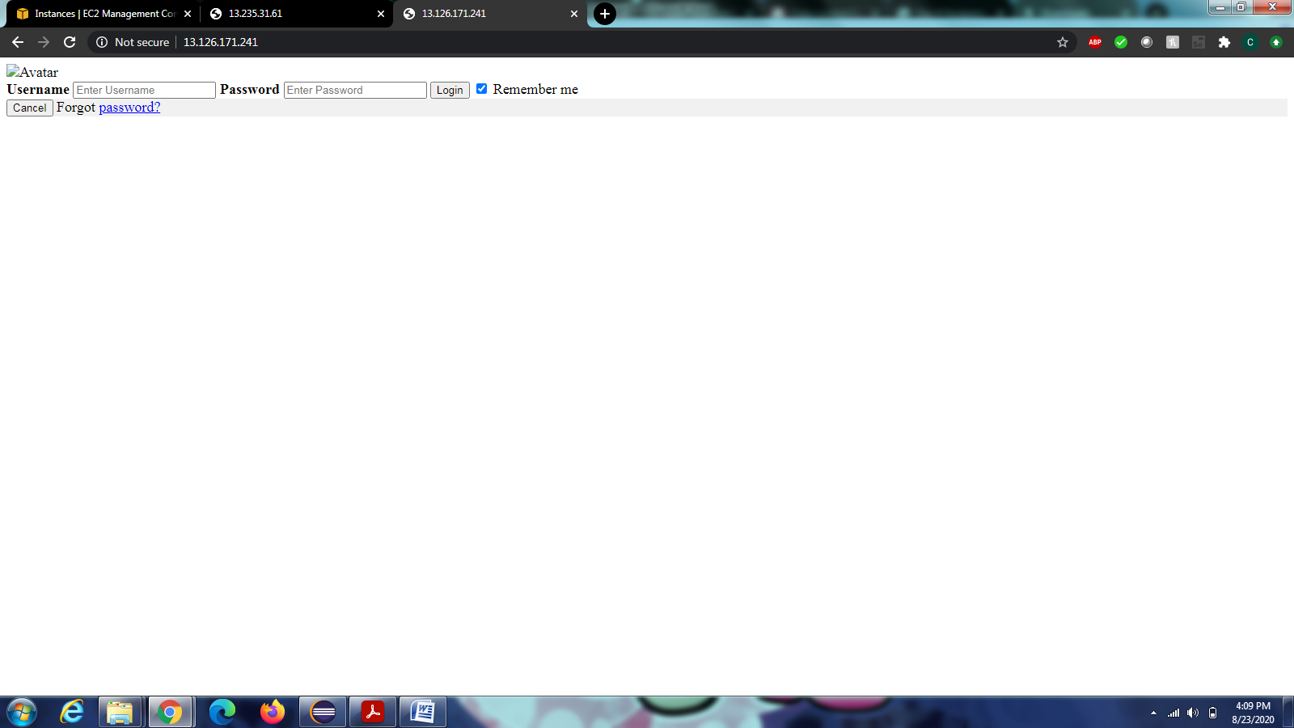

Load balancer :

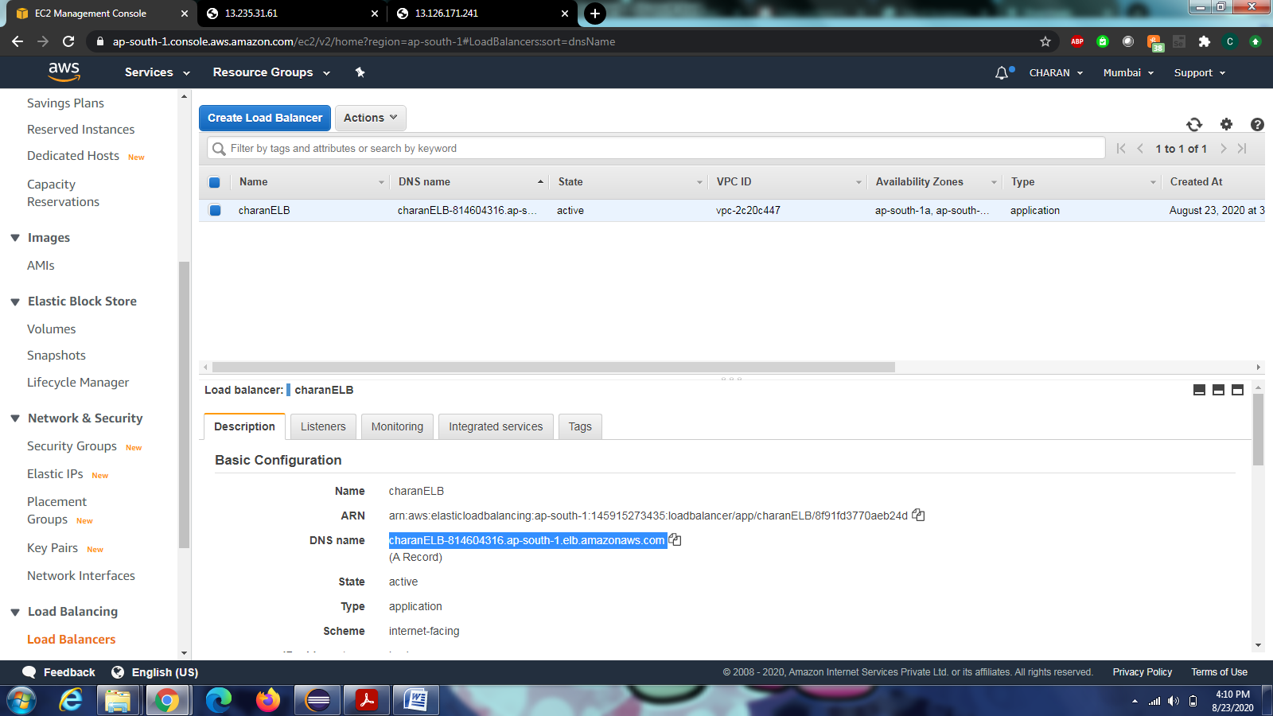

DNS NAME :  
charanELB-814604316.ap-south-1.elb.amazonaws.com

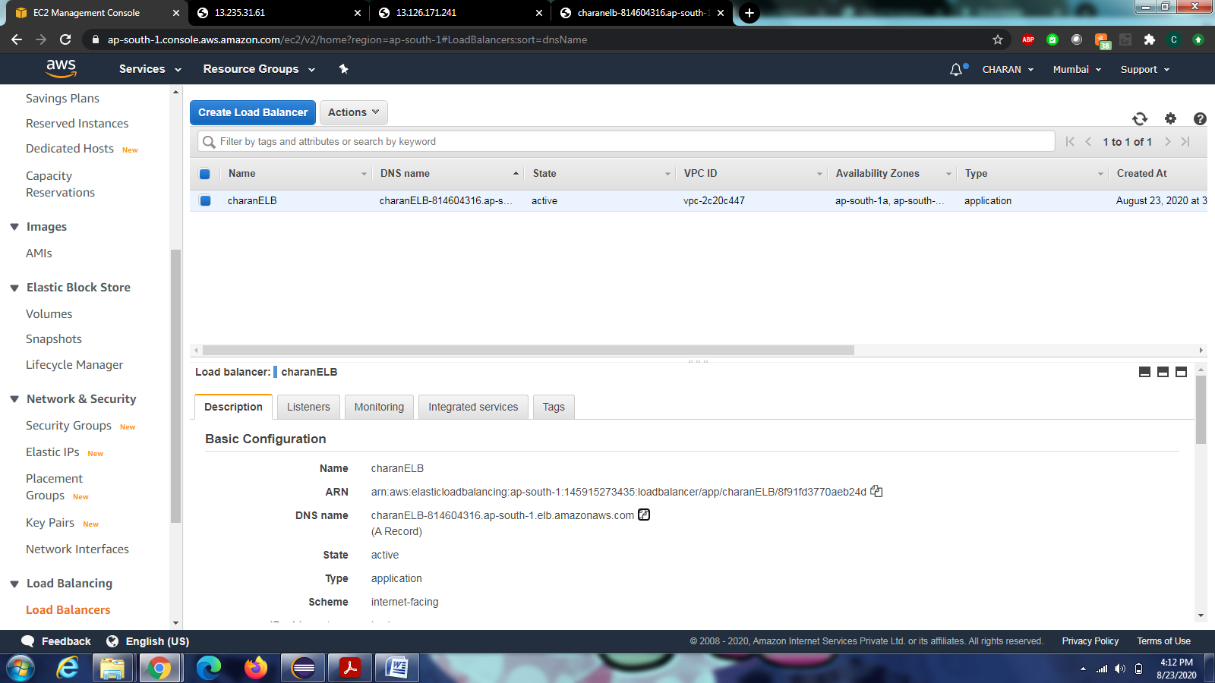

Running the load balancer with dns name:

