DATA ANALYSIS USING PANDAS AND MATPLOTLIB
Submitted By : KANDHI CHARAN YADAV
QSkill Python Internship
June 2026

- OBJECTIVE :
The objective of this project is to perform basic data analysis using the Pandas library and visualize the data using Matplotlib. The project demonstrates how to load a CSV file, calculate statistical measures, and generate graphical representations of data.
- TECHNOLOGIES USED :
• Python
• Pandas
• Matplotlib
• VS Code
- DATASET DESCRIPTION :
The dataset contains the names and marks of students.
Sample Dataset:
Name Marks
Charan 85
Rahul 78
Priya 92
Anil 67
Sneha 88
- DATA ANALYSIS :
The CSV file was loaded using the Pandas library. The mean() function was used to calculate the average marks of all students.
Average Marks = 82.0

- BAR CHART ANALYSIS :
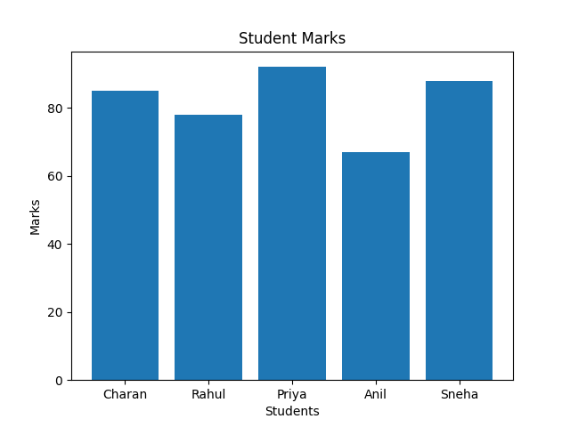
The bar chart displays the marks obtained by each student. It helps compare student performance visually and identify students with higher and lower scores.
- SCATTER PLOT ANALYSIS :
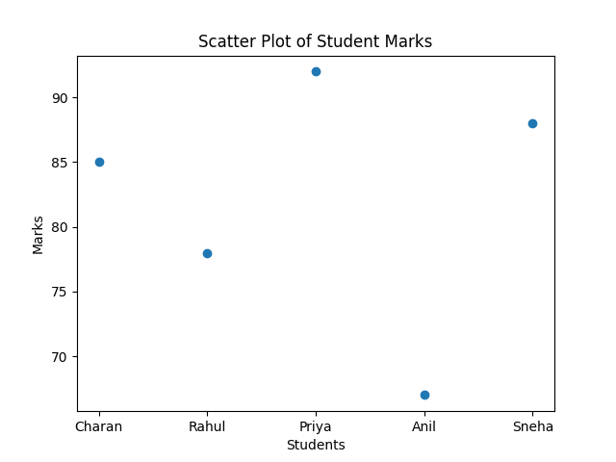
- The scatter plot represents individual student marks as points. It provides a simple visualization of score distribution among students.

- HEATMAP ANALYSIS :
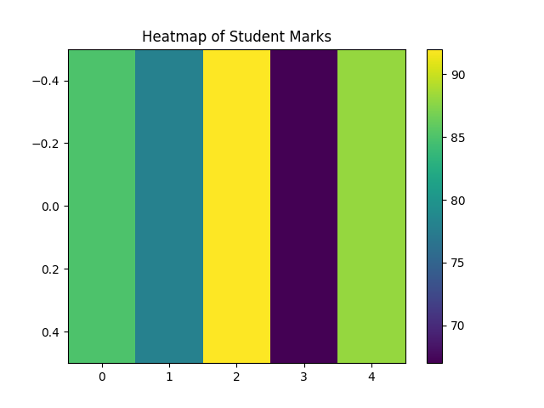
- The heatmap uses color intensity to represent marks. Higher values are displayed with stronger colors, making it easier to identify high-performing students.

- OBSERVATIONS :
• Priya scored the highest marks (92).
• Anil scored the lowest marks (67).
• The average marks of the class are 82.0.
• Most students scored above 75 marks.
- CONCLUSION :
This project successfully demonstrated data analysis and visualization using Python. Pandas was used for data handling and statistical analysis, while Matplotlib was used to generate visual representations such as bar charts, scatter plots, and heatmaps. The project provided valuable insights into student performance and helped understand the fundamentals of data analytics.

