HOUSE PRICE PREDICTION USING LINEAR REGRESSION
Submitted By : KANDHI CHARAN YADAV
QSkill Python Internship
June 2026

- OBJECTIVE :
The objective of this project is to develop a machine learning model that predicts house prices based on features such as the number of rooms and house size. Linear Regression is used to analyze the relationship between input features and house prices.
- TECHNOLOGIES USED :
• Python
• Pandas
• Scikit-Learn
• Matplotlib
• VS Code
- DATASET DESCRIPTION :
The dataset contains information about houses, including the number of rooms, house size, and corresponding prices.
Sample Dataset:
Rooms Size Price
2 1000 50000
3 1500 75000
4 2000 100000
5 2500 125000
6 3000 150000
- DATA PREPROCESSING :
The dataset was loaded using the Pandas library. The independent variables (Rooms and Size) were selected as input features, while Price was selected as the target variable.
- MODEL DEVELOPMENT :
A Linear Regression model was created using the Scikit-Learn library. The model was trained on the dataset to learn the relationship between house features and prices.

- HOUSE PRICE PREDICTION :
After training, the model was used to predict the price of a house based on the following input:
Rooms = 4
Size = 2200 sq ft
The model generated a predicted house price based on the learned patterns from the dataset.
- DATA VISUALIZATION :
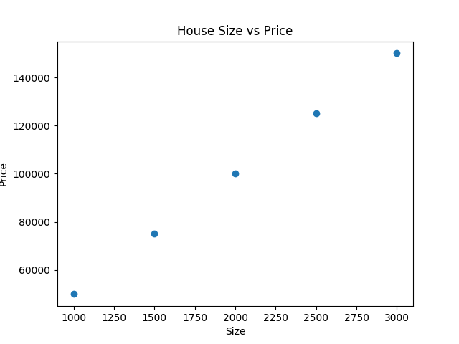
- The scatter plot shows the relationship between house size and house price. It helps visualize how house prices increase as the size of the house increases.
- OBSERVATIONS :
• House prices increase as house size increases.
• Houses with more rooms generally have higher prices.
• Linear Regression successfully identifies the trend in the data.
• The model can be used to estimate prices for new houses.
- CONCLUSION :
This project successfully implemented a House Price Prediction system using Linear Regression. The model was trained using housing data and was able to predict prices based on house characteristics. The project provided practical experience in machine learning, data preprocessing, model training, prediction, and visualization using Python.

