MATRIX OPERATIONS TOOL USING PYTHON AND NUMPY

- Submitted By : KANDHI CHARAN YADAV
- QSkill Python Internship
- June 2026

Objective :
To develop a Python application that performs matrix operations such as addition, subtraction, multiplication, transpose, and determinant calculation using NumPy.
Technologies Used :
- Python
- NumPy
- VS Code

- Matrix Addition :
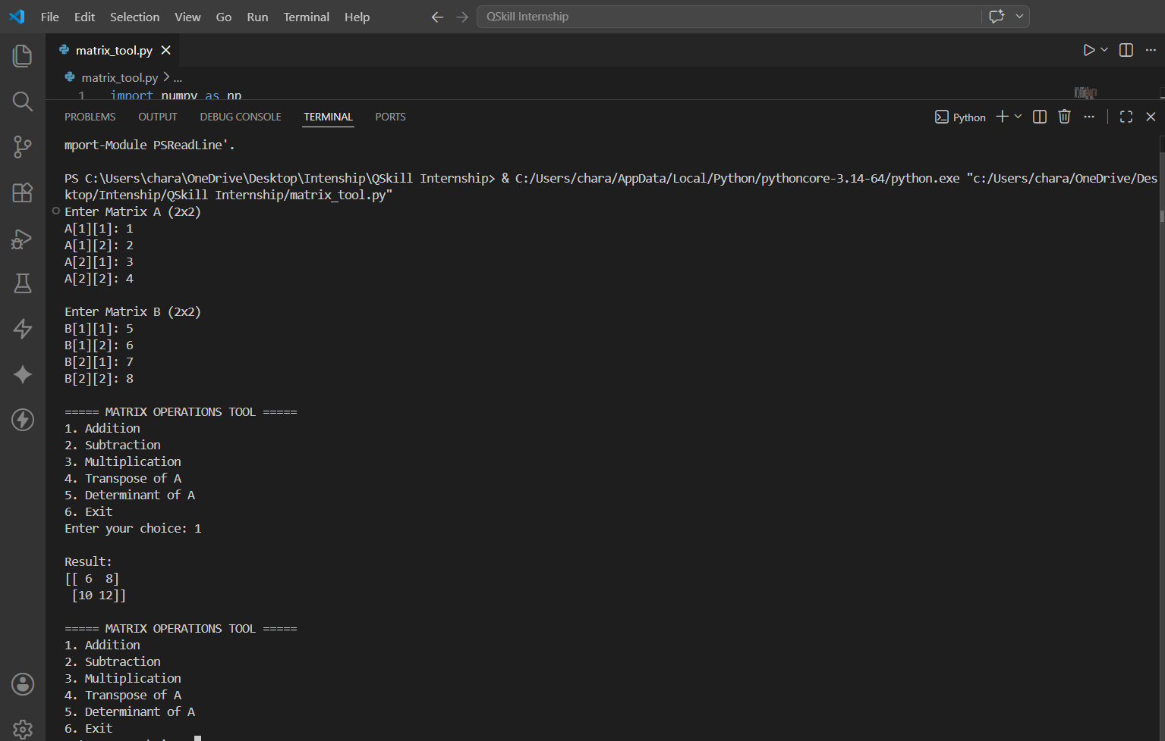
- The program adds corresponding elements of two matrices and displays the resulting matrix.
- Matrix Subtraction :
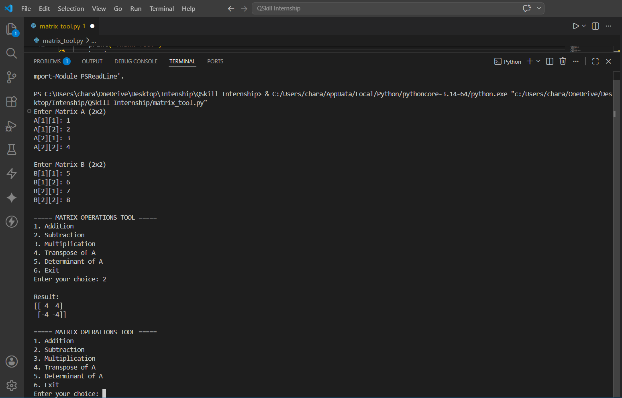
- The program subtracts corresponding elements of Matrix B from Matrix A.
- Matrix Multiplication :
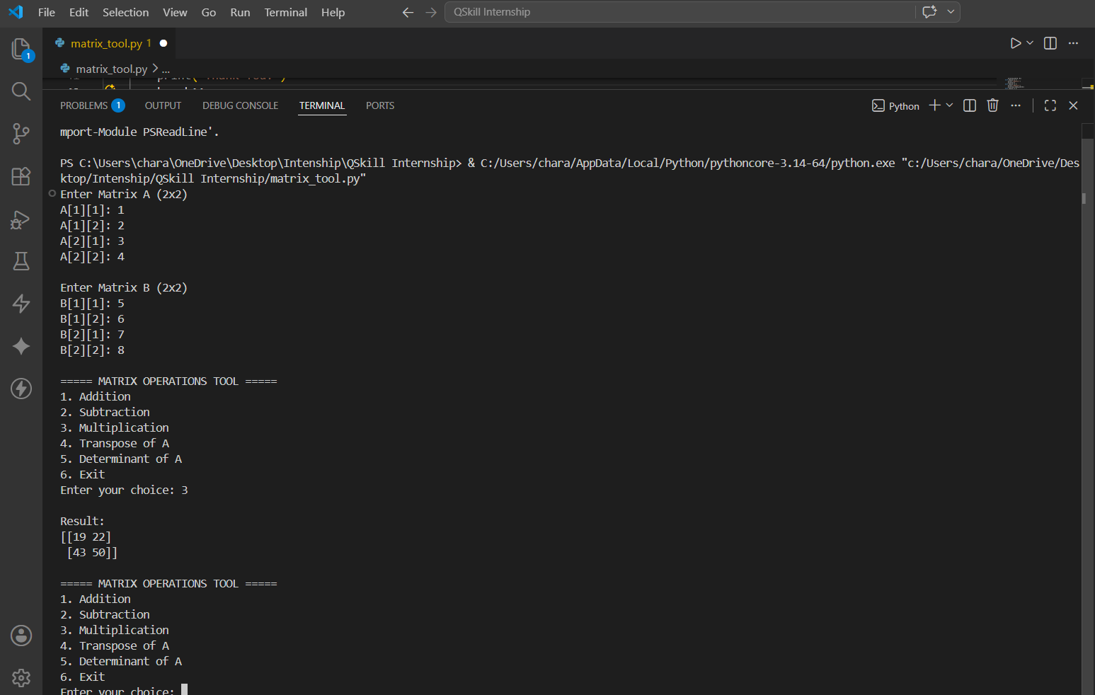
- The program performs matrix multiplication using NumPy's dot() function.
- Transpose :
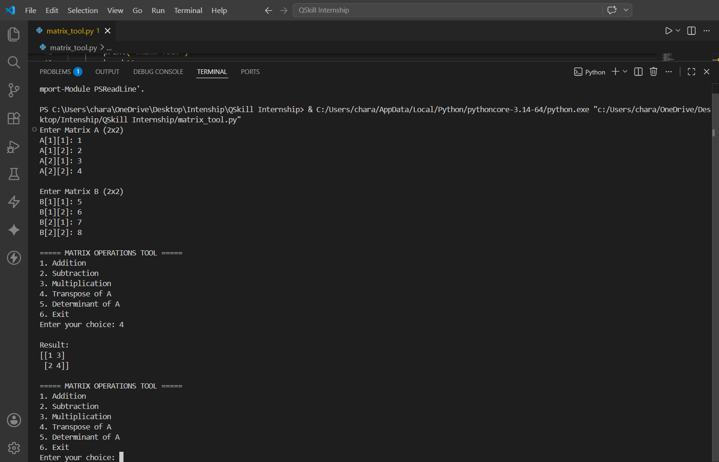
- The transpose operation converts rows into columns.
- Determinant :
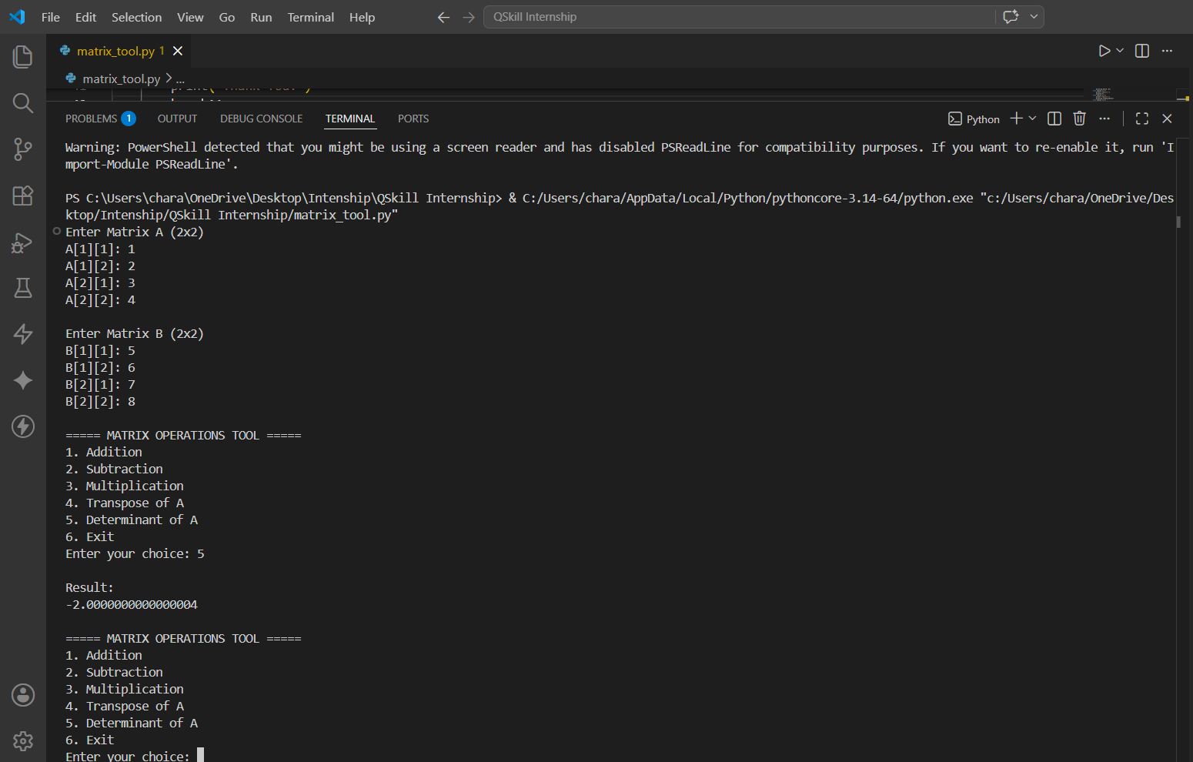
- The determinant is calculated using NumPy's linalg.det() function.

Conclusion :
The Matrix Operations Tool was successfully developed using Python and NumPy. The application performs addition, subtraction, multiplication, transpose, and determinant operations through a menu-driven interface. This project helped in understanding matrix manipulation and numerical computing using Python.

