NOTRE DAME UNIVERSITY

Faculty of Engineering

ECCE Department

#### 

#### EEN 221

#### Logic Design Lab

Section B

**Instructor:**

Dr. Joseph Massoud

Formal Report

Final Project

Due on:

10/12/24

Submitted by:

Pedro Keyrouz

Giorgio Kordahi

Habib Bou Maroun

Charbel Estephan

**I. Introduction**

This project involves the design and implementation of a digital clock and alarm system. The system is built around core functionalities such as timekeeping, user-settable alarm, and flexible display formats. It features separate counters for hours, minutes, and seconds, driven by a one-second pulse generator to ensure precise time tracking. The clock can operate in either a 12-hour format with AM/PM indication or a 24-hour format, offering versatility for user preferences.

A key component is the comparator, which continuously checks the current time against the user-defined alarm time. When the two match, the system activates the alarm function. Additionally, the clock includes user-friendly controls for setting or resetting both the time and the alarm. This project showcases the integration of digital counters, time comparison logic, and intuitive user interfaces to create a functional and efficient clock system with an alarm feature.

**III. Experiment Description**

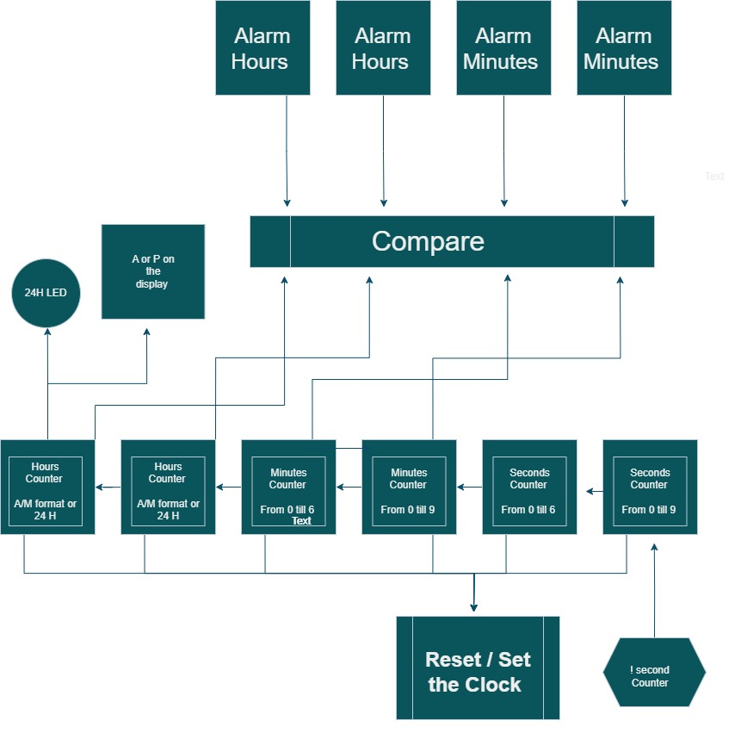

**Title:** Block Diagram of the Clock and all its features

*Equipment and Component List*

The components and equipment used in the experiment are:

Resistors:

* 1 kΩ: 11 pieces
* 220 Ω: 1 piece
* 470 Ω: 1 piece
* 470 kΩ: 2 pieces

Capacitor: 1.0 µF

Integrated Circuits (ICs):

* **555 Timer/oscillator**
* **4026 Decade counter with 7-segment display driver**
* **74157 Quad 2-to-1 Multiplexer**
* **7485 4-bit Comparator**
* **7408 Quad 2-input AND Gate**
* **7432 Quad 2-input OR Gate**
* **74HC21 Quad 2-input AND Gate with High Drive**
* **7404 Hex Inverter**
* **7474 Dual D Flip-Flop**
* **74HC86 Quad 2-input XOR Gate**

*Procedure*

**V. Conclusion**

The digital clock and alarm system successfully integrates essential features for accurate timekeeping and reliable alarm functionality. By employing modular components such as counters for hours, minutes, and seconds, alongside a comparator for alarm activation, the system achieves precision and efficiency. The inclusion of flexible 12-hour and 24-hour display formats enhances usability, catering to diverse user preferences.

This project demonstrates a practical application of digital design principles, combining functionality with user interaction. The system's robust design and ease of operation make it a valuable prototype for time management solutions, highlighting the potential for further enhancements, such as advanced alarm modes or integration with external devices.

**VII. Appendix**

1. **555 Timer/oscillator**:

Diodes Incorporated, NE555 Timer Datasheet, Rev. 5, Feb. 2021. [Online]. Available: <https://www.diodes.com/assets/Datasheets/NE555.pdf>. Accessed: Dec. 6, 2024.

1. **4026 Decade Counter with 7-Segment Display Driver**:

Texas Instruments, CD4026B Decade Counter, Datasheet. [Online]. Available: <https://www.ti.com/lit/ds/symlink/cd4026b.pdf>. Accessed: Dec. 6, 2024.

1. **74157 Quad 2-to-1 Multiplexer**:

Texas Instruments, SN74157 Quadruple 2-Line to 1-Line Data Selector/Multiplexer, Datasheet. [Online]. Available: <https://www.ti.com/lit/ds/symlink/sn74157.pdf>. Accessed: Dec. 6, 2024.

1. **7485 4-bit Comparator**:

Texas Instruments, SN74LS85 4-Bit Magnitude Comparator, Datasheet. [Online]. Available: <https://www.ti.com/lit/ds/symlink/sn74ls85.pdf>. Accessed: Dec. 6, 2024.

1. **7408 Quad 2-input AND Gate**:

Texas Instruments, SN7408 Quadruple 2-Input Positive-AND Gates, Datasheet. [Online]. Available: <https://www.ti.com/lit/ds/symlink/sn7408.pdf>. Accessed: Dec. 6, 2024.

1. **7432 Quad 2-input OR Gate**:

Texas Instruments, SN7432 Quadruple 2-Input Positive-OR Gates, Datasheet. [Online]. Available: <https://www.ti.com/lit/ds/symlink/sn7432.pdf>. Accessed: Dec. 6, 2024.

1. **74HC21 Quad 2-input AND Gate with High Drive**:

Nexperia, 74HC21; 74HCT21 Quad 2-Input AND Gates, Datasheet. [Online]. Available: <https://assets.nexperia.com/documents/data-sheet/74HC_HCT21.pdf>. Accessed: Dec. 6, 2024.

1. **7404 Hex Inverter**:

Texas Instruments, SN7404 Hex Inverter, Datasheet. [Online]. Available: <https://www.ti.com/lit/ds/symlink/sn7404.pdf>. Accessed: Dec. 6, 2024.

1. **7474 Dual D Flip-Flop**:

Texas Instruments, SN7474 Dual D Flip-Flop with Preset and Clear, Datasheet. [Online]. Available: <https://www.ti.com/lit/ds/symlink/sn7474.pdf>. Accessed: Dec. 6, 2024.

1. **74HC86 Quad 2-input XOR Gate**:

Texas Instruments, SN74HC86 Quadruple 2-Input Exclusive-OR Gates, Datasheet. [Online]. Available: <https://www.ti.com/lit/ds/symlink/sn74hc86.pdf>. Accessed: Dec. 6, 2024.