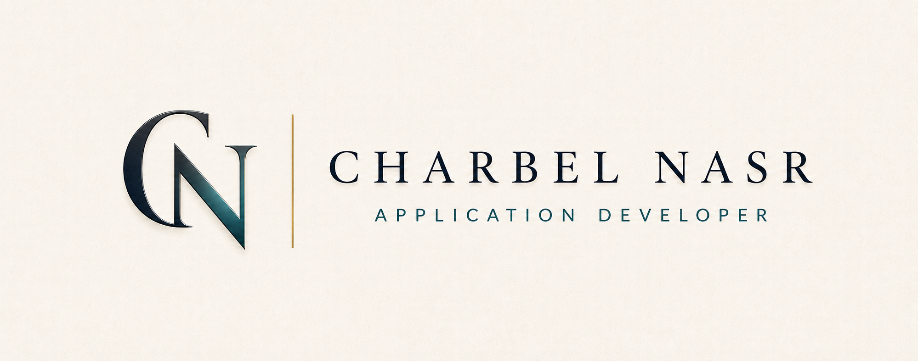
Beirut, Lebanon | +961 3 008457 | Charbel.21nasr@icloud.com | charbelnasr.online
PROFESSIONAL SUMMARY
Application Developer with production experience designing, delivering, and maintaining workflow-heavy enterprise platforms for admissions, academic operations, and internal coordination. Strongest in ASP.NET Core, SQL Server, Entity Framework, React, and backend-driven systems where operational clarity, security, and reliability matter.
CORE CAPABILITIES
- Enterprise application development across applicant-facing, evaluator-facing, and administrative workflows
- ASP.NET Core, SQL Server, Entity Framework, REST APIs, stored procedures, and structured backend services
- Workflow design for forms, document handling, recommendation flows, scoring logic, and review-state management
- Production support across deployment, issue resolution, permissions, and system reliability
PROFESSIONAL EXPERIENCE
Application Developer
Saint George University of Beirut | Achrafieh, Lebanon | February 2024 - Present
- Build and maintain production admissions and academic platforms supporting applicant submission, evaluator review, and administrative operations.
- Design and implement workflow-heavy systems covering dynamic forms, document intake, recommendation handling, scoring flows, and internal dashboards.
- Develop backend services and APIs using ASP.NET Core, SQL Server, Entity Framework, and secure business logic patterns.
- Support day-to-day platform reliability through deployment coordination, issue resolution, permissions handling, and post-launch improvements.
IT Support and Junior Development
Saint George University of Beirut | Achrafieh, Lebanon | February 2023 - February 2024
- Supported faculty and staff operations while contributing to internal system maintenance, testing, and technical documentation.
- Built early experience with production environments, enterprise processes, and structured technical delivery inside an academic institution.
IT Support and Development
Société Sakr | Jounieh, Lebanon | October 2023 - January 2024
- Managed cloud-based storage and internal network resources while supporting business-side technical operations.
- Led delivery of an inventory management system from requirements through deployment and user onboarding.
SELECTED PROJECTS
- SGUB Undergraduate Admissions Platform: production admissions platform supporting applicant submission, document review, scoring workflows, and administrative decision support.
- PGME Residency and Fellowship Applications: multi-step workflow built for document-heavy submissions, structured validation, reviewer coordination, and reliable processing.
- Lebanese Red Cross Youth Hub: internal coordination platform with role-based workflows, topic distribution, and operational ownership.
- UNISHELF Commerce Experience: commercial product platform combining structured catalog modeling, customer-facing filtering, and cloud-hosted media delivery.
TECHNICAL SKILLS
Languages: C#, JavaScript, TypeScript, Python, Java, SQL
Backend: ASP.NET Core, .NET MVC, REST APIs, Entity Framework
Frontend: React, Razor Views, HTML5, CSS, JavaScript
Data: SQL Server, Stored Procedures, Triggers, Query Optimization, MongoDB
Deployment: IIS, AWS S3, CloudFront, CI/CD-aware workflows, Docker (basic)
Architecture: Service layers, DTO-based design, role-based access control, server-side validation
EDUCATION AND CERTIFICATION
- B.S. in Information Technology (AI Emphasis) — Saint George University of Beirut, 2022 - 2025
- M.S. in Data Science (In Progress) — Lebanese American University, 2025 - Present
- Cisco Certified Support Technician (CCST IT Support)

