Distributed Systems – Lab 2 Part 2
Distributed Event Processing with C# and gRPC
Georgio Abi Aad Charbel BouDaher
1 /10/2026
Introduction:
We built a distributed event processing system in C# using gRPC. Producers send sensor events to one of two processors, which validate and enrich them and forward the result to a storage service. A registry tracks which processors are alive. All calls use HTTP/2 over TLS.
The steps below follow the order we did the lab in. The full test suite passed all 15 scenarios.
Environment:
Language and framework | C# with ASP.NET Core on .NET 10
Machine | Windows 11 x64, SDK 10.0.301, runtime 10.0.9
gRPC packages | Grpc.AspNetCore, Grpc.Net.Client, Grpc.Tools 2.71.0
Protocol Buffers | Google.Protobuf 3.31.1, proto3
Services | Registry (7100), storage (7200), two processors (7301, 7302)
Test run shown here | run-20261001-101446438
Result | 15 of 15 scenarios passed

Step 1 : Opening the project
One C# project holds every service role. The role is picked from the command line at startup, so each one runs as its own process and talks over the network.
// Program.cs - one executable, one role per process.
if (args[0] == "certs") { Security.Generate(); return; }
if (args[0] == "demo") { await Demo.Run(); return; }
if (args[0] == "producer") { await ProducerCli.Run(args); return; }
await Hosting.Run(args); // registry | storage | processor <port> <id>

File | What it does
Hosting.cs | Sets up the Kestrel HTTP/2 TLS endpoint for a role.
Security.cs | Creates the local CA and certificate, builds trusted client channels.
Interceptors.cs | Authentication, logging and metrics around every call.
RegistryService.cs | Takes processor heartbeats and returns the live endpoints.
ProcessorService.cs | Validates, classifies and enriches events, then calls storage.
StorageService.cs | Owns the journal file and handles duplicates.
Producer.cs / ProducerCli.cs | Discovery, retries and the three producer modes.
Demo.cs | The 15 automated test scenarios.

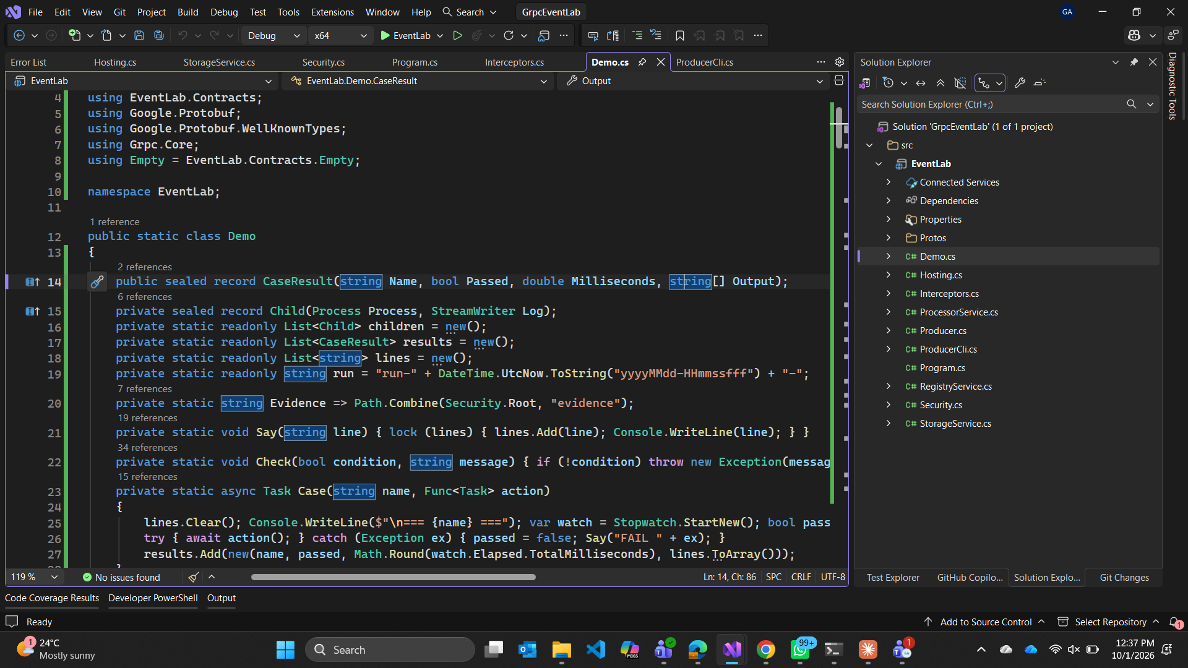
Figure 1 – The solution opened in Visual Studio with all the source files.

Step 2 : Writing the service contract
We wrote events.proto first, since the generated classes are what both sides compile against. The Processor service uses three RPC shapes so all the streaming patterns appear in one API.
service Processor {
rpc Publish(stream Event) returns (Summary); // client streaming
rpc Watch(Query) returns (stream Result); // server streaming
rpc Live(stream LiveInput) returns (stream Result); // bidirectional
}

Field 6 is reserved so the removed field can never be reused, and fields 7 and 8 are optional so "not sent" is different from "sent as zero".
reserved 6;
reserved "legacy_source";
optional string source = 7; // added in revision 2
optional int32 priority = 8;

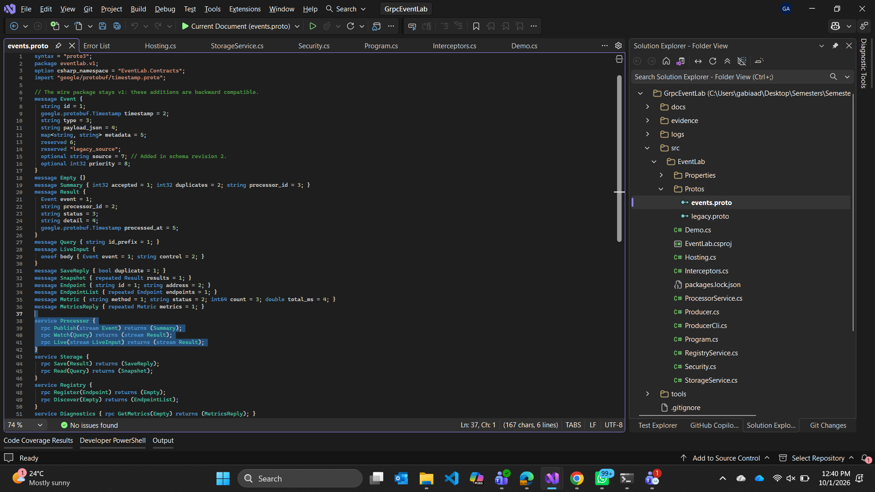
Figure 2 – events.proto open in the editor, showing the three Processor RPCs.

Step 3 : Building and starting the cluster
We built in Release mode and started the cluster with start-lab.ps1. It first creates a private CA and a localhost certificate. Nothing is added to the Windows trust store, so certificate checking stays on.
// Security.cs - a private CA signs a localhost certificate, inside the project folder.
File.WriteAllText (Cert("ca.pem"), ca.ExportCertificatePem());
File.WriteAllBytes(Cert("server.pfx"), leaf.Export(X509ContentType.Pfx, "lab-only"));

Four processes then start and each prints READY once its TLS endpoint is accepting traffic.
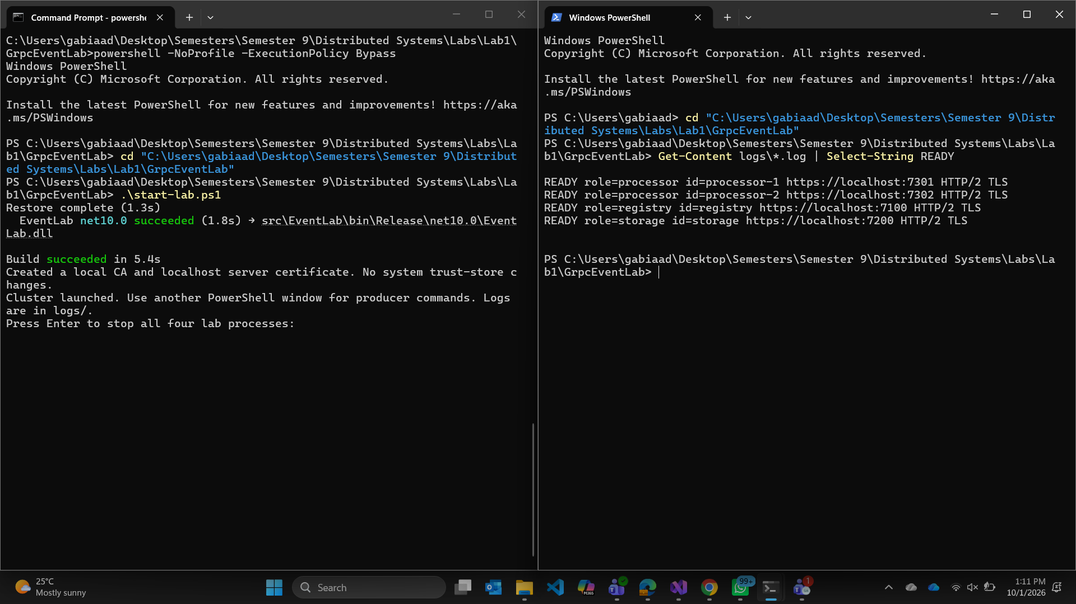
Figure 3 – Left: the build succeeds and the four processes start. Right: all four services are READY.

Step 4 : Client streaming (publish)
The producer asks the registry which processors are alive, opens one Publish call, writes five events into the request stream and gets one summary back for the whole batch.
// Producer.cs - discovery returns a live endpoint; "next" advances the round robin.
var nodes = await new Registry.RegistryClient(registryChannel)
.DiscoverAsync(new Empty(), Security.Headers("discovery"), deadline, token);
string address = nodes.Endpoints[next++ % nodes.Endpoints.Count].Address;

Events are validated as they arrive, so a batch is not all-or-nothing.
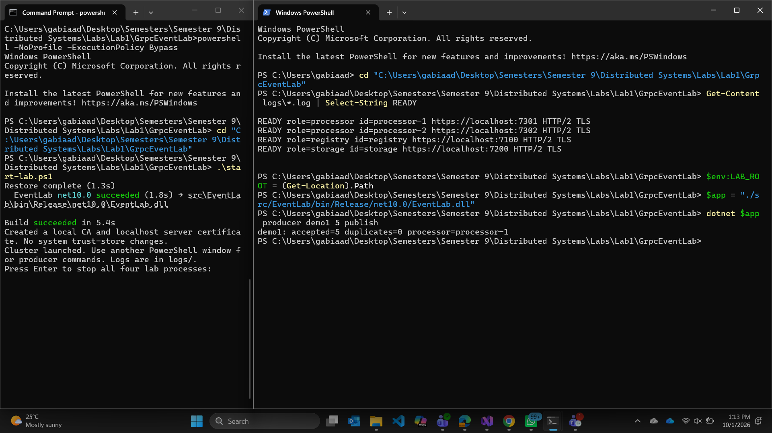
Figure 4 – Five events sent in one stream return one summary: accepted=5, duplicates=0.

Step 5 : Server streaming (watch)
The client sends one query and the processor writes the matching results back one at a time. The processor reads them from storage with a normal unary call first.
// ProcessorService.cs - read once from storage, then stream the snapshot out.
var snapshot = await downstream.Client.ReadAsync(req, ForwardHeaders(ctx),
ctx.Deadline, ctx.CancellationToken);
foreach (var result in snapshot.Results)
await output.WriteAsync(result);

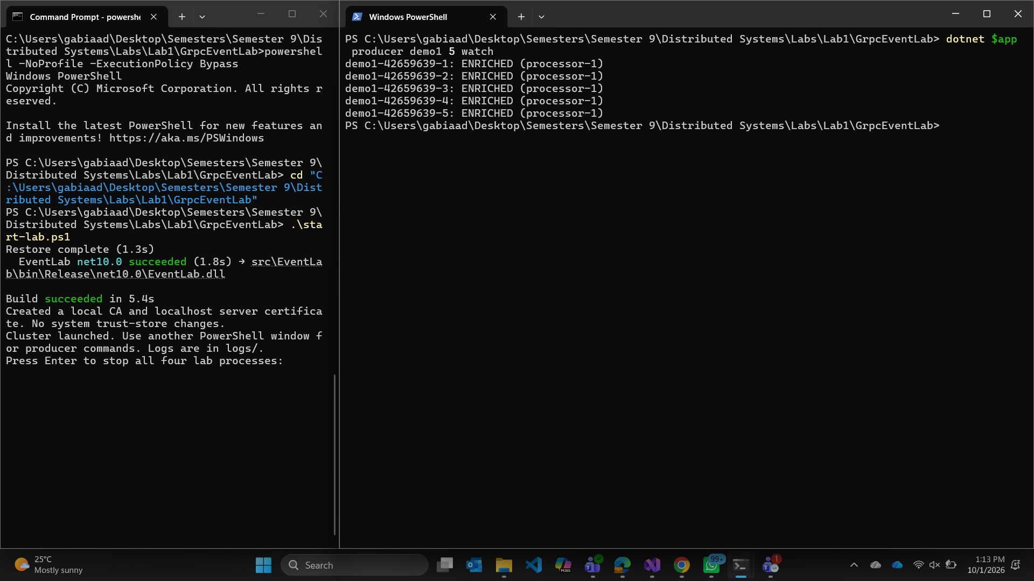
Figure 5 – The five events from Step 4 come back as a server stream, each marked ENRICHED.

Step 6 : Bidirectional streaming (live)
Both directions stay open at once. A frame is either an event or a control string, and feedback is sent back without waiting for the client to finish sending.
// ProcessorService.cs - one stream, two kinds of frame.
if (frame.BodyCase == LiveInput.BodyOneofCase.Control)
await output.WriteAsync(new Result { Status = "CONTROL", Detail = "pong" });
else if (frame.BodyCase == LiveInput.BodyOneofCase.Event)
await output.WriteAsync((await Process(frame.Event, ctx)).Result);

An invalid event gets its own error frame and the stream keeps going.
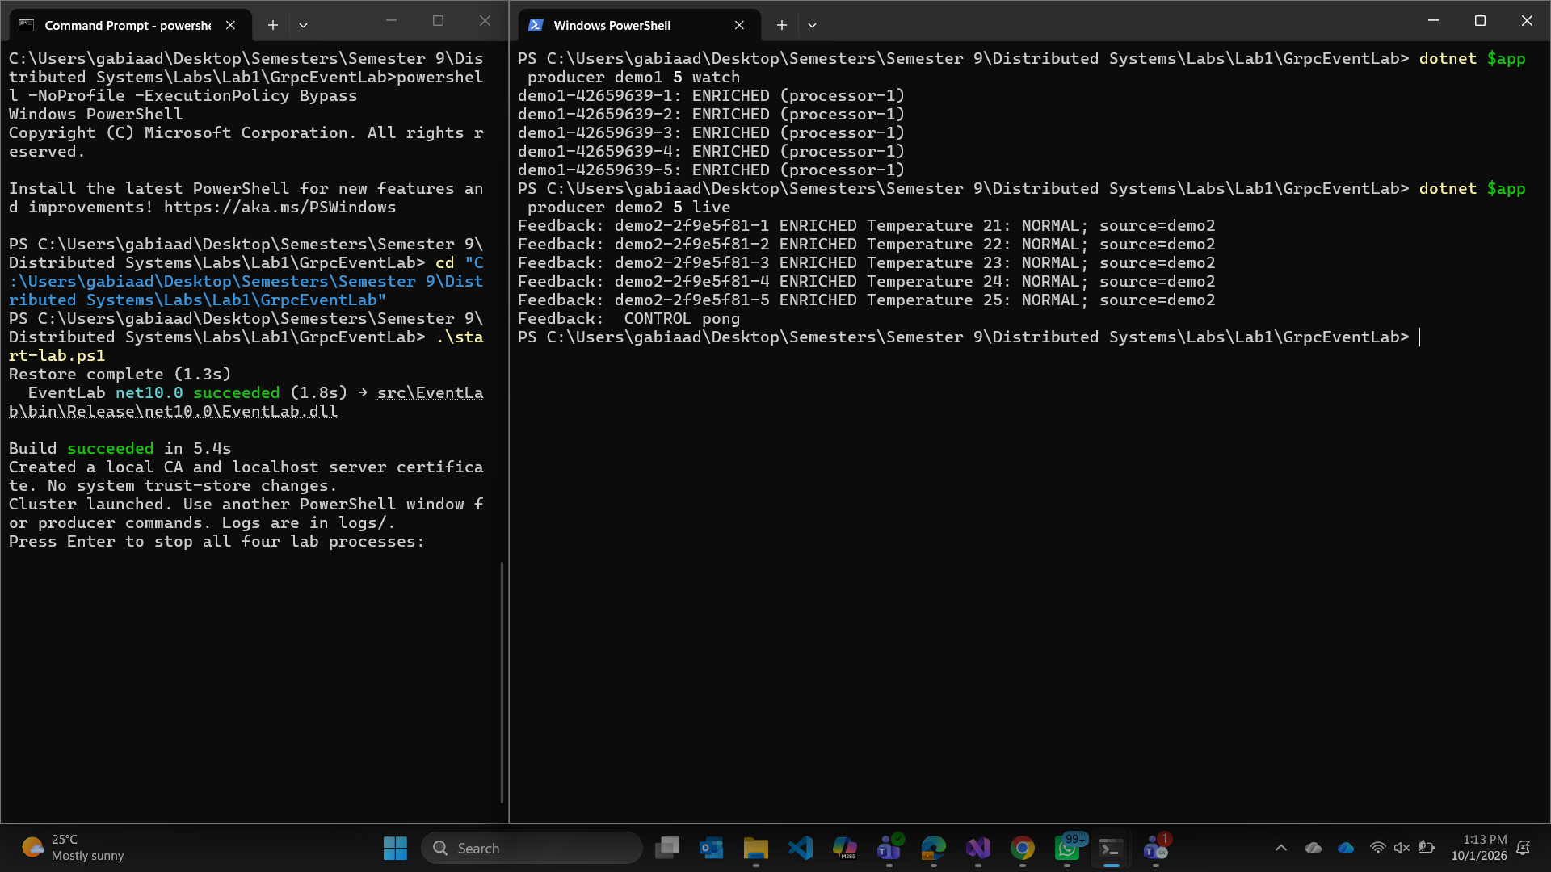
Figure 6 – Feedback arrives while the request stream is still open, and the ping is answered with pong.

Step 7: Storage and duplicate protection
Only the storage process writes the journal. The record is flushed to disk before the in-memory index is updated, and the journal is read back on restart.
// StorageService.cs - the event ID is the idempotency key.
if (records.TryGetValue(result.Event.Id, out var existing)) {
if (!existing.Event.Equals(result.Event))
throw new RpcException(new Status(StatusCode.AlreadyExists,
"Event ID reused with different content."));
return true; // same event again: safe duplicate
}

Same ID and same content is a duplicate, which makes retries safe. Same ID with different content is rejected, so nothing is overwritten silently.
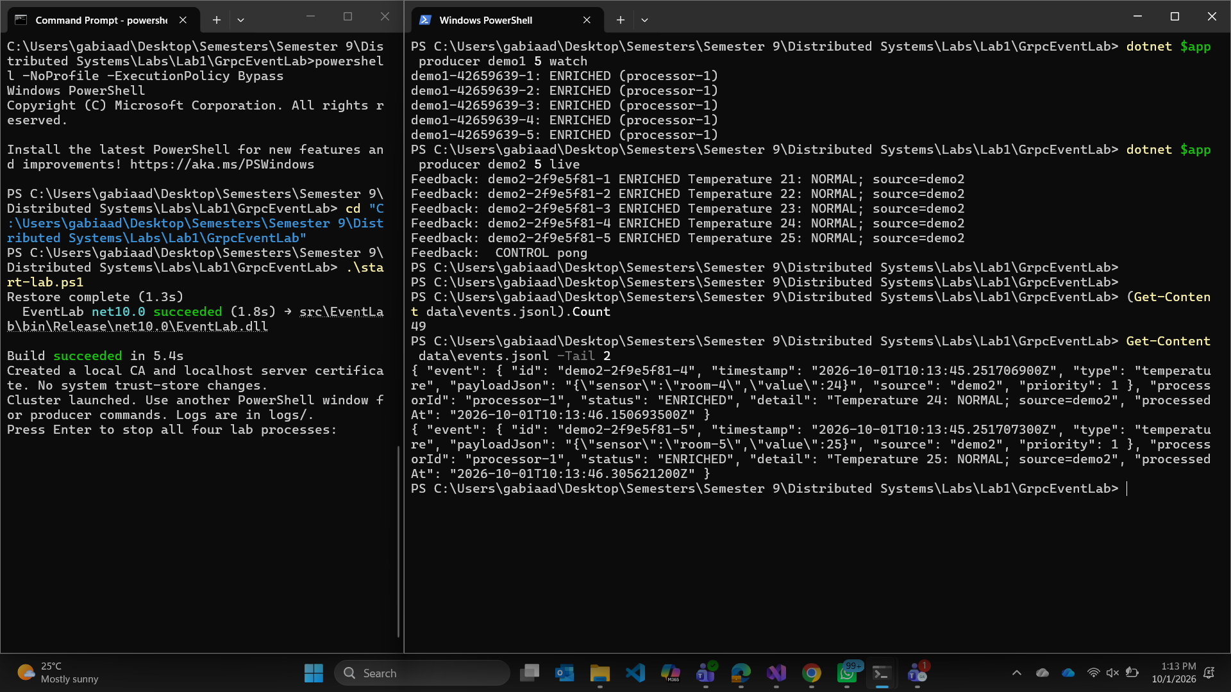
Figure 7 – The journal after the manual run: 49 events, with the last two records shown in full.

Step 8: Running the automated test suite
We stopped the manual cluster and ran run-demo.ps1, which builds, starts its own cluster, runs 15 scenarios with assertions, saves the evidence and shuts down.
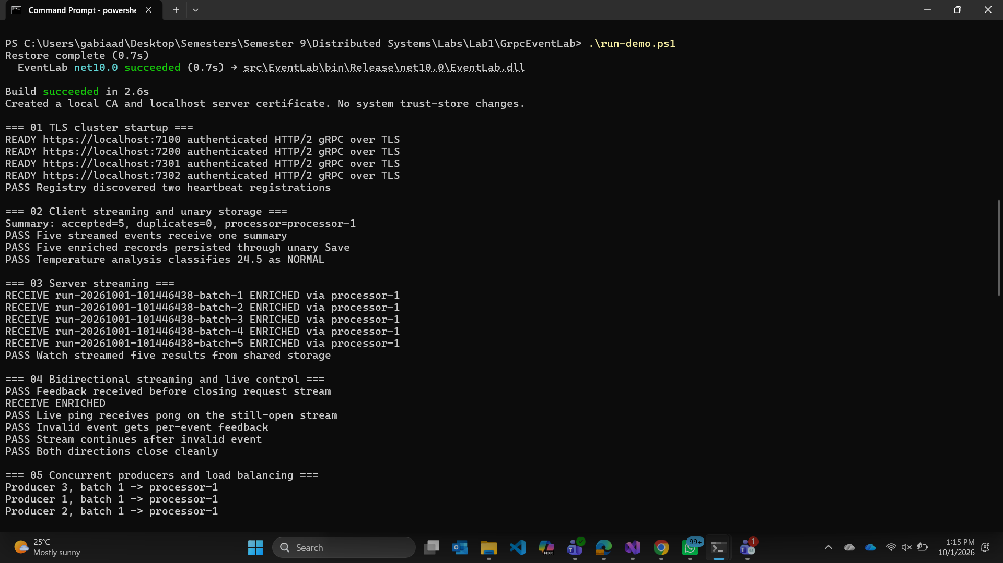
Figure 8 – Scenarios 1 to 5 running: four READY endpoints, one summary for five events, five results on the server stream.
Scenario 5 runs three producers at once and the 12 calls split six and six. Scenario 8 breaks the connection mid-batch, and the retry finds the already saved event as a duplicate.
Retry 1: Unavailable; backoff=229 ms
Retry 2: Unavailable; backoff=442 ms
Final attempt: accepted=2, duplicates=1

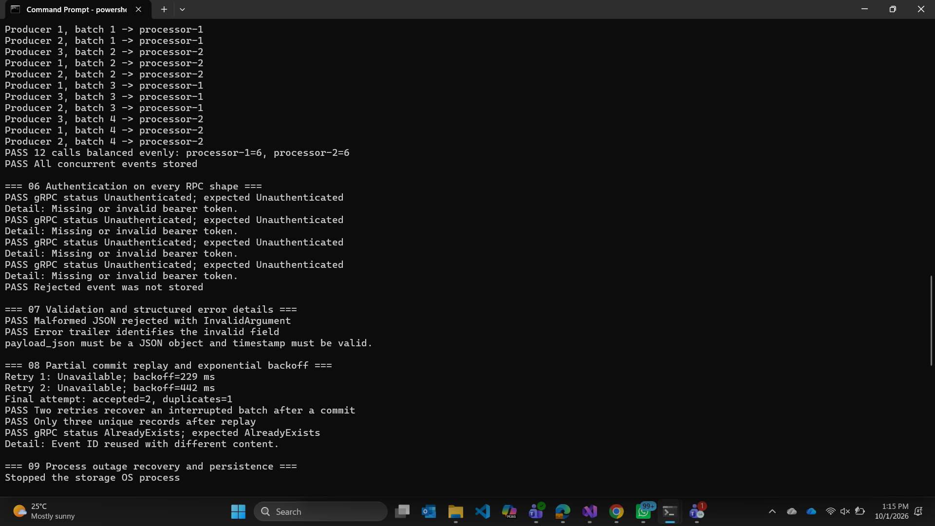
Figure 9 – Load balancing, authentication on every RPC shape, validation errors, and the replayed batch.
Step 9: Deadlines, cancellation, TLS and schema changes
The processor passes the caller deadline and cancellation token straight through to storage, so work downstream stops when the client gives up.
// ProcessorService.cs - the caller deadline and token reach the storage service.
var saved = await downstream.Client.SaveAsync(
result, ForwardHeaders(ctx), ctx.Deadline, ctx.CancellationToken);

Storage is delayed three seconds and then a 350 ms deadline or a cancellation is applied; both return before the commit. Scenario 12 shows TLS is really enforced and scenario 13 sends messages between the old and new schema both ways.
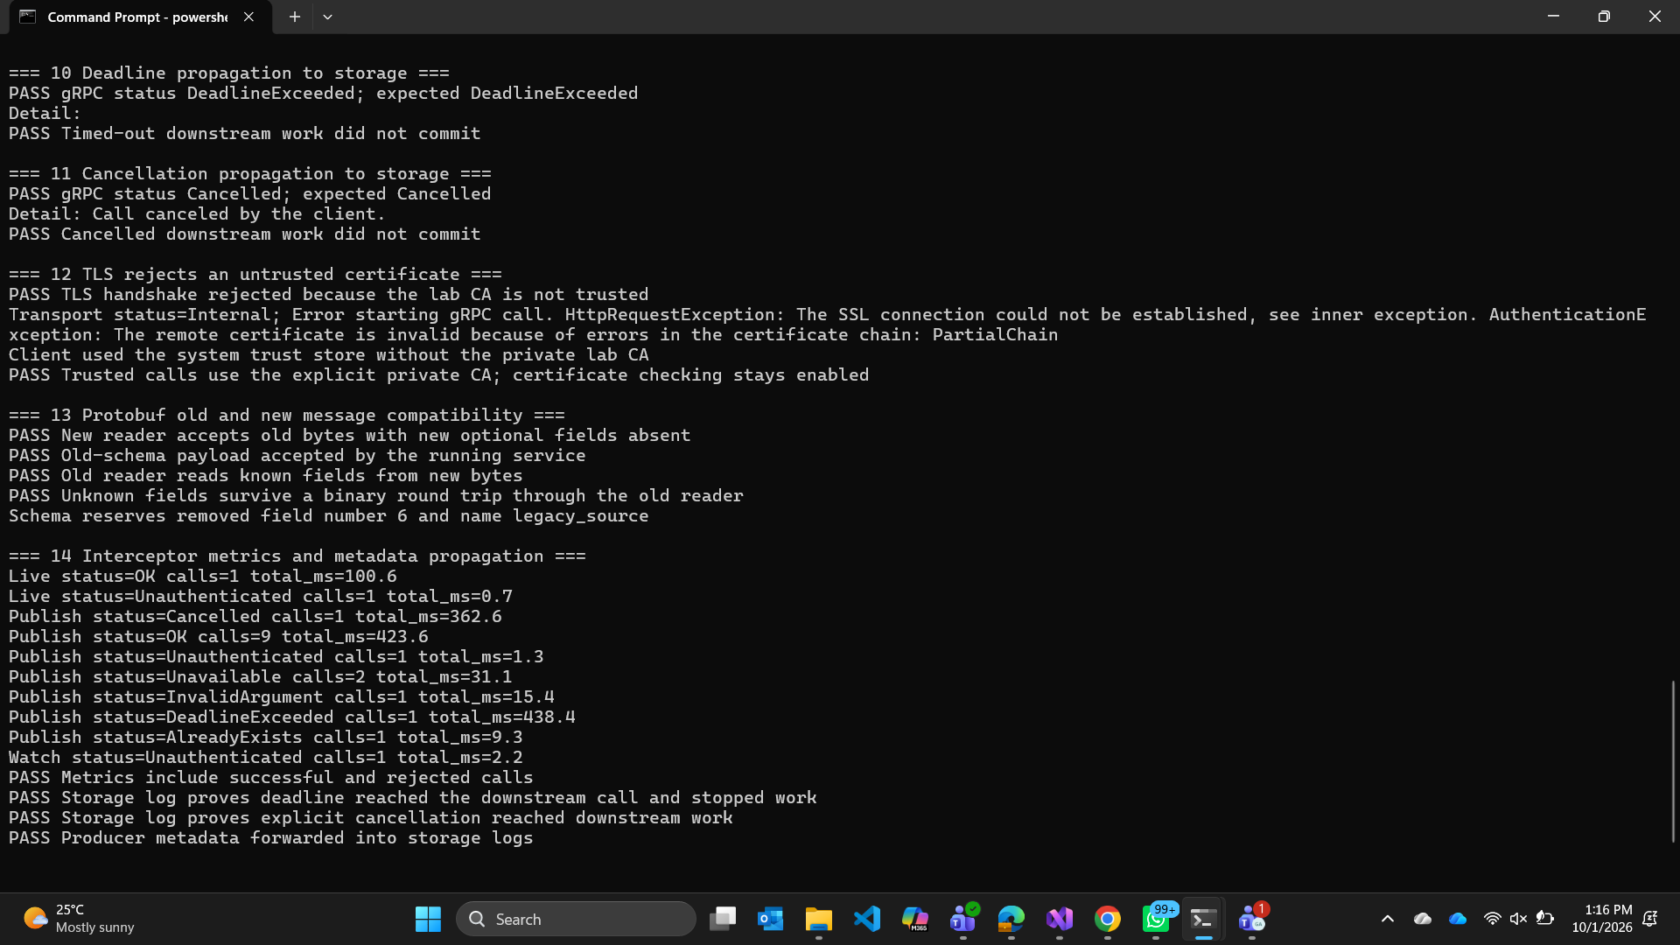
Figure 10 – Deadline and cancellation stop the commit, the untrusted certificate is rejected, and the protobuf compatibility checks pass.

Step 10: Metrics, failover and final result
Three interceptors wrap every handler, with metrics outside logging outside authentication, so a rejected call is still counted and logged.
// Interceptors.cs - the token is checked before the handler runs.
if (ctx.RequestHeaders.GetValue("authorization") != "Bearer " + Security.Token)
throw new RpcException(new Status(StatusCode.Unauthenticated, "Missing or invalid bearer token."));

The last scenario stops processor-2 and waits for its four second lease to expire, then checks that discovery drops it and a new call still works.
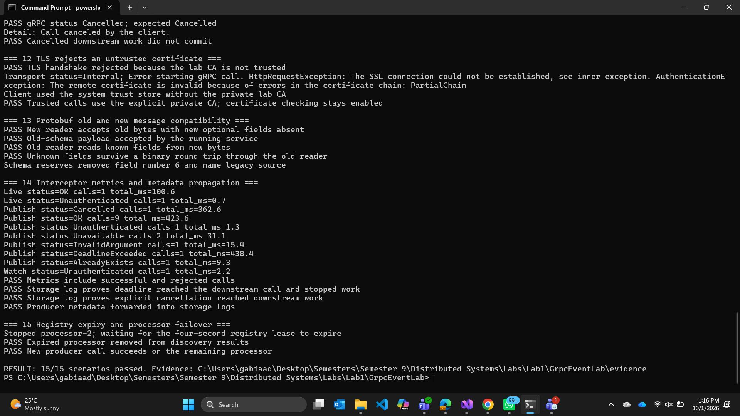
Figure 11 – Metrics include rejected calls, processor-2 is removed after its lease expires, and the run finishes with 15/15 scenarios passed.

Problems we ran into:
- Every manual producer command reported processor-1, which looked like broken load balancing. The round robin counter lives on the Producer object, and each command is a new process, so it always restarts at the first processor. Scenario 5 balances correctly because its three producers share one process.
- A deadline is not a rollback. Once the write starts it finishes, so a cancelled client cannot know whether the event was saved. That is why the event ID is used as an idempotency key.
- An earlier version enriched the original event instead of a copy, which broke retries: the replayed event no longer matched and storage answered AlreadyExists. Cloning fixed it.
- run-demo.ps1 fails if the manual cluster is still running, because it starts its own cluster on the same four ports.

Limitations:
- Load balancing is done in the client code, and a stream already running stays on its processor.
- Server TLS with a bearer token, not mutual TLS. The default token and certificate password are demonstration values.
- Metrics are in memory only.
- Watch returns a snapshot of existing records, not a subscription to future events.
Conclusion:
All 15 scenarios pass. The system uses the three streaming patterns plus unary calls, with TLS, token authentication, interceptors, discovery, retries, deadlines, cancellation, durable storage with duplicate protection, and a schema that can change without breaking older clients.
References:
[1] Microsoft Learn, Reliable gRPC services with deadlines and cancellation.
[2] Microsoft Learn, Transient fault handling with gRPC retries.
[3] Microsoft Learn, gRPC interceptors on .NET.
[4] Microsoft Learn, gRPC client-side load balancing.
[5] Protocol Buffers, Language guide (proto3), protobuf.dev.

