**Usability Study**

Charbel Marche

1. **Imaginary Users:**
2. Jill and John are a newly engaged couple that are planning for their wedding. They want to have their wedding outdoors at Malibu beach in California, but are not sure what month and day the weather will be ideal for having an outdoors wedding (meaning warm temperature, but not too warm, and a low chance of precipitation). They do know that they want to get married during the summer, since that is their favorite season of the year and the children in their families and friend groups will be out of school during that time and will be able to also attend. They also want to get married on a Saturday, because they want everyone to be able to be there and not have to worry about calling off of work. As a result, Jill and John search Weather Web App for the location they want, Malibu beach, CA, several times for each of the Saturdays during the summer season. They will then compare the averages for temperature and chance of precipitation presented by the system for each of the different dates and settle for the best date for the outdoors wedding to take place.
3. Tom is a senior in his final year at the University of Mary Washington. He wants to host a graduation party on the day of graduation and wants to invite all his friends to it. However, Tom is not sure if he should have the graduation party outside in his back yard, or if he should book a venue instead. He would not like to have the party outside if it is likely that it will rain that day, and the inside of his house is not large enough to host the party because Tom plans on inviting a lot of people. However, Tom would want to save the money and have the party in his backyard, if the weather allows him to. Tom uses the Weather Web Application to see what the historical averages are like in Fredericksburg, Virginia, his hometown, on the day of graduation. He will look at the percent chance of precipitation. If the percentage is higher than 15%, he will book a venue for his graduation party, instead of hosting it in his backyard.
4. Sarah is planning her 18th birthday party. It is currently January. She would like to have her party on the day of her birthday, which is April 14th. She knows that she wants to visit a beach for her birthday, but would like to know which beach is going to be warm enough so that everyone can get in the water and have a good time. As a result, Sarah uses the Weather Web Application to check the different beaches in her area and see what the average temperature is at each location on the 14th of April. She also checks the percent chance of precipitation because she would not want to be at the beach when it is raining or storming. Based on the results she can begin to plan her birthday party and get a better idea of which beach will have the appropriate weather on her birthday. She also will use the Weather Web Application 10 days before her birthday to get weather forecasts so that she can rearrange her plans, should she need to.
5. **User Model**
6. The Weather Web Application’s purpose is to show historical weather data for certain cities or locations on certain days. It is being made for anyone who is trying to plan an event in the future. It will be useful to these users because it will allow them to get the average weather data (e.g. average temperature, percent of days with precipitation) for a selected location, on a selected day of the year. Thus making planning events in the future much more convenient. Also if the date that the user is planning for is within the next 10 days, the weather web application will additionally display current weather forecasts for the user to view.
7. The primary function that I am doing my research on is the search feature. This was the feedback from my focus group.
   1. **Person 1:**
      1. **How do you think the search feature will work for this application?**

I think there would be a location and date field with a search button.

* + 1. **What do you think you should be able to do through the search feature?**

You should be able to type the location in by city and type the date in by day/month/year, and then search based off of that.

* + 1. **What shouldn't you be able to do through the search feature?**

You shouldn’t be able to put invalid dates like “2/31/2019” or put in dates that have already passed.

* + 1. **If you were to use this application, what aspects of the search feature would be important to you?**

Being able to easily search by location and date.

* 1. **Person 2:** 
     1. **How do you think the search feature will work for this application?**

You should search for a location on a certain day and submit for historical weather data.

* + 1. **What do you think you should be able to do through the search feature?**

Select from a list of dates and a list of locations.

* + 1. **What shouldn't you be able to do through the search feature?**

Should not be able to look back in time, because that doesn’t make any sense.

* + 1. **If you were to use this application, what aspects of the search feature would be important to you?**

Being able to quickly find the date and location.

* 1. **Person 3:**
     1. **How do you think the search feature will work for this application?**

There should be a date field that takes a month, day, and year. Also there should be a location field to allow you to search by area.

* + 1. **What do you think you should be able to do through the search feature?**

Search date by day, month, and year and search city and state from a drop down list.

* + 1. **What shouldn't you be able to do through the search feature?**

Dates have to be valid and locations have to be valid. You should not be able to search if not. If you do you should get an error message of some sort.

* + 1. **If you were to use this application, what aspects of the search feature would be important to you?**

Be able to get results quickly, within a few seconds.

* 1. **Person 4:**
     1. **How do you think the search feature will work for this application?**

Date field should be present and you enter your date there, then there should also be a location field where you type the city name in along with the state the city is in.

* + 1. **What do you think you should be able to do through the search feature?**

You should be able to enter a date and enter a location by typing them in. Then you should be able to hit a button and search results.

* + 1. **What shouldn't you be able to do through the search feature?**

You shouldn’t be able to search a date without a location or vice versa.

* + 1. **If you were to use this application, what aspects of the search feature would be important to you?**

It is important to me that entering a location and date is easy and convenient.

1. **User Model Paragraph**

The system should provide the user with two fields, one for date and one for location. There should also be a button to submit the search. The location field should take a city and state, and the date field should take a day, month, and year. If the user enters an invalid location and/or date, you should get an error message. The user should not be able to enter a location without a date, or a date without a location. Also the user should only be able to select days in the future, not in the past. The search feature should also be convenient and easy to use, allowing users to find their desired location and date quickly. After searching it should not take more than a few seconds to return results.

1. **Prototype Images**

The search bars before typing anything currently look like this.

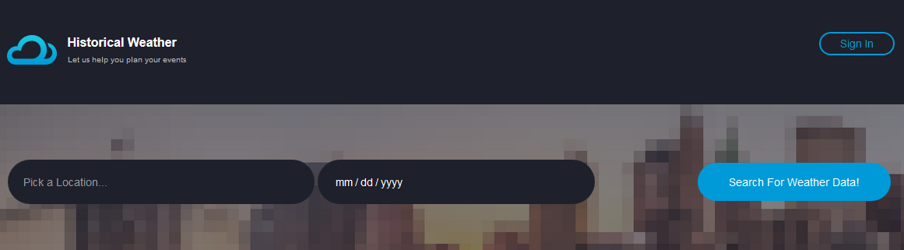

While typing in the search bar, you will get a list of valid cities, the list gets updated to give you all possible cities that start with whatever the user is typing. For example if you type in “Fred” you would get a list of cities that are valid that start with “Fred” like “Fredericksburg” and “Frederick”. It also will support searching by certain zip codes. This still needs to be implemented but it will look something like this.

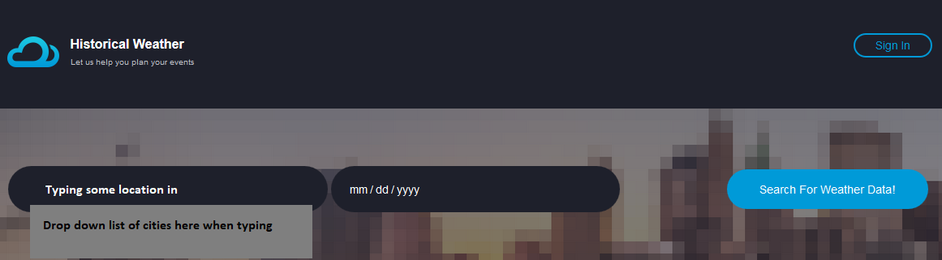

When typing in the date you will get a calendar widget that pops up, allowing the user to set the date as shown below. It will allow the user to select any date that is in the future. The calendar will be formatted to match the theme of the site.

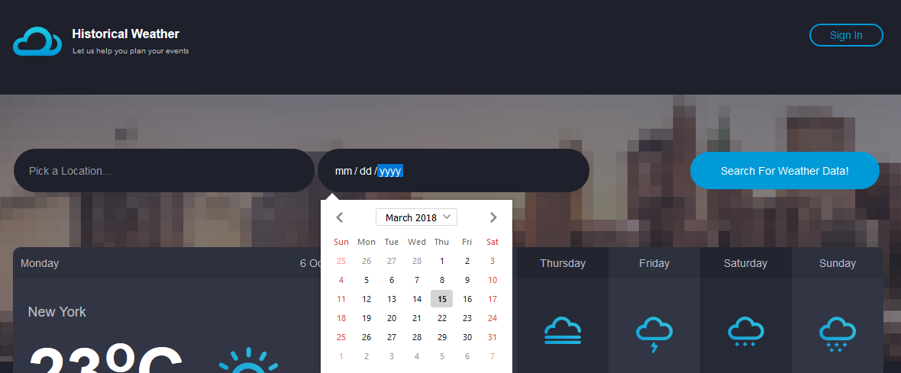

1. **Focus Group Feedback**
   1. **Comments on the prototype images:**
      1. **Person 1:**

Your prototype is intuitive and clear. I would type my city name in, select it from the list, then pick a date with the calendar and search for results. However, you should specify that the user can search by both city and state and zip code. I wouldn’t have known otherwise.

* + 1. **Person 2:**

I would click on location, type the location in by city and state, then select the date in and click search. Specify what is considered valid input for the location field, I would not have thought to enter zip code.

* + 1. **Person 3:**

I would click the location field and enter a city and state, then I would select a date on the calendar and hit search. I don’t think you need to change anything.

* + 1. **Person 4:**

I think it is clear how to use the search feature, you just enter the location that you want by city name and then you enter a date. Then hit the search button.

* 1. **Reflection on feedback**

The user model, in general, did match my interface. However, there were differences. Some of the differences included the fact that the prototype’s location field also takes zip code for input. The users did not suggest the feature, however, this is something the client asked for, so I will keep that functionality present. The location field, in retrospect, has a vague prompt that needs to be more specific in what kind of input can entered. This way the users will understand that they can not only search by the name of the city, but also by zip code.

1. **Changes**

I will likely specify in the prompt that you can search for location by either zip code or city and state. This will clarify the formats that are expected and make the search feature more intuitive. I will change the prototype to like this.

