Real-Time Facial Emotion Recognition
A Progressive Deep Learning Approach: From Baseline to EfficientNetB2

────────────────────────────────────────────────────────────────────────
Course: Artificial Intelligence and Computer Vision
University: [University Name]
Student(s): [Student Name(s)]
Instructor: [Instructor Name]
Date: May 2026

────────────────────────────────────────────────────────────────────────

Submitted in partial fulfillment of the requirements for the AI / Computer Vision course.
All experiments conducted on an NVIDIA RTX 4050 Laptop GPU using TensorFlow 2.21 and Python 3.10.

Abstract
Facial Emotion Recognition (FER) is a core problem in affective computing that requires automatically inferring emotional state from facial imagery. This report presents the design, implementation, evaluation, and deployment of a complete FER pipeline trained on the RAF-DB dataset across seven emotion classes: angry, disgust, fear, happy, sad, surprise, and neutral. The project follows a principled progression: a zero-shot DeepFace baseline (52.80%) establishes the task difficulty, followed by MobileNetV2 transfer learning (68.19%), a purpose-built Multi-Scale Squeeze-and-Excitation CNN (SE-CNN, 69.73%), a 4-model soft-voting ensemble (70.45%), and finally EfficientNetB2 fine-tuned with a 4-phase progressive unfreezing schedule, reaching 80.02% on the 3,068-image RAF-DB test set — a +27.22% absolute improvement. Key contributions include the SE-CNN architecture combining three convolutional scales with learned channel attention; the identification of a critical training instability caused by applying photometric augmentation after per-image standardization; a systematic fine-tuning protocol with Stochastic Weight Averaging (SWA) and 8-pass Test-Time Augmentation (TTA); Grad-CAM interpretability confirming anatomically meaningful attention; and a full-stack deployment comprising a Streamlit web application, real-time webcam inference, video analysis tools, and TFLite edge export.

Table of Contents
1. Introduction
2. Dataset and Preprocessing
3. Proposed System Architecture
4. Model Architectures
5. Training Protocol and Experimental Setup
6. Results and Analysis
7. Grad-CAM Interpretability
8. Deployment and Real-Time Application
9. Problems Faced, Solutions, and Lessons Learned
10. Limitations and Future Work
11. Conclusion
12. References

1. Introduction

1.1 Problem and Motivation
Facial expressions are among the most information-dense channels of human communication, carrying emotional content that is consistent across cultures and immediately interpretable. Automating the recognition of these expressions has direct application in human-computer interaction, healthcare monitoring, driver safety, smart classrooms, and meeting analytics. Despite these applications, automated FER is technically difficult. Primary challenges include illumination and pose variation, partial occlusion, severe class imbalance (happy and neutral dominate naturalistic data while disgust and fear are rare), low inter-class variance (fear and surprise share raised brows and widened eyes), and annotation ambiguity at low expression intensity.

1.2 Project Objectives
The four concrete objectives are:
• Establish a zero-shot baseline to quantify task difficulty without training.
• Progress through multiple model architectures — lightweight transfer learning, a custom architecture, and a high-capacity fine-tuned model — comparing each objectively.
• Analyze results at the per-class level to understand what the system does and does not handle well.
• Deploy the system as a real-time, interpretable application.

Table 1 — Project Contribution Summary
Contribution | Description | Why It Matters
DeepFace zero-shot baseline | Evaluated directly on RAF-DB without training | Establishes task difficulty; reference for all improvements
MobileNetV2 transfer learning | ImageNet pretrained backbone adapted to RAF-DB | Shows value of pretrained features over random init
Custom Multi-Scale SE-CNN | 3×3/5×5/7×7 branches + SE attention, trained from scratch | Purpose-built for FER; demonstrates architectural reasoning
4-model soft-voting ensemble | Aggregates MobileNetV2 + SE-CNN variants | Exploits model diversity to reduce prediction variance
EfficientNetB2 fine-tuning | 4-phase progressive unfreezing, 80.02% | Best result; shows power of large-scale pretraining
Augmentation instability fix | Removed photometric augmentation conflicting with standardization | Critical engineering insight; generalizable lesson
Grad-CAM interpretability | Visualizes model attention on facial regions | Validates anatomically meaningful feature learning
Full deployment stack | Streamlit, webcam, CLI, video, TFLite export | Proves the system is usable beyond a training experiment

2. Dataset and Preprocessing

2.1 RAF-DB Dataset
The Real-world Affective Faces Database (RAF-DB) is collected from the internet under unconstrained real-world conditions, covering natural variation in illumination, pose, age, ethnicity, and image quality. Aligned facial images are provided at 100×100 pixels. The official test partition contains 3,068 images used for all model evaluation. Training data combines RAF-DB's training partition with FER2013 and a supplementary dataset. Disgust and fear are the most underrepresented classes, a fact directly reflected in their lower per-class metrics.
Table 2 — Seven Emotion Classes in RAF-DB
Emotion | Primary Visual Cue | Training Frequency
Happy | Raised cheeks, visible teeth, crow's feet | High
Neutral | Absence of distinctive deformations | High
Sad | Inner brow raise, lip corner depression | Moderate
Angry | Lowered brows, tightened lips | Moderate
Surprise | Raised brows, widened eyes, dropped jaw | Moderate
Fear | Raised brows, widened eyes, pulled-back lips | Low
Disgust | Nose wrinkle, raised upper lip | Very low

2.2 Preprocessing Pipeline
Two separate preprocessing configurations are applied depending on the model, summarized in Table 3.
Table 3 — Preprocessing Comparison: SE-CNN vs. EfficientNetB2
Parameter | SE-CNN | EfficientNetB2
Input size | 48×48 px | 96×96 px
Color mode | Grayscale (1 channel) | RGB (3 channels)
Standardization | Per-image (zero-mean, unit-variance) | Per-image (zero-mean, unit-variance)
Augmentation | Flip, rotate, zoom, translate | Flip, rotate, zoom, translate
Photometric augmentation | Excluded | Excluded
Oversampling | 12,000 samples per class | Loaded from raw RAF-DB files
Data caching | NPZ cache on first run | No cache

Grayscale for the SE-CNN reduces dimensionality and overfitting risk, as emotion is encoded in facial geometry rather than color. RGB for EfficientNetB2 is required because its pretrained ImageNet weights encode color information from the first convolution. Per-image standardization normalizes each image independently to zero mean and unit variance, making the model robust to global illumination shifts.

2.3 Augmentation: A Critical Engineering Finding
Geometric augmentation (horizontal flip, ±15° rotation, ±10% zoom, ±10% translation) is applied stochastically during training. Photometric augmentations (brightness, contrast) were initially included but caused a complete training failure: accuracy remained at 14.3% — the 7-class random baseline — for the entire training run. The mechanism is a pipeline conflict: per-image standardization removes all global brightness and contrast information, so photometric augmentations applied on top introduce shifts that normalization immediately cancels, producing contradictory gradients. Removing photometric augmentation entirely resolved the collapse (see also Section 9).

2.4 Minority Class Oversampling
To correct class imbalance, minority classes are replicated with augmentation until each class has 12,000 training samples (84,000 total). This ensures equal gradient contribution from all classes, critical for preventing the classifier from ignoring disgust and fear.

3. Proposed System Architecture
The system is designed as a complete computer vision pipeline. Figure 1 shows the full data flow from raw input to application output.
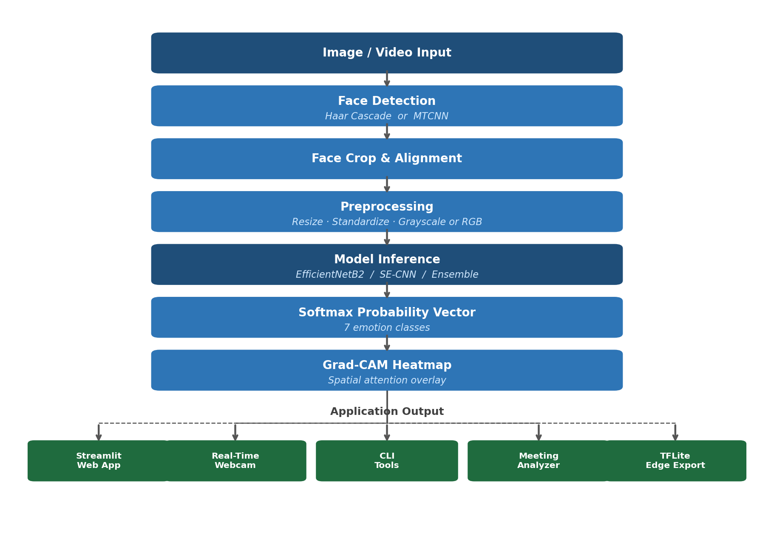
Figure 1: Complete system pipeline from image/video input through face detection, preprocessing, and model inference to Grad-CAM visualization and multi-mode deployment output.
Face detection uses two backends: Haar cascade (OpenCV) for fast CPU inference suitable for real-time processing, and MTCNN for higher accuracy on non-frontal or partially occluded faces. The face tracker applies temporal smoothing to prevent bounding box jitter across video frames. For offline evaluation, 8-pass TTA averages predictions over random augmented views. For real-time inference, single-pass mode is used to maintain acceptable latency. Grad-CAM is integrated directly: the gradient of the top predicted class score with respect to the final convolutional feature maps is computed, pooled to importance weights, and overlaid as a heatmap.

4. Model Architectures

4.1 DeepFace — Zero-Shot Baseline
DeepFace is evaluated without any training on RAF-DB, yielding 52.80% accuracy. This quantifies the cross-domain transfer gap and sets the reference point against which all subsequent improvements are measured.

4.2 MobileNetV2 — Lightweight Transfer Learning
MobileNetV2 uses depthwise separable convolutions and inverted residual blocks for efficient inference. Its ImageNet-pretrained backbone is adapted by freezing the backbone and training a new classification head (Global Average Pooling → Dense → Dropout → 7-class Softmax), then fine-tuning end-to-end at a reduced learning rate. SWA and 8-pass TTA are applied at the final stages. Achieved: 68.19% (+15.39% over DeepFace).

4.3 Custom Multi-Scale SE-CNN
The SE-CNN is designed for the spatial scale diversity inherent in facial expressions: subtle muscle tension requires fine-grained receptive fields (3×3), individual facial parts require medium fields (5×5), and holistic expression configurations require larger fields (7×7). Figure 2 shows the complete architecture.
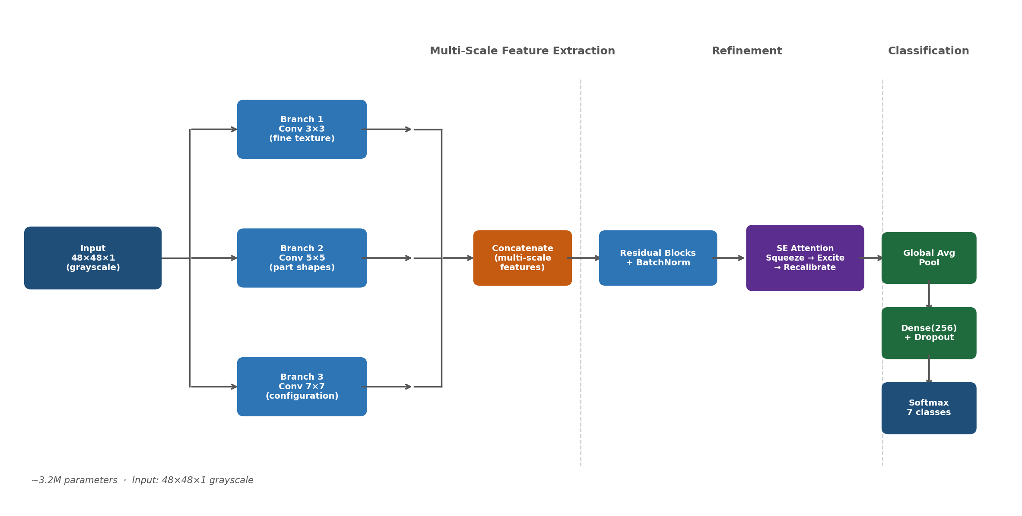
Figure 2: Multi-Scale SE-CNN architecture. Three parallel convolutional branches capture fine, medium, and coarse expression features; their outputs are concatenated and refined by residual blocks with SE channel attention before global average pooling and classification.
The Squeeze-and-Excitation (SE) block performs channel-wise attention: global average pooling (squeeze) reduces each feature map to a scalar; a two-layer MLP with sigmoid activation (excite) produces per-channel scaling weights that recalibrate feature maps by element-wise multiplication. He initialization, Batch Normalization on every convolutional layer, and residual connections complete the design. Approximately 3.2M parameters. SE-CNN v1 (best checkpoint + TTA): 69.42%; SE-CNN v2 (fine-tuned + SWA + TTA): 69.73%.

4.4 EfficientNetB2 — Progressive Fine-Tuning
EfficientNetB2 applies compound scaling to maximize accuracy per FLOP, pretrained on 14 million ImageNet images. Input: 96×96 RGB. Progressive unfreezing prevents catastrophic forgetting.
Table 4 — EfficientNetB2 Progressive Fine-Tuning Schedule
Phase | Layers Unfrozen | Epochs | Learning Rate | Val Accuracy
1 — Head only | 0% (frozen backbone) | 15 | 1×10⁻³ | 57.41%
2 — Top 40% | 40% (deepest layers) | 20 | 2×10⁻⁴ | 72.72%
3 — Full fine-tune | 100% | 10 | 5×10⁻⁵ | 74.59%
4 — SWA refinement | 100% | 8 | 1×10⁻⁵ | 75.16%
Final (8-pass TTA) | — | — | — | 80.02%

Phase 1 stabilizes the classification head before modifying backbone weights. Phase 2 unfreezes the deepest layers, producing the largest single gain (+15.31%). Phase 3 extends adaptation to the full backbone. Phase 4 applies SWA to bias toward flat loss landscape regions with better generalization. The final +4.86% from TTA reflects variance reduction across 8 augmented inference passes. Mixed-precision training (float16), uint8 in-memory image storage (~300 MB RAM), and gradient clipping (clipnorm=1.0) throughout. Achieved: 80.02%.

4.5 Ensemble, SWA, and TTA
The ensemble combines four models — MobileNetV2 SWA, SE-CNN v1 best, SE-CNN v2 best, and SE-CNN v2 SWA — through soft voting: 7-dimensional softmax vectors are averaged and the highest mean probability class is selected. Architectural and trajectory diversity produce partially uncorrelated errors, reducing variance. Achieved: 70.45%. SWA consistently yields +0.5–1% generalization improvement without additional data. TTA contributes +1–4.86% per model at zero training cost; single-pass mode is used for real-time inference to maintain latency.

5. Training Protocol and Experimental Setup
Table 5 — Experimental Configuration Summary
Parameter | SE-CNN | EfficientNetB2
Framework | TensorFlow 2.21 | TensorFlow 2.21
Hardware | RTX 4050 Laptop GPU | RTX 4050 Laptop GPU
Loss function | Categorical cross-entropy | Categorical cross-entropy
Optimizer | Adam | Adam
LR schedule | Cosine decay (1×10⁻³ → ~0) | Manual per-phase (Table 4)
Phase 1 epochs | 100 | 15
Phase 2 epochs | 30 (fine-tune from best ckpt) | 20
Phase 3 epochs | 8 (SWA) | 10
Phase 4 epochs | — | 8 (SWA)
Early stopping | Patience = 15 (val loss) | Patience = 10 (val loss)
Gradient clipping | — | clipnorm = 1.0
Mixed precision | No | float16
Batch size | 64 | 32
Evaluation set | Full RAF-DB test (3,068) | Full RAF-DB test (3,068)
Final inference | 8-pass TTA | 8-pass TTA

All model checkpoints are saved on every validation accuracy improvement. Training metrics are logged per epoch to CSV files, visualized in the Streamlit Training Curves tab.

6. Results and Analysis

6.1 Overall Model Comparison
Figure 3 plots the test accuracy of all six configurations on the RAF-DB test set (3,068 images, 8-pass TTA). Table 6 lists the numerical values.
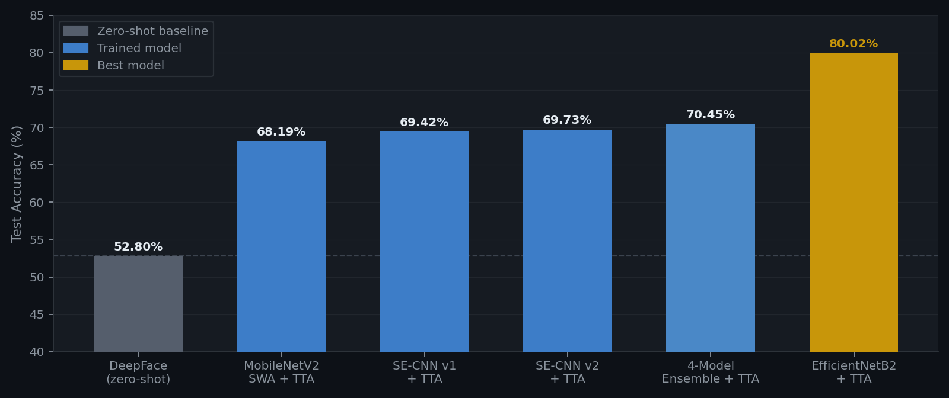
Figure 3: Test accuracy comparison of all model configurations on the RAF-DB test set (3,068 images, 8-pass TTA). Grey: zero-shot baseline. Blue: trained models. Gold: EfficientNetB2 best model.
Table 6 — Model Accuracy Comparison
Model | Test Accuracy | Gain vs. DeepFace | Configuration
DeepFace pretrained (zero-shot) | 52.80% | — | Baseline
MobileNetV2 SWA + TTA | 68.19% | +15.39% | Transfer learning
Custom SE-CNN v1 (best + TTA) | 69.42% | +16.62% | Trained from scratch
Custom SE-CNN v2 (fine-tuned + TTA) | 69.73% | +16.93% | Fine-tuned from v1
4-Model Soft-Voting Ensemble + TTA | 70.45% | +17.65% | Ensemble
EfficientNetB2 fine-tuned + TTA | 80.02% | +27.22% | Best model

6.2 Ablation and Contribution Analysis
Table 7 — Ablation: Contribution of Each Stage
Stage | Accuracy | Marginal Gain | Principal Factor
DeepFace (zero-shot) | 52.80% | — | No adaptation
+ Task-specific fine-tuning (MobileNetV2) | 68.19% | +15.39% | ImageNet weights adapted to RAF-DB
+ Custom architecture (SE-CNN) | 69.73% | +1.54% | Multi-scale branches + SE attention
+ Ensemble (soft voting) | 70.45% | +0.72% | Partially independent prediction errors
+ High-capacity backbone (EfficientNetB2) | 75.16% | +4.71% | Richer pretrained features
+ 8-pass TTA | 80.02% | +4.86% | Variance reduction at inference
Total improvement | +27.22%

The dominant contributions are task-specific fine-tuning (+15.39%) and the combined EfficientNetB2 effect (+4.71% backbone + +4.86% TTA). The custom SE-CNN adds +1.54% over MobileNetV2, confirming genuine benefit from the purpose-built architecture. The ensemble contributes +0.72%. The central finding is that ImageNet pretraining is the single most important factor: representational richness from 14 million images cannot be replicated by architecture design alone at this dataset scale.

6.3 Per-Class Performance
Table 8 — Per-Class Precision, Recall, and F1 Score (EfficientNetB2, 80.02%)
Emotion | Precision | Recall | F1 Score | Difficulty
Happy | 0.91 | 0.92 | 0.91 | Easiest
Surprise | 0.80 | 0.76 | 0.78 | Moderate
Angry | 0.80 | 0.64 | 0.71 | Moderate
Sad | 0.74 | 0.81 | 0.77 | Moderate
Neutral | 0.72 | 0.80 | 0.76 | Moderate
Fear | 0.63 | 0.49 | 0.55 | Difficult
Disgust | 0.60 | 0.33 | 0.42 | Hardest

Happy achieves F1 = 0.91 because the Duchenne smile produces a large, spatially distinctive, and universally consistent facial deformation. Fear (F1 = 0.55, recall = 0.49) and surprise share the same primary muscle activations; over 50% of fear instances are misclassified, likely as surprise. Disgust (F1 = 0.42, recall = 0.33) is most problematic: the primary cue — nasal wrinkle and raised upper lip — is a subtle texture-level deformation; disgust is the rarest class in naturalistic photography; and annotation ambiguity is highest for low-intensity disgust. Angry shows a precision-recall asymmetry (P=0.80, R=0.64): the model predicts anger only when the signal is strong, misclassifying moderate anger as neutral. These results confirm that overall accuracy is an insufficient evaluation criterion — the system still misclassifies the majority of fear and disgust expressions.

6.4 Confusion and Failure Patterns
Table 9 — Representative Failure Patterns
True Label | Predicted Label | Probable Cause
Fear | Surprise | Shared brows/eyes; inner brow oblique lift not resolved
Disgust | Angry | Low-intensity disgust with brow lowering misread as anger
Disgust | Neutral | Very subtle nasal wrinkle below discrimination threshold
Angry | Neutral | Moderate anger resembles concentrated neutral
Sad | Neutral | Low-intensity sadness; inner brow raise insufficient

Based on the per-class metrics, the principal confusion patterns are: Fear → Surprise (shared raised brows and widened eyes; mouth configuration is the key discriminator); Disgust → Angry or Neutral (overlapping brow-lowering muscle activation at low intensity); Angry → Neutral (low-intensity anger resembles a stern neutral face); Sad → Neutral (low-intensity sadness overlaps with neutral at the inner brow).

7. Grad-CAM Interpretability
Gradient-weighted Class Activation Mapping (Grad-CAM) computes the gradient of the predicted class score with respect to the final convolutional feature maps, pools these gradients to per-channel importance weights, and generates a spatial heatmap highlighting the most discriminative input regions. Interpretability serves two functions in this project: as a debugging tool during development (confirming whether the model attends to facial regions rather than background), and as a transparency feature in deployment (allowing end users to verify the model's reasoning).
Observed attention patterns are consistent with expected facial anatomy. For happy predictions, the heatmap concentrates on the lower face — mouth, cheeks, and periorbital region — corresponding to the Duchenne smile deformation. For angry predictions, attention falls on the brow and periorbital region, consistent with brow lowering and furrowing. For difficult classes (disgust, fear), heatmaps are more diffuse, reflecting lower model certainty and the fine-grained nature of the discriminative signal. In cases of correct disgust classification, attention occasionally concentrates around the nasal region — the expected locus of disgust cues. These anatomically meaningful patterns confirm that EfficientNetB2 solves the task through genuine expression recognition rather than spurious background correlations. Grad-CAM overlays are shown in the deployment screenshots (Figure 4, Section 8).

8. Deployment and Real-Time Application
The trained models are integrated into a complete deployment stack that demonstrates the system is functional beyond training experiments.
The Streamlit web application (app/app.py) provides five interactive tabs:
Tab | Functionality
Live Demo | Image upload or webcam snapshot; per-face emotion label, confidence, probability bar chart, and Grad-CAM heatmap; optional side-by-side DeepFace comparison
Video Analysis | Frame-by-frame emotion processing; temporal timeline; stacked area chart; dominant-emotion strip
Model Comparison | Benchmark bar chart; sortable accuracy table for all six configurations
Training Curves | Accuracy and loss curves loaded live from CSV logs for all training phases
About | Architecture overview, dataset description, command reference

[INSERT Figure 4 here: 2×2 grid of your deployment screenshots — deploy_happy_box.png, deploy_happy_bar.png, deploy_angry_box.png, deploy_angry_bar.png. Run: python3 evaluation/plots/make_figure4_grid.py Caption: "Figure 4: Deployed Streamlit application output showing happy detection (100% confidence, yellow box) and angry detection (99.9% confidence, red box)."]
Real-Time Webcam (realtime/realtime_webcam.py) overlays emotion labels, probability bars, and an optional Grad-CAM heatmap on live frames. The --compare flag displays predictions from both the custom model and DeepFace side-by-side. CLI tools (detect_image.py, detect_video.py, meeting_analyzer.py) provide batch processing and meeting PDF reporting. TFLite Export with INT8 quantization produces a 4× smaller model deployable on Android smartphones and Raspberry Pi.
Deployment tradeoff: 8-pass TTA is not suitable for real-time inference (8× latency multiplier). The deployed webcam system uses single-pass inference, accepting a modest accuracy reduction for acceptable frame rates. Figure 5 shows the complete training progression for both main model families.
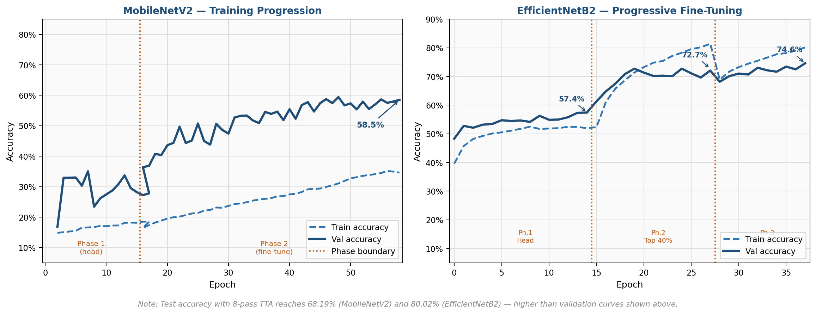
Figure 5: Training and validation accuracy curves from real experiment logs. Left: MobileNetV2 across head-only and full fine-tuning phases. Right: EfficientNetB2 across all three progressive unfreezing phases with phase boundaries marked. Test accuracy with 8-pass TTA reaches 68.19% (MobileNetV2) and 80.02% (EfficientNetB2).
The curves confirm expected training behavior. For MobileNetV2, validation accuracy rises steeply in Phase 1 (head training) and continues improving through full fine-tuning. For EfficientNetB2, Phase 2 (top-40% backbone unfreezing) produces the steepest accuracy gain, Phase 3 continues at a slower rate, and Phase 4 (SWA) stabilizes the model at its best generalization point. The large gap between training and validation accuracy in EfficientNetB2 is expected: training uses strong augmentation while validation does not.

9. Problems Faced, Solutions, and Lessons Learned
Table 10 — Engineering Challenges, Root Causes, Solutions, and Lessons
Problem | Root Cause | Solution | Lesson Learned
Training collapse to 14.3% | RandomBrightness/RandomContrast after per-image standardization — normalization cancels the photometric shift, contradictory gradients | Remove all photometric augmentation; geometric only | Preprocessing and augmentation are not independent. Validate full pipeline on small run before committing to full training
Class imbalance | Naturalistic photography skews toward happy/neutral | Oversample minority classes to 12,000 samples each | Oversampling is effective; focal loss is a complementary alternative
Catastrophic forgetting | High LR fine-tuning overwrites pretrained representations with noisy gradients | Progressive unfreezing at decreasing learning rates | Warm up task-specific layers before touching pretrained weights
Fear/surprise confusion | Both emotions share primary muscles; discriminative cues are subtle | No architectural fix; partially addressed by TTA and ensemble | Temporal modeling or audio fusion may be necessary
Disgust under-recalled (R=0.33) | Subtle texture cue, low training frequency, high annotation ambiguity | Accepted as limitation; harder negative mining is a future option | Per-class metrics should drive dataset curation decisions
Real-time latency vs. accuracy | 8-pass TTA is 8× more expensive than single-pass | Single-pass for real-time; TTA for offline evaluation only | Benchmark and deployment accuracy should be reported separately
EfficientNetB2 outperforms SE-CNN by ~10% | SE-CNN trained on ~84K samples; EfficientNetB2 pretrained on 14M images | Adopted EfficientNetB2 as primary model | At academic dataset scales, a pretrained backbone almost always outperforms a custom architecture trained from scratch

10. Limitations and Future Work
Current limitations:
RAF-DB images are aligned and pre-cropped. Real webcam footage presents faces at varying resolutions, angles, and occlusion levels; the 80.02% benchmark accuracy likely overstates real-world performance. Demographic bias in web-collected training data may affect performance across age groups and ethnicities. Fear and disgust remain substantially under-performing (F1 = 0.55 and 0.42); oversampling cannot compensate for the fundamental scarcity of high-quality examples or annotation noise. Real-time deployment uses single-pass inference, sacrificing approximately 4–5% accuracy.
Future directions:
• Vision Transformers (ViT / Swin): self-attention models long-range facial dependencies, potentially improving fear/surprise discrimination.
• Temporal modeling (LSTM / TCN): expression dynamics in video sequences are invisible in still images but strongly discriminate emotions like fear.
• Audio-visual fusion: vocal prosody resolves visually ambiguous expressions.
• Class-balanced loss functions: focal loss or class-frequency weighting as alternatives to oversampling.
• Larger datasets: AffectNet (1M+) or EmotioNet would provide more disgust/fear examples and greater demographic diversity.
• Mobile-optimized inference: knowledge distillation or neural architecture search for deployment without quantization quality loss.

11. Conclusion
This project designed, implemented, evaluated, and deployed a complete facial emotion recognition system progressing from a zero-shot DeepFace baseline at 52.80% to a fine-tuned EfficientNetB2 model at 80.02% — a +27.22% absolute improvement through a principled sequence of methodological choices on the RAF-DB dataset.
The key technical findings are:
• 1. Transfer learning from ImageNet is decisive. EfficientNetB2 outperforms a 4-model ensemble of purpose-built SE-CNNs by +9.57%, confirming that 14 million pretraining images provide representational richness that architectural design alone cannot replicate at academic dataset scales.
• 2. Preprocessing and augmentation interact non-trivially. Combining per-image standardization with photometric augmentation causes complete training collapse. Geometric-only augmentation is the correct choice for standardized FER pipelines.
• 3. Overall accuracy is an insufficient evaluation metric. EfficientNetB2's 80.02% coexists with F1 = 0.42 for disgust and F1 = 0.55 for fear. Per-class analysis is essential for any FER deployment decision.
• 4. Grad-CAM confirms anatomically meaningful reasoning — mouth/cheek focus for happy, brow focus for angry/surprised — validating that the learned representations are expression-grounded rather than spurious.
• 5. A functional deployment is achievable on modest hardware. The complete pipeline — Streamlit web app, real-time webcam, video analysis, and TFLite edge export — runs on a laptop GPU.

12. References
[1] M. Tan and Q. Le, "EfficientNet: Rethinking Model Scaling for Convolutional Neural Networks," Proc. ICML, vol. 97, pp. 6105–6114, 2019.
[2] J. Hu, L. Shen, and G. Sun, "Squeeze-and-Excitation Networks," Proc. CVPR, pp. 7132–7141, 2018.
[3] R. R. Selvaraju et al., "Grad-CAM: Visual Explanations from Deep Networks via Gradient-Based Localization," Proc. ICCV, pp. 618–626, 2017.
[4] M. Sandler, A. Howard, M. Zhu, A. Zhmoginov, and L.-C. Chen, "MobileNetV2: Inverted Residuals and Linear Bottlenecks," Proc. CVPR, pp. 4510–4520, 2018.
[5] S. Li, W. Deng, and J. Du, "Reliable Crowdsourcing and Deep Locality-Preserving Learning for Expression Recognition in the Wild," Proc. CVPR, pp. 2852–2861, 2017. [RAF-DB]
[6] S. Serengil and A. Ozpinar, "LightFace: A Hybrid Deep Face Recognition Framework," ASYU, 2020. [DeepFace]
[7] K. He, X. Zhang, S. Ren, and J. Sun, "Deep Residual Learning for Image Recognition," Proc. CVPR, pp. 770–778, 2016.
[8] P. Izmailov, D. Podoprikhin, T. Garipov, D. Vetrov, and A. G. Wilson, "Averaging Weights Leads to Wider Optima and Better Generalization," Proc. UAI, 2018. [SWA]
[9] D. P. Kingma and J. Ba, "Adam: A Method for Stochastic Optimization," ICLR, 2015.
[10] S. Ioffe and C. Szegedy, "Batch Normalization: Accelerating Deep Network Training by Reducing Internal Covariate Shift," Proc. ICML, pp. 448–456, 2015.
[11] I. J. Goodfellow et al., "Challenges in Representation Learning: FER2013 Dataset," ICONIP, pp. 117–124, 2013.
[12] P. Viola and M. Jones, "Rapid Object Detection Using a Boosted Cascade of Simple Features," Proc. CVPR, pp. 511–518, 2001.
[13] O. Russakovsky et al., "ImageNet Large Scale Visual Recognition Challenge," IJCV, vol. 115, no. 3, pp. 211–252, 2015.

