Project Documentation

A Project Report on

Programming in C

Submitted to: Computer Department
(Affiliated to: Kathmandu Model Secondary School)

In the partial fulfillment of internal evaluation of Grade XII

Submitted by: Charchil Neupane



Guided By: Mr. Santosh Paudel

Acknowledgment

I would like to express my sincere gratitude to my project advisor, Mr. Saroj Paudel, for his invaluable guidance and support throughout this project. His insightful comments and suggestions were instrumental in helping me refine my research question, develop my methodology, and overcome challenges. I am deeply grateful for his/her patience and encouragement, which allowed me to learn and grow as a researcher.
I would also like to thank the staff of the Computer Department for providing me with access to the resources and equipment I needed to conduct my research. Their technical expertise and willingness to assist me were essential to the successful completion of this project.
Finally, I would like to express my appreciation to my family and friends for their unwavering support and encouragement. Their belief in me helped me stay motivated throughout this challenging but rewarding experience.

Kathmandu Model College
Charchil Neupane
M11
Abstraction
The is a comprehensive collection of C programs designed to showcase diverse functionalities, providing an interactive and educational experience for users. This suite includes the following programs:
- Hangman: A classic word-guessing game where players attempt to discover a hidden word by guessing letters. The Hangman program engages users in a fun and challenging linguistic exercise.
- Quiz: An interactive quiz application that allows users to test their knowledge on various subjects. The Quiz program features a range of questions and provides immediate feedback to enhance the learning experience.
- Customer Billing System: A robust billing system designed for efficient and accurate customer transactions. This program incorporates features for itemized billing, tax calculation, and receipt generation, making it a practical tool for businesses.
- Contact Management System: A user-friendly system for organizing and managing contacts. The Contact Management System enables users to store, retrieve, and update contact information, streamlining communication and fostering efficient contact management.
- Tic Tac Toe: The classic game of Tic Tac Toe implemented in C, providing users with an entertaining and strategic gaming experience. The program supports two-player mode, allowing users to engage in friendly competitions.

Purpose:
The primary objective of the Multi-Program C Application Suite is to demonstrate the versatility of C programming in creating diverse and functional applications. Each program within the suite is carefully crafted to showcase different aspects of C.

Significance:
This project holds significance as an educational resource for individuals seeking to learn C programming or improve their skills. The collection of programs covers a range of programming concepts, including data structures, user input handling, and modular programming, making it a valuable tool for beginners.

Table of Contents
Title: 1
Acknowledgment: 2
Abstraction: 3
Table of Content: 4
Source code and output : 5
Contact Management System: 5
Customer Billing System: 13
Hangman: 21
Quiz: 32
Tic Tac Toe : 37
Conclusion: 47
Reference and Courtesy: 48

Source Code and Output
1. Contact Management System
#include <stdio.h>
#include <stdlib.h>
#include <unistd.h>////to manipulate the terminal output delay
//Check the working OS
#ifdef WIN_32
#define CLEAR_SCREENSCREEN "cls"
#else
#define CLEAR_SCREEN "clear"
#endif
void Credits(void);//display the credits at the startup
//this is the file
//declare the structure to save the data
struct Contact {
char fName[50], lName[50], address[50], email[50];
long long phNo;//phone number is long int
};
//for new user and ->is the arrow operator to save the value in struct Contact using *c
void createContact(struct Contact *c) {
printf("Enter your first name: ");
scanf("%s", c->fName);
printf("Enter your last name: ");
scanf("%s", c->lName);
printf("Enter phone: ");
scanf("%lld", &c->phNo);
printf("Enter address: ");
scanf("%s", c->address);
printf("Enter email: ");
scanf("%s", c->email);
}
//print contact information
void showContact(struct Contact *c) {
printf("Name: %s %s\n", c->fName, c->lName);
printf("Phone: %lld\n", c->phNo);
printf("Address: %s\n", c->address);
printf("Email: %s\n", c->email);
}
//save the data in the file
void writeOnFile() {
char ch;
FILE *f1;
struct Contact c;
f1 = fopen("CMS.dat", "ab");//append binary as .dat is used
do {
createContact(&c);
fwrite(&c, sizeof(struct Contact), 1, f1);
printf("Do you have next data? (y/n): ");
scanf(" %c", &ch);
} while (ch == 'y' || ch == 'Y');
printf("Contact has been successfully created...\n");
fclose(f1); }
//read and display all the saved contact information
void readFromFile() {
FILE *f2;
struct Contact c;
f2 = fopen("CMS.dat", "rb");
printf("\n================================\n");
printf("LIST OF CONTACTS\n");
printf("================================\n");
while (fread(&c, sizeof(struct Contact), 1, f2) == 1) {
showContact(&c);
printf("\n================================\n");
}
fclose(f2); }
//search the databased for the user according to saved contact
void searchOnFile() {
FILE *f3;
long long phone;
struct Contact c;
printf("Enter phone no.: ");
scanf("%lld", &phone);
f3 = fopen("CMS.dat", "rb");
while (fread(&c, sizeof(struct Contact), 1, f3) == 1) {
if (phone == c.phNo) { showContact(&c); }
else { printf("\n\nNo record not found\n"); } }
fclose(f3); }
//if the user is to be deleted from the database
void deleteFromFile() {
long long num;
int flag = 0;
FILE *f4, *f5;
struct Contact c;
f5 = fopen("CMS.dat", "rb");
f4 = fopen("temp.dat", "wb");
printf("Enter phone no. to delete: ");
scanf("%lld", &num);
while (fread(&c, sizeof(struct Contact), 1, f5) == 1) {
if (c.phNo != num) {
fwrite(&c, sizeof(struct Contact), 1, f4);
} else
flag = 1; }
fclose(f5);
fclose(f4);
remove("CMS.dat");
rename("temp.dat", "CMS.dat");
flag == 1 ? printf("\n\n\tContact Deleted...\n") : printf("\n\n\tContact Not Found...\n"); }
//edit the saved contact information
void editContact() {
long long num;
FILE *f6;
struct Contact c;
printf("Edit contact\n");
printf("===============================\n\n");
printf("Enter the phone number to be edited: ");
scanf("%lld", &num);
f6 = fopen("CMS.dat", "rb+");
while (fread(&c, sizeof(struct Contact), 1, f6) == 1) {
if (c.phNo == num) {
printf("Enter new record\n");
createContact(&c);
long long pos = -1 * sizeof(struct Contact);//declare the position to start of the contact saved (using -1 *)
fseek(f6, pos, SEEK_CUR);//seek cursor to start of the selected contact using the position defined above
fwrite(&c, sizeof(struct Contact), 1, f6);//save the edited contact
printf("\n\n\tContact Successfully Updated...\n");
fclose(f6);
return; } }
printf("\n\nNo record not found\n");
fclose(f6);
}
void Credits(void) {
system(CLEAR_SCREEN);
printf("\n\n\n\n\n\n\n\n\n\t\t\t\tPROJECT\n\t\t\t Contact Management System"); sleep(2);
printf("\n\n\n\n\n\t\t\t\tMADE BY\n\t\t\t Charchil Neupane"); sleep(2);
printf("\n\n\n\n\n\t\t\t\tROLL NO\n\t\t\t\t 12"); sleep(2);
printf("\n\n\n\n\t\t\t\tSECTION\n\t\t\t M11"); sleep(2);
printf("\n\n\n\n\t\t\t\tINSTITUTE:Kathmandu Model Secondary School"); sleep(2);
printf("\n\n\n\n\n\t\t\t\tSUBMITTED TO:Computer Department\n\t\t\t"); sleep(2);
system(CLEAR_SCREEN); }
int main() {
Credits();
system(CLEAR_SCREEN);
printf("\n\n\n\n\n\n\n\n\t\t\t * WELCOME TO CONTACT MANAGEMENT SYSTEM *");
getchar();
while (1) {
int choice;
system(CLEAR_SCREEN);
printf("\nCONTACT MANAGEMENT SYSTEM\n");
printf("\nMAIN MENU\n");
printf("=====================\n");
printf("[1] Add a new Contact\n");
printf("[2] List all Contacts\n");
printf("[3] Search for contact\n");
printf("[4] Delete a Contact\n");
printf("[5] Edit a Contact\n");
printf("[0] Exit\n");
printf("=====================\n");
printf("Enter your choice: ");
scanf("%d", &choice);
switch (choice) {
case 1:
system(CLEAR_SCREEN);
writeOnFile();
break;
case 2:
system(CLEAR_SCREEN);
readFromFile();
break;
case 3:
system(CLEAR_SCREEN);
searchOnFile();
break;
case 4:
system(CLEAR_SCREEN);
deleteFromFile();
break;
case 5:
system(CLEAR_SCREEN);
editContact();
break;
case 0:
system(CLEAR_SCREEN);
printf("\n\n\n\t\t\tThank you for using CMS.\n\n");
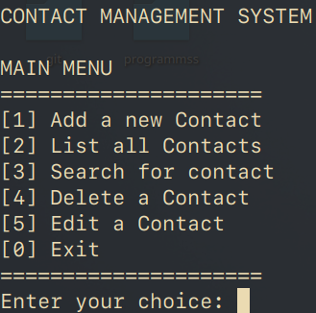
exit(0);
break;
default:
continue;
}
int opt;
printf("\n\n..::Enter the Choice:\n[1] Main Menu\t\t[0] Exit\n");
scanf("%d", &opt);
switch (opt) {
case 0:
system(CLEAR_SCREEN);
printf("\n\n\n\t\t\tThank you for using CMS.\n\n");
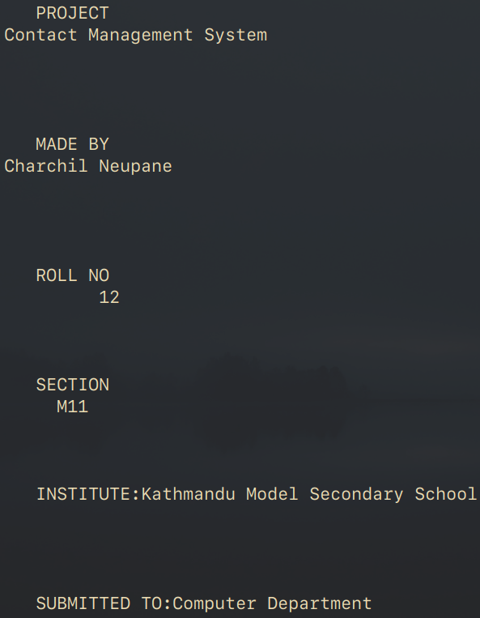
exit(0);
break;
default:
continue;
} }
return 0; }
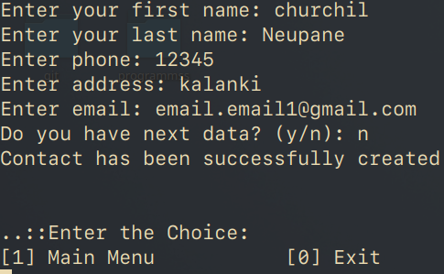

2.Customer Billing System
#include <stdio.h>
#include <stdlib.h>
#include <string.h>
#include <time.h>//to fetch the current date
//to check the current OS used
#ifdef _WIN32
#define CLEAR_SCREEN "cls"
#else
#define CLEAR_SCREEN "clear"
#endif
//Declare structures
struct items {
char items[100];
float price;
int quantity;
};
struct total {
float total,discount,cs,vat; };
struct orders {
char customers[100], date[100];
int noitems; };
//generate the bill headers by displaying the required information passed from struct orders...
void generateBillHeader(struct orders *c) {
printf("\n\n");
printf("\t Neupane. Restaurant");
printf("\n\t -----------------");
printf("\nDate:%s", c->date);
printf("\nInvoice To: %s\n", c->customers);
printf("---------------------------------------\nItems\t\t");
printf("Qty\t\tTotal\t\t");
printf("\n---------------------------------------\n\n");
}
//generate the bill body by displaying the required information passed from struct items...
void generateBillBody(struct items *a) {
printf("%s\t\t", a->items);
printf("%d\t\t", a->quantity);
printf("%.2f\t\t\n", a->quantity * a->price);
}
//calculate and generate the footer of the bill
void generateBillFooter(struct total *t) {
printf("---------------------------------------\n");
printf("Sub Total\t\t\t%.2f", t->total);
printf("\nDiscount @10%s\t\t\t%.2f", "%", t->discount);
printf("\n\t\t\t\t-------");
printf("\nNet Total\t\t\t%.2f", t->total - t->discount);
printf("\nCustomer Service @9%s\t\t%.2f", "%", t->cs);
printf("\nVat @13%s\t\t\t%.2f", "%", t->vat);
printf("\n---------------------------------------");
printf("\nGrand Total\t\t\t%.2f",
(t->cs + t->vat) + (t->total - t->discount));
printf("\n---------------------------------------\n");
}
int main() {//call up the main function
int opt, n;
char saveBill;
char name[30];
int search = 0;
char choice;
start: system(CLEAR_SCREEN);
printf("\t============ADV. RESTAURANT============");
printf("\n\nPlease select your prefered operation");
printf("\n\n1.Generate Invoice");
printf("\n2.Show all Invoices");
printf("\n3.Search Invoice");
printf("\n4.Exit");
printf("\n\nYour choice:\t");
scanf("%d", &opt);
struct orders ord, orders;
struct items *item;
struct total totals;
switch (opt) {
case 1:
system(CLEAR_SCREEN);
printf("\nPlease enter the name of the customer:\t");
scanf("%s", ord.customers);
time_t t = time(NULL);//generate the time by declaring the pointer t
strftime(ord.date, sizeof(ord.date), "%Y-%m-%d", localtime(&t));//print the current date
printf("\nPlease Enter the Numer of Item Ordered:\t");
scanf("%d", &n);
ord.noitems = n;
item = malloc(n * sizeof(struct items));//dynamic memory allocation for the items when large no. are collected from the file
totals.total = 0;
for (int i = 0; i < n; i++) {
fgetc(stdin);
printf("\n\n");
printf("Please enter the itemno. %d:\t", i + 1);
scanf("%s", item[i].items);
printf("Please enter the quantity of items: \t");
scanf("%d", &item[i].quantity);
printf("Please enter the unit price: \t");
scanf("%f", &item[i].price);
totals.total += item[i].price * item[i].quantity;
}
//Calculate service charge, vat and discount as per defined
totals.cs = 0.09 * totals.total;
totals.vat = 0.13 * totals.total;
totals.discount = 0.10 * totals.total;
ord.noitems = n;
generateBillHeader(&ord);//generate header using the above information
for (int i = 0; i < n; i++) {
generateBillBody(&item[i]);//generate body from the entered items stored in struct items..
}
generateBillFooter(&totals);//generate footer by calculating totals
printf("\nDo you want to save the invoice [y/n]:\t");
scanf(" %c", &saveBill);

//Save the invoice in the database and write the data into the file in format as per structure for easier to scan the data later
if (saveBill == 'y' || saveBill == 'Y') {
FILE *fp=fopen("bill.dat", "ab");//append binary as .dat is used
if (fp == NULL) {
printf("\n\nError in opening file");
} else {
fwrite(&ord, sizeof(struct orders), 1, fp);
for (int i = 0; i < ord.noitems; i++) {
fwrite(&item[i], sizeof(struct items), 1, fp);
}
fwrite(&totals, sizeof(struct total), 1, fp);
printf("\nSucessfully Saved the Invoice...::-)\n");
}
fclose(fp);
} free(item);//free memory allocated (otherwise overflow of memory)
break;
//generate saved invoices
case 2:
system(CLEAR_SCREEN);
FILE *fp = fopen("bill.dat", "rb");//read binary from the file in specific format as saved
printf("\n *****Your Previous Invoice(s) *****\n");
while (fread(&ord, sizeof(struct orders), 1, fp)) {
generateBillHeader(&ord);
item = malloc(ord.noitems * sizeof(struct items));
//free(item);
if (item == NULL) {
printf("Allocation fail");
break;
}
for (int i = 0; i < ord.noitems; i++) {
fread(&item[i], sizeof(struct items), 1, fp);
generateBillBody(&item[i]);
}
fread(&totals, sizeof(struct total), 1, fp);
generateBillFooter(&totals);
}
fclose(fp);
break;

//Search invoice based on customer name
case 3:
printf("Enter the name of the customer to search:\t");
scanf("%s", name);
system(CLEAR_SCREEN);
FILE *fp1 = fopen("bill.dat", "rb");
printf("\t*****Invoice of %s *****\n", name);
while (fread(&orders, sizeof(struct orders), 1, fp1) == 1) {
if (strcmp(orders.customers, name) == 0) {
generateBillHeader(&orders);
item = malloc(orders.noitems * sizeof(struct items));
if (item == NULL) {
printf("Allocation fail");
break; }
for (int i = 0; i < orders.noitems; i++) {
fread(&item[i], sizeof(struct items), 1, fp1);
}
fread(&totals, sizeof(struct total), 1, fp1);
for (int i = 0; i < orders.noitems; i++) {
generateBillBody(&item[i]);
}
generateBillFooter(&totals);
search++;
free(item);//free memory
break; } }
if (search == 0) {
printf("Sorry! The invoice for %s was not found...", name);
}
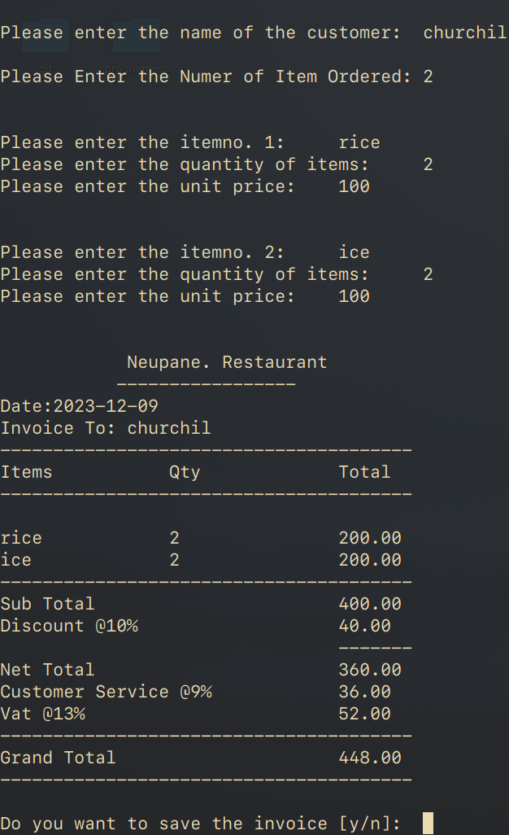
fclose(fp1);
break;
case 4:
printf("\n\t\tThanks for the visit :)\n");
exit(0);
break;
default:
printf("\n\t\tInvalid choice\n");
}
printf("\nDo you want to perfrom another option?[y/n]:\t\n");
scanf(" %c", &choice); {
if (choice == 'y' || choice == 'Y') {
system(CLEAR_SCREEN);
goto start;
}
}
return 0;
}
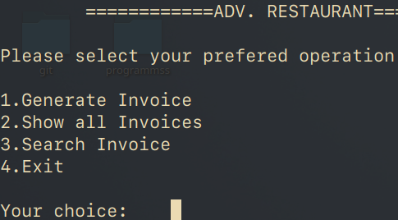

3. Hangman
fun.h
#include <stdio.h>
#include <stdlib.h>
#include <string.h>
#include <time.h>
#include <unistd.h>////to manipulate the terminal output delay
#ifdef _WIN32
#define CLEAR_SCREEN "cls"
#else
#define CLEAR_SCREEN "clear"
#endif
//function declaration
int prefrence(char);
void show(int, int);
void page(void);
void title(void);
void inst(void);
void hangman(int, int);
void credits(void);
//Display title at startup
inline void title(void) {
printf("--------------------------------------------\n");
printf("| # # # # # #### # # # # # |\n");
printf("| # # # # ## # # ## ## # # ## # |\n");
printf("| #### ##### # # # # ## # # # ##### # # # |\n");
printf("| # # # # # ## # # # # # # # ## |\n");
printf("| # # # # # # ### # # # # # # |\n");
printf("--------------------------------------------\n\n"); }
//instruction to be displayed
inline void inst(void) {
system(CLEAR_SCREEN);
printf("\n\n\n\t\t INSTRUCTIONS \n\t\t ============\n");
printf("\n 1: HANGMAN IS A GAME WHERE YOU HAVE TO GUESS THE WORD.");
printf("\n 2: GUESS THE MAXIMUM WORDS FOR THE MAXIMUM SCORE.");
printf("\n 3: EVERY LEVEL WILL HAVE A NEW WORD.");
printf("\n 4: 1 CORRECT LETTER = 1 SCORE");
printf("\n 5: YOU HAVE LIMITED CHANCES TO FIND THE WORD\n\n\n"); sleep(6);
system(CLEAR_SCREEN);
printf("\n\n\n\n\t\t HOW TO PLAY \n\t\t ===========");
printf("\nUse your keyboard to guess the word. If you press any letter and the letter is in the word, the game will tell you the position of the letter.\nGuess more, score more.\n\n\t\t\t BEST OF LUCK !");
}
//displays the credits in startup of the program
inline void credits(void) {
system(CLEAR_SCREEN);
printf("\n\n\n\n\n\n\n\n\n\t\t\t\tPROJECT\n\t\t\t HANGMAN ON C"); sleep(2);
printf("\n\n\n\n\n\t\t\t\tMADE BY\n\t\t\t Charchil Neupane"); sleep(2);
printf("\n\n\n\n\n\t\t\t\tROLL NO\n\t\t\t\t 12");sleep(2);
printf("\n\n\n\n\t\t\t\tSECTION\n\t\t\t M11"); sleep(2);
printf("\n\n\n\n\t\t\t\tINSTITUTE:Kathmandu Model Secondary School"); sleep(2);
printf("\n\n\n\n\n\t\t\t\tSUBMITTED TO:Computer Department\n\t\t\t"); sleep(2);
system(CLEAR_SCREEN);
}
//The inner page where the player can select the difficulty levels
inline void page(void) {
printf("\t\t\t \n");
printf("\t\t\t \n");
printf("\t\t\t 0 \n");
printf("\t\t\t \\|/\n");
printf("\t\t\t | \n");
printf("\t\t\t / \\\n");
printf("\t CAN YOU SAVE ME PLESASE ? \n\n");
printf("\n\t\t 1: 3 LETTERS GAME (Beginner) \n\t\t 2: 4 LETTERS GAME (ok i ""guess..) \n\t\t 3: 5 LETTERS GAME (ngl it's pretty hard) \n\n\t\t ""\n\n\t\t 4:MAIN MENU \n\n\t\t choice = ");
}
//the function that prints the ascii art of the hangman according to parameters score entered
inline void show(int a, int score) {
switch (a) {
case 1:
{
printf("\n\t\t\tAmount of wrong letters: %d\n\n", a);
printf(" _______\n");
printf(" |\n");
printf(" |\n");
printf(" |\n");
printf(" |\n");
printf(" |\n");
printf("__|_________\n\n");
printf("\nYour score = %d", score);
printf("\n\t\t\t\t Chances Left=%d", 5 - a);
} break;
case 2:
printf("\n\t\t\tAmount of wrong letters: %d\n\n", a);
printf(" _______\n");
printf(" |/ | \n");
printf(" | O \n");
printf(" |\n");
printf(" |\n");
printf(" |\n");
printf("__|_________\n\n");
printf("\nYour score = %d", score);
printf("\n\t\t\t\t Chances Left=%d", 5 - a);
break;
case 3:
printf("\n\t\t\tAmount of wrong letters: %d\n\n", a);
printf(" _______\n");
printf(" |/ | \n");
printf(" | O \n");
printf(" | |\n");
printf(" | |\n");
printf(" |\n");
printf("__|_________\n\n");
printf("\nYour score = %d", score);
break;
case 4:
printf("\n\t\t\tAmount of wrong letters: %d\n\n", a);
printf(" _______\n");
printf(" |/ | \n");
printf(" | O \n");
printf(" | \\|/\n");
printf(" | | \n");
printf(" | /\n");
printf("__|_________\n\n");
printf("\nYour score = %d", score);
printf("\n\t\t\t\t Chances Left=%d", 5 - a);
break;
case 5:
printf("\n\t\t\tAmount of wrong letters: %d\n\n", a);
printf(" _______\n");
printf(" |/ | \n");
printf(" | X \n");
printf(" | \\|/\n");
printf(" | | \n");
printf(" | / \\\n");
printf("__|_________\n\n");
printf("\nTotal score = %d", score);
printf("\n\t\t\t\t Chances Left=%d", 5 - a);
printf("\n\nYOU ARE DEAD ! GAME OVER!");
break;
} }
//Scan and display the inner page of the program according to user choices
inline int prefrence(char a) {
switch (a) {
case 'p':
case 'P':
system(CLEAR_SCREEN);
break;
case 'i':
case 'I':
inst();
break;
case 'c':
case 'C':
credits();
break;
default:
printf("Invalid Input! Try Again.");
}
return 0;
}
hang.c
#include "fun.h"
int num,max = 5,y = 0;
char pre;
//Function to select the word according to random index generated and return it
const char *chooseRandomWord(int a) {
const char *words3[] = {"top", "rat", "bat", "cat", "man", "hat", "hut","cut", "bit", "pen", "fox", "jog"};
const char *words4[] = {"four", "page", "home", "girl", "bird", "lamp", "drop", "high", "tick","copy", "zeal"};
const char *words5[] = {"earth", "nokia", "white", "bread", "table", "zebra", "mango", "paris","eagle", "china"};
if (a == 1) {//'a' checks the number of character user wants to play with
int index = rand() % (sizeof(words3) / sizeof(words3[0])); //generate random index withe the limits from 0 to no. of words declared
return words3[index];
}
if (a == 2) {
int index = rand() % (sizeof(words3) / sizeof(words3[0]));
return words4[index];
}
if (a == 3) {
int index = rand() % (sizeof(words3) / sizeof(words3[0]));
return words5[index];
}
return NULL;
}
//displays the words by comparing the each character entered by user
void displayWord(const char *word, const char *guessedLetters) {
for (int i = 0; word[i] != '\0'; i++) {
if (strchr(guessedLetters, word[i]) != NULL) {
printf("%c", word[i]);
}
else {
printf("_ "); }
}
printf("\n");
}
int main() {
char c;
credits();
again: puts("\n");
title();
printf("\n\t\tP:PLAY \n\t\tI:INSTRUCTIONS \n\t\tC:CREDITS \n\t\tQ:QUIT \n\t\t");
if (num == 4) {
while ((c = getchar()) != '\n' && c != EOF);
}
pre = getchar();
if (pre == 'q' || pre == 'Q')
return 0;
prefrence(pre);
puts("\n\n");
page();
scanf("%d", &num);
srand(time(NULL)); //Provide a seed for the use of rand() function above
if (num == 4) {
system(CLEAR_SCREEN);
goto again;
}
const char *WordToGuess = chooseRandomWord(num); //initialize pointer char to pass into the choooseRandomWord()
int wordLength = strlen(WordToGuess);
char guessedLetters[wordLength];
int incorrectGuesses = 0;
for (int i = 0; i < wordLength; i++) {
guessedLetters[i] = '_';// intially generate the lower border for word
}
while (1) {
printf("\n");
displayWord(WordToGuess, guessedLetters);
char guess;
printf("Enter a letter: ");
scanf(" %c", &guess); //clear stream
if (strchr(WordToGuess, guess) != NULL) {//compare the character entered and to be enter
printf("Correct guess!\n");
y++;
for (int i = 0; i < wordLength; i++) {//if correct letter is guessed
if (WordToGuess[i] == guess) {
guessedLetters[i] = guess;
}
}
} else {
printf("Incorrect guesn/ s!\n");
incorrectGuesses++;
max -= 1;//reduce the max tries remaining
show(incorrectGuesses, y);
if (max == 0) // if the max guess reached
printf("\nThe correct word was: %s\n", WordToGuess);
break; }
}
if (strcmp(WordToGuess, guessedLetters) == 0) {
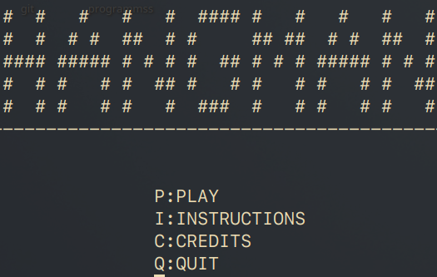
printf("Congratulations! You guessed the word: %s\n", WordToGuess);// if the whole word was guessed
break;
return 0;
}
} return 0; }
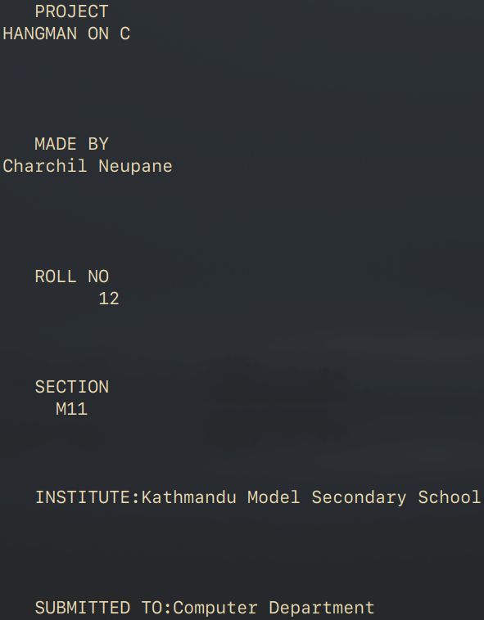
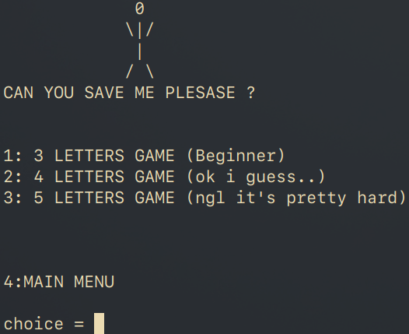

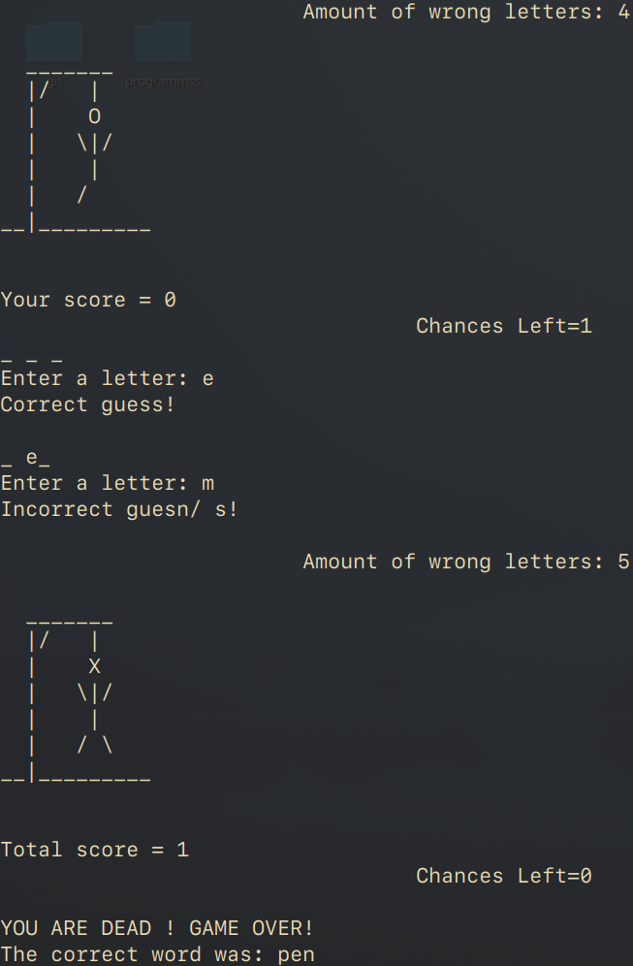
4. Quiz
#include <stdio.h>
#include <stdlib.h>
#include <string.h>
#include <unistd.h>////to manipulate the terminal output dela
//macro to define the maximum no. of each parameters
#define MAX_QUESTIONS 100
#define MAX_OPTION 4
#define MAX_OPTION_LENGTH 20
#define MAX_ANSWER_LENGTH 20
#define MAX_QUESTION_LENGTH 100
//check if the OS is windows or other
#ifdef _WIN32
#define CLEAR_SCREEN "cls"
#else
#define CLEAR_SCREEN "clear"
#endif
//Structure to save the questions, options and answers generated
typedef struct {
char question[MAX_QUESTION_LENGTH],option[MAX_OPTION][MAX_OPTION_LENGTH];
int answer;
} quiz;
//Declare the functions needed &&pointer *questions is not the same as char questions in the structure and is just the pointer to check around the structure
//take questions from the file "questions.txt" as initialized in main()
void takequestion(const char *filename, quiz *questions) {
FILE *file = fopen(filename, "r");
if (file == NULL) {
perror("Error Opening File");
exit(EXIT_FAILURE);
}
int i = 0;
while (fgets(questions[i].question, MAX_QUESTION_LENGTH, file) != NULL &&i < MAX_QUESTIONS) {
questions[i].question[strcspn(questions[i].question, "\n")] = '\0'; i++;
} fclose(file);
}
//take questions from the file "options.txt" as initialized in main()
void takeoption(const char *filename, quiz *questions) {
FILE *file = fopen(filename, "r");
if (file == NULL) {
perror("Error Opening File");
exit(EXIT_FAILURE);
}
int i = 0;
while (i < MAX_QUESTIONS &&
fscanf(file, "%s %s %s %s", questions[i].option[0],questions[i].option[1], questions[i].option[2],questions[i].option[3]) == 4) {
i++;
}
fclose(file);
}
//take answers from the file "answers.txt" as initialized in main()
void takeanswer(const char *filename, quiz *questions) {
FILE *file = fopen(filename, "r");
if (file == NULL) {
perror("Error Opening File");
exit(EXIT_FAILURE);
}
int i = 0;
while (fscanf(file, "%d", &questions[i].answer) == 1 && i < MAX_QUESTIONS) {
i++;
} fclose(file);
}
//display questions, options .. take and check the answers
void conductQuiz(quiz *questions, int numQuestions) {
int score = 0;
for (int i = 0; i < numQuestions; i++) {
printf("Question %d: %s\n", i + 1, questions[i].question);

for (int j = 0; j < MAX_OPTION; j++) {
printf("%d. %s\n", j + 1, questions[i].option[j]);
}
int userAnswer;
printf("Your answer (1-4): ");
scanf("%d", &userAnswer);
if (userAnswer == questions[i].answer) {
printf("Correct!\n");
score++;
} else {
printf("Incorrect. The correct answer is %d\n", questions[i].answer);
}
printf("\n"); }
printf("Your final score is %d out of %d\n", score, numQuestions); }
void credits(void) {//roll up the credits in startup
system(CLEAR_SCREEN);
printf("\n\n\n\n\n\n\n\n\n\t\t\t\tPROJECT\n\t\t\t\tQuiz"); sleep(2);
printf("\n\n\n\n\n\t\t\t\tMADE BY\n\t\t\t Charchil Neupane"); sleep(2);
printf("\n\n\n\n\n\t\t\t\tROLL NO\n\t\t\t\t 12"); sleep(2);
printf("\n\n\n\n\t\t\t\tSECTION\n\t\t\t M11"); sleep(2);
printf("\n\n\n\n\t\t\t\tINSTITUTE:Kathmandu Model Secondary School"); sleep(2);
printf("\n\n\n\n\n\t\t\t\tSUBMITTED TO:Computer Department\n\t\t\t"); sleep(2);
system(CLEAR_SCREEN);}
int main() {
credits();
printf("Welcome to Quiz!\nLet's Start, Shall we?:-)\n");
quiz questions[MAX_QUESTIONS];
takequestion("questions.txt", questions); //function call to store each of the parameters in the structure
takeoption("options.txt", questions);
takeanswer("answers.txt", questions);
int numQuestions = 12; //initialize the max amount of questions
conductQuiz(questions, numQuestions); //function call to display the acutal content
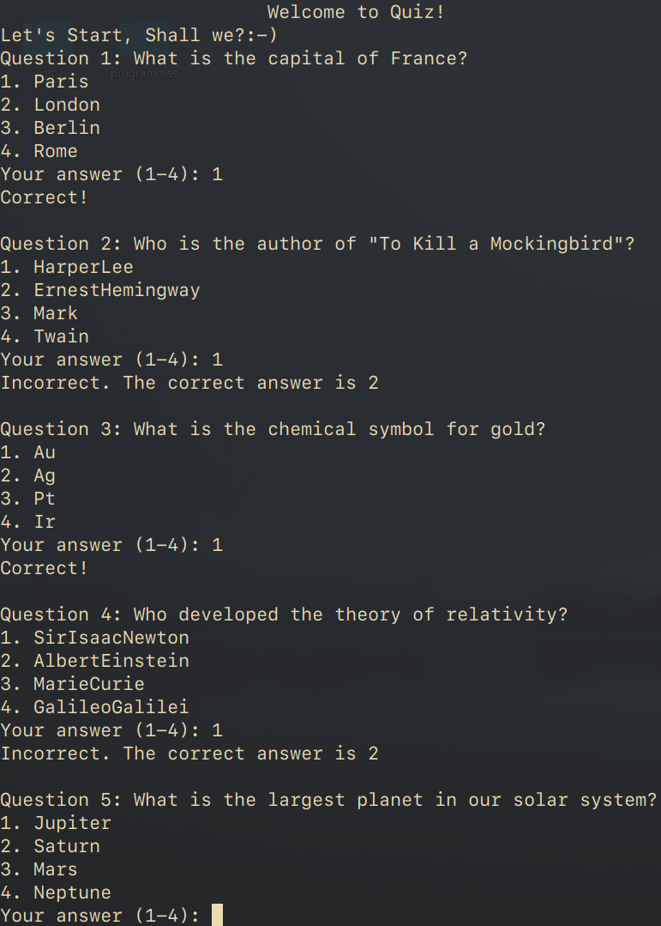
return 0; }

5. Tic Tac Toe
#include <stdio.h>
#include <stdlib.h>
#include <time.h>
#include <unistd.h>//to manipulate the terminal output delay
//Check the running OS
#ifdef WIN_32
#defineCLEAR_SCREENSCREEN "cls"
#else
#define CLEAR_SCREEN "clear"
#endif
////Define the board and name of the player
char board[3][3];
const char PLAYER = 'X';
const char COMPUTER = 'O';
void resetBoard(){
for (int i = 0; i < 3; i++) {
for (int j = 0; j < 3; j++) {
board[i][j] = ' ';
} } }
void printBoard(){
printf(" %c | %c | %c ", board[0][0], board[0][1], board[0][2]);
printf("\n---|---|---\n");
printf(" %c | %c | %c ", board[1][0], board[1][1], board[1][2]);
printf("\n---|---|---\n");
printf(" %c | %c | %c ", board[2][0], board[2][1], board[2][2]);
printf("\n---|---|---\n\n"); }
int checkFreeSpaces() {
int freeSpaces = 9;
for (int i = 0; i < 3; i++) {
for (int j = 0; j < 3; j++) {
if (board[i][j] != ' ') {
freeSpaces--;
} } }
return freeSpaces; }
void playerMove()
{
int x, y;
printf("Enter row #(1-3): ");
scanf("%d", &x); x--;
printf("Enter column #(1-3): ");
scanf("%d", &y); y--;
do {
if (board[x][y] != ' ') {
printf("Invalid move try again.\n");
printBoard();
playerMove(); }
else {
board[x][y] = PLAYER;
break; }

} while (board[x][y] == ' '); }
void printWinner(char winner) {
if (winner == PLAYER) {
printf("Player Wins!\n"); }
else if (winner == COMPUTER) {
printf("Computer Wins!\n"); }
else {
printf("It's a tie!\n"); } }

void computerMove() {
srand(time(0)); int x, y;
if (checkFreeSpaces() > 0) {
do {
x = rand() % 3;
y = rand() % 3;
} while (board[x][y] != ' ');
board[x][y] = COMPUTER; }
else {
printWinner(' '); } }
char checkWinner() {
for (int i = 0; i < 3; i++) {
if (board[i][0] == board[i][1] && board[i][0] == board[i][2]) {
return board[i][0]; }
}

for (int i = 0; i < 3; i++){
if (board[0][i] == board[1][i] && board[0][i] == board[2][i]) {
return board[0][i]; }
}
if (board[0][0] == board[1][1] && board[0][0] == board[2][2]) {
return board[0][0]; }
if (board[0][2] == board[1][1] && board[0][2] == board[2][0]) {
return board[0][2]; }
return ' '; }
void credits() {
printf("\n\n\n\n\n\n\n\n\n\n\n\t\t\t\tPROJECT\n\t\t\t Tic Tac Toe ON C"); system(CLEAR_SCREEN);
printf("\n\n\n\n\n\n\n\n\n\n\n\t\t\tDeveloped BY\n\t\t Charchil Neupane"); sleep(1 * 4);
printf("\n\n\n\n\n\n\n\n\n\n\n\t\t\t\tROLL NO\n\t\t\t\t 12"); sleep(1 * 4);
printf("\n\n\n\n\n\n\n\n\n\n\n\t\t\t\tSECTION\n\t\t\t M11"); sleep(1 * 4);
printf("\n\n\n\n\n\n\n\n\n\n\n\t\t\t\tINSTITUTE:Kathmandu Model College");
printf("\n\n\n\n\n\n\n\n\n\n\n\t\t\t\tSUBMITTED TO:Computer Department"); sleep(2);
system(CLEAR_SCREEN); puts("\n\n"); }

const char PX = 'X';
const char PO = 'O';
int freeSpaceCheck() {
int freeSpaces = 9;
for (int i = 0; i < 3; i++) {
for (int j = 0; j < 3; j++) {
if (board[i][j] != ' ') {
freeSpaces--; }
} }
return freeSpaces; }

void playerMoveFriend(char currentPlayer) {
int x, y;
printf("Player %c, enter row #(1-3): ", currentPlayer);
scanf("%d", &x); x--;
printf("Player %c, enter column #(1-3): ", currentPlayer);
scanf("%d", &y); y--;
do {
if (board[x][y] != ' '){
printf("Invalid move, try again.\n");
printBoard();
playerMoveFriend(currentPlayer);
}
else{
board[x][y] = currentPlayer;
break;
}
} while (board[x][y] == ' ');
}

char checkWinnerFriend(){
for (int i = 0; i < 3; i++){
if (board[i][0] == board[i][1] && board[i][0] == board[i][2]){
return board[i][0];
}
}
for (int i = 0; i < 3; i++){
if (board[0][i] == board[1][i] && board[0][i] == board[2][i]){
return board[0][i]; }
}
if (board[0][0] == board[1][1] && board[0][0] == board[2][2]){
return board[0][0];
}
if (board[0][2] == board[1][1] && board[0][2] == board[2][0]) {
return board[0][2];
}
return ' '; }
void printWinnerFriend(char winner) {
if (winner == PX) {
printf("Player X Wins!\n");
}
else if (winner == PO) {
printf("Player O Wins!\n");
}
else {
printf("It's a tie!\n");
}
}
int comp() {
char winner = ' ', response;//initially null winner
credits();
do {
winner = ' ';
response = ' ';
resetBoard();
while (winner == ' ' && checkFreeSpaces() != 0){//when no winner is decleard and there is free space available in the board
printBoard();
playerMove();
winner = checkWinner();
if (winner != ' ' || checkFreeSpaces() == 0){
break;
}
printBoard();
computerMove();
winner = checkWinner();
if (winner != ' ' || checkFreeSpaces() == 0){
break;
}
}
printBoard();
printWinner(winner);
printf("\nDo you want to play again? (Y/N)\n");
scanf(" %c", &response);
if (response == 'Y' || response == 'y'){
system(CLEAR_SCREEN);
}
} while (response == 'Y' || response == 'y');
return 0;
}
void Friends() {
char winner = ' ';
char response;
credits();
do {
winner = ' ';
response = ' ';
resetBoard();
while (winner == ' ' && freeSpaceCheck() != 0) {
printBoard();
playerMoveFriend(PX);
winner = checkWinnerFriend();
if (winner != ' ' || freeSpaceCheck() == 0) {
break;
}
printBoard();
playerMoveFriend(PO);
winner = checkWinnerFriend();
if (winner != ' ' || freeSpaceCheck() == 0) {
break;
}
}
printBoard();
printWinnerFriend(winner);
printf("\nDo you want to play again? (Y/N)\n");
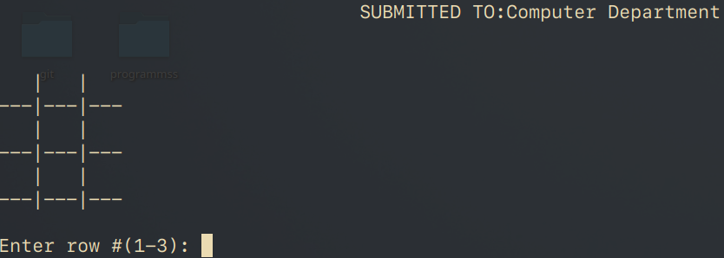
scanf(" %c", &response);
if (response == 'Y' || response == 'y'){
system(CLEAR_SCREEN);
}
} while (response == 'Y' || response == 'y');
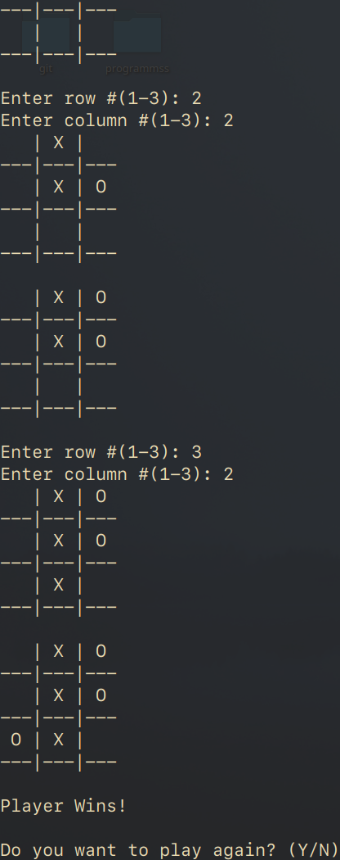
}
int main() {
puts("\n\n");
char c;
printf("Play against computer or friend (if you have any :-)) (C/F)\n");
scanf(" %c", &c);
if (c == 'C' || c == 'c'){
comp();
}
else if (c == 'F' || c == 'f'){
Friends();
}
return 0; }

Conclusion
In conclusion, the Multi-Program C Application Suite represents a harmonious blend of creativity, functionality, and educational value. Through the diverse set of programs – Hangman, Quiz, Customer Billing System, Contact Management System, and Tic Tac Toe – this project successfully showcases the versatility and power of C programming.
By engaging users in interactive and entertaining experiences, the suite not only serves as a testament to the programming prowess applied in game development but also addresses real-world applications such as billing and contact management. The project's significance lies not only in its entertainment value but also in its capacity to impart practical programming skills to learners at various levels.
As we reflect on the journey of conceptualizing, designing, and implementing each program, it becomes evident that this project encapsulates the essence of problem-solving and creativity within the realm of C programming. The modular design, efficient algorithms, and user-friendly interfaces collectively contribute to the project's success.
Moving forward, this Multi-Program C Application Suite stands as a valuable resource for both learners and enthusiasts. Its impact extends beyond the realm of individual programs, offering a holistic view of how C programming can be leveraged to create versatile and robust applications. This project serves as an inspiration for future programmers and underscores the timeless relevance of C in the ever-evolving landscape of computer science.
In essence, the journey from conceptualization to implementation has not only resulted in a collection of programs but has also fostered a deeper understanding and appreciation for the art and science of C programming. The Multi-Program C Application Suite stands as a testament to the endless possibilities that unfold when creativity meets code.
Reference and Courtesy

https://geeksforgeeks.org
https://stackoverflow.com
https://gnu.org
https://chat.openai.com

