High Level Design (HLD) Amazon Sales Data Analysis

Revision Number: 1.0

Last date of revision: 30/07/2022

Charchit Mangal

# Document Version Control

|  |  |  |  |
| --- | --- | --- | --- |
| **Date Issued** | **Version** | **Description** | **Author** |
| **30/07/2022** | 1.0 | First Version of Complete HLD | Charchit Mangal |
|  |  |  |  |
|  |  |  |  |
|  |  |  |  |
|  |  |  |  |
|  |  |  |  |
|  |  |  |  |

**Contents**

Document Version Control 2

Abstract 3

1. Introduction 5
   1. Why this High-Level Design Document? 5
   2. Scope 5
2. General Description 6
   1. Product Perspective & Problem Statement 6

Housing prices are an important reflection of the economy, and housing price ranges are of great interest for both buyers and sellers. In this project, house prices will be predicted given explanatory variables that cover many aspects of residential houses. 6

* 1. Tools used 6

1. Design Details 7
   1. Functional Architecture 7
   2. Optimization 8
2. KPIs 9
   1. KPIs (Key Performance Indicators) 9
3. Deployment 9

# Abstract

Sales management has gained importance to meet increasing competition and the need

for improved methods of distribution to reduce cost and to increase profits. Sales

management today is the most important function in a commercial and business

enterprise.

With given dataset various tasks are performed like ETL( Extract, Transform & Load), Sales trend with respect to many attributes, Key Metrics & meaningful relationship between different attributes.

# Introduction

## Why this High-Level Design Document?

The purpose of this High-Level Design (HLD) Document is to add the necessary detail to the current project description. This document is also intended to help detect contradictions and can be used as a reference manual for.

The HLD will:

* + - Present all of the design aspects and define them in detail
    - Describe the user interface being implemented
    - Describe the performance requirements
    - Include design features and the architecture of the project

## Scope

The HLD documentation presents the dashboards of the dataset and helps us understand how different attributes affect each other. For, example – When Expected delivery time decreases, Sales increases and much more.

# General Description

## Product Perspective & Problem Statement

Sales management has gained importance to meet increasing competition and the need

for improved methods of distribution to reduce cost and to increase profits. Sales

management today is the most important function in a commercial and business

enterprise.

With given dataset various tasks are performed like ETL( Extract, Transform & Load), Sales trend with respect to many attributes, Key Metrics & meaningful relationship between different attributes.

## Tools used

Business Intelligence tools and libraries works such as Excel, Power BI are used to build the whole framework.





# Design Details

## Functional Architecture

Figure 1: Functional Architecture of Business Intelligence

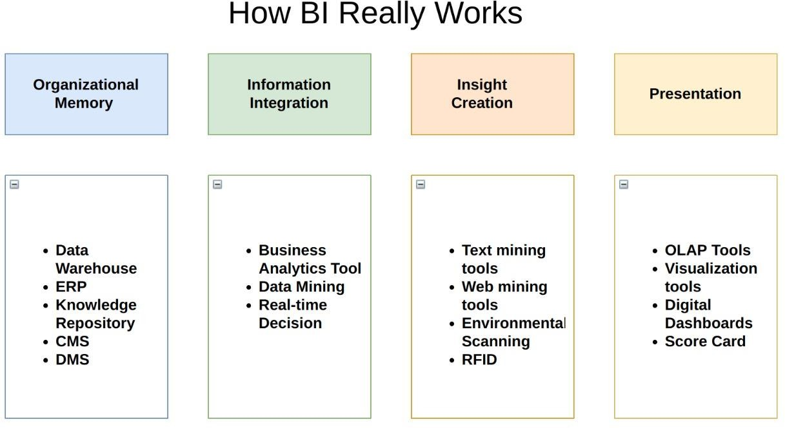

1. **Sales Quantity by Year**

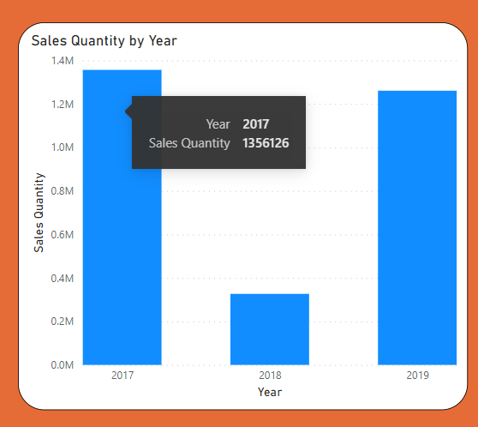

1. **Sales Amount by Year**

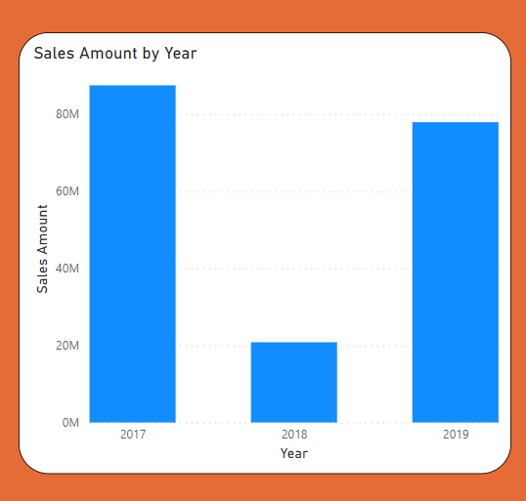

1. **Sales Amount by Month Name**

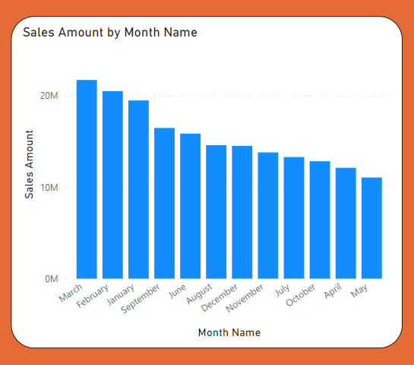

1. **Sales Quantity by Month Name**

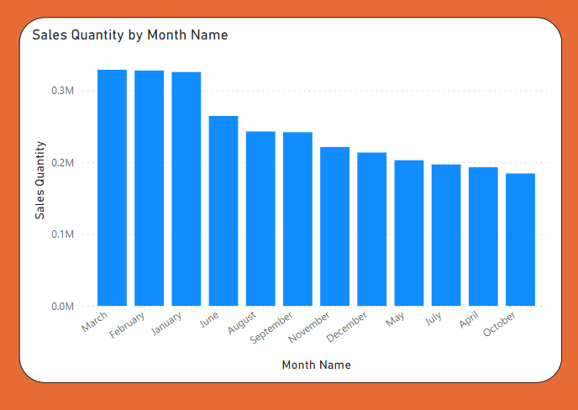

1. **Sales Amount by Month Year**

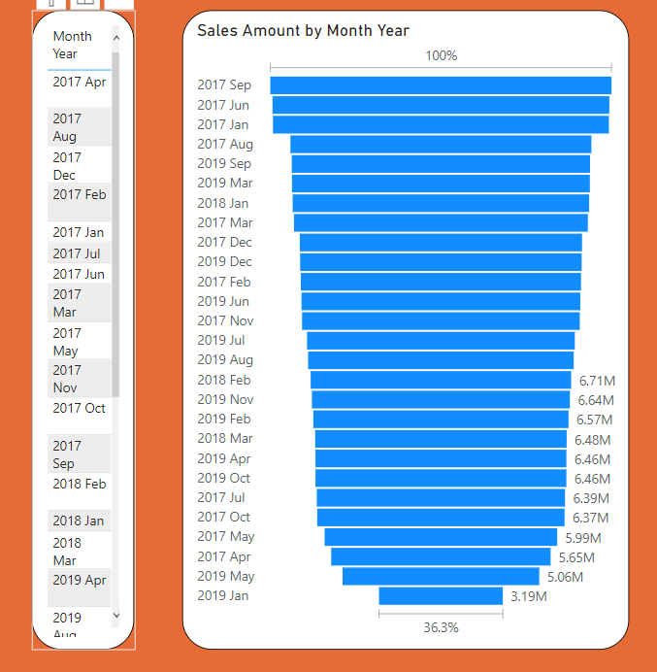

1. **Sales Quantity by Month Year**

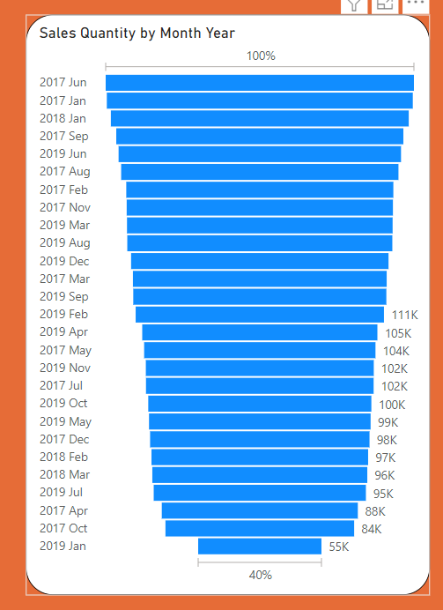

1. **Sales Amount by Item Number**

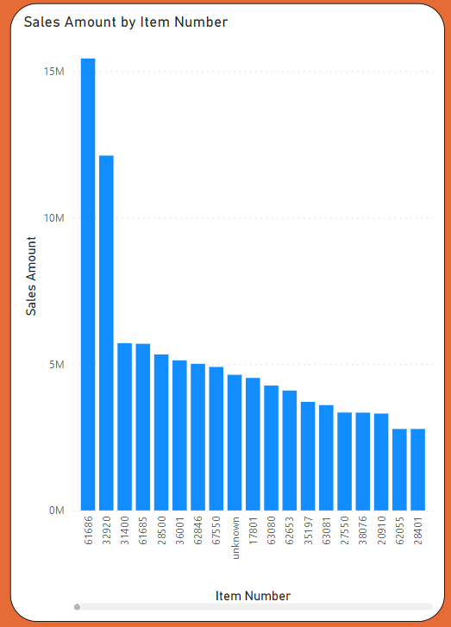

1. **Sales Amount by Item**

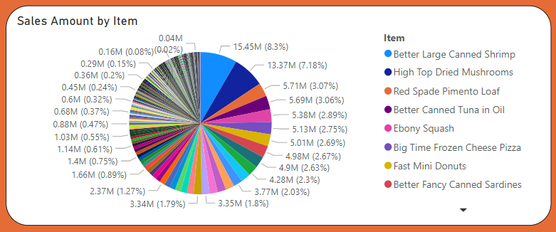

1. **Sales Amount by Line Number**

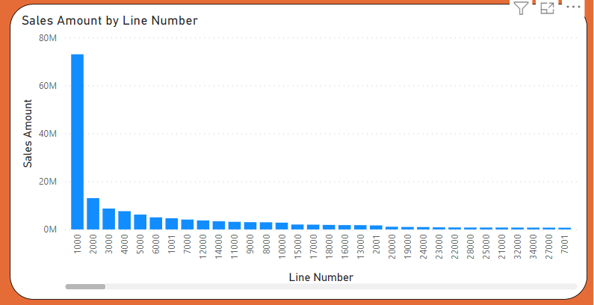

1. **Sales Repetition by Items**

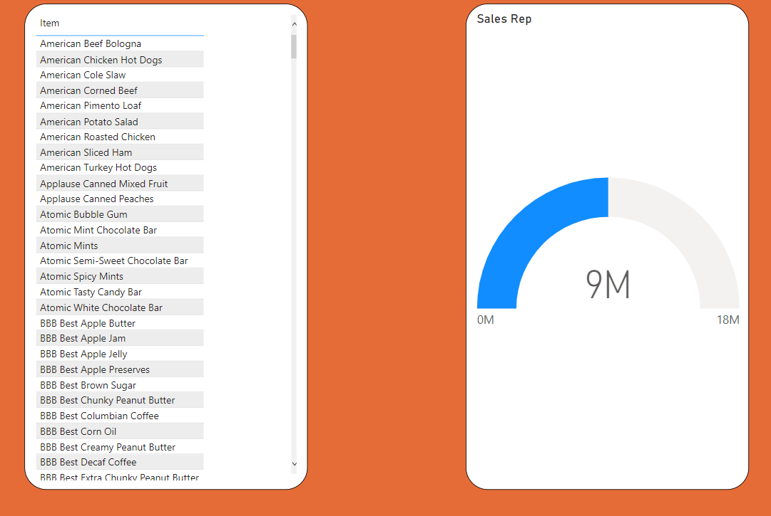

1. **Sales Repetition by Expected delivery days**

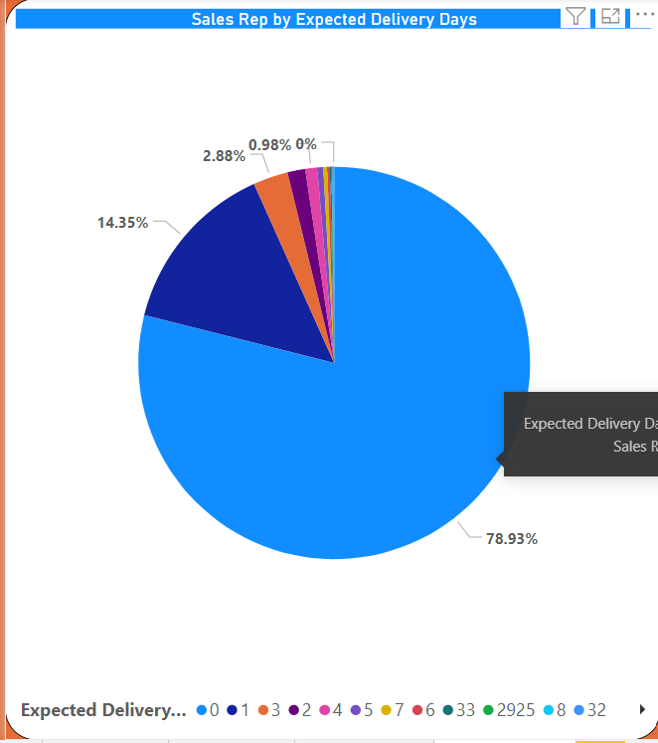

1. **Sales Amount by Expected delivery days**

