Amazon Sales Data Analysis

***Wireframe Documentation***

1. **Sales Quantity by Year**

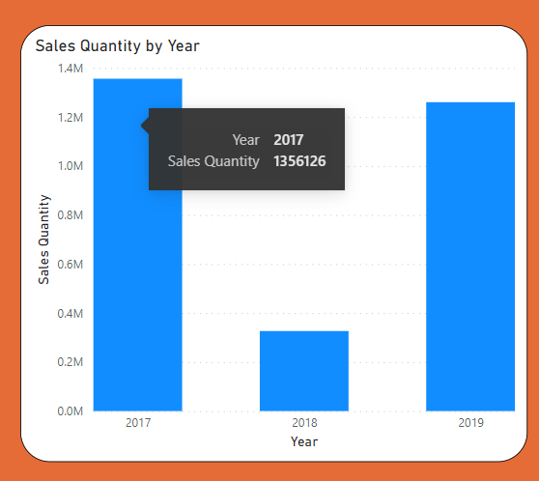

1. **Sales Amount by Year**

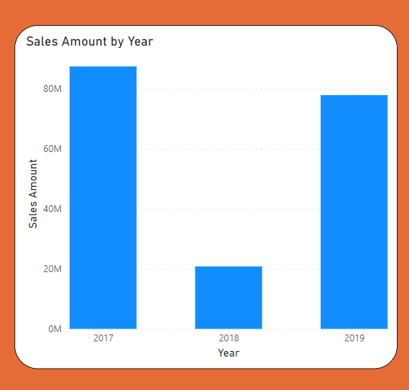

1. **Sales Amount by Month Name**

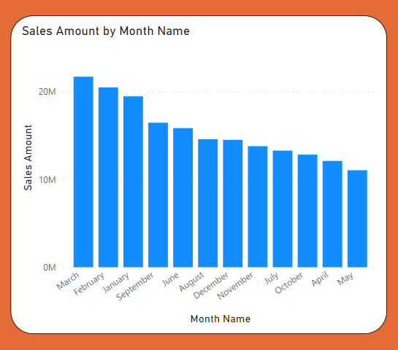

1. **Sales Quantity by Month Name**

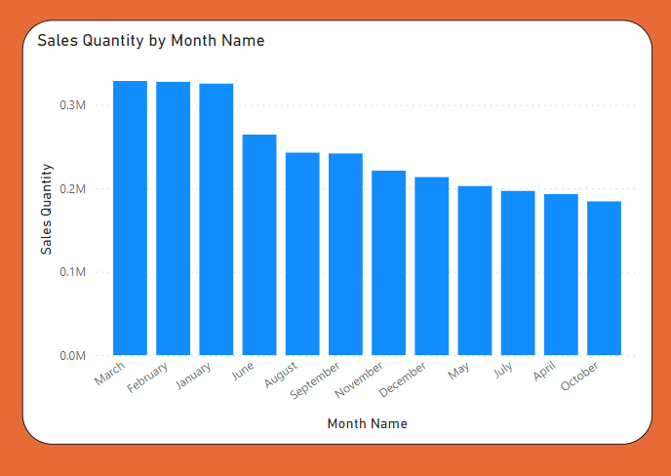

1. **Sales Amount by Month Year**

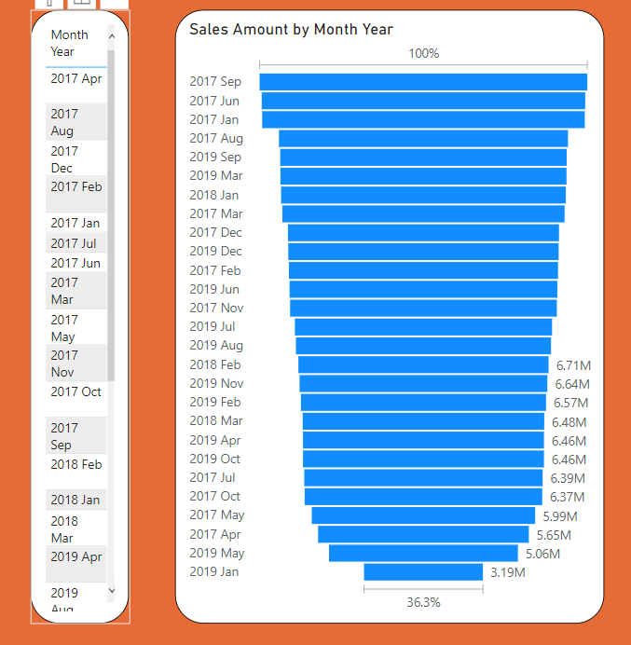

1. **Sales Quantity by Month Year**

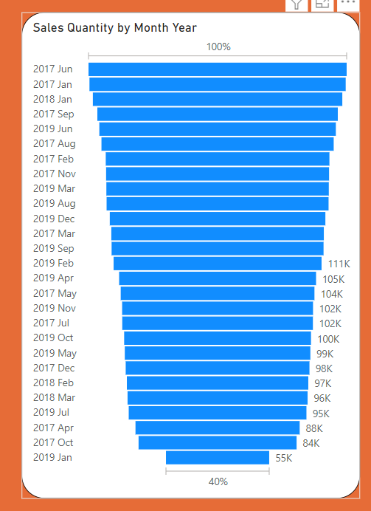

1. **Sales Amount by Item Number**

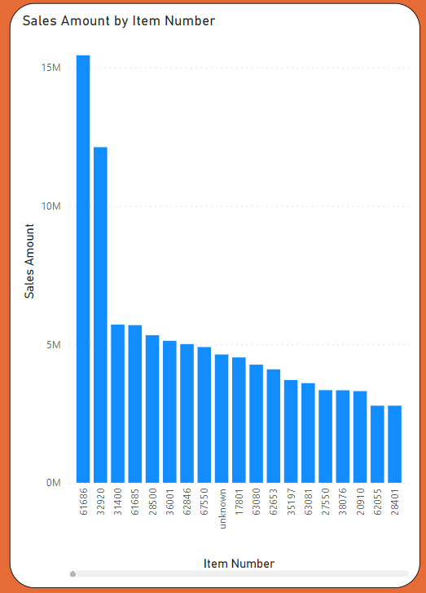

1. **Sales Amount by Item**

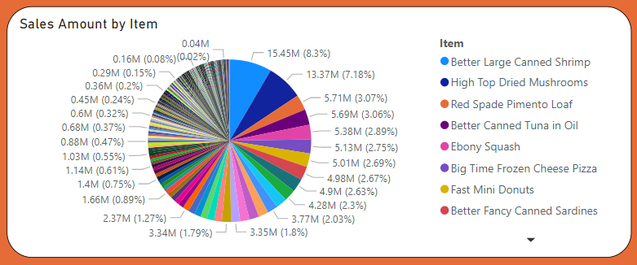

1. **Sales Amount by Line Number**

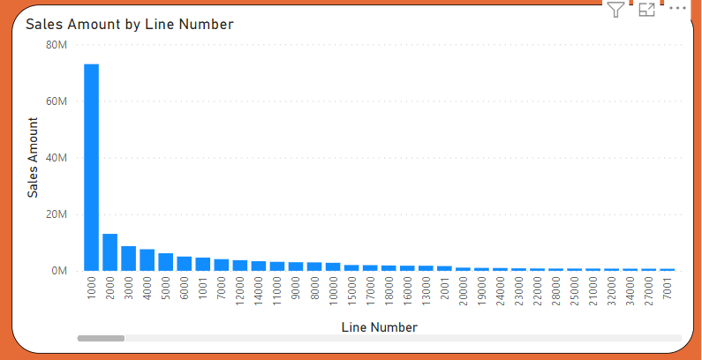

1. **Sales Repetition by Items**

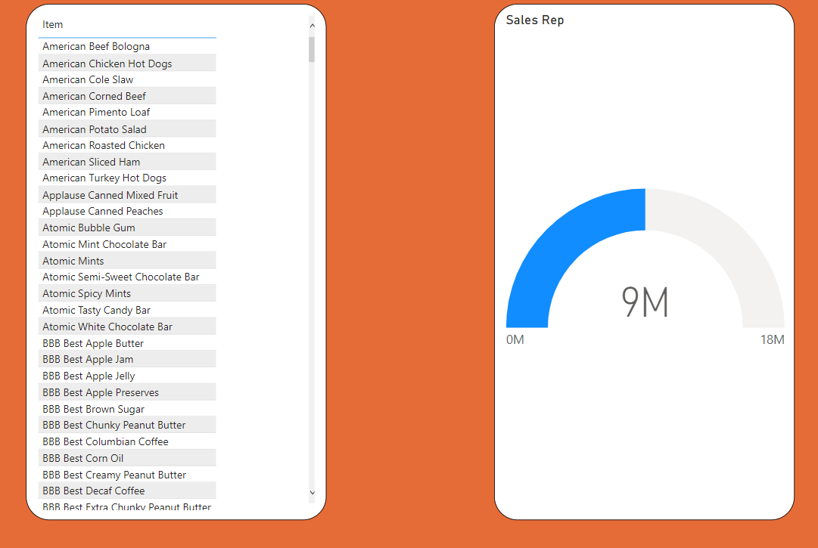

1. **Sales Repetition by Expected delivery days**

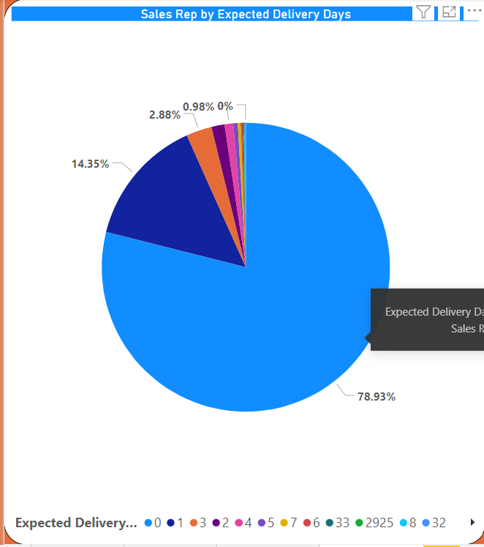

1. **Sales Amount by Expected delivery days**

