High Level Design (HLD) Budget Sales Data Analysis

Revision Number: 1.0

Last date of revision: 18/08/2022

Charchit Mangal

# Document Version Control

|  |  |  |  |
| --- | --- | --- | --- |
| **Date Issued** | **Version** | **Description** | **Author** |
| **18/08/2022** | 1.0 | First Version of Complete HLD | Charchit Mangal |
|  |  |  |  |
|  |  |  |  |
|  |  |  |  |
|  |  |  |  |
|  |  |  |  |
|  |  |  |  |

# Contents

1. Introduction 04
   1. Purpose of the Document? 04
   2. Scope 04
2. Architecture 05

Power Bi Architecture 05-07

EDA with Python 05-07

# Abstract

Our "Domain Sale" process is structured to help potential buyers purchase the domain

they want immediately without the hassle of contacting the seller directly. ... A seller lists a

domain for sale at a specific price in our Marketplace. An interested buyer sees this

domain for sale and decides to buy it.

Do ETL : Extract- Transform and Load data from heart disease diagnostic database

You can perform EDA through python.

Extract various information such as Sales, budget, variance.

You can even compare sales and budget with various attributes.

Extract necessary information about Products and Customers..

# Introduction

## Why this High-Level Design Document?

The purpose of this High-Level Design (HLD) Document is to add the necessary detail to the current project description. This document is also intended to help detect contradictions and can be used as a reference manual for.

The HLD will:

* + - Present all of the design aspects and define them in detail
    - Describe the user interface being implemented
    - Describe the performance requirements
    - Include design features and the architecture of the project

## Scope

The HLD documentation presents the dashboards of the dataset and helps us understand how different attributes affect each other. For, example – When Expected delivery time decreases, Sales increases and much more.

# General Description

## Product Perspective & Problem Statement

Our "Domain Sale" process is structured to help potential buyers purchase the domain

they want immediately without the hassle of contacting the seller directly. ... A seller lists a

domain for sale at a specific price in our Marketplace. An interested buyer sees this

domain for sale and decides to buy it.

Do ETL : Extract- Transform and Load data from heart disease diagnostic database

You can perform EDA through python.

Extract various information such as Sales, budget, variance.

You can even compare sales and budget with various attributes.

Extract necessary information about Products and Customers..

## Tools used

Business Intelligence tools and libraries works such as Excel, Power BI are used to build the whole framework.





# Design Details

## Functional Architecture

Figure 1: Functional Architecture of Business Intelligence

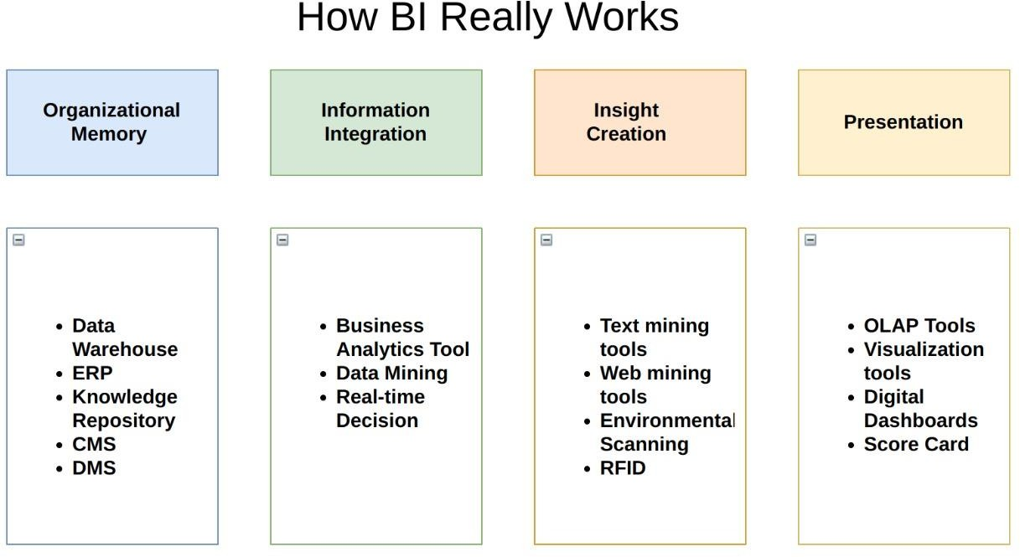

**1.) Sales by City**

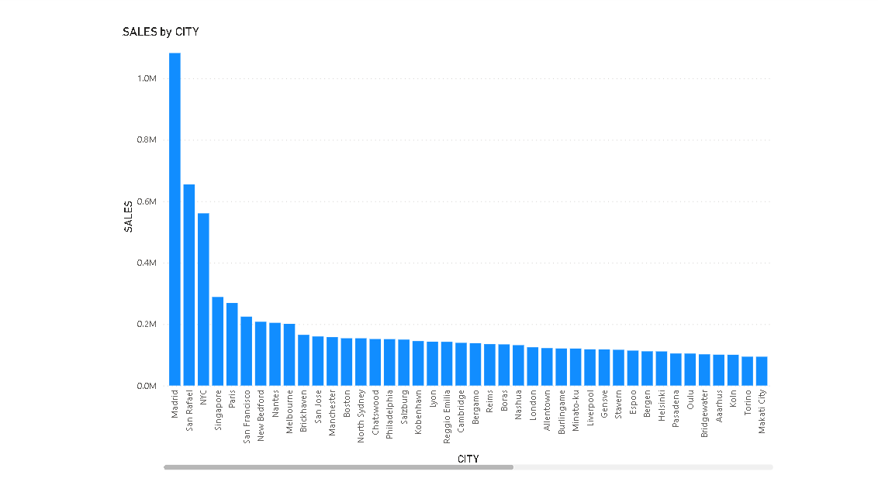

**2.) Sales by DealSize**

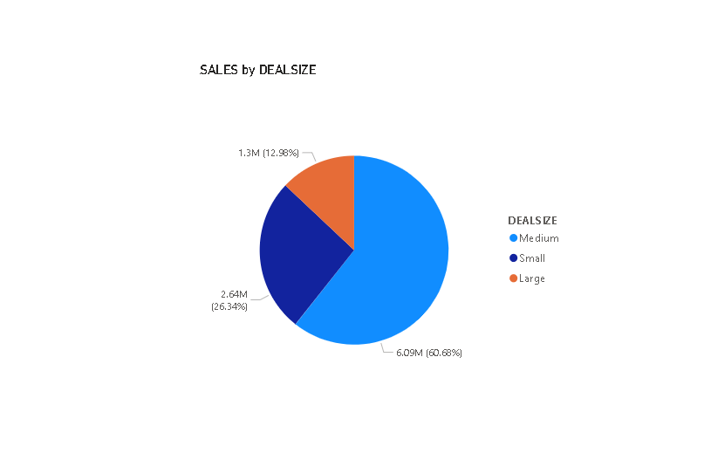

**3.) Sales by State & Sales by ProductLine**

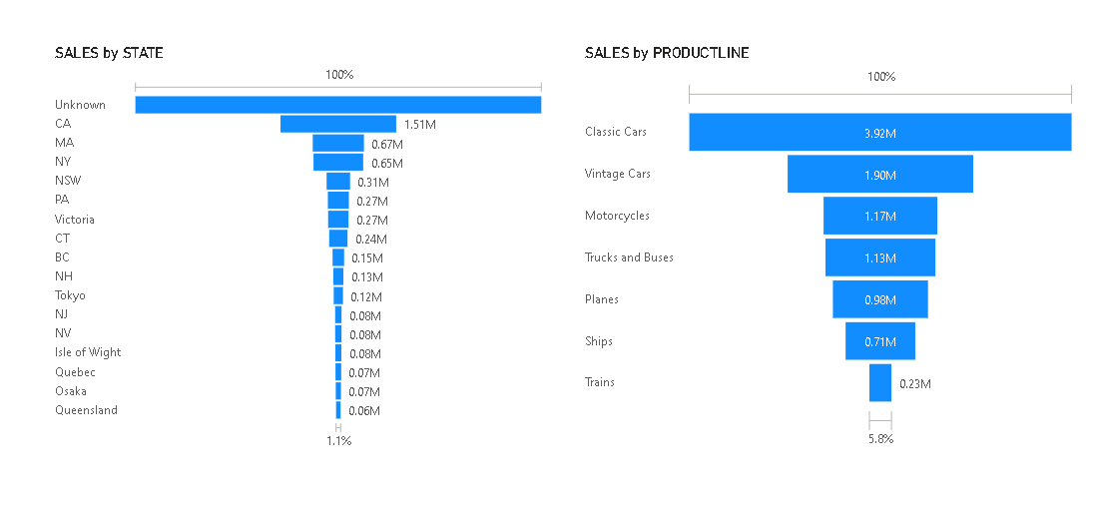

**4.) Sales by MSRP** 4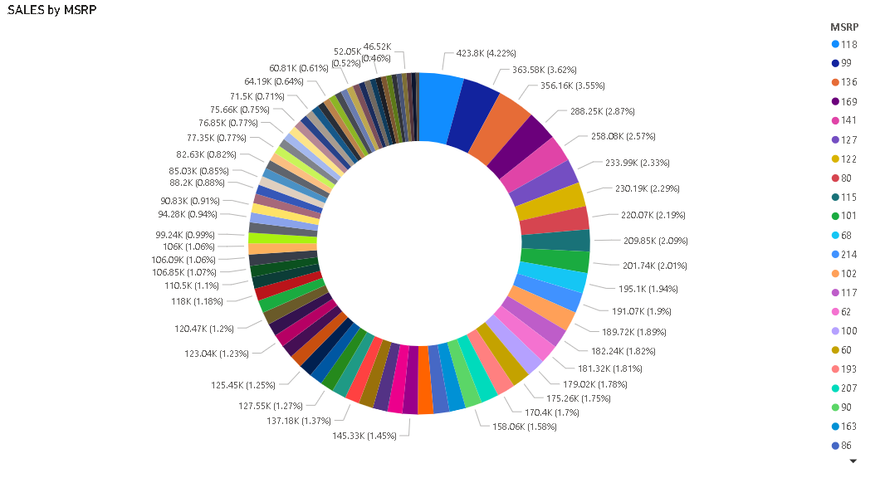

**5.) Sales by Country** 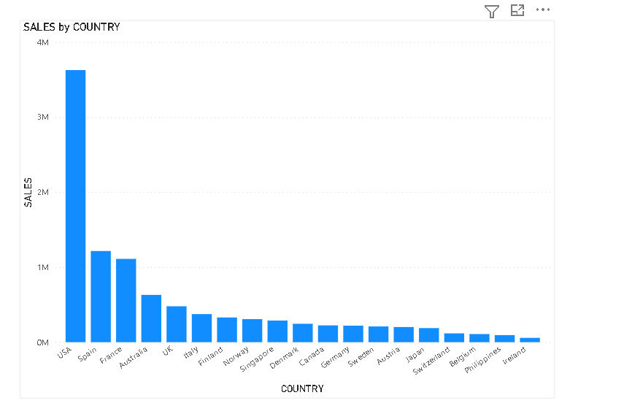

**EDA With Python**

This process involves understanding our dataset & data cleaning. It involves implementing probability & statistics concepts using python libraries and modules.

Checkout below implementation:

