Budget Data Sales Analysis

***Wireframe Documentation***

**EDA With Python**

This process involves understanding our dataset & data cleaning. It involves implementing probability & statistics concepts using python libraries and modules.

Checkout below implementation:

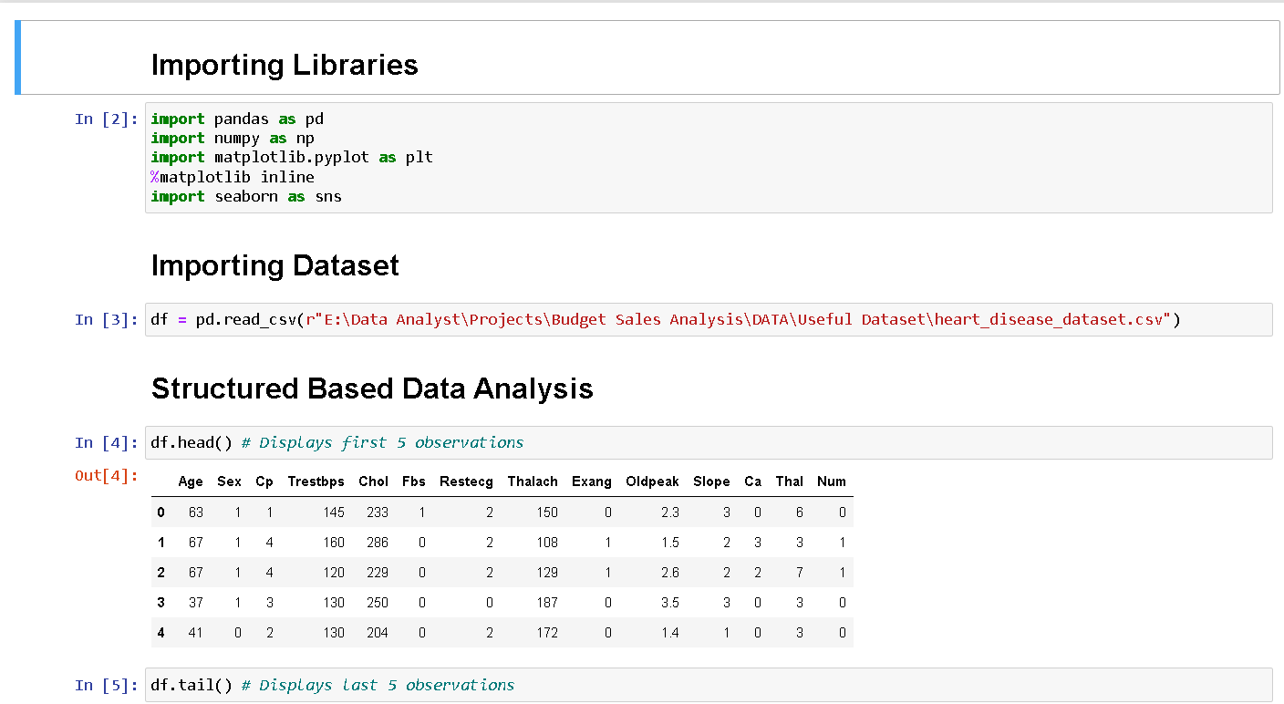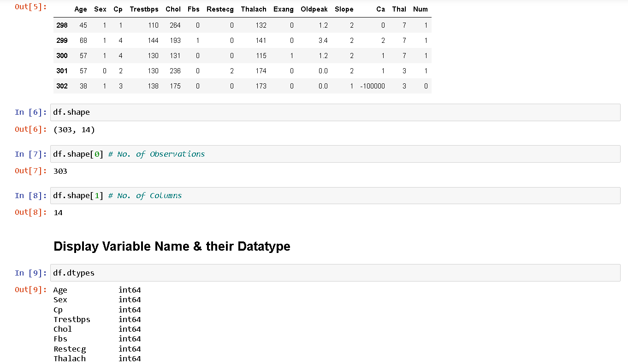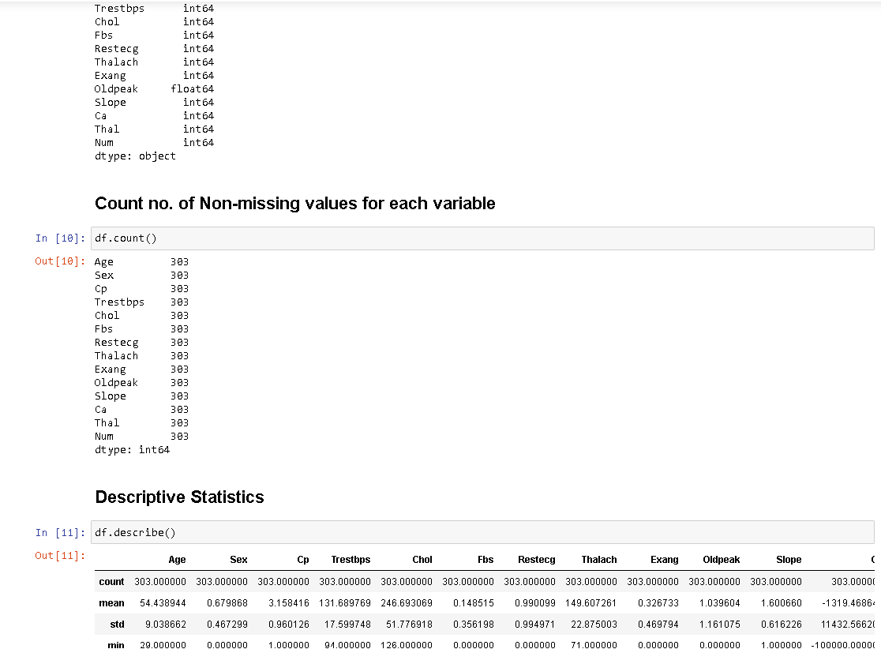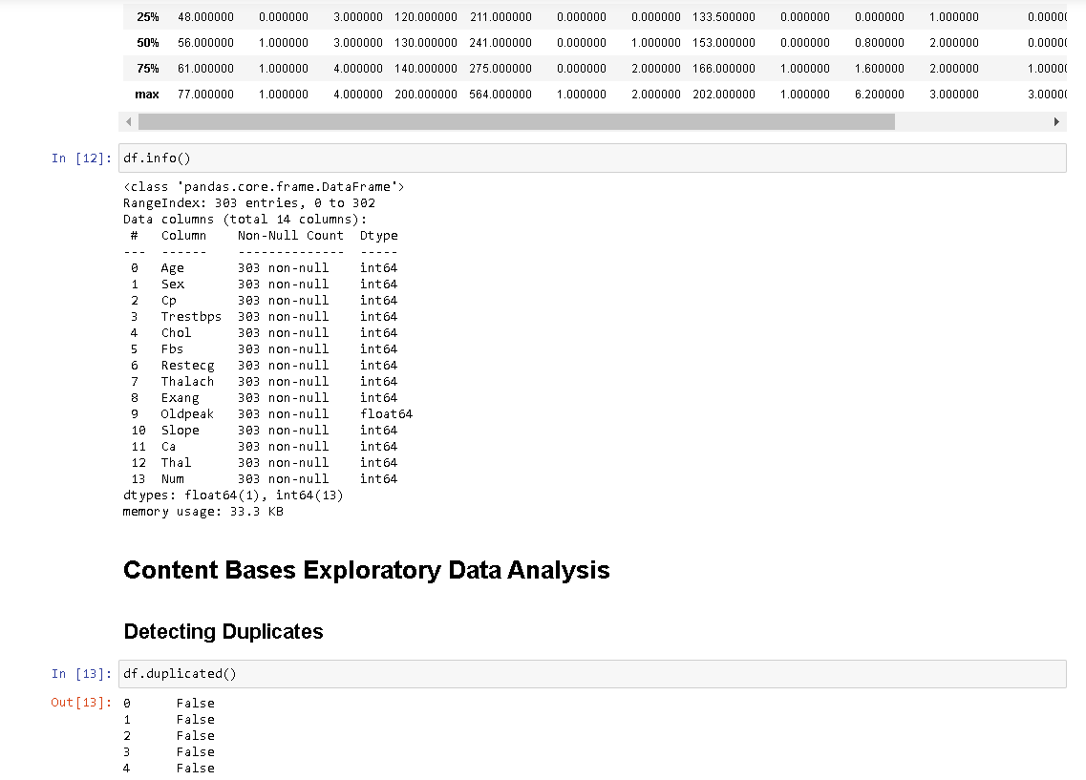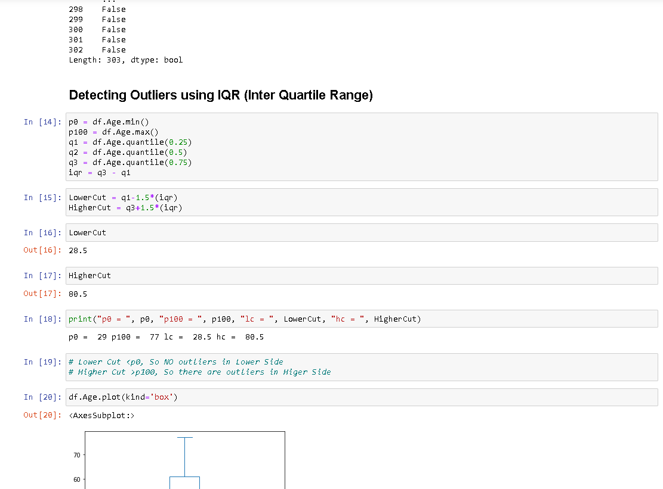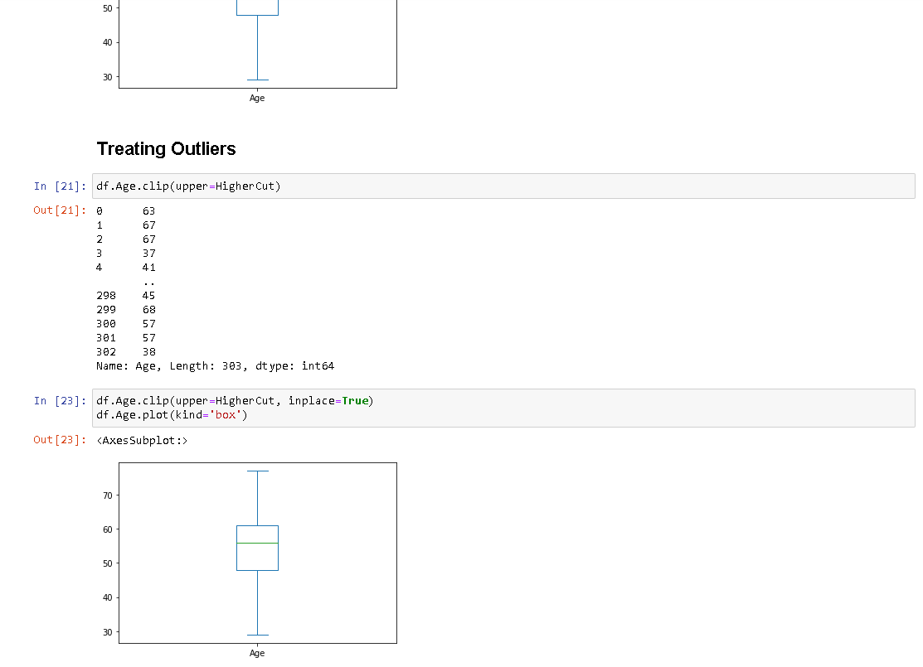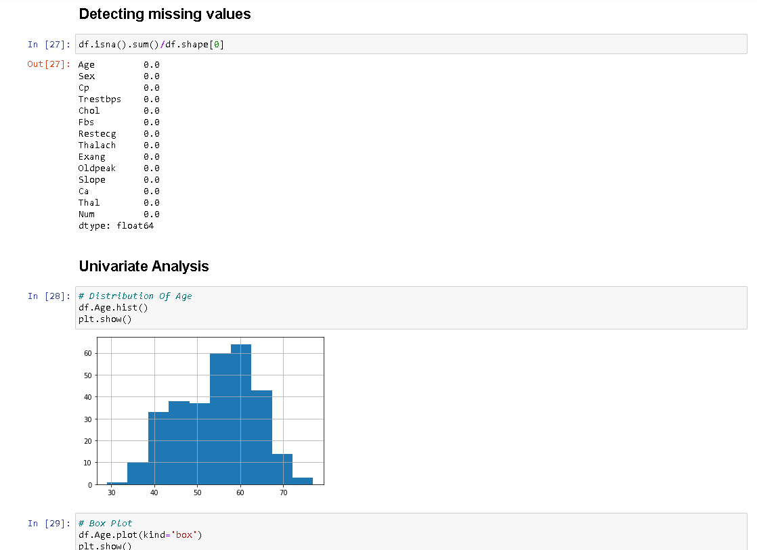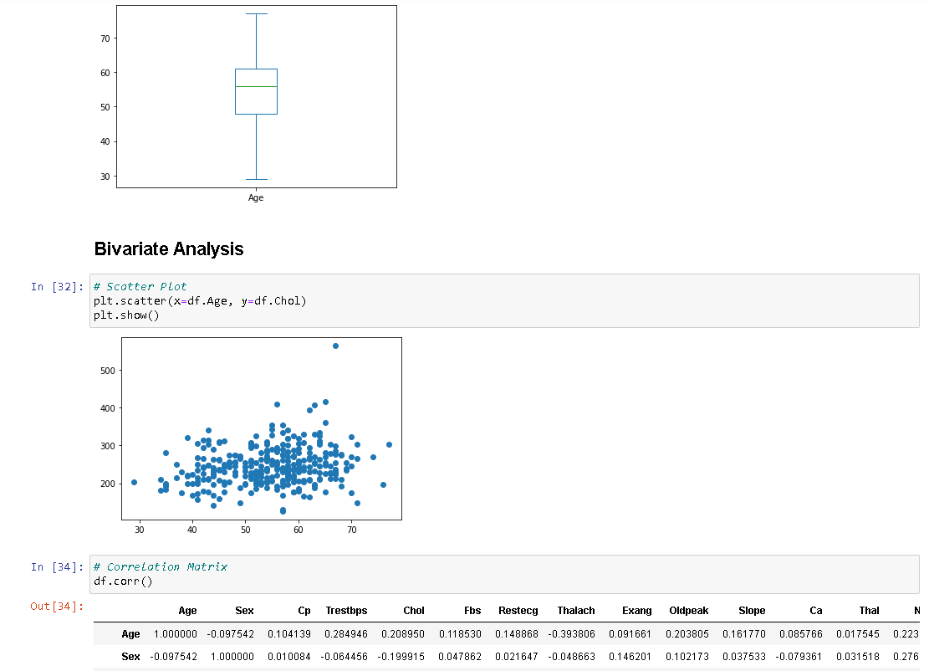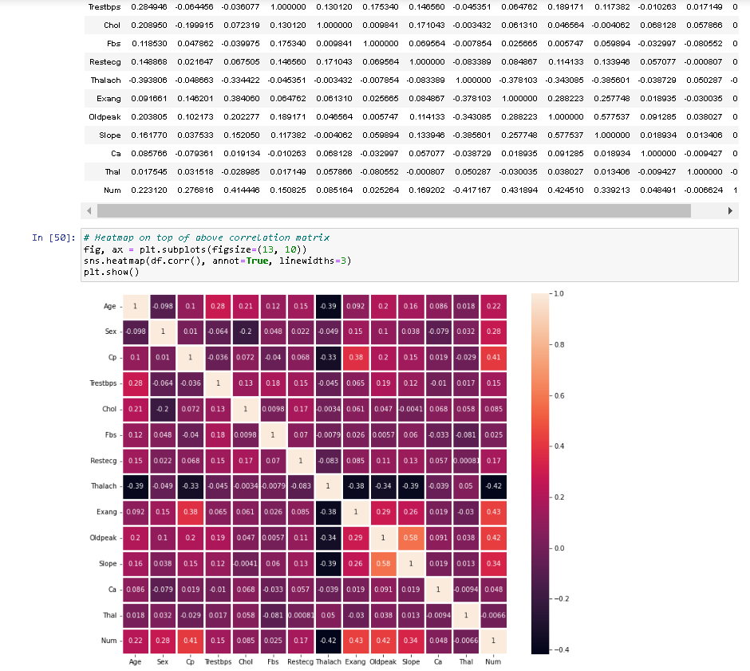

**Power Bi Architecture**

Power BI is an interactive data visualization software product developed by Microsoft with a primary focus on business intelligence. It is part of the Microsoft Power Platform. Power BI is a collection of software services, apps, and connectors that work together to turn unrelated sources of data into coherent, visually immersive, and interactive insights. Data may be input by reading directly from a database, webpage, or structured files such as spreadsheets, CSV, XML, and JSON.

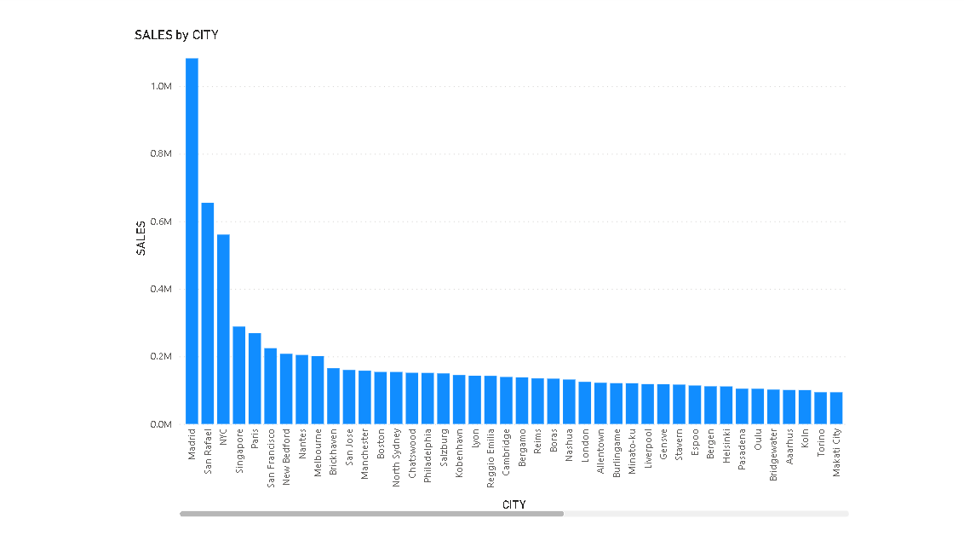

**1.) Sales by City**

**2.) Sales by DealSize**

**3.) Sales by State & Sales by ProductLine**

**4.) Sales by MSRP**

**5.) Sales by Country**