**Ecommerce Dashboard**

Wireframe Documentation

* Dashboard elements fetches data from ‘Working’ worksheet.
* Working worksheet contains many important data source such as bins, frequency, month wise sales & profit and region wise sales data.

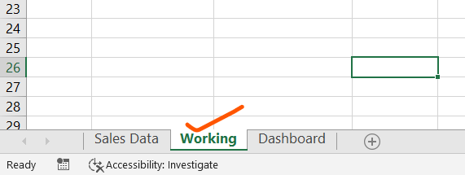

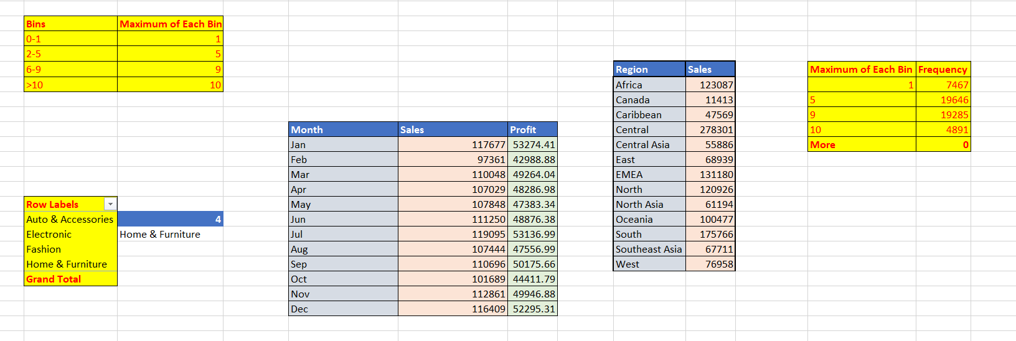

* Dataset Worksheet contains all the data

