iNeuron

Charchit Mangal

Assignment 1

1. What do you mean by cells in an Excel Sheet?

Solution – A cell is formed by intersection of Row and Column. A cell contain value which can be of different datatype like integer, string, Boolean etc. A cell can be called by using combination of ( Row Name + Column Name ). Basically Excel ( Worksheet contains data in form of combination of cells.



1. How can you restrict someone from copying a cell from your worksheet?

Solution – We can do so by setting a password for an Excel File by following below steps:

Step 1 : Go to Menu Bar

Step 2 : Go to Preview Option

Step 3 : Go on Protect Sheet option mentioned below

Step 4 : Set a password for sheet

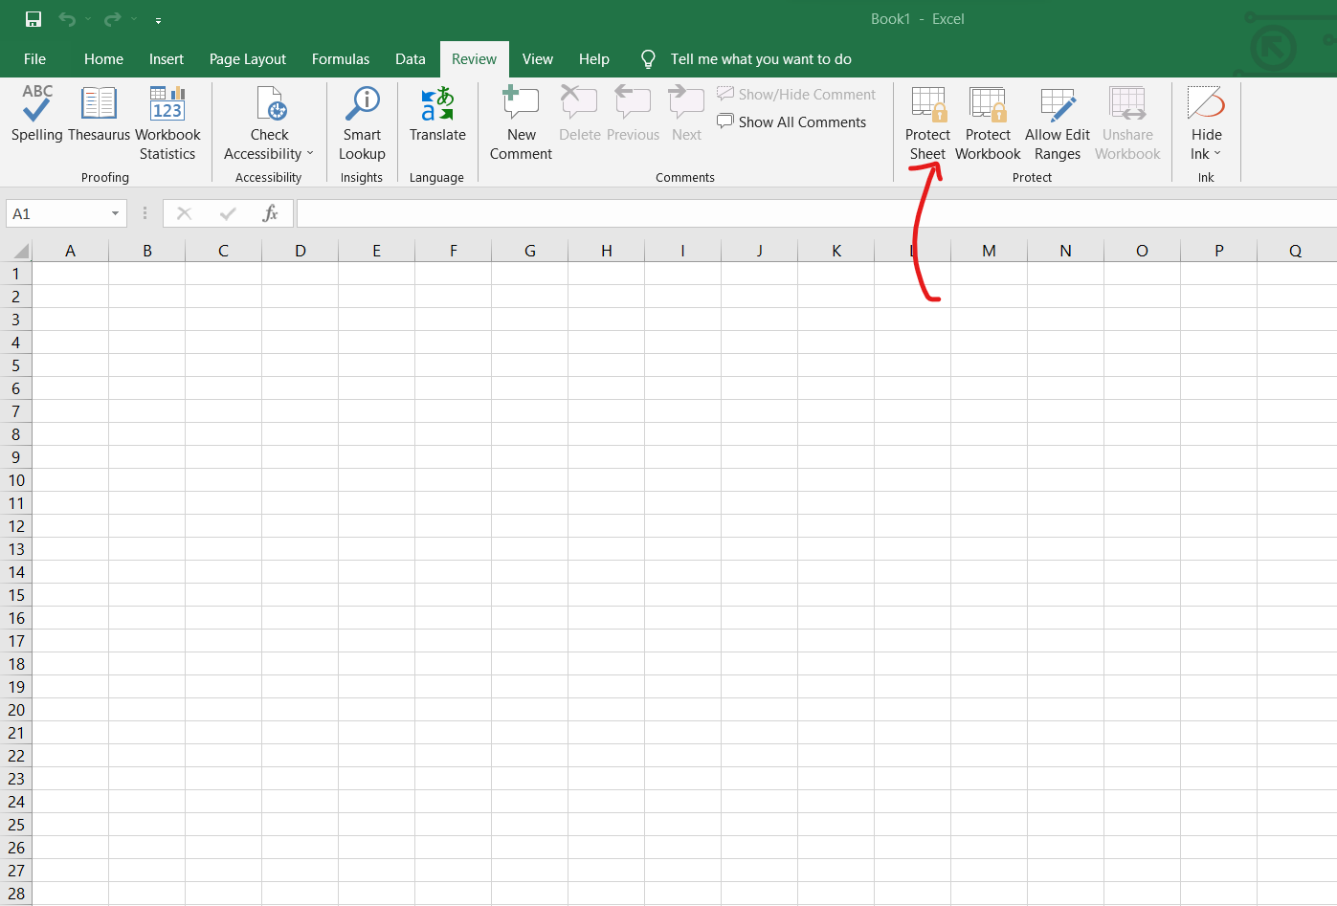

1. How to move or copy the worksheet into another workbook?

Solution – Follow these steps to Move or copy Worksheet

Step : 1 Select worksheet you want to move

Step : 2 Right click on it

Step : 3 Select Move or Copy

Step : 4 Select worksheet before which you want to move current worksheet

Step : 5 In, case you want to create copy of current worksheet, tick mark on ‘CREATE A Copy’

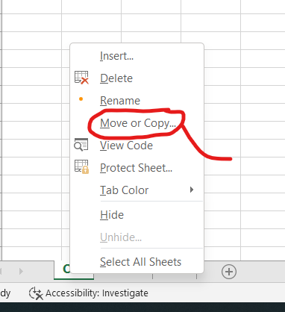 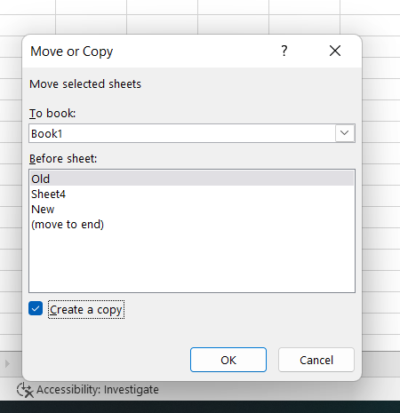

1. Which key is used as a shortcut for opening a new window document?

Solution : Click on, Alt + W + N



1. What are the things that we can notice after opening the Excel interface?

Solution – After opening a Excel Interface, we get

1. Default new worksheet opened with no name & which we can set
2. Title Bar



1. Menu Bar



1. Tool Bar

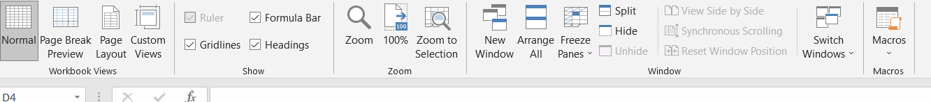

1. Column Headings



1. Row Headings



1. Formula Bar



1. Cell



1. Navigation Tabs & Worksheets



1. When to use a relative cell reference in excel?

Solution : We use Relative Cell Reference when we want to change address of cell and we don’t want to lock the reference to particular cell by putting $ sign. Like, in below example , we are using Relative Cell Reference & not absolute. That is whenever we want to repeat calculation along rows or columns we use relative reference cell :

