Excel Assignment

iNeuron

Charchit mangal

Assignment - 5

1. How many types of conditions are available in conditional formatting on Excel?

Solution : There are many conditions available

* Highlight Cell Rules – It highlights cells on the basis of various conditions such as greater than, less than, equal to, duplicate values etc.
* Top/Bottom Rules – It select top and bottom cells on various conditions such as above average, top 10%, bottom 10
* Data Bars – It provides bars to numerical values and makes it easy to find meaning out of them
* Color Scales – It provides color to numerical values
* Icon Sets – It given icons to numerical values
* New Rules – It allows us to create customized rules of our own and we can put in our own conditions

1. How to insert border in Excel with Format Cells dialog?

Solution : Follow below steps

Step 1 : Go on Home option

Step 2 : Select format option

Step 3 : Click on format cells option

Step 4 : Select border and give border style

Step 5 : Click OK

Below is an example I performed

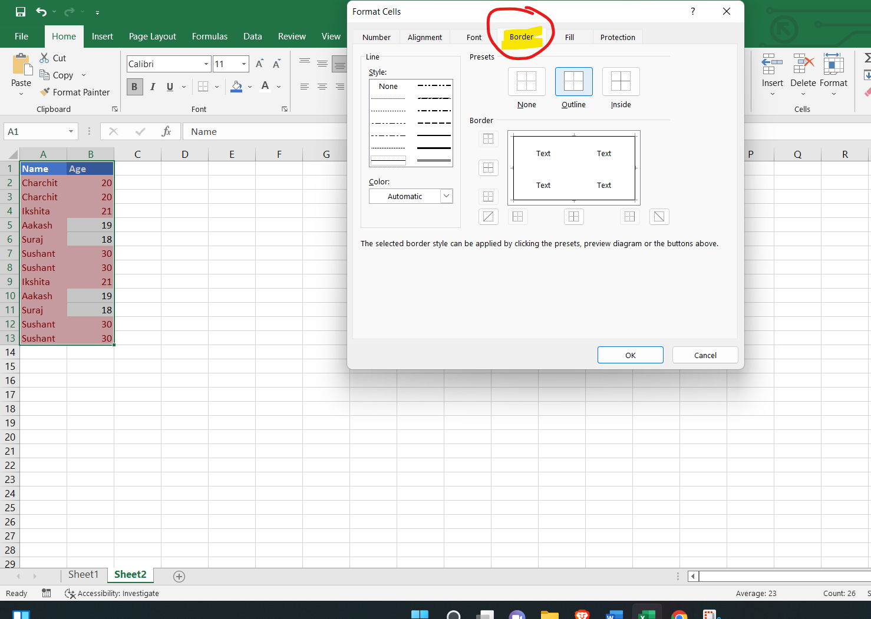

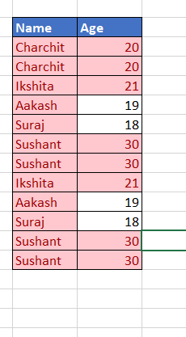

1. How to Format Numbers as Currency in Excel?

Solution : Follow below steps

Step 1 : Click on Home tool

Step 2 : From number section, click on dropdown

Step 3 : Select currency

Below is an example I performed

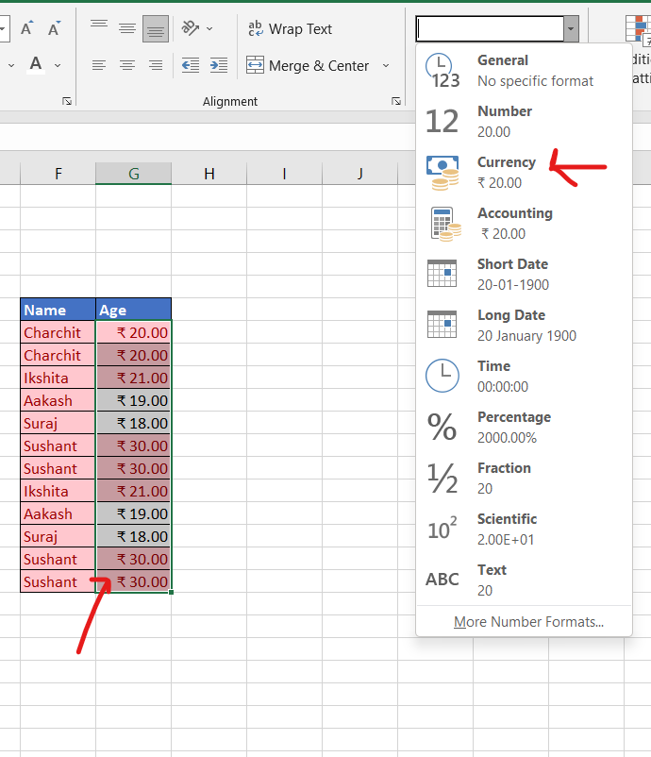

1. What are the steps to format numbers in Excel with the Percent style?

Solution : Follow steps mentioned below

Step 1 : Click on cell you want to change format

Step 2 : Go on Home Tab

Step 3 : Under numbers section, we will get a dropdown

Step 4 : Click on that and select percentage

Below attached is an example I performed

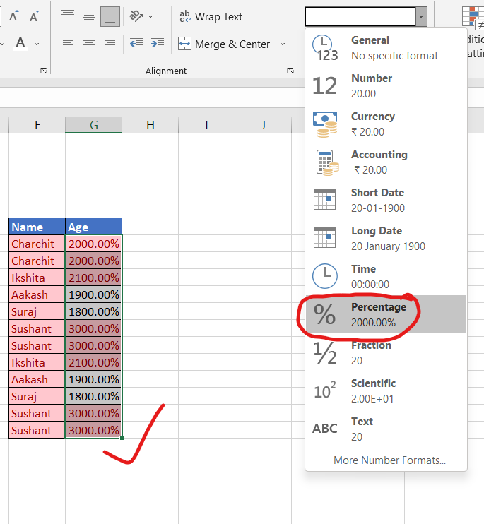

1. What is a shortcut to merge two or more cells in excel?

Solution : Follow below steps

Step 1 : Select cells you want to merge

Step 2 : Click on Home option

Step 3 : Under Alignment option, we will find merge scrolling option

Step 4 : Click on that and merge according to requirement

Below is an example I performed

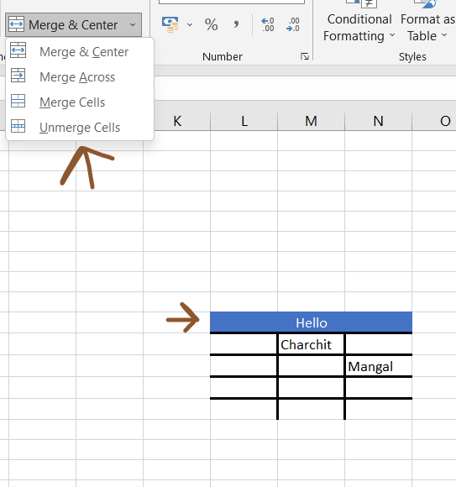

1. How do you use text commands in Excel?

Solution – There are many Text commands present in Excel like left(), len(), mis(), proper() etc

Use of few commands is given below

1. Proper() - It makes first letter of word uppercase

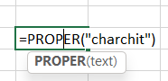

1. Len() – It finds length of string passed inside

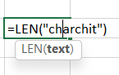

1. Rept() – It repeats text, no. of times

