7/8/2022

iNeuron

Charchit Mangal

Assignment - 4

1. To use the ribbon commands, what menu and grouping of commands will you

find the Insert and Delete command?

Solution : Follow below steps to Insert Column using command

Step 1 : Select the column, by pressing CTRL + SPACEBAR

Step 2 : Insert column, by pressing, CTRL + (+)

Below is an example I performed





Follow below steps to add Row using command

Step 1 : Select row by pressing SHIFT + SPACEBAR

Step 2 : Insert row by pressing ALT + L +R



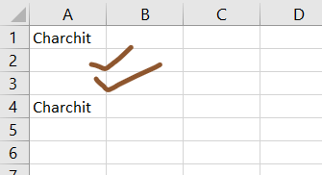

If you set a row height or column width to 0 (zero), what happens to the row and

column?

Solution : Excel will hide that row or column

Example of a column with 0 width is given below, which then become hidden. Below ‘D’ got hidden



1. Is there a need to change the height and width in a cell? Why?

Solution : Yes, definitely. We need to change height and width, whenever length of the data is more and its not visible properly. So, we can change dimensions of elements.

1. What is the keyboard shortcut to unhide rows?

Solution : CTRL + SHIFT + (

1. How to hide rows containing blank cells?

Solution : To hide rows, follow below steps

Step 1 : First activate Developer tool, by clicking on File -> Option -> Tick on Developer Option -> Click OK

Step 2 : In, the below example, first we will use if condition to see if row is empty or not

Step 3 : We will use visual basic option under developers tool

Step 4 : Here, we will code which check of cell is empty or not. If, cell is empty it will hide cell

Step 5 : Now, insert Button on column by selecting, Developer tool -> Insert -> select button

Step 6 : Right click on button -> click on select macro -> select module which we created

Step 7 : Simply click on button and it will automatically hide rows with empty cell

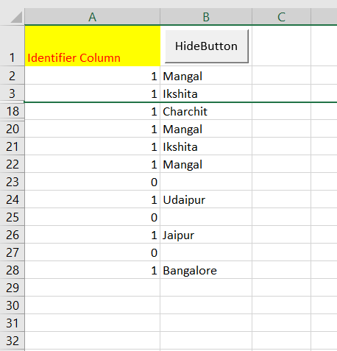

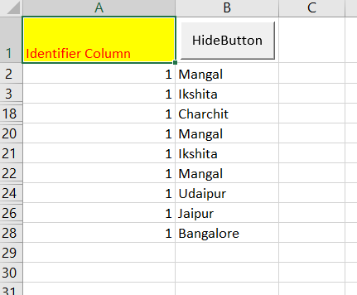

1. What are the steps to hide the duplicate values using conditional formatting in

excel?

Solution : In, below example there are two duplicate values



We will use conditional formatting

Follow below steps

Step 1 : Select table

Step 2 : From, Home tab go on conditional formatting & choose new rule

Step 3 : Then select, Format only unique or duplicate values

Step 4 : Select Format & change font Color to 0

