

AGGIE S.O.O.P

Requirements Analysis Documents (RAD)

COMP 496 – Spring 2016

Version Number: 1.0

Version Date: 02/03/2016

Group Name: AGGIE SOOP

Team Members: Michael Page

Paul Hammond

Dylan J. Gunn

Faculty Advisor: Kelvin Bryant

**TABLE OF CONTENTS**

**1 INTRODUCTION……………………………………**

* 1. **Purpose of a Requirements Analysis**
  2. **Audience……………………………………………………**

**2 CURRENT SYSTEM……………………………………**

**1 INTRODUCTION**

* 1. **PURPOSE OF A REQUIREMENTS ANALYSIS**

A requirements analysis document (RAD) encompasses activities conducted to determine the needs or conditions for a new or altered product. It commonly takes place after a request is received. It is the process of gathering information about business and technical requirements supporting a request, consolidating this information into a cohesive document, and assisting stakeholders in prioritizing these needs and conditions. A RAD is critical to the success of a project and can serve as a contractual basis between a customer and a vendor. Requirements must be documented, actionable, measurable, testable, related to identified business needs or opportunities, and defined to a level of detail sufficient for the design of a project.

The requirements management plan, a separate document, is used to document the necessary information required to effectively manage project requirements from definition, through traceability, to delivery and represents a subsequent document to the RAD.

* 1. **AUDIENCE**

The audience for this RAD in client and the advisors of the project.

1. **CURRENT SYSTEM**

As of now there isn’t a current system in place as this is a new project that is being developed.

1. **PROPOSED SYSTEM**
   1. **OVERVIEW**

AGGIE SOOP will be a web-based application that would allow students of the university to search and view available open campus jobs posted by the faculty, staff, and departments. This is separate from Financial Aid’s work-study program and the office of career services system. All current students should be able to find posted jobs and submit simple applications that are verified by the system to make sure the applicant meets the requirements for the job (i.e. a sophomore shouldn’t be able to apply to a position requiring graduate student classification.)

* 1. **FUNCTIONAL REQUIREMENTS**
     1. Professor/Student should be able to register as a new user and store their credentials into the system.
     2. Professor/Student should be able to login with their respective credentials (e-mail: @ncat.edu for professors or @aggies.ncat.edu for students and password).
     3. The professor, once logged in, should be able to create new jobs available for the student to apply to.
     4. The professor should be able to review the pool of applicants that applied for the job.
     5. The student should be able to search for any jobs that are automatically matched to his/her profile.
     6. The student should be able to search for any job that doesn’t match his/her profile.
     7. Professor/Student should be able to edit their profile.
     8. The system will be automatically show all jobs matched to the students profile on the students landing page (the page that shows up once the student is logged in).
     9. The system will send e-mail notifications to the professor if a student has recently applied to their job posting with his/her full name, classification, major, and G.P.A.
  2. **NONFUNCTIONAL REQUIREMENTS**
     1. **USABILITY**
* Web application should display all information about the student when the professor reviews them.
* Professor/Student should have a default photo posted unless they have their own photo they wish to upload.
* “About” and “Help” information about the web application must be able to be seen at any point during the session in which the person is logged in.
* Web application must display its’ affiliation with its’ respective university.
  + 1. **RELIABILITY**
* Components of the project code will be tested alongside the implementation phase to ensure that they are functional.
* The application will be coded and test procedural style to test each part of the application block by block.
* Final, integrated project code will be tested via node.js or via the server provided by the advisor to ensure that greater than or equal to 80% of the integrated code is covered at run-time, and is functioning. The remaining 20% will be inspected through manual testing to ensure the highest chance of being quality code.
  + 1. **PERFORMANCE**
* Navigation between pages must be smooth in transition.
* All photos’ and information must display in full and not in its’ alternate form.
* Search engine will display accurate information when searching for available jobs.
  + 1. **SUPPORTABILITY**
* The web application must not be browser dependent, i.e., it should be able to run on any browser supporting javascript, java, etc.
  + 1. **IMPLEMENTATION**
* Project will be implemented in HTML, JavaScript, Angular.JS, Node.JS, MySQL, and CSS.
  1. **SYSTEM MODELS**
     1. **USE CASE MODEL**

|  |  |
| --- | --- |
| **Name:** | RegisterNewUser |
| **Actor:** | Professor/Student |
| **Entry**  **Conditions:** | Web Application is running.  Professor/Student doesn’t have a registered account. |
| **Flow of**  **Events:** | 1. Professor/Student register function.  2. SYSTEM presents Professor/Student with AccountRegistrationForm  3. Professor/Student submits AccountRegistrationForm |
| **Exit**  **Conditions:** | WebApplication is now in a new state. |

* + 1. **COMPREHENSIVE SKETCHES**

**3.4.2.1 HOME PAGE**

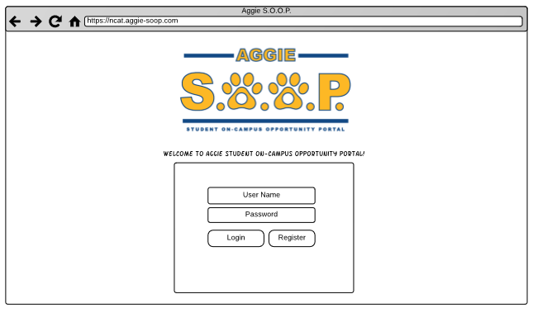

**3.4.2.2 LANDING PAGE**

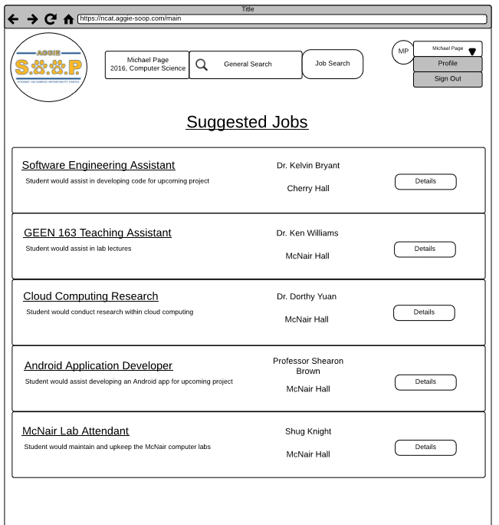

**3.4.2.3 ACCOUNT REGISTRATION PAGE**

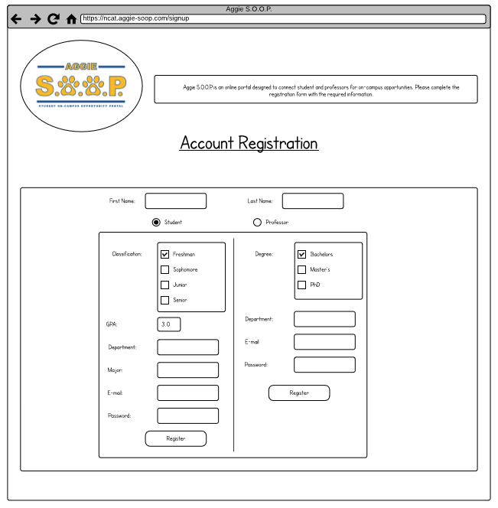

**3.4.2.4 PROFILE PAGE**

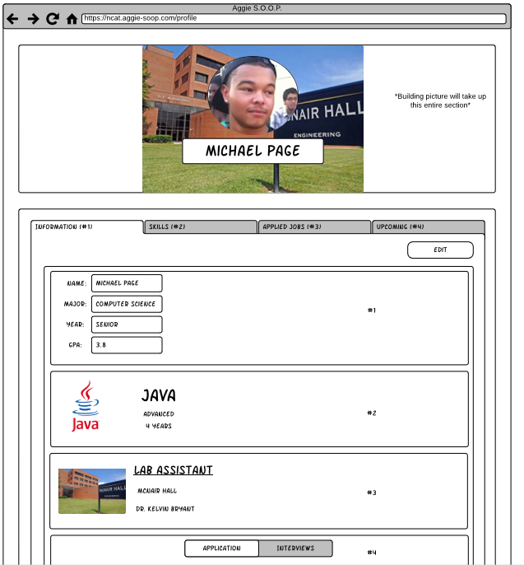

1. **GLOSSARY**

***Comprehensive Sketch*:** The page layout of a proposed design as initially presented by the designer to the client, showing the relative positions of text and illustrations before the final content of those elements has been decided upon.

***Non Functional Requirement*:** A software requirement that describes not what the software will do but how the software will do it.

***Advisor*:** A person who gives advice, typically someone who is expert in a particular field.

***Client*:** The person who has bought the services to have the project constructed.

**Appendix A: Requirements Analysis Approval**

The undersigned acknowledge that they have reviewed this requirements analysis document and agree with its information. Changes to this version will be coordinated with, and approved by, the undersigned, or their designated representatives.

|  |  |  |  |
| --- | --- | --- | --- |
| Signature: |  | Date: |  |
| Print Name: |  |  |  |
| Title: |  |  |  |
| Role: |  |  |  |

|  |  |  |  |
| --- | --- | --- | --- |
| Signature: |  | Date: |  |
| Print Name: |  |  |  |
| Title: |  |  |  |
| Role: |  |  |  |

|  |  |  |  |
| --- | --- | --- | --- |
| Signature: |  | Date: |  |
| Print Name: |  |  |  |
| Title: |  |  |  |
| Role: |  |  |  |