FULL ASS GUIDE FOR RUBX CUBE ALARM

**Python script using imageSnap to collect training data:**

import os

import subprocess

import random

while (True):

#check input of user

value = input("Type U for unsolved, S for solved, T for tests, E for escape\n")

rand = random.randint(1,10000)

if value == "U" or value == "u":

print("U!")

name = "imagesnap unsolved" + str(rand) + ".jpg -d \"USB Camera #3\""

os.system(name)

print("done!")

elif value == "S" or value == "s":

print("S!")

name = "imagesnap solved" + str(rand) +".jpg -d \"USB Camera #3\""

os.system(name)

print("done!")

elif value == "T" or value == "t":

print("T!")

name = "imagesnap test" + str(rand) + ".jpg -d \"USB Camera #3\""

os.system(name)

print("done!")

elif value == "B" or value == "b":

print("B!")

name = "imagesnap background" + rand + ".jpg -d \"USB Camera #3\""

os.system(name)

print("done!")

elif value == "E" or value == "e":

break

print("bye!")

else:

print("nope")

Next steps:

Instead of creating a network from scratch, I’m going to be re-working the one created and used in Tensorflow-for-poets-2

https://github.com/tensorflow/hub/raw/master/examples/image_retraining/retrain.py

We’re going to run this code:

python -m scripts.retrain \ --bottleneck_dir=tf_files/bottlenecks \ --model_dir=tf_files/models/"${ARCHITECTURE}" \ --summaries_dir=tf_files/training_summaries/"${ARCHITECTURE}" \ --output_graph=tf_files/retrained_graph.pb \ --output_labels=tf_files/retrained_labels.txt \ --image_dir=tf_files/flower_photos

|  |  |
| --- | --- |
| python -m scripts.retrain | Calling command -m – module name  Executes as a script |
| --bottleneck_dir=tf_files/bottlenecks | Stores final bottleneck values in directory |
| --summaries_dir=tf_files/training_summaries/"${ARCHITECTURE}" \ --output_graph=tf_files/retrained_graph.pb \ --output_labels=tf_files/retrained_labels.txt \ | direct to the different directories of the scripts |
| --image_dir=tf_files/flower_photos | Image directory (which folder to train from) |

Python retrain.py --image_dir ~/Documents/RubixCubeAlarm/images –image_dir --summaries_dir=tf_files/training_summaries/"${ARCHITECTURE}" \ --output_graph=tf_files/retrained_graph.pb \ --output_labels=tf_files/retrained_labels.txt \ -- --saved_model_dir = tf_files

imageSnap -l to see what the device is listed as

tensorboard --logdir /tmp/retrain_logs

tensorboard --logdir /tmp/test

So in order to visualize, save, etc the trainig model, we have to output the summaries to a specific location which we will then direct TensorBoard to

Commands: --summaries_dir and –logdir

This is the line in the code that uses that:

*# Merge all the summaries and write them out to the summaries_dir*

*merged = tf.summary.merge_all()*

*train_writer = tf.summary.FileWriter(FLAGS.summaries_dir + '/train',*

*sess.graph)*

*validation_writer = tf.summary.FileWriter(*

*FLAGS.summaries_dir + '/validation')*

|  |  |
| --- | --- |
| Training data | Python retrain.py --image_dir ~/Documents/RubixCubeAlarm/images --summaries_dir=/tmp/test/6 \ --output_graph=/tmp/test/6 \ --saved_model_dir=/tmp/test/6 --how_many_training_steps=100 -- |
| Visualizing data with tensorboard | tensorboard --logdir /tmp/test/1 |

Python retrain.py --image_dir ~/Documents/RubixCubeAlarm/images --summaries_dir= tmp/training_summaries/"${ARCHITECTURE}" \ --output_graph=tf_files/retrained_graph.pb \ --output_labels=tf_files/retrained_labels.txt \ -- --saved_model_dir = tf_files

tensorboard --logdir /tf_files3/training_summaries

tensorboard --logdir /tmp/test

Python retrain.py --image_dir ~/Documents/RubixCubeAlarm/images --summaries_dir=/tmp/test/2 \ --output_graph=/tmp/test/2 \ --saved_model_dir=/tmp/test/2 --how_many_training_steps=75

Python retrain.py --image_dir ~/Documents/RubixCubeAlarm/images --summaries_dir=/tmp/test/3 \ --output_graph=/tmp/test/3 --how_many_training_steps=50

|  |
| --- |
| python label_image.py --graph=/tmp/output_graph.pb --labels=/tmp/output_labels.txt --input_layer=Placeholder --output_layer=final_result --image=$HOME/Documents/RubixCubeAlarm/images/test.jpg |

**UPGRADED CODE TO retrain_upgraded.py and label_image_upgraded.py

Test 6: 2000 steps

Python retrain.py --image_dir ~/Documents/RubixCubeAlarm/images --summaries_dir=/tmp/test/6 \ --output_graph=/tmp/test/6/output_graph.pb \ --how_many_training_steps=2000 --output_labels=/tmp/test/6/output_labels.txt

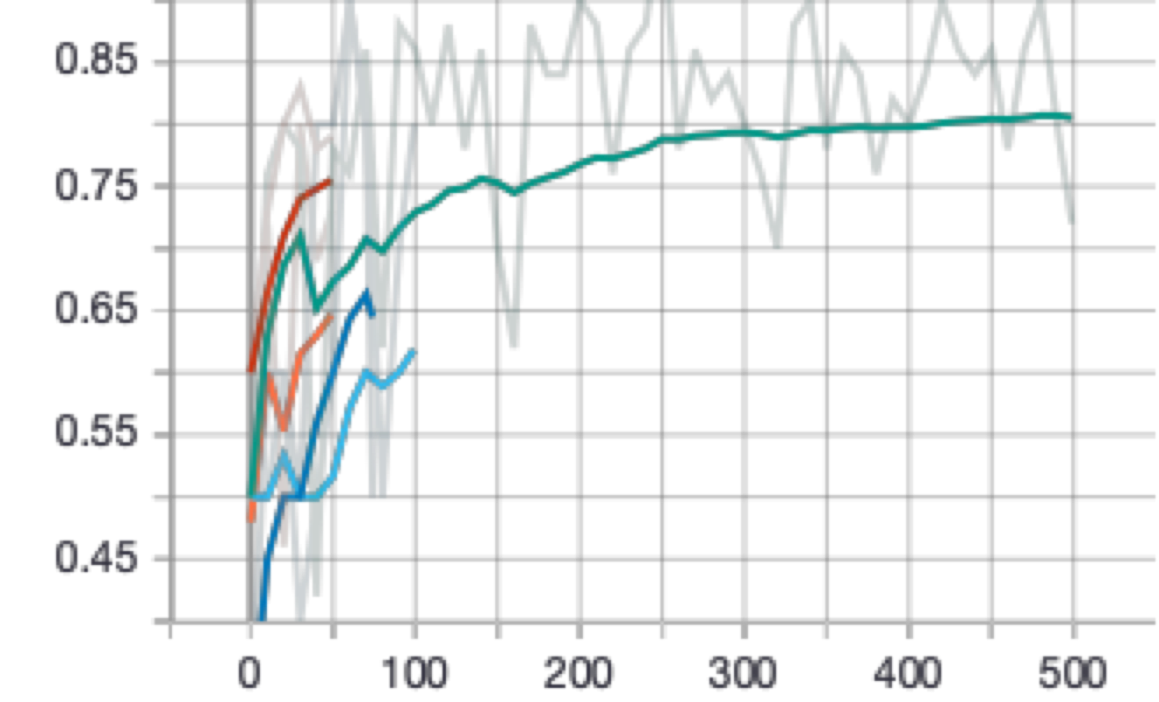 Green: Validation maxes out at 0.8

python label_image_upgraded.py --graph=/tmp/test/6/output_graph.pb --image=$HOME/Documents/RubixCubeAlarm/images/test.jpg --labels=/tmp/test/6/output_labels.txt

Test 7: trying to save graph to tmp/test/6

Python retrain_upgraded.py --image_dir ~/Documents/RubixCubeAlarm/images --summaries_dir=/tmp/test/6 --output_graph=/tmp/test/6/output_graph.pb --how_many_training_steps=100 --output_labels=/tmp/test/6/output_labels.txt

TODO: Add brightness adjustments

--random_brightness=20

--how_many_training_steps=1000

SAVING TO TF_FILES TEST: **WORKING**

Python retrain_upgraded.py --image_dir ~/Documents/RubixCubeAlarm/images --how_many_training_steps=100 --model_dir=tf_files --output_labels=tf_files/output_labels.txt --summaries_dir=tf_files/retrain_logs --output_graph=tf_files/output_graph.pb

python label_image_upgraded.py --graph=tf_files/output_graph.pb --labels=/tmp/output_labels.txt --image=$HOME/Documents/RubixCubeAlarm/images/test.jpg

This included just 100 steps, so I am interested if running longer will give better prediction

Also will be adding on --random_brightness=20.

I’ll be saving this to tf_files/2

Python retrain_upgraded.py --image_dir ~/Documents/RubixCubeAlarm/images --how_many_training_steps=100 --model_dir=tf_files/7 --output_labels=tf_files/7/output_labels.txt --summaries_dir=tf_files/7/retrain_logs --output_graph=tf_files/7/output_graph.pb --print_misclassified_test_images True --random_brightness=10

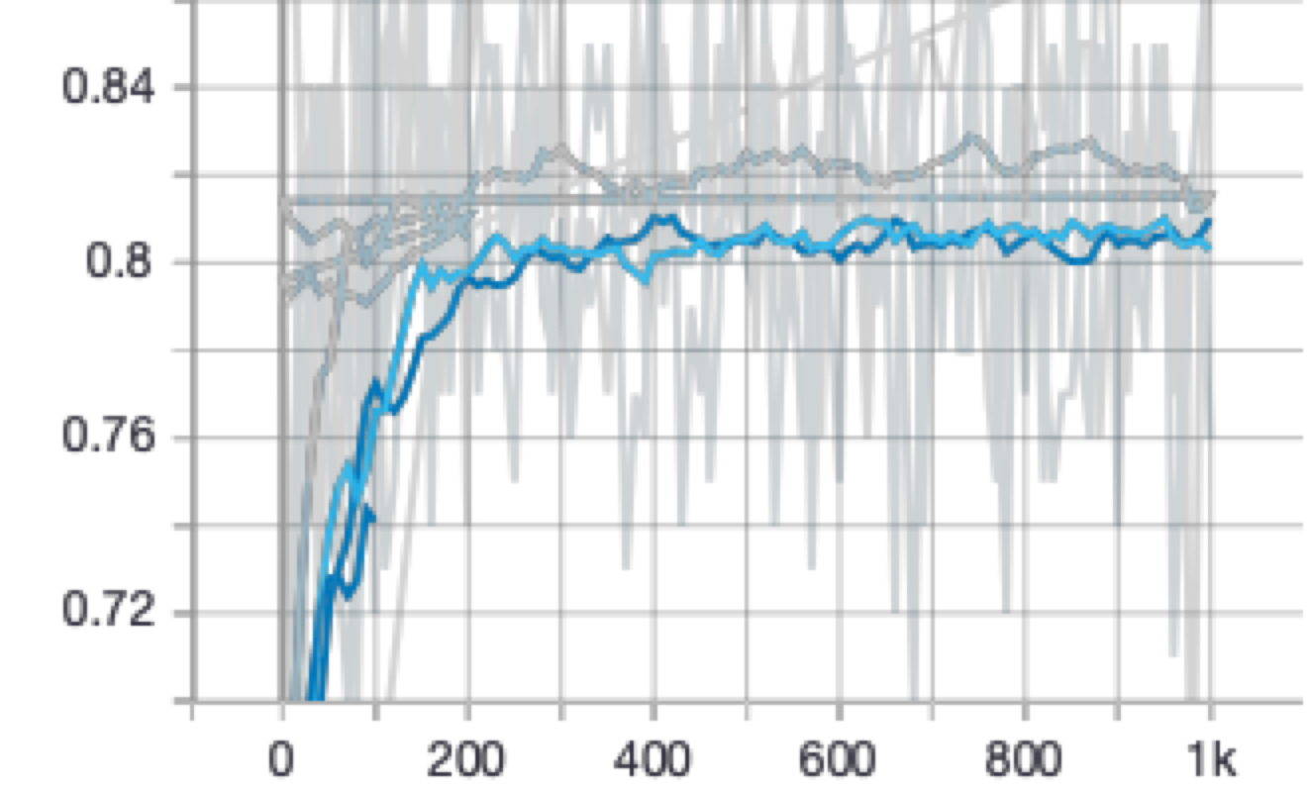Currently the validation is getting stuck at 0.8 ish.

Tried increasing the depth, but no effect

Currently just trying to get Tensorboard to display the images…

Okay t

This code to the left at least gets the image summary included. Hot dang

Switching architecture to mobile net:

Testing on flowers!!!

Python retrain_upgraded.py --image_dir ~/Documents/RubixCubeAlarm/flower_photos --how_many_training_steps=100 --model_dir=tf_files/8 --output_labels=tf_files/8/output_labels.txt --summaries_dir=tf_files/8/retrain_logs --output_graph=tf_files/8/output_graph.pb --print_misclassified_test_images True --architecture mobilenet_1.0_224

Success!!

Working on runner.py:

python label_image_upgraded.py --image=$HOME/Documents/RubixCubeAlarm/tensorflow-for-poets-2/scripts/test.jpg --graph=tf_files/6/output_graph.pb --labels=tf_files/6/output_labels.txt