"IAS Client Satisfaction Evaluation and Management System”
(IAS-CSEMS)

INTRODUCTION:
The IAS Client Satisfaction Evaluation and Management System (IAS-CSEMS) aims to revolutionize the way client feedback is gathered, managed, and analyzed within the IAS office. In today’s fast-paced and data-driven environment, understanding client satisfaction is crucial for improving services and addressing concerns effectively. However, traditional methods of gathering and managing feedback can be time-consuming, inefficient, and prone to errors.
This project proposes the development of a web-based system designed to streamline client satisfaction evaluations by offering a seamless platform for online survey submissions, real-time data access, and comprehensive reporting. By integrating secure data storage and user-friendly features, IAS-CSEMS will empower the IAS office to make data-informed decisions that improve service quality and overall client experience.
With its focus on accessibility, security, and analytics, IAS-CSEMS is positioned to become a vital tool for modernizing the IAS office's client satisfaction processes. This system not only addresses the challenges of traditional feedback mechanisms but also aligns with the growing demand for digital transformation in organizational operations.

General Objective:
To develop a web-based system for the IAS office to gather client satisfaction feedback, streamline evaluation processes, and provide efficient survey result management for administrators.
Specific Objectives:
1. To allow users to fill out survey forms online for client satisfaction evaluation.
2. To provide administrators with real-time access to survey results and analytics.
3. To ensure that survey responses are securely stored and easily retrievable.
4. To improve decision-making processes through detailed reporting of survey data.
5. To create a user-friendly interface for both users and administrators to enhance accessibility.

Data Flow Diagram

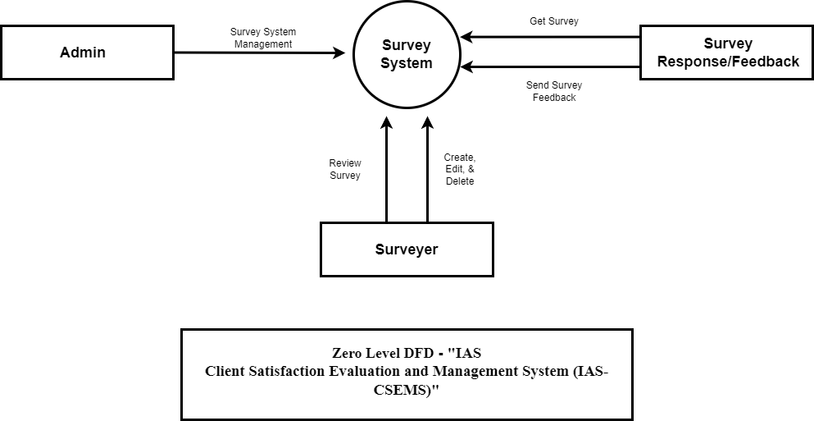

ERD & DATA DICTIONARY
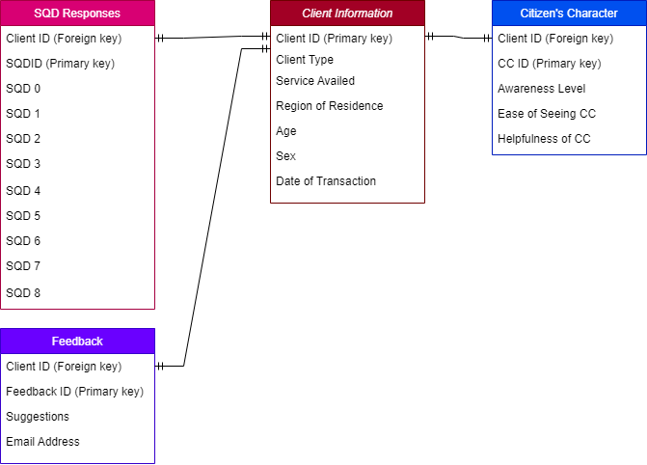

Prepared By:
Richard Victor Miculob
Mark Lester Elago
Joshua Abing
Rick Caseres

