Charles Durfee

Final Project

CS3550 Adv database SUM 18

1. As a first step I reviewed the data and the relationships between the data. I also clarified to make sure I understood the data.
2. The next step was to create a database and tables that match the existing data and the additional tables that will be needed in the future for inventory tracking. The table naming was standardized to camel-case to help with future development. Note: Id fields were added to Users and Vendors. All tables have primary keys to help with performance (clustering).
3. At this point I imported the data from the csv files to the database using a Bulk Insert command and checked to make sure the data was consistent.
4. Next I added the relationships to the tables. Please see the diagram below:

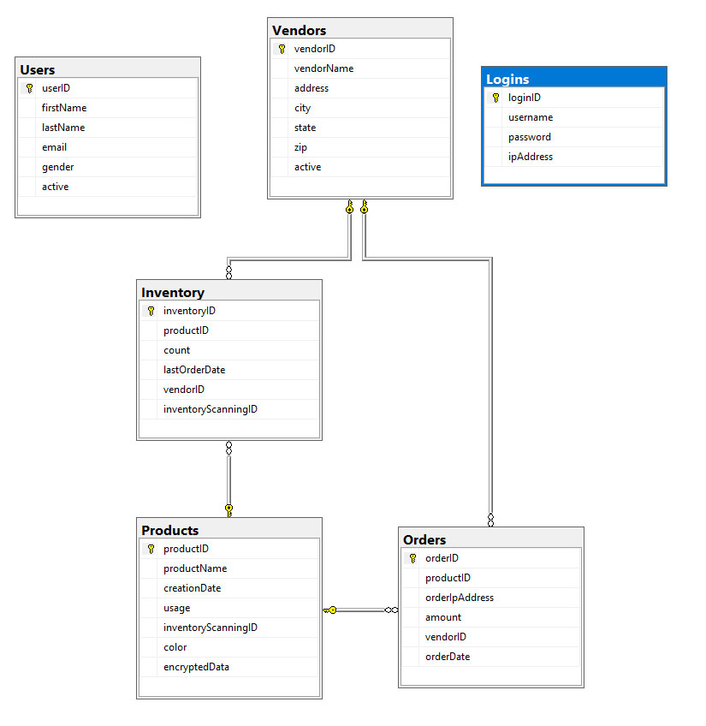

1. Created a trigger when a vendor is added, along with a vendorAudit table so that you can view the triggers easily. (see attachments)
2. Created a view that lists all our products and the last time it was ordered (see attachments)
3. Created a view that lists the top 3 orders (see attachments)
4. Created a view that displays the orders from the past 90 days (see attachments)
5. Created a stored procedure to list all the orders for a particular vendor (see attachments)
6. Created a stored procedure to insert new products (see attachments)
7. Created a stored procedure to insert new vendors (see attachments)
8. Created a stored procedure to update inventory (see attachments)
9. Created a stored procedure to dynamically search products (see attachments)
10. Created a function to return the last products order by a vendor (see attachments)
11. Created a function to convert DATETIME to DATE (see attachments)
12. The last step was to encrypt the username and password columns of the Logins table for security. The master-key, certificate and private key are also included in the attachments so that the information can be decrypted.