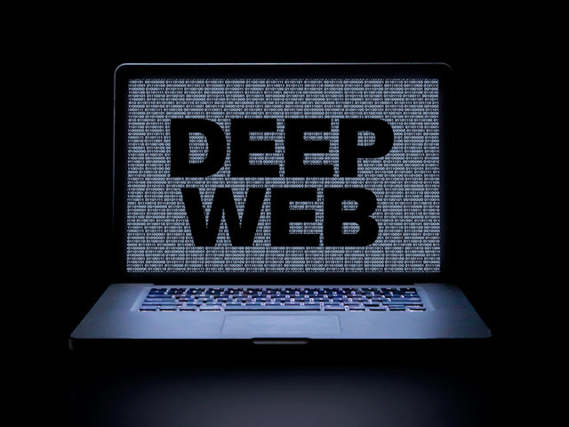

**Name: Baluyut, Richard L. Professor: Joemen Barrios**

**Course/Year/Section: BSCS 3-A Date: March 6, 2017**

As we all know, Deep Web is not easy to access. Jill Ellsworth used the term Invisible Web in 1994. Deep Web is to refer websites that were not registered with any search engine. The first use of the specific term Deep Web, no generally accepted. You cannot use simple search engine to enter to Deep Web. You must use special software to search in Deep Web, example of this is TOR (The Onion Router). TOR is an anonymous browsing client, which allows the user to browse the internet anonymously. Some websites in Deep Web can access in TOR. There is more software that can access in Deep Web not only TOR. Deep Web is a place where you can see everything even good or bad. You can use Deep Web to expand knowledge because there are websites that you can’t see in simple search engine like Google, etc. but you can do it in Deep Web, for example website is “Hidden Wiki” it will only available using TOR it can’t be seen in normal search engine. Hidden Wiki it contains articles, and links to other deep web sites. Deep Web is a storage of all. Deep web can contain information that is confidential like bank accounts. Deep web contains also a Child pornography. Deep Web it is hard to keep track. The Deep web is estimated to be 500X the size of the surface web. 96% of WWW content of Deep web and 4% of WWW content of Surface Web. Inside the deep web you can search databases, Download spreadsheets files, image and Multimedia files, various file formats such as .pdf, lots of Government information. I don’t want to access deep web because if you accidentally dive deep in Deep Web you can lose your personal data. Many hackers live in deep web there are professional’s hackers. There are hackers called White & Black Hat. White hat hackers are an allies. For example, if a black hat hacks a government files. Government calls a white hat to hack also, but hack in different way, it will hack the hacker to recover the files. On the other hand, the Black hat hacker’s, Black hat is like an enemy of all. They can hack your personal data’s, Government information, Bank accounts, etc... Deep web is not a safe place to others.