Athanase Industrial Partners
Fund II — Quarterly Report
Q1 2026 · As of 31 March 2026
Reconstructed, editorially corrected Word version of the original Publisher report. Narrative text reflects the grammar, spelling and academic-rigour corrections; figures and tables are reproduced from the source. Items flagged for verification are listed at the end.
Fund overview
Athanase Industrial Partners is a global equity investor with a 20-year track record. Our long-term, value-oriented strategy aligns our interests with those of our investors by focusing on companies with stable earnings, low leverage and predictable cash flows. We avoid speculative investments and enhance financial health through active ownership. Our record of improving company fundamentals underpins a disciplined focus on stable, long-term returns.
Performance (%)
 | ITD¹ | Downside risk | YTD | Q1-26 | Q4-25 | Q3-25 | Q2-25
AIP Fund II¹ | 414.3 | 8.7 | (5.0) | (5.0) | (5.1) | 0.5 | 7.4
MSCI World IMI | 225.8 | 9.0 | 0.2 | 0.2 | 1.0 | 6.0 | 5.8
DJ Stoxx 600 GRt | 148.0 | 8.6 | 0.5 | 0.5 | 4.3 | 2.2 | 6.5
Notes: 1) Inception 23 Feb 2015; share class E (1.75% management fee and 20% incentive fee). Source: StatPro. Indices are currency-adjusted where applicable and calculated with reinvested dividends.
Contributions, Q1 2026 (%)
Top 5 and bottom 5 investment contributors during the period 31 December 2025 – 31 March 2026.
Top contributors  LunR Royalties 1.2  Zalaris 0.3  Celina 0.0  Distit Bond 0.0 | Bottom contributors  Somero (1.9)  Röko (1.3)  Athanase Innovation (0.9)  Auto Trader Group (0.7)  Rightmove (0.6)
Risk exposures (%)
Metric | Value | Metric | Value
Downside risk | 8.7 | # Positions | 17
VaR (1d; 95%) | 1.5 | Cash | 6.9
Gross exposure | 85.3 | Net exposure | 85.3
Liquidity profile (% NAV)
Horizon | % NAV | Horizon | % NAV
1 day or less | 22.5 | 91 – 180 days | 7.5
2 – 7 days | 15.5 | 181 – 365 days | 2.4
8 – 30 days | 4.5 | More than 365 days | 29.2
31 – 90 days | 11.7
The Fund currently holds 17 positions in total, of which the ten largest represent 84.2% of NAV. XX% of the Fund’s assets can be liquidated within 90 days, and the estimated haircut required to liquidate the entire portfolio is XX% under normal market conditions. (XX placeholders unfilled in the source.)

Performance and portfolio commentary
Global equity markets weakened during the first quarter of 2026, with leadership shifting away from the large-cap U.S. growth stocks that had dominated the prior year. The S&P 500 declined 4.3% over the quarter, while the Nasdaq 100 fell 5.8%, reflecting pressure on richly valued technology and AI-related growth stocks. In contrast, smaller companies proved more resilient, with the Russell 2000 gaining approximately 0.9% and the equal-weighted S&P 500 rising 0.7%, indicating a meaningful broadening of participation beneath the headline indices despite headline weakness.
At the sector level within the S&P 500, the quarter was marked by a sharp rotation away from high-multiple growth and software stocks. Software companies came under significant pressure as investors grew increasingly concerned that artificial intelligence could disrupt parts of the enterprise software market. Hardware, semiconductors and AI-infrastructure areas were more resilient, supported by continued demand for chips, memory, data-centre equipment and connectivity.
Equity markets outside the U.S. also weakened but generally outperformed U.S. large-cap equities. The MSCI ACWI ex U.S. declined approximately 0.7%, while developed international markets, as measured by MSCI EAFE, fell around 1.2%. Emerging markets were broadly flat to slightly negative, with MSCI Emerging Markets down roughly 0.2%, outperforming the S&P 500 as commodity exposure and parts of Asia helped offset broader risk aversion.
In the Nordic region, performance was mixed. Swedish equities were volatile but ended the quarter modestly higher, with the OMXS30 supported by strong gains in January and February before a sharp decline in March. Danish equities lagged materially, with the OMX Copenhagen 25 falling during February and March after a positive January, reflecting continued pressure from the heavy healthcare weighting. Finnish equities remained relatively resilient, helped by industrial and financial exposure.
Fixed-income markets were broadly flat during the quarter. The Federal Reserve paused its easing cycle and kept the federal funds target range unchanged at 3.50%–3.75% at the March meeting, emphasising that policy was not on a preset course and that future decisions would depend on inflation, labour-market data and broader risks. U.S. Treasury yields rose modestly over the quarter, with the 10-year yield up around 15 basis points, as stronger growth, fiscal concerns and still-elevated inflation limited the benefit from expected future rate cuts.
Norvestor, a Norwegian private equity firm, made a cash offer for Zalaris in mid-March. Norvestor values the company at NOK 100 per share. The shares rose 37% relative to the previous day’s close. We have tendered our shares, as we consider the price to be fair.
Röko’s shares continued to decline in the first quarter of the year but have rebounded after quarter-end as both organic growth and the pace of capital deployment have accelerated.
In general, we find it difficult to identify value in the broader equity markets, and we are holding a meaningful cash position in the portfolio. We are actively looking for investments in markets such as the UK and Japan, where we see greater value.

Doing what we say — Q1 2026 in practice
Each standing claim in our investment- and risk-process is mapped below to what we actually did this quarter. The supporting detail sits in the holdings and tables that follow — so our claims can be checked against our actions.
Investment process
What we say (standing claim) | What we did (Q1 2026)
Selective; we won’t force deployment. | Held ~6.9% cash and flagged difficulty finding value; we are sourcing in the UK and Japan rather than chase an expensive market.
Buy quality at a discount. | Core holdings are dominant franchises bought on value — Auto Trader (~10× its nearest rival), Rightmove (~80% of portal time), Somero (~80% global share) at a cyclical low, TBK on ~2× normalised earnings.
Agreement before capital; determined, not forced, sellers. | Tendered Zalaris into Norvestor’s NOK 100 cash offer (+37% on the day) — sold on a fair-value trigger, on the facts, not sentiment.
We create the value from the boardroom. | Tempest: progressing a Lex Asea spin-off and a buyback / redemption of cash. TBK: pursuing the operational plan to lift margins toward 10%.
Returns from earnings, not re-rating. | Operating profit grew across the book — Röko EBITA +5% (SEK 415m), Tempest operating result up (sales +11%), TBK EBIT JPY 1.50bn (from 0.94bn).
Low cadence, high conviction. | 17 positions, the ten largest ~84% of NAV; no new platform forced in a quarter we judged expensive.
Risk process
What we say (standing claim) | What we did (Q1 2026)
No leverage at the fund. | Gross exposure 85.3% = net exposure 85.3% — zero fund-level leverage, with ~6.9% cash.
Sized and measured so no mark dominates. | 17 positions; downside risk 8.7%, 1-day 95% VaR 1.5%; a full liquidity profile disclosed (22.5% of NAV within one day).
Diversification across exposures. | Spread across Nordic, UK and Japanese listings and across software, industrials, gaming, media and resources.
Mechanised discipline, not emotion. | Acted on the Zalaris fair-value trigger; held cash rather than relax the valuation bar in a market we find expensive.
Quality cores; avoid permanent loss. | Concentrated in durable market leaders; speculative exposure is limited and disclosed (e.g. NGEx held as exploration optionality).
Independent checks and full disclosure. | Performance sourced from StatPro; figures reconciled, with open items (liquidity placeholders, unit flags) listed explicitly for verification.
Standing claims are drawn from our process and risk attestation; the actions above are evidenced in the holdings and tables of this report.
Monthly returns (%)
Year | Jan | Feb | Mar | Apr | May | Jun | Jul | Aug | Sep | Oct | Nov | Dec | YTD | MSCI
2006 | 5.8 | 4.5 | 0.9 | 6.0 | 2.2 | (5.6) | 2.3 | 5.4 | 9.3 | 8.5 | 11.1 | 0.3 | 62.5 | 18.9
2007 | 3.3 | 0.3 | 4.2 | 4.0 | 1.7 | (3.9) | (2.0) | (2.4) | (4.9) | (2.4) | (4.7) | (1.0) | (8.1) | 9.2
2008 | (10.9) | 7.2 | (0.3) | (4.7) | 2.1 | (17.9) | 0.8 | 3.8 | (13.9) | (12.7) | (0.4) | (1.5) | (41.4) | (43.6)
2009 | 0.5 | 2.2 | 3.1 | 21.7 | 6.4 | (1.2) | 8.3 | 8.7 | 3.6 | 4.8 | 2.8 | 2.3 | 82.1 | 33.3
2010 | 2.0 | (2.0) | 7.2 | 9.5 | (8.6) | (2.6) | 7.4 | (5.5) | 13.3 | (0.8) | 1.0 | 6.8 | 28.3 | 12.1
2011 | (2.0) | (1.2) | 5.5 | (0.3) | (2.4) | (4.2) | (3.2) | (4.2) | (4.0) | 5.2 | (3.7) | 14.2 | (2.0) | (9.9)
2012 | 5.9 | 11.2 | (5.1) | (0.8) | (6.7) | (1.8) | (2.8) | 2.1 | 4.0 | (3.4) | 1.9 | 1.7 | 5.0 | 13.8
2013 | 7.6 | 6.4 | 1.5 | (4.3) | 5.4 | (3.1) | 8.3 | (0.4) | 5.2 | 3.7 | 2.4 | 0.5 | 37.6 | 21.1
2014 | 6.5 | 7.4 | 0.6 | 2.2 | 1.6 | 1.0 | - | - | - | - | - | - | 20.7 | 5.0
2015 | - | 0.3 | 2.2 | 1.5 | 2.3 | (2.8) | 1.7 | (3.1) | (0.6) | 0.8 | 5.0 | 2.0 | 9.3 | (2.5)
2016 | (4.8) | 1.3 | 0.2 | 4.4 | 2.7 | (2.5) | 3.2 | 7.5 | 3.1 | 1.1 | 4.2 | 4.1 | 26.6 | 6.2
2017 | 5.4 | 4.5 | 0.5 | 8.5 | (3.1) | (1.0) | (0.9) | (3.9) | 2.2 | (3.7) | (0.6) | (2.7) | 4.4 | 21.7
2018 | 4.5 | (0.1) | (1.6) | 1.0 | 3.7 | (0.5) | 0.4 | (0.8) | (1.9) | (3.8) | (6.0) | (7.7) | (12.8) | (11.1)
2019 | 5.8 | 1.4 | (3.9) | 4.9 | (7.5) | 0.2 | (5.3) | (9.7) | 1.7 | (0.1) | 4.8 | 3.2 | (5.9) | 23.9
2020 | 0.6 | (8.4) | (18.5) | 11.9 | (0.2) | 3.0 | 3.0 | 10.0 | 2.6 | (5.9) | 12.6 | 9.7 | 16.9 | 14.4
2021 | 4.8 | 87.5 | 2.8 | 1.8 | (0.4) | 0.4 | (0.4) | 1.0 | 26.2 | 10.7 | 2.4 | 1.5 | 200.5 | 16.5
2022 | (1.2) | (1.7) | 0.5 | (2.9) | (0.7) | (3.9) | 0.4 | (3.6) | (5.3) | 6.3 | 14.4 | (0.6) | 0.3 | (19.8)
2023 | 0.0 | (6.5) | (7.0) | 4.9 | (0.2) | 6.4 | 5.2 | (2.1) | (1.7) | (3.3) | 1.2 | 3.6 | (0.5) | 19.5
2024 | 2.5 | 2.7 | 5.1 | 1.2 | 1.6 | (0.8) | 6.0 | (1.4) | 0.2 | (0.1) | 5.3 | 0.5 | 25.0 | 28.8
2025 | 3.5 | (0.1) | (1.8) | (1.4) | 7.0 | 1.8 | 2.5 | (1.5) | (0.5) | (3.0) | (0.8) | (1.4) | 4.1 | 0.9
2026 | (2.2) | (0.4) | (2.4) |  |  |  |  |  |  |  |  |  | (5.0) | 0.2
Auto-extracted from the source performance grid; please cross-check the current-year (2026) trailing cells, where unreported months may shift alignment.

Portfolio holdings
Tempest Security
Company description
Tempest Security offers high-quality security and surveillance services in the Nordic countries.
Key facts
Market capitalisation | SEK 278m
Enterprise value | SEK 45m
AIP ownership | 5%
% of portfolio | 4%
Board representation | Since 2020
Our view
The board is investigating the conditions for a future corporate structure, and part of this investigation concerns the possibility of distributing subsidiaries tax-free via Lex Asea. The company will obtain the Swedish Tax Agency’s position on whether such a distribution is possible. After the spin-off, the board will evaluate the use of the cash, which could be distributed through a further share-buyback programme or a redemption.
An actual and perceived increase in societal tension and crime, combined with fewer police resources, is driving demand for private security services. Tempest is one of the larger providers in Sweden and has a strong reputation. There are opportunities to improve profitability both through cost savings — as the company has refocused on its core markets — and through expansion in areas where the company has operational leverage, such as the security operations centre.
Recent events, Q1 2026
- Net sales increased by 11% to SEK 146m, driven by growth in the core business.
- The operating result for Q1 improved to SEK 1.9m.
- Operating cash flow was strongly positive at SEK 4.6m.
Share price & traded volume (3-year)
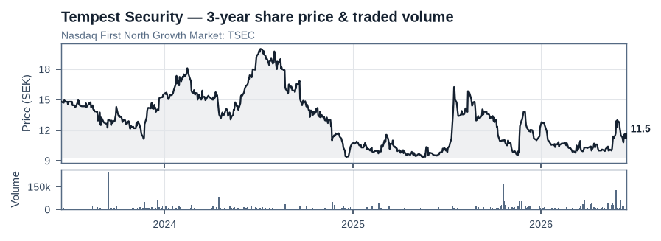
Source: exchange daily price history, 3-year series to 15 June 2026. Nasdaq First North Growth Market: TSEC.

Athanase Innovation (incl. Ivisys)
Company description
Athanase Innovation AB is an investor in private and public technology and innovation companies.
Key facts
Market capitalisation | SEK 190m
Enterprise value | SEK 146m
AIP ownership | 62%
% of portfolio | 18%
Board representation | Since 2018
Our view
Our wholly owned subsidiary, Ivisys, continues to show strong growth potential in the U.S. market. The company has established a presence among large global consumer-goods companies. The next logical step is a broader roll-out of the technology within their production processes.
Recent events, Q1 2026
- Earnings and sales at Ivisys have been adversely affected by the patent dispute with CHEP; both parties have agreed to settle after the close of Q1.
- A Norwegian private equity firm, Norvestor, launched a public offer for one of Athanase Innovation’s holdings, Zalaris. The company has accepted the bid and received approximately NOK 143m in cash after the close of Q1.
Financial results
MSEK | 20/21 | 21/22 | 22/23 | 23/24 | 24/25
Net Revenue | 44 | 88 | 109 | 130 | 171
EBITDA | (4) | (9) | (12) | 30 | 54
Margin | neg | neg | neg | 23% | 31%
Net Income | (13) | (20) | (23) | 9 | 30
Split fiscal year (30 June). Last public data available as of 30 June 2023.
Share price & traded volume (3-year)
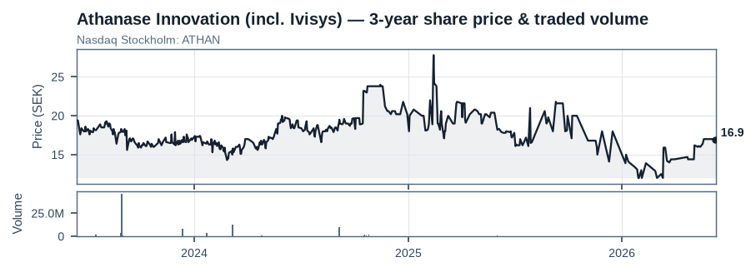
Source: exchange daily price history, 3-year series to 15 June 2026. Nasdaq Stockholm: ATHAN.

Zutec
Company description
Zutec provides next-generation, cloud-based software solutions for the construction, engineering and facilities-management industries. The business is customised to suit each client, with its headquarters in Dublin and a presence in London, Hong Kong, Doha, Abu Dhabi and Melbourne.
Our view
The company is growing and winning new customers, but the market remains under pressure. It stands ready to accelerate its customer outreach and to build a highly scalable value proposition. Several smaller acquisitions have created additional value for the company’s customers while scaling the Zutec back-end platform. We see expansion potential among customers that own existing buildings.
Recent events, Q3 2025/2026
- Sales grew 9% to £2.9m, with organic growth of −13% in Q3. Recurring revenues accounted for 97% of sales. The market in the UK remains challenging.
- Cash EBITDA was £0.6m, down from £1.2m a year earlier.
- Operating cash flow was zero, owing to seasonality.
Share price & traded volume (3-year)
Zutec is a privately held subsidiary of Athanase Innovation; no public share-price or volume data is available.

Somero
Company description
Somero is the market leader, with an approximately 80% global market share in laser-screeding machines, which are used to level concrete in all types of buildings and floors. The Somero machine is decisive for US concrete contractors’ win rates when bidding for large floor areas (>2,000 sqm), making its position near-monopolistic in those applications. Typical buildings in which it is used are warehouses and data centres.
Key facts
Market capitalisation | $134m
Enterprise value | $101m
AIP ownership | 3%
% of portfolio | 11%
Board representation | No
Our view
Somero is facing a cyclical downturn as new-build activity in the US construction sector has slowed amid economic weakness and uncertainty. Despite this, Somero has managed its cost base well and has not lost market share. In our view, its unique market position, which underpins its earnings power, will prove even more valuable when the market recovers. In addition, there is further scope to extend the product range, as evidenced by the product launch this summer.
Recent events, H2 2025
- Net sales in H2 2025 fell 14% year-on-year to $49m but rose 24% sequentially from H1 2025.
- Operating income declined to $9m in H2 2025 from $13m a year earlier.
- The company introduced two new, smaller models that will be sold to smaller concrete contractors to replace manual labour.
Financial results
M USD | 2020 | 2021 | 2022 | 2023 | 2024 | 2025
Net Revenue | 89 | 133 | 133 | 120 | 109 | 89
EBITA | 24 | 45 | 43 | 34 | 24 | 18
Margin | 27% | 34% | 32% | 28% | 22% | 16%
Net Income | 19 | 35 | 31 | 28 | 19 | 10
Share price & traded volume (3-year)
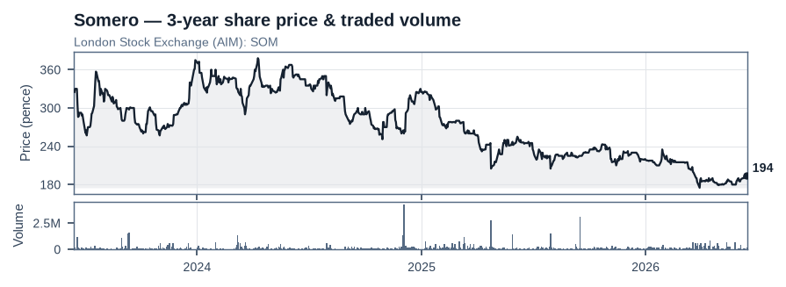
Source: exchange daily price history, 3-year series to 15 June 2026. London Stock Exchange (AIM): SOM.

TBK
Company description
TBK is a long-standing Tier 1–2 supplier of safety-critical braking systems, retarders, asbestos-free linings, engine water and oil pumps, and other engine components for trucks and buses. The business is underpinned by long-term customer relationships and by products that are designed into the platforms of major commercial-vehicle OEMs. Once qualified, parts typically remain in place for the full model cycle, creating significant switching costs.
Key facts
Market capitalisation | JPY 10,446 (unit per source)
Enterprise value | JPY 6,940 (unit per source)
AIP ownership | 7%
% of portfolio | 12%
Board representation | No
Our view
TBK has suffered from weak profitability, primarily owing to below-market pricing with its largest customer and an oversized manufacturing footprint in Japan. Drawing on our prior experience as the largest shareholder and a board member at Concentric and Haldex, we see potential operational improvements that could lift the operating margin to 10%. On that basis, the company would be trading at just 2x earnings.
Recent events, FY 25/26
- Sales increased 0.6% to JPY 54.8bn for the full year.
- Gross margin strengthened to 12.5%, versus 10.6% a year earlier.
- EBIT improved to JPY 1,496m, compared with JPY 941m a year earlier.
Financial results
BN JPY | 21/22 | 22/23 | 23/24 | 24/25 | 25/26
Net Revenue | 51 | 54 | 57 | 54 | 55
EBIT | 0.6 | (0.6) | 0.9 | 1.0 | 1.5
Margin | 1.2% | -1.2% | 1.6% | 1.7% | 2.7%
Net Income | 0.8 | -2.1 | 0.3 | -1.2 | 0
Source labels market cap/EV as “BN JPY”, which is inconsistent with ¥55bn revenue — likely a unit error in the original; reproduced as printed.
Share price & traded volume (3-year)
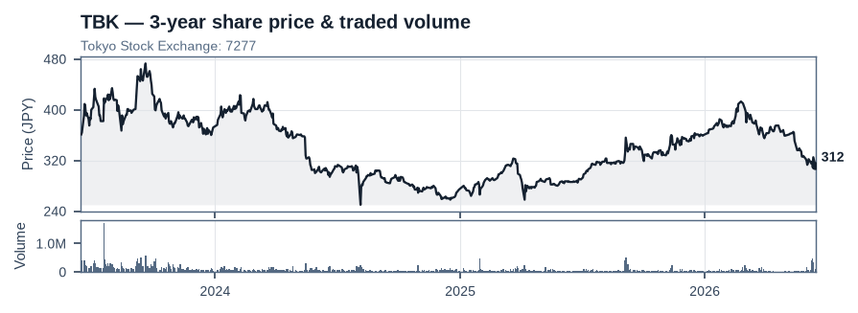
Source: exchange daily price history, 3-year series to 15 June 2026. Tokyo Stock Exchange: 7277.

Evolution
Company description
Evolution is the dominant global B2B supplier of live-dealer casino games, with a growing RNG-slots business. Its moat rests on economies of scale created by studio capacity and uptime, a global regulatory footprint, hit-driven IP and game shows, deep operator integrations, and industry-leading margins that fund rapid product roll-out and new studios. Evolution earns a revenue share per game round at structurally high incremental returns, as there can be an unlimited number of players per table.
Key facts
Market capitalisation | SEK 116,917m
Enterprise value | SEK 104,909m
AIP ownership | <1%
% of portfolio | 4%
Board representation | No
Our view
Evolution’s valuation has been affected by three main developments: (1) a report sponsored by a competitor (Playtech) alleging that the company has sold games to sanctioned countries — an allegation the company has rejected; both the New Jersey and Philadelphia gaming commissions have conducted audits and cleared the firm of wrongdoing. After significant due diligence, our conclusion is that Evolution is overstating the impact of cybercrime in order to mask poor execution in localising its games. (2) The UK regulator launched an investigation into games offered in the UK by Evolution through unregulated operators. The company is working with the regulator and has limited distribution to locally licensed operators in the UK and the rest of Europe, despite no such request from the regulator.
We believe that Evolution could double in value on a per-share basis within three years, driven by a combination of a re-rating of its multiple, earnings growth and share buybacks.
Recent events, Q1 2026
- Net revenues decreased by 2% to €513m, with Asian demand growing slightly quarter-on-quarter for the second consecutive quarter.
- Europe recorded another weak quarter, down 6%, with management attributing this to illegal gaming operators taking share.
- North America continued to grow in Q1, up 21% year-on-year.
- The company has a very active 2026 ahead, with numerous new game launches.
Share price & traded volume (3-year)
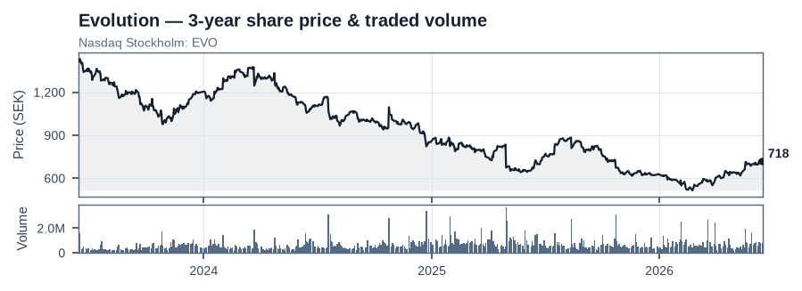
Source: exchange daily price history, 3-year series to 15 June 2026. Nasdaq Stockholm: EVO.

Röko
Company description
Röko invests its equity capital from its own balance sheet into stable and profitable companies with strong market positions in their respective niche markets. It is a long-term owner focused on independent governance, and the companies it acquires have a proven track record of growing profits over time. Röko’s core principles are empowerment, simplicity and continuous improvement.
Key facts
Market capitalisation | SEK 22,082m
Enterprise value | SEK 25,798m
AIP ownership | <1%
% of portfolio | 9%
Board representation | No
Our view
We were part of the initial group of investors who supported Fredrik Karlsson and Tomas Billing in the formation of the company. Fredrik in particular had been highly successful in building Lifco, a company whose value increased approximately 100-fold over a 20-year period. Röko’s investment model is based on continuously reinvesting its cash flow into new companies while simultaneously improving the profitability of its existing companies.
Recent events, Q1 2026
- Net sales grew 6% organically year-on-year to SEK 1,853m in Q1.
- EBITA increased 5% to SEK 415m.
- Fredrik Karlsson stepped down as CEO to become deputy CEO; Johan Bladh was appointed as the new CEO.
Financial results
MSEK | 2022 | 2023 | 2024 | 2025 | Q1 2026
Net Revenue | 4,313 | 5,614 | 6,182 | 6,452 | 1,853
EBITA | 787 | 1,047 | 1,227 | 1,339 | 415
Margin | 18% | 19% | 20% | 21% | 22%
Acquisitions # | – | 2 | 4 | 3 | 3
Share price & traded volume (3-year)
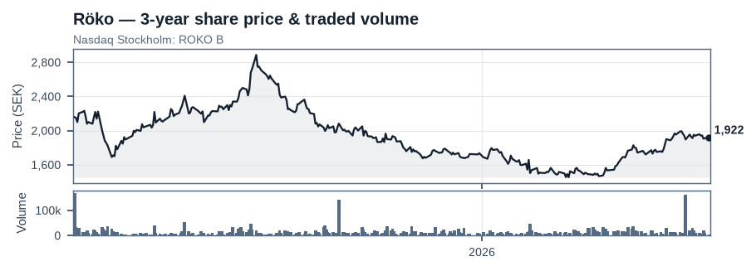
Source: exchange daily price history, 3-year series to 15 June 2026. Nasdaq Stockholm: ROKO B. Price history available from Mar 2025.

NGEx
Company description
NGEx is a growing copper and gold exploration company based in Canada, focused on the exploration of the Lunahuasi copper–gold–silver project in San Juan Province, Argentina, and the nearby Los Helados copper–gold project, located approximately nine kilometres to the north-east, in Chile’s Region III. Both projects lie within the emerging Vicuña District, which includes the Caserones mine and the Josemaria and Filo del Sol deposits.
Key facts
Market capitalisation | CAD 5,476m
Enterprise value | CAD 4,963m
AIP ownership | <1%
% of portfolio | 8%
Board representation | No
Our view
We invested early in NGEx on the basis that the company has an exceptional management team with significant ownership, backed by the Lundin family, which has a strong track record of developing mines in challenging regions. We invested early in the original company, which spun out Filo Mining and Josemaria; the proposal is now to spin out LunR Royalties Corp. Our thesis has been that this provides attractive exposure to the electrification trend, which we believe will drive copper prices higher.
Recent events, Q1 2026
- The results of the Phase 3 programme were positive and confirmed the discovery of one of the highest-grade copper, gold and silver intercepts drilled globally.
- The Phase 4 drill programme at Lunahuasi is now complete. Results continue to be very positive, indicating further potential at short range.
- The mid-range step-out drilling points to extensions of existing mineralised intersections and to the existence of two new high-grade zones with the same characteristics as those previously identified. Further analysis is required before Phase 5 is initiated in Q4 2026.
Share price & traded volume (3-year)
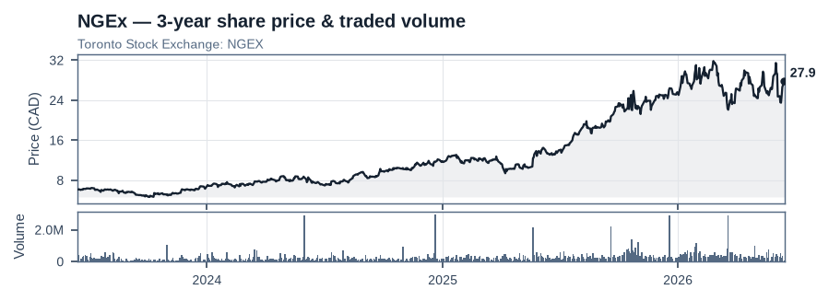
Source: exchange daily price history, 3-year series to 15 June 2026. Toronto Stock Exchange: NGEX.

Auto Trader Group
Company description
Auto Trader Group is the dominant market leader, providing the UK’s largest marketplace for automotive sales. The company is approximately 10x larger than its nearest competitor.
Key facts
Market capitalisation | £4,101m
Enterprise value | £4,246m
AIP ownership | <1%
% of portfolio | 3%
Board representation | No
Our view
Auto Trader Group has a very strong position. Its services are essential for car dealers seeking to maximise their profits. It is currently very difficult to envisage any competitor displacing Auto Trader, as its scale and dominance make it hard for rivals to offer customers the same value. The company has been able to raise prices as it has improved its product offering, delivering increased value to its customers.
Recent events, H1 FY2026
- There were few surprises in the first-half results. Net sales increased by 5% to £296m. Operating income grew by 6% to £200m, with margins maintained at 64%.
- The adoption of Deal Builder, a tool to drive sales, progressed. There were, however, some initial missteps in the product launch, which the company has acknowledged and intends to correct.
Financial results
M £ | 2021 | 2022 | 2023 | 2024 | 2025
Net Revenue | 263 | 433 | 500 | 571 | 601
EBITA | 162 | 305 | 280 | 352 | 378
Margin | 62% | 70% | 56% | 62% | 63%
Net Income | 128 | 245 | 234 | 257 | 283
Share price & traded volume (3-year)
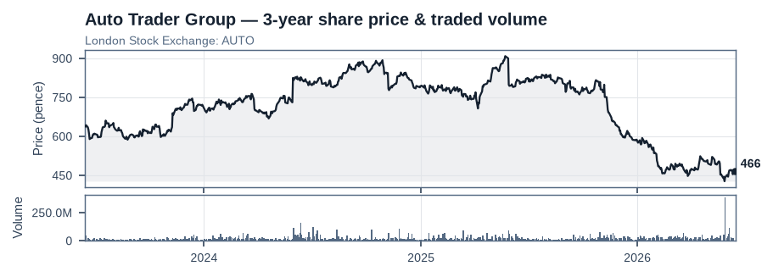
Source: exchange daily price history, 3-year series to 15 June 2026. London Stock Exchange: AUTO.

Rightmove
Company description
Rightmove plc is the dominant property portal in the UK, providing a digital marketplace where estate agents, letting agents and landlords advertise properties for sale and rent. It generates revenue primarily from subscription fees.
Key facts
Market capitalisation | £3,313m
Enterprise value | £3,270m
AIP ownership | <1%
% of portfolio | 4%
Board representation | No
Our view
Rightmove has a dominant position in the UK: approximately 80% of all time spent on property portals occurs on Rightmove. There are opportunities to increase monetisation in the core business, and there is also scope to grow in adjacent areas, although we ascribe less value to these. The stock is attractively priced on modest growth expectations. Our principal concern is that the CEO appears to view the competitive threat from AI-driven search agents through rose-tinted glasses, which we regard as a mistake.
Recent events, Q4 2025
- Results for FY25 were relatively uneventful, with revenues and underlying operating profit each growing 9%. Management reiterated previous guidance of 8–10% revenue growth for FY26. It expects to buy back more shares, with £90m committed for H1.
- The shares have been weak owing to several factors, among them concerns about AI and a class-action lawsuit alleging that the company has abused its dominant market position by charging unfair and excessive subscription fees.
Financial results
M £ | 2020 | 2021 | 2022 | 2023 | 2024 | 2025
Net Revenue | 206 | 305 | 333 | 364 | 390 | 425
EBITA | 135 | 226 | 241 | 258 | 256 | 288
Margin | 66% | 74% | 72% | 71% | 66% | 68%
Net Income | 110 | 183 | 196 | 199 | 193 | 217
Share price & traded volume (3-year)
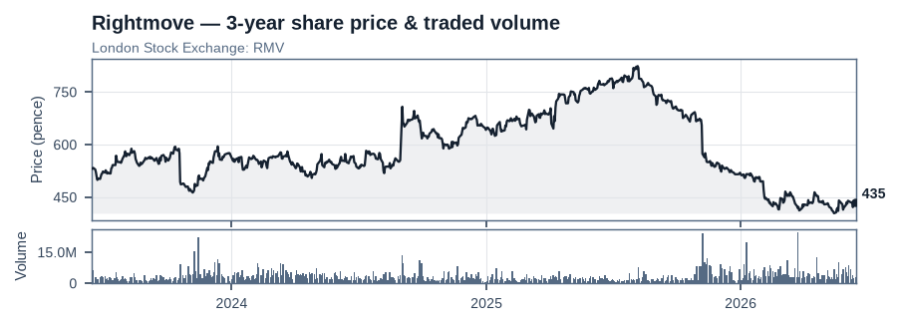
Source: exchange daily price history, 3-year series to 15 June 2026. London Stock Exchange: RMV.

Notes & items to verify
The following are not language issues; figures are reproduced as printed and should be checked against source data:
- Unfilled placeholders in the liquidity section: “XX%” liquidation share and haircut, and “Within redemption period: X%”.
- Template/placeholder residue in the source: a repeated facts block (SEK 104m mcap, SEK 95m EV, 20% ownership, “Since 2019”) and a Net Revenue series 300/340/424/469/486/276 appear beside more than one holding (and do not match them). These residual tables have been omitted rather than misattributed. A separate 108/106 MSEK block with a 340/424/469/486/582/132 series is similarly inconsistent.
- TBK market cap/EV are labelled “BN JPY” in the source, which is inconsistent with ¥55bn revenue — most likely a unit error; reproduced as printed.
- Norvestor offer for Zalaris: “NOK 100” assumed to be per share.
- Zutec, Evolution and NGEx had no self-consistent financial-results table in the source (narrative figures only), so only their key-facts boxes are shown.
- The monthly-returns grid was auto-extracted; the values are taken directly from the source, but the trailing (unreported) 2026 cells may be misaligned by one column and should be checked.

