View 1
- Name: Login
- View Number: 1
- Type: Form
- Description: This is the main login page for faculty who are using the system to make either administration changes, or for moderation purposes.
- Graphical Design:
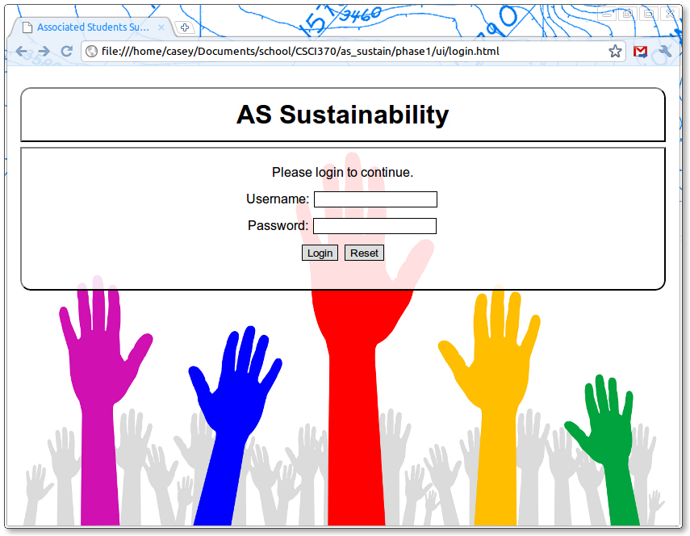

View 2
- Name: Main Menu
- View Number: 2
- Type: Menu
- Description: If login is successful, a main menu will display, with a list of options. These options will be displayed based on the users privileges (admin or moderator).
- Graphical Design(Admin):
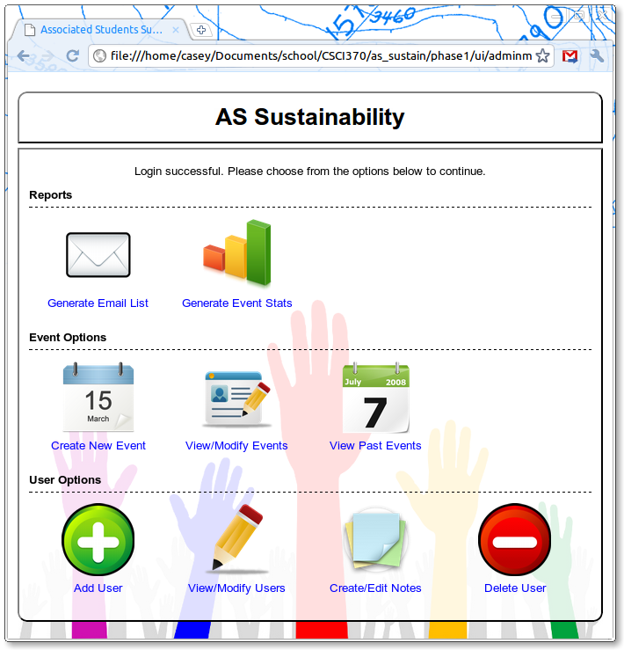
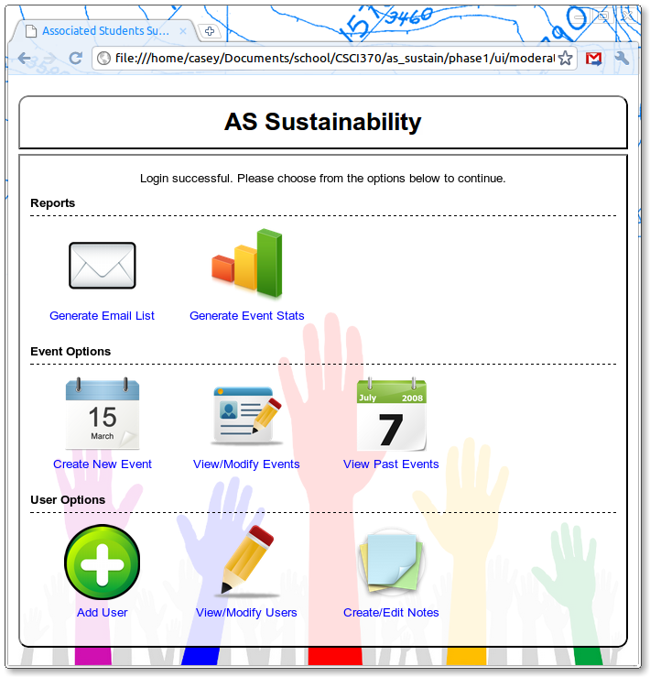
- Graphical Design(Moderator):

View 3
- Name: Add Person
- View Number: 3
- Type: Form
- Description: An administrator or moderator will use this form to add a new person to the database.
- Graphical Design:
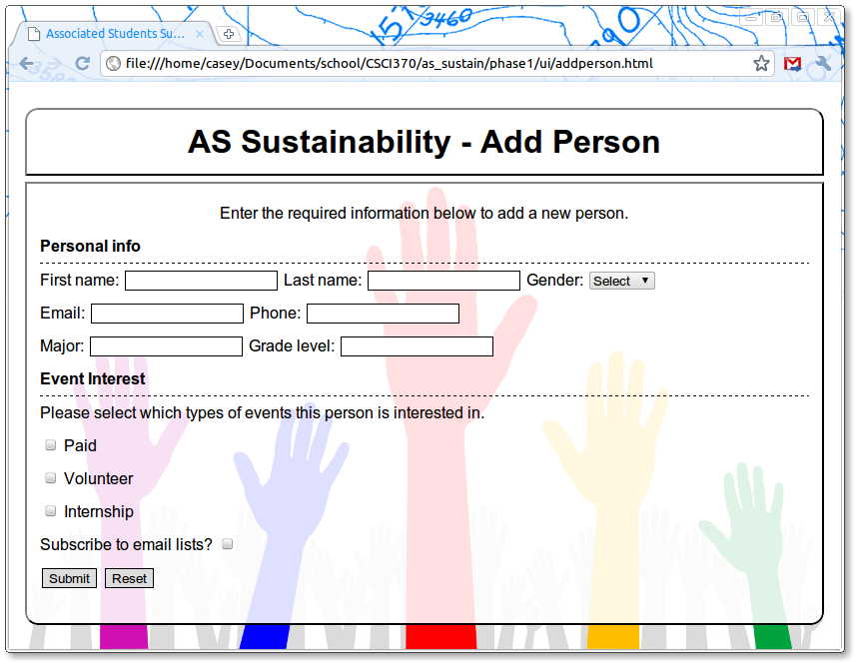

View 3
- Name: Delete Person
- View Number: 3
- Type: Form
- Description: Only an administrator will have access to this function. The purpose is to delete a person from the database. This should only be done in extreme circumstances. For most things, modify will work, instead of delete.
- Graphical Design:
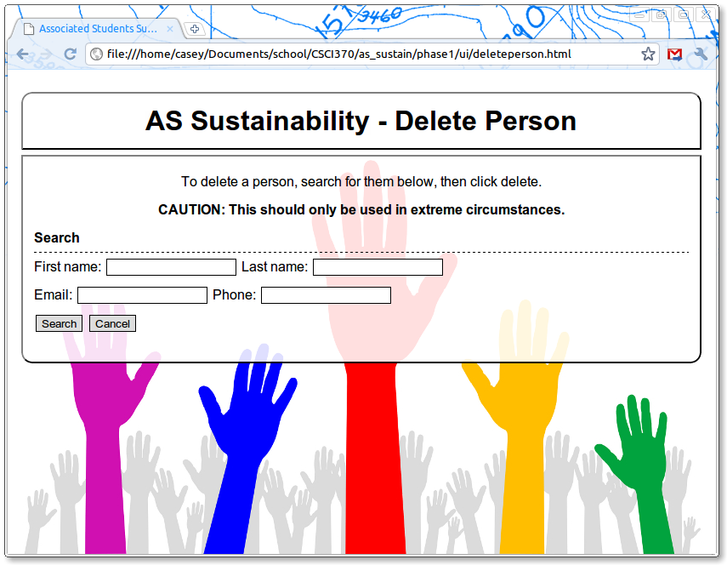

View 4
- Name: Modify Person
- View Number: 4
- Type: Form
- Description: An admin or moderator will be able to modify an existing user in the database. First they must search for the student to modify. Once they have found the student they would like to modify, a form will be populated with the person's details. Any changes will only take affect once the Modify button is pressed.
- Graphical Design:
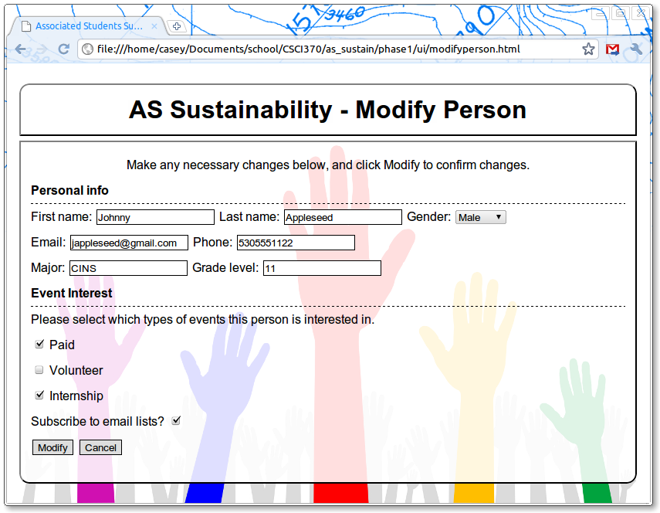

View 5
- Name: Approve Change Request
- View Number: 5
- Type: Form
- Description: An admin or moderator will be given access to a list of requests change requests awaiting approval. A change request is generated when a student submits a form requesting a change to their information.
- Graphical Design:
