Course Project Assignment – Hello World!

Christina Hargest

Rasmussen College

Author Note

This paper is being submitted on February 11, 2018, for COP1801 Section 01 Javascript course.

Here is the output:

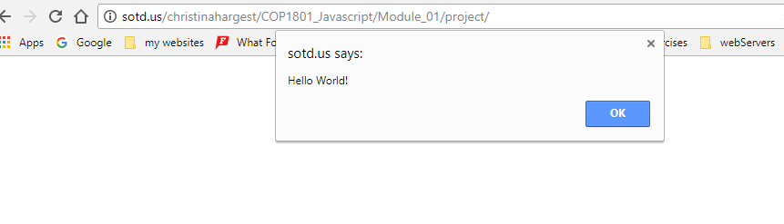

The URL for the webpage is: <http://sotd.us/christinahargest/COP1801_Javascript/>

Link to the github repository: https://github.com/chargest/COP1801_Javascript/tree/master/Module_01/project