Course Activity Assignment – Working with Data

Christina Hargest

Rasmussen College

Author Note

This paper is being submitted on February 16, 2018, for COP1801 Section 01 Javascript course.

Program 1: Here is the output from loaded page:

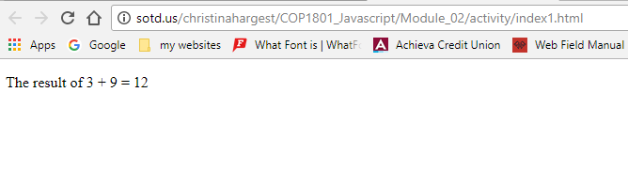

Program 1: Developer console output:

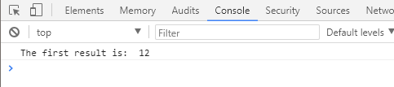

Program 2: Here is the output from loaded page:

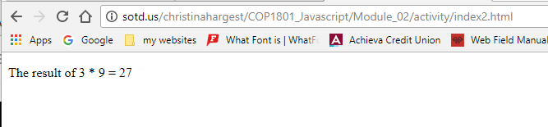Program 2: Developer console output:

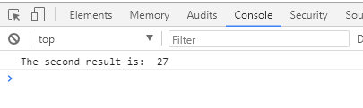

Program 3: Here is the output from loaded page:

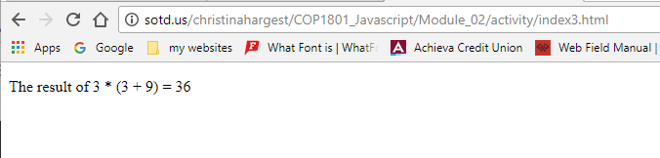

Program 3: Developer console output:

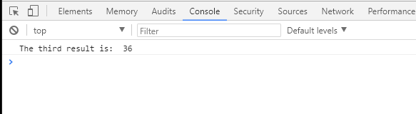

The URL for the webpage on SOTD is: <http://sotd.us/christinahargest/COP1801_Javascript/Module_02/activity/index1.html>

<http://sotd.us/christinahargest/COP1801_Javascript/Module_02/activity/index2.html>

<http://sotd.us/christinahargest/COP1801_Javascript/Module_02/activity/index3.html>

Link to the github repository: <https://github.com/chargest/COP1801_Javascript/tree/master/Module_02/activity>