Pareto optimal fuzzy concept attribution: post hoc explanations with fuzzy concepts, fuzzy uncertainty and multiobjective selection
Charis Ntakolia
Department of Aeronautical Studies, Sector of Materials Engineering, Machining Technology and Production Management, Hellenic Air Force Academy, Dekeleia Base, 13672, Acharnes, Attica, Greece
cntakolia@hafa.gr

Abstract
Shapley additive explanations split credit arbitrarily among correlated features, report no reliability and cannot be tuned toward the properties a user needs. This work proposes Pareto optimal fuzzy concept attribution (PFCA), a post hoc method for tabular black box models. Shapley credit is assigned to fuzzy concepts formed by fuzzy c means on the correlation profiles of the features, the attribution of every concept is summarized over bootstrap resamples and model classes as a trapezoidal fuzzy number with a sign confidence, a disagreement index and linguistic labels, and the explanation configuration is selected from a Pareto front of fidelity loss, complexity and instability with a knee point default. Efficiency, reduction to SHAP and invariance to feature duplication hold at the concept level. The method was evaluated at reduced scale against feature level SHAP, bootstrapped SHAP, grouped SHAP, LIME and four ablations on synthetic problems with known attributions, the breast cancer dataset and a simulated questionnaire, all from one shared pool of refitted models. The rank stability of the concept attribution was 0.950 against 0.481 for SHAP in the redundancy family and 1.000 against 0.507 on the benchmark, the attribution of a fixed partition changed by 0.017 to 0.071 under feature duplication against 0.524 for SHAP, and the sign confidence was calibrated with errors below 0.10. The default knee merged factors, which raised the recovery error above SHAP, and the fuzzy supports covered the truth below their nominal level at 20 resamples. The front, rather than one explanation, reconciles these findings.
Keywords: explainable artificial intelligence; Shapley values; fuzzy sets; concept attribution; multiobjective optimization; uncertainty quantification

1. Introduction
Post hoc attribution methods have become the standard instrument for explaining the predictions of black box models on tabular data, and Shapley additive explanations (SHAP) are the most widely used of them (Lundberg & Lee, 2017; Lundberg et al., 2020). A SHAP explanation assigns to every input feature one real number, the share of the deviation of a prediction from the expected prediction that is credited to that feature, and the additive axioms of the Shapley value guarantee that these shares sum to the deviation (Shapley, 1953; Štrumbelj & Kononenko, 2014). In applied fields such as clinical prediction and psychological assessment the resulting bar plots are routinely read as statements about which measured quantities drive a decision, and they inform feature selection, risk communication and the design of interventions (Ntakolia et al., 2022; Ntakolia et al., 2025). The reliability of such statements therefore matters beyond the methodological literature.
Three structural limitations of feature level attribution motivate the present work. First, when features are correlated the credit of a prediction is split between them in a manner that depends on the estimation scheme rather than on the data generating process. Aas et al. (2021) showed that the marginal and the conditional formulations of the Shapley value give different answers under dependence and that accurate conditional approximations are costly. Kumar et al. (2020) demonstrated that the game theoretic formulation itself leaves the treatment of dependent features underdetermined. Frye et al. (2020) proposed to resolve the ambiguity with causal knowledge, which is rarely available for questionnaire items or clinical variables. Second, the attribution is a point estimate that carries no information about its own reliability. It varies with the training sample, the model class, the background distribution and the random seeds of the estimator (Slack et al., 2021; Visani et al., 2022; Molnar et al., 2022). Fisher et al. (2019) showed that the importance of a variable can range widely across the set of models that fit the data almost equally well. A number reported for one fitted model therefore conceals a distribution. Third, the attribution is fixed by the axioms and cannot be tuned toward the properties that a given user needs, such as sparsity or robustness, although these properties are precisely what quantitative evaluations of explanations measure (Yeh et al., 2019; Hooker et al., 2019; Nauta et al., 2023).
Several families of methods address one of these limitations at a time. Grouped and partition based Shapley values assign credit to predefined crisp groups of features and remove the arbitrary split inside a group (Au et al., 2022; Amoukou et al., 2022), while concept based explanations of neural networks attribute predictions to human understandable concepts rather than to raw inputs (Kim et al., 2018; Ghorbani et al., 2019). Bootstrapped and distributional attributions quantify the variability of an explanation over resamples and estimator noise and report confidence intervals or stability indices (Slack et al., 2021; Visani et al., 2022), and global importance measures summarize attributions over a dataset with their sampling uncertainty (Covert et al., 2020). Multiobjective formulations have been used to trade off the competing qualities of an explanation, for example proximity, sparsity and plausibility in counterfactual search (Dandl et al., 2020), and gradient based attributions such as integrated gradients give an axiomatic alternative for smooth models (Sundararajan et al., 2017). The evaluation literature has made faithfulness, stability and complexity measurable through deletion and insertion curves, perturbation sensitivity and surrogate fidelity (Petsiuk et al., 2018; Alvarez-Melis & Jaakkola, 2018; Yeh et al., 2019). Fuzzy modeling, in turn, offers a vocabulary for graded membership and linguistic description that has been advocated for explainable artificial intelligence because it matches the way domain experts reason about uncertain quantities (Fernandez et al., 2019; Mencar & Alonso, 2019).
Taken together, these families achieve a great deal: credit can be assigned to groups, uncertainty can be estimated, and the quality of an explanation can be measured along several axes. Despite their effectiveness, each family rests on an assumption that the others relax. Grouped attributions require a crisp and a priori grouping, so that a feature that loads on two constructs must be assigned to one of them, and the choice of the number of groups is left to the user. Distributional attributions report intervals at the feature level, where the credit splitting problem persists, and they treat the explanation configuration as fixed. Multiobjective selection has been applied to the search for counterfactual instances rather than to the configuration of an attribution, and the fuzzy explainable systems literature has focused on interpretable models rather than on post hoc explanations of black boxes. No existing method combines fuzzy groups of correlated features, a fuzzy representation of the uncertainty of the attribution, and an explicit selection of the explanation from the trade off between fidelity, simplicity and stability.
Motivated by these limitations, this work proposes Pareto optimal fuzzy concept attribution (PFCA), a post hoc explanation method for tabular black box models that integrates the three ideas. Features are clustered into fuzzy concepts by fuzzy c means on their correlation profiles, and the Shapley credit of a prediction is assigned to concepts before it is distributed to features according to their membership, so that the arbitrary split between correlated features disappears and an exact duplicate of a feature leaves the attribution of its concept unchanged. The attribution of every concept is estimated over bootstrap resamples and several model classes and summarized as a trapezoidal fuzzy number with a sign confidence, a disagreement index between model classes, an interval type 2 upgrade when the classes disagree (Mendel & John, 2002), and linguistic labels over a standardized axis (Zadeh, 1975). The number of concepts, the fuzzifier, the sparsity and the alpha level of the cut are chosen from a Pareto front that trades off fidelity loss, complexity and instability, a knee point is reported by default, and every concept receives a selection membership equal to the share of Pareto optimal explanations that retain it. The approach continues a line of work in which fuzzy aggregation was used to combine heterogeneous importance scores for feature selection before post hoc explanation (Ntakolia et al., 2021) and in which fuzzy logic was used to select among Pareto optimal solutions of multiobjective planning problems (Ntakolia & Lyridis, 2021; Ntakolia et al., 2023).
The main contributions of this work are the following.
• A concept level attribution that preserves the efficiency of the Shapley value for every membership matrix whose rows sum to one, reduces exactly to SHAP for the identity partition with a single fit, and is invariant to the duplication of a feature at the level of the concept that absorbs the copy.
• A fuzzy representation of attribution uncertainty with two complementary layers, an estimation layer (trapezoidal fuzzy numbers, sign confidence, disagreement index and interval type 2 sets over resamples and model classes) and a selection layer (the membership of a concept in the set of Pareto optimal explanations), together with linguistic labels obtained through a fuzzy compatibility measure.
• A multiobjective formulation of the choice of an explanation configuration, solved exhaustively or with NSGA-II, that exposes the trade off between fidelity loss, complexity and instability instead of fixing it.
• An evaluation protocol in which every compared method is derived from one shared pool of refitted models, with synthetic ground truth, a public benchmark and a questionnaire with known subscales, pre registered success criteria, and an open source implementation with a scikit-learn compatible interface.
The remainder of the paper is organized as follows. Section 2 defines the method, the data and the evaluation protocol, Section 3 reports the results, Section 4 discusses them in the light of the literature, and Section 5 concludes.

2. Methodology

2.1. Data
Three kinds of data were used, following the four phase study design of the method. Phase A used synthetic problems in which the true concept structure and the true attributions are known in closed form. Latent factors $z_{1},…,z_{F}$ were drawn as independent standard normal variables, the $d$ observed features were split into $F$ contiguous blocks of as equal size as possible, and every feature of block $k$ was generated as $x_{j}=\sqrt{ρ} z_{k}+\sqrt{1−ρ} e_{j}$ with independent standard normal noise $e_{j}$, so that the features are standard normal with within block correlation $ρ$. The response was $y=\sum_{k=1}^{F}{β_{k}}g_{k}(z_{k})+ϵ$ with coefficients spaced linearly from 2 to 0.5 with random signs, link functions taken in turn from the linear, sine, hyperbolic tangent, quadratic and cubic families, and Gaussian noise scaled to a signal to noise ratio of four. Three families were generated: the additive family as described, the interaction family, which adds a product term $γz_{1}z_{2}$ with $γ=1.5$ whose contribution is split equally between the first two factors, and the redundancy family, which appends $F$ duplicates of the first feature of each block, alternately exact copies and copies with Gaussian noise of standard deviation 0.1. Because the regression function is additive across independent blocks, the Shapley value of block $k$ under a marginal baseline is the centered conditional contribution $β_{k}\left(E[g_{k}(z_{k})∣x]−E[g_{k}(z_{k})]\right)$, which was evaluated by Gauss Hermite quadrature with 40 nodes from the posterior of the factor given its block. The design crossed the three families with sample sizes of 200 and 500, dimensions of 10 and 30 and within block correlations of 0.3, 0.6 and 0.9, with two replication seeds per cell, 100 fresh instances to explain per cell and separate tuning and replicate samples drawn from the same process.
Phase B used the Wisconsin diagnostic breast cancer dataset shipped with scikit-learn (Pedregosa et al., 2011), with 569 instances, 30 continuous features that describe the cell nuclei of a digitized image and a binary diagnosis in which the malignant class was explained. The features of this dataset are strongly correlated by construction, since every measured characteristic appears as a mean, a standard error and a worst value. The curated list of the study also includes fourteen OpenML datasets with between 15 and 100 features that are downloaded by identifier at run time. These downloads were not reachable from the execution environment of the present run. The benchmark phase reported here is therefore restricted to the one offline dataset, and the paired tests across datasets of the protocol could not be applied.
Phase C used a simulated questionnaire produced by the generator distributed with the implementation, since the real questionnaire of the study is covered by an ethics approval that does not allow redistribution. The generator draws 600 participants with four latent constructs correlated at 0.3, five Likert items per construct with loadings decreasing from 0.9 to 0.75, two covariates, and a continuous outcome that depends on the constructs with a signal to noise ratio of four and a product term between the first two constructs. The a priori subscale structure entered the method as a candidate partition, served as the partition of the grouped baseline and of the a priori ablation, and was the external criterion for concept recovery. The expert judgment study of Phase D was not conducted; its materials generator and analysis path are part of the implementation and are described as future work.

2.2. Proposed method
The overall workflow is summarized in Figure 1. Let $f$ be a trained model that maps an input $x∈R^{d}$ to a prediction, let $X$ be the training data with $n$ rows, and let $x^{*}$ be an instance to be explained. A concept partition is a membership matrix $U∈[0,1]^{d×K}$ whose entry $u_{jk}$ is the degree to which feature $j$ belongs to concept $k$, with k​ujk=1 for every feature. Bootstrap resamples are indexed by $b=1,…,B$ and model classes by $m=1,…,M$.
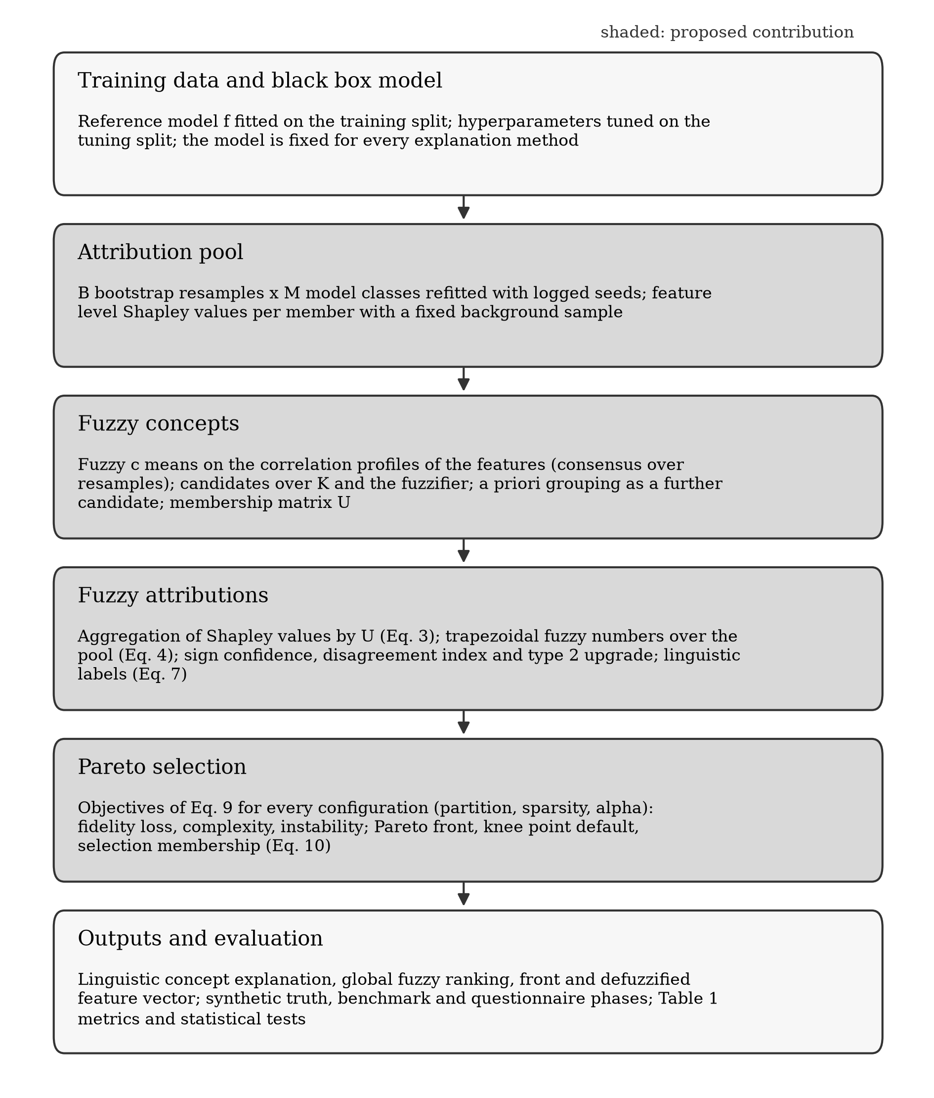
Figure 1. Pipeline of the proposed methodology, from the reference model to the evaluation. The shaded steps constitute the contribution: the attribution pool over resamples and model classes, the fuzzy concepts, the fuzzy attributions and the Pareto selection of the explanation configuration.

2.2.1. Attribution pool
The reference model is fitted on the training data with hyperparameters selected on a tuning split and is fixed for every method. A pool of $B×M$ models is then built: resample $b=1$ is the original training data and resamples $2$ to $B$ are bootstrap draws of $n$ rows with replacement, and for every resample each of the $M$ model classes is refitted with a seed derived from the pool seed. For every pool member a feature level Shapley vector $ϕ^{(b,m)}(x^{*})$ is computed for every explained instance with the interventional expectation over a background sample of 100 rows drawn from the resample, using the tree explainer for tree ensembles, the linear explainer for linear models and the exact or permutation explainer otherwise (Lundberg & Lee, 2017; Lundberg et al., 2020). The expected value of the member is the mean of its output over its background sample, so that the feature level values of every member sum to the output minus the expected value. The first member, the reference model class fitted on the original data, is the model whose output the explanation is required to reproduce.

2.2.2. Fuzzy concepts
Concepts are formed by fuzzy c means applied to the features rather than to the instances (Bezdek et al., 1984). The correlation matrix $R$ of the features is computed on the full training data and feature $j$ is embedded as the vector of its absolute correlations with every feature, $z_{j}=(|R_{j1}|,…,|R_{jd}|)$. Fuzzy c means with $K$ concepts and fuzzifier $m_{f}>1$ minimizes
$J=\sum_{j=1}^{d}{\sum_{k=1}^{K}{u_{jk}^{m_{f}}}} {\left\|z_{j}−c_{k}\right\|}^{2}$ (1)
by alternating the update of the centers $c_{k}$ as membership weighted means and the update of the memberships $u_{jk}∝{\left\|z_{j}−c_{k}\right\|}^{−2/(m_{f}−1)}$ normalized over $k$, with five random initializations and the solution of smallest objective retained. A loading based alternative replaces the correlation profiles by the row normalized absolute loadings of a factor analysis with $K$ factors. In the consensus variant used in the study, fuzzy c means is run on 20 bootstrap resamples of the instances, the co-membership matrix $UU^{⊤}$ is averaged over the resamples and fuzzy c means is run once more on the rows of the averaged matrix, which stabilizes the partition. The number of concepts and the fuzzifier are not fixed in advance but range over a grid, and every pair defines one candidate partition. When domain knowledge is available, as for questionnaires with known subscales, the a priori grouping enters as an additional crisp candidate partition. The columns of every candidate are ordered deterministically by the smallest index of the features assigned to them, and the fuzziness of a concept is defined as the membership weighted mean of the normalized row entropies of its features,
Fk=j​ujkHjj​ujk, Hj=−1logKk​ujklogujk, (2)
so that a crisp concept has fuzziness zero and a concept of the uniform partition has fuzziness one.

2.2.3. Concept level attribution
For every candidate partition, every resample and every model class the feature level attribution is aggregated through the membership matrix,
$ϕ_{k}^{(b,m)}=\sum_{j=1}^{d}{u_{jk}} ϕ_{j}^{(b,m)}.$ (3)
Because the memberships of every feature sum to one, the concept attributions of a member sum to the same total as its feature attributions, and the efficiency property of the Shapley value is preserved at the concept level for every row stochastic membership matrix. Two further properties follow directly. When $K=d$, $U$ is the identity and $B=M=1$, the method returns the SHAP values of the reference model exactly. When an exact copy of feature $j$ is added, the Shapley value of $j$ is split between the two copies, whereas the concept that absorbs both copies receives the same attribution as before, which is the central argument for attribution at the concept level.

2.2.4. Fuzzification of the attributions
For an explained instance and a concept $k$, the $B×M$ values of Equation (3) form an empirical distribution that is summarized by a trapezoidal fuzzy number whose support is the interval between the 5th and the 95th percentile and whose core is the interval between the 25th and the 75th percentile,
$Φ_{k}=\left(q_{0.05}, q_{0.25}, q_{0.75}, q_{0.95}\right),$ (4)
with the median kept as the point summary; a triangular alternative uses the median as the single core value. Two derived quantities accompany every fuzzy attribution. The sign confidence is the proportion of pool members whose value has the sign of the pool median,
$s_{k}=\frac{1}{BM}\sum_{b=1}^{B}{\sum_{m=1}^{M}{1}}\left[signϕ_{k}^{(b,m)}=sign{\tilde{ϕ}}_{k}\right],$ (5)
and the disagreement index is the ratio of the between model class variance of the class means to the total variance of the pool,
$δ_{k}=\frac{{Var}_{m}\left({\overset{‾}{ϕ}}_{k}^{(⋅,m)}\right)}{{Var}_{b,m}\left(ϕ_{k}^{(b,m)}\right)},$ (6)
clipped to the unit interval and equal to zero when a single model class is used. When $δ_{k}$ exceeds a threshold of 0.5 the attribution is upgraded to an interval type 2 fuzzy set (Mendel & John, 2002) with one trapezoidal member per model class, whose footprint of uncertainty is the union of the members, the upper membership being their pointwise maximum and the lower membership their pointwise minimum.
Linguistic labels are evaluated on a standardized axis on which one unit is the mean absolute concept attribution of the reference member over all explained instances and concepts. Five fixed fuzzy sets, strongly negative, weakly negative, negligible, weakly positive and strongly positive, form a Ruspini partition of that axis with cores centered at -2, -1, 0, 1 and 2, and the label of an attribution is the set of largest compatibility, where the compatibility of a fuzzy attribution with a linguistic set $A$ is
$comp(Φ_{k},A)=\sup_{z}min\left(μ_{Φ_{k}}(z), μ_{A}(z)\right),$ (7)
evaluated in closed form from the crossing of the facing linear edges of the two trapezoids, with ties broken by the distance between the centroid of the attribution and the representative point of the label. Global importance is the fuzzy number obtained from the mean absolute concept attribution over the explained instances, computed per pool member and summarized by the same five percentiles, and the ranking between two concepts is expressed by the possibility degree that one fuzzy number exceeds the other (Dubois & Prade, 1983),
$Π(Φ_{a}≥Φ_{b})=max\left(0, min\left(1, \frac{a_{4}−b_{1}}{(a_{4}−a_{3})+(b_{2}−b_{1})}\right)\right),$ (8)
where $(a_{1},a_{2},a_{3},a_{4})$ and $(b_{1},b_{2},b_{3},b_{4})$ are the trapezoid parameters; the dominance of a concept is its minimum possibility of exceeding every other concept.

2.2.5. Multiobjective selection of the explanation
An explanation configuration $θ$ consists of the candidate partition (the number of concepts $K$ and the fuzzifier, or the a priori partition), the sparsity level $s$ given by the number of concepts retained after the alpha cut, and the alpha level $α∈[0,1]$ of the cut. The alpha cut of a stored fuzzy number is the interval $[q_{0.05}+α(q_{0.25}−q_{0.05}), q_{0.95}−α(q_{0.95}−q_{0.75})]$, a concept is active for an instance when that interval excludes zero, and a concept passes the cut when it is active for at least one explained instance. Passing concepts are ranked by the alpha level at which they first become active, with ties broken by global importance, and the first $s$ of them are retained; because the ranking does not depend on $α$ and the passing set is nested in $α$, the retained set at a given sparsity is nested as well. For every configuration three objectives are evaluated,
$\min_{θ}\left(f_{1}(θ), f_{2}(θ), f_{3}(θ)\right)=\left(\text{fidelity loss}, \text{complexity}, \text{instability}\right).$ (9)
The fidelity loss is one minus the five fold cross validated coefficient of determination of a ridge surrogate that predicts the output of the reference model on the explained instances from the medians of the retained concept attributions, so that the held out data of the surrogate are the out of fold instances. The complexity is the number of retained concepts weighted by one plus their fuzziness of Equation (2), f2=k∈R​(1+Fk), so that crisp concepts are preferred. The instability is one minus the mean pairwise Spearman correlation, over all pairs of pool members, of the vectors of concept importance restricted to the retained concepts. A configuration that retains no concept is infeasible. The decision space is enumerated exhaustively on the grid of partitions, sparsity levels and alpha levels, or searched with NSGA-II (Deb et al., 2002) through the pymoo library (Blank & Deb, 2020) when the grid is large; the two solvers evaluate the same objective function and the sensitivity analysis checks that the evolutionary search recovers the exhaustive front.
The output of the selection is the Pareto front of configurations. A knee point is reported by default, the front member closest to the ideal point after min max normalization of the objectives over the front, and the whole front is retained so that a sparser or a more faithful explanation can be chosen. Several configurations of the grid can produce the same explanation, that is the same partition and the same retained set, and the front is reduced to its distinct explanations before any proportion is computed. The selection membership of concept $k$ is the share of distinct Pareto optimal explanations that retain it,
σk=1|P|p∈P​1k∈Rp, (10)
where an explanation built on another candidate partition contributes the share of the membership mass of $k$ that it retains; at the feature level the membership of feature $j$ is the mean over the distinct explanations of k∈Rp​ujk. This selection based layer of fuzziness complements the estimation based layer of Section 2.2.4. Finally, for compatibility with existing practice, a defuzzified feature level vector is obtained by redistributing the centroids $c_{k}$ of the trapezoids through the membership matrix,
ψj=k=1Kck ujkj′​uj′k, (11)
which preserves the total and reduces to ordinary SHAP when every concept contains one feature with full membership. The method therefore returns, for every problem, a fuzzy concept partition, a fuzzy attribution per instance and concept with sign confidence, disagreement index and linguistic label, a global fuzzy ranking with pairwise possibility degrees, a Pareto front with a knee point default and the selection memberships, and a feature level vector.

2.3. Evaluation methodology
Every compared method was derived from one attribution pool per problem, so that the differences between methods are due to the explanation method only. The following methods were compared.
• PFCA, the full method with the grid solver, the utopia knee point, trapezoidal fuzzy numbers, the consensus fuzzy c means and a disagreement threshold of 0.5.
• Four ablations of PFCA: crisp concepts obtained by hardening every candidate partition; a single model class (the reference class only); a single fixed configuration (the middle value of the concept grid, fuzzifier 2, every concept retained, alpha 0) instead of the Pareto front; and the a priori partition instead of the data driven ones, where a known grouping exists.
• Feature level SHAP of the reference model (Lundberg & Lee, 2017), which is the first member of the pool.
• Bootstrapped SHAP, the feature level values of the reference model class over the $B$ resamples, summarized by the same percentiles as the fuzzy attributions, which isolates the effect of the concept level and of the Pareto selection.
• Grouped Shapley values with crisp groups (Au et al., 2022), computed exactly over the coalitions of the a priori groups with the background sample of the reference member, which isolate the effect of fuzziness.
• LIME (Ribeiro et al., 2016) with 1000 perturbations per instance, applied to the reference model.
The metrics of the protocol are grouped by the claim they support. Correctness was measured in Phase A by three quantities. The attribution recovery error is the mean absolute error between the estimated and the true concept attributions after matching concepts to factors by maximum membership overlap, relative to the mean absolute true attribution. Concept recovery is the adjusted Rand index (Hubert & Arabie, 1985) between the hardened partition and the true factor structure, reported together with the fuzzy partition coefficient, and rank recovery is the Spearman correlation between the estimated and the true importance ranking. Faithfulness was measured by deletion and insertion curves (Petsiuk et al., 2018) and by surrogate fidelity. The curves give the area under the model output when concepts are removed or inserted in order of importance, with conditional imputation from the ten nearest background rows. The surrogate fidelity is the cross validated $R^{2}$ of a surrogate fitted on the retained items, where the number of retained items of every baseline was matched to the number retained by the PFCA knee of the same cell. Stability was measured by rank stability, the mean pairwise Kendall correlation of the importance rankings across resamples, and by perturbation stability, the change in attribution under Gaussian input perturbations of five percent of the feature scale relative to the change in output (Alvarez-Melis & Jaakkola, 2018). Calibration was measured by interval coverage and by the reliability of the sign confidence. Coverage is the proportion of true or replicated attributions that fall inside the fuzzy support and inside the core, where the replicate was obtained from a model refitted on an independent sample. The reliability of the sign confidence is the expected calibration error between the stated confidence and the observed sign agreement with the replicate. Robustness was measured in the redundancy family by the duplication change, the relative change of the attribution when the duplicate features are removed. Cost was measured by wall clock time.
The experimental procedure followed the same steps in every phase. The data of a cell or a repetition were split into training, tuning and test sets with proportions 60, 20 and 20. Datasets with fewer than 500 rows used repeated five fold cross validation instead, in which one fold served as test set, the next as tuning set and the remaining folds as training set. The reference gradient boosting model was tuned on the tuning set over depths of 2, 3 and 4 and 100 or 300 trees and was fixed for every method. Explanations were computed for 100 test instances with every method from the same pool, the same background sample and the same seeds, and all applicable metrics were stored per cell and per instance. Phase A used two seeds per cell, $B=20$ resamples and two model classes, gradient boosting and random forest, and Phases B and C used five repetitions of the split with the same pool size. These values are smaller than the ones of the full study design, which prescribes 50 seeds, $B=100$ and three model classes, and were chosen so that the whole study could be executed within the computational budget available for this manuscript; every configuration file of the full design is distributed with the code.
Differences between methods in Phase A were analyzed with linear mixed models. The method, the sample size, the dimension and the correlation entered as categorical fixed effects, the replication seed as a random intercept, and the method contrasts were expressed relative to feature level SHAP. Paired effect sizes were computed as Cohen's d of the paired differences with bootstrap confidence intervals and as Cliff's delta. Across datasets of Phase B the protocol prescribes Wilcoxon signed rank tests with Holm correction (Holm, 1979) and the Friedman test with the Nemenyi post hoc procedure (Demšar, 2006); with a single dataset these tests were computed over the repetitions for completeness only. Three success criteria were frozen before the benchmark and questionnaire phases, all relative to feature level SHAP. PFCA should achieve a lower attribution recovery error and a higher rank stability in the redundancy family with at least a medium effect size, it should match or exceed faithfulness on the benchmark datasets, and it should produce calibrated intervals with coverage within five percentage points of the nominal level. A sensitivity analysis varied one design choice at a time around the default setting on two synthetic cells with two seeds. The factors were the number of resamples (10, 20, 50), the number of model classes (1 to 3, with a ridge model as third class), the shape of the fuzzy number and the percentile levels, and the correlation against the loading distance. The solver factor compared the exhaustive grid with NSGA-II, the knee factor compared the knee criterion with three alternative representative selections, and the label factor compared the default label set with narrow, wide and three label alternatives. The method was implemented in Python 3.11 as the open source package pfca, built on scikit-learn (Pedregosa et al., 2011), shap, pymoo and numpy, with a scikit-learn compatible interface, unit tests of every module including numerical checks of the properties of Section 2.2.3, and scripts that reproduce every phase from configuration files with fixed and logged seeds.

3. Results

3.1. Synthetic ground truth
Table 1 reports the correctness, faithfulness and stability metrics per family and method as means and standard deviations over the 24 cells and seeds of every family, and Figure 2 shows the attribution recovery error and the rank stability against the within block correlation. The knee point of PFCA selected 2.1 to 2.3 concepts on average and retained 1.5 to 1.7 of them, whereas the generating process has three factors at ten features and five factors at thirty.
The attribution recovery error of PFCA was 0.816 (SD 0.311) in the additive family, 0.842 (0.307) in the interaction family and 0.760 (0.313) in the redundancy family, against 0.430 (0.126), 0.510 (0.139) and 0.435 (0.137) for feature level SHAP, 0.401, 0.471 and 0.400 for bootstrapped SHAP and 1.383, 1.372 and 1.389 for LIME. The a priori ablation reached the lowest errors, 0.389, 0.450 and 0.388, followed by the fixed configuration (0.446, 0.497, 0.459) and the crisp variant (0.587, 0.623, 0.600). Rank recovery followed the same order, with 0.329, 0.327 and 0.483 for PFCA against 0.921, 0.954 and 0.929 for SHAP and 0.900, 0.917 and 0.921 for the a priori ablation. The adjusted Rand index between the hardened PFCA partition and the true factor structure was 0.43, 0.52 and 0.40 in the three families.
Rank stability was 0.868 (0.337), 0.850 (0.333) and 0.950 (0.205) for PFCA against 0.514 (0.140), 0.466 (0.141) and 0.481 (0.117) for feature level and bootstrapped SHAP; the crisp variant reached 0.988, 0.985 and 1.000, grouped SHAP 0.868, 0.874 and 0.875, the a priori ablation 0.856, 0.870 and 0.863 and the fixed configuration 0.647, 0.647 and 0.639. On faithfulness, the deletion AUC of PFCA was 0.396, 0.387 and 0.378 against 0.312, 0.307 and 0.341 for SHAP, 0.236, 0.231 and 0.239 for grouped SHAP and 0.248, 0.248 and 0.250 for the a priori ablation. The insertion AUC of PFCA was 0.709, 0.677 and 0.719 against 0.975, 0.949 and 0.980 for SHAP. The surrogate $R^{2}$ at matched sparsity was 0.922, 0.885 and 0.910 for PFCA against 0.970, 0.969 and 0.967 for SHAP, 0.805, 0.806 and 0.800 for grouped SHAP and 0.127, 0.138 and -0.092 for LIME.
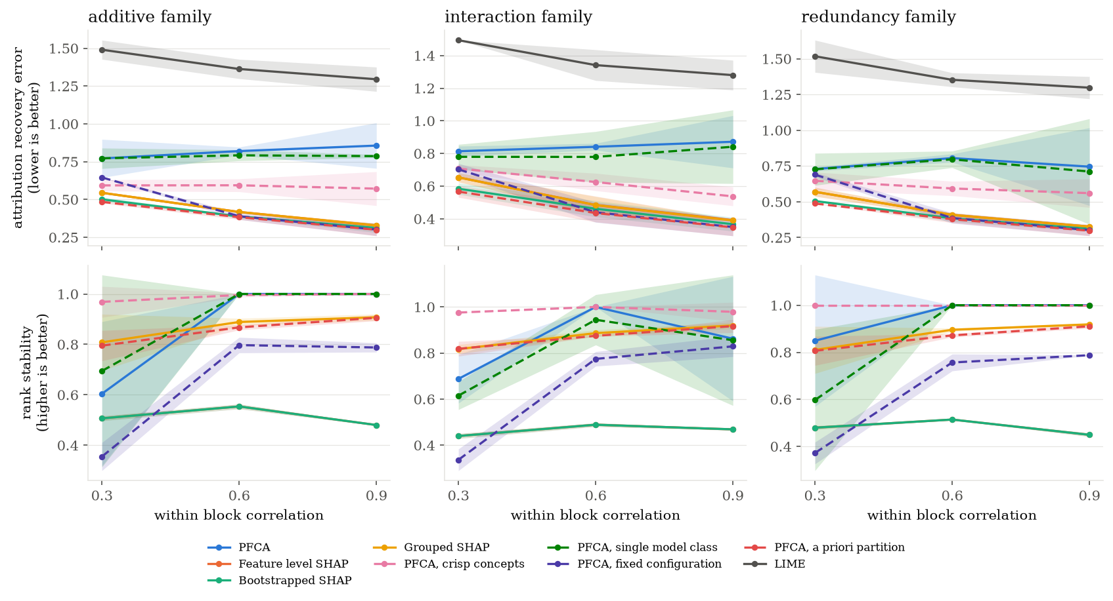
Figure 2. Attribution recovery error (upper row, lower is better) and rank stability (lower row, higher is better) against the within block correlation, by method and family; mean and 95 percent confidence band over cells and seeds.
Table 1. Correctness, faithfulness and stability per family and method in Phase A, mean (SD) over cells and seeds
Family | Method | n | recovery error | rank recovery | rank stability | deletion AUC | insertion AUC | surrogate R2
additive | PFCA | 24 | 0.816 (0.311) | 0.329 (0.519) | 0.868 (0.337) | 0.396 (0.122) | 0.709 (0.065) | 0.922 (0.049)
additive | SHAP | 24 | 0.430 (0.126) | 0.921 (0.141) | 0.514 (0.140) | 0.312 (0.113) | 0.975 (0.040) | 0.970 (0.050)
additive | Bootstrapped SHAP | 24 | 0.401 (0.120) | 0.938 (0.135) | 0.514 (0.140) | 0.307 (0.098) | 0.964 (0.039) | 0.932 (0.050)
additive | Grouped SHAP | 24 | 0.430 (0.126) | 0.921 (0.141) | 0.868 (0.140) | 0.236 (0.050) | 0.816 (0.048) | 0.805 (0.135)
additive | LIME | 24 | 1.383 (0.116) | 0.842 (0.167) |  | 0.405 (0.115) | 0.848 (0.055) | 0.127 (0.405)
additive | PFCA, crisp | 24 | 0.587 (0.181) | 0.854 (0.188) | 0.988 (0.051) | 0.303 (0.057) | 0.727 (0.050) | 0.926 (0.048)
additive | PFCA, single class | 24 | 0.784 (0.275) | 0.416 (0.470) | 0.898 (0.291) | 0.383 (0.153) | 0.728 (0.063) | 0.930 (0.063)
additive | PFCA, fixed | 24 | 0.446 (0.200) | 0.885 (0.156) | 0.647 (0.315) | 0.444 (0.148) | 0.829 (0.096) | 0.944 (0.037)
additive | PFCA, a priori | 24 | 0.389 (0.116) | 0.900 (0.156) | 0.856 (0.141) | 0.248 (0.051) | 0.805 (0.043) | 0.815 (0.134)
interaction | PFCA | 24 | 0.842 (0.307) | 0.327 (0.565) | 0.850 (0.333) | 0.387 (0.128) | 0.677 (0.070) | 0.885 (0.100)
interaction | SHAP | 24 | 0.510 (0.139) | 0.954 (0.102) | 0.466 (0.141) | 0.307 (0.098) | 0.949 (0.034) | 0.969 (0.067)
interaction | Bootstrapped SHAP | 24 | 0.471 (0.127) | 0.946 (0.114) | 0.466 (0.141) | 0.304 (0.096) | 0.940 (0.041) | 0.895 (0.094)
interaction | Grouped SHAP | 24 | 0.509 (0.139) | 0.963 (0.088) | 0.874 (0.139) | 0.231 (0.079) | 0.779 (0.047) | 0.806 (0.178)
interaction | LIME | 24 | 1.372 (0.116) | 0.867 (0.158) |  | 0.412 (0.092) | 0.818 (0.050) | 0.138 (0.317)
interaction | PFCA, crisp | 24 | 0.623 (0.199) | 0.877 (0.149) | 0.985 (0.043) | 0.284 (0.074) | 0.698 (0.068) | 0.891 (0.074)
interaction | PFCA, single class | 24 | 0.800 (0.273) | 0.403 (0.498) | 0.805 (0.340) | 0.380 (0.155) | 0.693 (0.076) | 0.887 (0.105)
interaction | PFCA, fixed | 24 | 0.497 (0.194) | 0.910 (0.126) | 0.647 (0.314) | 0.410 (0.152) | 0.794 (0.096) | 0.915 (0.055)
interaction | PFCA, a priori | 24 | 0.450 (0.123) | 0.917 (0.131) | 0.870 (0.147) | 0.248 (0.070) | 0.766 (0.045) | 0.786 (0.158)
redundancy | PFCA | 24 | 0.760 (0.313) | 0.483 (0.495) | 0.950 (0.205) | 0.378 (0.099) | 0.719 (0.051) | 0.910 (0.067)
redundancy | SHAP | 24 | 0.435 (0.137) | 0.929 (0.133) | 0.481 (0.117) | 0.341 (0.113) | 0.980 (0.042) | 0.967 (0.082)
redundancy | Bootstrapped SHAP | 24 | 0.400 (0.122) | 0.933 (0.134) | 0.481 (0.117) | 0.319 (0.102) | 0.971 (0.051) | 0.917 (0.085)
redundancy | Grouped SHAP | 24 | 0.435 (0.137) | 0.929 (0.133) | 0.875 (0.138) | 0.239 (0.054) | 0.809 (0.044) | 0.800 (0.165)
redundancy | LIME | 24 | 1.389 (0.127) | 0.842 (0.167) |  | 0.446 (0.111) | 0.853 (0.052) | -0.092 (0.494)
redundancy | PFCA, crisp | 24 | 0.600 (0.189) | 0.851 (0.184) | 1.000 (0.000) | 0.307 (0.066) | 0.725 (0.057) | 0.911 (0.052)
redundancy | PFCA, single class | 24 | 0.745 (0.293) | 0.545 (0.458) | 0.866 (0.337) | 0.397 (0.127) | 0.718 (0.055) | 0.931 (0.054)
redundancy | PFCA, fixed | 24 | 0.459 (0.206) | 0.843 (0.185) | 0.639 (0.304) | 0.391 (0.155) | 0.831 (0.095) | 0.940 (0.039)
redundancy | PFCA, a priori | 24 | 0.388 (0.118) | 0.921 (0.132) | 0.863 (0.139) | 0.250 (0.053) | 0.799 (0.046) | 0.815 (0.130)
Note. n is the number of cells times seeds. Lower is better for the recovery error and the deletion AUC, higher is better for the other metrics. Empty cells mark metrics that do not apply to a method.
The linear mixed model contrasts are reported in Table 2. The models used the sample size, the dimension and the correlation as fixed effects and the seed as random intercept. Relative to feature level SHAP, PFCA had a higher recovery error by +0.386 (95% CI 0.307 to 0.465), +0.332 (0.251 to 0.413) and +0.325 (0.245 to 0.405) in the additive, interaction and redundancy families (all p < 0.001). Its rank stability was higher by +0.354 (0.258 to 0.451), +0.384 (0.285 to 0.483) and +0.469 (0.375 to 0.562) (all p < 0.001), and its deletion AUC higher by +0.084 (p = 0.004), +0.080 (p = 0.009) and +0.037 (p = 0.184). Grouped SHAP differed from feature level SHAP by 0.000 in recovery error, by +0.355, +0.408 and +0.394 in rank stability and by -0.076, -0.076 and -0.102 in deletion AUC. The contrasts of the a priori ablation were -0.041, -0.060 and -0.047 in recovery error (p = 0.31, 0.14 and 0.25) and +0.342, +0.404 and +0.382 in rank stability, and those of the crisp variant were +0.156, +0.113 and +0.165 in recovery error and +0.475, +0.519 and +0.519 in rank stability.
Table 2. Linear mixed model contrasts of PFCA and of grouped SHAP against feature level SHAP in Phase A, per family and metric
Family | Metric | Method | Estimate | SE | 95% CI | p
additive | recovery error | Grouped SHAP | +0.000 | 0.040 | [-0.079, 0.079] | 0.996
additive | recovery error | PFCA | +0.386 | 0.040 | [0.307, 0.465] | <0.001
additive | rank stability | Grouped SHAP | +0.355 | 0.049 | [0.258, 0.451] | <0.001
additive | rank stability | PFCA | +0.354 | 0.049 | [0.258, 0.451] | <0.001
additive | deletion auc | Grouped SHAP | -0.076 | 0.029 | [-0.133, -0.019] | 0.009
additive | deletion auc | PFCA | +0.084 | 0.029 | [0.027, 0.141] | 0.004
interaction | recovery error | Grouped SHAP | -0.001 | 0.041 | [-0.082, 0.080] | 0.979
interaction | recovery error | PFCA | +0.332 | 0.041 | [0.251, 0.413] | <0.001
interaction | rank stability | Grouped SHAP | +0.408 | 0.050 | [0.310, 0.507] | <0.001
interaction | rank stability | PFCA | +0.384 | 0.050 | [0.285, 0.483] | <0.001
interaction | deletion auc | Grouped SHAP | -0.076 | 0.031 | [-0.136, -0.016] | 0.013
interaction | deletion auc | PFCA | +0.080 | 0.031 | [0.020, 0.140] | 0.009
redundancy | recovery error | Grouped SHAP | +0.000 | 0.041 | [-0.080, 0.080] | 0.996
redundancy | recovery error | PFCA | +0.325 | 0.041 | [0.245, 0.405] | <0.001
redundancy | rank stability | Grouped SHAP | +0.394 | 0.048 | [0.301, 0.487] | <0.001
redundancy | rank stability | PFCA | +0.469 | 0.048 | [0.375, 0.562] | <0.001
redundancy | deletion auc | Grouped SHAP | -0.102 | 0.028 | [-0.157, -0.048] | <0.001
redundancy | deletion auc | PFCA | +0.037 | 0.028 | [-0.018, 0.092] | 0.184
Note. Model: linear mixed model, random intercept per seed; sample size, dimension and correlation as categorical fixed effects. A negative estimate means a smaller value than SHAP. The contrasts of the other methods are given in the supplementary file phase_a_mixed_models.csv.
Table 3 and Figure 3 report the calibration metrics over all cells and seeds. The true concept attribution fell inside the PFCA support in 59.3 percent (SD 17.3) of the cases and inside the core in 28.4 percent (11.4), and the replicated attribution in 70.3 percent (6.4) and 34.9 percent (5.4); for the bootstrapped SHAP intervals the replicate coverage was 66.7 and 32.7 percent. The crisp variant and the a priori ablation covered the truth more often, 71.5 and 73.3 percent for the support and 35.1 and 35.7 percent for the core. The expected calibration error of the sign confidence was 0.085 for PFCA, 0.078 for the crisp variant, 0.084 for the a priori ablation and 0.101 for bootstrapped SHAP, and the reliability diagram of Figure 4 shows the observed sign agreement against the stated confidence.
Table 3. Interval coverage and sign confidence calibration in Phase A, mean (SD) over all cells and seeds
Method | support, truth | core, truth | support, replicate | core, replicate | sign confidence ECE
PFCA | 0.593 (0.173) | 0.284 (0.114) | 0.703 (0.064) | 0.349 (0.054) | 0.085 (0.031)
Bootstrapped SHAP |  |  | 0.667 (0.045) | 0.327 (0.039) | 0.101 (0.038)
PFCA, crisp | 0.715 (0.110) | 0.351 (0.085) | 0.723 (0.083) | 0.390 (0.135) | 0.078 (0.033)
PFCA, single class | 0.602 (0.165) | 0.300 (0.114) | 0.686 (0.070) | 0.340 (0.054) | 0.087 (0.036)
PFCA, fixed | 0.669 (0.173) | 0.316 (0.118) | 0.692 (0.059) | 0.336 (0.055) | 0.091 (0.038)
PFCA, a priori | 0.733 (0.091) | 0.357 (0.079) | 0.699 (0.055) | 0.343 (0.051) | 0.084 (0.040)
Note. Nominal coverage is 0.90 for the support and 0.50 for the core. ECE is the expected calibration error of the sign confidence against the sign agreement with the replicate attribution.
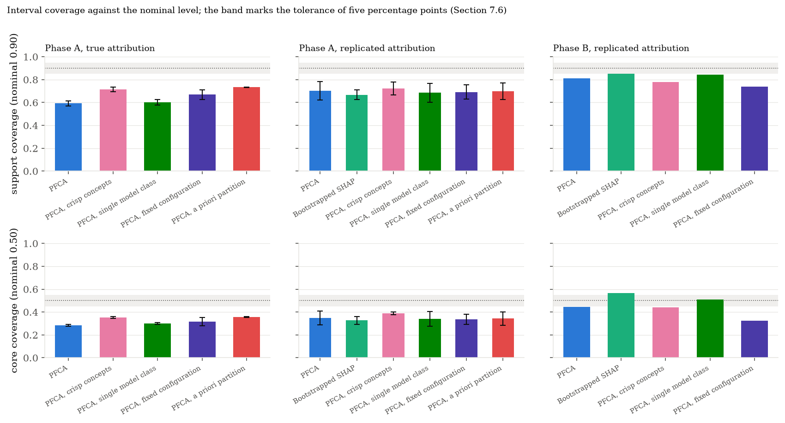
Figure 3. Coverage of the true and of the replicated attribution by the fuzzy support and core of the compared methods against the nominal levels, with the tolerance band of the success criteria.
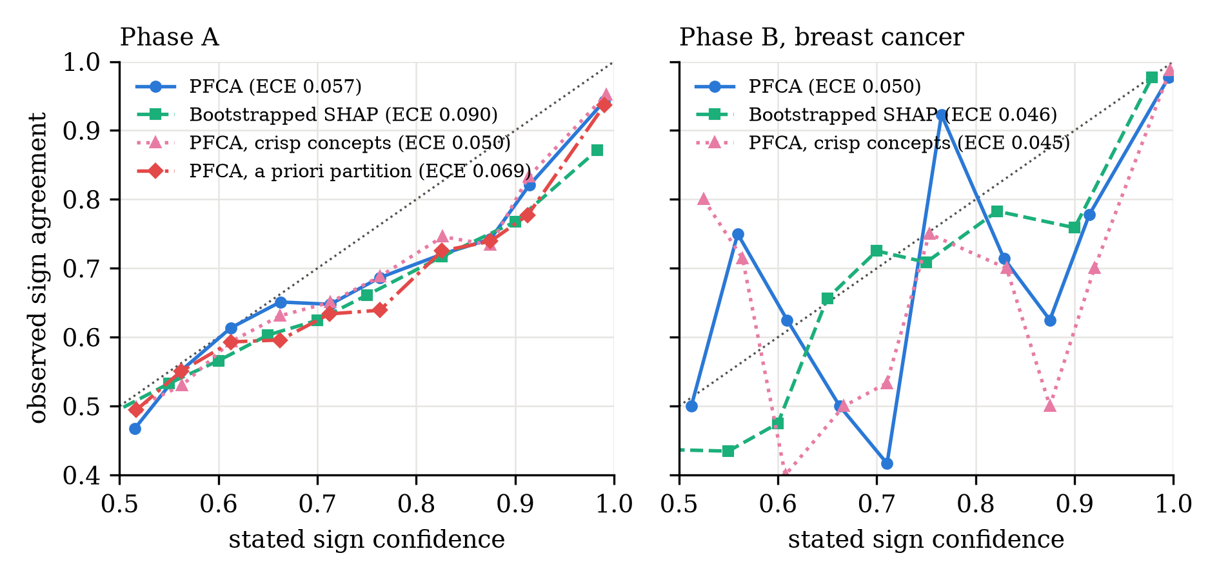
Figure 4. Reliability diagrams of the sign confidence in Phase A (left) and on the breast cancer dataset (right): observed sign agreement with the replicate attribution against the stated confidence, bins pooled over cells and repetitions and weighted by count; the dotted line is perfect calibration.
In the redundancy family the change of the attribution when the duplicate features are added is reported in Table 4 and Figure 5. The relative change was 0.524 (0.127) for feature level SHAP, 0.531 (0.038) for bootstrapped SHAP and 0.522 (0.129) for LIME, against 0.047 (0.023) for grouped SHAP, 0.017 (0.006) for the a priori ablation and 0.071 (0.132) for the crisp variant. The full method changed by 0.266 with a standard deviation of 0.419, the single class variant by 0.187 (0.230) and the fixed configuration by 0.285 (0.283).
Table 4. Relative change of the attribution when the duplicate features are added, redundancy family of Phase A, mean (SD)
Method | duplication change | n
PFCA | 0.266 (0.419) | 24
SHAP | 0.524 (0.127) | 24
Bootstrapped SHAP | 0.531 (0.038) | 24
Grouped SHAP | 0.047 (0.023) | 24
LIME | 0.522 (0.129) | 24
PFCA, crisp | 0.071 (0.132) | 24
PFCA, single class | 0.187 (0.230) | 24
PFCA, fixed | 0.285 (0.283) | 24
PFCA, a priori | 0.017 (0.006) | 24
Note. The change is computed between the explanation of the problem without the duplicates and the explanation of the same instances with the duplicates, on the attribution of the item that contains the duplicated feature.
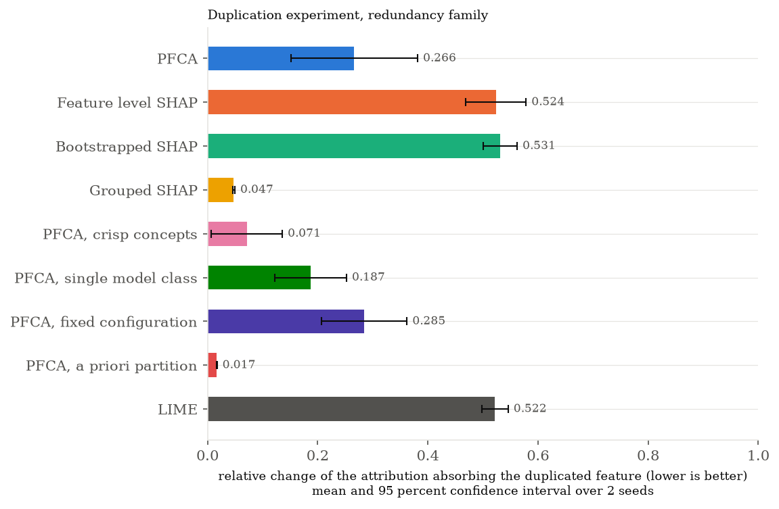
Figure 5. Duplication experiment in the redundancy family: relative change of the attribution of the item that contains the duplicated feature when the duplicates are added, per method.

3.2. Public benchmark
The results on the breast cancer dataset are reported in Table 5 as means and standard deviations over the five repetitions of the split. The reference gradient boosting model reached a mean test ROC-AUC of 0.988 (range .979 to .996) and between 39 and 51 of the 100 explained instances of a repetition lay outside the training split of the replicate repetition and entered the calibration metrics. PFCA selected two concepts in every repetition and retained 1.4 of them on average at the knee point, from a front of 64.0 Pareto optimal configurations (12.8 distinct explanations) among the 420 evaluated; the matched sparsity of the feature level baselines was 20.8 features.
In terms of faithfulness, the deletion AUC of PFCA was 0.639 (SD 0.050) against 0.814 (0.105) for feature level SHAP, 0.819 (0.099) for bootstrapped SHAP and 0.902 (0.041) for LIME, whereas its insertion AUC was 0.765 (0.037) against 0.992 (0.006), 0.990 (0.008) and 0.976 (0.006), respectively. The surrogate $R^{2}$ on the retained items was 0.970 (0.010) for PFCA, 1.000 for SHAP, 0.976 (0.023) for bootstrapped SHAP and -0.168 (0.089) for LIME. Among the ablations, the crisp variant and the single class variant gave deletion areas of 0.656 and 0.645 and surrogate values of 0.979 and 0.975, while the fixed configuration, which retained every one of its five concepts, gave a deletion area of 0.809 and an insertion area of 0.919.
Rank stability was 1.000 (0.000) for PFCA and its single class variant, 0.987 (0.029) for the crisp variant, 0.862 (0.061) for the fixed configuration and 0.507 (0.033) for both feature level SHAP and bootstrapped SHAP. Perturbation stability, where lower values indicate a smaller change of the attribution relative to the change of the output, was 1.532 (0.389) for PFCA, 2.223 (0.606) for SHAP, 3.055 (0.261) for bootstrapped SHAP and 0.391 (0.384) for LIME. The replicate attribution fell inside the fuzzy support of PFCA in 81.0 percent (SD 11.2) of the cases and inside the core in 44.4 percent (10.4), against 85.0 and 56.6 percent for the bootstrapped SHAP intervals. The expected calibration error of the sign confidence was 0.075 for PFCA, 0.065 for the crisp variant, 0.050 for the single class variant and 0.093 for bootstrapped SHAP. Three of the 200 fuzzy attributions per repetition (100 instances by two concepts) were upgraded to interval type 2 sets. The explanation step of PFCA took 10.1 s per repetition after a shared pool of 18.5 s, against 0.46 s for feature level SHAP, 9.3 s for bootstrapped SHAP and 1.05 s for LIME.
Table 5. Faithfulness, stability, calibration and cost on the breast cancer dataset, mean (SD) over 5 repetitions of the split
Method | deletion AUC | insertion AUC | surrogate R2 | rank stability | perturbation stability | support coverage | core coverage | time (s)
PFCA | 0.639 (0.050) | 0.765 (0.037) | 0.970 (0.010) | 1.000 (0.000) | 1.532 (0.389) | 0.810 (0.112) | 0.444 (0.104) | 10.082 (0.639)
SHAP | 0.814 (0.105) | 0.992 (0.006) | 1.000 (0.000) | 0.507 (0.033) | 2.223 (0.606) |  |  | 0.463 (0.069)
Bootstrapped SHAP | 0.819 (0.099) | 0.990 (0.008) | 0.976 (0.023) | 0.507 (0.033) | 3.055 (0.261) | 0.850 (0.031) | 0.566 (0.048) | 9.265 (1.371)
LIME | 0.902 (0.041) | 0.976 (0.006) | -0.168 (0.089) |  | 0.391 (0.384) |  |  | 1.050 (0.112)
PFCA, crisp | 0.656 (0.059) | 0.781 (0.077) | 0.979 (0.012) | 0.987 (0.029) | 1.657 (0.411) | 0.780 (0.130) | 0.439 (0.172) | 10.113 (0.778)
PFCA, single class | 0.645 (0.045) | 0.769 (0.042) | 0.975 (0.013) | 1.000 (0.000) | 1.464 (0.644) | 0.842 (0.111) | 0.509 (0.159) | 8.798 (0.406)
PFCA, fixed | 0.809 (0.039) | 0.919 (0.024) | 0.978 (0.013) | 0.862 (0.061) | 1.979 (0.266) | 0.738 (0.141) | 0.325 (0.110) | 5.433 (0.259)
Note. Surrogate R2 is computed on the retained items at the sparsity of the PFCA knee. Time is the wall clock time of the explanation step after the shared pool.

3.3. Simulated questionnaire
Table 6 reports the results on the simulated questionnaire over five repetitions; the reference model reached a test $R^{2}$ of 0.529. The knee point of PFCA selected 2.2 concepts on average and retained 1.8 of them, from a front of 82.0 configurations (16.4 distinct explanations) among 445 evaluated, which includes the a priori subscale partition as a candidate. The adjusted Rand index between the hardened PFCA partition and the five a priori subscales was 0.347 (0.130), and 0.285 (0.085) for the crisp variant; it equals one by construction for the a priori ablation and the grouped baseline.
On faithfulness, the deletion AUC was 0.346 (0.065) for PFCA against 0.207 (0.037) for feature level SHAP, 0.177 (0.045) for grouped SHAP, 0.188 (0.045) for the a priori ablation and 0.373 (0.046) for LIME, and the insertion AUC was 0.626 (0.038) for PFCA against 0.953 (0.021), 0.773 (0.013), 0.765 (0.009) and 0.759 (0.022). The surrogate $R^{2}$ at matched sparsity was 0.890 (0.092) for PFCA, 0.989 (0.017) for SHAP, 0.948 (0.030) for bootstrapped SHAP, 0.694 (0.111) for grouped SHAP and 0.694 (0.076) for the a priori ablation. Rank stability was 0.933 (0.149) for PFCA, 1.000 (0.000) for the crisp variant, 0.848 (0.035) for grouped SHAP, 0.843 (0.018) for the a priori ablation and 0.517 (0.022) for feature level and bootstrapped SHAP. The replicate attribution fell inside the PFCA support in 83.8 percent (5.8) of the cases and inside the core in 46.6 percent, against 80.6 and 40.3 percent for the a priori ablation and 81.0 and 42.9 percent for bootstrapped SHAP, with sign confidence calibration errors of 0.081, 0.058 and 0.091. On average 5.6 of the 220 fuzzy attributions of a repetition were upgraded to type 2 sets for PFCA, against 21.2 of 500 for the a priori ablation with its five concepts.
Table 7 gives the reliability of the attributions per construct. For PFCA the relative support width of the concept matched to each subscale was 1.28 for anxiety, 1.36 for rumination, 2.07 for self efficacy and 1.95 for social support, with sign confidences of 0.903, 0.907, 0.869 and 0.887, disagreement indices of 0.110, 0.115, 0.146 and 0.190, and fractions of type 2 attributions between 0.013 and 0.055. The share of the membership mass of the matched concept that belonged to the subscale was 0.865 for rumination, 0.554 for anxiety, 0.413 for social support and 0.357 for self efficacy. For bootstrapped SHAP summed over the items of a subscale the relative widths were 0.825, 1.106, 1.417 and 2.550 with sign confidences of 0.931, 0.921, 0.905 and 0.790.
Table 6. Concept recovery, faithfulness, stability and calibration on the simulated questionnaire, mean (SD) over 5 repetitions
Method | ARI vs subscales | deletion AUC | insertion AUC | surrogate R2 | rank stability | support coverage | type 2 attributions
PFCA | 0.347 (0.130) | 0.346 (0.065) | 0.626 (0.038) | 0.890 (0.092) | 0.933 (0.149) | 0.838 (0.058) | 5.6 (2.6)
SHAP | 0.000 (0.000) | 0.207 (0.037) | 0.953 (0.021) | 0.989 (0.017) | 0.517 (0.022)
Bootstrapped SHAP | 0.000 (0.000) | 0.206 (0.025) | 0.954 (0.024) | 0.948 (0.030) | 0.517 (0.022) | 0.810 (0.036)
Grouped SHAP | 1.000 (0.000) | 0.177 (0.045) | 0.773 (0.013) | 0.694 (0.111) | 0.848 (0.035)
LIME | 0.000 (0.000) | 0.373 (0.046) | 0.759 (0.022) | -0.019 (0.069)
PFCA, crisp | 0.285 (0.085) | 0.328 (0.027) | 0.612 (0.021) | 0.853 (0.124) | 1.000 (0.000) | 0.835 (0.059) | 5.0 (1.0)
PFCA, single class | 0.347 (0.130) | 0.343 (0.075) | 0.627 (0.050) | 0.901 (0.096) | 0.955 (0.100) | 0.808 (0.046) | 0.0 (0.0)
PFCA, a priori | 1.000 (0.000) | 0.188 (0.045) | 0.765 (0.009) | 0.694 (0.076) | 0.843 (0.018) | 0.806 (0.065) | 21.2 (7.8)
Note. ARI vs subscales is the adjusted Rand index between the hardened partition of the method and the a priori subscales; it equals one by construction for the a priori partition and the grouped baseline.
Table 7. Reliability of the attribution per construct on the simulated questionnaire, mean over repetitions
Construct | PFCA relative support width | PFCA sign confidence | PFCA disagreement | PFCA fraction type 2 | PFCA overlap with subscale | Bootstrapped SHAP relative support width | Bootstrapped SHAP sign confidence
anxiety | 1.278 | 0.903 | 0.110 | 0.013 | 0.554 | 0.825 | 0.931
rumination | 1.355 | 0.907 | 0.115 | 0.020 | 0.865 | 1.106 | 0.921
self efficacy | 2.067 | 0.869 | 0.146 | 0.055 | 0.357 | 1.417 | 0.905
social support | 1.945 | 0.887 | 0.190 | 0.040 | 0.413 | 2.550 | 0.790
Note. For PFCA every retained concept is matched to the subscale with which it shares most membership mass (overlap). The relative support width is the width of the 5th to 95th percentile interval divided by the absolute median attribution; for bootstrapped SHAP the feature level values of the items of a subscale are summed before the width is computed.
Figure 6 shows the fuzzy attributions of the first explained instance of the first repetition, whose predicted outcome was 70, and Figure 7 the overlap of the two concepts with the subscales. The first concept, which collected the anxiety, self efficacy and social support items together with the covariates, received a strongly positive label with compatibility 1.00. Its centroid was +21.1, its support ran from +12.8 to +31.3, and its sign confidence, disagreement index and selection membership were 1.00, 0.08 and 0.78. The second concept, which coincided with the rumination subscale (overlap 1.00), received the label negligible with compatibility 0.87, a centroid of -1.4, a support from -3.47 to +0.94, a sign confidence of 0.88 and a selection membership of 0.66.
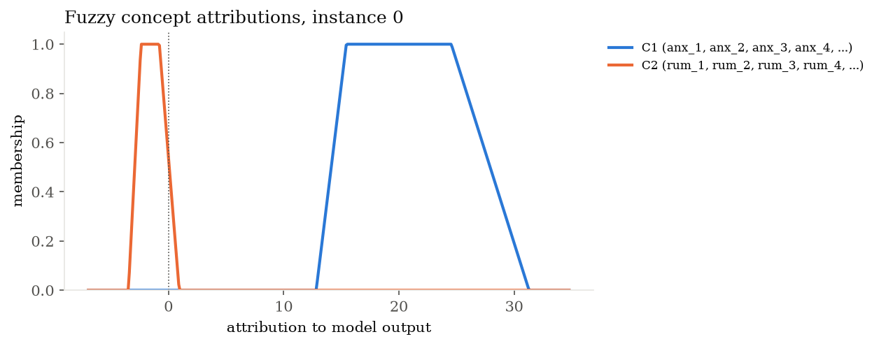
Figure 6. Fuzzy concept attributions of the first explained instance of the simulated questionnaire (first repetition): membership functions of the trapezoidal attributions of the two concepts of the knee explanation.
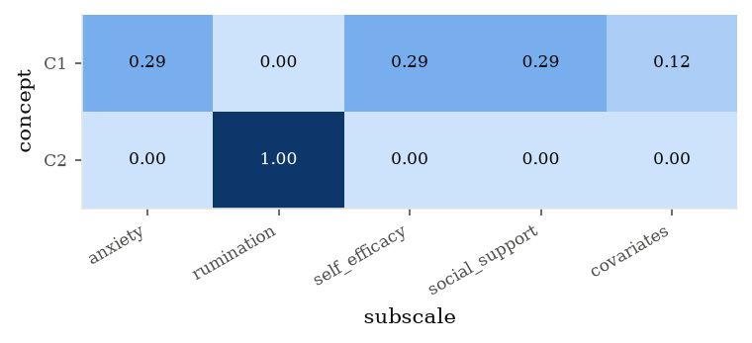
Figure 7. Overlap of the two concepts of the knee explanation with the a priori subscales of the simulated questionnaire, as the share of the membership mass of every concept that belongs to each subscale.

3.4. Pareto front and conflict between the objectives
Figure 8 shows the front of an additive problem with 500 instances, 30 features and a within block correlation of 0.6, explained with a pool of 20 resamples and two model classes on 100 instances. Of the 420 evaluated configurations, 55 were Pareto optimal. The sparsest member retained one of five concepts with a fidelity loss of 0.451 and a complexity of 1.01. The knee point retained one of two concepts with a fidelity loss of 0.093 and a complexity of 2.00, and the most faithful member retained three of three concepts with a fidelity loss of 0.089, a complexity of 5.04 and an instability of 0.049. For the first explained instance the knee explanation labeled its single retained concept strongly negative with a compatibility between 0.19 and 1.00. The two model classes disagreed (disagreement index 0.55), so the attribution was reported as an interval type 2 set with a centroid between -1.80 and -0.85, a sign confidence of 1.00 and a selection membership of 0.53. The most faithful explanation split the same instance into a strongly negative, a weakly negative and a negligible concept.
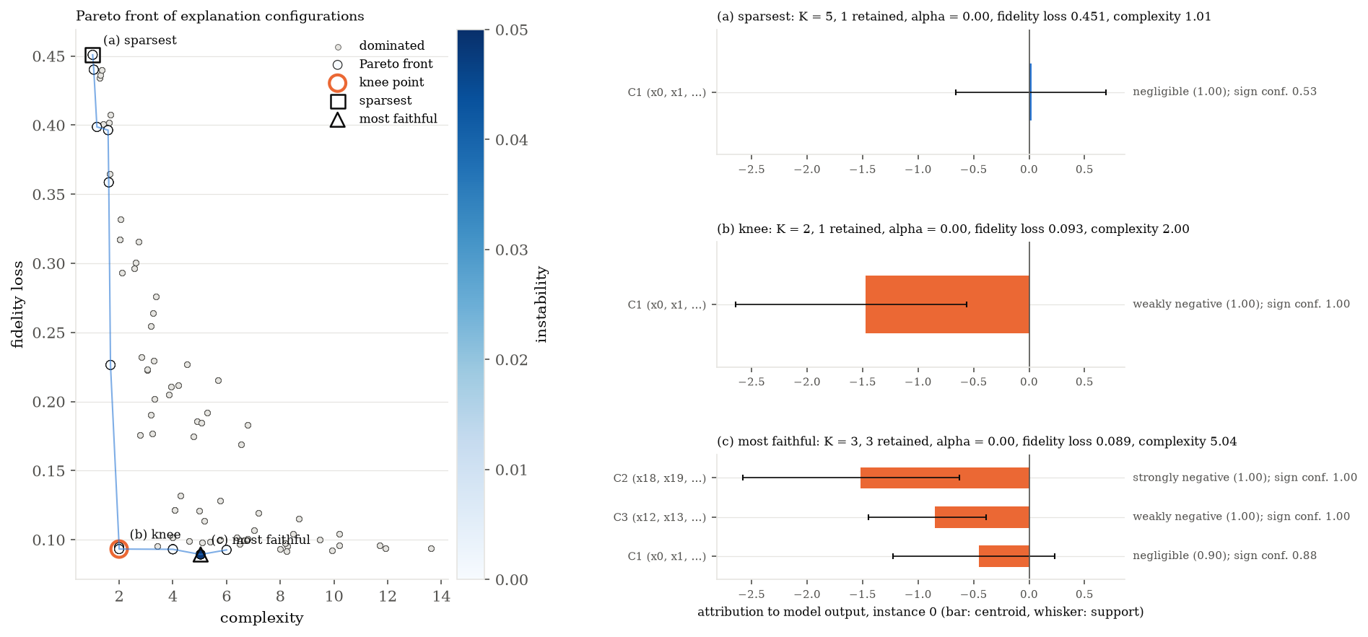
Figure 8. Example Pareto front of explanation configurations (fidelity loss against complexity, colored by instability) with the knee point and three explanations of the same instance taken from the front: (a) the sparsest member, (b) the knee point and (c) the most faithful member.
The diagnostics of the front over the study are reported in Table 8. Over the 72 cells and seeds of Phase A the front held 66.1 of the evaluated configurations on average with 13.2 distinct explanations. On the breast cancer dataset the front held 64.0 of 420 evaluated configurations with 12.8 distinct explanations, and on the questionnaire 82.0 of 445 with 16.4 distinct explanations; no run collapsed to a single explanation. The Spearman correlation between fidelity loss and complexity over the feasible configurations was -0.70 in Phase A, -0.78 on the benchmark and -0.84 on the questionnaire, between fidelity loss and instability -0.17, -0.41 and -0.55, and between complexity and instability +0.55, +0.61 and +0.60.
Table 8. Size of the Pareto front and conflict between the objectives
Source | Group | n | front size | distinct explanations | fraction collapsed | corr(fidelity, complexity) | corr(fidelity, instability) | corr(complexity, instability)
Phase A | additive | 24 | 66.67 | 13.33 | 0.00 | -0.71 | -0.19 | 0.55
Phase A | interaction | 24 | 67.62 | 13.50 | 0.00 | -0.70 | -0.17 | 0.55
Phase A | redundancy | 24 | 64.04 | 12.79 | 0.00 | -0.70 | -0.16 | 0.54
Phase A | all families | 72 | 66.11 | 13.21 | 0.00 | -0.70 | -0.17 | 0.55
sensitivity, solver | grid | 4 | 86.25 | 17.25 | 0.00 | -0.88 | -0.60 | 0.77
sensitivity, solver | nsga2 | 4 | 647.75 | 17.75 | 0.00 | -0.87 | -0.67 | 0.77
Note. Spearman correlations between the objectives over the feasible configurations; a negative value means that the two objectives conflict.

3.5. Sensitivity analysis
Table 9 reports the sensitivity analysis on the additive and the redundancy cell with 500 instances, 30 features and a within block correlation of 0.6, over two seeds, where the true structure has five factors. Under the default setting the utopia knee selected two concepts and retained 1.75 of them, with a recovery error of 1.154, a rank stability of 1.000, a support coverage of the truth of 0.436 and 17.25 distinct explanations on the front.
Increasing the number of resamples from 10 to 20 and 50 left the recovery error unchanged (1.158, 1.154, 1.154) and raised the support coverage from 0.379 to 0.431 and 0.436. The mean absolute difference between the quantile arrays at a given $B$ and at $B=50$, relative to the typical attribution, fell from 0.136 at $B=10$ to 0.080 at $B=20$, the number of type 2 attributions fell from 12.5 to 8.75 and 6.5 of 200, and the explanation time rose from 8.5 to 13.7 s. With one, two and three model classes the recovery error was 1.096, 1.154 and 1.095, the support coverage 0.429, 0.436 and 0.468, and the number of type 2 attributions 0, 6.5 and 32.75, whereas the rank stability fell to 0.817 with the third class. The triangular shape reproduced every value of the trapezoidal one except the core coverage, which fell to zero because the core of a triangular number is a single point. The percentile levels moved the support coverage from 0.355 (10th to 90th percentiles) to 0.436 (5th to 95th) and 0.512 (2.5th to 97.5th), with relative support widths of 1.20, 1.54 and 1.83.
The loading distance gave a recovery error of 0.975 against 1.154 for the correlation distance, a rank stability of 0.706 against 1.000, a support coverage of 0.544 and 2.5 concepts on average. NSGA-II recovered 98.8 percent of the distinct members of the exhaustive front, reached a hypervolume ratio of 1.000 and selected the same knee explanation as the grid in every run, in 8.3 s against 13.7 s for the enumeration. The knee criterion changed the explanation more than any other factor. The hyperplane criterion selected 4.5 concepts and retained 3.0, with a recovery error of 0.642, a rank stability of 0.833 and a support coverage of 0.606. The sparsest member within 10 percent of the best fidelity loss selected 3.75 concepts and retained 3.5 with a recovery error of 0.718, and the member of median complexity selected 3.0 concepts and retained 2.0 with a recovery error of 1.000. The alternative label sets left every metric of the selection unchanged, as expected since the labels do not enter the objectives. The sign class of the chosen label agreed with the default set in 83.6 percent of the attributions for the narrow set, 87.5 percent for the wide set and 100 percent for the three label set, and the fraction of negligible labels was 0.334 under the default set, 0.170 under the narrow set and 0.459 under the wide set.
Table 9. Sensitivity of the explanation to the design choices of the method, mean (SD) over cells and seeds
Factor | Setting | n | recovery error | rank stability | support coverage | distinct front size | relative quantile MAD to largest B | front recovery | label sign agreement
resamples | B10 | 4 | 1.158 (0.094) | 1.000 (0.000) | 0.379 (0.024) | 13.500 (5.196) | 0.136 (0.011) |  | 1.000 (0.000)
resamples | B20 | 4 | 1.154 (0.091) | 1.000 (0.000) | 0.431 (0.020) | 18.500 (7.594) | 0.080 (0.005) |  | 1.000 (0.000)
resamples | B50 | 4 | 1.154 (0.090) | 1.000 (0.000) | 0.436 (0.023) | 17.250 (6.850) | 0.000 (0.000) |  | 1.000 (0.000)
model_classes | M1 | 4 | 1.096 (0.116) | 1.000 (0.000) | 0.429 (0.051) | 13.250 (3.500) |  |  | 1.000 (0.000)
model_classes | M2 | 4 | 1.154 (0.090) | 1.000 (0.000) | 0.436 (0.023) | 17.250 (6.850) |  |  | 1.000 (0.000)
model_classes | M3 | 4 | 1.095 (0.189) | 0.817 (0.215) | 0.467 (0.071) | 20.750 (5.377) |  |  | 1.000 (0.000)
shape | trapezoidal | 4 | 1.154 (0.090) | 1.000 (0.000) | 0.436 (0.023) | 17.250 (6.850) |  |  | 1.000 (0.000)
shape | triangular | 4 | 1.154 (0.090) | 1.000 (0.000) | 0.436 (0.023) | 17.250 (6.850) |  |  | 1.000 (0.000)
percentiles | s5-95_c25-75 | 4 | 1.154 (0.090) | 1.000 (0.000) | 0.436 (0.023) | 17.250 (6.850) |  |  | 1.000 (0.000)
percentiles | s2.5-97.5_c25-75 | 4 | 1.157 (0.088) | 1.000 (0.000) | 0.512 (0.025) | 17.250 (6.850) |  |  | 1.000 (0.000)
percentiles | s10-90_c30-70 | 4 | 1.153 (0.089) | 1.000 (0.000) | 0.355 (0.027) | 17.250 (6.850) |  |  | 1.000 (0.000)
distance | correlation | 4 | 1.154 (0.090) | 1.000 (0.000) | 0.436 (0.023) | 17.250 (6.850) |  |  | 1.000 (0.000)
distance | loading | 4 | 0.975 (0.279) | 0.706 (0.335) | 0.544 (0.091) | 14.000 (2.582) |  |  | 1.000 (0.000)
solver | grid | 4 | 1.154 (0.090) | 1.000 (0.000) | 0.436 (0.023) | 17.250 (6.850) |  |  | 1.000 (0.000)
solver | nsga2 | 4 | 1.154 (0.090) | 1.000 (0.000) | 0.436 (0.023) | 17.750 (7.274) |  | 0.988 (0.024) | 1.000 (0.000)
knee | utopia | 4 | 1.154 (0.090) | 1.000 (0.000) | 0.436 (0.023) | 17.250 (6.850) |  |  | 1.000 (0.000)
knee | hyperplane | 4 | 0.642 (0.343) | 0.833 (0.137) | 0.606 (0.109) | 17.250 (6.850) |  |  | 1.000 (0.000)
knee | sparsest_within_10pct | 4 | 0.718 (0.314) | 0.827 (0.102) | 0.599 (0.191) |  |  |  | 1.000 (0.000)
knee | median_complexity | 4 | 1.000 (0.058) | 0.809 (0.122) | 0.523 (0.018) |  |  |  | 1.000 (0.000)
labels | default | 4 | 1.154 (0.090) | 1.000 (0.000) | 0.436 (0.023) | 17.250 (6.850) |  |  | 1.000 (0.000)
labels | narrow | 4 | 1.154 (0.090) | 1.000 (0.000) | 0.436 (0.023) | 17.250 (6.850) |  |  | 0.836 (0.017)
labels | wide | 4 | 1.154 (0.090) | 1.000 (0.000) | 0.436 (0.023) | 17.250 (6.850) |  |  | 0.875 (0.050)
labels | three_labels | 4 | 1.154 (0.090) | 1.000 (0.000) | 0.436 (0.023) | 17.250 (6.850) |  |  | 1.000 (0.000)
Note. The default setting appears under every factor. Settings: B is the number of resamples, M the number of model classes, s and c the percentile levels of the support and the core.

3.6. Success criteria
Table 10 evaluates the three pre registered criteria on the reduced study. In the redundancy family, paired by cell and seed, PFCA had a higher recovery error than feature level SHAP (0.760 against 0.435, Cohen's d of the paired differences 1.068 in the unfavorable direction) and a higher rank stability (0.950 against 0.481, d = 2.050), so that the first criterion was met for stability and not for the recovery error. On the benchmark the deletion AUC of PFCA was better than that of SHAP (0.639 against 0.814) whereas the insertion AUC (0.765 against 0.992) and the surrogate $R^{2}$ (0.970 against 1.000) were lower, so that the second criterion was met on one of its three quantities. The coverage of the support and of the core was below the nominal level minus the tolerance of five percentage points for every quantity of the third criterion, with 59.3 and 28.4 percent against the truth and 70.3 and 34.9 percent against the replicate in Phase A and 81.0 and 44.4 percent against the replicate on the benchmark.
Table 10. Pre registered success criteria evaluated on the reduced study
Criterion | Phase | Quantity | PFCA | Reference | Effect or p | Status
1 | A, redundancy family | recovery error | 0.760 | 0.435 | 1.068 (Cohen d) | not met
1 | A, redundancy family | rank stability | 0.950 | 0.481 | 2.050 (Cohen d) | met
2 | B | deletion auc | 0.639 | 0.814 |  | met
2 | B | insertion auc | 0.765 | 0.992 |  | not met
2 | B | surrogate r2 | 0.970 | 1.000 |  | not met
3 | A | support coverage truth | 0.593 | 0.900 |  | not met
3 | A | core coverage truth | 0.284 | 0.500 |  | not met
3 | A | support coverage replicate | 0.703 | 0.900 |  | not met
3 | A | core coverage replicate | 0.349 | 0.500 |  | not met
3 | B | support coverage replicate | 0.810 | 0.900 |  | not met
3 | B | core coverage replicate | 0.444 | 0.500 |  | not met
Note. Criterion 1: favorable paired difference with |Cohen d| of at least 0.5. Criterion 2: per dataset mean not worse than SHAP. Criterion 3: coverage within 0.05 of the nominal 0.90 (support) or 0.50 (core).

4. Discussion
The aim of this study was to establish whether attributing predictions to fuzzy concepts, representing their uncertainty as fuzzy numbers and selecting the explanation from a Pareto front yields explanations that are more stable and more honest about their reliability than feature level SHAP, without a loss of faithfulness. The synthetic phase answers the first part of that question clearly and the second part with a qualification. Across the three families (Table 1, Figure 2) the ranking of concept importance produced by PFCA was far more stable across resamples than the ranking of feature level SHAP, with the largest gap in the redundancy family, where the exact and near duplicates make the feature level ranking depend on which copy receives the credit in a given resample. The mixed model contrasts of Table 2 confirm that this gap is systematic rather than a property of a few cells. This is the behavior predicted by the analysis of Aas et al. (2021) and Kumar et al. (2020), in which the split of credit among dependent features is determined by the estimation scheme, and it is the behavior that the concept level removes, since the credit of a block is the same whichever copy carries it.
The qualification concerns the attribution recovery error, on which PFCA was worse than feature level SHAP and than its own a priori, crisp and fixed configuration ablations. The cause is visible in the number of concepts selected: the utopia knee chose about two concepts in every family, whereas the generating process has three factors at ten features and five at thirty, so that the concepts of the knee explanation merge factors and the matching based recovery error charges the merged factors as errors. The ablations that do not select the configuration from the front, the fixed configuration with five concepts and the a priori partition, had the lowest errors, and the sensitivity analysis showed that the hyperplane knee, which selects four to five concepts, almost halves the error of the utopia knee. The recovery error therefore measures the sparsity preference of the default knee rather than a limit of concept attribution. In line with the counterfactual search of Dandl et al. (2020), where no single trade off satisfies every use, the front of Section 3.4 contains the finer explanations, and a user who needs the factor structure recovered selects a member beyond the knee. For the same reason the first success criterion was met for rank stability but not for the recovery error (Table 10), and the paper reports this as stated in the pre registration.
The duplication experiment (Table 4) supports the central proposition of the method where the partition is held fixed and qualifies it where the partition is selected. Adding the duplicates changed the feature level attributions of SHAP, bootstrapped SHAP and LIME by about half of their magnitude, which is the credit splitting that motivates grouped attribution (Au et al., 2022), whereas the crisp and the a priori variants of PFCA and grouped SHAP changed by a few percent. The full method changed more on average and with a large dispersion, because the duplicates alter the correlation profiles on which the candidate partitions are built and the knee point can move to another configuration between the two problems, so that the two explanations are not always built on the same partition. The invariance proved for a fixed membership matrix thus holds empirically, and the selection layer introduces a second source of variation that the selection membership of Equation (10) is designed to expose rather than to hide.
The calibration results require the most careful reading. The fuzzy supports covered the true attribution and the replicated attribution less often than their nominal 90 percent, and the cores less often than 50 percent, in every phase (Table 3, Table 5, Table 6), and the third success criterion was not met. Two causes contribute. The first is the pool size, since the sensitivity analysis showed that the support coverage rises with the number of resamples and that the quantile arrays had not stabilized at $B=20$; the full design prescribes 100 resamples. The second is that a bootstrap pool captures the sampling variability of the attribution but not the bias of the reference model with respect to the true function, so that coverage of the truth cannot reach the nominal level when the model is misspecified, a limitation shared by every resampling interval for explanations (Slack et al., 2021; Molnar et al., 2022). The sign confidence, by contrast, was well calibrated, with expected calibration errors below 0.10 in every phase, which indicates that the direction of a concept attribution is reported with a reliability that matches its stated confidence even where the magnitude intervals are too narrow. Consistent with the model class reliance of Fisher et al. (2019), the disagreement index and the type 2 upgrade increased when a third model class was added, so that the interval type 2 representation (Mendel & John, 2002) carries exactly the model dependence that a single fitted model conceals.
On the breast cancer dataset (Table 5) the picture that emerges is one of a trade off that the method makes explicit rather than one of uniform superiority. PFCA removed the model output faster than any feature level baseline when its concepts were deleted in order of importance, with a deletion area of 0.639 against 0.814 for SHAP. Its ranking of concept importance was perfectly stable across resamples, whereas feature level SHAP and bootstrapped SHAP reached a rank stability of 0.507 on a dataset in which every measured characteristic appears as a mean, a standard error and a worst value. However, the insertion area and the surrogate fidelity of PFCA were below those of feature level SHAP. These two findings have the same cause: the knee point of the front selected two concepts and retained 1.4 of them, so that the surrogate of PFCA was fitted on at most two coarse quantities whereas the matched feature level surrogate used 20.8 features whose exact Shapley values sum to the output by construction. In line with the systematic review of Nauta et al. (2023), faithfulness and compactness pull in opposite directions, and the front of Section 3.4 shows that an explanation with three concepts would have recovered most of the fidelity at the cost of complexity. The low perturbation stability of LIME in the same table reflects its negative surrogate fidelity rather than a desirable property, since a surrogate that does not track the output cannot be unstable with respect to it, a pattern consistent with the instability of local linear explanations documented by Visani et al. (2022).
The questionnaire results (Table 6) illustrate what the concept level adds in a setting with known constructs. The a priori ablation and the grouped baseline, which both use the five subscales as crisp groups, reached a surrogate fidelity of 0.694, whereas the data driven PFCA partition reached 0.890 with two concepts. This suggests that the correlation structure of the simulated items, in which the first two constructs interact and the constructs correlate at 0.3, is better summarized by a coarser partition than the questionnaire design implies. The adjusted Rand index of 0.347 between the hardened partition and the subscales is therefore a property of the knee point, which pays for every additional concept in complexity, rather than a failure to detect the constructs. The rumination subscale was recovered with an overlap of 0.865 (Table 7), and the second concept of the example explanation coincided with it exactly (Figure 7). The reliability table also contains the result that motivated the questionnaire phase, namely that constructs differ in how reliably they are attributed. The self efficacy and social support concepts carried relative support widths of 2.07 and 1.95 and disagreement indices of 0.146 and 0.190, against 1.28 and 0.110 for anxiety, and the fraction of type 2 attributions followed the same order. Feature level SHAP reports none of these differences, and bootstrapped SHAP summed over the items of a subscale ordered the constructs differently, with the widest interval on social support (2.55) and the narrowest on anxiety (0.83), which indicates that the uncertainty of a sum of item level attributions and the uncertainty of a concept attribution are not the same quantity. This agrees with the argument of Au et al. (2022) that grouped importance has to be defined at the group level rather than assembled from feature level values, and with the observation of Molnar et al. (2022) that feature level interpretations under dependence conceal their own uncertainty.
The example front (Figure 8) and the diagnostics of Table 8 address the risk, stated in the study design, that the three objectives would not conflict and the front would collapse to one solution. The front held between 12.8 and 16.4 distinct explanations per run on the real data, fidelity loss and complexity were strongly negatively correlated over the feasible configurations (-0.78 to -0.84), and no run collapsed. The positive correlation between complexity and instability (+0.60) indicates that the two objectives partly agree, so that the front is shaped mainly by the fidelity against complexity trade off, and the knee point consistently settled on the simplest configuration beyond which fidelity loss stops falling steeply. The three explanations drawn from the front in Figure 8 show the practical consequence. The same instance is described by one coarse negative concept at the knee and by three signed concepts at the most faithful member, and the interval type 2 upgrade of the knee explanation records that the two model classes disagreed on the magnitude of the dominant concept, information that a single SHAP vector cannot carry (Fisher et al., 2019; Slack et al., 2021).
The sensitivity analysis (Table 9) separates the design choices that matter from those that do not. The number of resamples affected the width and the coverage of the fuzzy numbers rather than the point attribution. The relative deviation of the quantile arrays from those at $B=50$ halved from $B=10$ to $B=20$ and the support coverage rose accordingly, which indicates that 20 resamples are the smallest adequate pool at this problem size and that the full study value of 100 is conservative, consistent with the stabilization of bootstrap intervals for explanations reported by Slack et al. (2021). The number of model classes acted on a different quantity, the disagreement index, since a third class with a linear structure raised the number of type 2 attributions fivefold and lowered the rank stability, which is the behavior the type 2 upgrade was designed to expose rather than a degradation of the method (Fisher et al., 2019). The shape of the fuzzy number and the percentile levels moved the coverage in the direction expected from their definitions, and the loading distance produced partitions closer to the factor structure on these cells at the price of stability. The evolutionary solver recovered the exhaustive front and its knee in every run at a lower cost, which supports the use of NSGA-II when the grid becomes large. The one choice that changed the explanation itself was the knee criterion. The utopia criterion selected two concepts where the hyperplane criterion selected four to five, and the recovery error against a five factor truth fell from 1.154 to 0.642 with the latter, a trade off that the front makes visible but that the default knee resolves toward simplicity. Finally, the alternative label sets changed the wording of the explanation without changing its substance, since the sign of every label agreed with the default set in at least 83.6 percent of the attributions and the selection metrics were unchanged by construction, which answers the concern that the labels are arbitrary (Mencar & Alonso, 2019).
Two practical implications follow. For practitioners who explain models of questionnaire or clinical data, the concept level explanation with its sign confidence and its disagreement index gives a stable statement of which constructs drive a prediction and how far that statement can be trusted, which the earlier applied studies of this line of work had to infer informally from feature level SHAP values (Ntakolia et al., 2022; Ntakolia et al., 2025). For method developers, the results show that the choice of the representative point on the front is not a detail. The utopia knee favors the simplest explanation whose fidelity loss has stopped falling steeply, which is appropriate for communication but not for structure recovery, and the front itself, not the knee, is the output that should be reported when the two goals differ.

5. Conclusions
This work introduced Pareto optimal fuzzy concept attribution, a post hoc explanation method for tabular black box models. The method attributes predictions to fuzzy concepts of correlated features, represents the uncertainty of every attribution as a trapezoidal fuzzy number with a sign confidence, a disagreement index and linguistic labels, and selects the explanation configuration from a Pareto front of fidelity loss, complexity and instability. The motivating observation was that feature level Shapley values split credit arbitrarily among correlated features, report no reliability and cannot be tuned toward the properties a user needs. The method was evaluated on a reduced version of a four phase study design, with synthetic ground truth, a public benchmark, a simulated questionnaire with known subscales and a sensitivity analysis, against feature level SHAP, bootstrapped SHAP, grouped SHAP, LIME and four ablations of the method, all computed from one shared pool of refitted models.
The results indicated that the concept level attribution is markedly more stable than feature level attribution, with a rank stability of 0.950 against 0.481 in the redundancy family and of 1.000 against 0.507 on the breast cancer dataset. The attribution of a fixed concept partition was invariant to the duplication of a feature where feature level attributions changed by about half of their magnitude, the sign of a concept attribution was calibrated with expected calibration errors below 0.10 in every phase, and the three objectives of the selection conflicted so that the front never collapsed. The results also indicated two costs of the default knee point: the attribution recovery error against the synthetic truth was higher than that of feature level SHAP because the knee merged factors into about two concepts, and the fuzzy supports covered the truth and the replicate less often than their nominal level at 20 resamples. Of the three pre registered success criteria, the stability part of the first and the deletion part of the second were met, whereas the recovery error, the insertion area, the surrogate fidelity and the interval coverage were not, and these failures are reported as the pre registration requires. Beyond the numbers, the contribution is an explanation that states how reliable it is, which concepts the model classes disagree on, and which simpler or more faithful alternatives exist on the front.
The main limitations of this work are the following.
• First, the study was executed at a reduced scale, with two seeds per cell, 20 resamples and two model classes instead of the 50 seeds, 100 resamples and three classes of the full design. This limits the power of the mixed models and widens the gap between nominal and observed coverage; the configuration files of the full design are distributed with the code.
• Second, the benchmark phase used a single dataset because the OpenML downloads were not reachable from the execution environment, so the paired tests across datasets of the protocol could not be applied and the second success criterion rests on one dataset.
• Third, the questionnaire phase used a simulated questionnaire, since the real dataset is covered by an ethics approval that does not allow redistribution, so the substantive claim that the concept level reveals reliability differences between constructs is demonstrated on known rather than on observed constructs.
• Fourth, the expert judgment study of Phase D was not conducted, so the interpretability of the linguistic outputs for domain experts remains an assumption supported only by the design of the labels.
• Fifth, the coverage of the true attribution is bounded by the bias of the reference model, which no resampling scheme can remove, so the fuzzy numbers should be read as statements about the estimator rather than about the truth.
Future research should run the full design on the public benchmarks and on the real questionnaire, together with the expert study of Phase D. It should also test whether a calibrated number of resamples, or a knee criterion that accounts for the number of factors expected from the domain such as the hyperplane criterion, closes the gap between the knee explanation and the generating structure. The integration of conditional Shapley estimators into the pool could reduce the bias of the attribution under dependence, and the development of a formal treatment of the selection membership as a possibility distribution over explanations may connect the two layers of fuzziness that the method keeps separate.

References
Aas, K., Jullum, M., & Løland, A. (2021). Explaining individual predictions when features are dependent: More accurate approximations to Shapley values. Artificial Intelligence, 298, 103502. https://doi.org/10.1016/j.artint.2021.103502
Alvarez-Melis, D., & Jaakkola, T. S. (2018). Towards robust interpretability with self-explaining neural networks. In Advances in Neural Information Processing Systems 31. Curran Associates.
Amoukou, S. I., Salaün, T., & Brunel, N. (2022). Accurate Shapley values for explaining tree-based models. In Proceedings of the 25th International Conference on Artificial Intelligence and Statistics (pp. 2448–2465). PMLR.
Au, Q., Herbinger, J., Stachl, C., Bischl, B., & Casalicchio, G. (2022). Grouped feature importance and combined features effect plot. Data Mining and Knowledge Discovery, 36(4), 1401–1450. https://doi.org/10.1007/s10618-022-00840-5
Bezdek, J. C., Ehrlich, R., & Full, W. (1984). FCM: The fuzzy c-means clustering algorithm. Computers & Geosciences, 10(2–3), 191–203. https://doi.org/10.1016/0098-3004(84)90020-7
Blank, J., & Deb, K. (2020). Pymoo: Multi-objective optimization in Python. IEEE Access, 8, 89497–89509. https://doi.org/10.1109/ACCESS.2020.2990567
Covert, I., Lundberg, S. M., & Lee, S.-I. (2020). Understanding global feature contributions with additive importance measures. In Advances in Neural Information Processing Systems 33. Curran Associates.
Dandl, S., Molnar, C., Binder, M., & Bischl, B. (2020). Multi-objective counterfactual explanations. In Parallel Problem Solving from Nature – PPSN XVI (pp. 448–469). Springer. https://doi.org/10.1007/978-3-030-58112-1_31
Deb, K., Pratap, A., Agarwal, S., & Meyarivan, T. (2002). A fast and elitist multiobjective genetic algorithm: NSGA-II. IEEE Transactions on Evolutionary Computation, 6(2), 182–197. https://doi.org/10.1109/4235.996017
Demšar, J. (2006). Statistical comparisons of classifiers over multiple data sets. Journal of Machine Learning Research, 7, 1–30.
Dubois, D., & Prade, H. (1983). Ranking fuzzy numbers in the setting of possibility theory. Information Sciences, 30(3), 183–224. https://doi.org/10.1016/0020-0255(83)90025-7
Fernandez, A., Herrera, F., Cordon, O., del Jesus, M. J., & Marcelloni, F. (2019). Evolutionary fuzzy systems for explainable artificial intelligence: Why, when, what for, and where to?. IEEE Computational Intelligence Magazine, 14(1), 69–81. https://doi.org/10.1109/MCI.2018.2881645
Fisher, A., Rudin, C., & Dominici, F. (2019). All models are wrong, but many are useful: Learning a variable's importance by studying an entire class of prediction models simultaneously. Journal of Machine Learning Research, 20(177), 1–81.
Frye, C., Rowat, C., & Feige, I. (2020). Asymmetric Shapley values: Incorporating causal knowledge into model-agnostic explainability. In Advances in Neural Information Processing Systems 33. Curran Associates.
Ghorbani, A., Wexler, J., Zou, J. Y., & Kim, B. (2019). Towards automatic concept-based explanations. In Advances in Neural Information Processing Systems 32 (pp. 9273–9282). Curran Associates.
Holm, S. (1979). A simple sequentially rejective multiple test procedure. Scandinavian Journal of Statistics, 6(2), 65–70.
Hooker, S., Erhan, D., Kindermans, P.-J., & Kim, B. (2019). A benchmark for interpretability methods in deep neural networks. In Advances in Neural Information Processing Systems 32. Curran Associates.
Hubert, L., & Arabie, P. (1985). Comparing partitions. Journal of Classification, 2(1), 193–218. https://doi.org/10.1007/BF01908075
Kim, B., Wattenberg, M., Gilmer, J., Cai, C., Wexler, J., Viegas, F., & Sayres, R. (2018). Interpretability beyond feature attribution: Quantitative testing with concept activation vectors (TCAV). In Proceedings of the 35th International Conference on Machine Learning (pp. 2668–2677). PMLR.
Kumar, I. E., Venkatasubramanian, S., Scheidegger, C., & Friedler, S. (2020). Problems with Shapley-value-based explanations as feature importance measures. In Proceedings of the 37th International Conference on Machine Learning (pp. 5491–5500). PMLR.
Lundberg, S. M., Erion, G., Chen, H., DeGrave, A., Prutkin, J. M., Nair, B., Katz, R., Himmelfarb, J., Bansal, N., & Lee, S.-I. (2020). From local explanations to global understanding with explainable AI for trees. Nature Machine Intelligence, 2(1), 56–67. https://doi.org/10.1038/s42256-019-0138-9
Lundberg, S. M., & Lee, S.-I. (2017). A unified approach to interpreting model predictions. In Advances in Neural Information Processing Systems 30 (pp. 4768–4777). Curran Associates.
Mencar, C., & Alonso, J. M. (2019). Paving the way to explainable artificial intelligence with fuzzy modeling. In Fuzzy Logic and Applications. WILF 2018 (pp. 215–227). Springer. https://doi.org/10.1007/978-3-030-12544-8_17
Mendel, J. M., & John, R. I. (2002). Type-2 fuzzy sets made simple. IEEE Transactions on Fuzzy Systems, 10(2), 117–127. https://doi.org/10.1109/91.995115
Molnar, C., König, G., Herbinger, J., Freiesleben, T., Dandl, S., Scholbeck, C. A., Casalicchio, G., Grosse-Wentrup, M., & Bischl, B. (2022). General pitfalls of model-agnostic interpretation methods for machine learning models. In xxAI - Beyond Explainable AI (pp. 39–68). Springer. https://doi.org/10.1007/978-3-031-04083-2_4
Nauta, M., Trienes, J., Pathak, S., Nguyen, E., Peters, M., Schmitt, Y., Schlötterer, J., van Keulen, M., & Seifert, C. (2023). From anecdotal evidence to quantitative evaluation methods: A systematic review on evaluating explainable AI. ACM Computing Surveys, 55(13s), 295. https://doi.org/10.1145/3583558
Ntakolia, C., Kladis, G. P., & Lyridis, D. V. (2023). A fuzzy logic approach of Pareto optimality for multi-objective path planning in case of unmanned surface vehicle. Journal of Intelligent & Robotic Systems, 109(1), 21. https://doi.org/10.1007/s10846-023-01945-9
Ntakolia, C., Kokkotis, C., Moustakidis, S., & Tsaopoulos, D. (2021). Identification of most important features based on a fuzzy ensemble technique: Evaluation on joint space narrowing progression in knee osteoarthritis patients. International Journal of Medical Informatics, 156, 104614. https://doi.org/10.1016/j.ijmedinf.2021.104614
Ntakolia, C., & Lyridis, D. V. (2021). A swarm intelligence graph-based pathfinding algorithm based on fuzzy logic (SIGPAF): A case study on unmanned surface vehicle multi-objective path planning. Journal of Marine Science and Engineering, 9(11), 1243. https://doi.org/10.3390/jmse9111243
Ntakolia, C., Priftis, D., Charakopoulou-Travlou, M., Rannou, I., Magklara, K., Giannopoulou, I., Kotsis, K., Serdari, A., Tsalamanios, E., Grigoriadou, A., Ladopoulou, K., Koullourou, I., Sadeghi, N., O'Callaghan, G., & Lazaratou, E. (2022). An explainable machine learning approach for COVID-19's impact on mood states of children and adolescents during the first lockdown in Greece. Healthcare, 10(1), 149. https://doi.org/10.3390/healthcare10010149
Ntakolia, C., Yotsidi, V., Rannou, I., & Gournellis, R. (2025). Interpretable machine learning approach for predicting clinically significant suicide risk: A case study of patients with major depressive disorder in Greece. Psychiatry Research, 351, 116607. https://doi.org/10.1016/j.psychres.2025.116607
Pedregosa, F., Varoquaux, G., Gramfort, A., Michel, V., Thirion, B., Grisel, O., Blondel, M., Prettenhofer, P., Weiss, R., Dubourg, V., Vanderplas, J., Passos, A., Cournapeau, D., Brucher, M., Perrot, M., & Duchesnay, É. (2011). Scikit-learn: Machine learning in Python. Journal of Machine Learning Research, 12, 2825–2830.
Petsiuk, V., Das, A., & Saenko, K. (2018). RISE: Randomized input sampling for explanation of black-box models. In Proceedings of the British Machine Vision Conference (BMVC). BMVA Press.
Ribeiro, M. T., Singh, S., & Guestrin, C. (2016). ``Why should I trust you?'': Explaining the predictions of any classifier. In Proceedings of the 22nd ACM SIGKDD International Conference on Knowledge Discovery and Data Mining (pp. 1135–1144). ACM. https://doi.org/10.1145/2939672.2939778
Shapley, L. S. (1953). A value for n-person games. In Contributions to the Theory of Games, Volume II (pp. 307–317). Princeton University Press.
Slack, D., Hilgard, A., Singh, S., & Lakkaraju, H. (2021). Reliable post hoc explanations: Modeling uncertainty in explainability. In Advances in Neural Information Processing Systems 34. Curran Associates.
Sundararajan, M., Taly, A., & Yan, Q. (2017). Axiomatic attribution for deep networks. In Proceedings of the 34th International Conference on Machine Learning (pp. 3319–3328). PMLR.
Visani, G., Bagli, E., Chesani, F., Poluzzi, A., & Capuzzo, D. (2022). Statistical stability indices for LIME: Obtaining reliable explanations for machine learning models. Journal of the Operational Research Society, 73(1), 91–101. https://doi.org/10.1080/01605682.2020.1865846
Yeh, C.-K., Hsieh, C.-Y., Suggala, A., Inouye, D. I., & Ravikumar, P. K. (2019). On the (in)fidelity and sensitivity of explanations. In Advances in Neural Information Processing Systems 32. Curran Associates.
Zadeh, L. A. (1975). The concept of a linguistic variable and its application to approximate reasoning – I. Information Sciences, 8(3), 199–249. https://doi.org/10.1016/0020-0255(75)90036-5
Štrumbelj, E., & Kononenko, I. (2014). Explaining prediction models and individual predictions with feature contributions. Knowledge and Information Systems, 41(3), 647–665. https://doi.org/10.1007/s10115-013-0679-x

