Gradient magnitude optimizer experiment on Iris
Charis Aletraris | 6 October 2026
This report compares six optimizers using the same Iris neural network. It documents the learning-rate search, the validation-based choice of one base rate per optimizer, and the resulting training, validation and test accuracy curves. In the latest fixed-rate experiment, Adam achieved 98.67% mean test accuracy and my original MAG rule achieved 98.17% after 40 epochs.

Algorithms and learning rate values
The base rate is a constant hyperparameter. For adaptive rules, the effective learning rate can change at every minibatch. Four candidates per optimizer were tested; each candidate was trained with 20 seeds.
Optimizer | Tested base rates | Selected
SGD | 0.01, 0.1, 1, 10 | 1
Adam | 0.0001, 0.001, 0.01, 0.1 | 0.1
Inverse MAG | 1e-05, 0.0001, 0.001, 0.01 | 0.01
AdaGrad Norm | 0.01, 0.1, 1, 10 | 10
MAG | 0.01, 0.1, 1, 10 | 10
MAG floor | 0.01, 0.1, 1, 10 | 1

Reference methods
SGD uses a fixed learning rate and zero momentum. Adam uses TensorFlow defaults apart from its base rate: beta 1 = 0.9, beta 2 = 0.999 and epsilon = 0.0000001; it adapts updates through first and second gradient moments.
Inverse MAG uses the professor’s suggested denominator variant: eta_t = base_rate / (m_t + epsilon), with epsilon = 0.00000001. AdaGrad Norm accumulates the squared global gradient norm, starts with b_0 = 1, and applies eta_t = base_rate / b_t after adding the current gradient norm to b_t squared.
RMSProp and coordinate-wise AdaGrad are available in the code but were not included in these six-method experiments. LARS and Polyak-type step sizes were discussed as related approaches and were not implemented.

My two proposed rules
MAG multiplies the base rate by the mean absolute gradient. MAG floor uses the same multiplier when it exceeds 1 and uses 1 otherwise. Their exact equations are given next.

Equations for my two algorithms
For minibatch t, L_t is mean categorical cross-entropy and theta_t contains all trainable weights and biases. The gradient is taken after averaging the minibatch loss, rather than averaging absolute per-example gradients.
$$gₜ = ∇Lₜ(θₜ) mₜ = (1/N) ∑ᵢ₌₁ᴺ |gₜ,ᵢ|$$
The network has N = (4 × 16 + 16) + (16 × 3 + 3) = 131 trainable scalars. Thus m_t is the sum of the absolute values of all 131 gradient components divided by 131, across all layers.

MAG with the original multiplier
$$ηₜ = η′ mₜ θₜ₊₁ = θₜ − ηₜ gₜ η′ = 10$$
Large gradient magnitudes increase both the gradient and its multiplier; small gradient magnitudes reduce both. The implementation does not add clipping, smoothing, momentum or a learning-rate cap to this rule.

MAG floor with a minimum multiplier of one
$$m̃ₜ = max(mₜ, 1) ηₜ = η′ m̃ₜ θₜ₊₁ = θₜ − ηₜ gₜ η′ = 1$$
If m_t is greater than 1, the original MAG multiplier is used. If m_t is at most 1, the multiplier is 1 and the update equals plain SGD with the same base rate. A zero gradient still produces a zero update.

Experimental setup
I used the 150-sample Iris dataset with four input features and three classes. The network has 4 inputs, one hidden layer of 16 tanh units, and 3 softmax outputs. Labels are one-hot encoded. Training uses mean categorical cross-entropy, batch size 32 and 40 epochs.
The assignment split is reproduced exactly: 108 training samples, 12 validation samples and 30 test samples. A non-stratified 80/20 split with random_state = 42 produces 120 non-test rows; the last 12 are reserved for validation before shuffling. StandardScaler is fitted on all 120 non-test rows, as in the assignment. Validation features therefore contribute to scaling statistics, although test features do not.
Seeds 42–61 provide 20 independent initializations and batch orders on one fixed data split. For a given seed, all methods and candidates start with the same weights and use the same minibatch order. TensorFlow 2.21.0 was used. The search contains 6 × 4 × 20 = 480 runs; the fixed-rate comparison contains 6 × 20 = 120 runs.

Learning rate search results
For each run_experiment.py candidate and seed, the lowest validation loss reached during the 40 epochs was recorded. The table reports the mean of these minima across all 20 seeds. Lower is better. Every one of the 480 search runs completed with status ok; this indicates numerical completion, not necessarily good accuracy.
Optimizer | Base rate | Mean best validation loss | Chosen
SGD | 0.01 | 0.582529
SGD | 0.1 | 0.230214
SGD | 1 | 0.033932 | Yes
SGD | 10 | 1.740385
Adam | 0.0001 | 1.064437
Adam | 0.001 | 0.578548
Adam | 0.01 | 0.102360
Adam | 0.1 | 0.013509 | Yes
Inverse MAG | 1e-05 | 1.165521
Inverse MAG | 0.0001 | 0.982811
Inverse MAG | 0.001 | 0.385130
Inverse MAG | 0.01 | 0.030021 | Yes
AdaGrad Norm | 0.01 | 0.996306
AdaGrad Norm | 0.1 | 0.493922
AdaGrad Norm | 1 | 0.087604
AdaGrad Norm | 10 | 0.080151 | Yes
MAG | 0.01 | 1.000226
MAG | 0.1 | 0.685303
MAG | 1 | 0.446558
MAG | 10 | 0.160824 | Yes
MAG floor | 0.01 | 0.582529
MAG floor | 0.1 | 0.230214
MAG floor | 1 | 0.033932 | Yes
MAG floor | 10 | 1.740385
The selected value is the lowest-scoring tested candidate for each optimizer. Adam, MAG, inverse MAG and AdaGrad Norm select the upper boundary of their grids, so larger or more finely spaced rates could still be worth investigating. These are the best tested values, not proven global optima.

Selection rationale and numerical results
One base rate per optimizer was selected by averaging best validation loss over all 20 seeds and choosing the smallest average. A tie would favor the smaller rate. This uses the same validation-loss criterion as the original runner, aggregated across seeds. Test accuracy was not used to select rates. Loss was used because it is the training objective and retains confidence information that accuracy alone discards.
The original search selected both the rate and best epoch separately for each seed. Its test summary therefore describes per-seed selected checkpoints. The new runner fixes one rate per optimizer and reports epoch 40 without restoring an earlier checkpoint. These two result tables measure different selection procedures.

Original search selected checkpoint results
Optimizer | Mean test accuracy | SD across seeds
SGD | 96.00% | 2.32 pp
Adam | 97.67% | 1.57 pp
Inverse MAG | 96.83% | 0.75 pp
AdaGrad Norm | 96.50% | 0.75 pp
MAG | 97.83% | 1.63 pp
MAG floor | 96.00% | 2.32 pp

Fixed rate results after 40 epochs
Optimizer | Base rate | Training | Validation | Test
SGD | 1 | 96.67% | 97.92% | 96.67%
Adam | 0.1 | 97.04% | 97.08% | 98.67%
Inverse MAG | 0.01 | 96.85% | 98.33% | 97.50%
AdaGrad Norm | 10 | 96.44% | 93.33% | 97.50%
MAG | 10 | 95.93% | 95.42% | 98.17%
MAG floor | 1 | 96.67% | 97.92% | 96.67%
All accuracies are arithmetic means across 20 runs. In the fixed-rate results, Adam has the highest mean test accuracy at 98.67%; MAG follows at 98.17%, a difference of 0.50 percentage points. Inverse MAG and AdaGrad Norm each reach 97.50%, while SGD and MAG floor each reach 96.67%. MAG floor and SGD also match in final training and validation accuracy.
The mean test score aggregates repeated predictions on the same 30 test samples. It is not evidence from 600 independent test cases. The following figures show every epoch, rather than only the final values.

Training and validation accuracy curves
Each curve uses the fixed base rate in the legend and averages all 20 seeds at each epoch. Training accuracy is evaluated on the full training partition after the epoch’s updates.
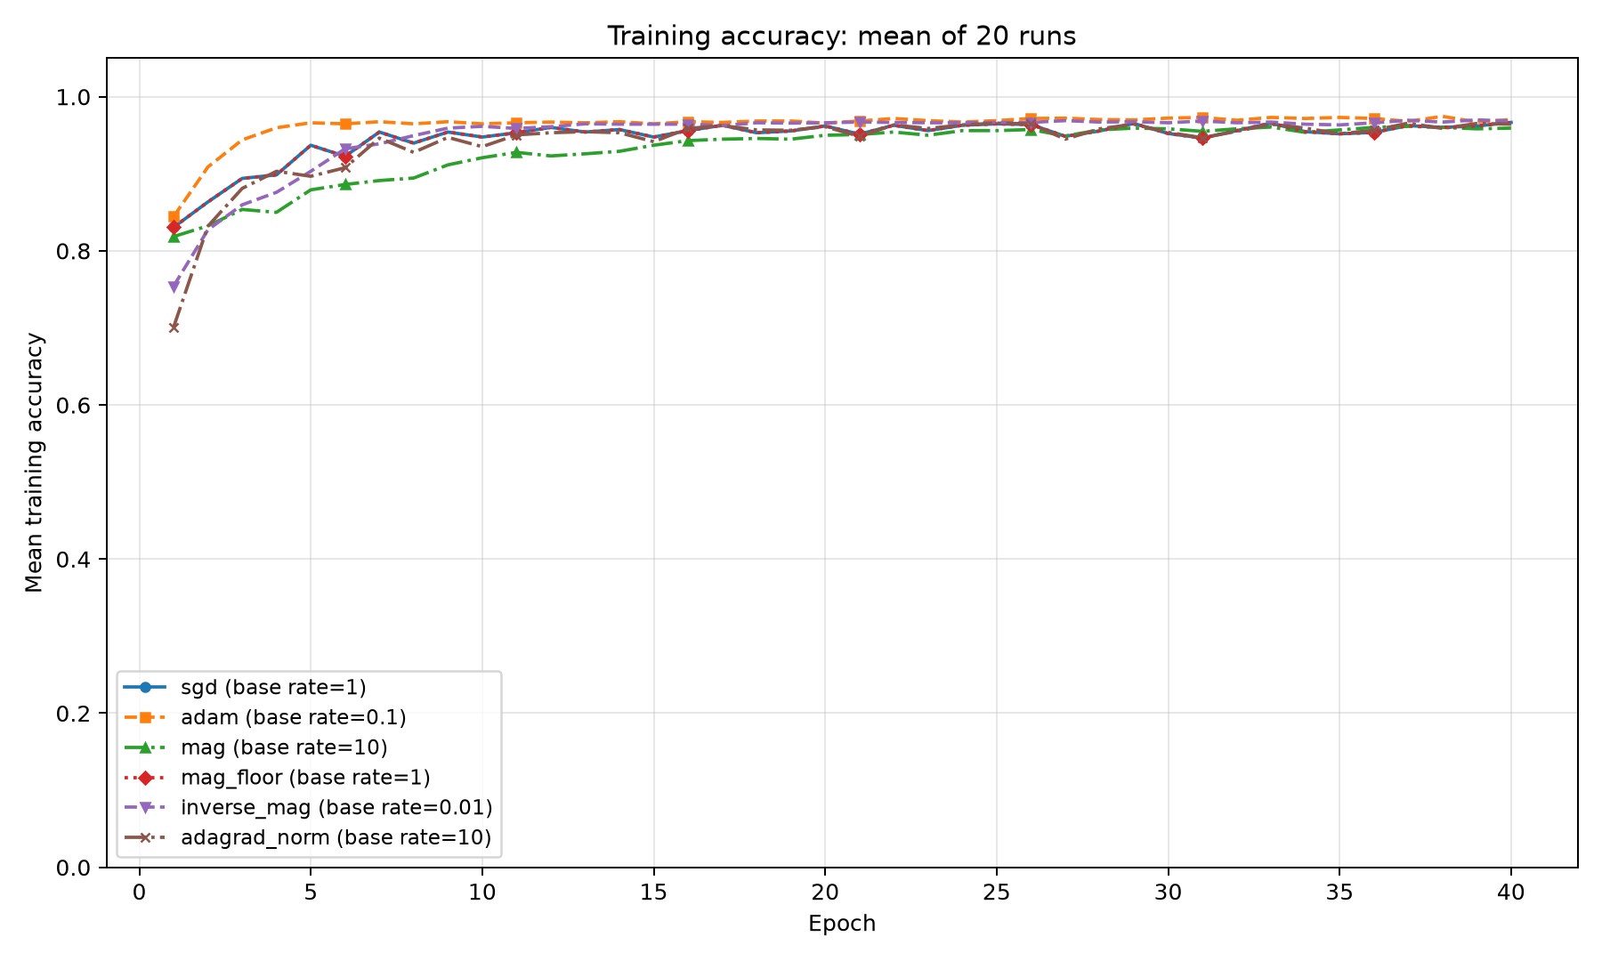
Figure 1 Mean training accuracy at each epoch with one selected base rate per optimizer
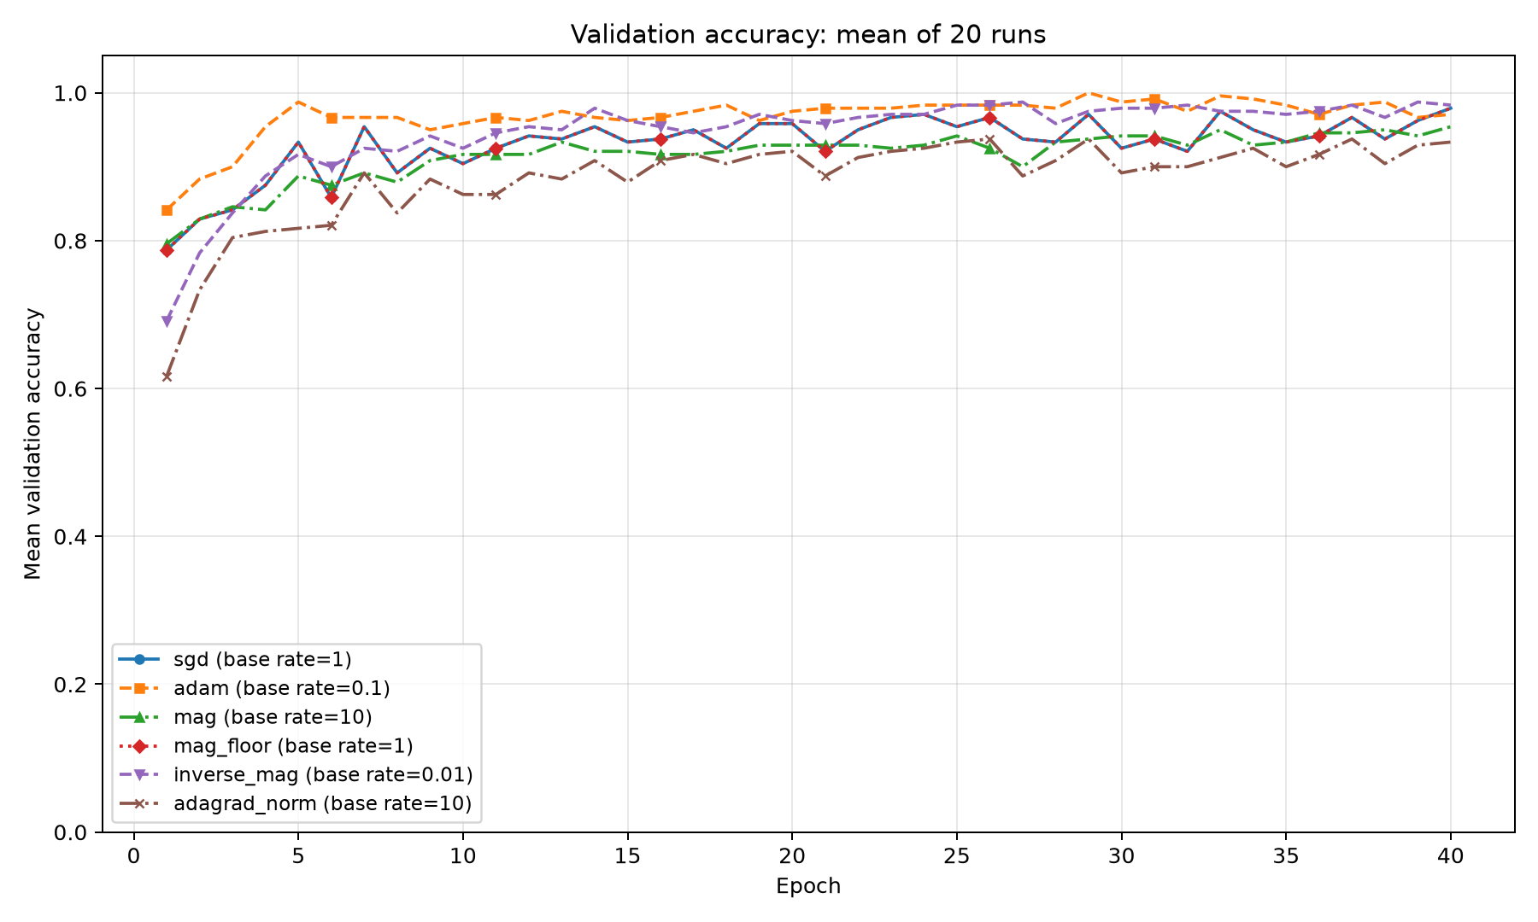
Figure 2 Mean validation accuracy at each epoch on the fixed 12-sample validation partition

Test accuracy and interpretation
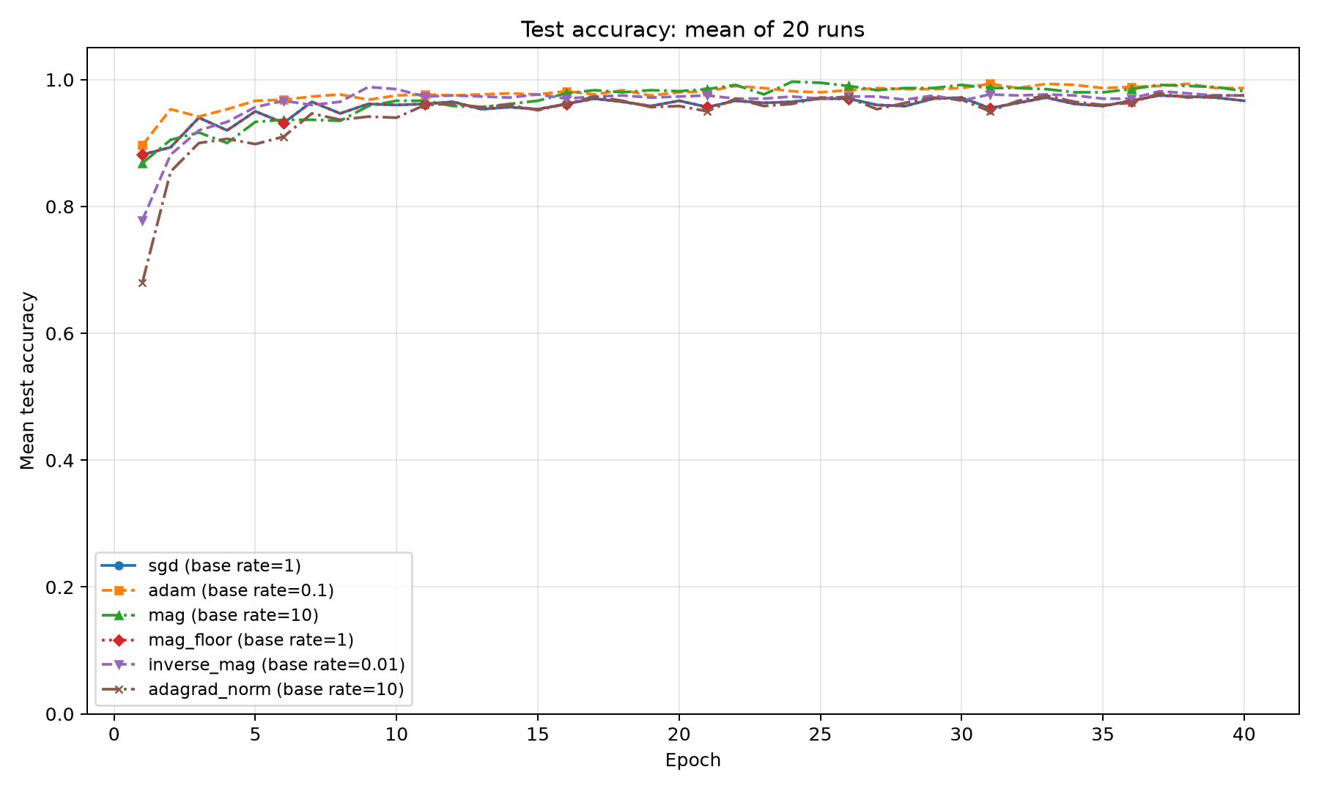
Figure 3 Mean test accuracy at each epoch on the fixed 30-sample test partition
The test set is evaluated after every epoch for reporting only. These evaluations do not affect gradients, stopping, checkpoint restoration or learning-rate selection. The fixed-rate rerun reuses the original seeds and split, so it reproduces the selected setting rather than providing an independent confirmation study.

What the results support
My original MAG rule is competitive in this small experiment but does not surpass the latest Adam result. MAG floor matches SGD’s final metrics, consistent with its SGD-like behavior whenever the mean absolute gradient is at most 1. Matching final accuracies alone does not establish that every intermediate update was identical.
The findings concern one small dataset, architecture and fixed partition. The validation set has only 12 samples and influences preprocessing statistics. The learning-rate search was expanded after earlier results were inspected, so the test set is not a fresh final holdout for the overall exploratory process. Further comparisons should use training-only preprocessing, additional datasets and splits, fixed search budgets and an untouched final test set before claiming general superiority or novelty.

Sources and reproducibility
Learning-rate search: results/20261006-093705-631888, using config.json, runs.csv and summary.csv. Fixed-rate comparison: results_best_rates/20261006-102613-956673, using config.json, final_accuracy.csv and the three original PNG plots. All paths are relative to gradient-magnitude-experiment.
Implementation: optimizers.py, run_experiment.py and run_best_rates.py. Related reference: Ward, R., Wu, X. and Bottou, L. (2019), AdaGrad Stepsizes: Sharp Convergence Over Nonconvex Landscapes, PMLR 97, 6677–6686. https://proceedings.mlr.press/v97/ward19a.html

