Assignment 3 Charis Aletraris

Exercise 1: Recurrent Neural Networks

Question 1: Feedforward networks and RNNs

What is a feedforward neural network
A feedforward neural network learns a mapping from an input to an output. Information moves in one direction: from the input, through hidden layers, to the prediction. There is no loop carrying information from a previous input into the next one. The previous inputs are used just to train the parameters of the hidden layer (if the model is still learning).
Feedforward networks are used for tasks such as predicting prices from numerical features, classifying customer records and recognizing handwritten digits from pixel values. They are useful when the information needed for a prediction is supplied together as a fixed-size input.
What is a recurrent neural network
A recurrent neural network (RNN) processes a sequence one step at a time. At each step, it uses the current input and a hidden state from the previous step. The hidden state acts as a short summary of what the network has read so far. The same weights are reused at every step.
For example, an RNN reads a movie review word by word. In "The movie was not good", it can learn to carry information about "not" forward when it reaches "good". This helps it predict the meaning of the whole review instead of relying on one word alone.
RNNs are used for sequential data, including text, speech and measurements collected over time.

Main Difference
Feedforward network | RNN
Processes the supplied input through its layers | Processes a sequence step by step
Does not carry a hidden state between inputs | Carries a hidden state between sequence steps
Usually expects a fixed-size input | Can process sequences of different lengths
Has no built-in mechanism for remembering earlier sequence steps | Is designed to use information from earlier steps

Question 2: The vanishing gradient problem
What it means
During training, a network measures its prediction error and works backward to calculate how its weights should change. A gradient tells it how changing a weight would affect the error. If this gradient becomes extremely small, the learning signal is weak and the weight may change very little. This is the vanishing gradient problem.
Why it happens in RNNs
In an RNN, the learning signal travels backward through the sequence steps. This is called backpropagation through time. The calculation repeatedly multiplies values. If these multiplications keep shrinking the signal, it can become almost zero before reaching the early steps.
How it affects training
The RNN gives more weight to the relationships between nearby information. That has resulted in struggles to learn how information near the beginning of a sequence affects a prediction at the end. For example, a long review may begin with "I did not enjoy this film" and later describe many details. The model may struggle to learn to preserve that early opinion for its final sentiment prediction.
This problem comes to reduce the LSTMs and GRUs by using gates that control how information is kept and updated.

Question 3: Where RNNs are used
Sensor signals
RNNs are useful for analysing sensor signals because these measurements form sequences over time. A single reading may provide limited information, while a sequence can reveal a movement, an activity or a developing fault.
For example Zhu, Chen and Brown (2018) developed a sequence-to-sequence approach for recognising daily activities from motion and environmental sensor data. This demonstrates the usefulness of analysing sensor sequences for monitoring daily activities and supporting older adults living independently.
Speech recognition
Speech recognition converts spoken audio into written words. Audio is processed as a sequence of short segments. An RNN can use information from earlier segments to help interpret the current sound, rather than treating each segment independently.
This is useful because a sound that is unclear on its own may be easier to identify from nearby sounds. RNN-based models, especially LSTM variants, have been effective in speech recognition because they can learn context across the audio sequence.

Question 4
Instead of running only the RNN model I desire to run the 3 different types of model in order to be able to compare the result of those models.I compared SimpleRNN, GRU and LSTM networks with 1, 2 and 3 recurrent layers. Each of the nine experiments ran for 15 epochs on the same data split. I stop running the code at the 15 epochs because I see that the best results in all cases are achieved at the early epochs and in all cases after the epochs 5 I start having an over fidding. The best results have been achieved with the 3-layer GRU: at epoch 3 it achieved both the highest validation accuracy, 89.38%, and the lowest validation binary cross-entropy, 0.2724, across the nine experiments. Test results were not used for this choice.
Best accuracy reached by each model family
Model | Layers | Epoch | Validation accuracy | Loss at that epoch
SimpleRNN | 1 | 4 | 87.72% | 0.3522
GRU | 3 | 3 | 89.38% | 0.2724
LSTM | 2 | 2 | 88.90% | 0.2727
Each row shows the highest validation accuracy in that family and the loss measured at the same epoch. It does not combine accuracy from one epoch with loss from another. For SimpleRNN, its lowest loss was instead 0.3248 at epoch 3, with 86.42% accuracy. The two class labels remain negative and positive; layers describe the depth of the network.
Main values shared by all experiments
Setting | Value | Purpose
Data split | 70% / 10% / 20% | 35,000 training, 5,000 validation and 10,000 test reviews; balanced classes and seed 42.
Input | 10,000 IDs; 500 tokens | Uses the assignment vocabulary limit and review length; retains the last 500 tokens.
Embedding | 32 dimensions | Learns a compact vector for each word ID; zero padding is masked.
Recurrent layers | 1, 2 or 3; 32 units each | Changes model type and depth while keeping the width fixed.
Training | 15 epochs; batch size 128 | Gives every candidate the same epoch budget and batch size.
Optimizer | Adam; learning rate 0.001 | Uses adaptive weight updates with a conventional starting learning rate.
Gradient clipping | Norm limit 1.0 | Limits excessively large updates; it does not solve vanishing gradients.
Output and loss | 1 sigmoid; binary cross-entropy | Predicts positive sentiment probability; threshold 0.5 gives the class.
These are practical starting values, not proven optimal settings. No dropout or extra regularization was added. Parameter counts differ between models, so this compares architectures at fixed width and training settings, not at equal capacity or equal computation.
Results for every model and depth
Model | Layers | Parameters | Best accuracy | Epoch | Related loss
SimpleRNN | 1 | 322,113 | 87.72% | 4 | 0.3522
SimpleRNN | 2 | 324,193 | 84.96% | 1 | 0.3752
SimpleRNN | 3 | 326,273 | 85.58% | 1 | 0.3656
GRU | 1 | 326,369 | 89.12% | 9 | 0.3479
GRU | 2 | 332,705 | 88.94% | 6 | 0.2877
GRU | 3 | 339,041 | 89.38% | 3 | 0.2724
LSTM | 1 | 328,353 | 88.54% | 3 | 0.2939
LSTM | 2 | 336,673 | 88.90% | 2 | 0.2727
LSTM | 3 | 344,993 | 88.66% | 3 | 0.2898

Comparison learning curves
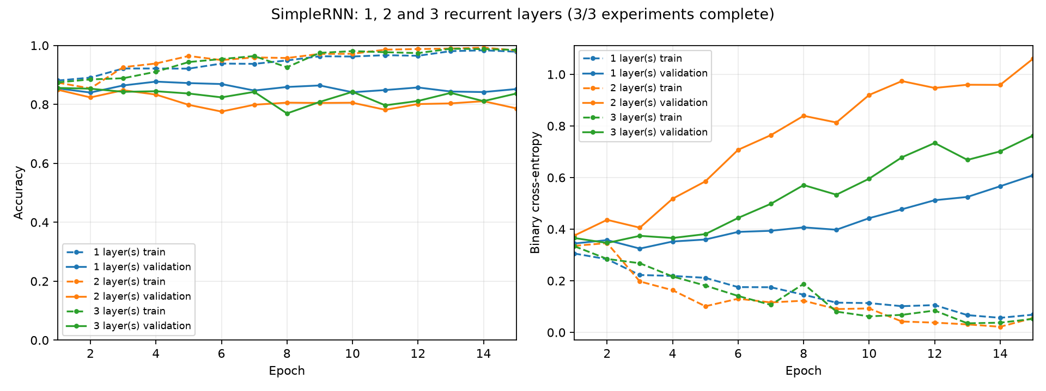
SimpleRNN: training and validation accuracy and loss for 1, 2 and 3 recurrent layers. Dashed lines show training; solid lines show validation.
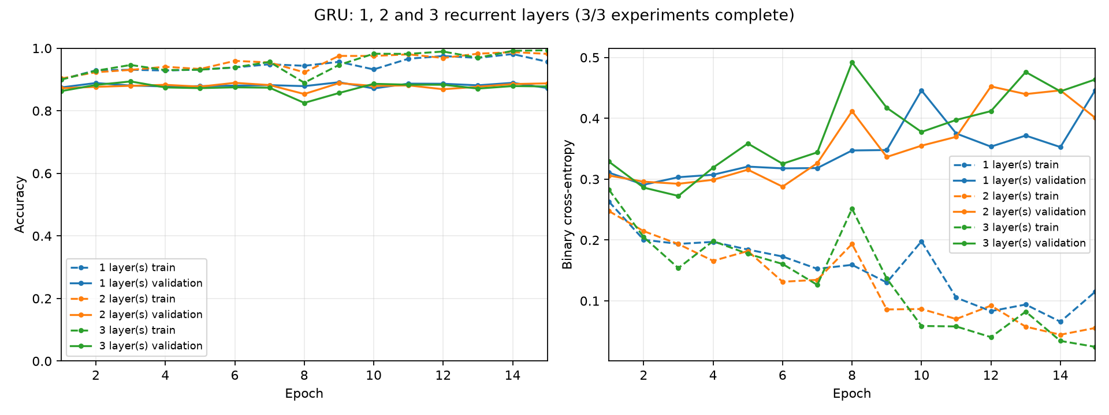
GRU: training and validation accuracy and loss for 1, 2 and 3 recurrent layers. Dashed lines show training; solid lines show validation.
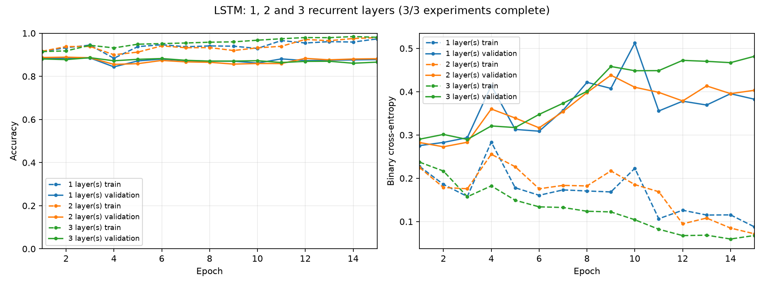
LSTM: training and validation accuracy and loss for 1, 2 and 3 recurrent layers. Dashed lines show training; solid lines show validation.
Source: results_recurrent_comparison/20261015_150230_305523, histories.json, config.json and the three comparison figures. Each curve uses end-of-epoch evaluation with the same current weights for training and validation.
Overall conclusion
We can easily identify that for all models we have the best accuracy in the early layer. Also, as we expected the simple RNN has the lowest accuracy. We accept those results because the simple RNN is struggling to retain information across long reviews because the learning signal can become very small. GRU and LSTM networks use gates that help preserve useful context. It is therefore reasonable to expect gated networks to help with this task.
Regarding the time we can see a noticeable difference between the simple RNN with the LSTM and GRU, which needs almost half the time per epoch. The time for GRU and LSTM is very similar.The 3-layer GRU can process the word sequence through several stages, allowing later layers to combine patterns learned by earlier layers. The comparison supports this depth for the GRU on this split. More layers are not always better: the 1-layer SimpleRNN and 2-layer LSTM gave the best accuracy within their families. Extra layers can also make optimization harder or increase overfitting.

Exercise 2: Long Short-Term Memory Networks

Question 1: How LSTMs reduce vanishing gradients
A separate memory path
An LSTM is a type of RNN designed to learn relationships across longer sequences. In a standard RNN, the learning signal can become very small as it travels backward through many steps. An LSTM adds a cell state, which acts as a memory carried from one step to the next. This gives information and the learning signal a more direct path through the sequence.
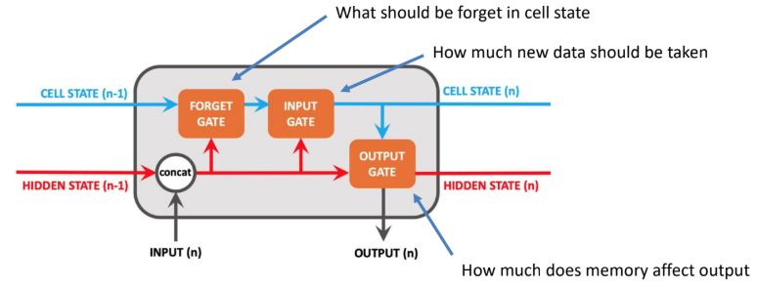
The three gates
The LSTM cell controls information using three gates. Each gate learns values between 0 and 1 from the current input and the previous hidden state. A value close to 0 blocks information, while a value close to 1 allows it through.
Input gate: controls the intake of new information. It decides how much of the new candidate information is added to the cell state.
Forget gate: determines which parts of the previous cell state are kept or removed. In this way, it helps control which old information is updated; the input gate controls what new information is added.
Output gate: determines which information from the updated cell state is exposed as the hidden state. This hidden state is passed to the next step and can be used to make a prediction.
Why this helps training
The memory update can be described simply as: new memory = retained old memory + selected new information. The addition allows the network to carry useful memory forward without repeatedly replacing it with a new transformed hidden state. When the forget gate stays close to 1, the gradient along this memory path can remain strong across many steps. This helps the network learn how an early input affects a later prediction.

Question 2: Applications where LSTMs outperform standard RNNs
Speech recognition
Speech is a sequence of sounds, and an unclear sound may be easier to identify using the sounds around it. LSTMs can retain useful context across the sequence. Graves and Schmidhuber (2005) compared LSTMs and standard RNNs on speech sound classification using the TIMIT dataset. Their bidirectional LSTM achieved 69.8% test accuracy, compared with 69.0% for a bidirectional standard RNN. Bidirectional means that both models read the sequence in both directions. This is a measured improvement for that experiment, rather than a guarantee for every speech task. [1]
Language modelling and next-word prediction
A language model predicts the next word from earlier words. Information near the beginning of a sentence can help determine which word should come later. LSTMs can learn to keep that information for longer than a standard RNN. Sundermeyer, Schluter and Ney (2012) reported about an 8% relative reduction in perplexity compared with standard RNN language models on English and French tasks. Perplexity measures how well the model predicts a word sequence; a lower value means better predictions. This is not an 8 percentage point increase in accuracy. [2]
Connection to our IMDB experiment
Our comparison also showed an advantage for LSTM over SimpleRNN: the best LSTM reached 88.90% validation accuracy, compared with 87.72% for SimpleRNN. However, the three-layer GRU reached 89.38%, so LSTM was not the best model in our experiment. The best choice depends on the task, data and settings.
References
[1] Graves, A. and Schmidhuber, J. (2005). Framewise phoneme classification with bidirectional LSTM and other neural network architectures. Neural Networks, 18(5-6), 602-610. https://doi.org/10.1016/j.neunet.2005.06.042
[2] Sundermeyer, M., Schluter, R. and Ney, H. (2012). LSTM neural networks for language modeling. Interspeech 2012, 194-197. https://doi.org/10.21437/INTERSPEECH.2012-65

Question 3: Reuters classification with LSTM networks
Task and model
I trained three separate LSTM models with 1, 2 and 3 recurrent layers for 15 epochs each. Each model reads a Reuters news article and predicts one of 46 topics. This is text classification: the sequence is the words in an article, rather than measurements used to predict a future time value. The one-layer LSTM gave the lowest validation loss and was selected for the final evaluation.
Data split
The 11,228 articles were divided into 7,859 training, 1,123 validation and 2,246 test articles, approximately 70%, 10% and 20%. I kept the original Keras test set and reserved 12.5% of the remaining articles for validation. The training/validation split was stratified to approximately preserve the proportion of each topic. Training updates the weights, validation selects the model, and test data measures its performance. All three models used the same split.
Why these parameter values were chosen
Vocabulary and input length: I kept the 10,000 most frequent word IDs, as in the assignment, to limit the vocabulary size. As we know we have to keep the sequence in the same size of tokens for the LSTM. In many early experiments 200 tokens are used , but in the exercise are mentioned to use only 20 tokens. For this reason I have made the experiment with both options in order to be able to compare the results. I also use padding="post" in order to include zeros at the end if the total sequent is less than the selected size. Keeping the beginning is a practical choice because news articles often introduce their topic early; it may lose useful information later in a long article. Short articles are padded on the right, and masking makes the LSTM ignore padding.
Embedding and LSTM size: The embedding represents each word with 64 learned values, and each recurrent layer has 64 units. These are moderate starting sizes that provide capacity to learn word and sequence patterns. Comparing 1, 2 and 3 layers tests whether additional processing improves the result. The intermediate layers return the full sequence so the next LSTM can read it; the final LSTM returns one vector for classification.
Dropout and output: Dropout of 0.2 after the last LSTM randomly removes 20% of its output features during training to help reduce overfitting. Dropout is disabled during evaluation. The final layer has 46 outputs with softmax, giving one probability per topic. Sparse categorical cross-entropy is used because each article has one integer topic label.

Results and choice of model
The table compares the checkpoint with the lowest validation loss for each depth. Accuracy values are taken from that same epoch. Test accuracy is included for reporting only; it did not control the choice of depth or checkpoint.
LSTM layers | Selected epoch | Validation loss | Validation accuracy | Test accuracy
1-200tokens | 10 | 1.3587 | 68.39% | 65.58%
2-200tokens | 14 | 1.4902 | 63.13% | 61.49%
3-200tokens | 14 | 1.4545 | 64.74% | 63.31%
1-20tokens | 9 | 1.3309 | 70.97% | 69.68%
2-20tokens | 6 | 1.3643 | 68.03% | 66.52%
3-20tokens | 11 | 1.4395 | 67.76% | 67.76%
Selected model
The one-layer LSTM at epoch 10 achieved validation loss of 1.3587 and validation accuracy of 68.39%. On the test set, this saved checkpoint achieved accuracy of 65.58% and loss of 1.4672. It uses fewer recurrent layers and obtained better validation loss than the deeper alternatives. Additional layers did not improve the result within this 15-epoch experiment; this does not prove that one layer is always best for Reuters.
Accuracy and loss do not always choose the same epoch
The highest validation accuracy for the one-layer model was 70.17% at epoch 14, whereas the lowest validation loss occurred at epoch 10. Accuracy only checks whether the predicted topic is correct. Cross-entropy also considers the predicted probabilities and penalizes confident mistakes. Therefore, accuracy can improve slightly while loss becomes worse. I kept the original selection rule of lowest validation loss.
Learning trends and limitations
For the one-layer model, validation loss reached 1.3587 at epoch 10 and increased to 1.4846 by epoch 15, while training loss reached 0.7905. This widening difference suggests overfitting after the best checkpoint, although the curves fluctuate. The deeper models had their minimum validation loss at epoch 14, so the same onset of overfitting should not be assumed for all depths.
The selected model had a test macro F1 of 0.1116. Macro F1 gives each of the 46 topics equal weight. This low value shows that overall accuracy does not reflect strong performance across all topics. Unequal topic frequencies can help explain this difference, but per-topic precision and recall are needed to identify which topics are difficult. The results should be treated as a baseline from one split and seed.
Training and validation guide model choices. The test curves were recorded each epoch for the requested comparison; using them to choose further changes would weaken their role as an independent final assessment.

Reuters learning curves of 200 tokens
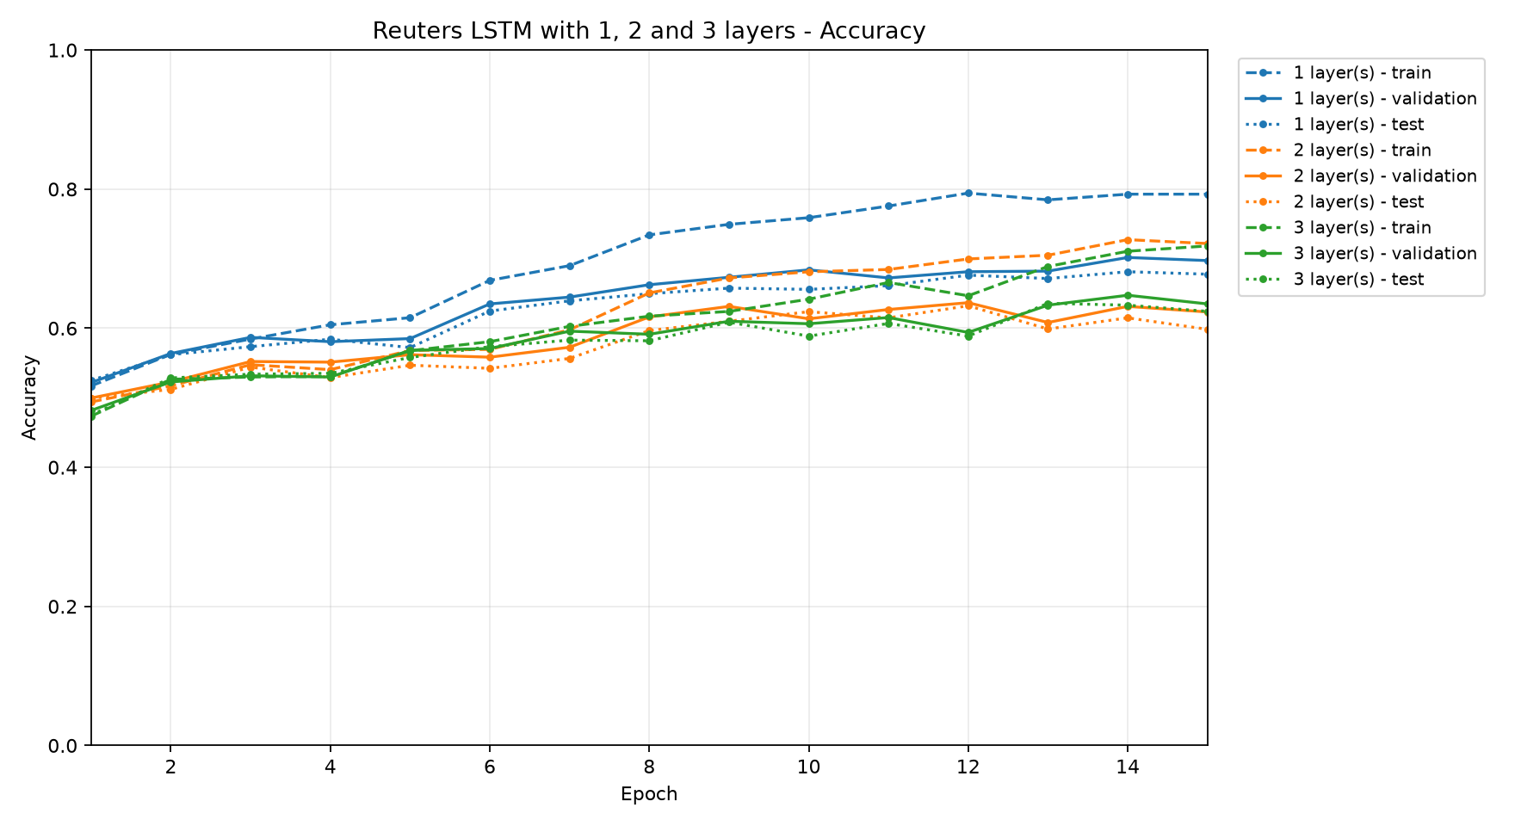
Accuracy across 15 epochs. Higher values indicate more correct topic predictions.
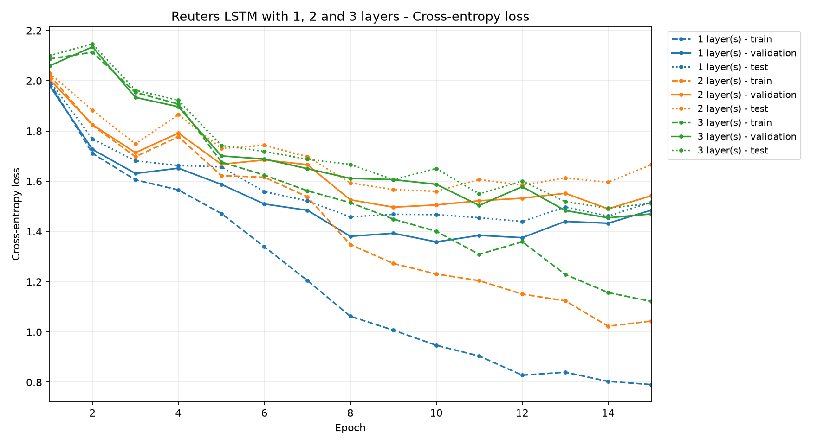
Sparse categorical cross-entropy across 15 epochs. Lower values indicate better predicted probabilities.
Blue: 1 layer; orange: 2 layers; green: 3 layers. Dashed lines show training, solid lines validation and dotted lines test. All curves use end-of-epoch evaluation, with dropout disabled, so the measurements are comparable.
Source: results_reuters_lstm/20261025_210925_742240. Settings and results are taken from config.json, history.json, summary.json and selected_model.json. All three models completed 15 epochs.

Reuters results with 20 tokens
Using 20 tokens, the one-layer LSTM was selected by lowest validation loss: 1.3309 at epoch 9, with 70.97% validation accuracy. Its saved checkpoint achieved 69.68% test accuracy, 1.3971 test loss and a macro F1 score of 0.2185. The table above reports each depth at its lowest-validation-loss epoch. Test scores are reported for evaluation only and were not used to select the model or epoch.
Compared with the 200-token run, the selected 20-token checkpoint had higher test accuracy in this experiment. This is a result from one split and seed, not evidence that shorter input is generally better.

Reuters learning curves of 20 tokens
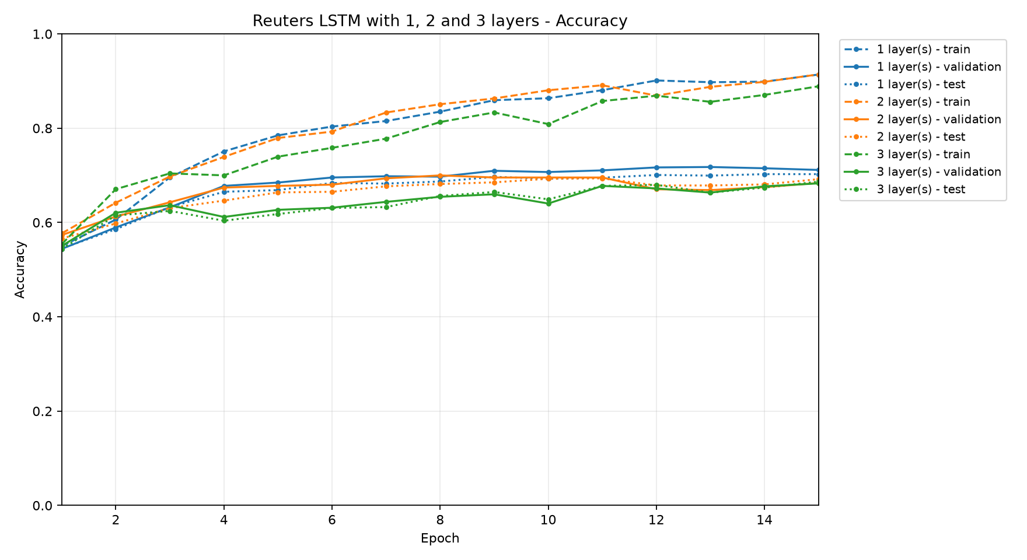
Accuracy across 15 epochs for the 20-token experiment. Higher values indicate more correct topic predictions.

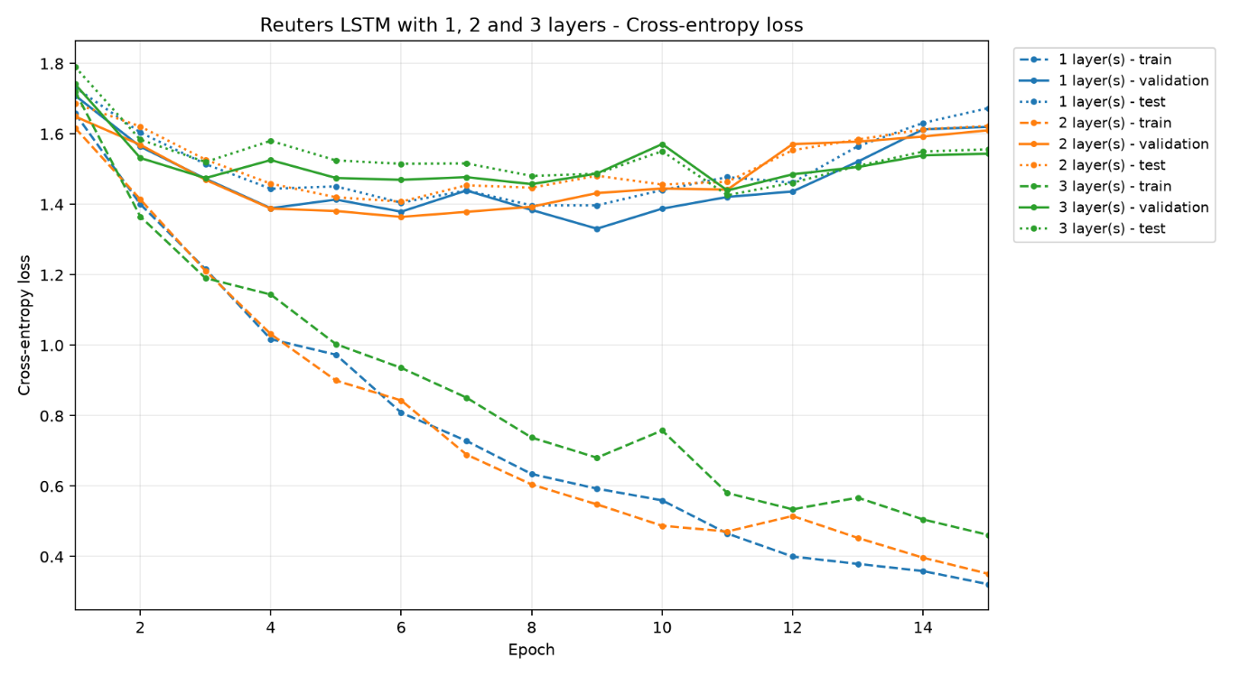
Sparse categorical cross-entropy across 15 epochs for the 20-token experiment. Lower values indicate better predicted probabilities.

Blue: 1 layer; orange: 2 layers; green: 3 layers. Dashed lines show training, solid lines validation and dotted lines test. All curves use end-of-epoch evaluation, with dropout disabled. Source: results_reuters_lstm/20tokens; metrics from config.json, history.json, summary.json and selected_model.json.

