Exercise 1

1A) Learning rate

Model and experimental procedure
The model takes four measurements per flower as inputs. A fully connected hidden layer contains 16 neurons with tanh activation, followed by a fully connected output layer with three softmax neurons, one for each Iris species. The network has 131 trainable parameters: 80 in the hidden layer and 51 in the output layer.
We used stochastic gradient descent (SGD), momentum 0, categorical cross-entropy loss and accuracy as the evaluation metric. The learning rates were 0.003, 0.03, 0.06, 0.2 and 0.5. Batch size was fixed at 32.
The 150 flowers were split into 120 training examples and 30 test examples with random_state=42. Labels were one-hot encoded. StandardScaler was fitted on the 120-example training partition and then applied to the test partition. With validation_split=0.1, Keras reserved 12 of the 120 examples for validation, leaving 108 for weight updates. Validation and test evaluation did not update the weights.

Why 40 epochs and 20 runs
Both settings were specified by the assignment. An epoch is one pass through the 108 examples used for learning. With batches of 32, each epoch contains four updates (32 + 32 + 32 + 12 examples), giving 160 updates in 40 epochs. Using the same 40-epoch budget makes the learning rates comparable; it does not guarantee that every rate has fully converged.
Each rate was trained from scratch 20 times using seeds 42 to 61. Repeating runs reduces dependence on a lucky or unlucky random initialization and shuffle order. The same seed sequence and data split were used for every rate. At each epoch, accuracies were averaged across the 20 runs, producing one 40-point curve per rate and accuracy type. There were 100 training runs in total.

Mean accuracy after 40 epochs
Learning rate | Training | Validation | Test
0.003 | 73.66% | 68.75% | 76.67%
0.03 | 88.33% | 88.75% | 94.33%
0.06 | 92.82% | 91.67% | 96.00%
0.2 | 96.16% | 95.00% | 98.00%
0.5 | 96.30% | 96.25% | 97.67%

Training and validation accuracy curves
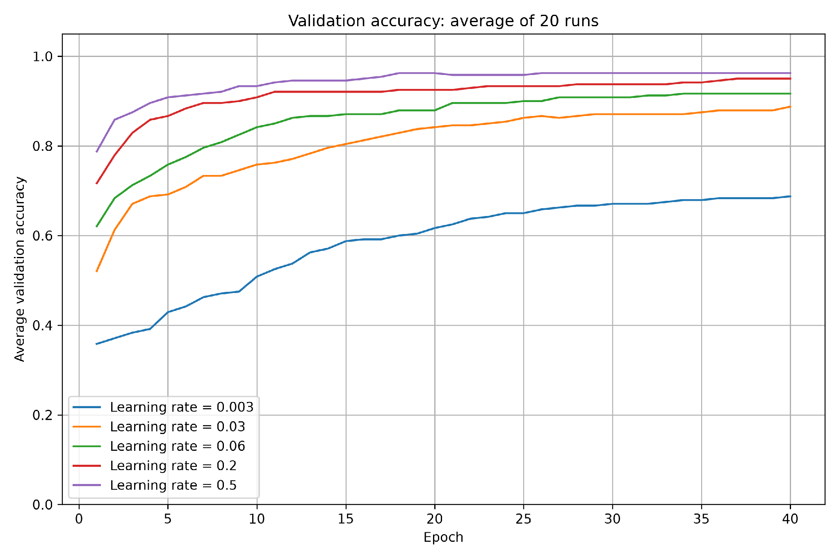
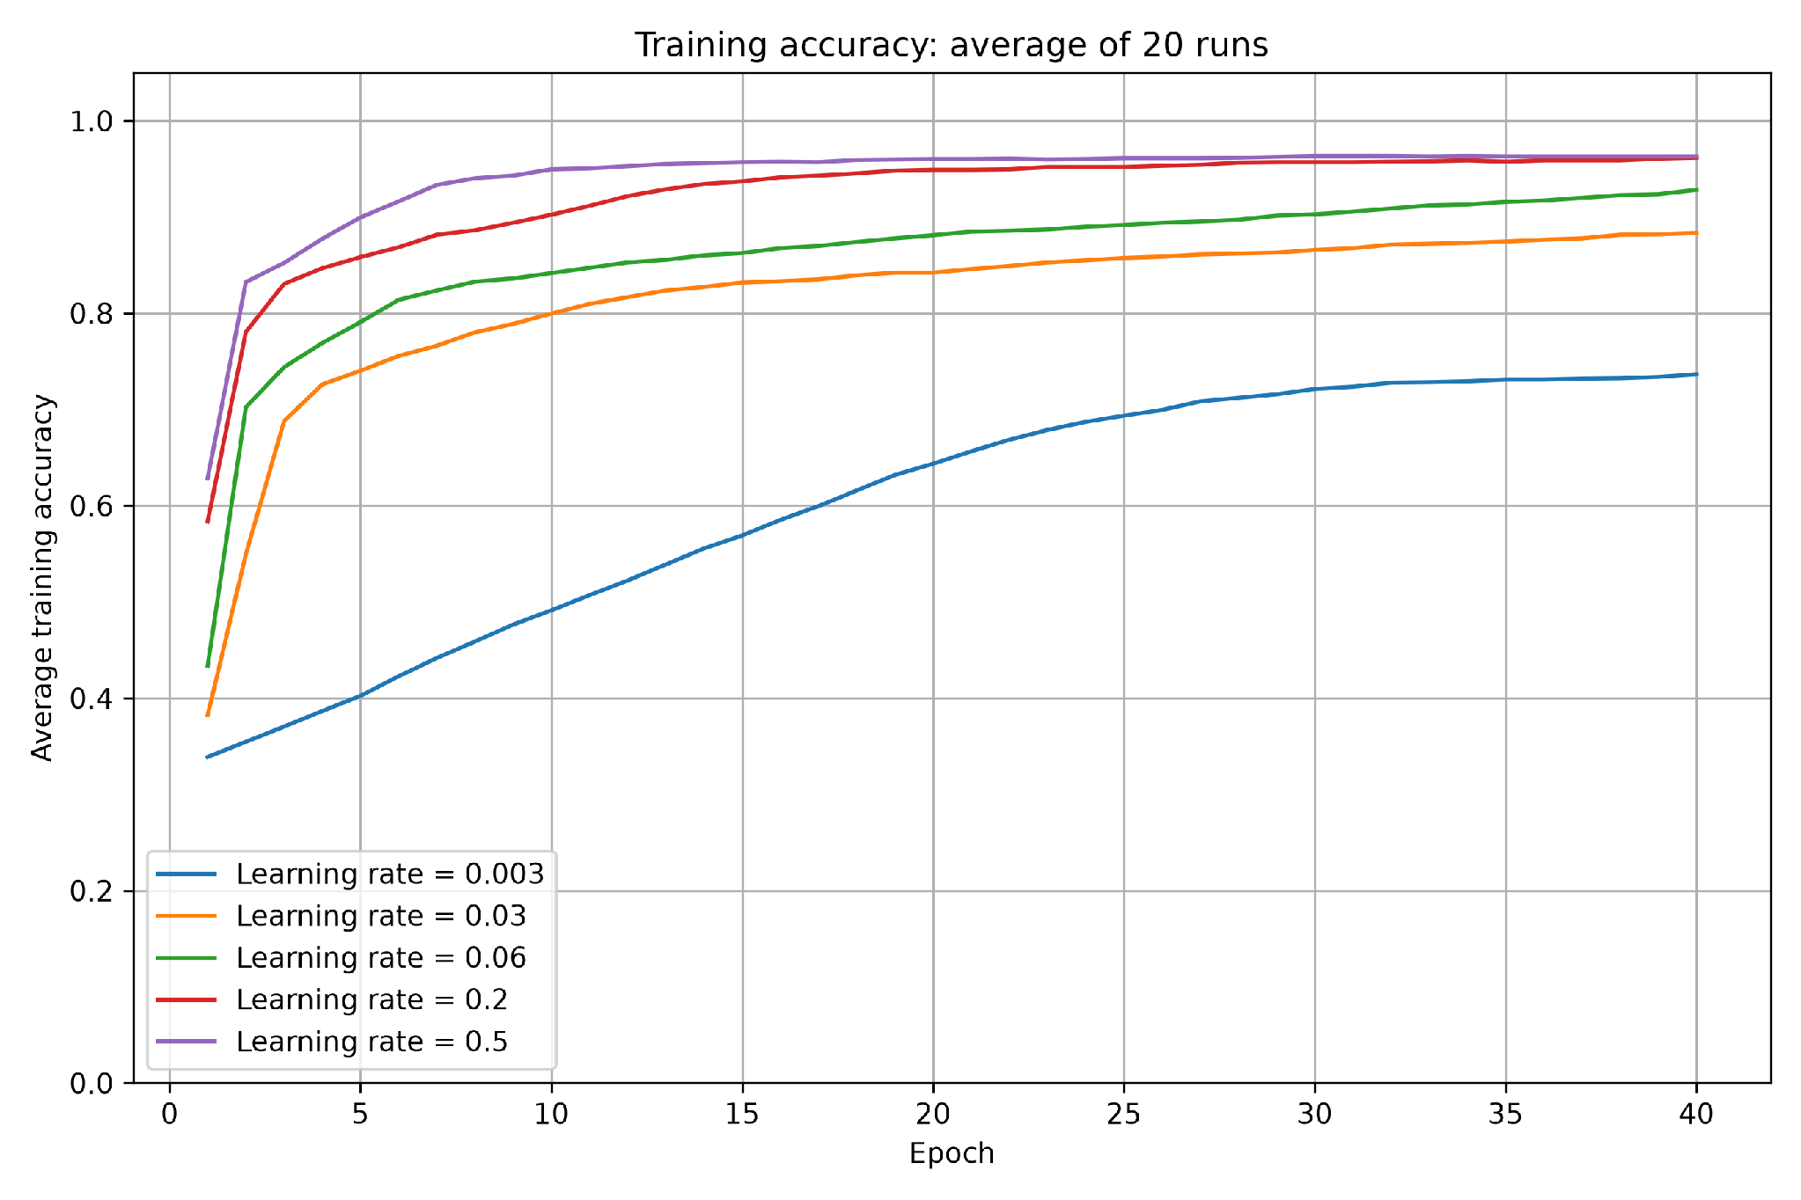
As we can see from the training and validation accuracy curves, larger learning rates generally reach high training and validation accuracy sooner, as expected for this experiment. Test accuracy also improves more quickly for the larger rates. Because our epochs/training values are limited, the lowest rate improves gradually and remains below the other rates. The 0.5 curve rises fastest initially, while 0.2 catches up and slightly exceeds it on the test set later in training. Increasing the rate therefore helps substantially up to this range, but the highest rate does not give the highest final test accuracy.
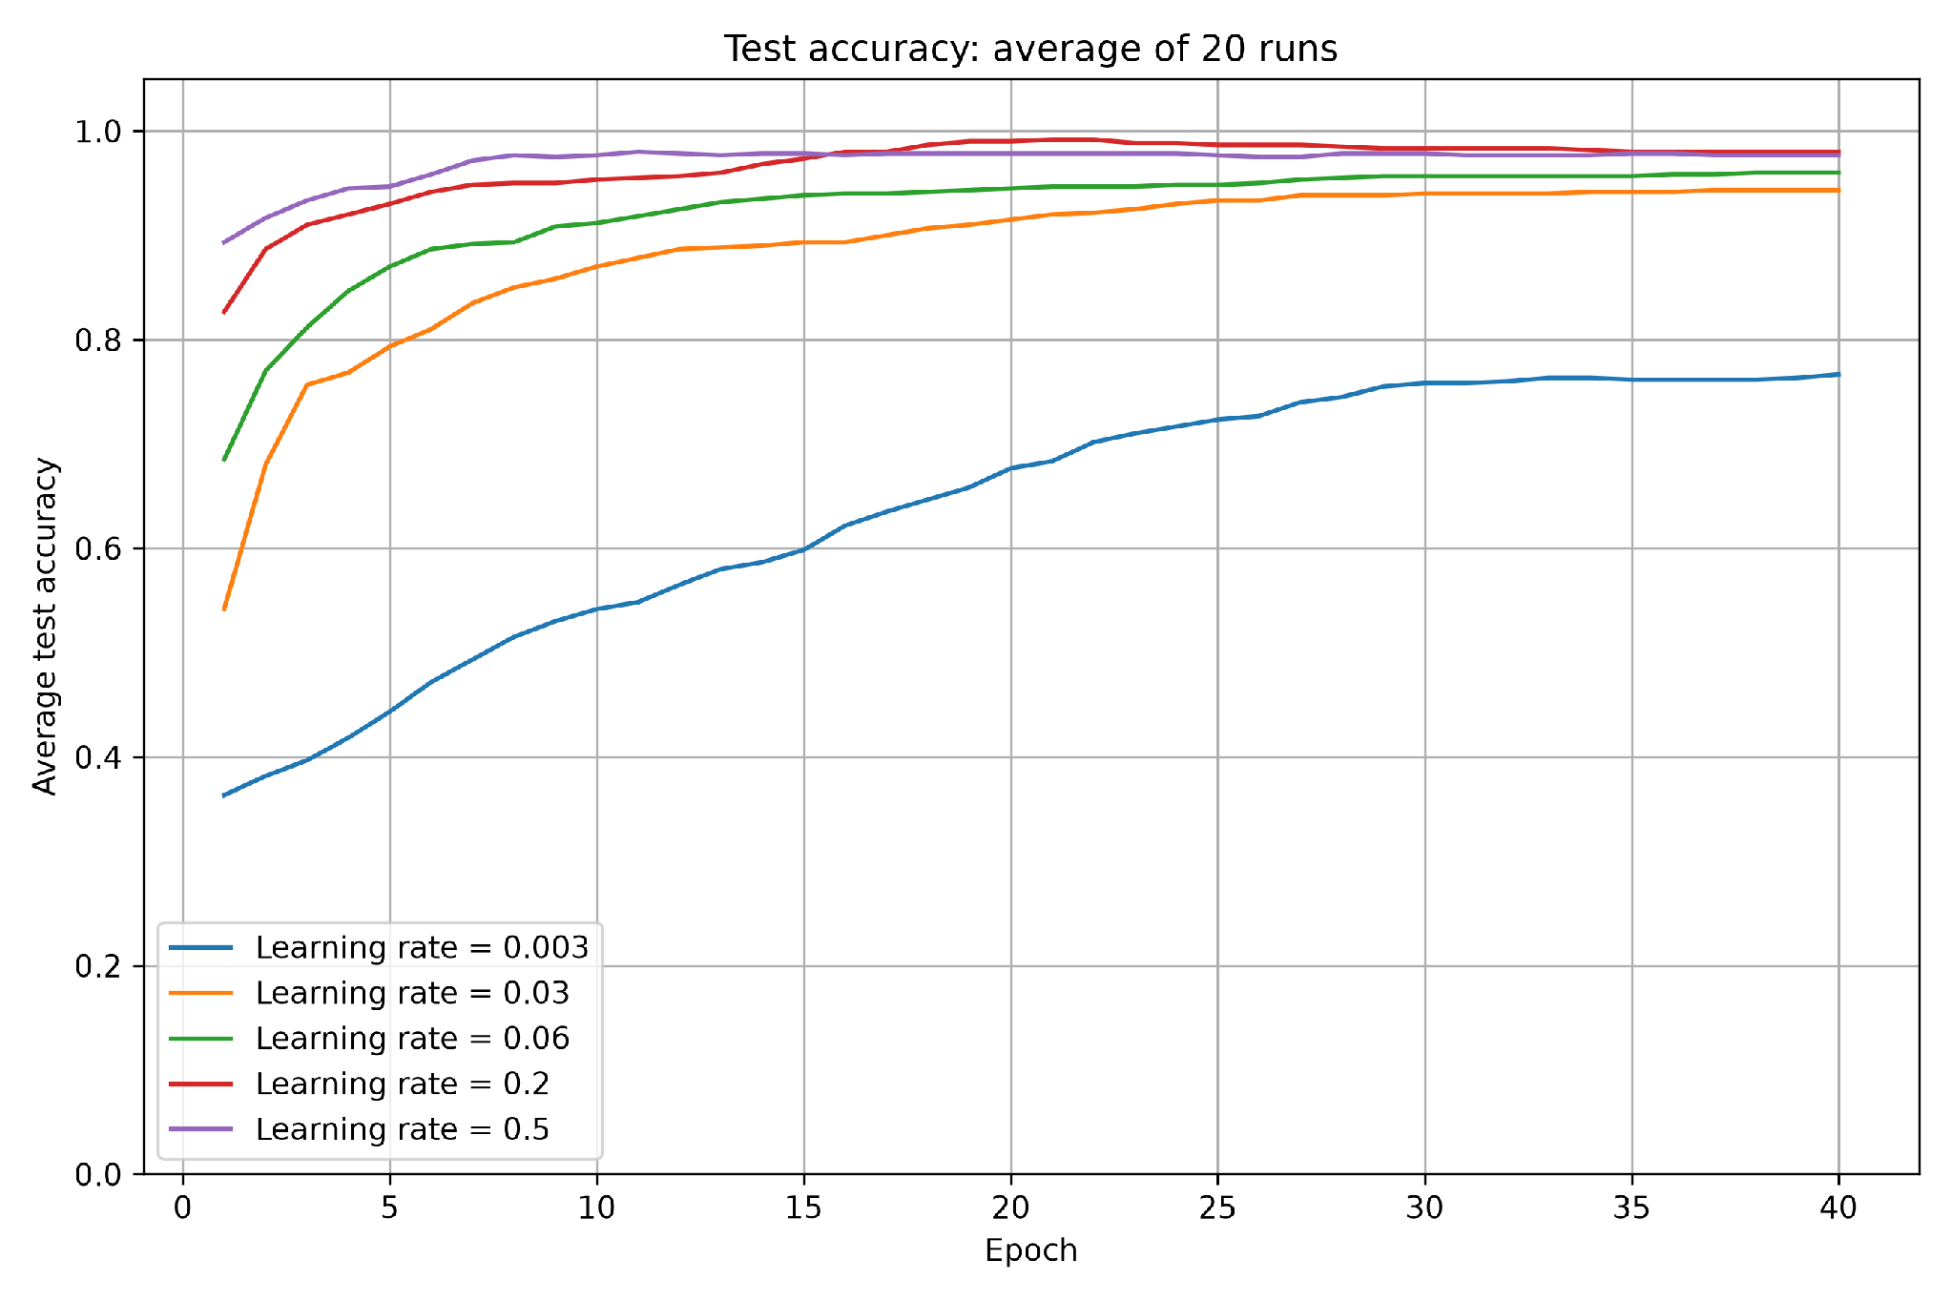

a Which learning rate performed best
Using mean test accuracy at epoch 40 as the comparison criterion, 0.2 performs best at 98.00%, followed by 0.5 at 97.67%. The difference is only 0.33 percentage points, so these two rates have nearly the same final test performance. Their final training accuracies are also almost identical (96.16% and 96.30%), while validation accuracy is slightly higher for 0.5 (96.25% versus 95.00%).
The saved curves show that larger learning rates generally reach high training and validation accuracy sooner, as expected for this experiment. Test accuracy also improves more quickly for the larger rates. The 0.5 curve rises fastest initially, while 0.2 catches up and slightly exceeds it on the test set later in training. Increasing the rate therefore helps substantially up to this range, but the highest rate does not give the highest final test accuracy

b What the learning rate is and how it affects training
The learning rate controls the size of each weight and bias update. With zero momentum, SGD subtracts the learning rate multiplied by the current batch loss gradient from each parameter. A larger rate therefore makes a more aggressive change for the same gradient; a smaller rate makes a more cautious change.
Small updates usually require more epochs to make comparable progress. The rate of 0.003 learns much more slowly within the fixed 40-epoch budget, and its curves are still improving near the end. Additional training could improve its accuracy, although this experiment does not establish how many extra epochs would be needed or guarantee that it would match the best rate.
A plausible optimization explanation for the slightly lower final test accuracy at 0.5 is its more aggressive parameter updates. Larger steps can overshoot a useful low-loss region or fluctuate around it, whereas 0.2 can offer a better balance between rapid progress and smaller adjustments. However, the 0.33-point difference alone does not prove that overshooting caused the gap. Random variation and the small test set can also contribute; per-run variability would be needed to assess how reliable the difference is.
A high rate such as 0.5 may need additional training to settle if its updates are oscillating, but more epochs at the same high rate do not guarantee stabilization. Reducing the rate later can help in that situation. In these plots, the mean curves for 0.5 already flatten relatively early, so the results do not demonstrate that it needs more epochs than 0.2 to stabilize. By epoch 40, both rates have reached similarly high accuracy.

1B) Momentum

Model and experimental procedure
We used the same network and data preparation as in Exercise 1(a): four inputs, 16 hidden neurons with tanh, and three outputs with softmax. The learning rate was fixed at 0.02, and we compared momentum values of 0, 0.3, 0.6, 0.9 and 0.99. Batch size remained 32, with categorical cross-entropy loss and a validation split of 0.1.
Each momentum value was trained for 40 epochs in 20 fresh runs, using seeds 42 to 61 and the same data split. The fixed number of epochs gives each value the same training budget. Averaging the runs reduces the effect of random starting weights. Each curve shows the mean accuracy at every epoch.

Mean accuracy after 40 epochs
momentum | Training | Validation | Test
0.0 | 86.11% | 86.25% | 93.83%
0.3 | 88.06% | 87.92% | 94.33%
0.6 | 91.25% | 91.25% | 95.83%
0.9 | 96.20% | 95.00% | 97.83%
0.99 | 97.22% | 93.33% | 99.67%

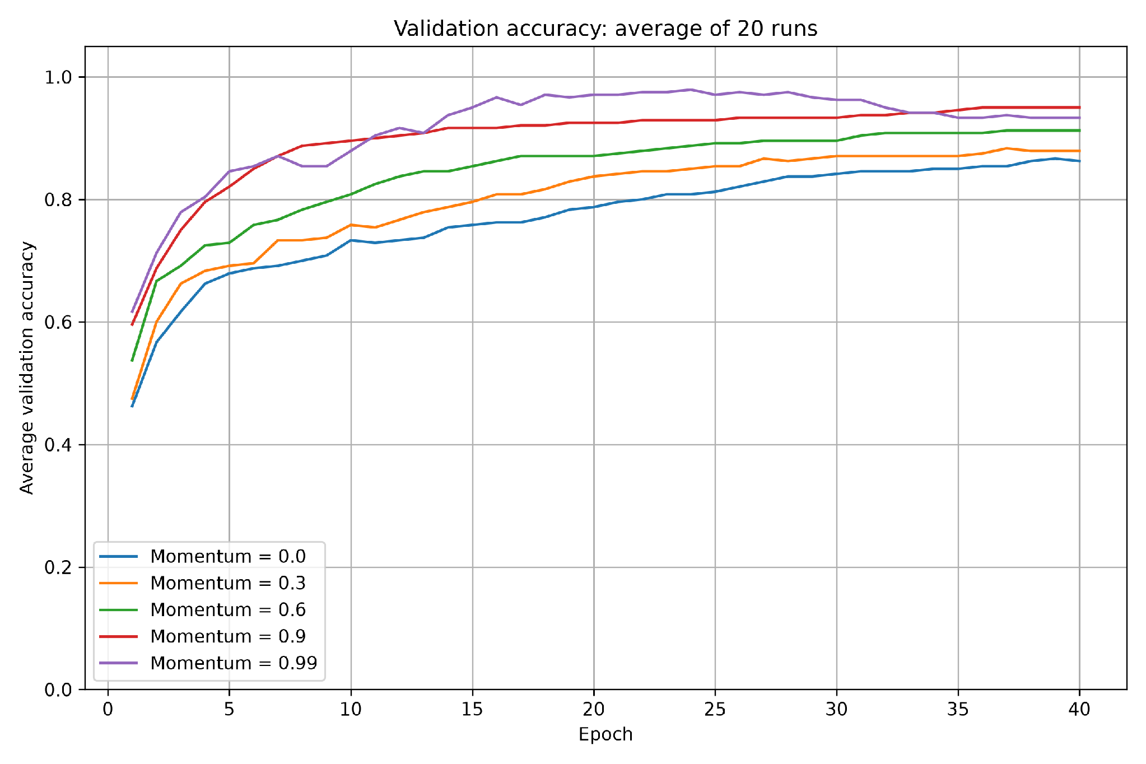
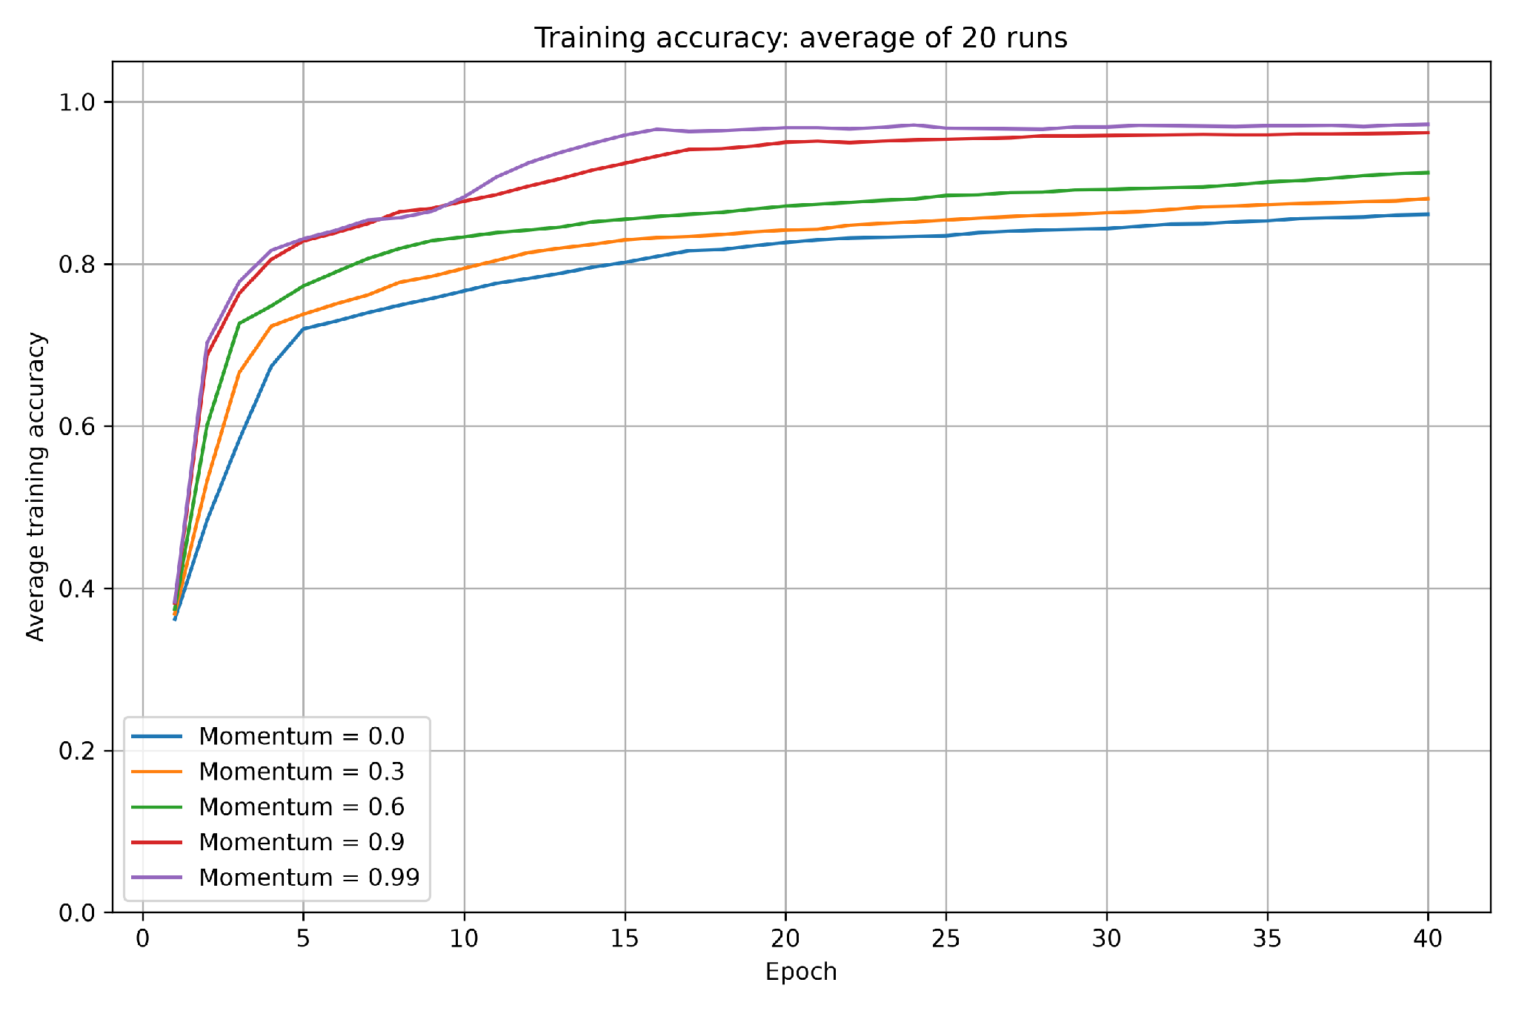
Training and validation accuracy curves

Higher momentum generally helped the model reach high accuracy sooner in this experiment. Values of 0.9 and 0.99 learned faster than 0, 0.3 and 0.6. The training accuracy for 0.99 ended highest, but its validation curve fluctuated and fell after an earlier peak. By epoch 40, 0.9 had the highest validation accuracy. Higher momentum therefore did not improve every measure in the same way.
Test accuracy curves
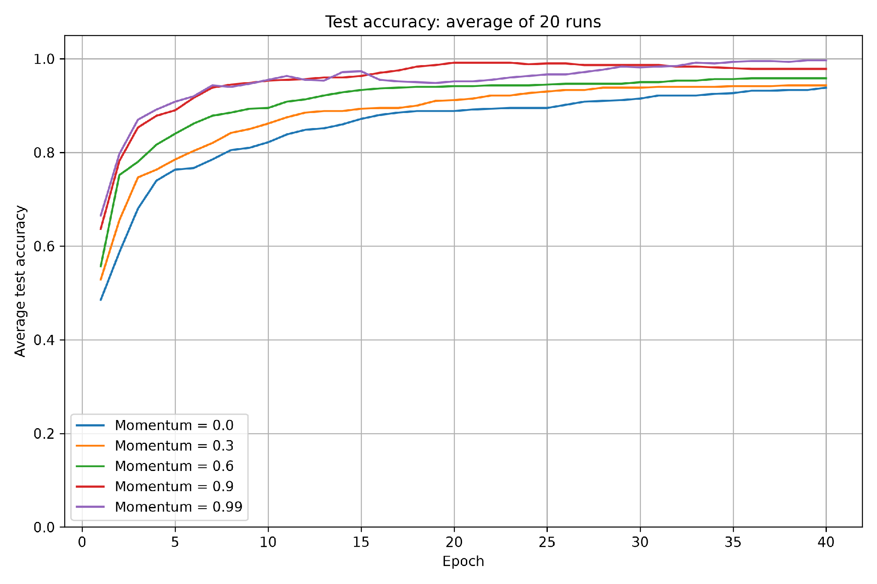

a Which momentum performed best
Using mean test accuracy at epoch 40, momentum 0.99 performed best. Its test curve finished just below 100%, above the 0.9 curve at about 98%. These percentages are approximate readings from the plot. Momentum 0.9 reached high test accuracy earlier and followed a smoother curve, but 0.99 finished with the highest value. This is the best result for the tested setup, rather than a guarantee that 0.99 will always be best. From the general reasons for the choice of momentum that we mention below, we can tell that our database is a smooth or very flat loss surface.

b What momentum is and how it affects training
Momentum is a technique that helps a neural network learn by using information from previous weight updates. It is maintained between batches and continues across epoch boundaries. Instead of calculating each update only from the current batch, the optimizer also retains part of the previous accumulated update. This can help training move consistently in a useful direction and reduce some back-and-forth movement.
For standard SGD with momentum:
New update = momentum value × previous update − learning rate × current gradient
New weights = old weights + new update
Some common reasons to choose a specific rate of different momentum values?:
- 0.0: To establish a baseline without momentum and assess whether retaining previous updates improves training.
- 0.1–0.5: When we want a modest influence from previous updates while allowing the optimizer to change direction quickly. This range is useful to test when stronger momentum produces overshooting or unstable training at the chosen learning rate.
- 0.5 to 0.8: When low momentum provides too little acceleration, but stronger momentum causes persistent oscillations. This offers an intermediate range to investigate. 9.
- 0.9: As a common starting point for SGD with momentum, particularly when training progresses slowly or repeatedly moves back and forth. It gives substantial influence to previous updates.
- 0.99: A higher value that builds up a longer "memory" of past gradients. It works well on smooth or very flat loss surfaces, but risks overshooting if set too high.
We include 0.1–0.5 to investigate whether a small amount of momentum is sufficient to improve convergence without the stronger accumulation associated with 0.9 or 0.99. The best choice depends on the model, dataset, batch size, and learning rate. We should compare validation performance and training stability, rather than assume that higher momentum is always better.

1C) Hidden layer neurons

Model and experimental procedure
We compared 4, 8, 16, 32 and 64 neurons in a single hidden layer. The learning rate stayed at 0.02 and momentum at 0.9. We kept tanh in the hidden layer, three softmax outputs, categorical cross-entropy loss, batch size 32 and validation_split=0.1. The data preparation and split were the same as in the earlier experiments.
Each size was trained from scratch 20 times for 40 epochs, using seeds 42 to 61. We averaged accuracy across the 20 runs at each epoch. This gives every size the same number of training passes and reduces the effect of random starting weights.

Mean accuracy after 40 epochs
Hidden neurons | Training | Validation | Test
4 | 95.83% | 94.17% | 97.83%
8 | 96.25% | 95.00% | 97.67%
16 | 96.20% | 95.00% | 97.83%
32 | 96.25% | 96.25% | 98.00%
64 | 96.44% | 97.92% | 97.67%

Training and validation accuracy curves
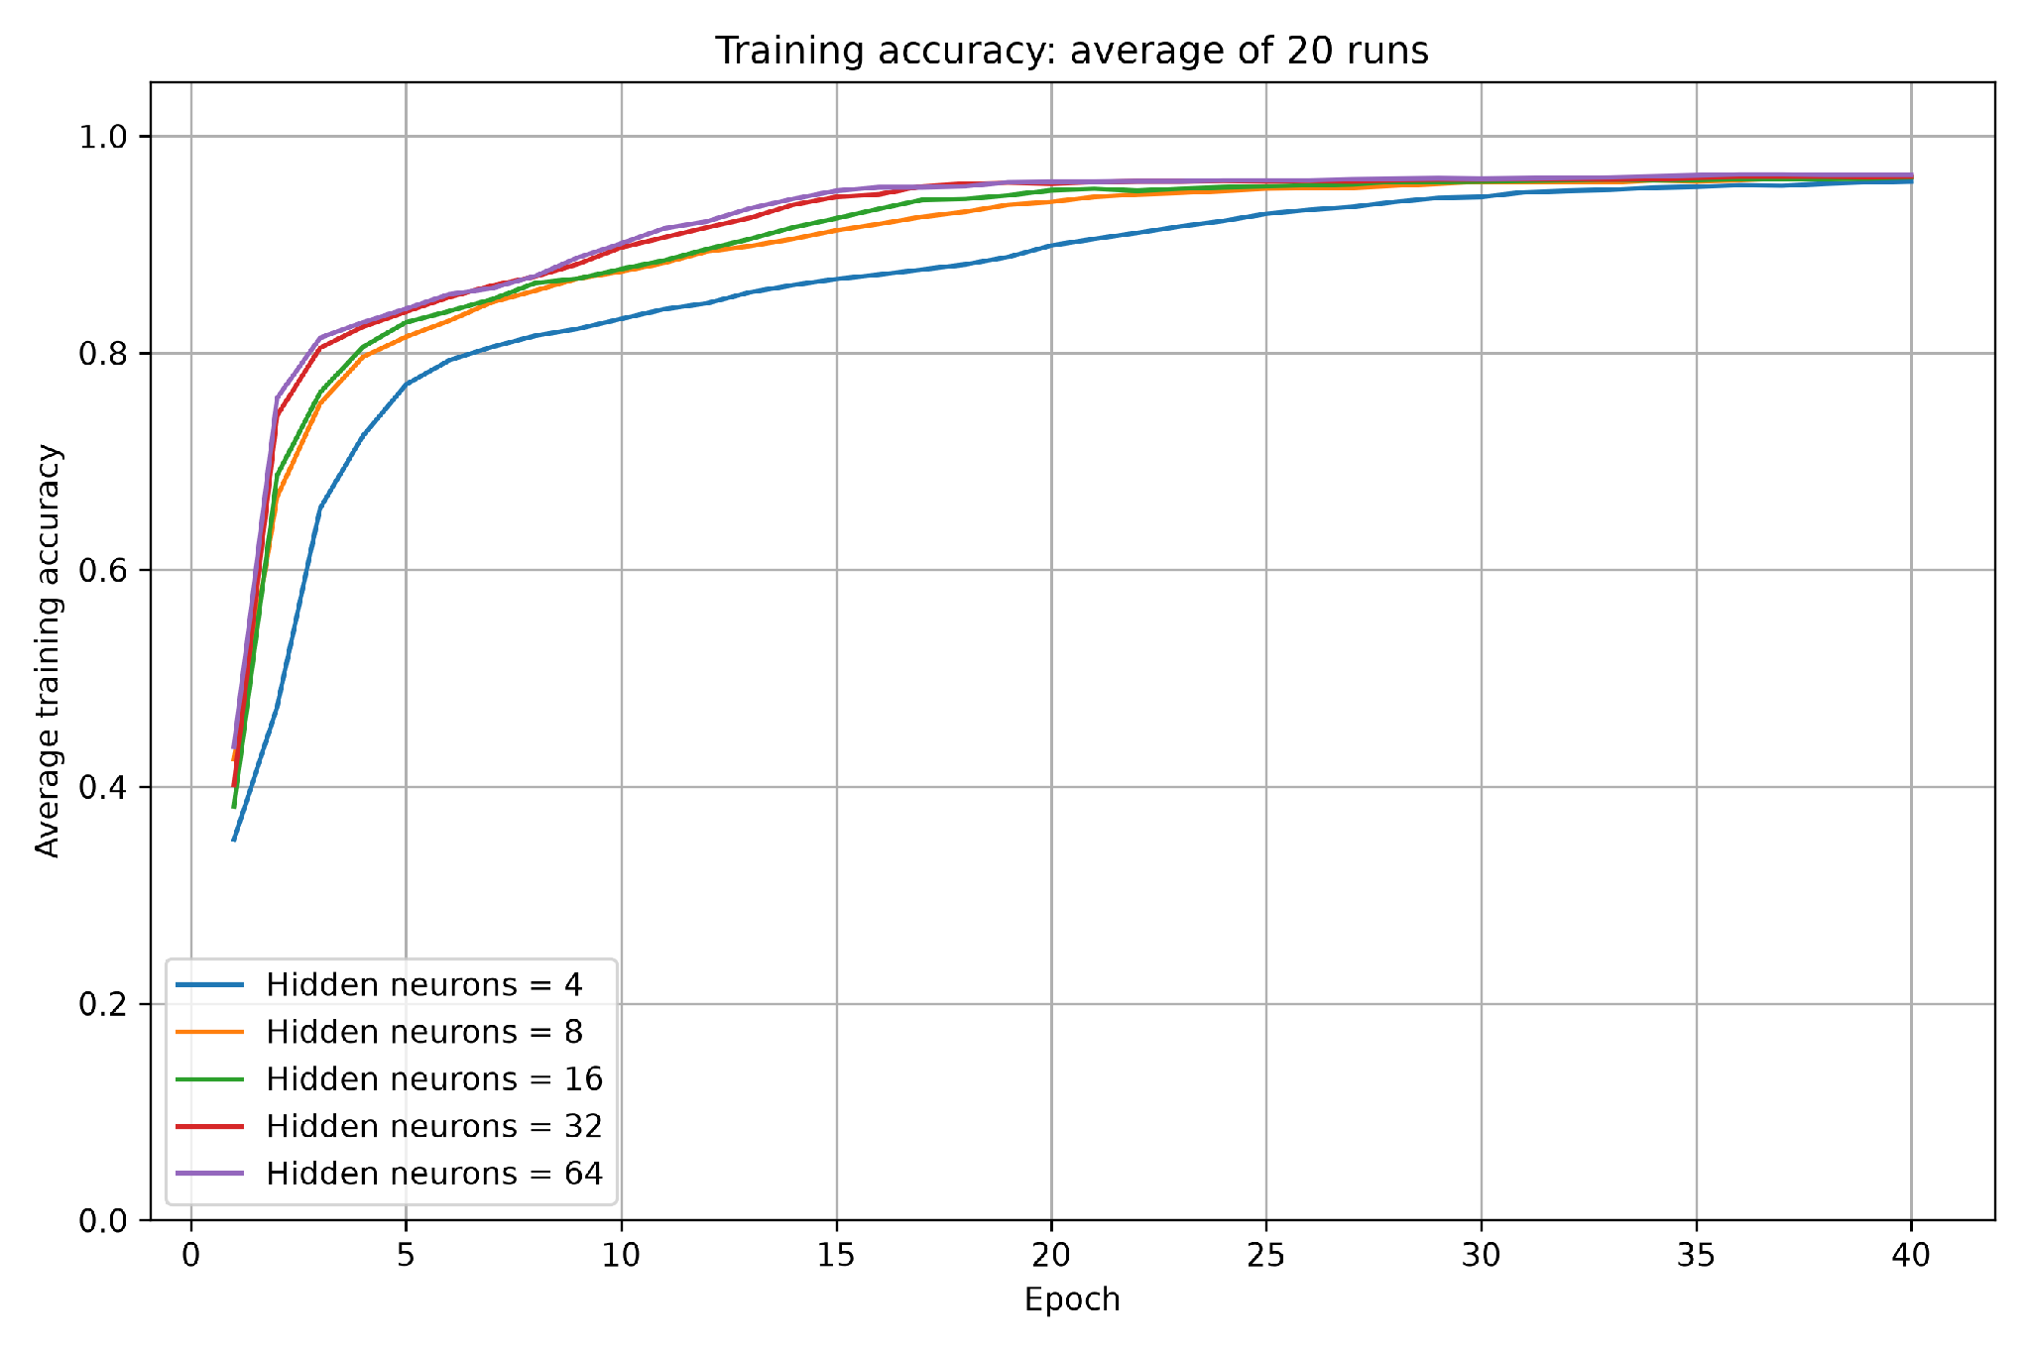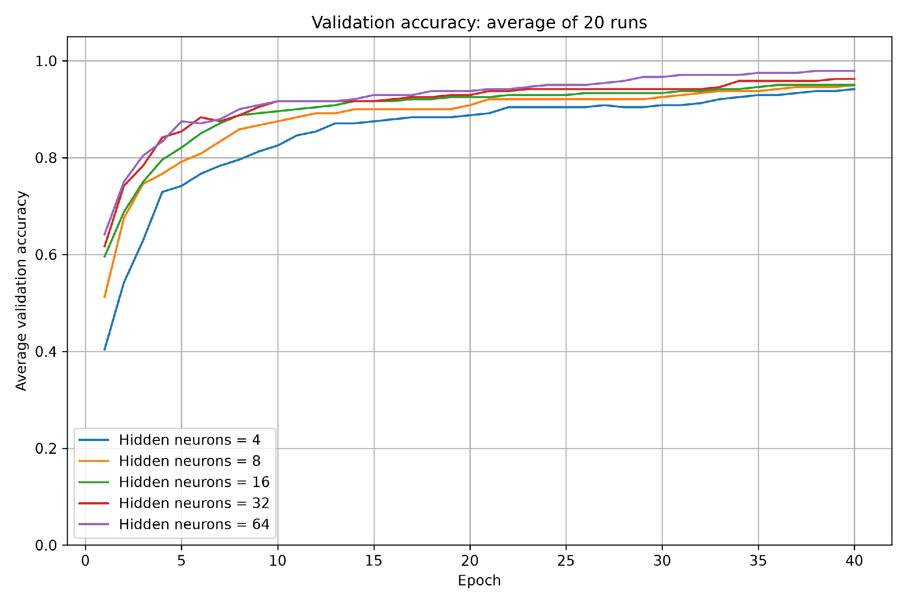
The models with the highest number of neurons generally reached high training and validation accuracy sooner but we can see that for 32 and 64 neurons we have very close accuracy. The model with four neurons learned more slowly, but caught up by the end. Final training accuracies were close, from 95.83% to 96.44%. The 64-neuron model had the highest average validation and training accuracy, but it did not have the highest test accuracy.

Test accuracy curves
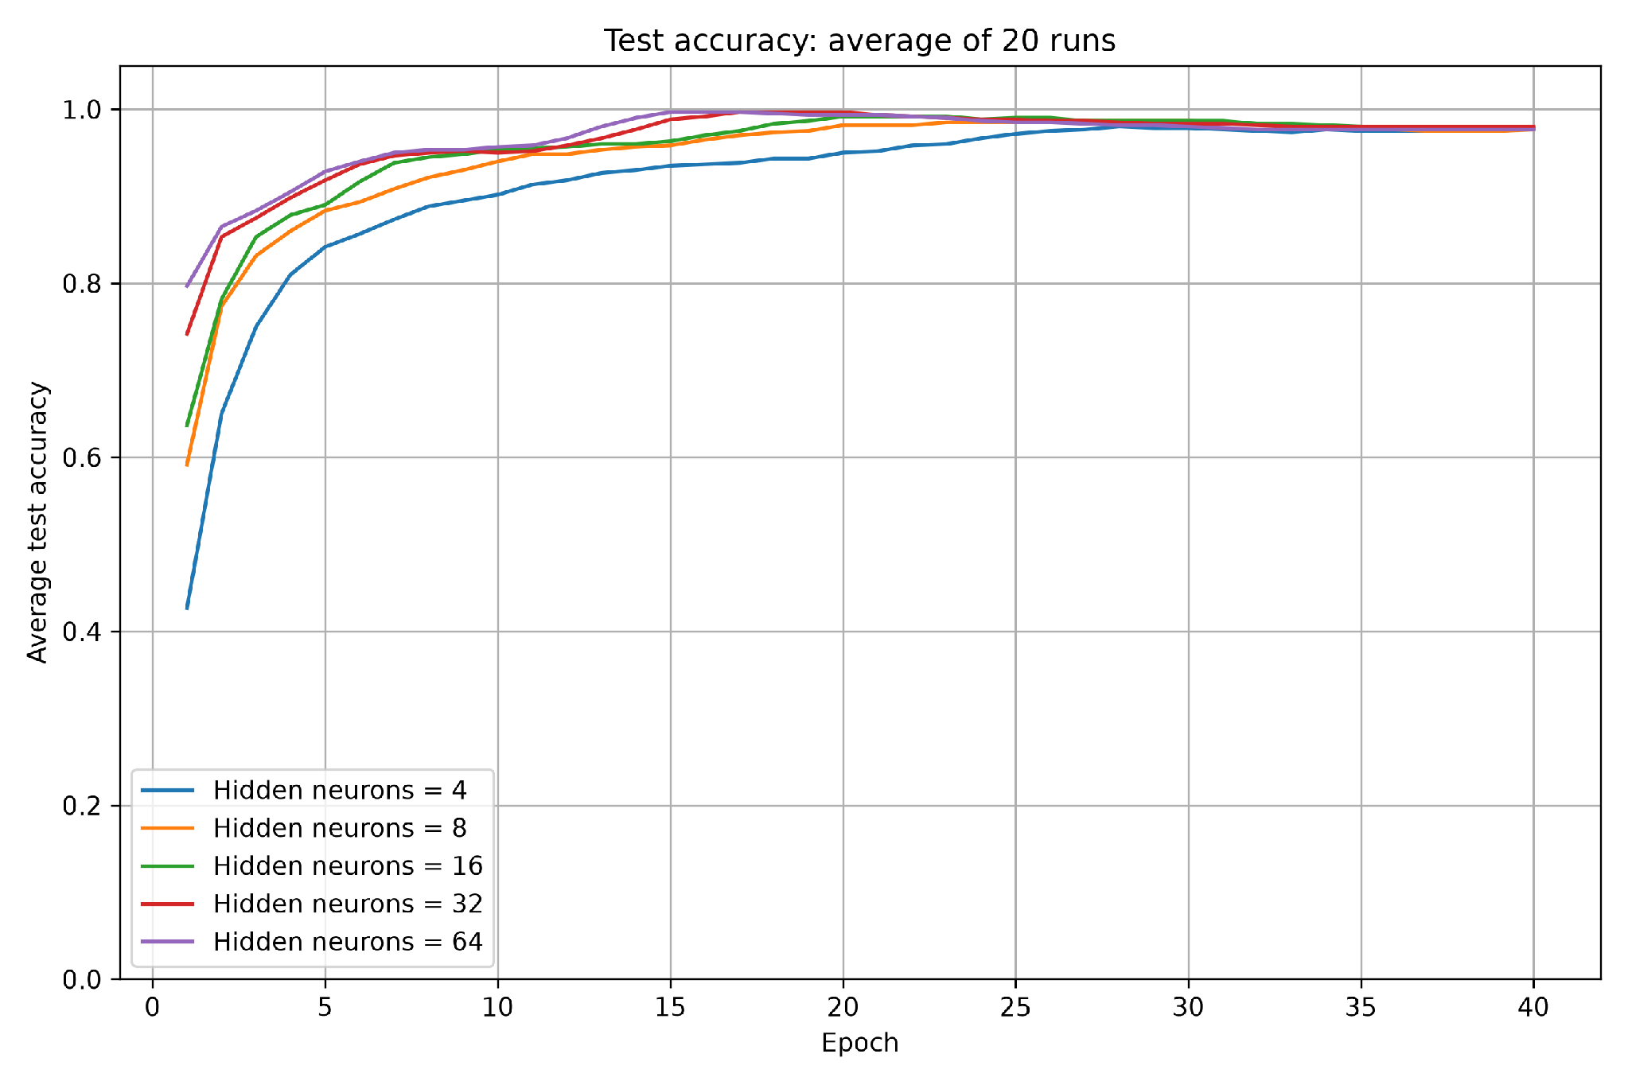

a Which hidden layer size performed best
Using mean test accuracy at epoch 40, 32 neurons performed best at 98.00%. Models with 4 and 16 neurons both reached 97.83%, while 8 and 64 neurons reached 97.67%. The largest gap was only 0.33 percentage points, so the final test results were very similar. The 32-neuron model was the best in this experiment, but such a small difference does not establish that it will always be better.

b What hidden neurons are and how they affect training
Hidden neurons are the units between the input measurements and the output predictions. They are hidden because your code only feeds data into the input layer and reads results from the output layer. Each neuron combines the four flower measurements using learned weights and a bias, then applies tanh. Together, these neurons learn patterns that help separate the three flower species.
Adding neurons gives the model more weights and more ability to learn complex patterns. They also increase the number of trainable weights and biases as follows:
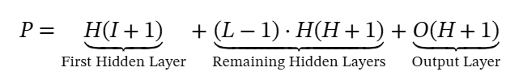
where:
- I = number of input features.
- H = number of hidden neurons.
- O = number of output neurons.
- 𝐿 = total number of hidden layers
In our network, the total number of hidden layers is 1, which means that the equation becomes:
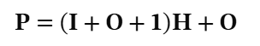

For our network, (I=4) and (O=3):
P= 8H + 3
Therefore, 4, 8, 16, 32 and 64 neurons give 35, 67, 131, 259 and 515 parameters, respectively.
Too few neurons can limit what a model learns. More neurons require more computation per batch and can increase the risk of fitting training details that do not help on new flowers. More neurons therefore do not guarantee better test accuracy. Here, larger models learned faster early on, but even four neurons achieved a similar final test result. Increasing from 32 to 64 neurons did not improve the final test accuracy.

1D) Activation functions

Model and experimental procedure
We compared tanh, sigmoid and ReLU in the hidden layer. The network kept four inputs, 16 hidden neurons and three softmax outputs. The learning rate was 0.02, momentum was 0.9, batch size was 32, and the loss was categorical cross-entropy. The data split, standardization and validation_split=0.1 stayed the same as in the earlier parts.
Each activation function was trained from scratch 20 times for 40 epochs, using seeds 42 to 61. We averaged the accuracy at each epoch across the 20 runs. Only the hidden activation changed; each model still had 131 trainable parameters.

Mean accuracy after 40 epochs
Activation | Training | Validation | Test
tanh | 96.20% | 95.00% | 97.83%
sigmoid | 91.81% | 88.75% | 94.83%
relu | 96.39% | 93.75% | 98.17%

Training and validation accuracy curves
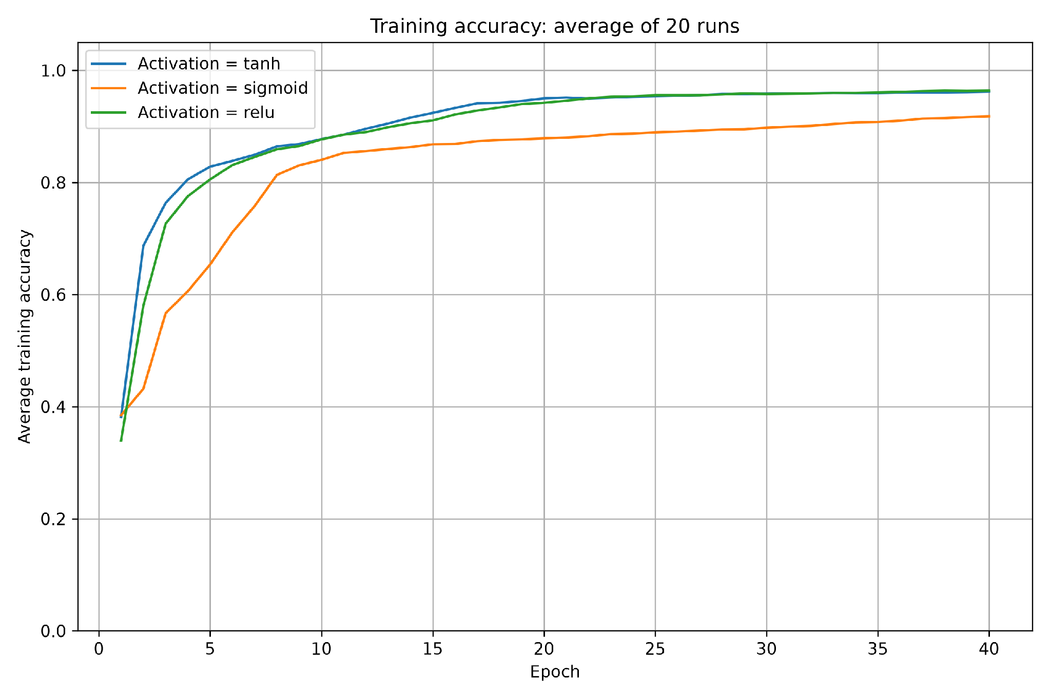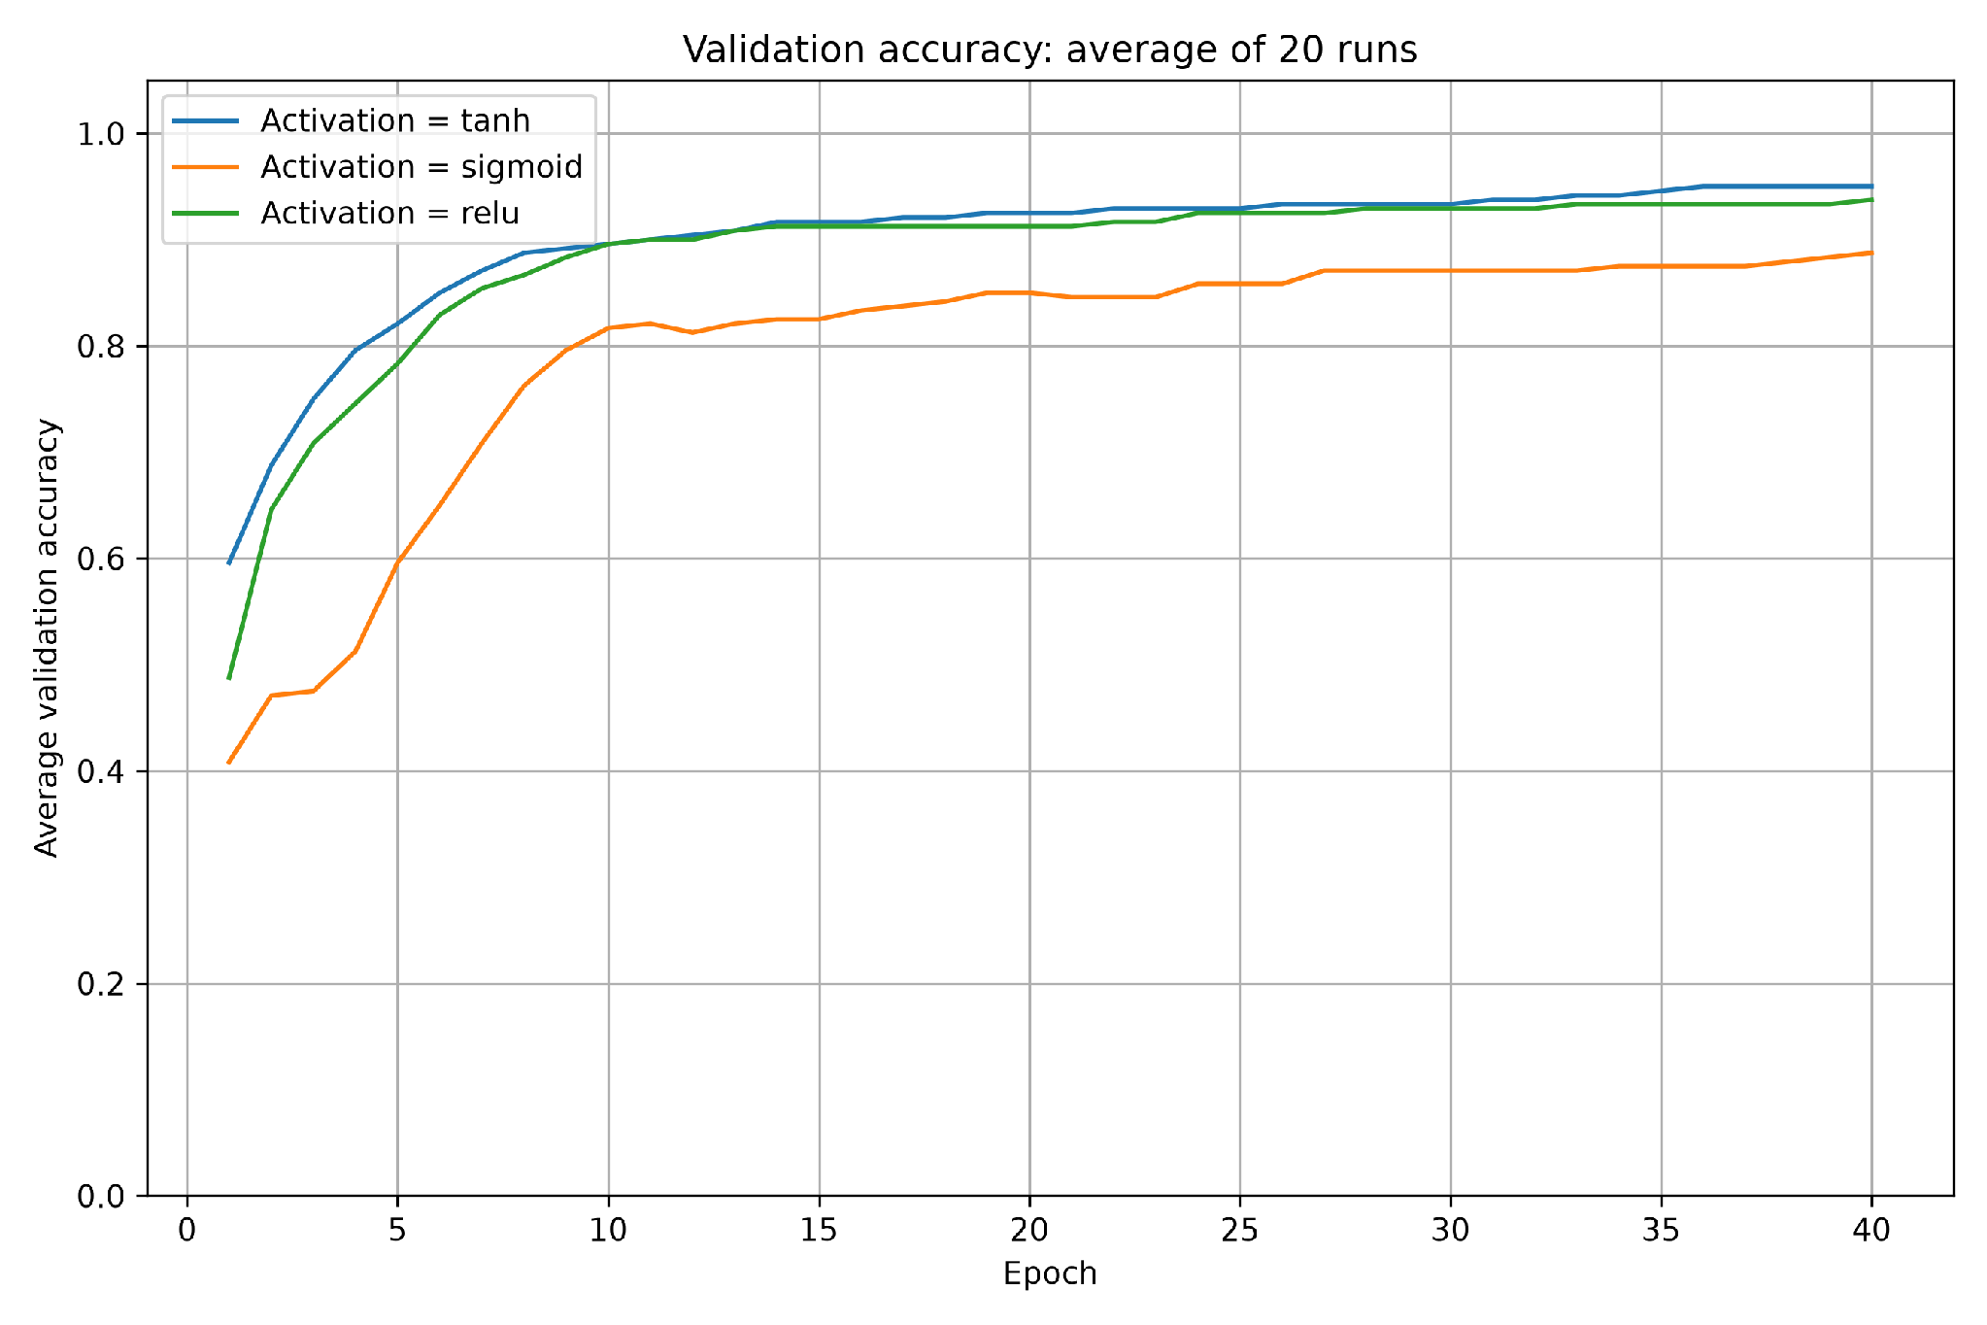
Tanh and ReLU learned faster than sigmoid and reached similar final training accuracies: 96.20% and 96.39%. Sigmoid improved more slowly and finished at 91.81%. Tanh had the highest final validation accuracy at 95.00%, followed by ReLU at 93.75% and sigmoid at 88.75%.

Test accuracy curves
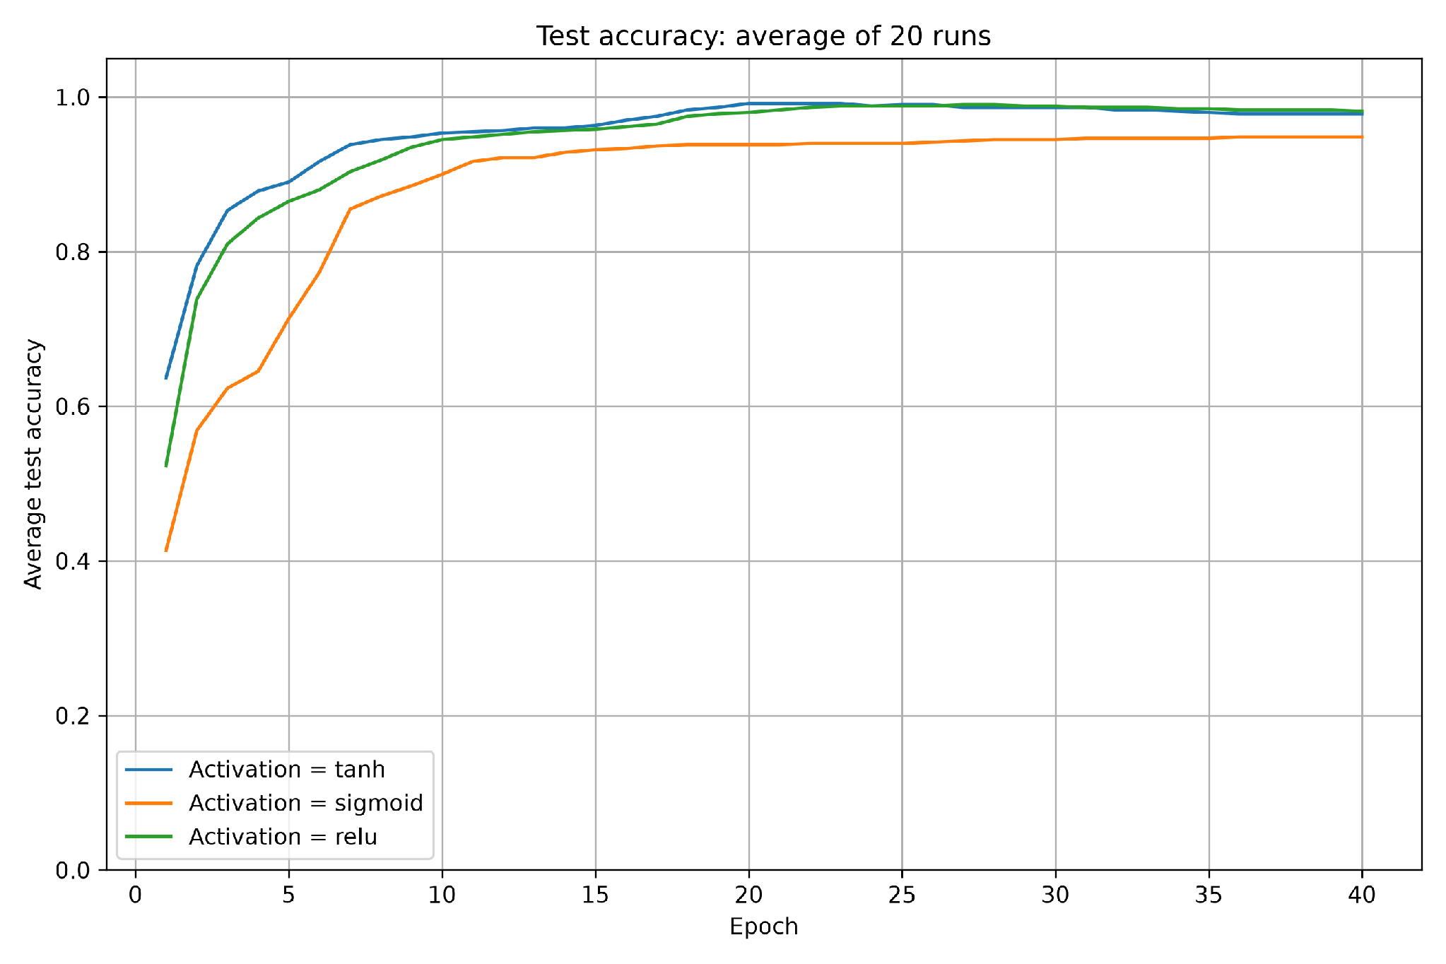

a Which activation function performed best
Using mean test accuracy at epoch 40, ReLU performed best at 98.17%. Tanh was very close at 97.83%, while sigmoid reached 94.83%. Tanh learned faster early in training, but ReLU finished slightly higher on the test set. The difference between ReLU and tanh was only about 0.33 percentage points, so their final test performance was very similar. Tanh had the better validation result; ReLU was best according to the test-based comparison required here.

b What an activation function is and how it affects training
A neuron first calculates a weighted sum of its inputs and adds a bias. The activation function transforms that value before passing it to the next layer. These functions allow the network to learn more complex relationships than a straight-line combination of the inputs. They also affect the gradients used to update the weights, which can change the speed of learning.
Let z be the weighted sum of a neuron's inputs plus its bias. The hidden activation is applied to z. The following equations describe the three functions compared in this experiment.
$tanh(z) = \frac{e^{z} − e^{−z}}{e^{z} + e^{−z}}$
Tanh has outputs between -1 and 1. Its derivative is 1 - tanh(z)^2. It is smooth and centred on zero, but its derivative becomes small for large positive or negative inputs.
$sigmoid(z) = \frac{1}{1 + e^{−z}}$
Sigmoid has outputs between 0 and 1. If its output is a, its derivative is a(1 - a). This derivative is at most 0.25 and becomes small near either output limit, which can slow learning.
$ReLU(z) = max(0, z)$
ReLU returns zero when z is negative and returns z otherwise. Its derivative is 0 for z < 0 and 1 for z > 0. At z = 0 it is not mathematically differentiable; implementations choose a value for training.
At fixed numerical precision, all three functions take O(1) work per neuron, so applying any of them to N values takes O(N) work. Their big-O complexity is therefore the same, but the amount of work per value differs.ReLU is usually the cheapest: it needs a comparison or maximum operation. Sigmoid requires an exponential calculation and arithmetic including division. Tanh is also a more expensive smooth function, its equation uses exponentials and division, although numerical libraries usually use optimized implementations rather than directly evaluating that formula.

1E) Batch size

Model and experimental procedure
We compared batch sizes of 1, 8, 16, 32 and 64. The network kept four inputs, 16 hidden neurons with tanh, and three softmax outputs. The learning rate was fixed at 0.02 and momentum at 0.9. We used categorical cross-entropy loss and the same data preparation and split as before, with 108 flowers used for weight updates, 12 for validation and 30 for testing.
Each batch size was trained from scratch 20 times for 40 epochs, using seeds 42 to 61. We averaged the accuracy across the 20 runs at each epoch. Changing batch size does not change the network structure or its 131 trainable parameters.

Mean accuracy after 40 epochs
Batch size | Training | Validation | Test
1 | 96.34% | 96.67% | 95.50%
8 | 96.94% | 99.58% | 99.83%
16 | 96.48% | 99.17% | 97.33%
32 | 96.20% | 95.00% | 97.83%
64 | 95.00% | 91.67% | 99.33%

Training and validation accuracy curves
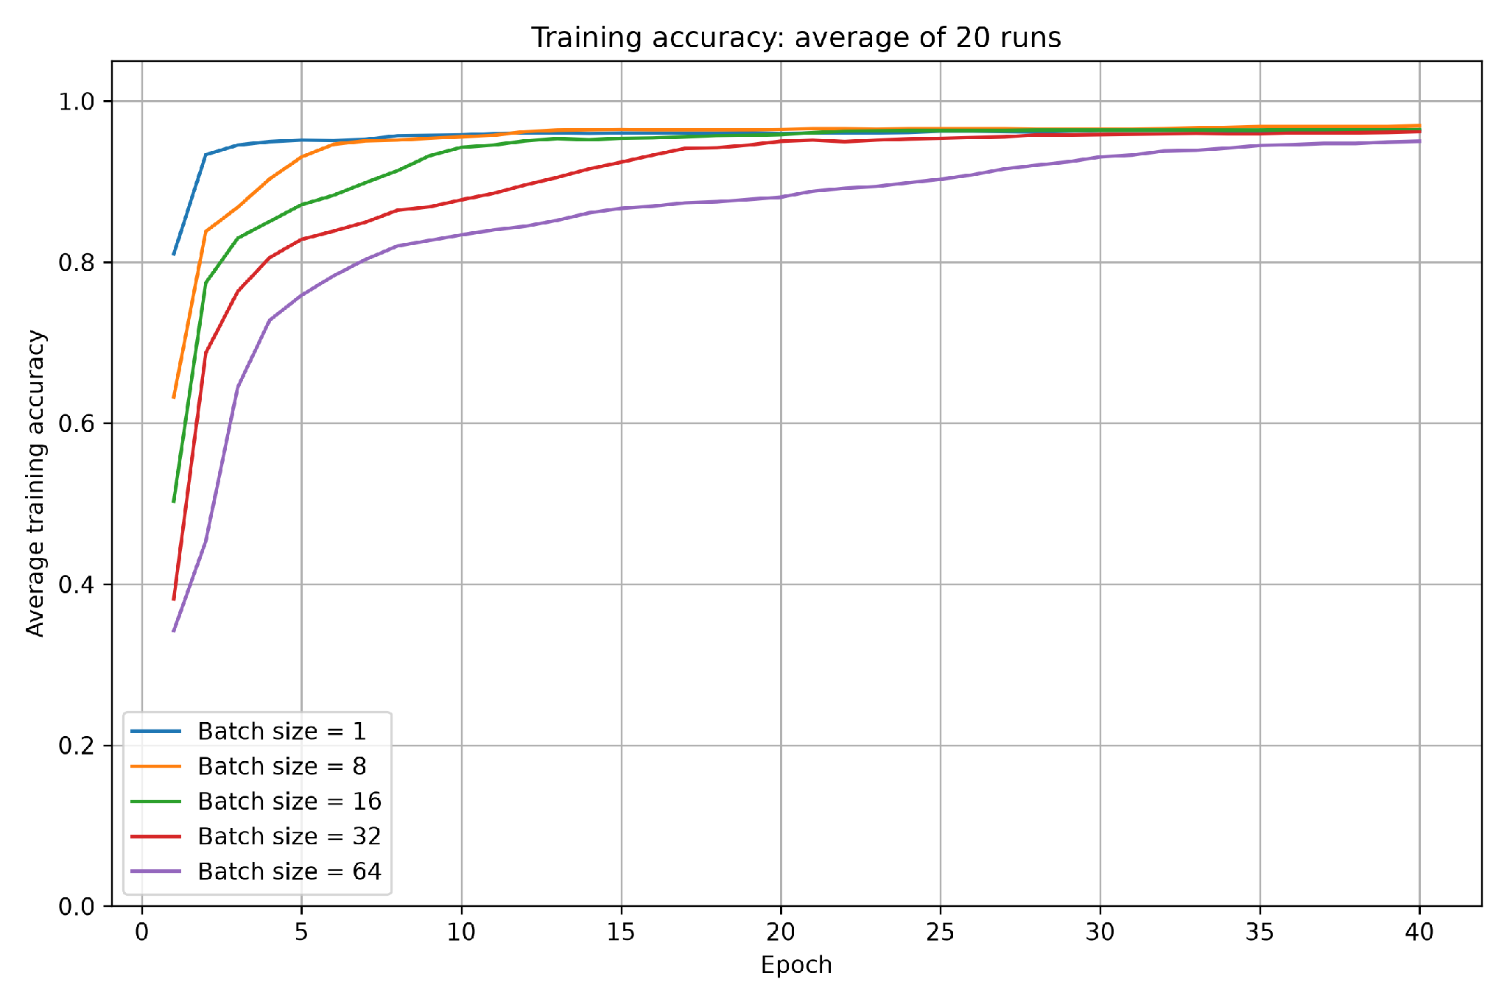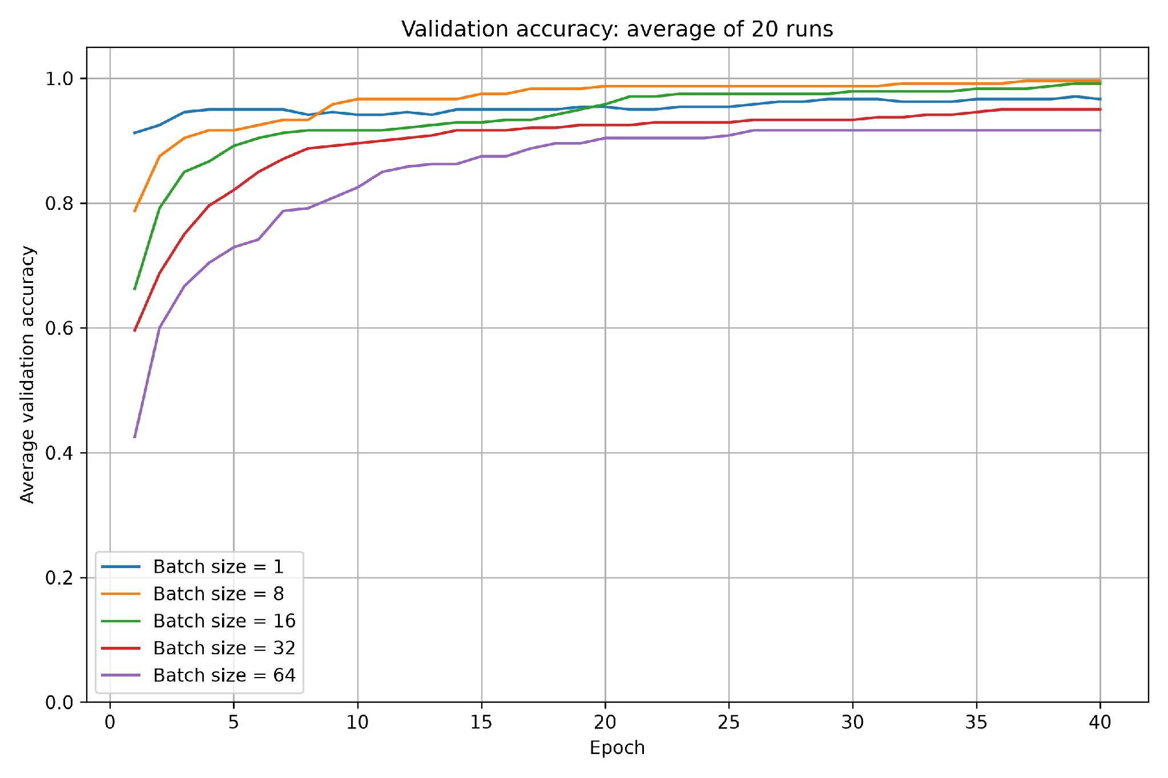
Batch size 1 reached high training accuracy very quickly, while batch size 64 improved more slowly. By epoch 40, training accuracies were close, from 95.00% to 96.94%. Batch size 8 gave the highest final training accuracy and validation accuracy, at 96.94% and 99.58%. Batch size 16 also achieved high validation accuracy at 99.17%.

Test accuracy curves
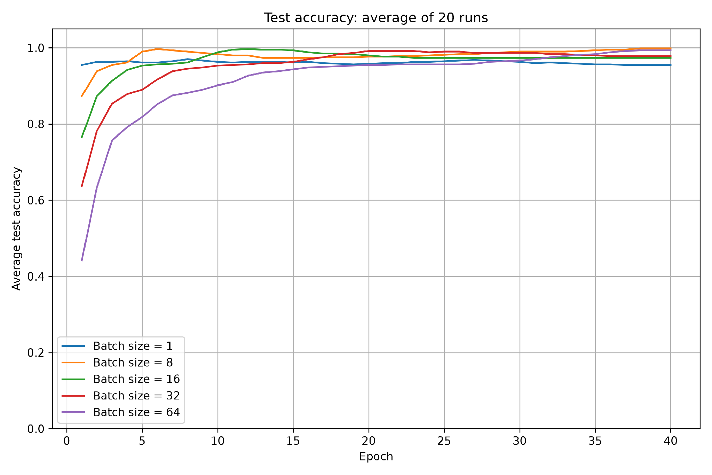

a Which batch size performed best
Using mean test accuracy at epoch 40, batch size 8 performed best at 99.83%, followed by 64 at 99.33%, 32 at 97.83%, 16 at 97.33% and 1 at 95.50%. Batch size 8 also had the highest final validation accuracy, making it the strongest choice in this experiment. Batch size 64 started more slowly but finished with the second-highest test accuracy, despite its lower validation accuracy. These sets contain different flowers, so their rankings need not match.

b What batch size is and how it affects training
Batch size is the number of training examples processed before one weight update. The model averages the loss gradients over the current batch and uses that information, together with momentum, to update its weights. Small batches give more frequent but usually noisier updates. Large batches use more examples per update, but make fewer updates per epoch.
With 108 training flowers, updates per epoch = ceil(108 / batch size), where ceil means rounding up. Batch sizes 1, 8, 16, 32 and 64 therefore make 108, 14, 7, 4 and 2 updates per epoch. Over 40 epochs, this gives 4320, 560, 280, 160 and 80 updates respectively. The last batch is smaller when the division is not exact. The experiment gives every model the same number of epochs, not the same number of weight updates.
This helps explain why small batches can improve quickly when accuracy is plotted against epochs. However, more frequent updates do not guarantee higher final accuracy: batch size 1 learned quickly but finished with the lowest test accuracy. Batch size 8 appears to provide a useful balance of frequent updates and averaging across examples for these settings.
Larger batches usually need more working memory and can make better use of parallel computation. Smaller batches involve more update overhead per epoch. Our experiment measured accuracy rather than runtime, so it does not establish which batch size was fastest in seconds. Batch size should be judged together with the learning rate and momentum; neither the smallest nor the largest size is always best.

Exercise 2 Proposed model

Selected parameters and reasons
I chose the best configuration from Exercise 1(e) as my starting point. It achieved 99.83% mean test accuracy, the highest final mean test accuracy in the Exercise 1 experiments. I kept its learning rate of 0.02, momentum of 0.9 and batch size of 8, but changed the hidden layer to four neurons and its activation to ReLU. My aim was to keep high accuracy while reducing computation per example.

Learning rate and momentum
I kept the learning rate low at 0.02 so that the current gradient makes a smaller contribution to each weight update. Although 0.2 performed best in Exercise 1(a), that experiment used momentum 0.0. Without momentum, the optimizer does not carry part of the previous update forward. A low learning rate can therefore make progress slower, as seen in the earlier curves.
Here I used momentum 0.9 to carry part of the previous update forward and help learning progress in a consistent direction. Exercise 1(b), which fixed the learning rate at 0.02, showed faster improvement with 0.9 than with zero momentum. This supported my expectation of reaching high accuracy in fewer epochs despite the low learning rate. It does not prove a reduction in training time in seconds, and momentum can accumulate updates, so a low learning rate does not guarantee that every total update is small.

Hidden neurons and activation
I chose four hidden neurons because they achieved 97.83% test accuracy in Exercise 1(c), the same rounded result as 16 neurons and only about 0.17 percentage points below 32 neurons. Such a small gap does not show that 32 neurons will always perform better. Four neurons reduce the network from 131 to 35 trainable parameters compared with the original 16-neuron model, lowering the work needed per example.
I chose ReLU instead of tanh because it gave the highest final test accuracy in Exercise 1(d) and usually needs less computation per value. I kept batch size 8 because it gave the best final test and validation accuracies in Exercise 1(e). These choices are based on the earlier experiments, but changing two settings together requires a new evaluation; the original 99.83% result is not guaranteed.

Final model and training procedure
The final model has four inputs, one hidden layer of four ReLU neurons, and three softmax output neurons. It uses SGD with learning rate 0.02 and momentum 0.9, categorical cross-entropy loss, batch size 8, and validation_split=0.1. I trained it for 40 epochs in 20 independent runs, using seeds 42 to 61 and the same data preparation and split as Exercise 1. The curves show accuracy averaged across those runs.

Mean accuracy after 40 epochs
Model | Training | Validation | Test
Four neurons ReLU | 96.71% | 96.67% | 98.33%

Accuracy over epochs
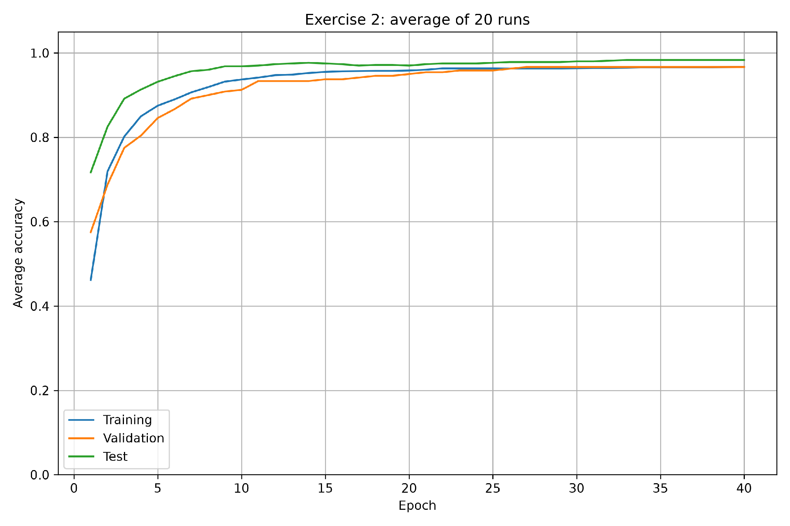

Discussion of the results
The proposed model achieved 98.33% mean test accuracy, with 96.71% training accuracy and 96.67% validation accuracy. The curves improve quickly in the early epochs and then level off. The final test accuracy is 1.50 percentage points below the 99.83% result from the original 16-neuron tanh model with batch size 8.
The smaller model therefore retained high accuracy but did not exceed the best earlier result. It offers a trade-off: fewer parameters and cheaper activation calculations, in exchange for a lower observed mean test accuracy. These results support it as a compact alternative; if maximizing the observed test accuracy alone were the priority, the original Exercise 1(e) configuration would remain preferable. Runtime was not measured, and the reused test set does not provide an independent final assessment after selecting the settings.

