- Empirical Antibiotics Recommendation System (EARS)
Dataset:
- Period - May 2021 – Jan 2022
- Locations - 20+ Locations pan India
- Gender - All AGE Group (0 – 90+ years)
- Quantum - 193K bacterial Isolates | 54 Specimens Types | 187 Organisms | 140 Antibiotics
- The data includes 1,33,608 (69%) Inpatient isolates and 60,040 (31%) Outpatient isolates. The performance of the recommendation system can further be increased by increasing the number of outpatients in the dataset
Methodology:
The methodology mentioned in the Apollo EARS document has been followed.
Results:
- Overall Cosine Similarity – All Sample :: All Location – 0.87 (>0.6 is a good measure)
- Model (Regression)
a. Mean Absolute Error (MAE): 0.353
b. Mean Squared Error (MSE): 0.256
- Classification Results:
a. Sensitivity – 0.707
b. Specificity – 0.770
c. AUC – 0.793
d. Accuracy – 0.741
Appendix:
- Cosine similarity
Location: ALL
Specimen name | Cosine similarity
Urine | 0.996068
Blood | 0.999413
Respiratory | 0.829265
Wound_pus | 0.972794
stool | 0.967605
Body_fluid | 0.945071

Location: Bangalore
Specimen name | Cosine similarity
Urine | 0.985635
Blood | 0.930261
Respiratory | 0.785829
Wound_pus | 0.955533
stool | 0.816882
Body_fluid | 0.883391

Location: Bhubaneshwar
Specimen name | Cosine similarity
Urine | 0.985635
Blood | 0.930261
Respiratory | 0.857829
Wound_pus | 0.955533
stool | 0.816882
Body_fluid | 0.883391

Location: Chennai
Specimen name | Cosine similarity
Urine | 0.996849
Blood | 0.988326
Respiratory | 0.929316
Wound_pus | 0.984731
stool | 0.834527
Body_fluid | 0.966552

Location: Delhi
Specimen name | Cosine similarity
Urine | 0.979251
Blood | 0.909477
Respiratory | 0.720601
Wound_pus | 0.931281
stool | 0.869032
Body_fluid | 0.899522

Location: Kolkata
Specimen name | Cosine similarity
Urine | 0.982957
Blood | 0.909734
Respiratory | 0.741464
Wound_pus | 0.940263
stool | 0.786330

Location: Hyderabad
Specimen name | Cosine similarity
Urine | 0.991465
Blood | 0.995170
Respiratory | 0.797127
Wound_pus | 0.952537
Body_fluid | 0.858764

Location: Mumbai
Specimen name | Cosine similarity
Urine | 0.965271
Blood | 0.997639
Respiratory | 0.781220
Wound_pus | 0.974962
stool | 0.967010
Body_fluid | 0.887393

2) Classifier on entire data (193k): Training 70%-Testing 30%
Based on the Type of Specimen vs Location
Results:
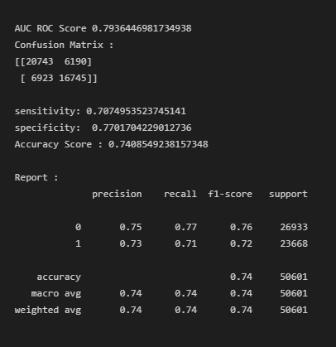
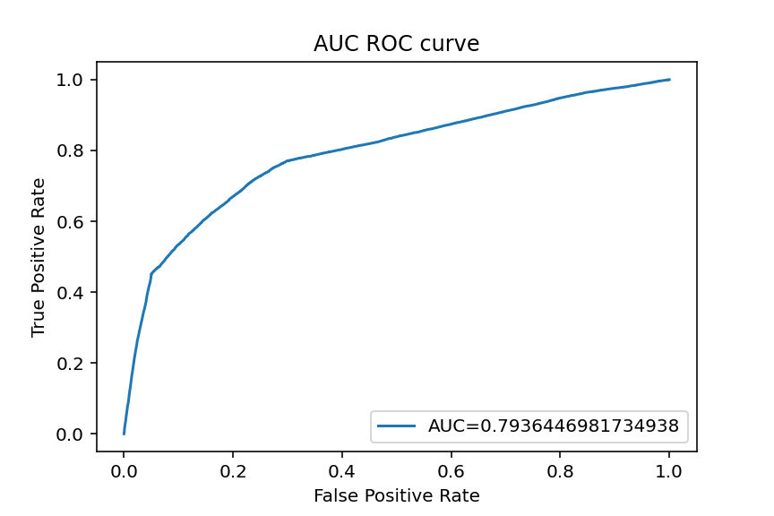
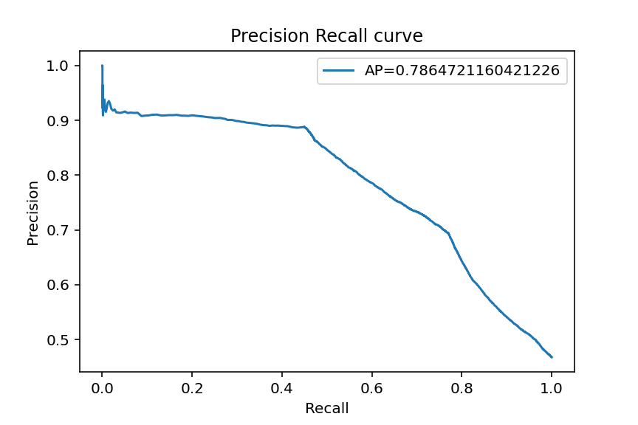

3) Classifier on location specific data:
AUC curves for each location are shown below:
- Bangalore
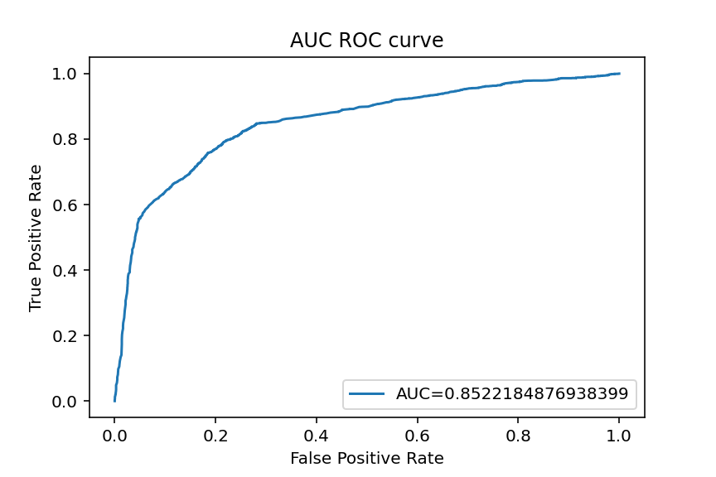
- Chennai
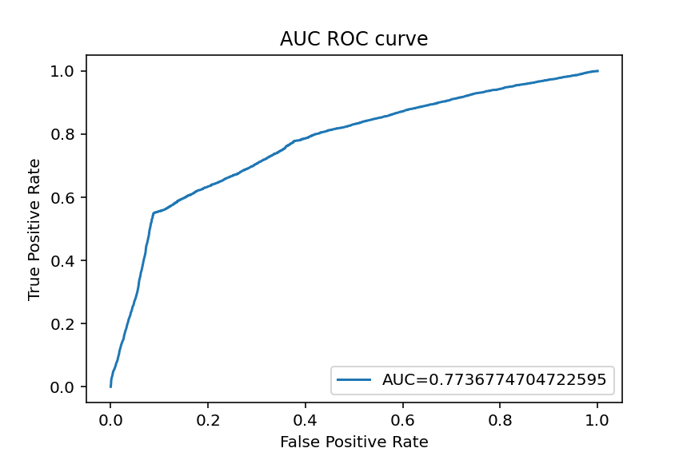
- Delhi
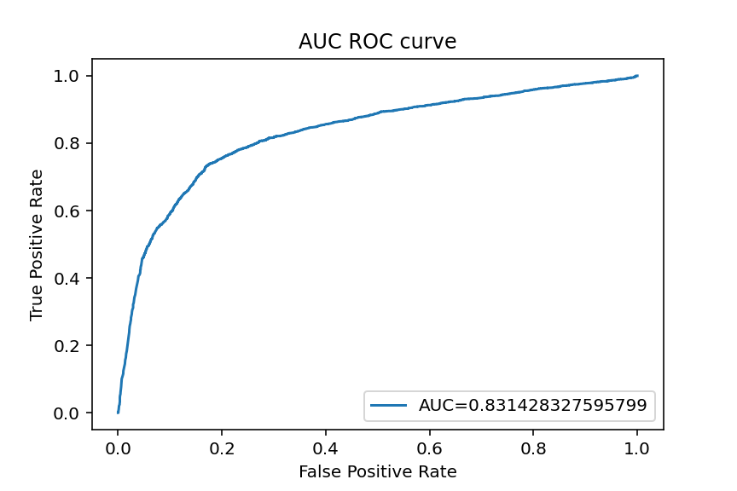

- Hyderabad
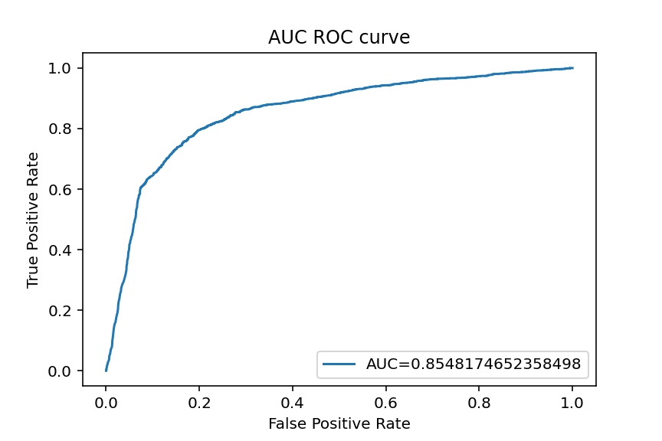
- Kolkatta
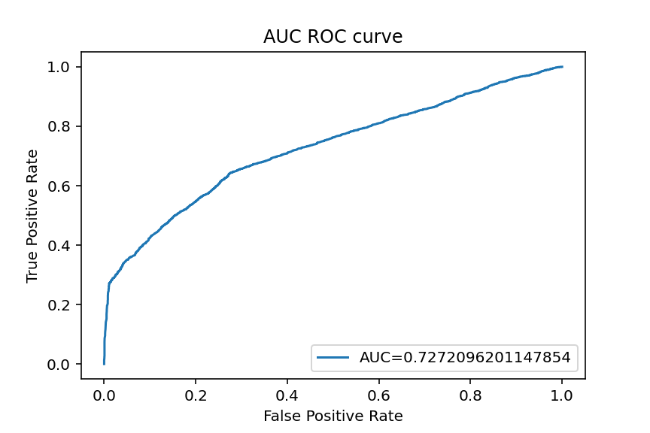
- Mumbai
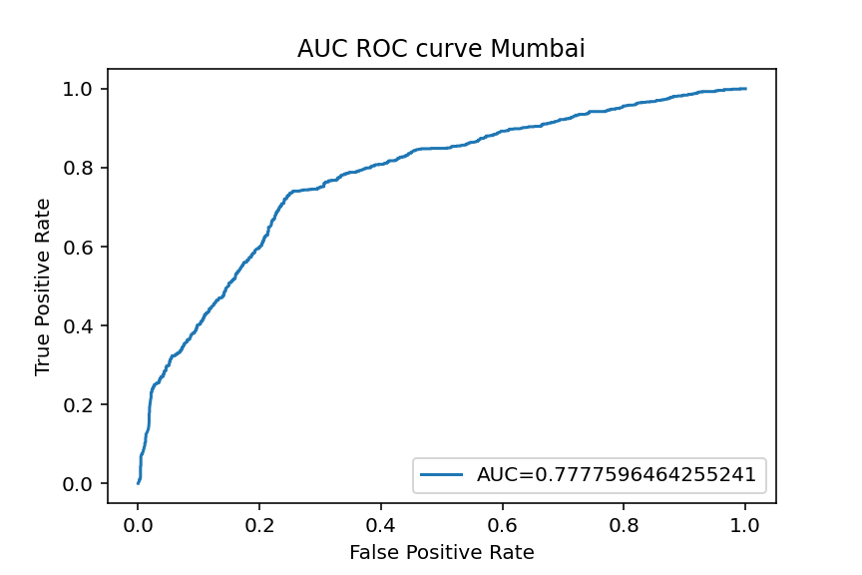
- Nashik
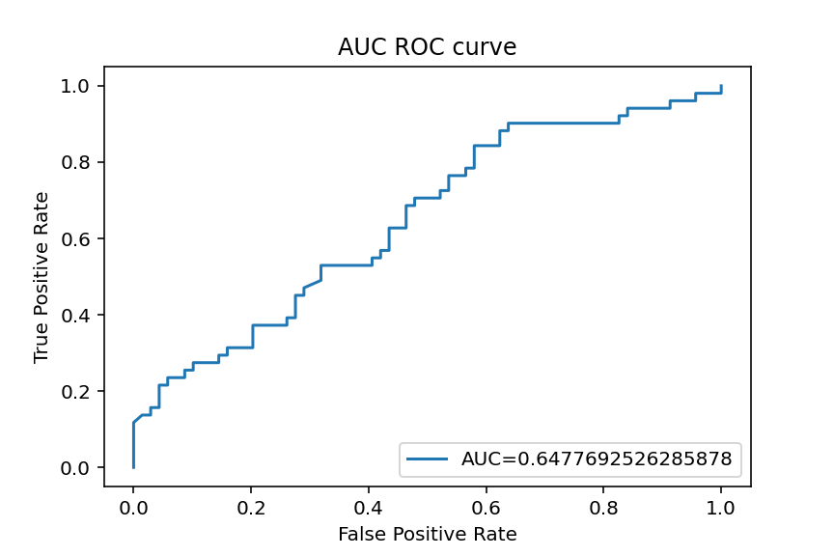
b) Precision-recall curves for each location are shown below:
i. Bangalore
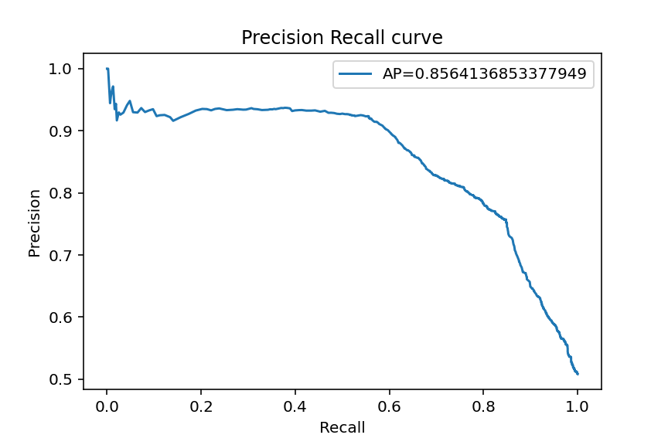
ii. Chennai
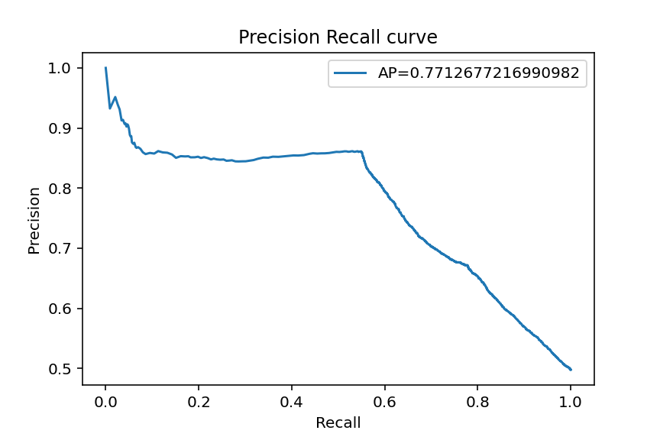
iii. Delhi
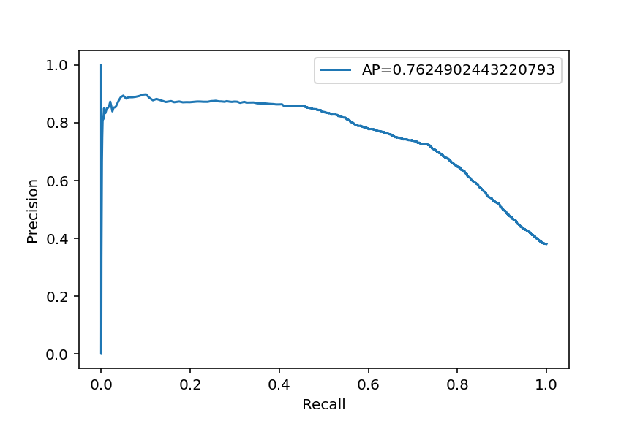
iv. Hyderabad
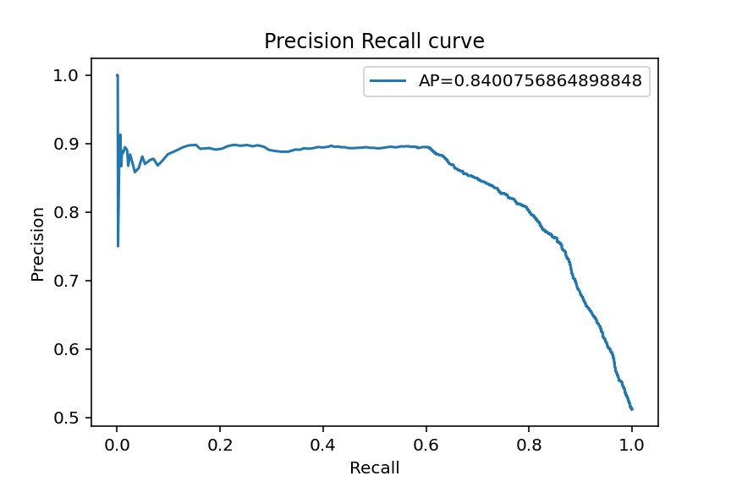
v. Mumbai
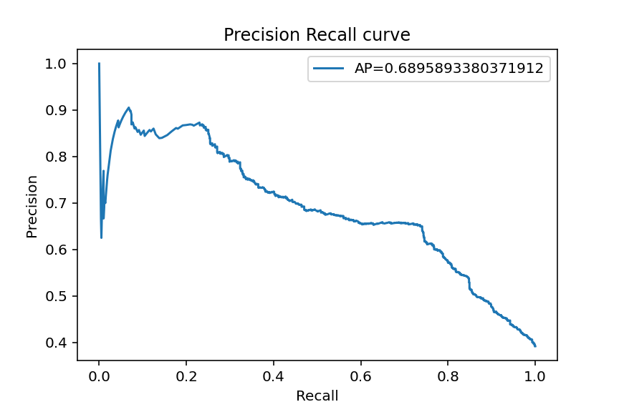
vi. Nashik
