**WEEK-2 HANDS-0N EXERCISES**

**DATE: 28-06-2025**

**PLSQL_Exercises:  
Exercise 1: Control Structures:  
Accounts table:**

SELECT * FROM user_tables WHERE table_name = 'ACCOUNTS';

**Testing-Table:**

CREATE TABLE Accounts (

AccountID NUMBER PRIMARY KEY,

Balance NUMBER(10, 2),

AccountType VARCHAR2(20),

LastModified DATE

);

**Procedure:**

CREATE OR REPLACE PROCEDURE ProcessMonthlyInterest IS

v_AccountID Accounts.AccountID%TYPE;

v_Balance Accounts.Balance%TYPE;

BEGIN

FOR acc IN (

SELECT AccountID, Balance

FROM Accounts

WHERE AccountType = 'Savings'

)

LOOP

v_AccountID := acc.AccountID;

v_Balance := acc.Balance;

UPDATE Accounts

SET Balance = v_Balance + (v_Balance * 0.01),

LastModified = SYSDATE

WHERE AccountID = v_AccountID;

DBMS_OUTPUT.PUT_LINE('Interest applied to Account ID ' || v_AccountID);

END LOOP;

END;

/

**Run the Procedure:**SET SERVEROUTPUT ON;

EXEC ProcessMonthlyInterest;

**OUTPUT:  
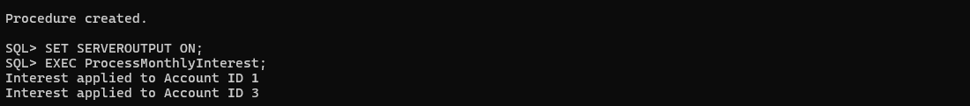**

**Exercise 3: Stored Procedures  
Replace Procedure:**

CREATE OR REPLACE PROCEDURE ProcessMonthlyInterest IS

BEGIN

FOR acc IN (

SELECT AccountID, Balance

FROM Accounts

WHERE AccountType = 'Savings'

)

LOOP

UPDATE Accounts

SET Balance = Balance + (Balance * 0.01),

LastModified = SYSDATE

WHERE AccountID = acc.AccountID;

DBMS_OUTPUT.PUT_LINE('Interest applied to Account ID ' || acc.AccountID);

END LOOP;

END;

/

BEGIN

ProcessMonthlyInterest;

END;

/

**Employees table:**

CREATE TABLE Employees (

EmployeeID NUMBER PRIMARY KEY,

Name VARCHAR2(100),

Department VARCHAR2(50),

Salary NUMBER(10,2)

);  
**Data:**

INSERT INTO Employees VALUES (1, 'John', 'HR', 50000);

INSERT INTO Employees VALUES (2, 'Jane', 'HR', 60000);

INSERT INTO Employees VALUES (3, 'Mike', 'IT', 70000);

COMMIT;

**UpdateEmployeeBonus:**

CREATE OR REPLACE PROCEDURE UpdateEmployeeBonus (

p_Department IN VARCHAR2,

p_BonusPercent IN NUMBER

) IS

v_EmpID Employees.EmployeeID%TYPE;

v_Salary Employees.Salary%TYPE;

BEGIN

FOR emp IN (

SELECT EmployeeID, Salary

FROM Employees

WHERE Department = p_Department

)

LOOP

v_EmpID := emp.EmployeeID;

v_Salary := emp.Salary;

UPDATE Employees

SET Salary = v_Salary + (v_Salary * (p_BonusPercent / 100))

WHERE EmployeeID = v_EmpID;

DBMS_OUTPUT.PUT_LINE('Bonus applied to Employee ID ' || v_EmpID);

END LOOP;

END;

/

BEGIN

UpdateEmployeeBonus('IT', 10);

END;

/

CREATE OR REPLACE PROCEDURE TransferFunds (

p_FromAccountID IN NUMBER,

p_ToAccountID IN NUMBER,

p_Amount IN NUMBER

) IS

v_FromBalance NUMBER;

BEGIN

-- Check source balance

SELECT Balance INTO v_FromBalance

FROM Accounts

WHERE AccountID = p_FromAccountID

FOR UPDATE;

IF v_FromBalance < p_Amount THEN

RAISE_APPLICATION_ERROR(-20001, 'Insufficient balance in source account.');

END IF;

-- Deduct from source

UPDATE Accounts

SET Balance = Balance - p_Amount,

LastModified = SYSDATE

WHERE AccountID = p_FromAccountID;

-- Add to destination

UPDATE Accounts

SET Balance = Balance + p_Amount,

LastModified = SYSDATE

WHERE AccountID = p_ToAccountID;

DBMS_OUTPUT.PUT_LINE('Transferred ' || p_Amount ||

' from Account ID ' || p_FromAccountID ||

' to Account ID ' || p_ToAccountID);

END;

/

**OUTPUT:**

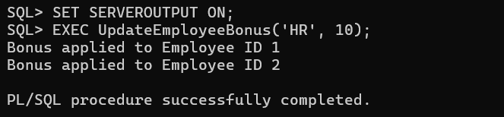

**JUnit_Basic Testing Exercises:  
Exercise 1: Setting Up Junit  
PROGRAM:**

<project xmlns="http://maven.apache.org/POM/4.0.0"

xmlns:xsi="http://www.w3.org/2001/XMLSchema-instance"

xsi:schemaLocation="http://maven.apache.org/POM/4.0.0

https://maven.apache.org/xsd/maven-4.0.0.xsd">

<modelVersion>4.0.0</modelVersion>

<groupId>com.example</groupId> <!-- You can customize this -->

<artifactId>junit-demo</artifactId> <!-- Project name -->

<version>1.0-SNAPSHOT</version>

<dependencies>

<dependency>

<groupId>junit</groupId>

<artifactId>junit</artifactId>

<version>4.13.2</version>

<scope>test</scope>

</dependency> </dpendencies>

</project>

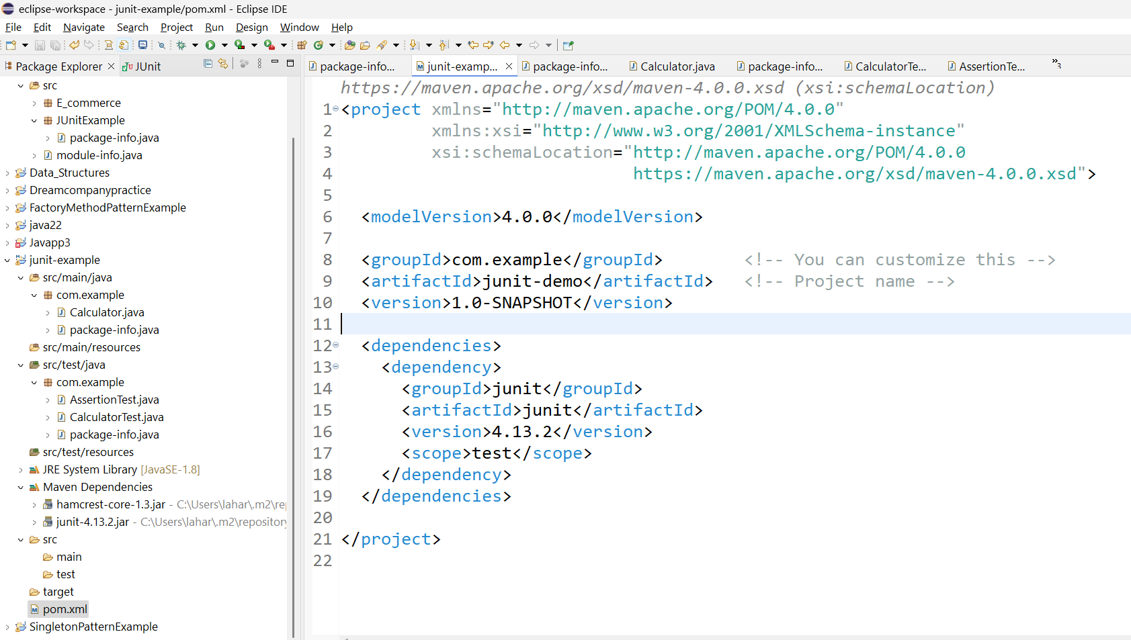

TEST CASE CREATED:

package com.example;

import static org.junit.Assert.*;

import org.junit.Test;

public class CalculatorTest {

@Test

public void testAdd() {

Calculator calc = new Calculator();

assertEquals(5, calc.add(2, 3));

}

@Test

public void testMultiply() {

Calculator calc = new Calculator();

int result = calc.multiply(3, 4);

assertEquals(12, result);

} }  
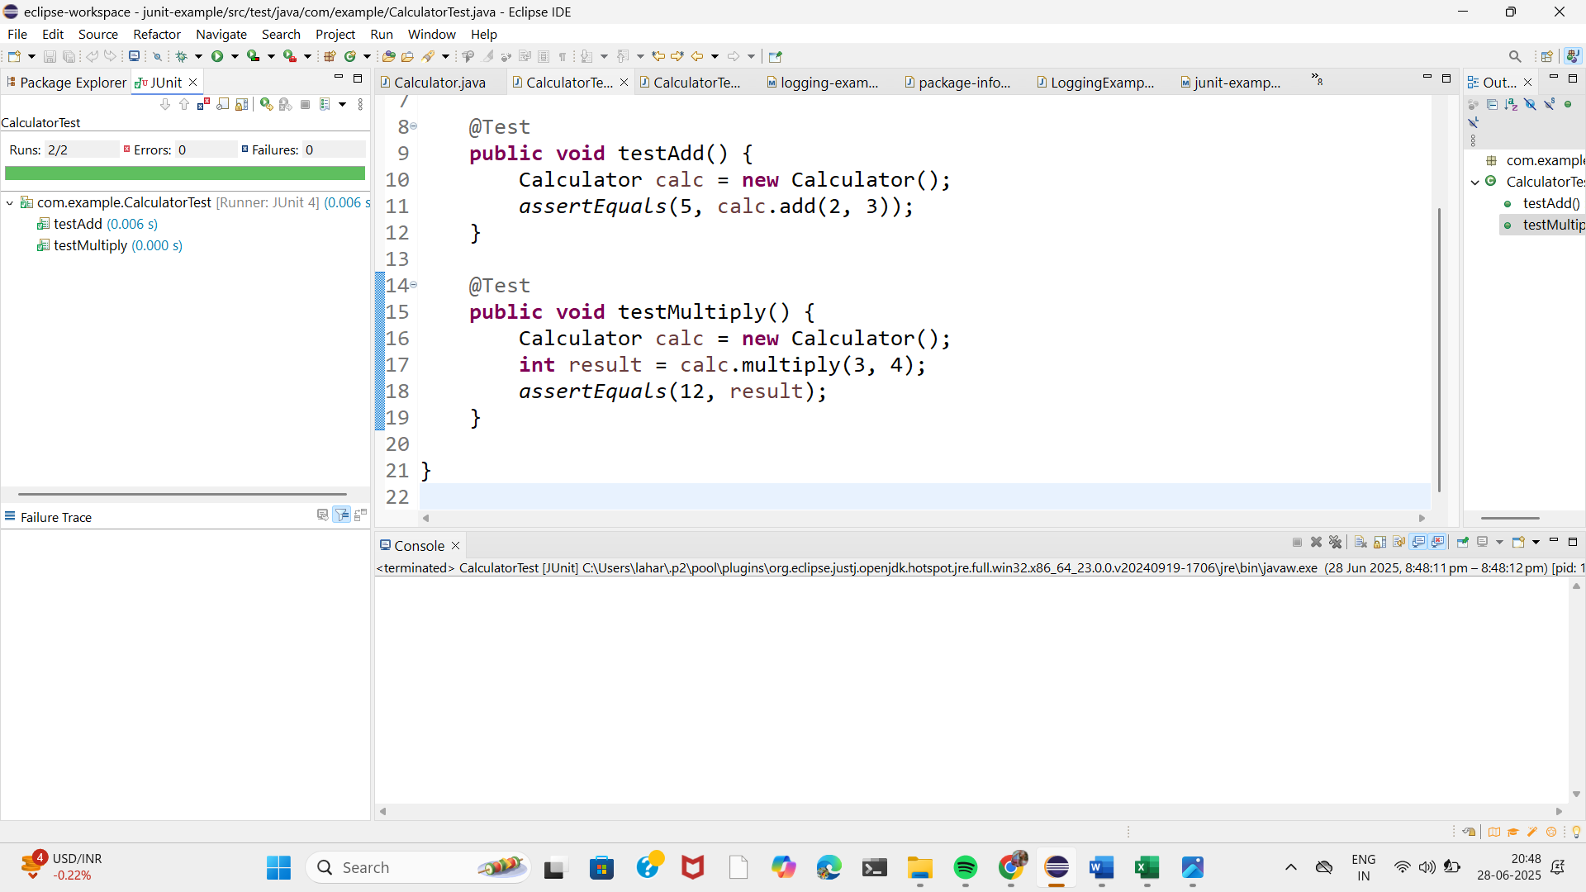

**Exercise 3: Assertions in Junit  
PROGRAM:**

**ASSERTIONSTEST.JAVA:**

package com.example;

import static org.junit.Assert.*;

import org.junit.Test;

public class AssertionTest {

@Test

public void testAssertions() {

assertEquals(5, 2 + 3);

assertTrue(5 > 3);

assertFalse(5 < 3);

Object obj1 = null;

assertNull(obj1);

Object obj2 = new Object();

assertNotNull(obj2);

}

}

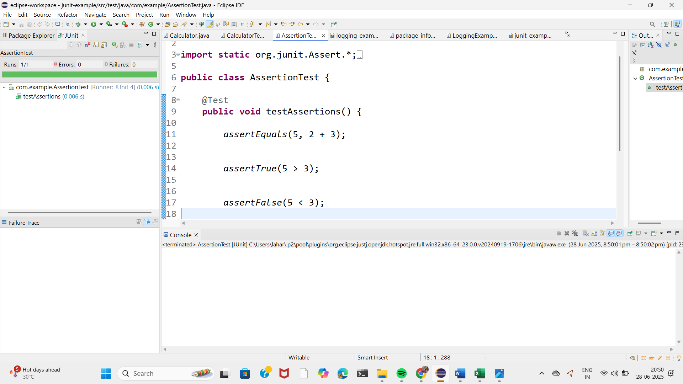

**Exercise 4: Arrange-Act-Assert (AAA) Pattern, Test Fixtures, Setup and Teardown Methods in Junit:**

package com.example;

import static org.junit.Assert.*;

import org.junit.After;

import org.junit.Before;

import org.junit.Test;

public class CalculatorTest1 {

private Calculator calc;

// 🔧 Setup method (runs before each @Test)

@Before

public void setUp() {

System.out.println("Setting up Calculator...");

calc = new Calculator(); // Arrange

}

// 🧹 Teardown method (runs after each @Test)

@After

public void tearDown() {

System.out.println("Tearing down Calculator...");

calc = null;

}

@Test

public void testAdd() {

// Act

int result = calc.add(2, 3);

// Assert

assertEquals(5, result);

}

@Test

public void testMultiply() {

// Act

int result = calc.multiply(4, 3);

// Assert

assertEquals(12, result);

}

}

**Output:**

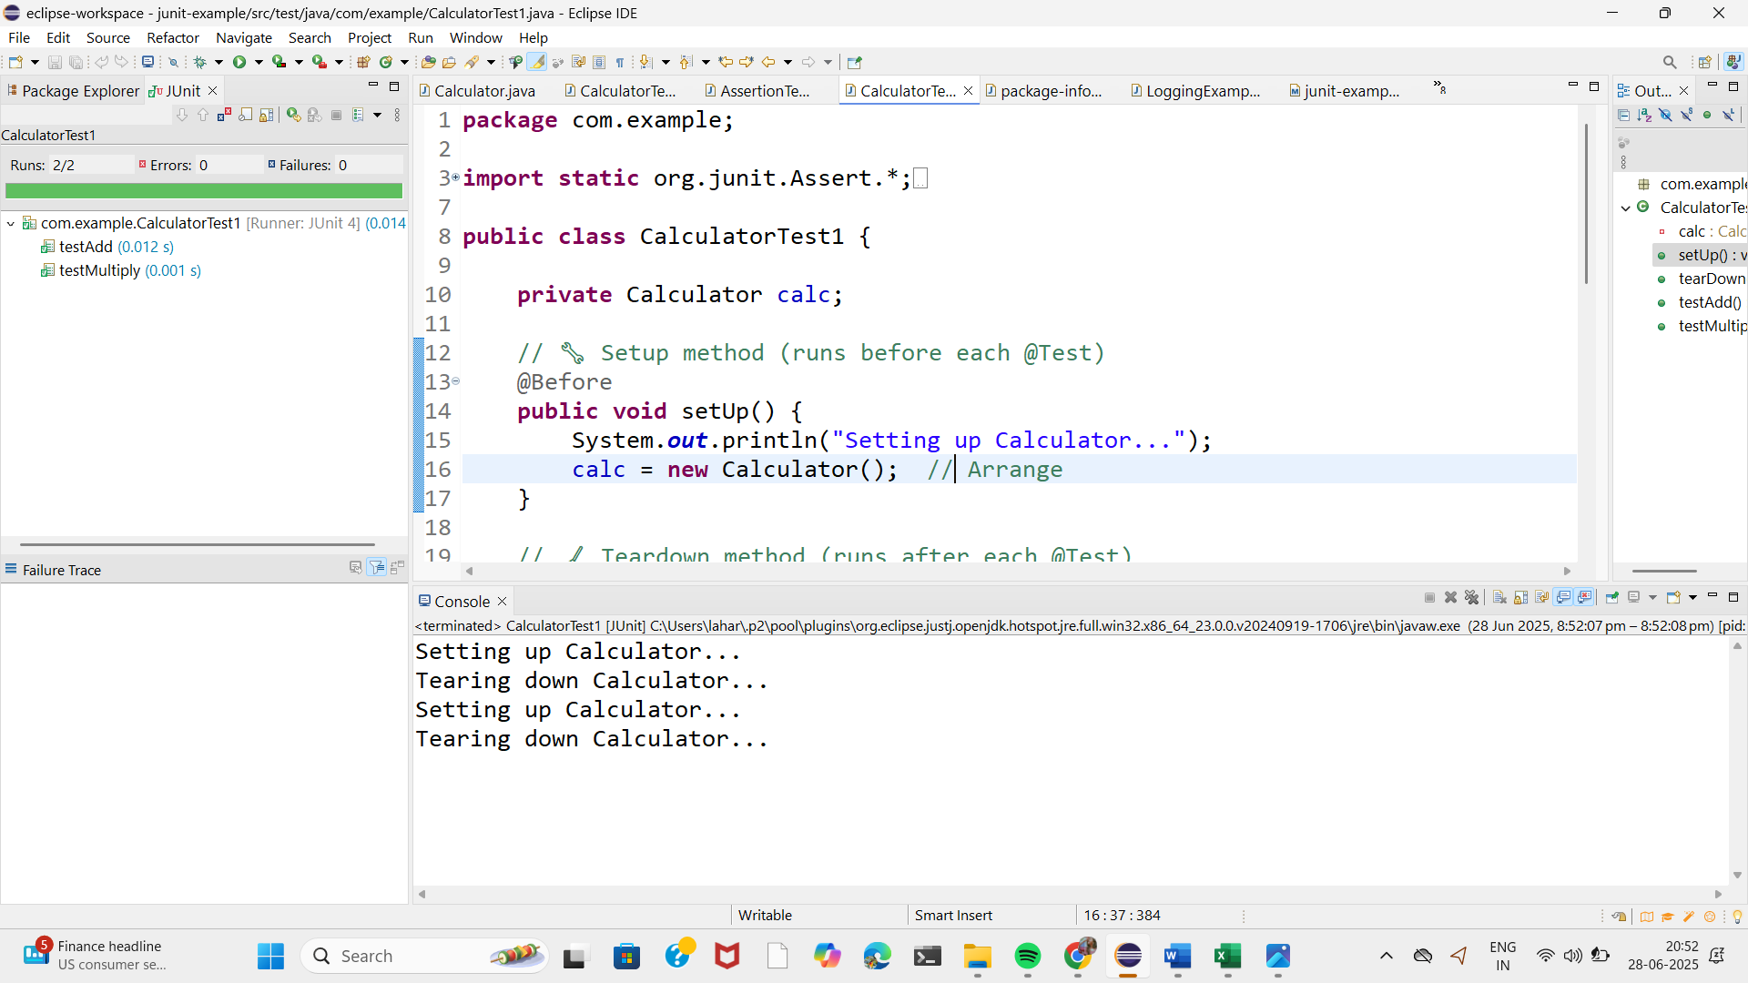

**3. Mockito exercises:**

**Exercise 1: Mocking and Stubbing:**

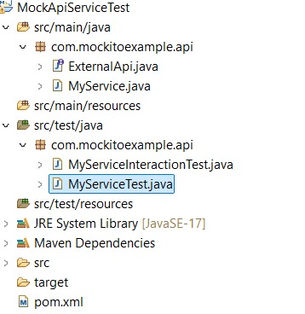

**Program:**

MyServiceTest :

package com.mockitoexample.api;

import static org.mockito.Mockito.*;

import static org.junit.jupiter.api.Assertions.*;

import org.junit.jupiter.api.Test;

import org.mockito.Mockito;

public class MyServiceTest {

@Test

public void testExternalApi() {

// Step 1: Create mock of ExternalApi

ExternalApi mockApi = Mockito.mock(ExternalApi.class);

// Step 2: Stub the getData() method

when(mockApi.getData()).thenReturn("Mock Data");

// Step 3: Inject into service

MyService service = new MyService(mockApi);

// Step 4: Assert

String result = service.fetchData();

assertEquals("Mock Data", result);

}

}

**Output:**

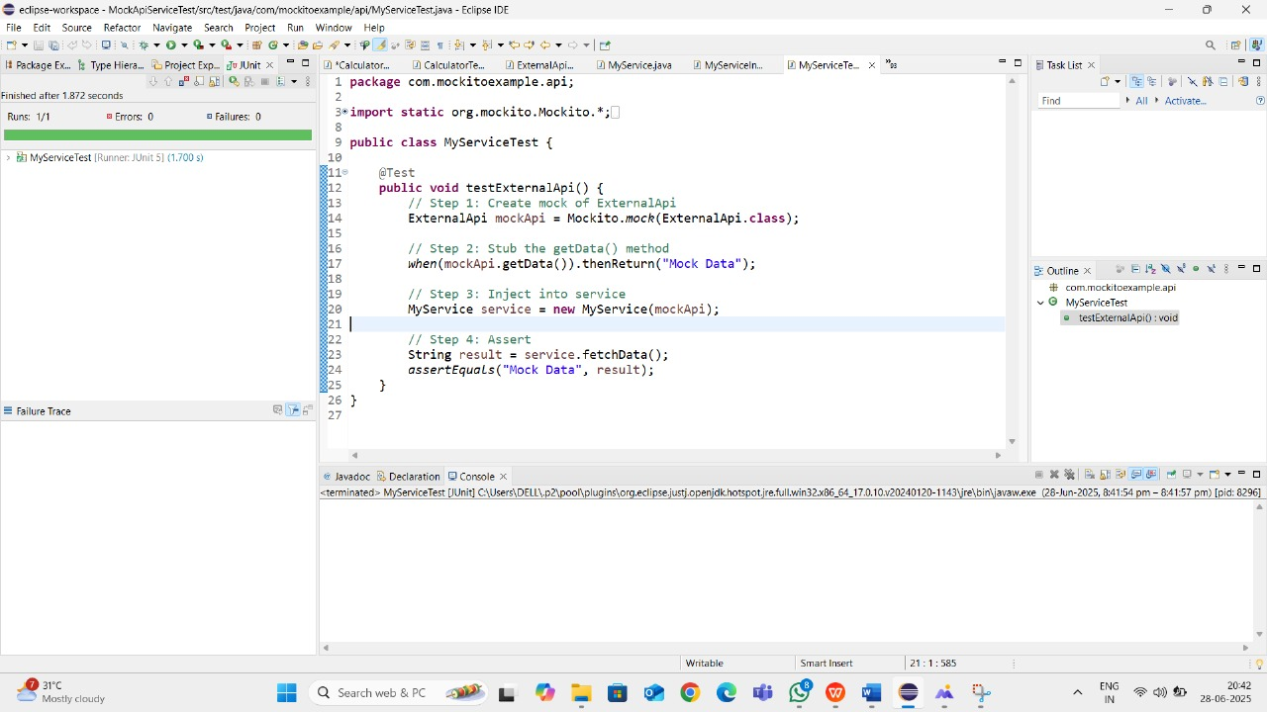

**Exercise 2: Verifying Interactions:**

MyServiceInteractionTest.java:

package com.mockitoexample.api;

import static org.mockito.Mockito.*;

import org.junit.jupiter.api.Test;

import org.mockito.Mockito;

public class MyServiceInteractionTest {

@Test

public void testVerifyInteraction() {

// Step 1: Create mock

ExternalApi mockApi = Mockito.mock(ExternalApi.class);

// Step 2: Inject into service

MyService service = new MyService(mockApi);

// Step 3: Call method

service.fetchData();

// Step 4: Verify method call

verify(mockApi).getData(); // ✅ Verifies that getData() was called

}

}

**Output:**

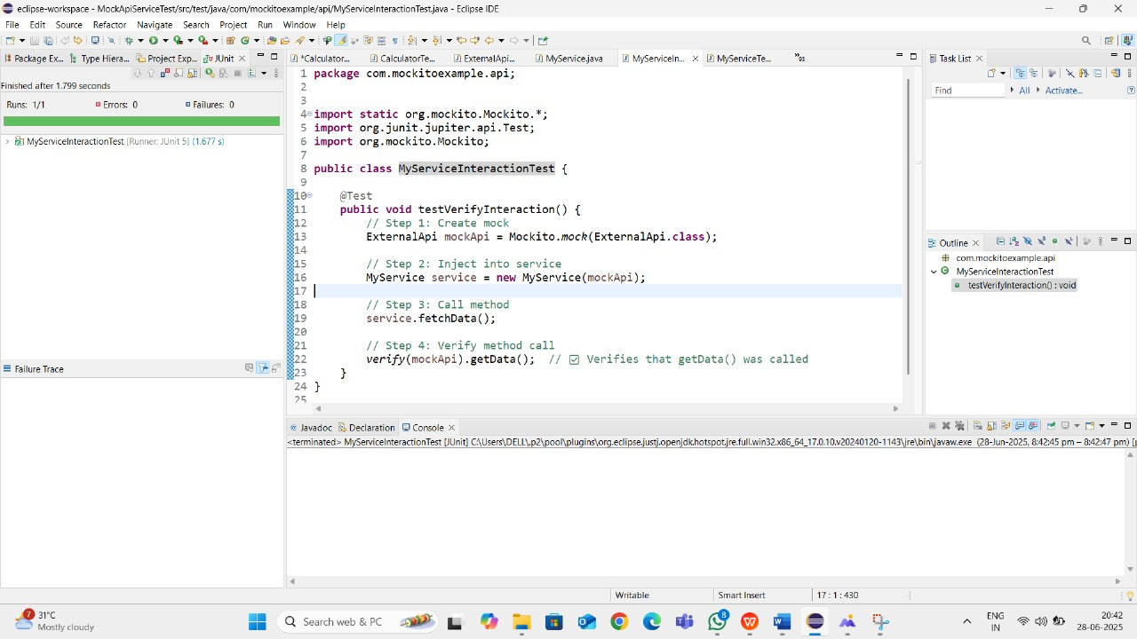

**6. SL4J Logging exercises:  
Exercise 1: Logging Error Messages and Warning Levels:**

**LoggingExample.java:**

**package** com.example;

**import** org.slf4j.Logger;

**import** org.slf4j.LoggerFactory;

**public** **class** LoggingExample {

**private** **static** **final** Logger ***logger*** = LoggerFactory.*getLogger*(LoggingExample.**class**);

**public** **static** **void** main(String[] args) {

***logger***.error("This is an error message");

***logger***.warn("This is a warning message");

}

}

