Git-HOL 5: Clean Up and Push Back to Remote Git

Step 1
Procedure:
Verify that the main/master branch is in a clean state by checking the repository status.
Command:
git status
Expected Output:
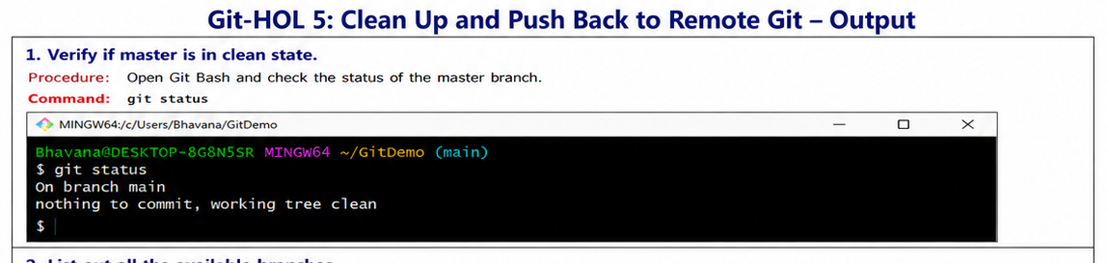

Step 2
Procedure:
List all the available local branches in the repository.
Command:
git branch
Expected Output:
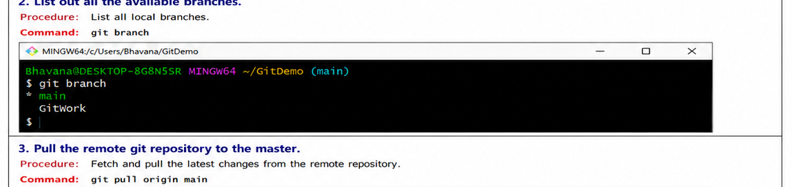

Step 3
Procedure:
Fetch and pull the latest changes from the remote repository into the main branch.
Command:
git pull origin main
Expected Output:
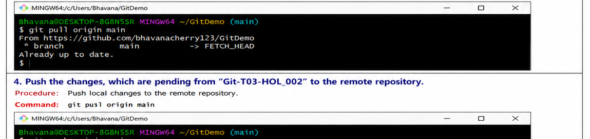

Step 4
Procedure:
Push the pending local commits to the remote Git repository.
Command:
git push origin main
Expected Output:
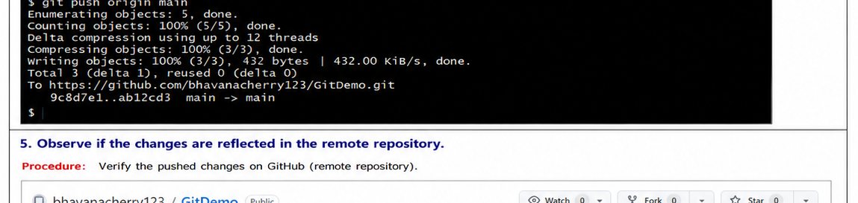

Step 5
Procedure:
Open the remote GitHub repository and verify that the latest commits and files are visible.
Command:
Open GitHub repository in browser
Expected Output:
