Git-HOL 2: Step-by-Step Procedure with Output

Step 1
Procedure:
Navigate to the existing Git repository.
Command:
cd GitDemo
Expected Output:
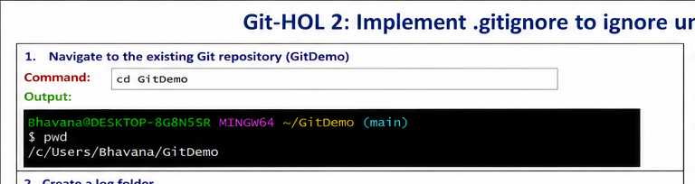

Step 2
Procedure:
Create a log folder.
Command:
mkdir log
Expected Output:
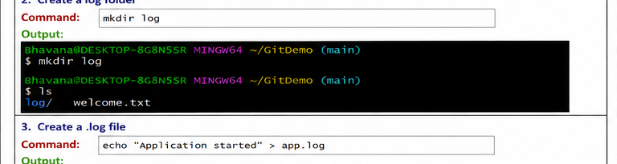

Step 3
Procedure:
Create a .log file.
Command:
echo "Application started" > app.log
Expected Output:
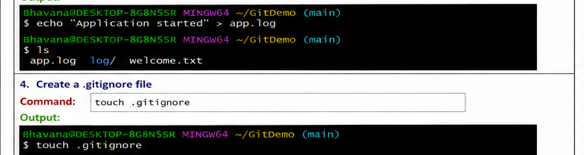

Step 4
Procedure:
Create a .gitignore file.
Command:
touch .gitignore
Expected Output:
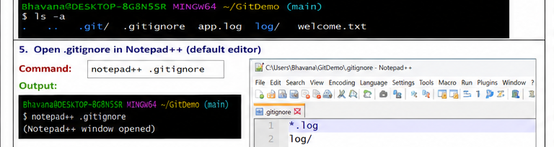

Step 5
Procedure:
Open .gitignore in Notepad++.
Command:
notepad++ .gitignore
Expected Output:
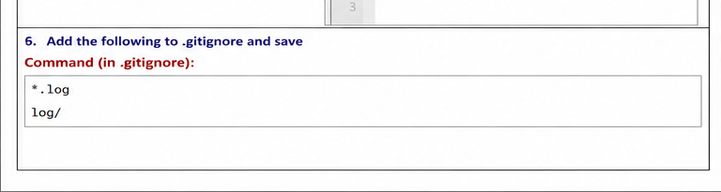

Step 6
Procedure:
Add ignore rules and save.
Command:
*.log
log/
Expected Output:


Step 7
Procedure:
Verify ignored files.
Command:
git status
Expected Output:
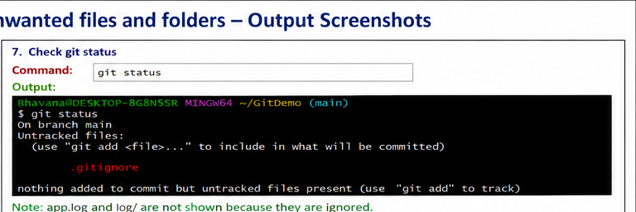

Step 8
Procedure:
Stage .gitignore.
Command:
git add .gitignore
Expected Output:
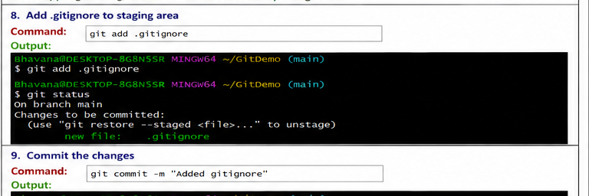

Step 9
Procedure:
Commit the changes.
Command:
git commit -m "Added gitignore"
Expected Output:
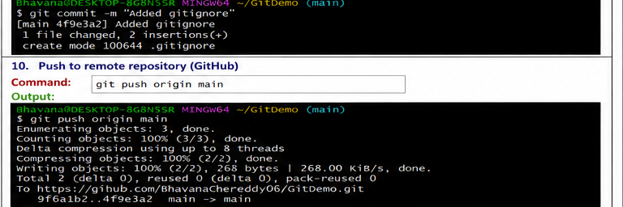

Step 10
Procedure:
Push to GitHub.
Command:
git push origin main
Expected Output:
