Git-HOL 3: Branching and Merging - Step by Step with Output

Step 1
Procedure:
Navigate to the existing Git repository.
Command:
cd GitDemo
Expected Output:
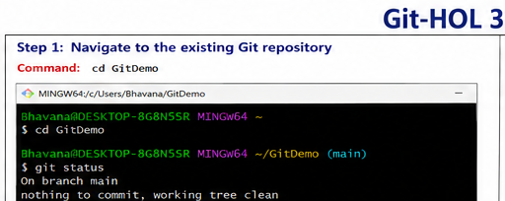

Step 2
Procedure:
Create a new branch named GitNewBranch.
Command:
git branch GitNewBranch
Expected Output:
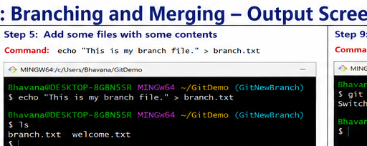

Step 3
Procedure:
List all local and remote branches.
Command:
git branch -a
Expected Output:
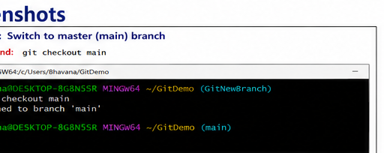

Step 4
Procedure:
Switch to the newly created branch.
Command:
git checkout GitNewBranch
Expected Output:
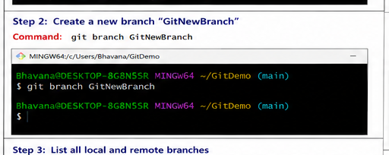

Step 5
Procedure:
Create a new file in the branch.
Command:
echo "This is my branch file." > branch.txt
Expected Output:
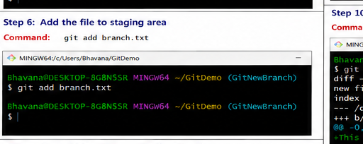

Step 6
Procedure:
Stage the file.
Command:
git add branch.txt
Expected Output:
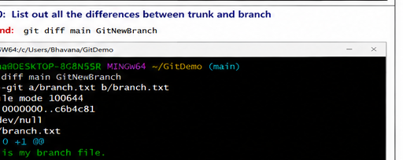

Step 7
Procedure:
Commit the changes.
Command:
git commit -m "Added branch file"
Expected Output:
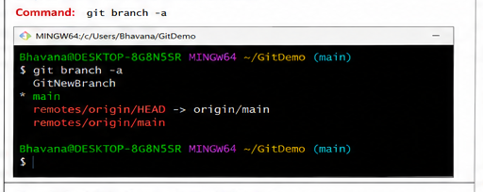

Step 8
Procedure:
Check repository status.
Command:
git status
Expected Output:
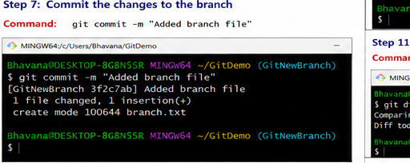

Step 9
Procedure:
Switch back to main/master.
Command:
git checkout main
Expected Output:
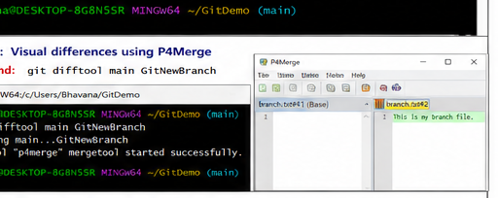

Step 10
Procedure:
Compare main and branch.
Command:
git diff main GitNewBranch
Expected Output:
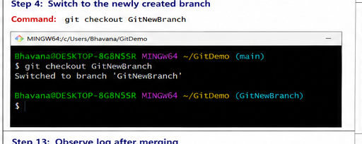

Step 11
Procedure:
View visual differences using P4Merge.
Command:
git difftool main GitNewBranch
Expected Output:
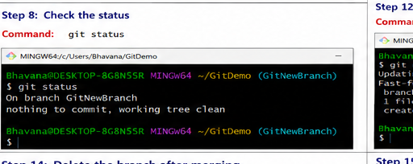

Step 12
Procedure:
Merge the branch.
Command:
git merge GitNewBranch
Expected Output:
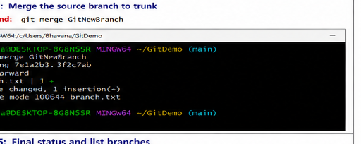

Step 13
Procedure:
View commit history.
Command:
git log --oneline --graph --decorate
Expected Output:
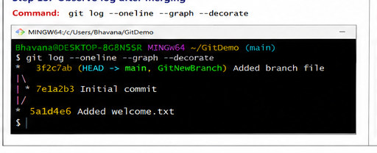

Step 14
Procedure:
Delete the merged branch.
Command:
git branch -d GitNewBranch
Expected Output:
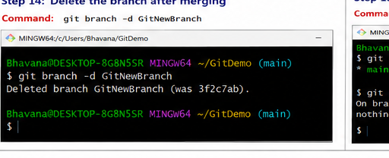

Step 15
Procedure:
Verify final branch list and status.
Command:
git branch
git status
Expected Output:
