Git-HOL 4: Conflict Resolution During Merge

Step 1
Procedure:
Verify master is in clean state.
Command:
git status
Expected Output:
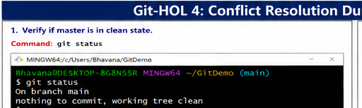

Step 2
Procedure:
Create branch GitWork and switch to it.
Command:
git branch GitWork
git checkout GitWork
Expected Output:
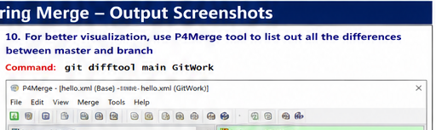

Step 3
Procedure:
Create hello.xml and check status.
Command:
echo "<message>Hello from GitWork</message>" > hello.xml
git status
Expected Output:
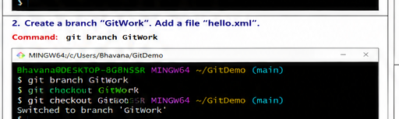

Step 4
Procedure:
Commit the file.
Command:
git add hello.xml
git commit -m "Added hello.xml in GitWork"
Expected Output:
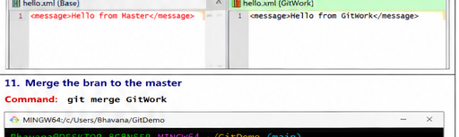

Step 5
Procedure:
Switch to master/main.
Command:
git checkout main
Expected Output:
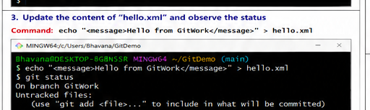

Step 6
Procedure:
Create hello.xml with different content.
Command:
echo "<message>Hello from Master</message>" > hello.xml
Expected Output:
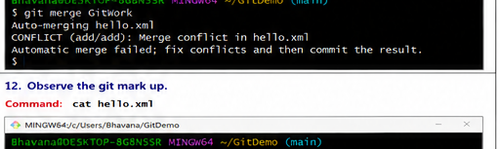

Step 7
Procedure:
Commit changes on master.
Command:
git add hello.xml
git commit -m "Added hello.xml in master"
Expected Output:
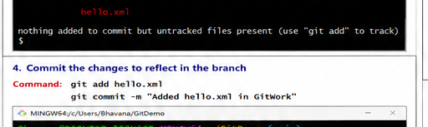

Step 8
Procedure:
View commit history.
Command:
git log --oneline --graph --decorate --all
Expected Output:
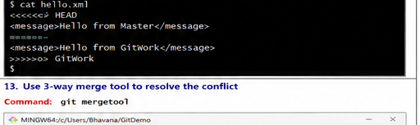

Step 9
Procedure:
Compare branches.
Command:
git diff main GitWork
Expected Output:
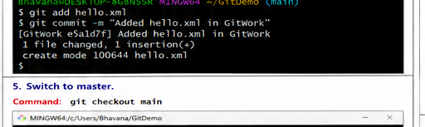

Step 10
Procedure:
Open P4Merge.
Command:
git difftool main GitWork
Expected Output:
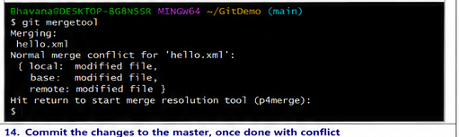

Step 11
Procedure:
Merge GitWork into main.
Command:
git merge GitWork
Expected Output:
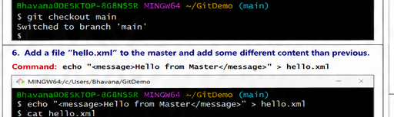

Step 12
Procedure:
Observe conflict markers.
Command:
cat hello.xml
Expected Output:
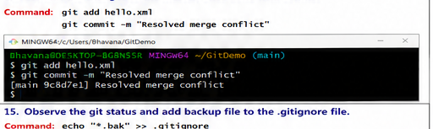

Step 13
Procedure:
Resolve using mergetool.
Command:
git mergetool
Expected Output:
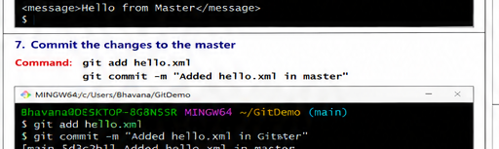

Step 14
Procedure:
Commit resolved merge.
Command:
git add hello.xml
git commit -m "Resolved merge conflict"
Expected Output:
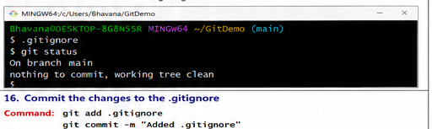

Step 15
Procedure:
Check status and edit .gitignore.
Command:
echo "*.bak" >> .gitignore
git status
Expected Output:
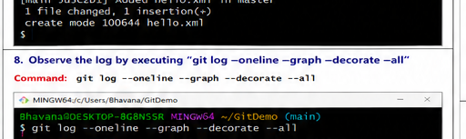

Step 16
Procedure:
Commit .gitignore.
Command:
git add .gitignore
git commit -m "Added .gitignore"
Expected Output:
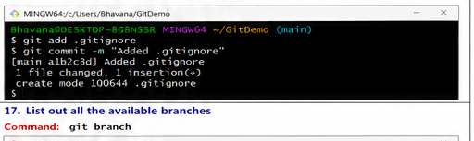

Step 17
Procedure:
List branches.
Command:
git branch
Expected Output:
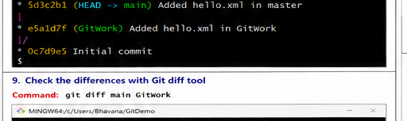

Step 18
Procedure:
Delete merged branch.
Command:
git branch -d GitWork
Expected Output:
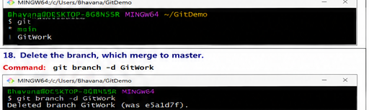

Step 19
Procedure:
View final log.
Command:
git log --oneline --graph --decorate
Expected Output:
