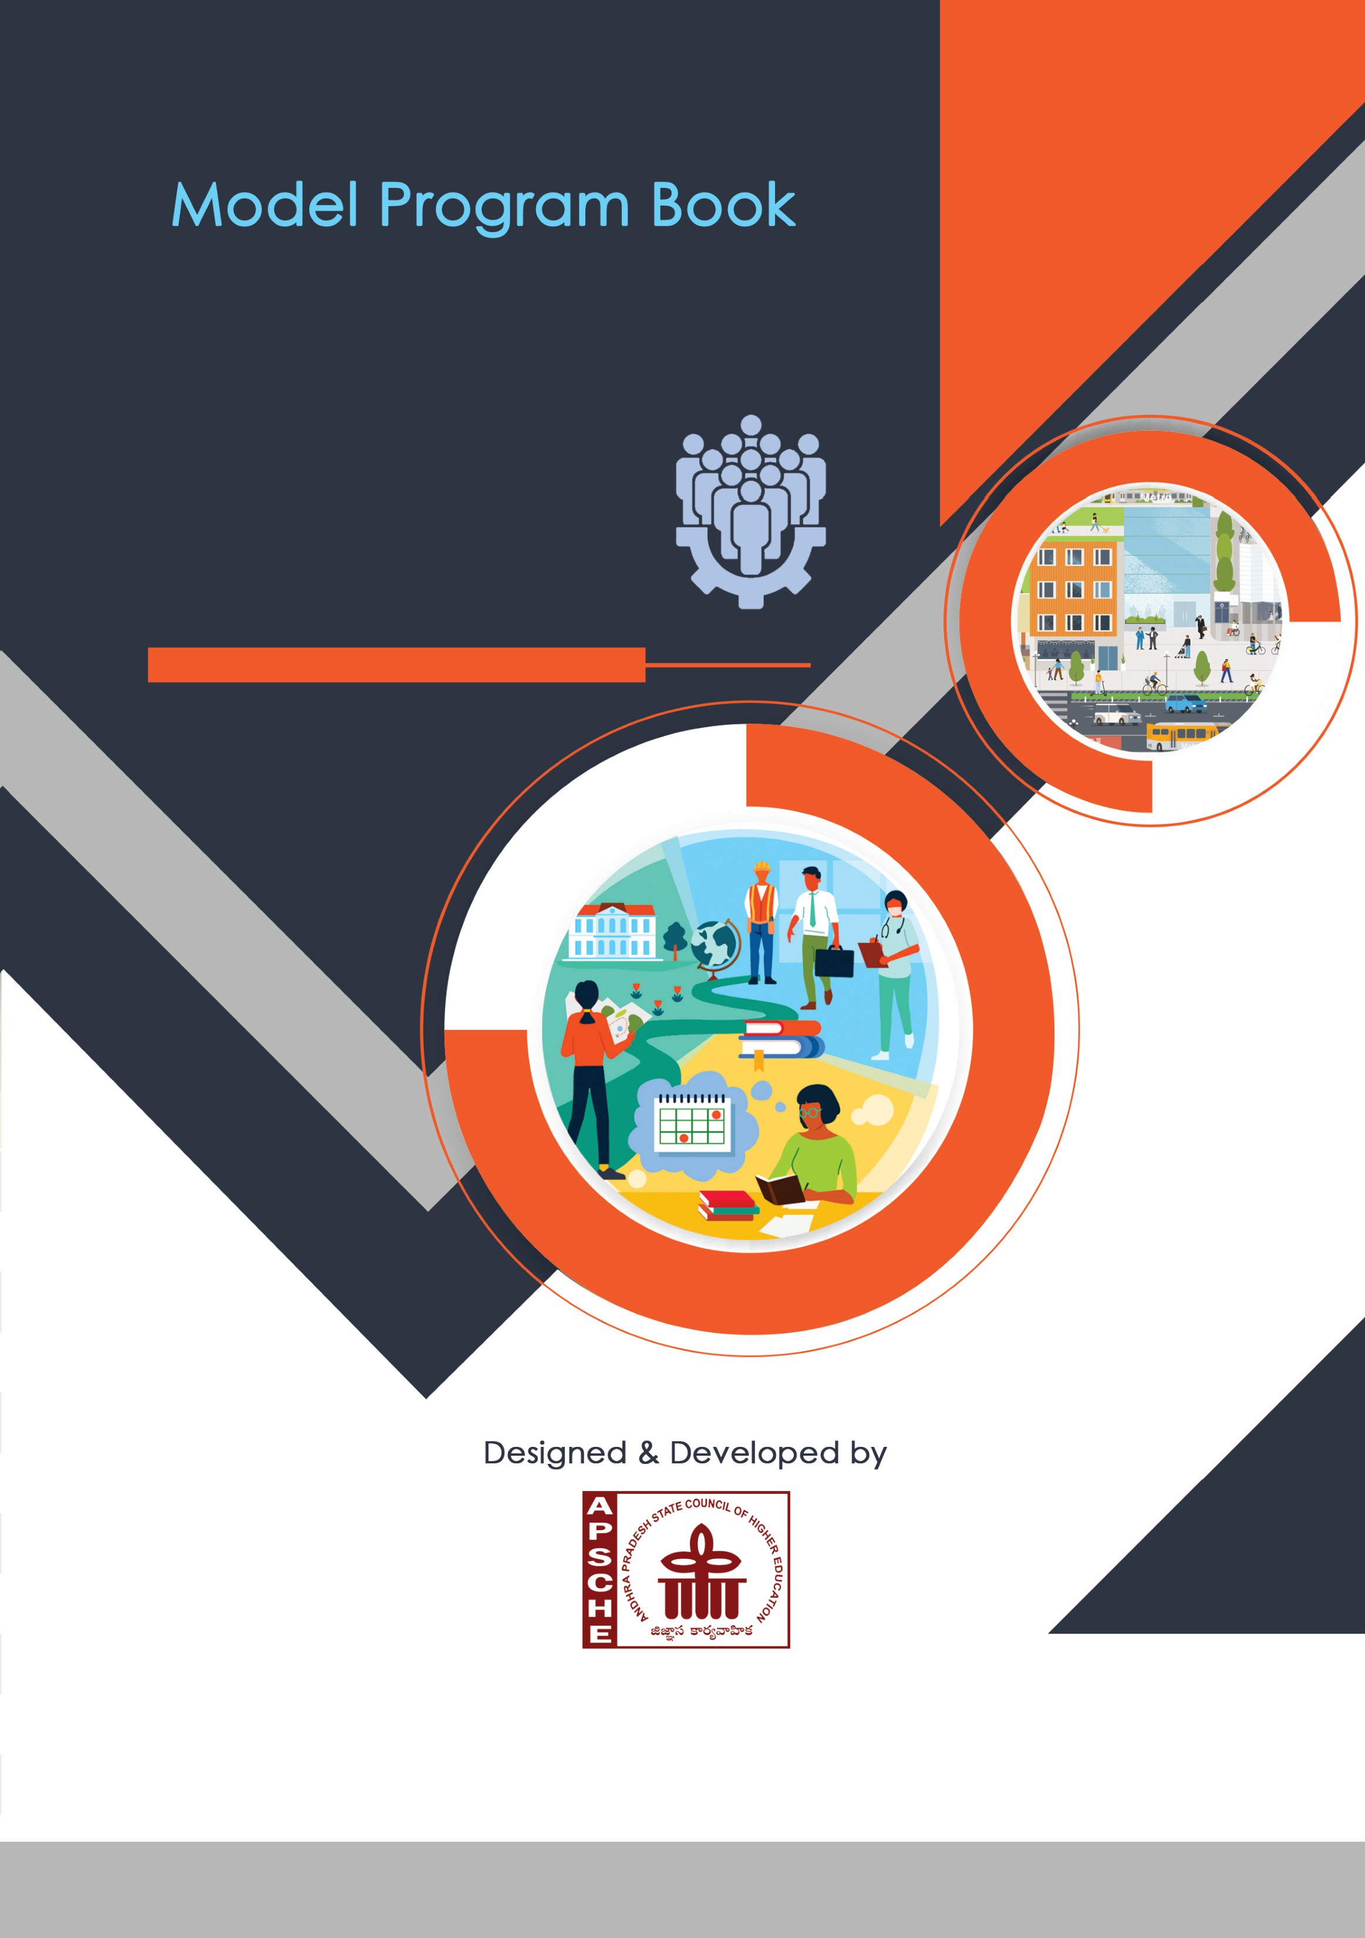


















Page No:

PROGRAM

BOOK
FOR

COMMUNITY

SERVICE

PROJECT

University

Instructions to Students for Community Service Project

Please read the detailed Guidelines on Community Service Project hosted on the website of AP State Council of Higher Education https://apsche.ap.gov.in

Link:
https://apsche.ap.gov.in/Pdf/Guidelines%20for%20the%20OJT%20Internship
%20Community%20Service%20Project.pdf

- It is mandatory for all the students to complete 2 months (180 hours) of Community Service Project as a part of the 10-month mandatory internship/on the job training.
- Consider yourself a committed volunteer in the community, you work with.
- Every student should identify the village/community/habitation for Community Service Project (CSP) in consultation with the College Principal/the authorized person nominated by the Principal.
- Report to the community/habitation as per the schedule given by the College. You must make your own arrangements for transportation to reach the community/habitation.
- You will be assigned a Faculty Guide from your College. He/She will be creating a WhatsApp group with your fellow volunteers. Post your daily activity done and/or any difficulty you encounter during the programme.
- You should maintain punctuality in attending the CSP. Daily attendance is compulsory.
- You are expected to learn about the community/habitation and their problems.
- Know the leaders and the officials of the community/habitation.
- While in the project, always wear your College Identity Card.
- If your College has a prescribed dress as uniform, wear the uniform daily.
- Identify at least five learning objectives in consultation with your Faculty Guide. These learning objectives can address:
  - Information about the community, including the realities and
problems of the society.
  - Need for creating awareness on socially relevant aspects/programs.
  - Acquiring specific Life Skills.
  - Learning areas of application of knowledge and technologies related to your discipline.
  - Identifying developmental needs of the community/habitation.

- Practice professional communication skills with team members, and with the leaders and officials of the community. This includes expressing thoughts and ideas effectively through oral, written, and non-verbal communication, and utilizing listening skills.
- Be regular in filling up your Program Book. It shall be filled up in your own handwriting. Add additional sheets wherever necessary.
- At the end of Community Service Project, you shall be evaluated by the person in-charge of the community/habitation to whom you report to.
- There shall also be an evaluation at the end of the community service by the Faculty Guide and the Principal.
- Do not indulge in any political activities.
- Ensure that you do not cause any disturbance to the inhabitants or households during your interaction or collection of data.
- Be cordial but not too intimate with the people you come across during your service activities.
- You should understand that during this activity, you are the ambassador of your College, and your behavior during the community service programme is of utmost importance.
- If you are involved in any discipline related issues, you will be withdrawn from the programme immediately and disciplinary action shall be initiated.
- Do not forget to keep up your family pride and prestige of your College.

- Remember that you are rendering valuable service to the society and your role in the community development will become part of the history of the community.
Page No:

Community Service Project Report

Submitted in accordance with the requirement for the degree of………….

Name of the College:
Department:
Name of the Faculty Guide:
Duration of the CSP: From……… To……… Name of the Student:
Programme of Study:
Year of Study:
Register Number:
Date of Submission:

Student’s Declaration

I,__________________________________, a student of ________________ Program, Reg. No. ________________ of the Department of ______________, _____________________________ College do hereby declare that I have completed the mandatory community service from ________ to _________ in ____________________ (Name of the Community/Habitation) under the Faculty Guideship of ___________________________, (Name of the Faculty Guide), Department of ________________________________in College

(Signature and Date)

Endorsements

Faculty Guide

Head of the Department

Principal

Certificate from Official of the Community

This is to certify that _______________________________ (Name of the Community Service Volunteer) Reg. No __________________ of _____________________(Name of the College) underwent community service in
______________________________(Name of the Community) from ___________ to __________ The overall performance of the Community Service Volunteer during his/her community service is found to be ____________________ (Satisfactory/Good).

Authorized Signatory with Date and Seal

Acknowledgements

Contents

CHAPTER 1: EXECUTIVE SUMMARY

The community service report shall have only a one-page executive summary. It shall include a brief description of the Community and summary of all the activities done by the student in CSP and five or more learning objectives and outcomes.

CHAPTER 2: OVERVIEW OF THE COMMUNITY

About the Community/Village/Habitation including historical profile of the community / habitation, community diversity, traditions, ethics and values.
Brief note on Socio-Economic conditions of the Community/Habitation.

CHAPTER 3: COMMUNITY SERVICE PART

Description of the Activities undertaken in the Community during the Community Service Project. This part could end by reflecting on what kind of values, life skills, and technical skills the student acquired.

CHAPTER 5: OUTCOMES DESCRIPTION
Details of the Socio-Economic Survey of the Village/Habitation Attach the questionnaire prepared for the survey.

Describe the problems you have identified in the community

Short-term and long-term action plan for possible solutions for the problems identified and that could be recommended to the concerned authorities for implementation.

Description of the Community awareness programme/s conducted w.r.t the problems and their outcomes.
Report of the mini-project work done in the related subject w.r.t the habitation/village.

A mini-project work in the related subject w.r.t the habitation/village. (For ex., a student of Botany may do a project on Organic Farming or Horticulture or usage of biofertilizers or biopesticides or effect of the inorganic pesticides, etc. A student of Zoology may do a project on Aquaculture practices or animal husbandry or poultry or health and hygiene or Blood group analysis or survey on the Hypertension or survey on the prevalence of diabetes, etc.

The Report shall be limited to 8-10 pages.

Page No:
CHAPTER 6: RECOMMENDATIONS AND CONCLUSIONS OF THE MINI
PROJECT

Student Self-Evaluation for the Community Service Project

Student Name:
Registration No:
Period of CSP: From: To:
Date of Evaluation:

Please rate your performance in the following areas:

Rating Scale: Letter grade of CGPA calculation to be provided

1 Oral communication | 1 | 2 | 3 | 4 | 5
2 Written communication | 1 | 2 | 3 | 4 | 5
3 Proactiveness | 1 | 2 | 3 | 4 | 5
4 Interaction ability with community | 1 | 2 | 3 | 4 | 5
5 Positive Attitude | 1 | 2 | 3 | 4 | 5
6 Self-confidence | 1 | 2 | 3 | 4 | 5
7 Ability to learn | 1 | 2 | 3 | 4 | 5
8 Work Plan and organization | 1 | 2 | 3 | 4 | 5
9 Professionalism | 1 | 2 | 3 | 4 | 5
10 Creativity | 1 | 2 | 3 | 4 | 5
11 Quality of work done | 1 | 2 | 3 | 4 | 5
12 Time Management | 1 | 2 | 3 | 4 | 5
13 Understanding the Community | 1 | 2 | 3 | 4 | 5
14 Achievement of Desired Outcomes | 1 | 2 | 3 | 4 | 5
15 OVERALL PERFORMANCE | 1 | 2 | 3 | 4 | 5

Date: Signature of the Student

Evaluation by the Person in-charge in the Community / Habitation

Student Name:
Registration No:
Period of CSP: From: To:
Date of Evaluation:
Name of the Person in-charge:
Address with mobile number:

Please rate the student’s performance in the following areas:
Please note that your evaluation shall be done independent of the Student’s selfevaluation

Rating Scale: 1 is lowest and 5 is highest rank
1 Oral communication | 1 | 2 | 3 | 4 | 5
2 Written communication | 1 | 2 | 3 | 4 | 5
3 Proactiveness | 1 | 2 | 3 | 4 | 5
4 Interaction ability with community | 1 | 2 | 3 | 4 | 5
5 Positive Attitude | 1 | 2 | 3 | 4 | 5
6 Self-confidence | 1 | 2 | 3 | 4 | 5
7 Ability to learn | 1 | 2 | 3 | 4 | 5
8 Work Plan and organization | 1 | 2 | 3 | 4 | 5
9 Professionalism | 1 | 2 | 3 | 4 | 5
10 Creativity | 1 | 2 | 3 | 4 | 5
11 Quality of work done | 1 | 2 | 3 | 4 | 5
12 Time Management | 1 | 2 | 3 | 4 | 5
13 Understanding the Community | 1 | 2 | 3 | 4 | 5
14 Achievement of Desired Outcomes | 1 | 2 | 3 | 4 | 5
15 OVERALL PERFORMANCE | 1 | 2 | 3 | 4 | 5

Date: Signature of the Supervisor
PHOTOS & VIDEO LINKS

Page No:

EVALUATION
Internal Evaluation for the Community Service Project

Objectives:
- To facilitate an understanding of the issues that confront the vulnerable / marginalized sections of society.
- To initiate team processes with the student groups for societal change.
- To provide students an opportunity to familiarize themselves with the urban / rural community they live in.
- To enable students to engage in the development of the community.
- To plan activities based on the focused groups.
- To know the ways of transforming society through systematic programme implementation.

Assessment Model:
- There shall only be internal evaluation.
- The Faculty Guide assigned is in-charge of the learning activities of the students and for the comprehensive and continuous assessment of the students.
- The assessment is to be conducted for 100 marks.
- The number of credits assigned is 4. Later the marks shall be converted into grades and grade points to include finally in the SGPA and CGPA.
- The weightings shall be:
o Activity Log 20 marks o Community Service Project Implementation 30 marks o Mini Project Work 25 marks o Oral Presentation 25 marks
- Activity Log is the record of the day-to-day activities. The Activity Log is assessed on an individual basis, thus allowing for individual members within groups to be assessed this way. The assessment will take into consideration the individual student’s involvement in the assigned work.
- While evaluating the student’s Activity Log, the following shall be considered -
  - The individual student’s effort and commitment.
  - The originality and quality of the work produced by the individual student.
  - The student’s integration and co-operation with the work assigned.
  - The completeness of the Activity Log.
- The assessment for the Community Service Project implementation shall include the following components and based on Weekly Reports and Outcomes Description
  - Details of the Socio-Economic Survey of the village/habitation.
  - Problems identified.
  - Community Awareness Programs organized.
e. Suggested Short-Term and Long-Term Action Plan.

MARKS STATEMENT
(To be used by the Examiners)

Page No

