**Hospital Management System**

**Abstract**

The purpose of the project entitled as “HOSPITAL MANAGEMENT SYSTEM” is to computerize the Front Office Management of Hospital to develop software which is user friendly simple, fast, and cost-effective. It deals with the collection of patient’s information, diagnosis details, etc. Traditionally, it was done manually. The main function of the system is register and store patient details and doctor details and retrieve these details as and when required, and also to manipulate these details meaningfully System input contains patient details, diagnosis details, while system output is to get these details on to the screen. The Hospital Management System can be entered using a username and password. It is accessible either by an administrator or receptionist. Only they can add data into the database. The data can be retrieved easily. The data are well protected for personal use and makes the data processing very fast.

**Introduction**

The project Hospital Management system includes registration of patients, storing their details into the system, and also computerized billing in the pharmacy, and labs. The software has the facility to give a unique id for every patient and stores the details of every patient and the staff automatically. It includes a search facility. User can search availability of a doctor and the details of a patient using the id.

**Existing system**

Hospitals currently use a manual system for the management and maintenance of critical information. The current system requires numerous paper forms, with data stores spread throughout the hospital management infrastructure. Often information is incomplete or does not follow management standards. Forms are often lost in transit between departments requiring a comprehensive auditing process to ensure that no vital information is lost. Multiple copies of the same information exist in the hospital and may lead to inconsistencies in data in various data stores.

**Proposed System**

The Hospital Management System is designed for any hospital to replace their existing manual paper based system. The new system is to control the information of patients.Staff and operating room schedules and patient invoices. These services are to be provided in an efficient, cost effective manner, with the goal of reducing the time and resources currently required for such tasks .

**Advantages of proposed system:**

The system proposed has many advantages.

1. The proposed system is highly secured, because for login the system it requires the username and password which is different for each.

2. It maintains records for all the Patients.

3. Manages patients records.

4. Maintain Transaction records.

5. The application can be put online easily and will be assessable throughout the globe.

System Modules:

The proposed project contains mainly three modules they are

* Admin module
* Faculty module
* Patient module

Admin Module features:

* Login
* can add services
* can add service price
* can register patients
* can manage transaction
* can delete patients
* can generate bills for patient

Faculty Module Features

* Can update faculty details along with available timing.

**System design:**

Patient

Service

Admin

Patient Record

Transaction

**ER Diagram for Placement Cell**

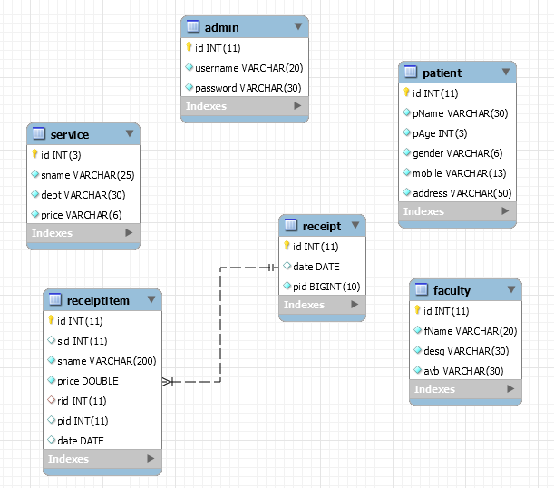

**System Requirements**

**Software Requirements:**

* Windows XP/7/8/10
* Browsers Chrome/Firefox/EDGE (For best view preferred browser is Chrome)
* Netbeans IDE 8.2(frontend)
* PhpMyi.e, MySQL(backend)
* Internet Connectivity(must required)

**Hardware Requirements:**

* Hard Disk Drive(HDD) 10GB
* RAM 1GB
* Processor 1.2GHz

**Language Used**

HTML,CSS,Javascript, PHP(main functionality),MYSQL.

**NOTE:**

* In PhpMyAdmin create a database by name "hospital" then import database contents by clicking on Import- browse-local disk:C-xampphtdoc/hospital/sql/hospital.sql click Go. Complete apartment database will be created.

Internet connectivity is required.