**Real Time Non-invasive Cardiac Health Monitoring System**

Pavan Kumar R, Sanjay Rao A, Vaibhav V Rao, Vasudev Anant Bongale, Vijay S – P.E.S Institute of Technology, Bangalore

**Abstract:**

There are several vital parameters that indicate the state of cardiac health of a person. These include pulse rate, blood pressure, SpO2, respiration rate, Cardiac output, heart rate variability etc. This paper presents a cuff free portable device which measures these parameters non-invasively in real time by making use of the principles of electrocardiography(ECG) and photoplethysmography(PPG). Blood volume changes in the arteries can be detected using PPG technique. ECG signal reflects the electrical activity in the heart. PPG sensor is placed on a finger and the signal is obtained using reflectance method. ECG electrodes are placed on the right arm, left arm and right leg from among which the voltage between the right and left arm is used to obtain the signal. We have designed and implemented the hardware to obtain stable signals. Signal processing techniques are used to analyze the signal characteristics and thereby obtain the parameters.

**Introduction:**

A person’s cardiac health can be assessed based on parameters such as pulse rate, blood pressure, cardiac output, peripheral oxygen saturation, breathing rate and heart rate variability. Devices to measure these parameters in hospitals are very bulky and expensive. Also setting up of these devices takes time which is disadvantageous during emergency conditions. A comprehensive device which measures all these parameters non-invasively is not available in current Indian market.

Devices that measure blood pressure employ auscultatory method requires a cuff, stethoscope and a trained specialist to measure the blood pressure while those which measure BP using oscillometric method do not require a stethoscope but still requires a cuff.

Pulmonary artery Catheter (PAC), used to measure CO is very accurate but is highly invasive and requires experienced practitioners[10]. Flotrac is another device for CO monitoring which is less invasive when compared to PAC. A recent study shows an underestimation of CO by more than 2L/min in 41% of measurements.

Photoplethysmography (PPG) offers a low cost, portable means of realizing such a device. Photoplethysmography is an optical method of measuring changes in blood volume. It has widespread clinical applications and has been used in commercially available health monitoring systems. Various physiological parameters such as blood oxygen saturation, heart rate, blood pressure, cardiac output and respiration can be found using PPG [1]. Measurement of heart rate can be done by various algorithms such as simple digital ﬁltering and zero crossing detection [2], time-frequency techniques [3 Yan]. We employ peak detection algorithm using first derivatives approach to calculate heart rate. Breathing rate is obtained using Fast Fourier Transform techniques. Blood pressure is obtained by measuring a parameter called Pulse Transit Time(PTT). PTT has been found to have inverse relationship with BP (Park [4], and Lass [5]). Time difference between the R peak of ECG and the peak of PPG gives the PTT. Correlation is done between PTT and BP by which the device is calibrated and then BP can be monitored continuously. Cardiac output is the amount of blood ejected by the heart in one minute (expressed in L/min). It obtained by calculating an index called IHAR [6] which makes use of FFT and area under the PPG curve. Heart Rate Variability (HRV) measurements can provide a considerable amount of information pertaining to an individual’s physiological state. HRV is predominantly a reflection of activity in the autonomic nervous system [13].HRV is obtained by finding the standard deviation (SDNN) and root mean square(RMSSD) of the peak to peak intervals from the PPG signal.

**BACKGROUND:**

**Electrocardiography:** It is a fundamental method of assessing one’s cardiac health and also helpful in diagnosis of cardiac disorders. It arises from the contraction and relaxation of cardiac muscles which sends electrical impulses through the heart [7]. These impulses can be measured by placing electrodes, called ECG leads, on the chest or on the limbs. Lead II is used in our implementation to obtaining the ECG waveform. It measures the voltage between Left leg and the Right arm [8].

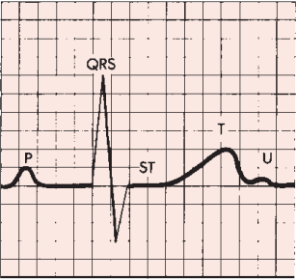

1.a 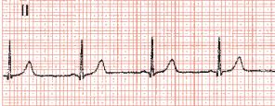

1.b

Figure 1: a. ECG Morphology: It consists of 5 waveforms: P wave, QRS complex, ST segment, T wave, and U wave. The QRS Complex is of concern to us. It is caused by ventricular depolarization. b. A typical ECG wave obtained from Lead II electrodes. [7]

**Photoplethsmography(PPG):** A typical PPG wave consists of two major components namely, an AC component due to the pulsatile blood volume changes and a DC component mainly due to respiration. The AC component consists of two phases: the anacrotic phase which is the rising edge of the pulse and the catacrotic phase which is the falling edge of the pulse. PPG signals can be obtained from peripheral sites such as ears, fingers and toes. Finger PPG is used in our implementation.

**METHODOLOGY:**

The cardiac health monitoring system consists of a data acquisition system and a data analysis system. Data acquisition involves ECG electrodes, PPG sensor, analog pre-processing circuits and a microcontroller. Data analysis involves digital processing of sensor data to obtain the required parameters. After placing of the sensors, the data acquisition system receives the sensor data and sends it for data analysis where algorithms implemented calculate the required parameter values and displays them on the screen.

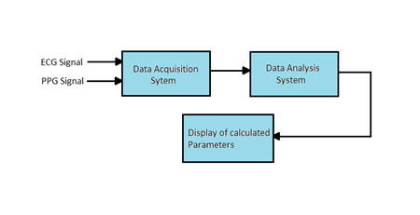

Figure 2: Basic block diagram of the system

**DATA ACQUISITION SYSTEM:**

The finger PPG Sensor used consists of IR LED of peak emission wavelength of 950nm and a phototransistor. The output of the phototransistor is connected to an active Band pass filter with cut-off frequencies of 0.4 Hz and 5Hz. The role of the Band pass filter is to reject signals that lie outside its bandwidth and to amplify the PPG signal. The signal is then connected to atmega328 microcontroller board for analog to digital conversion and serial transmission.

ECG electrodes are of type lead II. The signal obtained from the leads is connected to an instrumentation amplifier. Its purpose is to amplify the low-level output signals. The output is connected to a Band pass filter of cut-off frequencies 0.05Hz and 15Hz.

The outputs of both the filters are fed to the Analog pins of the microcontroller board for data sampling and A/D conversion. The digital data is then serially transmitted to a computer for data analysis. The data is sampled at 107samples/second. Serial transmission baud rate is 9600bps.

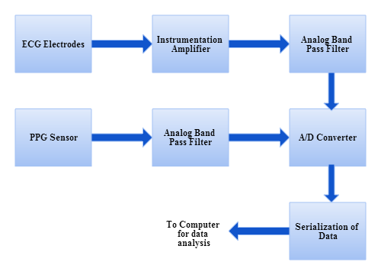

Figure 3: Data Acquisition System

**DATA ANALYSIS:**

Serial data is received by a COM port. It is plotted in Serial Oscilloscope software in real time. Signal processing is done in python programming language. Serial data received consists of both ECG and PPG signals that are interleaved. Both these signal are then extracted and separately analyzed.

Figure 4: a. Snapshot of Serial Oscilloscope. b. Plot of the interleaved signal in python. c. Plot of extracted ECG signal d. Plot of extracted PPG Signal

**Heart rate:** The AC component of the PPG signal is used to calculate the heart rate. The time difference between two peaks gives the duration of a pulse. The time interval between successive peaks of the signal is used to obtain heart rate [9]. First derivative approach is used to identify the location of a peak in the signal.

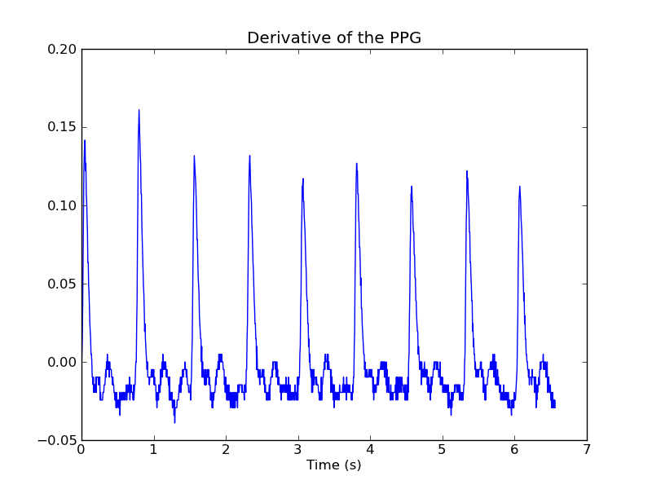

5.a

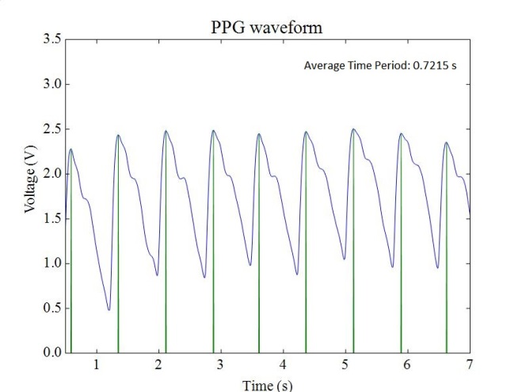

Figure 5: a. Derivative of a sampled PPG signal. B. Determination of heart rate: Peak detection algorithm using derivative approach

**Blood Pressure** (BP): The algorithm used to calculate blood pressure involves three stages namely A. Identification of characteristic points from the ECG and PPG waveforms. B. Calculation of PTT and heart rate from the obtained points. C. Estimation of BP from PTT and heart rate

A. Identification of characteristic points from ECG and PPG signals: We have taken the R peak as reference point from ECG signal because detection of R peak is efficient when first derivative approach is used. The maximum point during systole was taken to be the reference point in the PPG signal.

B. Calculation of PTT and heart rate from the obtained points

The time interval from the R peak and the successive peak from the PPG signal gives PTT. Heart rate is obtained from PPG signal using peak detection algorithm.

C. Estimation of BP from PTT and heart rate

Correlation on obtained PTT values and measured BP was performed. When ECG and PPG data was obtained from a subject, we took simultaneously SBP and DBP values from the subject using a auscultation based digital BP instrument [12]. From each subject we took 5 readings at rest and 5 readings after exercise. The obtained values of PTT and BP were correlated. We also correlated BP with the ratio of HR and PTT and obtained a better correlation coefficient that with PTT alone. Hence we used HR/PTT ratio for estimation of BP.

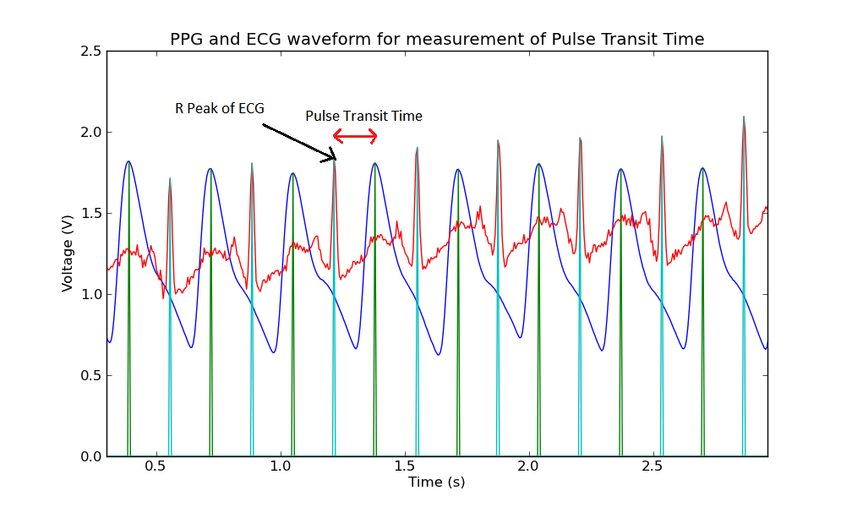

Figure 6: PTT measured as time Interval between the R peak of ECG and peak of PPG signals.

**Heart Rate Variability (HRV):** HRV is traditionally calculated from the RR intervals in the ECG waveform. However the peak to peak interval in the PPG closely relates to the RR interval of ECG. Hence to obtain distinct peak in PPG, the first derivative of PPG is taken and squared from which the time interval between two peaks is obtained. Using this the standard deviation (SDNN) of these interval widths and also the root mean square(RMSSD) of the deviation in the intervals is obtained to determine HRV.

**Breathing rate:** We have used the DC component of the PPG signal to extract information on breathing rate. Performing FFT on the PPG signal reveals the low frequency component corresponding to respiration. Using value of digital frequency corresponding to the peak and the sampling frequency of the microcontroller, we obtain respiration rate.

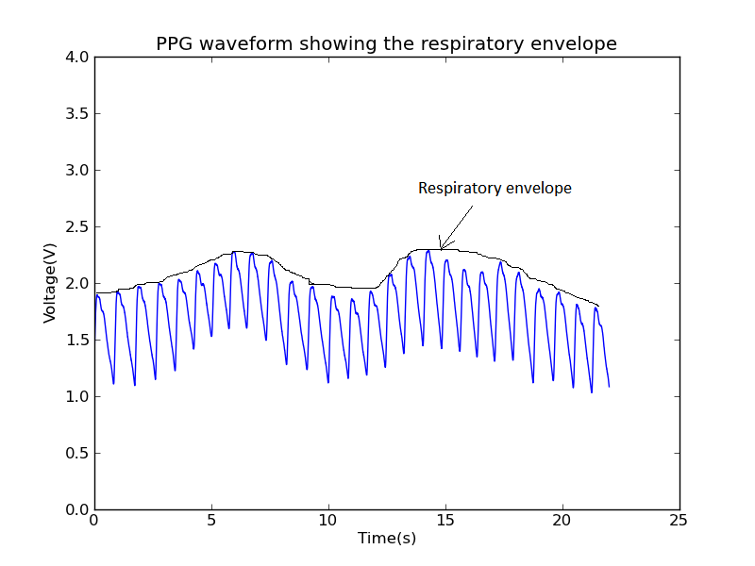

7a.

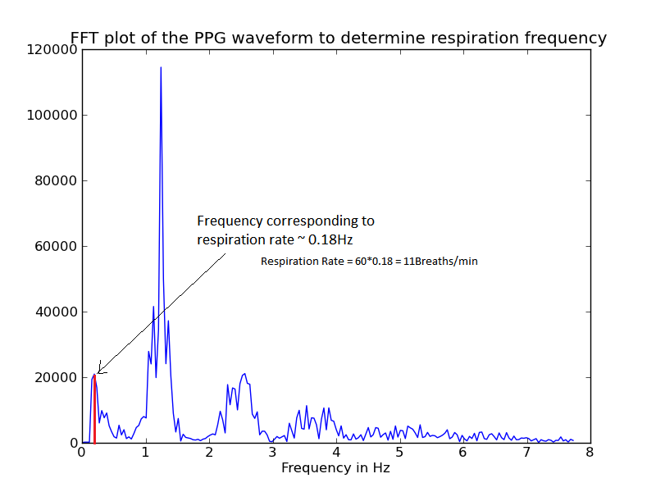

7b.

Figure 7: a. Sampled PPG waveform used for breathing rate calculation. B. FFT of the signal indicating the peak corresponding to the breathing rate.

**Cardiac Output (CO):** Studies have shown that CO is correlated to the area under the PPG curve. We implemented the algorithm to find Inflection and Harmonic Area ratio (IHAR) which is defined as

$$IHAR= \frac{1-\frac{\sum_{n=2}^{N}{{FFT}^{2}(f_{n})}}{\sum_{n=1}^{N}{{FFT}^{2}(f_{n})}}}{\frac{S_{2}}{S1}}$$

Where A­­2 and A1 are areas under a single PPG curve and the part of it from the inflection point (dicrotic notch) respectively. We have correlated CO obtained from an invasive CO device from a Pulmonary arterial catheter and our calculated IHAR value.

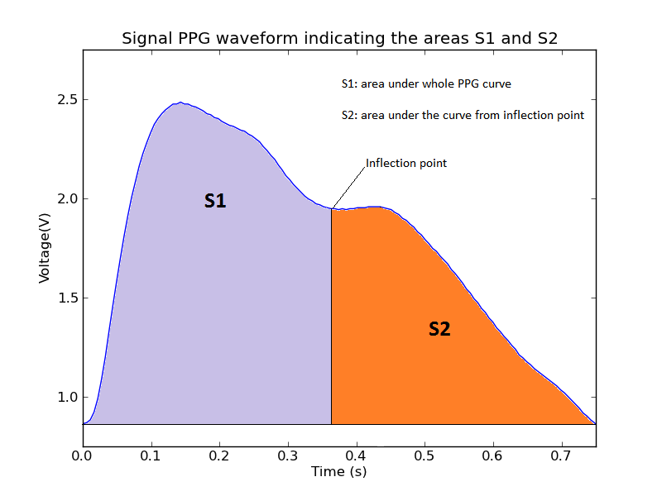

8a.

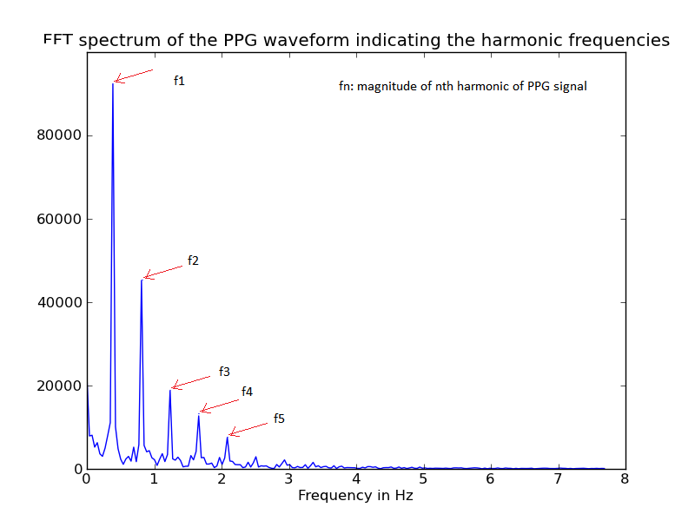

8b.

Figure 8: a. Areas S1 and S2 shown b. Plot of FFT showing the harmonics.

**RESULTS:**

|  |  |  |  |  |  |
| --- | --- | --- | --- | --- | --- |
| Subject | Sl.  No | Actual Heart Rate  (beats/min) | Measured Heart Rate  (beats/min) | Actual Blood Pressure  SBP/DBP  (mmHg) | Estimated Blood Pressure  (mmHg) |
| 1 | 1 | 86 | 78.65 | 101/65 | 108.67/70.56 |
|  | 2 | 84 | 80.12 | 106/71 | 109.34/65.23 |
|  | 3 | 96 | 94.63 | 112/67 | 110.433/70.89 |
| 2 | 1 | 70 | 74.23 | 103/63 | 109.39/70.23 |
|  | 2 | 69 | 70.6 | 109/67 | 105.75/65.45 |
|  | 3 | 89 | 93.56 | 117/66 | 106.07/75.55 |
| 3 | 1 | 103 | 98.65 | 120/78 | 111.49/80.56 |
|  | 2 | 95 | 98.23 | 114/75 | 110.67/70.49 |
|  | 3 | 98 | 100.52 | 115/86 | 112.91/95.56 |
| 4 | 1 | 76 | 80.21 | 120/75 | 114.0/79.24 |
|  | 2 | 68 | 72.05 | 130/84 | 116.56/90.75 |
|  | 3 | 75 | 79.86 | 132/89 | 121.36/80.78 |

The device has been tested for 7 individuals, out of which 5 were in normal health and two were suffering from cardiac disorders. The results are tabulated below. We find that in the measurement of heart rate the error is 4.8bpm in which the standard device used for testing has 4bpm error. Hence we deduce that our device has an error of 1.2bpm. Heart rate variability parameters SDNN and RMSSD are well correlated with each other indicating the algorithms implemented are efficient. Breathing rate obtain are in the normal range for a healthy person. Blood Pressure measurements are indicating an error of more than 5mmHg which is more than accepted value as given by American National Standards of the Association for the Advancement of Medical Instrumentation. Cardiac Output was taken for two individuals and the mean error rate was 0.32L/min and 0.31L/min respectively.

|  |  |  |  |
| --- | --- | --- | --- |
| Subject | Sl.  No | Heart Rate Variability  [SDNN,RMSSD]  seconds | Respiration Rate  (breaths/min) |
| 1 | 1 | [0.156,0.1707] | 14.43 |
|  | 2 | [0.054,0.063] | 16.56 |
|  | 3 | [0.075,0.089] | 20.15 |
| 2 | 1 | [0.103,0.0944] | 13.86 |
|  | 2 | [0.101,0.095] | 10.23 |
|  | 3 | [0.123,0.102] | 12.45 |
| 3 | 1 | [0.0872,0.068] | 17.06 |
|  | 2 | [0.089,0.073] | 15.48 |
|  | 3 | [0.065,0.072] | 19.56 |
| 4 | 1 | [0.038,0.031] | 21.54 |
|  | 2 | [0.023,0.031] | 14.23 |
|  | 3 | [0.054,0.073] | 9.48 |

Figure 9a.

Figure 9.b

|  |  |  |  |  |  |
| --- | --- | --- | --- | --- | --- |
| Subject 1:  Age 22 | | | Subject 2:  Age 55 | | |
| Sl. No. | Actual CO  (L/min) | Estimated CO  (L/min) | Sl. No. | Actual CO  (L/min) | Estimated CO  (L/min) |
| 1 | 5 | 4.707 | 1 | 5 | 4.707 |
| 2 | 4.4 | 5.512 | 2 | 4.4 | 5.512 |
| 3 | 4.5 | 4.955 | 3 | 4.5 | 4.955 |
| 4 | 4.9 | 5 | 4 | 4.9 | 5 |
| 5 | 4.8 | 4.833 | 5 | 4.8 | 4.833 |
| 6 | 4.8 | 4.76 | 6 | 4.8 | 4.76 |
| 7 | 5.1 | 5.002 | 7 | 5.1 | 5.002 |
| 8 | 5 | 4.56 | 8 | 5 | 4.56 |

Figure 9.c

Figure 9: a. Comparison of Actual and Estimated Heart rate and blood pressure. b. Calculated values of HRV parameters and breathing rate c. Comparison of Actual and Estimated Cardiac Output for two patients in Sri Jayadeva Institute of Cardiovascular Sciences & Research, Bangalore

**CONCLUSION:** The Cardiac Health Monitoring system we have developed gives Heart rate, breathing rate, Heart Rate Variability with acceptable accuracy. We need to build a database of the signals to make the Cardiac Output and Blood Pressure monitoring independent of other devices. Also including oxygen saturation will make our device a complete cardiac health monitoring system. The device is completely non-invasive and portable making it ideal for emergency situations where time is a factor for immediate assessment of the patient at hand.

**REFERENCES:**

[1] John Allen, “Photoplethysmography and its applications in clinical physiological measurement.”

[2] Nakajima K, Tamura T and Mike H 1996 “Monitoring of heart and respiratory rates by photoplethysmography using a digital ﬁltering technique” Med. Eng. Phys. 18 365–72

[3] Yan Y S, Poon C C and Zhang Y T 2005 “Reduction of motion artifact in pulse oximetry by smoothed pseudo Wigner–Ville distribution” J. Neuroeng. Rehabil.

[4] E.K. Park, S.M. Lee, Y.H. Han, et al., "A study on estimation of systolic blood pressure using PTT", J. Biomed. Eng. Res., Vol. 25, No. 6, pp. 605-609, 2004.

[5] J. Lass, K. Meigas, D. Karai, et al., "Continuous blood pressure monitoring during exercise using pulse wave transit time measurement", Proceedings of the 26th Annual International Conference of the IEEE EMBS, pp.2239-2242, 2004.

[6] Wang L, Pickwell-Macpherson E, Liang YP, Zhang YT. “Noninvasive cardiac output estimation using a novel photoplethysmogram index.” Conf Proc IEEE Eng Med Biol Soc. 2009

[7]. Clinical Electrocardiography: A Simplified Approach by AryL.Goldberger, M.D.

[8] ABC of Electrocardiography by FRANCIS MORRIS, JUNE EDHOUSE, WILLIAM J BRADY, JOHN CAMM BMJ Books

[9] BHAVIRISETTY RAVI TEJA, “Calculation of Blood Pulse Transit Time from PPG”

[10] Mateu Campos ML, Ferrándiz Sellés A, Gruartmoner de Vera G, Mesquida Febrer J, Sabatier Cloarec C, Poveda Hernández Y, García Nogales X “Techniques available for hemodynamic monitoring. Advantages and limitations” Med Intensiva. 2012 Aug-Sep; 36(6):434-44

[11] Saraceni E, Rossi S, Persona P, et al. Comparison of two methods for cardiac output measurement in critically ill patients. Br J Anaesth 2011; 106:690-4.

[12] Operon Comfort Arm type Blood Pressure Monitor <http://www.operonbiotech.com/bpcare.html>

[13] Mohamed Elgendi, Mirjam Jonkman and Friso DeBoer, "Heart rate variability and the acceleration plethysmogram signals measured at rest", School of Engineering and Information Technology, Charles Darwin University, Australia