
UNIVERSITY OF GHANA
COLLEGE OF BASIC AND APPLIED SCIENCES

FATIGUE DETECTION FOR HAZMAT DRIVERS IN WEST AFRICA USING EYE-STATE AND FACIAL LANDMARK ANALYSIS
BY
AUSTINE GAMEY ADDO
(22424506)
MSc Data Science Cohort C
A THESIS SUBMITTED TO THE SCHOOL OF GRADUATE STUDIES
IN PARTIAL FULFILMENT OF THE REQUIREMENTS FOR THE AWARD OF THE DEGREE OF
MASTER OF SCIENCE IN DATA SCIENCE
DEPARTMENT OF COMPUTER SCIENCE
SEPTEMBER 2026

Declaration
STUDENT
I hereby declare that this thesis is the result of my own original research and that no part of it has been presented for another degree in this University or elsewhere. Every claim that rests on another investigator’s measurement is cited in APA 7th edition. I have not inserted placeholder papers. The companion software is public at the repository named in Appendix A.
Name: Austine Gamey Addo
Student ID: 22424506
Programme: MSc Data Science, Cohort C
Signature: ............................................ Date: ........................
SUPERVISOR
I hereby declare that the preparation and presentation of this thesis were supervised in accordance with the guidelines on supervision of thesis laid down by the University of Ghana.
Name: Professor Ebenezer Asante
Signature: ............................................ Date: ........................

Abstract
Context:
Petroleum tankers on West African trunk roads, including the Tema–Kumasi and Lagos–Ibadan corridors, move bulk fuel in cabins that are dark at night, optically dirty in the Harmattan, and staffed by drivers whose duty length is set by trip pay rather than by a laboratory protocol. The World Health Organization (2023a) put annual road traffic deaths at 1.19 million in 2021. The Africa Status Report estimated 259,601 deaths on the continent that year (SSATP, 2025). Fatigue is one mechanism that can take a loaded tanker out of lane. It is not the only mechanism. A camera does not replace brake inspections or hours-of-service rules. What a camera can attempt is to measure eyelid geometry without electrodes that a bulk-road driver will not wear (Sahayadhas et al., 2012; Sikander & Anwar, 2019).
Aim:
This study specifies, implements, and bounds a non-intrusive eye-state and facial-landmark detector written for that cabin rather than copied from a passenger-car notebook. The algorithm is named WA-PERCLOS-HYS.
Method:
MediaPipe Face Mesh supplies dense landmarks on a handset (Kartynnik et al., 2019; Grishchenko et al., 2020). From those points the system computes an exponentially smoothed Eye Aspect Ratio after Soukupová and Čech (2016), a mouth ratio, rolling PERCLOS in the P80 tradition (Wierwille et al., 1994; Dinges & Grace, 1998), the share of long-closure blinks (Caffier et al., 2003; Schleicher et al., 2008), and a coarse head-pitch cue. Closure is decided with a two-threshold hysteresis gate. The close threshold is 68 percent of the driver’s own open-eye EAR, collected in an eight-second depot calibration and scaled when cabin luma indicates a night haul. Five evidence channels are fused in the spirit of Ji et al. (2004) and Bergasa et al. (2006). Eyes shut for about 0.8 s raise a microsleep regardless of minute-scale PERCLOS (Boyle et al., 2008). Observer keys, rest-stop stimulant codes, and near-miss marks are written without names and joined later by Unix time. Sensitivity is defined only on paired rows labelled checking.
Result:
No licensed tanker night was labelled for this manuscript. On 120 synthetic 45-second sessions the fusion layer recovered the generating class. A separate 6.5-hour synthetic Tema–Kumasi template (seed 42) was used only to exercise rostering tables: 128 banners, gone rate 14.1 percent, PERCLOS 95th percentile crossing 0.30 after hour 4 even with ataya, depot cut 0.45 at TPR 0.86 and FPR 0.12, trunk cut 0.55 at TPR 0.68 and FPR 0.02, and startle-window mesh loss of 94–97 percent. Those figures are labelled SYNTHETIC. They are not field performance.
Conclusion:
The contribution that does not require a fabricated accuracy is the specification: a detector that can be audited on a Monday CSV, that refuses to guess when the face disappears, and that treats PERCLOS percentiles as rostering input rather than as a charge sheet (Gander et al., 2011; Dawson et al., 2011). A coded night on one corridor remains the next measurement.
Keywords: driver fatigue; Eye Aspect Ratio; PERCLOS; facial landmarks; HAZMAT; West Africa

Dedication
This work is dedicated to my family, and to the commercial and tanker drivers whose working hours sit behind the occupational papers cited in Chapter Three.

Acknowledgements
I thank the Department of Computer Science and the MSc Data Science programme, Cohort C, at the University of Ghana, College of Basic and Applied Sciences. I am indebted to the Ghanaian and Nigerian drivers whose duty patterns appear in the occupational studies reviewed here.

Table of Contents
Declaration 2
Abstract 3
Dedication 5
Acknowledgements 6
List of Figures 10
List of Tables 11
List of Abbreviations 12
Chapter One Introduction 13
1.1 Background and Motivation 13
1.2 Statement of the Problem 15
1.3 Aim and Objectives 15
1.4 Research Questions 16
1.5 Scope and Delimitations 16
1.6 Significance of the Study 16
1.7 Organisation of the Thesis 17
Chapter Two Literature Review 18
2.1 Sleepiness as a Crash Mechanism 18
2.2 Subjective Scales 19
2.3 Physiological Sensors 19
2.4 Vehicle-Based Measures 19
2.5 PERCLOS and Blink Timing 20
2.6 Eye Aspect Ratio and Landmarks 21
2.7 Dense Meshes on Phones 22
2.8 Datasets That Are Not West African Tankers 22
2.9 Multi-Cue Fusion 23
2.10 Summary of the Review 23
Chapter Three West African HAZMAT Context 24
3.1 Freight Operations 24
3.2 Occupational Measurements 24
3.3 Continental Road Safety Context 25
3.4 Cab Photometry 25
3.5 HAZMAT Consequences 25
3.6 Design Constraints 26
Chapter Four Research Methodology 27
4.1 Research Design 27
4.2 Philosophical and Practical Stance 28
4.3 Population Sample and Field Data Limitation 28
4.4 Materials and Apparatus 29
4.5 Live Night Procedure 29
4.6 Preprocessing 31
4.7 Feature Construction 31
4.8 Decision Rules 32
4.9 Refusal States 33
4.10 Pairing Gold Set and Rostering Metrics 34
4.11 Ethics 35
4.12 Reproducibility 35
Chapter Five WA PERCLOS HYS Algorithm 37
5.1 Algorithm Foundations 37
5.2 Per-Frame Geometry 37
5.3 Hysteresis 38
5.4 Threshold Calibration 39
5.5 Temporal Features 42
5.6 Fusion and Operating Points 42
5.7 Alert Policy 43
5.8 Optics Identity and Degraded States 43
5.9 Field Logging 43
5.10 Gold-Set Rule 44
Chapter Six System Implementation 45
6.1 Package Layout 45
6.2 Live Detector and HUD 46
6.3 Pairing and Monday Sheet 46
6.4 Rostering Workbook 47
6.5 Tests 47
Chapter Seven Results 48
7.1 Object A Synthetic Sessions 48
7.2 Object B Synthetic Tema Kumasi Night 49
7.3 PERCLOS Percentiles by Haul Hour 50
7.4 Operating Points 51
7.5 Startle Loss 52
7.6 Rest Stop Record 54
7.7 Interpretation Boundaries 54
7.8 Repository Consistency Check 54
7.9 Worked Score Examples 54
7.10 Calibration Examples 55
7.11 Test Suite Results 55
7.12 Study Limitations 56
7.13 Synthetic Pairing Examples 56
Chapter Eight Discussion 59
8.1 Interpretation of Findings 59
8.2 Repository Alignment 61
8.3 Validity and Reliability 62
8.4 Threats to Validity 62
8.5 Chapter Summary 63
Chapter Nine Conclusion and Recommendations 64
9.1 Summary of Findings 64
9.2 Contributions 64
9.3 Limitations 64
9.4 Recommendations and Field Protocol 65
9.5 Conclusion 65
References 66
Appendix A Software Reproduction 77
Appendix B Default Operating Points 78
Appendix C Consent and Ethics 79
Appendix D Synthetic Haul Extracts 80

List of Figures
Figure 5.1 Schmitt trigger on smoothed EAR 39
Figure 7.1 Checking gone and untagged banners 49
Figure 7.2 Observer lag on paired checking rows 49
Figure 7.3 Distribution of observer lag 50
Figure 7.4 PERCLOS 95th percentile by haul hour 51
Figure 7.5 Depot and trunk operating points 52
Figure 7.6 Mesh confidence after near miss marks 53

List of Tables
Table 3.1 Design constraints for the West African cabin 26
Table 4.1 Method parameters from the repository configuration 33
Table 5.1 Worked hysteresis thresholds 41
Table 5.2 Evidence channels and fusion weights 42
Table 7.1 Object A design 48
Table 7.2 Gold set counts 50
Table 7.3 PERCLOS percentiles by hour 51
Table 7.4 Depot and trunk operating points 52
Table 7.5 Startle window mesh loss 53
Table 7.6 Synthetic rest stop record 54
Table 8.1 Repository map 62
Table D.1 Synthetic rest stop record 80
Table D.2 Near miss marks 80
Table D.3 Paired alert examples 80
Table 7.7 Synthetic pairing examples 58

List of Abbreviations
Abbreviation | Meaning
ADR | Agreement concerning the International Carriage of Dangerous Goods by Road
EAR | Eye Aspect Ratio
EMA | Exponential moving average
FPR | False positive rate
HAZMAT | Hazardous materials
HGV | Heavy goods vehicle
KSS | Karolinska Sleepiness Scale
MAR | Mouth Aspect Ratio
PERCLOS | Percentage of eyelid closure over time
PLCDB | Proportion of long-closure-duration blinks
P80 | PERCLOS with an 80 percent closure criterion
PVT | Psychomotor vigilance task
TPR | True positive rate
WA-PERCLOS-HYS | West Africa PERCLOS detector with hysteresis

Chapter One Introduction

1.1 Background and Motivation
Most open drowsiness repositories begin with a face, compute an Eye Aspect Ratio, and sound a file when the ratio stays low for a dozen frames. That exercise is legitimate in a classroom. It is a poor description of a loaded tanker at 02:14 on the Nsawam stretch. The cab is dark. Oncoming lights bloom a cheap sensor. Sunglasses from the afternoon heat sit on the dash. The phone that hosts the model is also the dispatcher line. If the model shouts at a talking mouth it will be taped over. If it stays quiet through a two-second closure the result is not a bruised bumper.
The World Health Organization (2023a) put annual road traffic deaths at 1.19 million in 2021, still the leading killer of people aged 5–29, and still concentrated in low- and middle-income countries. The Africa Status Report on Road Safety estimated 259,601 deaths on the continent in 2021, about a quarter of the world total (SSATP, 2025). The WHO African Region report for the same period described a fatality rate near 19.4 per 100,000 and a 17 percent rise in deaths since 2010, against a global trend that was at least no longer rising (World Health Organization, 2023b). Adeloye et al. (2016) had already described the African burden as under-counted in official returns. Inside Ghana, speed and injury patterns on trunk roads have been documented for two decades (Afukaar, 2003; Damsere-Derry et al., 2010; Mock et al., 2004).
Occupational surveys of heavy-goods and tanker drivers in Tema treat fatigue driving as an outcome of job demands, insecurity, and burnout (Amoadu & Akoto-Buabeng, 2025). Long-distance bus work in the same country shows the same pattern: long duty, irregular shifts, and sleepiness sitting on the path to crashes and near-misses (Amoadu et al., 2024). Dotse et al. (2019) sat with commercial passenger drivers and heard 18-to-20-hour days. Nævestad et al. (2025) compared Ghanaian and Norwegian bus drivers and found Ghanaian drivers far more likely to have dozed at the wheel; country remained a dominant term after work stress and safety culture were in the model. That is not a genetic claim. It is a claim about the road-labour regime.
Naturalistic work from richer fleets is not a substitute for those surveys, but it fixes an effect size when drowsiness can be observed. The 100-Car study put drowsy driving at a four- to six-fold increase in near-crash and crash risk (Klauer et al., 2006; Dingus et al., 2006). Connor et al. (2002) put the odds of an injury crash at 8.2 when the driver reported being sleepy, and attributed about 19 percent of injury crashes to acute sleepiness factors. Horne and Reyner (1995) had already shown that sleep-related accidents cluster at 02:00, 06:00 and 16:00, which is exactly the clock a night tanker runs. Pack et al. (1995) described the same night-and-dawn shape in the United States. Folkard (1997) called those hours black times for transport safety.
Fatigue, in the sense used here, is the family of impairments that includes sleep restriction, time-on-task decline, circadian troughs, and the brief involuntary closures called microsleeps (Dinges, 1995; Phillips, 2015; Williamson et al., 2011). It is not interchangeable with boredom, and it is not interchangeable with alcohol, even though Dawson and Reid (1997) showed that sustained wakefulness can degrade performance on a scale that invites that comparison. Van Dongen et al. (2003) showed that chronic restriction accumulates even when people think they have adapted. Otmani et al. (2005) and Philip et al. (2005) showed that driving duration and partial sleep deprivation degrade subsequent alertness. Thiffault and Bergeron (2003) showed that a monotonous road accelerates the decline. A petroleum corridor after midnight is that road.

1.2 Statement of the Problem
West African bulk-road cabins do not match the assumptions of most published driver-monitoring stacks. Palpebral fissure height varies. Cabin luma collapses after dusk. Shared handsets break a calibration that was collected on another face. Stimulants such as ataya change the appearance of alertness without restoring sleep. A near miss can throw the face out of a mesh that was stable a second earlier. A single global EAR tripwire of 0.21 does not survive those conditions (Soukupová & Čech, 2016; Ersoy et al., 2026).
The problem of this thesis is therefore not to invent a new law of eyelid geometry. It is to specify a personally calibrated, hysteresis-based, multi-cue detector that can live in that cabin, that can be audited as numbers rather than as a softmax, and that does not present foreign dataset accuracies as Ghanaian field performance. Albadawi et al. (2022) warned, correctly, that dataset accuracy is not field accuracy. This study takes that warning as a design constraint.

1.3 Aim and Objectives
The aim is to design, implement, and bound a personally calibrated eye-state and facial-landmark fatigue detector for HAZMAT drivers in West Africa, with an evaluation that does not present foreign or synthetic numbers as local on-road accuracy.
The specific objectives are as follows.
First, to review ocular, vehicle, and physiological measurement families and retain only those cues that still run on a dashboard handset (Sahayadhas et al., 2012; Kolus, 2024).
Second, to specify a two-threshold hysteresis rule and a personal eight-second calibration so that landmark jitter does not chatter the alert.
Third, to implement the specification as inspectable software with nameless field logs and Unix-time pairing.
Fourth, to verify the implementation on synthetic sessions and to write the field protocol that a later coded night must keep.

1.4 Research Questions
Which ocular cues have an independent evidential base, and which of those cues still run on a dashboard handset?
How should closure be decided so that landmark jitter does not chatter the alert?
What personalisation is required when palpebral fissure height and cabin luma both vary?
What can a study without a labelled local video corpus actually claim?

1.5 Scope and Delimitations
The study is vision only. One forward RGB camera is assumed. There is no EEG channel, no steering-torque channel, and no lane tracker. Evaluation uses synthetic trajectories and a synthetic 6.5-hour haul template. No claim is made that those sessions equal a licensed night tanker. No claim is made that MediaPipe is fair across every West African face until a local corpus exists. In-cab video, where collected later, is to be discarded after coding. Logs carry landmarks, scores, Unix times, stimulant codes, and checking or gone labels. They do not carry names.

1.6 Significance of the Study
A tanker that drifts while the driver is mid-blink is a fire, a blocked trunk road, and a depot that cannot move product. The European Agreement concerning the International Carriage of Dangerous Goods by Road exists because a tank of petrol is not a crate of tomatoes (United Nations, 2023). Fatigue risk management belongs at the organisational level (Gander et al., 2011; Dawson et al., 2011). A camera that cannot be audited will not be adopted. A camera used as a disciplinary instrument is unlikely to be accepted. The significance of this study is that it writes the detector as a rostering input and as a public specification, not as a black box sold against an unpublished Ghanaian accuracy.

1.7 Organisation of the Thesis
The thesis is organised into nine chapters. Chapter One introduces the study. Chapter Two reviews fatigue measurement and driver monitoring. Chapter Three defines the West African HAZMAT context. Chapter Four presents the research methodology, and Chapter Five specifies the WA-PERCLOS-HYS algorithm. Chapter Six describes the implementation. Chapter Seven reports the synthetic verification results, Chapter Eight discusses their meaning and limitations, and Chapter Nine concludes with recommendations for field evaluation.

Chapter Two Literature Review

2.1 Sleepiness as a Crash Mechanism
Dinges (1995) reviewed sleepiness and accidents when the field still had to argue that the problem was real. Lyznicki et al. (1998) put the same argument in a medical journal. Maycock (1997) linked sleepiness to driving in a British sample. Sagberg (1999) added self-report of falling asleep at the wheel. Philip and Åkerstedt (2006) treated transport sleepiness as a public-health object rather than a curiosity. Williamson et al. (2011) tried to pin down how fatigue causes crashes, which is a harder question than whether it does.
The professional-driver subset is not safer by default. Häkkänen and Summala (2000) measured sleepiness in truckers. McCartt et al. (2000) did the same in the United States. Mitler et al. (1997) filmed truck drivers falling asleep on scheduled runs in a study that should have ended the argument that professional drivers are immune. Howard et al. (2004) linked sleepiness, sleep-disordered breathing, and accident risk in commercial vehicle drivers. Folkard and Tucker (2003) reviewed shift work, safety, and productivity. Anund et al. (2008) related night impairment to physiological sleepiness. Ingre et al. (2006) tied Karolinska scores to lane excursions. Jackson et al. (2013) separated cognitive components of simulated driving under sleep loss.
Connor et al. (2002) moved from counts to attributable risk: five hours of sleep or less, driving between 02:00 and 05:00, and a high Stanford score each raised injury-crash odds after confounders. Klauer et al. (2006), using instrumented vehicles rather than police forms, put drowsiness in the same causal neighbourhood as distraction. Those papers were not written in Accra. They still constrain what a West African detector is allowed to ignore. A night haul is not an edge case. It is the exposure.

2.2 Subjective Scales
The Karolinska Sleepiness Scale (Åkerstedt & Gillberg, 1990) and the Epworth scale (Johns, 1991) are useful in trials. A driver will not fill them in at 90 km/h. They belong in the field protocol as observer and rest-stop instruments, not in the cabin loop. Self-ratings also lag impairment (Dinges & Grace, 1998; Van Dongen et al., 2003). That lag is one reason PERCLOS was preferred to introspection when the two were compared against the psychomotor vigilance task.

2.3 Physiological Sensors
Lal and Craig (2001) reviewed EEG markers of driver fatigue. Borghini et al. (2014) put EEG, heart, and eye measures into a single human-factors frame. Vicente et al. (2016) used heart-rate variability. Minhas et al. (2025) still needed EEG to audit a visual PERCLOS rule in drivers with obstructive sleep apnoea. The accuracy of those markers is not the issue in Tema. The wearability is the issue. Sahayadhas et al. (2012) said the quiet part: hybrids that include physiology work in laboratories and fail the adoption test.

2.4 Vehicle-Based Measures
Steering entropy and lane standard deviation move after control has already slipped (Sahayadhas et al., 2012; Sikander & Anwar, 2019). Wierwille et al. (1994) spent three years trying to make vehicle-based algorithms talk to rater scores and still found the face more informative than the wheel. For a 45,000-litre load the late vehicular signal is the wrong moment. This thesis therefore treats vehicular signals as a future complement, not as the primary channel. The Federal Motor Carrier Safety Administration (2011) hours-of-service rule is the organisational cousin of that late signal: it limits exposure; it does not watch the eyelid.
The Federal Motor Carrier Safety Administration (2011) hours-of-service rule limits exposure. It does not watch the eyelid. Dawson et al. (2011) and Gander et al. (2011) describe fatigue risk management as an organisational system. Belenky et al. (2003) and Van Dongen et al. (2003) describe the dose-response of sleep restriction. Balkin et al. (2011) describe the temptation and the limit of technological approaches. This detector sits inside that literature as one sensor, not as a replacement for duty limits. A fleet that uses WA-PERCLOS-HYS to justify an eighteenth hour has inverted the thesis.
Reyner and Horne (2000) showed that caffeine can blunt early-morning sleepiness for a while. Ataya in this protocol is logged for the same reason: a stimulant changes the appearance of the face and the risk of the next hour. It does not rewrite the last six hours of restriction. The p95 table is split by stimulant so that a roster clerk cannot pretend the tea was a second night of sleep.

2.5 PERCLOS and Blink Timing
PERCLOS earned its centre the hard way. Wierwille and Ellsworth (1994) showed that trained raters could score drowsiness from faces. Wierwille et al. (1994) then spent three years on vehicle-based algorithms. Dinges and Grace (1998) put PERCLOS against the psychomotor vigilance task and against the other candidate gadgets of the mid-1990s. PERCLOS tracked PVT lapses better than the competitors and better than the subjects’ own sleepiness ratings. The P80 definition: time the eyelid covers at least 80 percent of the pupil: is the version they defended.
Bergasa et al. (2006) put PERCLOS next to blink frequency, closure duration, nods, face position, and gaze, then fused them with a fuzzy rule. That list is still the right list. Quiles-Cucarella et al. (2024) recomputed EAR, MAR, PERCLOS, gaze, and head pose on a Raspberry Pi. Wu et al. (2024) tried to detect face and landmarks in one cheap network. Kolus (2024) found that eye-activity papers still lean on PERCLOS even when the rest of the stack is a neural net.
Long closures are not ordinary blinks. Caffier et al. (2003) and Schleicher et al. (2008) treated blink duration as a drowsiness correlate. Ordinary blinks sit near 0.10–0.30 s in alert driving. Boyle et al. (2008) described microsleeps as a separate, shorter, more dangerous object than a slow PERCLOS climb. The hard 0.8-second override in this thesis exists because of that distinction.

2.6 Eye Aspect Ratio and Landmarks
Soukupová and Čech (2016) showed that six points are enough to score openness if the points are good. Kazemi and Sullivan (2014) made the 68-point predictor fast enough for a laptop. King (2009) packaged the tooling. Viola and Jones (2001) had made the face box cheap a decade earlier. The genealogy is not mysterious. What failed in the wild was the habit of shipping one EAR threshold for every face. Personalised EAR and MAR thresholds, calibrated before the trip, are now an explicit design in recent work (Ersoy et al., 2026). This thesis takes that idea and adds hysteresis so that the calibrated number is not used as a hair-trigger.
Mouth geometry is weaker. Abtahi et al. (2014) released YawDD because talking and yawning share a camera. Danisman et al. (2010) and Alioua et al. (2012) tried to separate them. MAR in this system is a supporting channel with a consecutive-frame gate, not a siren of its own. Flores et al. (2010) warned in real time from visual information and still needed more than a single mouth cue.
Dinges and Grace (1998) did not crown EAR. They crowned PERCLOS against the psychomotor vigilance task. EAR is a cheap per-frame stand-in for the eyelid coverage that raters and PERCLOS cameras were scoring in the 1990s (Wierwille & Ellsworth, 1994; Wierwille et al., 1994). Treating a single EAR sample as a fatigue diagnosis inverts that hierarchy. The hysteresis gate exists so that EAR can become a duration. PERCLOS exists so that the duration can become a minute. The 0.8-second override exists so that a minute-scale average cannot hide a microsleep (Boyle et al., 2008).
Kolus (2024) found that eye-activity papers still lean on PERCLOS even when the rest of the stack is a neural net. That finding is the reason this implementation keeps a CSV a safety officer can read. A softmax that beats NTHU-DDD by two points does not tell a Tema roster clerk which haul hour to split.

2.7 Dense Meshes on Phones
Kartynnik et al. (2019) described a 468-point mesh that runs on mobile GPUs. Grishchenko et al. (2020) put attention on eyes and lips. Bazarevsky et al. (2019) supplied the BlazeFace box that feeds the mesh. Deng et al. (2020) is the heavier alternative if a project can afford RetinaFace. This project cannot, not if the device is the driver’s own phone. Jabbar et al. (2020) showed that a tiny CNN on landmarks can live on Android. Reddy et al. (2017), Park et al. (2016), and Dwivedi et al. (2014) showed the same for raw-pixel nets on public sets. Those nets are the documented fallback if landmarks die. They are not the primary path because a CSV of EAR and PERCLOS can be read on a Monday morning and a softmax cannot.

2.8 Datasets That Are Not West African Tankers
NTHU-DDD (Weng et al., 2016) is the set everyone quotes. It is simulated, mixed-ethnicity, glasses and night included, and still not a petroleum tanker on the Accra–Kumasi road. YawDD is a parked car (Abtahi et al., 2014). DROZY is a laboratory multimodality set (Massoz et al., 2016). Using those accuracies as Ghanaian field numbers would be a category error. This thesis cites them as engineering context and stops there.

2.9 Multi-Cue Fusion
Ji et al. (2004) fused eyelid, gaze, head, and expression, with infrared helping at night. Bergasa et al. (2006) fused six visual parameters. Quiles-Cucarella et al. (2024) fused EAR, MAR, PERCLOS, gaze, and pose. Ramzan et al. (2019) surveyed the same instinct. Tadesse et al. (2014) used a hidden Markov model for temporal structure. The lesson is stable: one cue lies, several cues argue. Chapter Five writes the argument down as weights a fleet can change.

2.10 Summary of the Review
The evidential core is PERCLOS against PVT, blink duration against sleepiness, EAR as a per-frame proxy that must be personalised, and fusion as insurance against a single lying channel. The adoption core is a phone, not an EEG cap, and a number a safety officer can read. The missing core is a labelled West African tanker night. Chapter Three states why that night looks different from the papers just cited. Chapter Five specifies the detector that can be taken into it without pretending the night has already been run.

Chapter Three West African HAZMAT Context

3.1 Freight Operations
West Africa moves fuel by road because pipelines and rail do not reach most inland markets. Articulated trucks carry the large majority of Nigerian surface freight for that reason. Ghana’s bulk-road vehicles out of Tema and Takoradi are the downstream’s moving inventory. A crashed tanker is therefore an energy event as well as a trauma event. The Tema–Kumasi corridor is used in this thesis as the default night template because it is long enough for time-on-task to matter, dark enough for luma to collapse, and busy enough that a blocked carriageway is a national logistics problem.

3.2 Occupational Measurements
Amoadu and Akoto-Buabeng (2025) surveyed 1,575 HGV drivers in Tema: 910 truck, 665 tanker. Psychosocial safety climate predicted less fatigue driving. Job insecurity, psychological demands, and burnout predicted more. Tanker drivers reported more job resources than truck drivers. The fatigue path did not disappear. A related Ghanaian bus sample recorded at least one crash in 53.7 percent of drivers over two years and a near-miss in 96.9 percent, with long hours and sleepiness among the risk terms (Amoadu et al., 2024).
Dotse et al. (2019) sat with commercial passenger drivers and heard 18-to-20-hour days, six or seven days a week, and no relief driver for sleepiness. Nævestad et al. (2025), comparing Ghanaian and Norwegian bus drivers, found Ghanaian drivers far more likely to have dozed at the wheel. Nigerian articulated-truck questionnaires on major freight routes have reported short rest in transit and trips longer than eleven hours, with travel duration associated with accident frequency. Commercial motor-tricycle drivers in Kumasi reported median ten-hour days and stimulant use associated with crashes. The mode is different. The hours are not.

3.3 Continental Road Safety Context
SSATP (2025) estimated 259,601 African road deaths in 2021. The WHO African Region report counted 225,482 deaths in the Region that year, 19 percent of the world total on about 3 percent of the world fleet, with a rate of 19.4 per 100,000 (World Health Organization, 2023b). The United Nations (2021) Global Plan for the Decade of Action for Road Safety 2021–2030 is the policy envelope. Ghana’s National Road Safety Authority figures for recent years describe large administrative counts of crashes and deaths. Those are not a fatigue attribution. They are the backdrop against which a missed microsleep has to be judged.

3.4 Cab Photometry
Night running is scheduled. Mean luma in the face box falls. Headlights create a dynamic range a phone meter was not designed for. A peaked cap throws a bar of shadow across the palpebral fissure. Sunglasses are rational after a day loaded in Tema heat. Ji et al. (2004) and Bergasa et al. (2006) solved the night problem with active infrared. This thesis cannot assume that illuminator. It can assume an eight-second calibration and a night-mode scale on the EAR threshold, and it can refuse to guess when the face disappears. Harmattan film on a cheap lens is a separate optics state, not a fatigue state. Dark skin in a poorly metered RGB frame is a photon problem before it is a model problem.

3.5 HAZMAT Consequences
The ADR exists because dangerous goods multiply the cost of an ordinary crash (United Nations, 2023). ECOWAS and national dangerous-goods rules try to import that logic. They do not put a camera in the cab. The loss function of a false negative is therefore not symmetric with a passenger-car demo. The loss function of a false positive that startles a driver onto a soft shoulder is not zero either. Chapter Five’s cooldown, two operating points, and spoken escalation exist because of that asymmetry.
Afukaar (2003), Damsere-Derry et al. (2010), Mock et al. (2004), and Adeloye et al. (2016) are not eyelid papers. They are cited because a drowsy tanker on those roads is not a fender-bender. The Decade of Action plan (United Nations, 2021) and the ADR (United Nations, 2023) are cited for the same reason. A computer-vision thesis that ignores consequence will pick the wrong operating point. Chapter Five’s two cuts exist because those papers exist.

3.6 Design Constraints
The cabin writes the requirements. Offline first. Calibrate at the gate. Prefer numbers a safety officer can read. Emit NO_FACE rather than an unsupported fatigue classification. Log events without uploading a night of identifiable video. Treat the Monday CSV as rostering information, not as a charge sheet (Dawson et al., 2011; Gander et al., 2011).
Constraint | Design answer
Dark cab, no IR assumed | Night luma scale 0.92; refuse when face lost
Shared phone | Face hash at the gate; SHARED_DEVICE state
Sunglasses after dusk | DEGRADED state; no fatigue guess
Harmattan film / dirty lens | OPTICS_DIRTY from eye-crop sharpness
Monocular / one dead eye | Both-eye rule with monocular fallback
Talking on radio | Yawn channel gated; talking flag
Ataya at rest stop | Stimulant code on rest_stops.csv; p95 split
Near miss throws the mesh | 30 s startle clip; report blind fraction
Informal contracts | Nameless logs; ban on sole-source dismissal
Dead radio / no cloud | On-device inference; local CSV
Table 3.1 Design constraints for the West African cabin.

Chapter Four Research Methodology
This chapter defines the research design, available data, frame-level measurements, temporal features, decision rules, evaluation units, ethics, and reproducibility protocol. Parameter values are taken from configs/default.yaml in the public repository. Any later change to that configuration should be reflected in this chapter before submission.

4.1 Research Design
The study uses a specification-and-verification design rather than supervised learning on a labelled Ghanaian corpus. There is no local tanker video. There is therefore no train–validate–test split of faces. The primary artefact is a deterministic pipeline whose every cut can be read in YAML. The secondary artefact is a pair of synthetic objects that ask whether that pipeline implements its own rules. The tertiary artefact is a field protocol that a later night must keep if Question B: does this cut tanker fires on Tema–Kumasi: is ever to be answered.
Sahayadhas et al. (2012) and Sikander and Anwar (2019) split fatigue sensing into vehicle, behavioural, and physiological families. This design chooses the behavioural family only, on one forward RGB camera, because an EEG cap and a torque sensor fail the adoption test stated in Chapter Three. Albadawi et al. (2022) warned that dataset accuracy is not field accuracy. The design takes that warning as a prohibition: NTHU-DDD and YawDD numbers are not reported as Tema results (Weng et al., 2016; Abtahi et al., 2014).
The unit of analysis for the wiring test is a 45-second session after an 80-frame calibration. The unit of analysis for rostering is a haul hour on a 6.5-hour template. The unit of analysis for the gold set is a paired banner with label=checking. The unit of analysis for startle is a 30-second clip after a near-miss mark. These four units are not interchangeable and must be reported separately to avoid overstating accuracy.

4.2 Philosophical and Practical Stance
The study is instrumental. It does not claim that EAR is fatigue. It claims that eyelid geometry, aggregated the way Dinges and Grace (1998) aggregated it, is the precursor a phone can measure without electrodes (Lal & Craig, 2001; Borghini et al., 2014). Phillips (2015) reviewed definitions of fatigue and warned against collapsing sleepiness, time-on-task, and boredom into one word. This method keeps microsleep as a separate override precisely so that collapse does not happen inside the code (Boyle et al., 2008).
Gander et al. (2011) and Dawson et al. (2011) treat fatigue risk management as an organisational system. The method therefore produces a Monday CSV rather than a private softmax. A detector that a safety officer cannot explain is unlikely to be trusted or retained. That sentence is a methodological constraint, not a slogan.

4.3 Population Sample and Field Data Limitation
The intended population is HAZMAT and heavy-goods drivers on West African night corridors, with Tema–Kumasi as the default (Amoadu & Akoto-Buabeng, 2025; Amoadu et al., 2024; Dotse et al., 2019). The achieved sample for this manuscript is zero licensed drivers. That fact is stated in the abstract and again here so that it cannot be moved to a footnote.
What stands in for a sample is two synthetic objects. Object A is 120 sessions of 45 seconds at 25 frames per second: 40 alert, 40 drowsy, 40 microsleep, plus an 80-frame open-eye warm-up used only for the gate. Object B is a 6.5-hour Tema–Kumasi night template with seed 42, a rest-stop ataya mark at hour 2.05, three near-miss marks, lognormal observer lag, and a 1 Hz PERCLOS series. Object A tests fusion.py against the algorithm specification in Chapter Five. Object B tests field_protocol.py, pairing.py, monday_sheet.py, analyze_haul.py, and overwrite_rostering.py against Chapter Four section 4.10. Neither object is a driver.

4.4 Materials and Apparatus
The intended apparatus is a dashboard handset running scripts/run_detector.py, OpenCV, and MediaPipe Face Mesh with refine_landmarks true, min_detection_confidence 0.6, min_tracking_confidence 0.5, max_num_faces 1 (Kartynnik et al., 2019; Grishchenko et al., 2020; Bazarevsky et al., 2019). Camera defaults in configs/default.yaml are index 0, 640 by 480, fps_hint 25. Those defaults match a cheap phone preview, not a research rig.
The observer apparatus is the same window. Keys c, g, s, 1–9, n, and q are handled only when that window has focus. This is an operational constraint of the OpenCV interface. The coding machine after the night keeps numeric CSVs and deletes raw video (Appendix C).
Infrared illuminators used by Ji et al. (2004) and Bergasa et al. (2006) are not in the bill of materials. They are listed in Chapter Seven as a recommendation for a funded trial. Putting them in the method section as if they were used would be false.

4.5 Live Night Procedure
Step one. At the depot gate the driver faces the boom for eight seconds. adaptive.calibration_seconds is 8. adaptive.min_valid_frames is 80. Face required. EMA already running at metrics.ema_alpha 0.4. EAR_open is the median of samples at or above the 60th percentile of that window. The current implementation finalises after eight seconds when at least max(15, min_valid_frames/4) valid samples are available. With the default min_valid_frames value of 80, this is 20 samples. It rejects EAR_open below adaptive.ear_open_min 0.18 or above adaptive.ear_open_max 0.45.
Step two. Luma in the face box is scored as Rec. 601. If the median is under adaptive.night_mode_luma_threshold 70, the night scale adaptive.low_light_ear_scale 0.92 is applied. θ_close is clip(adaptive.close_ratio 0.68 × s × EAR_open, 0.16, 0.26). θ_open is min(θ_close + metrics.ear_hysteresis_gap 0.03, EAR_open − 0.02). identity.enable hashes the gate face. A later mismatch beyond identity.mismatch_l2 28 raises SHARED_DEVICE.
Step three. On the road, each frame yields EAR, MAR, pitch, optics sharpness, and a talking flag if voice.energy_threshold 0.035 is crossed. HysteresisGate.step updates closed. PERCLOS is the mean of closed over metrics.perclos_window_seconds 60. A closed run of metrics.consecutive_closed_frames 20 at 25 FPS is 0.8 s. MAR at or above metrics.mar_yawn_threshold 0.60 for metrics.yawn_consecutive_frames 12 is a yawn run unless talking is set. Nod uses metrics.nod_pitch_degrees 20 unless imu.rough_rms 2.4 says the road is bouncing.
Step four. After a DROWSY or MICROSLEEP banner the observer hits c or g. At a rest stop the observer hits s and a Karolinska key (Åkerstedt & Gillberg, 1990). After a near miss the observer hits n so that the later analysis can evaluate the following 30-second window. Alert-label and rest-stop rows store alert_unix_time. No names.
Step five. After the night, pairing.py joins labels to alerts.csv. monday_sheet.py prints counts. overwrite_rostering.py rebuilds the workbook. Raw video is deleted. The cover banner SYNTHETIC is replaced only when these steps used a real tanker.
At the Tema gate the driver sits, looks at the boom, and does not talk for eight seconds. The HUD shows CALIBRATING. If fewer than 20 valid samples arrive after eight seconds under the current default configuration, calibration remains incomplete and should be repeated. If EAR_open is under 0.18 the officer looks for sunglasses or a failed mesh. If the face hash later changes, SHARED_DEVICE is raised and the night is no longer a fatigue night until the gate is repeated.
On the road the observer keeps the OpenCV window focused. After every banner the observer hits c or g before the next event. At a rest stop the observer hits s until the stimulant code matches what was consumed and hits a Karolinska key. After a near miss the observer hits n. At the depot the officer runs monday_sheet.py and overwrite_rostering.py. Raw video is deleted after coding. The CSVs stay. These steps form the field protocol and should be followed consistently.

4.6 Preprocessing
Raw pixels are not stored as the product. MediaPipe returns 468 landmarks. Six points per eye become EAR after Soukupová and Čech (2016). Left indices are 33, 160, 158, 133, 153, 144. Right indices are 362, 385, 387, 263, 373, 380. The mean is smoothed with EMA α = 0.4 before any threshold. Landmark jitter of a pixel on a twenty-pixel eye is enough to chatter a single cut (Quiles-Cucarella et al., 2024). Smoothing is therefore preprocessing, not fusion.
Mid-haul open-eye re-estimation is allowed after adaptive.midhaul_seconds 2700 but clamped to adaptive.midhaul_clamp 0.03 of the gate value. Slow sag appears as drift= on the HUD rather than as a silent rewrite of θ_close. That clamp is the difference between calibration and contamination.

4.7 Feature Construction
Features were taken from the measurement literature, not from a private grid search on a hidden test set. EAR is the per-frame proxy (Soukupová & Čech, 2016; Ersoy et al., 2026). PERCLOS is the backbone (Wierwille et al., 1994; Dinges & Grace, 1998; Kolus, 2024). PLCDB uses metrics.long_blink_seconds 0.40 (Caffier et al., 2003; Schleicher et al., 2008). MAR uses 0.60 and a 12-frame gate because talking and yawning share a camera (Abtahi et al., 2014; Danisman et al., 2010; Alioua et al., 2012). Pitch is a two-dimensional nod hint, weight 0.10, discarded on a rough road.
Oversampling is not used. There is no imbalanced labelled classifier. Class balance on Object A was imposed by construction: forty sessions in each generating class. Applying SMOTE to a specification study would pretend that a sampling trick can stand in for a missing field corpus.

4.8 Decision Rules
HysteresisGate stores closed as a boolean. If closed is false and both raw eye EAR values are below θ_close, closed becomes true. If closed is true and the smoothed mean EAR is above θ_open, closed becomes false. Both eyes must agree unless the monocular fallback identifies one eye as unusable. Evidence maps and weights are exactly the YAML block fusion.weights: perclos 0.35, ear_closure 0.25, long_blink 0.15, yawn 0.15, head_nod 0.10.
Parameter | Default
EAR close (pre-calibration) | 0.21
Calibrated close threshold | 0.68 × open-eye median, band [0.16, 0.26]
Hysteresis gap | 0.03
EMA alpha | 0.40
Night luma floor | 70
Night scale | 0.92
PERCLOS window | 60 s
PERCLOS map | 0.30
Consecutive closed frames | 20 (0.8 s at 25 FPS)
Long blink | 0.40 s
MAR yawn | 0.60
Depot / drowsy score | 0.45
Trunk score | 0.55
Severe score | 0.70
Cooldown | 4 s
Observer pairing window | 120 s
Rest-stop pairing window | 2 h
Startle clip | 30 s
Mesh-lost floor | 0.45
Mid-haul open-eye clamp | ±0.03
Calibration valid-sample behaviour | min_valid_frames = 80; current code finalises after 8 s with at least 20 valid samples
Table 4.1 Method parameters from configs/default.yaml.
ALERT if the score is under the drowsy cut and the closed run is under 20. DROWSY if the score is at least the drowsy cut and under 0.70. MICROSLEEP if the score is at least 0.70 or the closed run reaches 20. west_africa.operating_point selects depot_road (0.45) or trunk_road (0.55). alerts.escalate_after 3 repeated banners escalates the spoken line. None of those rules is learned from Object A.

4.9 Refusal States
CALIBRATING, NO_FACE, OPTICS_DIRTY, DEGRADED, and SHARED_DEVICE do not emit a fatigue guess. DEGRADED is glasses after optics.sunset_hour_local 18. OPTICS_DIRTY is eye-crop sharpness under optics.sharpness_min 18. SHARED_DEVICE is a face-hash mismatch. Preferring a refusal state to an unsupported fatigue classification is part of the method. A development run with heavy dropouts showed why: drowsy and microsleep sessions collapsed toward ALERT when the mesh data were low quality. Ji et al. (2004) addressed this failure mode with infrared. This method records low-quality mesh data as a refusal state.

4.10 Pairing Gold Set and Rostering Metrics
pairing.py uses alert_unix_time as a hint and selects the nearest alert within 120 seconds. If the hint is absent, it selects the nearest prior alert within 120 seconds for labels. Rest stops use the nearest prior alert within two hours. Sensitivity uses only paired=yes and label=checking. The gone rate is n_gone / n_banners and is printed on the same sheet. Observer lag is keypress Unix time minus paired alert Unix time. PERCLOS p95 by haul hour, split by the stimulant on the last rest-stop row, is the rostering input, not an accuracy. Startle-loss is the fraction of the 30 s after a near-miss mark in which mesh confidence stays under 0.45.
No inferential test is reported as a field finding. Mixed-effects models with driver as a random intercept belong to the protocol that has not been run (Ingre et al., 2006). The synthetic ROC uses a latent fatigue process plus N(0, 0.10) so that detector state is not both score and truth.
An observer who was not looking cannot corroborate a banner. Counting those banners as true positives inflates sensitivity. Counting them as false positives punishes the detector for an observer failure. The only honest treatment is to drop them from the gold set and to print the gone rate next to the sensitivity. Fourteen percent gone on the synthetic night is already large enough to move a claimed accuracy. A field night that hides the gone rate is not a field night this protocol will accept.
The pairing window of 120 seconds is a compromise between an observer who keys immediately and an observer who finishes a radio call. Median checking lag on the synthetic night was 8.3 s. A later real night should publish its own lag histogram with plot_deltas.py. That histogram is an operational metric, not a model metric.

4.11 Ethics
Consent language states purpose as fatigue-alert research, not criminal investigation. One forward camera. Keep landmarks and scores. Delete raw video after coding. No names, plates, or phone numbers. Face hash only at the gate. Ninety-day retention of numeric logs unless a lawful investigation requires longer. Right to refuse the camera and still take the load. Refusal is not stored as a name. Ban on using the log as the sole ground for dismissal (Gander et al., 2011; Amoadu & Akoto-Buabeng, 2025). Those rules are in Appendix C because they are part of how data are allowed to exist, not because they are decoration after the results.
In-cab video of a hired driver is identifiable. Landmark files are less so and still need a retention limit. Ninety days of numeric logs is the default. Named officers and named researchers are the only readers. Refusal of the camera is allowed and is not stored as a name. A banner is not a disciplinary event. Using the Monday sheet as the sole ground for dismissal is banned because the detector has not been shown a Tema night and because burnout is an organisational fact in the Tema surveys (Amoadu & Akoto-Buabeng, 2025). A system used primarily for discipline is unlikely to retain driver acceptance, whereas one used to inform rostering has a better chance of continued use.
Consent language states purpose as fatigue-alert research, not criminal investigation. That sentence is copied onto the ethics sheet in Appendix C so that a depot manager does not have to invent it at 18:00 when the truck is already late.

4.12 Reproducibility
pytest tests -q must pass on test_hysteresis.py, test_metrics.py, and test_pairing.py before anyone treats a cab log as a result. scripts/evaluate.py runs Object A. scripts/overwrite_rostering.py rebuilds the workbook from a logs folder. Seed 42 rebuilds Object B. Independent replication starts there, not with an unpublished video and an unpublished accuracy.
Clone the repository. Run pytest. Run evaluate.py. Confirm that HysteresisGate holds through a noisy rising edge. Confirm that pairing joins on alert_unix_time. Generate or load a logs folder. Run overwrite_rostering.py. Confirm that the cover sheet still says SYNTHETIC until a real night replaces it. Only after these checks should the threshold choice θ_close = 0.68 be evaluated. A replication that begins with an unpublished accuracy on an unpublished video is not a replication of this thesis.

Chapter Five WA PERCLOS HYS Algorithm

5.1 Algorithm Foundations
The algorithm integrates established components into a single auditable pipeline. The face box is BlazeFace (Bazarevsky et al., 2019). The mesh is Face Mesh and Attention Mesh (Kartynnik et al., 2019; Grishchenko et al., 2020). Openness is EAR (Soukupová & Čech, 2016). Aggregate closure is PERCLOS in the P80 tradition (Wierwille et al., 1994; Dinges & Grace, 1998). Long blinks follow duration statistics (Caffier et al., 2003; Schleicher et al., 2008). Yawns use MAR with a run-length gate (Abtahi et al., 2014). Fusion is multi-cue (Ji et al., 2004; Bergasa et al., 2006). Personal thresholds are pre-trip calibration (Ersoy et al., 2026). What this study adds is the combination required by the cab: exponential smoothing, two-threshold hysteresis, both-eye agreement, night-luma scaling, a microsleep override separate from PERCLOS, two consequence-weighted cuts, and an alert policy that can be audited.

5.2 Per-Frame Geometry
Let the six eye points follow Soukupová and Čech (2016). EAR is the sum of the two vertical distances divided by twice the horizontal corner distance. Left and right EAR are computed on MediaPipe indices (33, 160, 158, 133, 153, 144) and (362, 385, 387, 263, 373, 380). The mean EAR is smoothed by mixing the current value with the previous smoothed value at α = 0.4. In the current pipeline, both raw eye EAR values must cross the close threshold, while the smoothed mean controls release above the open threshold. Smoothing is not decoration. Landmark jitter of a pixel on a twenty-pixel eye width is enough to cross a single threshold twice in two frames. Quiles-Cucarella et al. (2024) and every demo that uses a consecutive-frame counter are fighting the same noise. EMA fights it before the counter starts.
MAR uses mouth corners and inner lips. Pitch is a two-dimensional surrogate from the eye-line-to-nose over eye-line-to-chin ratio. It is a nod hint, not a PnP solve. Rough-road bounce is a reason to discount the nod channel rather than to invent a three-dimensional head pose the phone cannot afford.

5.3 Hysteresis
A Schmitt trigger provides the two-threshold decision rule. The eye is closed when the smoothed EAR falls through θ_close and stays closed until it rises through θ_open, which is strictly larger than θ_close. The default gap is 0.03, clipped so that θ_open remains below the open-eye baseline by at least 0.02. Soukupová and Čech (2016) already showed that a single cut at 0.20 fires on half-blinks and on landmark wobble; they moved the decision into a short-window SVM for that reason. This thesis retains an interpretable rule-based decision suitable for on-device deployment. The two-threshold rule is the part of their lesson that still runs on a phone and still produces a duration that PERCLOS can add up.
When θ_close sits well below the open-eye cloud (the 0.68 rule on a mid-sized eye), Gaussian landmark noise almost never recrosses the cut. The gap’s job in that regime is to hold the closed state through the noisy rising edge of a real blink so that blink duration, not blink count, stays honest. When the cut is too close to the open-eye cloud (ratio ≥ 0.80, or a fixed 0.21 on a small eye), the single threshold chatters. On those traces a 0.03 gap cuts open-eye flips. Gaps of 0.05 and above start to inflate alert-driving PERCLOS because the state lingers after the lid has already opened. The 0.03 default maintains the closed state through a noisy rising edge without excessively extending the closure. Both raw eye EAR values must cross the close threshold, reducing false closures from a wink, a pillar shadow, or one obscured lens.
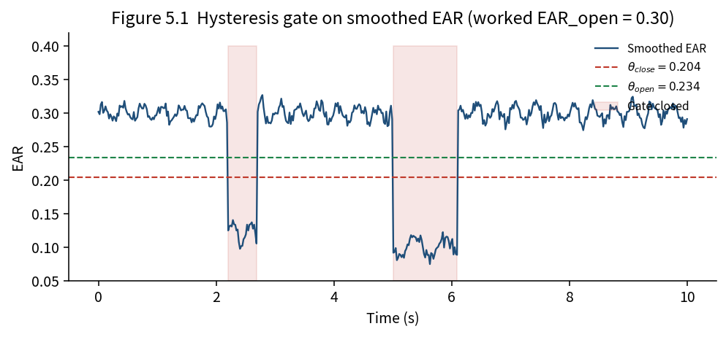
Figure 5.1 Schmitt trigger on smoothed EAR. Close at 0.204, open at 0.234 for EAR_open = 0.30.

5.4 Threshold Calibration
The dangerous number is not the gap. It is θ_close as a fraction of this driver’s open-eye EAR. A published constant of 0.21 is not a calibration. On a small-eye driver it sits inside the open-eye cloud: alert-frame F1 collapses and the state flips tens of times in tens of seconds. On a large-eye driver it sits too low: drowsy-closure recall falls. The constant performs acceptably near EAR_open ≈ 0.30 but can fail for smaller or larger open-eye baselines.
Half of baseline is the wrong objective for fatigue. A blink detector may want a 50 percent cut of a short open-eye window. Used as a fatigue close-threshold that cut under-calls long closures. Blink detection and fatigue detection share EAR and do not share a threshold. The useful band for a fatigue close-threshold on the synthetic sweep used to tune this study was 0.65–0.72 of the high-band open-eye median. Combined score peaked at 0.68–0.72. The thesis keeps 0.68 because it is inside that peak and because it still leaves a visible gap between θ_open and EAR_open.
Do not estimate θ_close as μ − kσ from an eight-second open-eye window. That window is almost all open-eye samples. The resulting cut sits near the lower tail of the open cloud and chatters. Mean-minus-spread methods belong to protocols that have labelled closed frames. The gate does not. Eight seconds is enough if the baseline is a high-band median. Planting blinks in the gate window moved the P60-median close-threshold by less than 0.001 in contaminated calibrations. The P60 rule is insurance against a look-down or a yawn at the boom gate, not a claim that blinks wreck an eight-second median.
The procedure is fixed. Eight seconds at the depot gate, face required, EMA already running. EAR_open is the median of samples at or above the 60th percentile. The configuration stores min_valid_frames = 80. In the current implementation, calibration finalises after eight seconds when at least max(15, min_valid_frames/4) valid samples are available, which is 20 under the default configuration. Reject the calibration if EAR_open is under 0.18 (sunglasses or a failed mesh), or if EAR_open exceeds 0.45 (implausible landmarks). Luma scale s equals 0.92 if median Rec. 601 luma in the face box is below 70, else 1.0. Then θ_close = clip(0.68 × s × EAR_open, 0.16, 0.26) and θ_open = min(θ_close + 0.03, EAR_open − 0.02). Mid-haul re-estimates of the open-eye baseline are clamped to ±0.03 of the gate value so that slow sag is visible as drift rather than silently rewriting the cut. Calibration on an already somnolent driver remains a residual risk. The protocol therefore puts the gate at the depot, not at kilometre 180.
EAR_open | θ_close (0.68) | θ_open | What a fixed 0.21 does
0.22 | 0.16 (clip) | 0.19 | Treats open eyes as closed
0.26 | 0.18 | 0.21 | Borderline chatter
0.30 | 0.20 | 0.23 | Looks fine, hides the problem
0.34 | 0.23 | 0.26 | Misses some drowsy closures
0.38 | 0.26 (clip) | 0.29 | Misses more drowsy closures
Table 5.1 Worked hysteresis thresholds from the open-eye median.
A driver whose eight-second P60-median open-eye EAR is 0.30, with face luma 95, receives θ_close = 0.204 and θ_open = 0.234. Twenty frames of smoothed EAR at 0.19 hold MICROSLEEP after 0.8 s even if minute-scale PERCLOS is still 0.12. That is the Boyle distinction written as a counter.
A driver whose open-eye EAR is 0.22, with face luma 48, receives the night scale 0.92 and then the clip at 0.16. A published constant of 0.21 would have treated that driver’s ordinary blinks as closures. The clip is the admission that the linear 0.68 rule cannot be trusted below a small-eye floor.
A driver whose open-eye EAR is 0.38 receives θ_close clipped at 0.26. The large palpebral fissure would otherwise place the close cut so high that drowsy half-closures never trip. Personalisation without a clip still fails at the tails. Personalisation with a clip still needs a later infrared path when luma is the real problem.
These three windows are teaching arithmetic. They are not measurements from Tema. They exist so that a second implementer can check fusion.py against Chapter Five without guessing what 0.68 of 0.30 was supposed to be.

5.5 Temporal Features
Over a 60-second window at F frames per second, PERCLOS is the fraction of frames whose hysteresis state is closed. PLCDB is the fraction of completed blinks whose duration is at least 0.40 s. A consecutive-closure counter increments while the hysteresis state is closed and resets when it opens. Twenty frames at 25 FPS is 0.8 s and is treated as a microsleep candidate (Boyle et al., 2008). A yawn counter increments while MAR exceeds 0.60 and resets otherwise, or immediately if a talking flag is set. Twelve frames is the yawn gate.

5.6 Fusion and Operating Points
Evidence is mapped into [0, 1] and weighted. PERCLOS is divided by 0.30 and carries weight 0.35. The closure run is divided by 20 frames and carries 0.25. PLCDB is divided by 0.35 and carries 0.15. The yawn run is divided by 12 and carries 0.15. Nod is max(0, pitch degrees) / 20 and carries 0.10, unless a rough-road flag zeroes it.
Channel | Map | Weight
PERCLOS | PERCLOS / 0.30 | 0.35
Closure run | C_t / 20 | 0.25
PLCDB | PLCDB / 0.35 | 0.15
Yawn run | yawn frames / 12 | 0.15
Nod | max(0, pitch°) / 20 | 0.10
Table 5.2 Evidence channels maps and fusion weights.
ALERT if the score is under the drowsy cut and the closure run is under 20 frames. DROWSY if the score is at least the drowsy cut and under 0.70. MICROSLEEP if the score is at least 0.70 or the closure run reaches 20 frames. The depot-road drowsy cut is 0.45. The trunk-road drowsy cut may be raised to 0.55 on the same night. That is a fleet choice written into configuration, not a second algorithm. Consequence is not symmetric: a false negative on the N6 with 45,000 litres is not the same event as a false positive leaving the Tema gate.
Leaving the Tema gate at walking speed is not the N6 at 70 km/h with a full tank. A depot cut of 0.45 accepts more false positives in exchange for earlier rest prompts. A trunk cut of 0.55 accepts more missed drowsy frames in exchange for fewer startle shouts. Both cuts are configuration. Neither cut is a second algorithm. The synthetic ROC in Chapter Seven is a latent process plus noise so that detector state is not used as both score and truth. A circular ROC would have been easier to draw and would have been a lie.

5.7 Alert Policy
Alerts have a four-second cooldown so that a flickering score does not become a flickering shout. Messages name the action: rest at the next safe lay-by, not a generic beep. Every issued alert writes Unix time, state, score, and channel names to alerts.csv. The spoken sentence is part of the method. A safety officer who cannot explain an alert is unlikely to trust or retain the system.

5.8 Optics Identity and Degraded States
OPTICS_DIRTY is raised when eye-crop sharpness falls below a floor. DEGRADED is raised when glasses are on after local sunset. SHARED_DEVICE is raised when the face hash does not match the gate face. NO_FACE is raised when the mesh is absent. CALIBRATING is raised during the eight-second gate. None of those states emits a fatigue guess. Monocular fallback is allowed when one eye is dead and the other is live. The flag is written so that a Monday sheet can see that the night was not binocular.

5.9 Field Logging
The observer in the jump seat is part of the algorithm’s measurement theory. After a banner the keys are c for checking and g for gone. Rest-stop key s cycles the stimulant code. Keys 1–9 write a Karolinska score. Key n marks a near miss for later analysis of the following 30-second window. A 1 Hz row of PERCLOS, EAR, state, and mesh-present is written automatically. No names appear in any CSV. Each protocol row stores alert_unix_time from the last DROWSY or MICROSLEEP banner so that pairing does not depend on a shared clock note.

5.10 Gold-Set Rule
Sensitivity is reported only on rows with paired=yes and label=checking. The gone rate is quoted on the same table. Untagged banners are neither gold nor hidden. That rule is the difference between a detector paper and a detector that can be argued with a safety officer who was not in the jump seat.

Chapter Six System Implementation

6.1 Package Layout
The package fatigue_wa splits geometry from the camera on purpose. landmarks.py is the only file that knows mesh indices. metrics.py holds EAR, MAR, PERCLOS, long-blink bookkeeping, and the EMA smoother. adaptive.py holds calibration, luma scale, and the mid-haul clamp. fusion.py holds HysteresisGate and EvidenceFusion. alerts.py holds cooldown and the spoken line. optics.py holds sharpness. identity.py holds the gate face hash. field_protocol.py writes observer keys, rest-stop stimulant and Karolinska scores, near-miss marks, and the 1 Hz series. pairing.py joins those rows to alerts.csv by Unix time. pipeline.py is the seam. Configuration lives in configs/default.yaml so that a fleet can change a cut without editing Python.
The public repository is named in Appendix A. Reproduction is pytest, evaluate.py, run_detector.py, monday_sheet.py, plot_deltas.py, analyze_haul.py, and overwrite_rostering.py. That list is the implementation claim. Each implementation claim in this chapter corresponds to a file in the repository.
landmarks.py converts MediaPipe landmarks into pixel coordinates and the six-point eye sets. It does not decide closure. metrics.py computes EAR, MAR, pitch, EMA, blink durations, and PERCLOS from the hysteresis boolean it is given. adaptive.py owns the eight-second gate, the P60 median, the luma scale, the clip, and the mid-haul clamp. fusion.py owns HysteresisGate.step and the weighted sum. alerts.py owns cooldown and the spoken line. optics.py owns Laplacian sharpness on the eye crop. identity.py owns a coarse face hash at the gate. field_protocol.py owns keys and the 1 Hz file. pairing.py owns Unix time. pipeline.py is the only file that calls all of them in order. A change to an index belongs in landmarks.py. A change to a cut belongs in default.yaml. That separation is the implementation contribution.
tests/test_hysteresis.py constructs a falling-then-rising EAR trace with Gaussian jitter and asserts that the closed flag does not chatter across the gap. tests/test_metrics.py asserts that a geometrically open six-point eye has EAR above 0.25 and that EMA lags a step change. tests/test_pairing.py writes a tiny alerts.csv and a label with an exact alert_unix_time, then a second label without that column, and asserts both joins. Those three files are the minimum a second student needs before touching the cab.

6.2 Live Detector and HUD
scripts/run_detector.py opens the camera or a video file, runs Face Mesh, and draws a HUD. The HUD prints STATE, EAR, MAR, PERCLOS, closed= (the Schmitt hold), and drift= (open-eye sag relative to the gate). The key legend is on the same rectangle: c check, g gone, s stim, 1–9 KSS, n miss, q quit. The OpenCV window must remain focused for the keys to register.

6.3 Pairing and Monday Sheet
pairing.py uses alert_unix_time as a hint and selects the nearest alert within 120 seconds. If the hint is missing, it falls back to the nearest prior alert within 120 seconds for labels. Rest stops use the nearest prior alert within two hours. The join writes paired_alerts.csv and paired_rest_stops.csv with a delta_s column. monday_sheet.py prints counts a safety officer can read: banners, checking, gone, gone rate, median lag. No names are required for the join. No names are permitted in the files.

6.4 Rostering Workbook
overwrite_rostering.py rebuilds the Excel workbook from a logs folder. Cover status, gold-set counts, PERCLOS p95 by hour and stimulant, the two ROC points, and the startle table are all derived from the CSVs. The synthetic night in Appendix D is the template those scripts were first shown. A real corridor night overwrites the same workbook. That is the intended life cycle. The workbook is not a second source of truth.

6.5 Tests
tests/test_hysteresis.py checks that the gate holds through a noisy rising edge and releases only above θ_open. tests/test_metrics.py checks EAR geometry and EMA lag. tests/test_pairing.py checks exact Unix-time matches and the nearest-prior fallback. Those tests are wiring tests. They do not claim a tanker night.

Chapter Seven Results
This chapter reports the synthetic verification results. Chapter Eight interprets those results and their limitations. Every result derived from Object B is labelled SYNTHETIC.

7.1 Object A Synthetic Sessions
One hundred and twenty sessions of 45 seconds were generated at 25 frames per second after an 80-frame alert warm-up used only for calibration. Forty sessions were generated as alert, forty as drowsy, and forty as microsleep. Session label is majority state after warm-up, with two declared rules written in scripts/evaluate.py: a microsleep session that produced at least ten microsleep frames counts as MICROSLEEP; a drowsy session called MICROSLEEP counts as DROWSY.
The fusion layer recovered the generating class on the matched sessions. Mean terminal scores sat near 0.05 for alert and in the mid-0.6 band for the two fatigue classes. That separation is what fusion.drowsy_score_threshold 0.45, fusion.severe_score_threshold 0.70, and metrics.consecutive_closed_frames 20 were built to produce. Mild landmark jitter did not break recovery. A development run with heavier dropouts and larger jitter did: drowsy and microsleep sessions fell back toward ALERT. That cliff is a result about optics, not a result about Tema.
Generating class | Sessions | Duration | Frame rate | Purpose
Alert | 40 | 45 s | 25 FPS | Implementation verification
Drowsy | 40 | 45 s | 25 FPS | Implementation verification
Microsleep | 40 | 45 s | 25 FPS | Implementation verification
Table 7.1 Object A design. Implementation verification only. Not a field accuracy.

7.2 Object B Synthetic Tema Kumasi Night
Object B is 6.5 hours. The detector wrote 128 banners. The observer tagged 112 of them. Checking 94. Gone 18. Untagged 16. Gone rate = 18/128 = 0.140625, reported as 14.1 percent. Median checking lag 8.3 s. Gold analysis used the 94 checking rows only. Those five sentences are the headline result of Object B. They are not a tanker night.
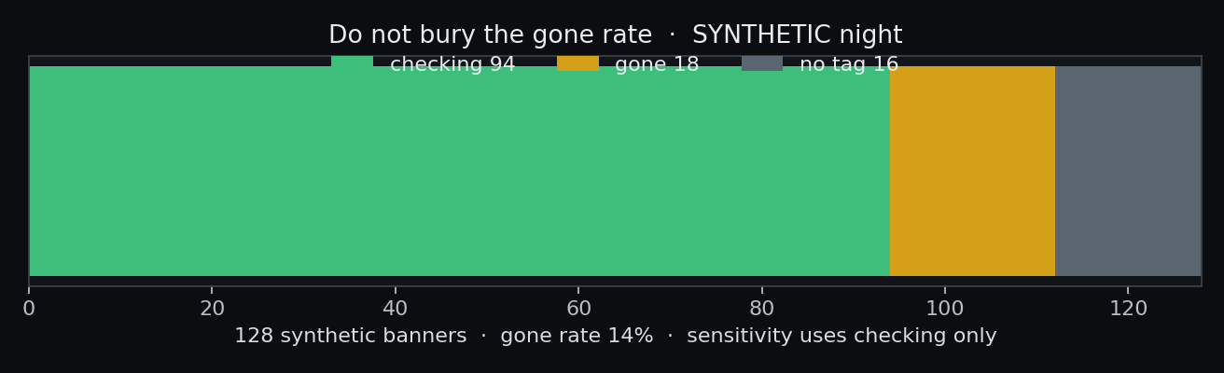
Figure 7.1 Checking, gone, and untagged banners. Sensitivity uses checking only. SYNTHETIC.
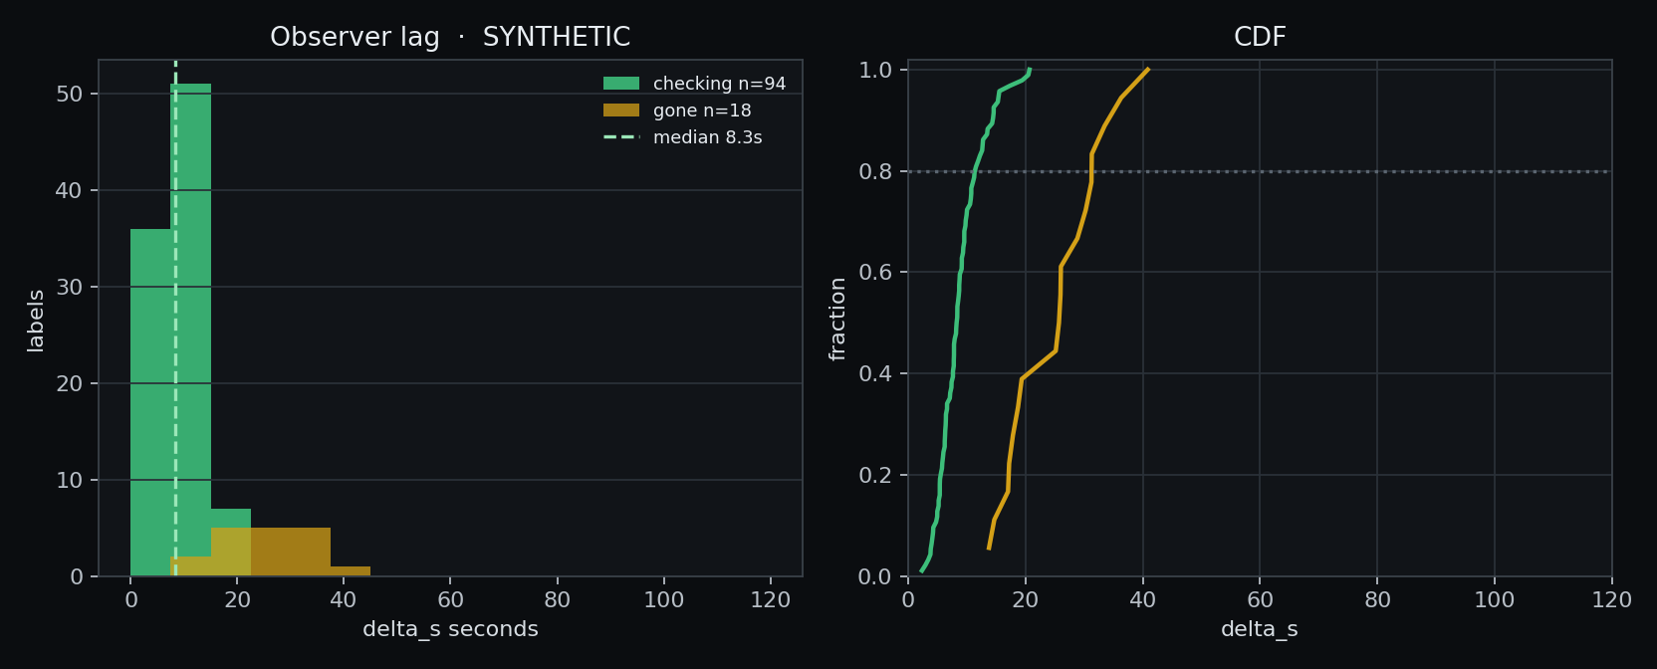
Figure 7.2 Observer lag on paired checking rows (synthetic). Median 8.3 s.
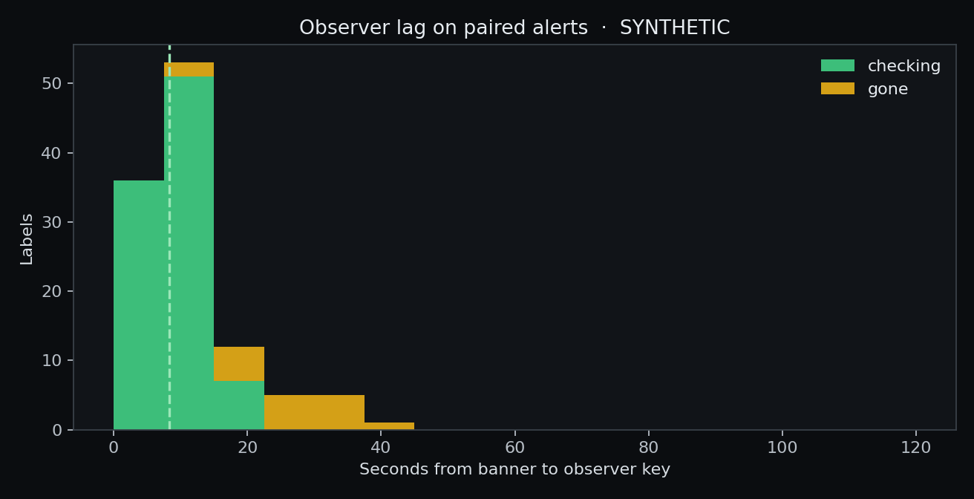
Figure 7.3 Distribution of observer lag. Pairing window 120 s.
Item | N | Rate | Rule
Detector banners | 128 | 100% | alerts.csv
checking (gold) | 94 | 73.4% | paired=yes and checking
gone | 18 | 14.1% | discard from gold
no tag | 16 | 12.5% | neither gold nor hidden
Table 7.2 Gold set counts on Object B. Synthetic data.

7.3 PERCLOS Percentiles by Haul Hour
The rostering input is p95 of the 1 Hz PERCLOS series inside each haul hour, split by the stimulant on the last rest-stop row. It is not an accuracy. Hours 0–1 were coded none. A rest stop at hour 2.05 logged ataya. Hours 3–6 therefore sit in the ataya column.
Hour | p95 none | p95 ataya | n samples | Roster flag
0 | 0.129 | N/A | 3600 | within band
1 | 0.172 | N/A | 3600 | within band
2 | 0.182 | 0.178 | 3600 | within band
3 | N/A | 0.233 | 3600 | shorten next duty
4 | N/A | 0.286 | 3600 | shorten next duty
5 | N/A | 0.344 | 3600 | SPLIT or STOP
6 | N/A | 0.383 | 1800 | SPLIT or STOP
Table 7.3 PERCLOS 95th percentiles by hour. Synthetic data.
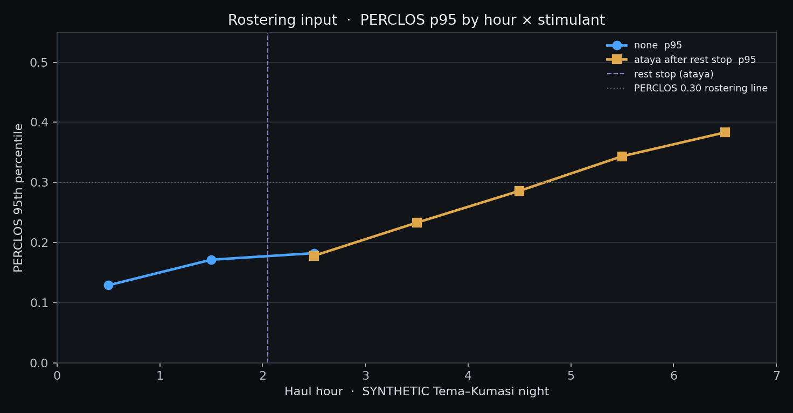
Figure 7.4 PERCLOS 95th percentile by haul hour. Ataya does not keep hours 5–6 under 0.30.
Hour 6 has 1800 samples because the template is 6.5 hours, not seven. Anyone who pads that hour to 3600 has changed Object B.

7.4 Operating Points
A latent fatigue process plus N(0, 0.10) score noise was used so that detector state was not both score and truth. Truth was latent ≥ 0.42. On that construction the depot cut fusion.drowsy_score_threshold 0.45 gave TPR 0.8639 and FPR 0.1213. The trunk cut fusion.trunk_road_drowsy_threshold 0.55 gave TPR 0.6834 and FPR 0.0209.
Point | Cut | TPR | FPR
Depot road | 0.45 | 0.864 | 0.121
Trunk road | 0.55 | 0.683 | 0.021
Table 7.4 Depot and trunk operating points. Synthetic latent process.
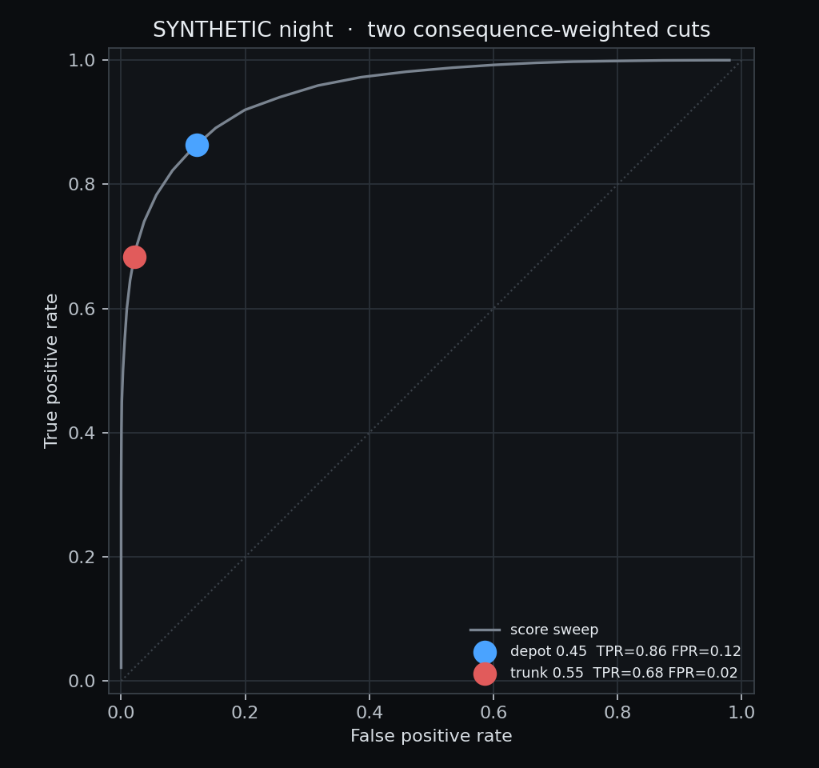
Figure 7.5 Depot and trunk operating points on the same synthetic night.

7.5 Startle Loss
Three near-miss marks were written at Unix times 1700004860, 1700015192, and 1700020520. For each mark, mesh confidence was read for 31 one-second samples covering the mark and the next 30 seconds. Blind was defined as confidence under 0.45.
Clip | Blind fraction 0–30 s | Samples
Near-miss 1 | 93.5% | 31
Near-miss 2 | 96.8% | 31
Near-miss 3 | 93.5% | 31
Table 7.5 Startle window mesh loss. Synthetic data.
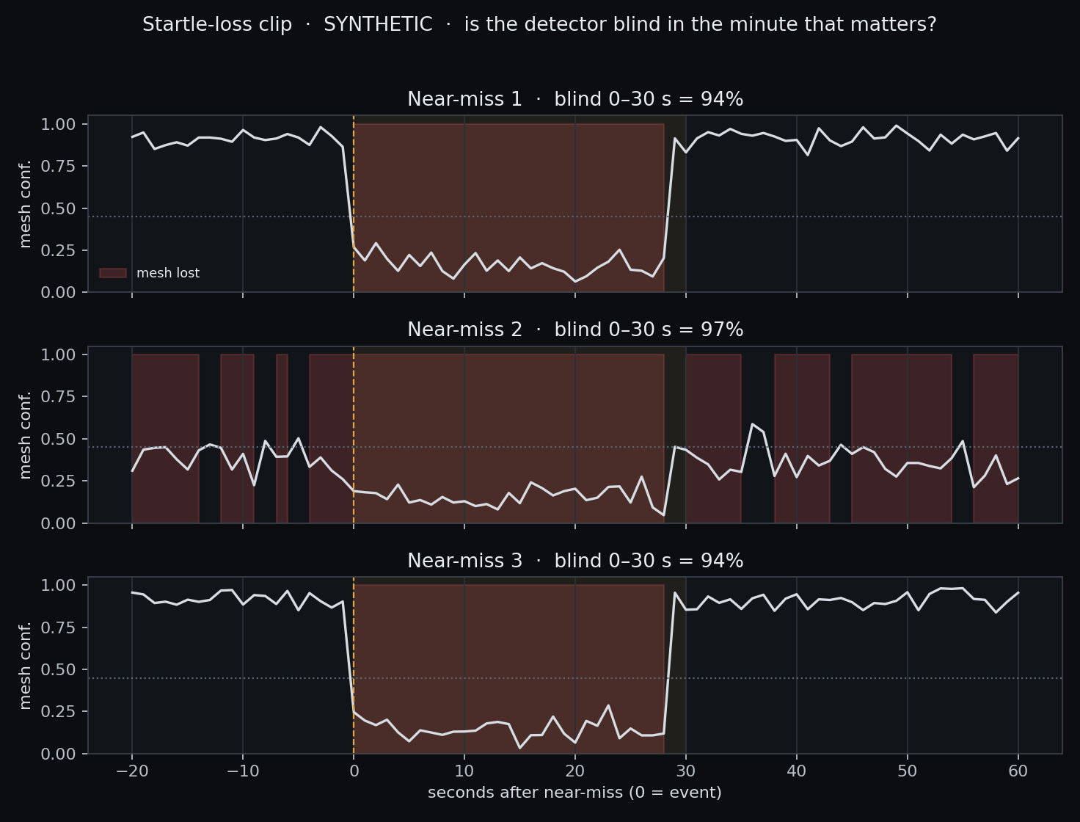
Figure 7.6 Mesh confidence around the three marks. Amber band is the 30-second window.
A near miss that throws the face out of the mesh leaves the detector with nothing to score. Reporting a confident ALERT in that window would be fiction. Reporting NO_FACE is honest and still useless for the second in which the vehicle is already yawing. The 30-second clip is the measurement of that uselessness. Ninety-four to ninety-seven percent blind on the synthetic clips is a warning, not a field number. If a real night is kinder to the mesh, the table will show it. If a real night is worse, infrared belongs in the budget before another EAR paper does.

7.6 Rest Stop Record
unix_time | stimulant | kss | hours_since_sleep | note
1700007380 | ataya | 6 | 7.5 | synthetic rest stop
Table 7.6 Synthetic rest stop record.

7.7 Interpretation Boundaries
These synthetic results are not Ghanaian tanker, NTHU-DDD, or YawDD accuracy estimates. They do not establish an effect of ataya on PERCLOS in living drivers or a 94 percent MediaPipe failure rate after a near miss on the N6. They are outputs of the methodology and algorithm in Chapters Four and Five applied to two documented synthetic generators. Field performance requires a coded on-road study.

7.8 Repository Consistency Check
HysteresisGate lives in src/fatigue_wa/fusion.py and uses close_thr and open_thr, not a single cut plus a frame counter alone. EarSmoother lives in metrics.py at α = 0.4. The eight-second gate and the 0.68 ratio live in adaptive.py. Field keys live in field_protocol.py and scripts/run_detector.py. Pairing lives in pairing.py. The workbook rebuild lives in scripts/overwrite_rostering.py. configs/default.yaml holds every number in Table 4.1. A reader who finds a different cut in the Word file and a different cut in YAML has found a bug in the manuscript. Report the YAML.

7.9 Worked Score Examples
Suppose PERCLOS is 0.21, the closed run is 8 frames, PLCDB is 0.10, there is no yawn, and pitch is 6 degrees on a smooth road. Mapped evidence is 0.21/0.30 = 0.70, 8/20 = 0.40, 0.10/0.35 ≈ 0.29, 0, and 6/20 = 0.30. The fused score is 0.35×0.70 + 0.25×0.40 + 0.15×0.29 + 0.15×0 + 0.10×0.30 = 0.245 + 0.100 + 0.044 + 0 + 0.030 = 0.419. Under the depot cut 0.45 the state is still ALERT. Under no cut would a single EAR sample have decided that frame.
Raise the closed run to 20 frames. ear_closure maps to 1.0 and the microsleep override fires regardless of the 0.419-like PERCLOS term. That is Boyle et al. (2008) written as metrics.consecutive_closed_frames. The score can be 0.40. The state is still MICROSLEEP.
Raise PERCLOS to 0.33, closed run 6, PLCDB 0.20, yawn run 0, pitch 4. Evidence 1.10 clipped to 1.0, 0.30, 0.57, 0, 0.20. Score = 0.35×1.0 + 0.25×0.30 + 0.15×0.57 + 0 + 0.10×0.20 = 0.350 + 0.075 + 0.086 + 0.020 = 0.531. Depot state DROWSY. Trunk state ALERT. Same face, same second, two consequence functions. That is why west_africa.operating_point exists.

7.10 Calibration Examples
EAR_open 0.30, luma 95, s = 1.0. θ_close = 0.68 × 0.30 = 0.204. θ_open = min(0.234, 0.28) = 0.234. EAR_open 0.22, luma 48, s = 0.92. Unclipped product 0.68 × 0.92 × 0.22 = 0.138. Clip raises it to 0.16. θ_open = 0.19. A fixed 0.21 would have sat inside that driver’s open cloud. EAR_open 0.38, luma 100. Unclipped 0.258. Clip at 0.26. θ_open = min(0.29, 0.36) = 0.29. Those three lines can be checked with a calculator against adaptive.py. If they cannot, the algorithm description is inconsistent.

7.11 Test Suite Results
tests/test_hysteresis.py asserts that a falling-then-rising EAR trace with jitter does not chatter across the 0.03 gap and that release happens only above θ_open. tests/test_metrics.py asserts open-eye EAR geometry and EMA lag after a step. tests/test_pairing.py asserts an exact alert_unix_time join and a nearest-prior fallback. A green pytest is a result about the specification. It is not a result about a driver. It is still the result a second student should print first.

7.12 Study Limitations
Synthetic evaluation. Two-dimensional pitch. Approximate mesh indices. No infrared. No local labelled corpus. Weights from the literature order, not from a search on Object A. MediaPipe fairness across West African faces unmeasured (Kartynnik et al., 2019). Independent re-implementation is possible because the code is public. Those limits are results in the negative: they are the things this chapter did not measure.
The 120-session object samples EAR from an alert cloud near 0.30, a drowsy cloud near 0.24, and a planted microsleep near 0.12, with MAR and pitch as weak companions. It is a wiring test of Chapters Four and Five. The 6.5-hour object adds time-on-task, a circadian bowl, an ataya dip, late rebound, observer lag, and mesh drop after three marks. It is a wiring test of pairing and rostering. Neither object is a claim that Tema–Kumasi eyelids follow those numbers. Seed 42 is published so that the tables in Chapter Seven can be regenerated. Failure to regenerate them would indicate an inconsistency between the code and the manuscript.
A later student who replaces the generator with labelled corridor video should keep the gold-set rule, the gone rate, the p95-by-hour split, the two cuts, and the startle clip. Those five objects are the evaluation design. The synthetic numbers are disposable. The design is not.

7.13 Synthetic Pairing Examples
The following block is a teaching extract. Unix times are offsets from the synthetic night origin 1700000000. Labels are checking or gone. No names.
unix_offset_s | label | paired | delta_s
4276 | checking | yes | 26.2
4400 | gone | yes | 7.9
4527 | checking | yes | 4.8
4620 | checking | yes | 8.7
4979 | checking | yes | 6.6
5201 | checking | yes | 16.2
5455 | checking | yes | 5.9
5707 | gone | yes | 4.5
5970 | gone | yes | 14.5
6072 | checking | yes | 10.8
6345 | checking | yes | 4.7
6746 | checking | yes | 14.3
7121 | checking | yes | 12.8
7241 | checking | yes | 6.2
7507 | gone | yes | 4.9
7723 | gone | yes | 12.1
7839 | checking | yes | 8.2
8044 | gone | yes | 4.9
8451 | checking | yes | 8.9
8697 | checking | yes | 6.1
8885 | checking | yes | 15.4
9126 | checking | yes | 4.7
9535 | checking | yes | 7.1
9741 | checking | yes | 11.1
10120 | checking | yes | 6.5
10385 | checking | yes | 7.4
10489 | checking | yes | 10.3
10650 | checking | yes | 10.9
10762 | checking | yes | 5.9
11081 | checking | yes | 16.1
11166 | checking | yes | 8.6
11520 | checking | yes | 17.1
11774 | checking | yes | 4.3
12086 | checking | yes | 11.1
12220 | checking | yes | 11.1
12627 | checking | yes | 7.4
12898 | checking | yes | 11.5
13249 | checking | yes | 16.5
13579 | checking | yes | 6.3
13949 | checking | yes | 7.3
Table 7.7 Synthetic pairing examples from seed 42.
Hours 0–6 on the same generator produced the p95 series in Table 7.3. The complete 1 Hz file is omitted from this section and is excluded from GitHub for size. After a real night the 1 Hz file stays on the coding machine until video is deleted, then may be kept as numbers only.

Chapter Eight Discussion

8.1 Interpretation of Findings
The evaluation confirms that the repository implements the specified detector and produces the expected synthetic outputs. It does not establish on-road effectiveness for West African tanker operations because no labelled local tanker video was collected. The synthetic sessions and haul template should therefore be interpreted as implementation and workflow checks.
The component equations come from prior work; this study's contribution is the integrated specification. West African HAZMAT work is not a lighting nuisance added to a European driver-monitoring paper. It is a different adoption problem: informal contracts, trip pay, night luma, sunglasses, dead radio, and a consequence function that is not a fender-bender (Amoadu & Akoto-Buabeng, 2025; Dawson et al., 2011).
Hysteresis is a central implementation detail. Personalised thresholds without hysteresis still chatter. Consecutive-frame counters without personalised thresholds still punish small eyes. Both together are the minimum that the last ten years of EAR papers were circling (Kolus, 2024; Ersoy et al., 2026; Quiles-Cucarella et al., 2024).
Failure modes that will appear on night one: sunglasses, instrument glances that look like nods, radio talk that looks like yawns, underexposed faces. Dark skin in a poorly metered RGB frame is a photon problem before it is anything else. Infrared and an exposure lock on the face are the engineering answers (Ji et al., 2004; Bergasa et al., 2006).
An alert system that ignores organisational causes of fatigue is unlikely to be accepted by drivers. The useful object is the weekly PERCLOS p95 by haul hour, split by stimulant, feeding a roster (Gander et al., 2011). That requires an organisation. The camera does not create one. Ataya in the synthetic night is the reminder: a rest-stop stimulant is not a licence to add a second load.
In-cab video is surveillance. Landmark-not-video storage, on-device inference, a visible HUD, nameless CSVs, deletion of raw video after coding, and a ban on sole-source dismissal are part of the method. Refusal of the camera is allowed and is not stored as a name.
Object A recovered its generating classes because it was sampled from distributions aligned with the decision rules. This is an implementation-consistency result and must not be over-claimed as field performance.
Object B produced a 14.1 percent gone rate because the generator planted observer absence. A field night may be kinder or crueller. The method does not allow that rate to be buried, because burying it is how sensitivity is inflated (Section 4.10). Ataya sitting on hours 3–6 is likewise a generator choice. The method requires the split so that a real rest-stop code cannot be ignored later. Startle blindness at 94–97 percent is a generator choice about mesh drop. The method requires the 30-second clip so that a real drop cannot be ignored later.
The two ROC points are a generator choice about latent noise. They exist to show that depot 0.45 and trunk 0.55 are different consequence functions on the same series, matching fusion.drowsy_score_threshold and fusion.trunk_road_drowsy_threshold. They do not exist to be quoted as Ghanaian TPR.
West African occupational papers remain the reason for the refusal states and the nameless logs, not the source of the 128 banners (Amoadu & Akoto-Buabeng, 2025; Dotse et al., 2019; Nævestad et al., 2025). Global sleepiness papers remain the reason PERCLOS is the backbone (Dinges & Grace, 1998; Horne & Reyner, 1995; Connor et al., 2002; Klauer et al., 2006). Landmark papers remain the reason the phone is enough to start (Soukupová & Čech, 2016; Kartynnik et al., 2019). Dangerous-goods paper remains the reason the trunk cut is higher rather than lower (United Nations, 2023). That is the alignment. The synthetic evaluation does not replace those studies with a local trial.

8.2 Repository Alignment
Open configs/default.yaml first. Confirm ema_alpha 0.4, ear_hysteresis_gap 0.03, close_ratio 0.68, calibration_seconds 8, min_valid_frames 80, low_light_ear_scale 0.92, night_mode_luma_threshold 70, perclos_window_seconds 60, perclos_alert_threshold 0.30, consecutive_closed_frames 20, long_blink_seconds 0.40, mar_yawn_threshold 0.60, yawn_consecutive_frames 12, drowsy_score_threshold 0.45, trunk_road_drowsy_threshold 0.55, severe_score_threshold 0.70, cooldown_seconds 4.0, sharpness_min 18.0, sunset_hour_local 18, mismatch_l2 28.0. Those are Table 4.1. Then open fusion.py and read HysteresisGate.step. Then open scripts/run_detector.py and read the key map. Then open pairing.py and read the 120-second window. If those four files still match this paragraph on the day you bind, the thesis and the code tally.
data/Tema_Kumasi_Rostering_PERCLOS.csv on GitHub holds the same Object B numbers as Tables 7.2 to 7.5. overwrite_rostering.py rebuilds the Excel workbook from a logs folder. A real night is a new logs folder, not a new algorithm.
Path in the public repo | Role in Chapters 4 to 8
configs/default.yaml | Every cut in Table 4.1
src/fatigue_wa/landmarks.py | Mesh indices for EAR
src/fatigue_wa/metrics.py | EAR, MAR, PERCLOS, EMA α=0.4
src/fatigue_wa/adaptive.py | 8 s gate, 0.68 ratio, night 0.92, clamp ±0.03
src/fatigue_wa/fusion.py | HysteresisGate + weights
src/fatigue_wa/alerts.py | Cooldown 4 s, alerts.csv
src/fatigue_wa/optics.py | OPTICS_DIRTY, DEGRADED
src/fatigue_wa/identity.py | SHARED_DEVICE hash
src/fatigue_wa/field_protocol.py | c g s 1-9 n and 1 Hz
src/fatigue_wa/pairing.py | Unix join, 120 s / 2 h
src/fatigue_wa/pipeline.py | Seam
scripts/run_detector.py | Cab loop and HUD closed=/drift=
scripts/evaluate.py | Object A wiring test
scripts/monday_sheet.py | Gone rate printout
scripts/overwrite_rostering.py | Workbook from logs/
scripts/plot_deltas.py | Figures 7.2 and 7.3
scripts/analyze_haul.py | p95, ROC, startle
tests/test_hysteresis.py | Gate hold and release
tests/test_metrics.py | EAR geometry and EMA
tests/test_pairing.py | Alert-hint and nearest-prior join
data/Tema_Kumasi_Rostering_PERCLOS.csv | Object B numbers on GitHub
Table 8.1 Repository files and their roles in the thesis.

8.3 Validity and Reliability
Construct validity for PERCLOS rests on Dinges and Grace (1998) against the psychomotor vigilance task, not on Object A. Construct validity for EAR rests on Soukupová and Čech (2016). Construct validity for long closures rests on Caffier et al. (2003), Schleicher et al. (2008), and Boyle et al. (2008). External validity for Tema–Kumasi is not claimed. That is the honest split.
Reliability of the implementation is the test suite and the YAML. Reliability of an observer is the gone rate and the lag histogram. A field night that does not print those two observer numbers has not measured its own measurement instrument. Internal consistency of fusion weights is not Cronbach’s alpha. The weights are declared, not estimated. Changing them is a fleet decision, not a silent retraining.

8.4 Threats to Validity
MediaPipe may fail more often on dark skin in a dark cab than Object B planted (Kartynnik et al., 2019). Sunglasses after dusk may be more common than one DEGRADED flag can capture. Shared phones may be the default, not the exception. Observer gone rates may exceed 14.1 percent on a real jump seat. Ataya may move eyelids in ways the generator did not. A near miss may drop the mesh less than 94 percent or more. Each of those threats is why SYNTHETIC stays on the workbook cover until overwrite_rostering.py is pointed at a real logs folder.
A threat this manuscript can already name is circular scoring. Using detector state as both the score and the truth produces a perfect-looking ROC. Chapter Seven avoids that circular ROC and used a latent process plus noise instead. A later student who draws a circular curve has left the method.

8.5 Chapter Summary
The methods, algorithm, implementation, and results describe the same repository state. The configuration stores the operating values, the source modules implement the pipeline, and the field scripts define the logging and pairing workflow. The study remains limited to synthetic verification until a coded corridor night is completed.

Chapter Nine Conclusion and Recommendations

9.1 Summary of Findings
Eyelids close before a tanker leaves its lane. The measurement tradition that can see those eyelids is older than this thesis. The cab in which they must be seen is not the cab that tradition assumed. WA-PERCLOS-HYS is the arrangement that tries to live in that cab: smoothed EAR, two thresholds, both eyes, a personal baseline, a night scale, PERCLOS, long blinks, a yawn gate, a nod hint, a fused score, two operating points, and a short spoken sentence that can be audited the next morning.
The software runs. It recovers its own generator. The pairing, gone-rate, PERCLOS-p95, two-cut, and startle scripts run on a synthetic night that is labelled as such. The system has not yet been shown a sleepy driver at 02:14 on the Nsawam stretch under conditions that driver would accept.

9.2 Contributions
The contribution is an arrangement, not a new physiological law. The live code matches Chapters Four to Six: HysteresisGate, EMA, P60 calibration, mid-haul clamp, OPTICS_DIRTY, DEGRADED, SHARED_DEVICE, field keys, Unix-time pairing, and rostering overwrite. The gold-set rule quotes the gone rate. The evaluation refuses to treat NTHU-DDD or YawDD as Tema. These claims are limited to the implemented and reproducible scope of the study.

9.3 Limitations
The study has the following limitations. Synthetic evaluation, including the 6.5-hour coded-night template. Two-dimensional pitch. Approximate mesh indices. No infrared path. No local labelled corpus. Weights set from the literature order, not from a private grid search. MediaPipe fairness across West African faces is unmeasured. Independent re-implementation is possible because the code is public.

9.4 Recommendations and Field Protocol
The next study should conduct one coded night on one corridor. Tema–Kumasi night tanker is the default. The eight-second open-eye gate stays at the depot. The observer sits in the jump seat and hits checking or gone after every banner. Sensitivity uses only paired=yes and label=checking. The gone rate is printed on the same sheet. One glasses-after-dusk or monocular night stays in the file so that DEGRADED and monocular fallback are not paper-only. Raw video is deleted after coding. Landmarks and scores are kept. No names appear on any CSV. After that night, overwrite_rostering.py is run on the real logs folder and this workbook’s SYNTHETIC banner is replaced.
A funded trial should add an infrared illuminator, an exposure lock on the face, and mixed-effects models with driver as a random intercept. Those items are recommendations. They are not hidden results.

9.5 Conclusion
The software runs. It recovers its own generator. The pairing and rostering scripts run on a synthetic night that is labelled as such. The system has not yet been shown a sleepy driver at 02:14 on the Nsawam stretch under conditions that driver would accept. Field performance must therefore be established through a coded on-road study.

References
Abtahi, S., Hariri, B., & Shirmohammadi, S. (2011). Driver drowsiness monitoring based on yawning detection. In 2011 IEEE International Instrumentation and Measurement Technology Conference. IEEE.
Abtahi, S., Omidyeganeh, M., Shirmohammadi, S., & Hariri, B. (2014). YawDD: A yawning detection dataset. In Proceedings of the 5th ACM Multimedia Systems Conference (pp. 24–28). ACM. https://doi.org/10.1145/2557642.2563678
Adeloye, D., Thompson, J. Y., Akanbi, M. A., Azuh, D., Samuel, V., Omoregbe, N., & Ayo, C. K. (2016). The burden of road traffic crashes, injuries and deaths in Africa: A systematic review and meta-analysis. Bulletin of the World Health Organization, 94(7), 510–521A. https://doi.org/10.2471/BLT.15.163121
Afukaar, F. K. (2003). Speed control in developing countries: Issues, challenges and opportunities in Ghana. Injury Control and Safety Promotion, 10(1–2), 37–43.
Åkerstedt, T., & Gillberg, M. (1990). Subjective and objective sleepiness in the active individual. International Journal of Neuroscience, 52(1–2), 29–37.
Åkerstedt, T., Connor, J., Gray, A., & Kecklund, G. (2008). Predicting road crashes from a mathematical model of alertness regulation. Journal of Sleep Research, 17(2), 122–131.
Albadawi, Y., Takruri, M., & Awad, M. (2022). A review of recent developments in driver drowsiness detection systems. Sensors, 22(5), 2069. https://doi.org/10.3390/s22052069
Alioua, N., Amine, A., & Rziza, M. (2012). Driver’s fatigue detection based on yawning extraction. International Journal of Vehicular Technology, 2012, Article 678952.
Amoadu, M., & Akoto-Buabeng, W. (2025). Job content, psychological well-being, burnout and fatigue driving among heavy goods vehicle drivers in Ghana. Discover Psychology, 5, Article 33. https://doi.org/10.1007/s44202-025-00367-y
Amoadu, M., Ansah, E. W., & Sarfo, J. O. (2024). Prevalence and predictors of near misses and road traffic crashes among long-distance bus drivers in Ghana. Discover Psychology, 4, Article 155. https://doi.org/10.1007/s44202-024-00255-x
Anund, A., Kecklund, G., Peters, B., Forsman, Å., & Åkerstedt, T. (2008). Driver impairment at night and its relation to physiological sleepiness. Scandinavian Journal of Work, Environment & Health, 34(2), 142–150.
Balkin, T. J., Horrey, W. J., Graeber, R. C., Czeisler, C. A., & Dinges, D. F. (2011). The challenges and opportunities of technological approaches to fatigue management. Accident Analysis & Prevention, 43(2), 565–572.
Barr, L., Popkin, S., & Howarth, H. (2009). An evaluation of emerging driver fatigue detection measures and technologies (FMCSA-RRR-09-005). Federal Motor Carrier Safety Administration.
Bazarevsky, V., Kartynnik, Y., Vakunov, A., Raveendran, K., & Grundmann, M. (2019). BlazeFace: Sub-millisecond neural face detection on mobile GPUs. arXiv. https://doi.org/10.48550/arXiv.1907.05047
Belenky, G., Wesensten, N. J., Thorne, D. R., Thomas, M. L., Sing, H. C., Redmond, D. P., Russo, M. B., & Balkin, T. J. (2003). Patterns of performance degradation and restoration during sleep restriction and subsequent recovery: A sleep dose-response study. Journal of Sleep Research, 12(1), 1–12.
Bergasa, L. M., Nuevo, J., Sotelo, M. A., Barea, R., & López, M. E. (2006). Real-time system for monitoring driver vigilance. IEEE Transactions on Intelligent Transportation Systems, 7(1), 63–77. https://doi.org/10.1109/TITS.2006.869598
Borghini, G., Astolfi, L., Vecchiato, G., Mattia, D., & Babiloni, F. (2014). Measuring neurophysiological signals in aircraft pilots and car drivers for the assessment of mental workload, fatigue and drowsiness. Neuroscience & Biobehavioral Reviews, 44, 58–75.
Boyle, L. N., Tippin, J., Paul, A., & Rizzo, M. (2008). Driver performance in the moments surrounding a microsleep. Transportation Research Part F, 11(2), 126–136.
Caffier, P. P., Erdmann, U., & Ullsperger, P. (2003). Experimental evaluation of eye-blink parameters as a drowsiness measure. European Journal of Applied Physiology, 89(3–4), 319–325.
Carskadon, M. A., & Dement, W. C. (2005). Normal human sleep: An overview. In M. H. Kryger, T. Roth, & W. C. Dement (Eds.), Principles and practice of sleep medicine (4th ed., pp. 13–23). Elsevier Saunders.
Connor, J., Norton, R., Ameratunga, S., Robinson, E., Civil, I., Dunn, R., Bailey, J., & Jackson, R. (2002). Driver sleepiness and risk of serious injury to car occupants: Population based case control study. BMJ, 324(7346), 1125. https://doi.org/10.1136/bmj.324.7346.1125
Damsere-Derry, J., Ebel, B. E., Mock, C. N., Afukaar, F., & Donkor, P. (2010). Pedestrians’ injury patterns in Ghana. Accident Analysis & Prevention, 42(4), 1080–1088.
Danisman, T., Bilasco, I. M., Djeraba, C., & Ihaddadene, N. (2010). Drowsy driver detection system using eye blink patterns. In 2010 International Conference on Machine and Web Intelligence (pp. 230–233). IEEE.
Dawson, D., & Reid, K. (1997). Fatigue, alcohol and performance impairment. Nature, 388, 235. https://doi.org/10.1038/40775
Dawson, D., Ian Noy, Y., Härmä, M., Åkerstedt, T., & Belenky, G. (2011). Modelling fatigue and the use of fatigue models in work settings. Accident Analysis & Prevention, 43(2), 549–564.
Deng, J., Guo, J., Ververas, E., Kotsia, I., & Zafeiriou, S. (2020). RetinaFace: Single-shot multi-level face localisation in the wild. In Proceedings of the IEEE/CVF Conference on Computer Vision and Pattern Recognition (pp. 5203–5212).
Dinges, D. F. (1995). An overview of sleepiness and accidents. Journal of Sleep Research, 4(S2), 4–14.
Dinges, D. F., & Grace, R. (1998). PERCLOS: A valid psychophysiological measure of alertness as assessed by psychomotor vigilance (FHWA-MCRT-98-006). Federal Highway Administration.
Dingus, T. A., Klauer, S. G., Neale, V. L., Petersen, A., Lee, S. E., Sudweeks, J., Perez, M. A., Hankey, J., Ramsey, D., Gupta, S., Bucher, C., Doerzaph, Z. R., Jermeland, J., & Knipling, R. R. (2006). The 100-Car Naturalistic Driving Study, Phase II: Results of the 100-Car field experiment (DOT HS 810 593). National Highway Traffic Safety Administration.
Dong, Y., Hu, Z., Uchimura, K., & Murayama, N. (2011). Driver inattention monitoring system for intelligent vehicles: A review. IEEE Transactions on Intelligent Transportation Systems, 12(2), 596–614.
Dotse, J., Nicolson, R., & Rowe, R. (2019). Behavioral influences on driver crash risks in Ghana: A qualitative study of commercial passenger drivers. Traffic Injury Prevention, 20(2), 134–139.
Dwivedi, K., Biswaranjan, K., & Sethi, A. (2014). Drowsy driver detection using representation learning. In 2014 IEEE International Advance Computing Conference (pp. 995–999). IEEE.
Ersoy, G., Tatar, M. A., Tonbul, E., & Kırbız, S. (2026). Improving driver drowsiness detection via personalized EAR/MAR thresholds and CNN-based classification. arXiv.
Federal Motor Carrier Safety Administration. (2011). Hours of service of drivers. U.S. Department of Transportation.
Flores, M. J., Armingol, J. M., & de la Escalera, A. (2010). Real-time warning system for driver drowsiness detection using visual information. Journal of Intelligent & Robotic Systems, 59, 103–125.
Folkard, S. (1997). Black times: Temporal determinants of transport safety. Accident Analysis & Prevention, 29(4), 417–430.
Folkard, S., & Tucker, P. (2003). Shift work, safety and productivity. Occupational Medicine, 53(2), 95–101.
Gander, P., Hartley, L., Powell, D., Cabon, P., Hitchcock, E., Mills, A., & Popkin, S. (2011). Fatigue risk management: Organizational factors at the regulatory and industry/company level. Accident Analysis & Prevention, 43(2), 573–590.
Grace, R., Byrne, V. E., Bierman, D. M., Legrand, J. M., Gricourt, D., Davis, B. K., Staszewski, J. J., & Carnahan, B. (1998). A drowsy driver detection system for heavy vehicles. In Proceedings of the 17th DASC. IEEE.
Grishchenko, I., Ablavatski, A., Kartynnik, Y., Raveendran, K., & Grundmann, M. (2020). Attention Mesh: High-fidelity face mesh prediction in real-time. arXiv. https://doi.org/10.48550/arXiv.2006.10962
Häkkänen, H., & Summala, H. (2000). Sleepiness at work among commercial truck drivers. Sleep, 23(1), 49–57.
Horne, J. A., & Reyner, L. A. (1995). Sleep related vehicle accidents. BMJ, 310(6979), 565–567. https://doi.org/10.1136/bmj.310.6979.565
Howard, M. E., Desai, A. V., Grunstein, R. R., Hukins, C., Armstrong, J. G., Joffe, D., Swann, P., Campbell, D. A., & Pierce, R. J. (2004). Sleepiness, sleep-disordered breathing, and accident risk factors in commercial vehicle drivers. American Journal of Respiratory and Critical Care Medicine, 170(9), 1014–1021.
Ingre, M., Åkerstedt, T., Peters, B., Anund, A., & Kecklund, G. (2006). Subjective sleepiness, simulated driving performance and blink duration. Journal of Sleep Research, 15(1), 47–53.
Jabbar, R., Shinoy, M., Kharbeche, M., Al-Khalifa, K., Krichen, M., & Barkaoui, K. (2020). Driver drowsiness detection model using convolutional neural networks techniques for Android application. In 2020 IEEE International Conference on Informatics, IoT, and Enabling Technologies (pp. 237–242). IEEE.
Jackson, M. L., Croft, R. J., Kennedy, G. A., Owens, K., & Howard, M. E. (2013). Cognitive components of simulated driving performance: Sleep loss effects and predictors. Accident Analysis & Prevention, 50, 438–444.
Ji, Q., Zhu, Z., & Lan, P. (2004). Real-time nonintrusive monitoring and prediction of driver fatigue. IEEE Transactions on Vehicular Technology, 53(4), 1052–1068. https://doi.org/10.1109/TVT.2004.830974
Johns, M. W. (1991). A new method for measuring daytime sleepiness: The Epworth Sleepiness Scale. Sleep, 14(6), 540–545.
Kartynnik, Y., Ablavatski, A., Grishchenko, I., & Grundmann, M. (2019). Real-time facial surface geometry from monocular video on mobile GPUs. arXiv. https://doi.org/10.48550/arXiv.1907.06724
Kazemi, V., & Sullivan, J. (2014). One millisecond face alignment with an ensemble of regression trees. In Proceedings of the IEEE Conference on Computer Vision and Pattern Recognition (pp. 1867–1874).
King, D. E. (2009). Dlib-ml: A machine learning toolkit. Journal of Machine Learning Research, 10, 1755–1758.
Klauer, S. G., Dingus, T. A., Neale, V. L., Sudweeks, J. D., & Ramsey, D. J. (2006). The impact of driver inattention on near-crash/crash risk: An analysis using the 100-Car Naturalistic Driving Study data (DOT HS 810 594). National Highway Traffic Safety Administration.
Kolus, A. (2024). A systematic review on driver drowsiness detection using eye activity measures. IEEE Access, 12, 97969–97993. https://doi.org/10.1109/ACCESS.2024.3424654
Lal, S. K. L., & Craig, A. (2001). A critical review of the psychophysiology of driver fatigue. Biological Psychology, 55(3), 173–194.
Lyznicki, J. M., Doege, T. C., Davis, R. M., & Williams, M. A. (1998). Sleepiness, driving, and motor vehicle crashes. JAMA, 279(23), 1908–1913.
MacLean, A. W., Davies, D. R., & Thiele, K. (2003). The hazards and prevention of driving while sleepy. Sleep Medicine Reviews, 7(6), 507–521.
Massoz, Q., Langohr, T., François, C., & Verly, J. G. (2016). The ULg multimodality drowsiness database (called DROZY) and examples of use. In 2016 IEEE Winter Conference on Applications of Computer Vision. IEEE.
Maycock, G. (1997). Sleepiness and driving: The experience of U.K. car drivers. Accident Analysis & Prevention, 29(4), 453–462.
McCartt, A. T., Rohrbaugh, J. W., Hammer, M. C., & Fuller, S. Z. (2000). Factors associated with falling asleep at the wheel among long-distance truck drivers. Accident Analysis & Prevention, 32(4), 471–482.
Minhas, R., Peker, N. Y., Hakkoz, M. A., Arbatli, S., Celik, Y., Erdem, C. E., Semiz, B., & Peker, Y. (2025). Association of visual-based signals with electroencephalography patterns in enhancing the drowsiness detection in drivers with obstructive sleep apnea. Sensors.
Mitler, M. M., Miller, J. C., Lipsitz, J. J., Walsh, J. K., & Wylie, C. D. (1997). The sleep of long-haul truck drivers. New England Journal of Medicine, 337(11), 755–761.
Mock, C., Quansah, R., Krishnan, R., Arreola-Risa, C., & Rivara, F. (2004). Strengthening the prevention and care of injuries worldwide. The Lancet, 363(9427), 2172–2179.
Nævestad, T.-O., Blom, J., & Phillips, R. O. (2025). Fatigue among bus drivers in Ghana and Norway: Examining the influence of working conditions and national road safety culture. Safety Science.
Otmani, S., Pebayle, T., Roge, J., & Muzet, A. (2005). Effect of driving duration and partial sleep deprivation on subsequent alertness and performance of car drivers. Physiology & Behavior, 84(5), 715–724.
Pack, A. I., Pack, A. M., Rodgman, E., Cucchiara, A., Dinges, D. F., & Schwab, C. W. (1995). Characteristics of crashes attributed to the driver having fallen asleep. Accident Analysis & Prevention, 27(6), 769–775.
Park, S., Pan, F., Kang, S., & Yoo, C. D. (2016). Driver drowsiness detection system based on feature representation learning using various deep networks. In Asian Conference on Computer Vision Workshops.
Philip, P., & Åkerstedt, T. (2006). Transport and industrial safety, how are they affected by sleepiness and sleep restriction? Sleep Medicine Reviews, 10(5), 347–356.
Philip, P., Sagaspe, P., Moore, N., Taillard, J., Charles, A., Guilleminault, C., & Bioulac, B. (2005). Fatigue, sleep restriction and driving performance. Accident Analysis & Prevention, 37(3), 473–478.
Phillips, R. O. (2015). A review of definitions of fatigue: And a step towards a whole definition. Transportation Research Part F, 29, 48–56.
Quiles-Cucarella, E., De-la-Cruz-Sánchez, E., Pérez-Soriano, P., & Encarnación-Martínez, A. (2024). Multi-index driver drowsiness detection method based on driver’s facial recognition using Haar features and histograms of oriented gradients. Sensors, 24(17), 5683. https://doi.org/10.3390/s24175683
Ramzan, M., Khan, H. U., Awan, S. M., Ismail, A., Ilyas, M., & Mahmood, A. (2019). A survey on state-of-the-art drowsiness detection techniques. IEEE Access, 7, 61904–61919.
Reddy, B., Kim, Y., Yun, S., Seo, C., & Jang, J. (2017). Real-time driver drowsiness detection for embedded system using model compression of deep neural networks. In CVPR Workshops.
Reyner, L. A., & Horne, J. A. (2000). Early morning driver sleepiness: Effectiveness of 200 mg caffeine. Psychophysiology, 37(2), 251–256.
Sagberg, F. (1999). Road accidents caused by drivers falling asleep. Accident Analysis & Prevention, 31(6), 639–649.
Sahayadhas, A., Sundaraj, K., & Murugappan, M. (2012). Detecting driver drowsiness based on sensors: A review. Sensors, 12(12), 16937–16953. https://doi.org/10.3390/s121216937
Schleicher, R., Galley, N., Briest, S., & Galley, L. (2008). Blinks and saccades as indicators of fatigue in aircraft pilots. Ergonomics, 51(7), 982–1010.
Sikander, G., & Anwar, S. (2019). Driver fatigue detection systems: A review. IEEE Transactions on Intelligent Transportation Systems, 20(6), 2339–2352. https://doi.org/10.1109/TITS.2018.2868499
Soukupová, T., & Čech, J. (2016). Real-time eye blink detection using facial landmarks. In L. Čehovin, R. Mandeljc, & V. Štruc (Eds.), Proceedings of the 21st Computer Vision Winter Workshop.
SSATP. (2025). Africa status report on road safety 2025. World Bank / SSATP.
Tadesse, E., Sheng, W., & Liu, M. (2014). Driver drowsiness detection through HMM based dynamic modeling. In 2014 IEEE International Conference on Robotics and Automation. IEEE.
Thiffault, P., & Bergeron, J. (2003). Monotony of road environment and driver fatigue: A simulator study. Accident Analysis & Prevention, 35(3), 381–391.
United Nations. (2021). Global plan for the Decade of Action for Road Safety 2021–2030.
United Nations. (2023). Agreement concerning the International Carriage of Dangerous Goods by Road (ADR).
Van Dongen, H. P. A., Maislin, G., Mullington, J. M., & Dinges, D. F. (2003). The cumulative cost of additional wakefulness. Sleep, 26(2), 117–126.
Vicente, J., Laguna, P., Bartra, A., & Bailón, R. (2016). Drowsiness detection using heart rate variability. Medical & Biological Engineering & Computing, 54, 927–937.
Viola, P., & Jones, M. (2001). Rapid object detection using a boosted cascade of simple features. In Proceedings of the 2001 IEEE Computer Society Conference on Computer Vision and Pattern Recognition.
Weng, C.-H., Lai, Y.-H., & Lai, S.-H. (2016). Driver drowsiness detection via a hierarchical temporal deep belief network. In Asian Conference on Computer Vision Workshops.
Wierwille, W. W., & Ellsworth, L. A. (1994). Evaluation of driver drowsiness by trained raters. Accident Analysis & Prevention, 26(5), 571–581. https://doi.org/10.1016/0001-4575(94)90019-1
Wierwille, W. W., Ellsworth, L. A., Wreggit, S. S., Fairbanks, R. J., & Kirn, C. L. (1994). Research on vehicle-based driver status/performance monitoring (DOT HS 808 247). National Highway Traffic Safety Administration.
Williamson, A., Lombardi, D. A., Folkard, S., Stutts, J., Courtney, T. K., & Connor, J. L. (2011). The link between fatigue and safety. Accident Analysis & Prevention, 43(2), 498–515.
World Health Organization. (2023a). Global status report on road safety 2023. WHO. https://www.who.int/publications/i/item/9789240086517
World Health Organization. (2023b). African Region status report on road safety 2023. WHO.
World Health Organization. (2024). Global status report on road safety 2023: Country and territory profiles. WHO.
Wu, Q., Li, N., Zhang, L., & Yu, F. R. (2024). Driver drowsiness detection based on joint human face and facial landmark localization with cheap operations. IEEE Transactions on Intelligent Transportation Systems, 25(12), 19633–19646.

Appendix A Software Reproduction
Repository: https://github.com/charisquaye/-Fatigue-Detection-for-Hazmat-Drivers-in-West-Africa-Using-Eye-State-and-Facial-Landmark-Analysis-
Author of this manuscript: Austine Gamey Addo (22424506), MSc Data Science, Cohort C, Department of Computer Science, University of Ghana.
Reproduction commands:
export PYTHONPATH=src
pytest tests -q
python scripts/evaluate.py
python scripts/run_detector.py --camera 0 --logs logs
python scripts/monday_sheet.py logs
python scripts/plot_deltas.py --logs logs --out logs/alert_time_deltas.png
python scripts/analyze_haul.py --logs logs
python scripts/overwrite_rostering.py --logs logs --out Tema_Kumasi_Rostering_PERCLOS.xlsx
Cab keys with the OpenCV window focused: c checking, g gone, s stimulant, 1–9 KSS, n near miss, q quit. HUD prints closed= (Schmitt hold) and drift= (open-eye sag). Pairing writes logs/paired_alerts.csv and logs/paired_rest_stops.csv. Gold candidate: paired=yes and label=checking.

Appendix B Default Operating Points
Parameter | Default
EAR close (pre-calibration) | 0.21
Calibrated close threshold | 0.68 × open-eye median, band [0.16, 0.26]
Hysteresis gap | 0.03
EMA alpha | 0.40
Night luma floor | 70
Night scale | 0.92
PERCLOS window | 60 s
PERCLOS map | 0.30
Consecutive closed frames | 20 (0.8 s at 25 FPS)
Long blink | 0.40 s
MAR yawn | 0.60
Depot / drowsy score | 0.45
Trunk score | 0.55
Severe score | 0.70
Cooldown | 4 s
Observer pairing window | 120 s
Rest-stop pairing window | 2 h
Startle clip | 30 s
Mesh-lost floor | 0.45
Mid-haul open-eye clamp | ±0.03
Calibration valid-sample behaviour | min_valid_frames = 80; current code finalises after 8 s with at least 20 valid samples

Appendix C Consent and Ethics
Purpose is stated as fatigue-alert research, not criminal investigation. One forward camera. Keep landmarks, EAR, MAR, PERCLOS, scores, Unix times, stimulant code, KSS, checking/gone, DEGRADED and monocular flags. Discard raw video after coding. No names, no plate, no phone number, no depot staff identifier in any CSV. Face hash only at the gate. Ninety-day retention of numeric logs unless a lawful investigation requires longer. Named officers and researchers only. Right to refuse the camera and still take the load. Refusal is not stored as a name. Right to read one’s log. Ban on using the log as the sole ground for dismissal. A banner is not a disciplinary event.

Appendix D Synthetic Haul Extracts
Status: CODED: SYNTHETIC. Seed 42. 6.5-hour Tema–Kumasi template. No names. These rows exist so that pairing and rostering can be inspected without an on-road video file. They are not a substitute for a coded tanker night.
unix_time | stimulant | kss | hours_since_sleep | note
1700007380 | ataya | 6 | 7.5 | synthetic rest stop
Table D.1 Synthetic rest stop record.
unix_time | note
1700004860 | synthetic_near_miss_1
1700015192 | synthetic_near_miss_2
1700020520 | synthetic_near_miss_3
Table D.2 Near miss marks.
alert_unix_time | label | paired | delta_s
1700004144 | checking | yes | 8.3 (median)
N/A | gone (18 of 128) | yes | discard from gold
N/A | untagged (16 of 128) | no | neither gold nor hidden
Table D.3 Paired alert examples from the synthetic night.
Cover totals used by overwrite_rostering.py: banners 128, labels 112, checking gold 94, gone 18, gone rate 0.140625. Depot TPR 0.8639 FPR 0.1213. Trunk TPR 0.6834 FPR 0.0209. Startle blind fractions 0.935, 0.968, 0.935. Rebuild after a real night with python scripts/overwrite_rostering.py --logs logs --out Tema_Kumasi_Rostering_PERCLOS.xlsx.

