Oops laboratory project

# STUDENT ATTENDANCE MANAGEMENT SYSTEM

A Dissertation submitted in partial fulfillment of the academic

requirements for the award of the degree.

# Bachelor of Technology

In

Computer Science and Engineering

Submitted by

## (Student Name) (Roll No)

B. CHARITH REDDY (22H51A0503)

G. SRAVAN SAI (22H51A0527)

G. KEERTHI REDDY (22H51A0520)

Under the esteemed guidance of

Tripti Deshkar

Assistant professor, CSE



Department of Computer Science and Engineering

CMR COLLEGE OF ENGINEERING & TECHNOLOGY

(Autonomous)

(NAAC Accredited with ‘A+’ Grade & NBA Accredited) (Approved by AICTE, Permanently Affiliated to JNTU Hyderabad)

KANDLAKOYA, MEDCHAL ROAD, HYDERABAD-501401

2022-26

# CMR COLLEGE OF ENGINEERING & TECHNOLOGY

## KANDLAKOYA, MEDCHAL ROAD, HYDERABAD – 501401

DEPARTMENT OF COMPUTER SCIENCE AND ENGINEERING



## CERTIFICATE

This is to certify that the oops laboratory project report entitled “Student Attendance Management System” being submitted by B. Charith (22H51A0503), G. Sravan Sai(23H55A0527), and G. Keerthi

(23H55A0520), in partial fulfillment for the award of Bachelor of Technology in Computer Science and Engineering is a record of Bonafide work carried out his/her under my guidance and supervision. The results embodied in this project report have not been submitted to any other University or Institute for the award of any Degree.

|  |  |
| --- | --- |
| Tripti Deshkar | Dr. S.Shiva Skandha |
| (Assistant Professor) | (Assoc. Professor & HOD) |

Dept. of CSE Dept. of CSE

## ACKNOWLEDGMENT

With great pleasure I want to take this opportunity to express my heartfelt gratitude to all the people who helped in making this project work a grand success.

I am grateful to Tripti Deshkar, Assistant Professor, Dept of Computer Science and Engineering for her valuable suggestions and guidance during the execution of this project work.

I would like to thank Dr. S.Shiva Skandha, Head of the Department of Computer Science and Engineering, for his moral support throughout the period of my study in CMRCET.

I am highly indebted to Major Dr. V.A. Narayana, Principal CMRCET for giving permission to carry out this project in a successful and fruitful way.

I would like to thank the Teaching & Non- teaching staff of Department of Computer Science and Engineering for their co-operation

Finally, I express my sincere thanks to Mr. Ch. Gopal Reddy, Secretary, CMR Group of Institutions, for his continuous care. I sincerely acknowledge and thank all those who gave support directly and indirectly in completion of this project work.

B. CHARITH REDDY (22H51A0503)

G. SRAVAN SAI (22H51A0527)

G. KEERTHI REDDY (22H51A0520)

## 

## DECLARATION

We hereby declare that results embodied in this Report of Project on “**Student Attendance Management System**” are from work carried out by using partial fulfillment of the requirements for the award of B. Tech degree. We have not submitted this report to any other university/institute for the award of any other degree.

|  |  |  |
| --- | --- | --- |
| NAME | ROLL NO | SIGNATURE |
| B. CHARITH REDDY | (22H51A0503) |  |
| G. SRAVAN SAI | (22H51A0527) |  |
|  |  |  |

G. KEERTHI REDDY (22H51A0520)

## ABSTRACT

The Student Attendance Management System (SAMS) is a comprehensive Java-based application designed to automate and streamline the process of tracking and managing student attendance in educational institutions. This system aims to enhance efficiency, accuracy, and transparency in recording and analyzing attendance data, ultimately contributing to improved academic outcomes.

* SAMS provides a secure login system for administrators, teachers, and students, ensuring that only authorized personnel can access and modify attendance records.
* The system allows teachers to mark attendance for each class session, with the flexibility to mark absences, tardiness, and leave details for individual students.
* Administrators have full control over system configurations, while teachers have access to attendance data for their respective classes. Students and parents have restricted access for viewing their individual attendance records.

## TABLE OF CONTENTS

|  |  |  |  |
| --- | --- | --- | --- |
| CHAPTERS | | DESCRIPTION | PAGE  NO |
| 1 |  | INTRODUCTION | 7 |
|  | 1.1 | OBJECTIVES | 7 |
|  | 1.2 | SCOPE | 8 |
| 2 |  | LITERATURE REVIEW | 9 |
| 3 |  | EXISTING SOLUTIONS | 10 |
| 4 |  | PROPOSED SYSTEM | 11 |
|  | 4.1 | REQUIREMENT ANALYSIS | 11 |
|  | 4.2 | MERITS AND DEMERITS | 12 |
| 5 |  | SYSTEM DESIGN | 13 |
|  | 5.1 | CONCEPTUAL DESIGN | 13 |
| 6 |  | IMPLEMENTATION | 14 |
| 7 |  | RESULTS | 19 |
| 8 |  | CONCLUSION AND FUTURE  ENHANCEMENT | 21 |
|  | 8.1 | CONLUSION | 21 |
|  | 8.2 | FUTURE ENHANCEMENT | 21 |
| 9 |  | REFERENCES | 22 |

## INTRODUCTION

The efficient management of student attendance plays a pivotal role in ensuring academic success and institutional effectiveness. Recognizing the need for a streamlined and technologically advanced approach to attendance tracking, we introduce the Student Attendance Management System (SAMS) implemented in Java. SAMS is a comprehensive solution designed to automate the traditionally cumbersome process of attendance management in educational institutions, offering a range of features that enhance accuracy, accessibility, and overall efficiency.

The integration of technology into attendance management not only reduces the administrative burden but also brings about transparency and accountability. SAMS enables educators to mark attendance seamlessly, provides students and parents with instant access to attendance records, and empowers administrators with insightful analytics to make data-driven decisions.

1.1 OBJECTIVES

The Student Attendance Management System (SAMS) implemented in Java is designed with specific objectives in mind to address the challenges associated with traditional attendance tracking methods.

* The primary objective is to automate the process of recording student attendance, eliminating the need for manual entry and reducing the likelihood of errors. Automation ensures efficiency and accuracy in attendance tracking.
* Enable real-time monitoring of student attendance, allowing teachers, administrators, students, and parents to access up-to-date attendance information at any given moment.
* Minimize the risk of errors associated with manual attendance recording, promoting accurate data collection.
* Provide administrators and educators with comprehensive reports and analytics on attendance trends. This objective aims to assist decision-making processes, identify patterns, and implement strategies to improve overall student engagement.
* Implement a secure user authentication system to ensure that only authorized personnel can access and modify attendance records. Define access levels for administrators, teachers, students, and parents, ensuring data privacy and security.
* Encourage proactive attendance management by identifying potential issues early through alerts and notifications.

1.2 SCOPE

The following can be considered the scope of our project:

Educational Institutions:

* SAMS is designed to cater to various types of educational institutions, including schools, colleges, universities, and other training centers. It addresses the unique attendance management needs of different levels of education.

Real-time Attendance Tracking:

* SAMS provides the capability for real-time attendance tracking, allowing educators to mark attendance and students/parents to access the latest attendance records instantly. This ensures that stakeholders have access to up-to-date information.

Technological Adaptability:

* Being implemented in Java, the system is technologically adaptable and can run on various platforms. It ensures compatibility with different operating systems, databases, and hardware configurations commonly used in educational environments.

The scope of a Student Attendance Management System in Java is comprehensive, encompassing the entire process of attendance tracking, reporting, and communication within educational institutions. The system's flexibility and adaptability make it suitable for a wide range of institutions, contributing to administrative efficiency and fostering a positive learning environment.

- The system will follow important rules to ensure it's legal and safe.

## 2. LITERATURE REVIEW

It's essential to search academic databases, journals, and conference proceedings related to educational technology, information systems, and educational management.

Literature in this area might discuss the broader context of technology adoption in educational institutions, highlighting the impact of digital solutions on administrative processes, including attendance management.

Studies may focus on the advantages and challenges of adopting automated attendance systems, emphasizing how these systems contribute to efficiency, accuracy, and transparency compared to traditional manual methods.

Research may delve into the importance of user-friendly interfaces in attendance management systems, examining how well-designed systems can positively impact user experience for teachers, administrators, students, and parents.

Literature might address concerns related to data security and privacy in attendance management systems. Researchers may explore the measures taken to protect sensitive student information and comply with data protection regulations.

Scholars may focus on the significance of real-time monitoring and reporting features in attendance systems, discussing how these capabilities contribute to timely interventions, decision-making, and communication among stakeholders.

Literature might discuss the challenges and benefits of integrating attendance management systems with broader school management systems. This integration is crucial for maintaining consistency in data across various school processes.

Some studies may explore the perspectives of students and parents regarding attendance management systems. This could include their experiences with accessing real-time attendance data, receiving notifications, and the overall impact on their engagement.

Literature might include comparative analyses of different attendance management systems, evaluating their features, functionalities, and effectiveness in diverse educational settings.

## 3. EXISTING SOLUTIONS

**Open Source Platforms:** Check platforms like GitHub, GitLab, or Bitbucket for open-source projects related to student attendance management systems. Search using keywords like "student attendance system Java."

**Educational Institutions:** Some universities or educational institutions develop their own solutions for managing student attendance. You may contact educational institutions or check their public repositories.

**Online Learning Platforms:** Platforms that offer courses in Java or software development might have example projects or solutions related to student attendance management.

**Community Forums:** Check forums like Stack Overflow, Reddit, or other programming communities. Developers might share their projects or solutions there.

**Educational Technology Companies:** Some companies specialize in educational technology solutions. They might have proprietary solutions or open-source projects related to attendance management.

## 4. PROPOSED SYSTEM

The primary goal of the proposed Java-Based Student Attendance Management System (JSAMS) is to create a robust and efficient platform for automating the attendance tracking process within educational institutions. Leveraging the capabilities of Java, JSAMS aims to enhance accuracy, accessibility, and overall administrative efficiency in managing student attendance.

* Implement a secure login system with role-based access control, ensuring that administrators, teachers, students, and parents have appropriate access to the system.
* Enable teachers to mark attendance in real-time, updating the attendance database instantly. This feature ensures that stakeholders have access to the latest and most accurate attendance information.
* Design an intuitive and responsive user interface that simplifies attendance marking for teachers, facilitates easy access to attendance records for students and parents, and provides powerful administrative tools.

Benefits:

Efficiency and Time Savings:

* Streamline attendance recording processes, saving time for educators and administrators.

Accuracy and Accountability:

* Minimize errors associated with manual attendance tracking, fostering a culture of accountability.

Improved Communication:

* Enhance communication between educators, students, and parents through automated notifications.

Data-Driven Decision Making:

* Enable administrators to make informed decisions based on comprehensive attendance data and analytics.

4.1 REQUIREMENT ANALYSIS

Software Requirements :

* + Eclipse (2019-9 version)
  + JDK version 8
  + Backend framework
  + Web development framework

Hardware Requirements :

* + System 32 bit with 4 GB RAM
  + Good internet connection

4.2 MERITS AND DEMERITS

Merits of a Student Attendance Management System:

* Automates the attendance tracking process, saving time and reducing the manual effort required.
* Minimizes errors associated with manual attendance recording, leading to more accurate and reliable attendance data.
* Provides real-time attendance updates, allowing stakeholders to access the latest information instantly, promoting transparency and timely decision-making.
* Enhances communication between educators, students, and parents through automated notifications, facilitating quick and effective information sharing.
* Generates detailed reports and analytics, offering insights into attendance trends and supporting data-driven decision-making.
* Incorporates secure user authentication and access control, ensuring that only authorized individuals can access specific functionalities, enhancing data security.
* Seamlessly integrates with other school management systems, promoting data consistency across various platforms and reducing redundancy.
* Allows customization to meet the specific needs of educational institutions, such as setting attendance policies and notification preferences.
* Facilitates proactive attendance management by providing real-time data and automated alerts, enabling early intervention.

Demerits of a Student Attendance Management System:

* The initial implementation of the system may face challenges, including staff training, system integration issues, and resistance to change.
* Like any technology, SAMS may experience technical glitches or downtime, affecting the accessibility of attendance data.
* Institutions become dependent on technology, and any system failures can disrupt normal operations, causing inconvenience.
* Implementing and maintaining a robust system involves costs, including software development, hardware infrastructure, and ongoing maintenance expenses.
* Some stakeholders may have concerns about privacy, particularly regarding the collection and storage of sensitive student information.
* Resistance to change from traditional manual systems to automated processes may be encountered, requiring effective change management strategies.
* If biometric attendance systems are used, there may be occasional inaccuracies or issues with recognition, leading to potential errors.
* The system's functionality may be affected by network issues, and its effectiveness relies on a stable and secure network infrastructure.

## 5. SYSTEM DESIGN

5.1 CONCEPTUAL DESIGN

The diagram shows the working of the Student Attendence Management System.

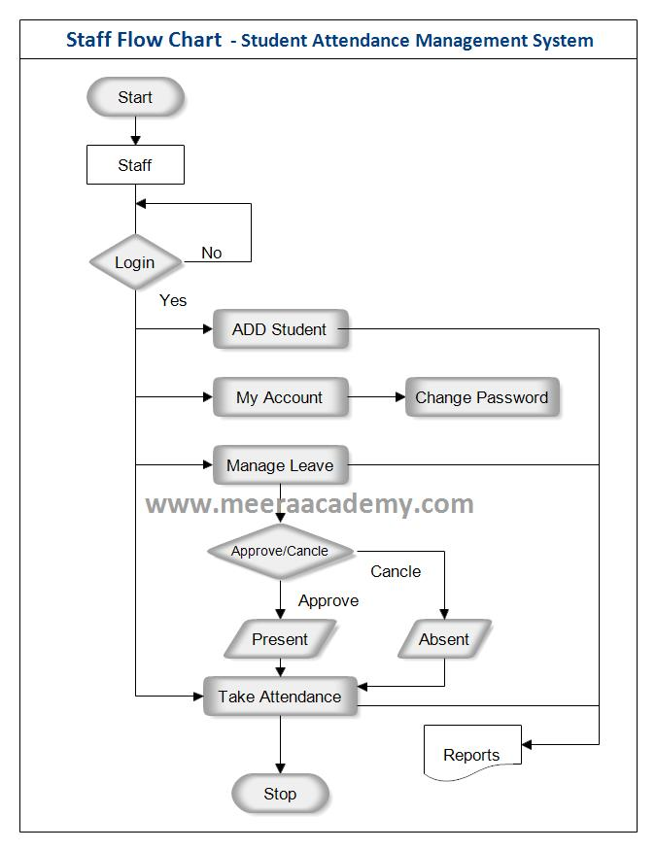

## IMPLEMENTATION

Sample code:

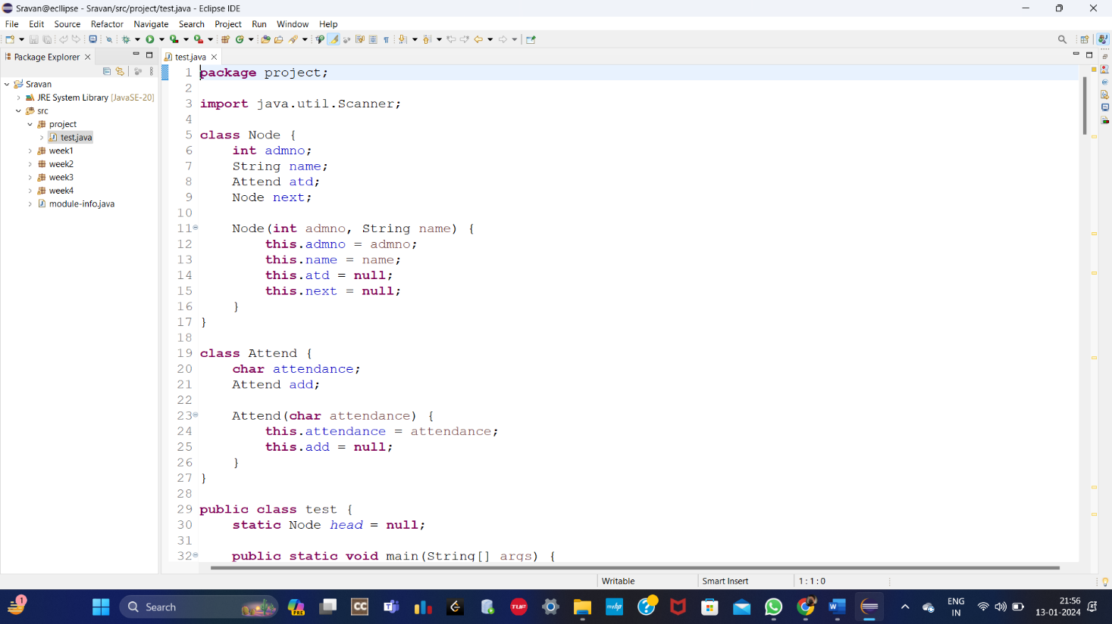

Fig:1. JAVA code

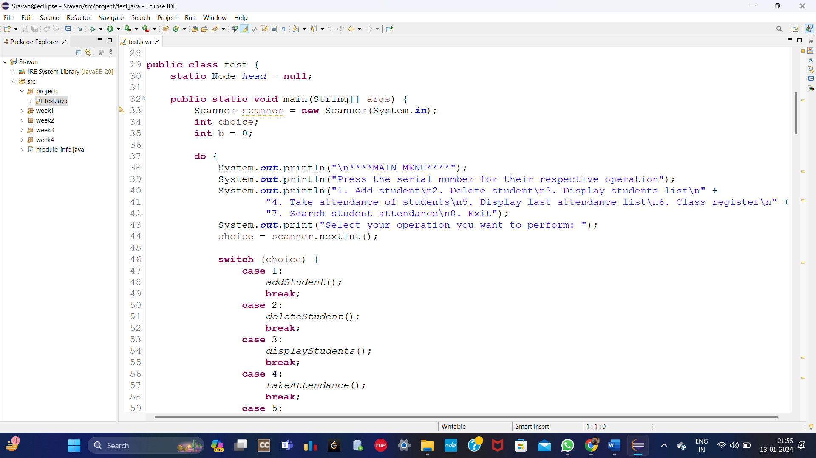

Fig:2. JAVA code

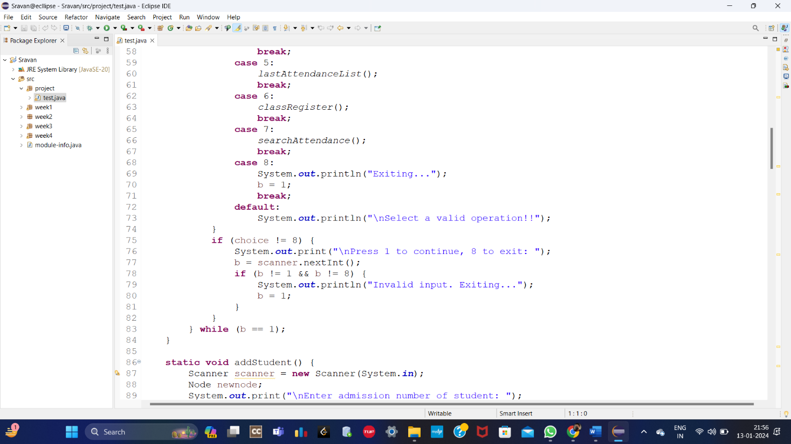

Fig:3. java code

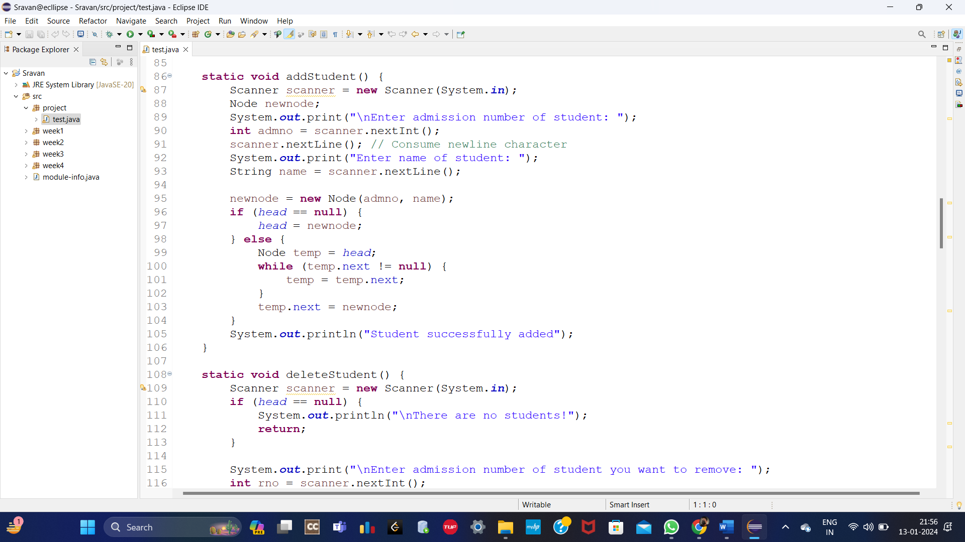

Fig:4. java code

## 

Fig:5. java code

## 

Fig:6. java code

## 

Fig:7. java code

## 

Fig:8. java code

## 

Fig:9. java code

## 7. RESULTS

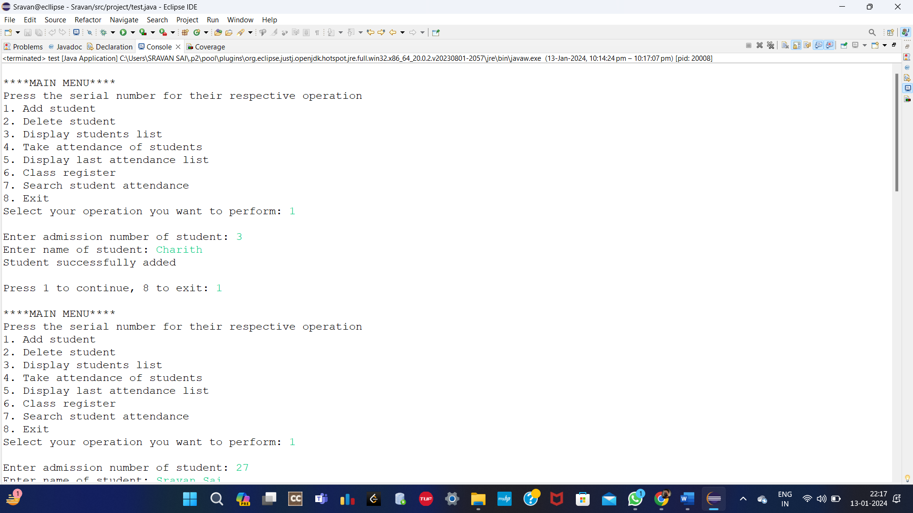

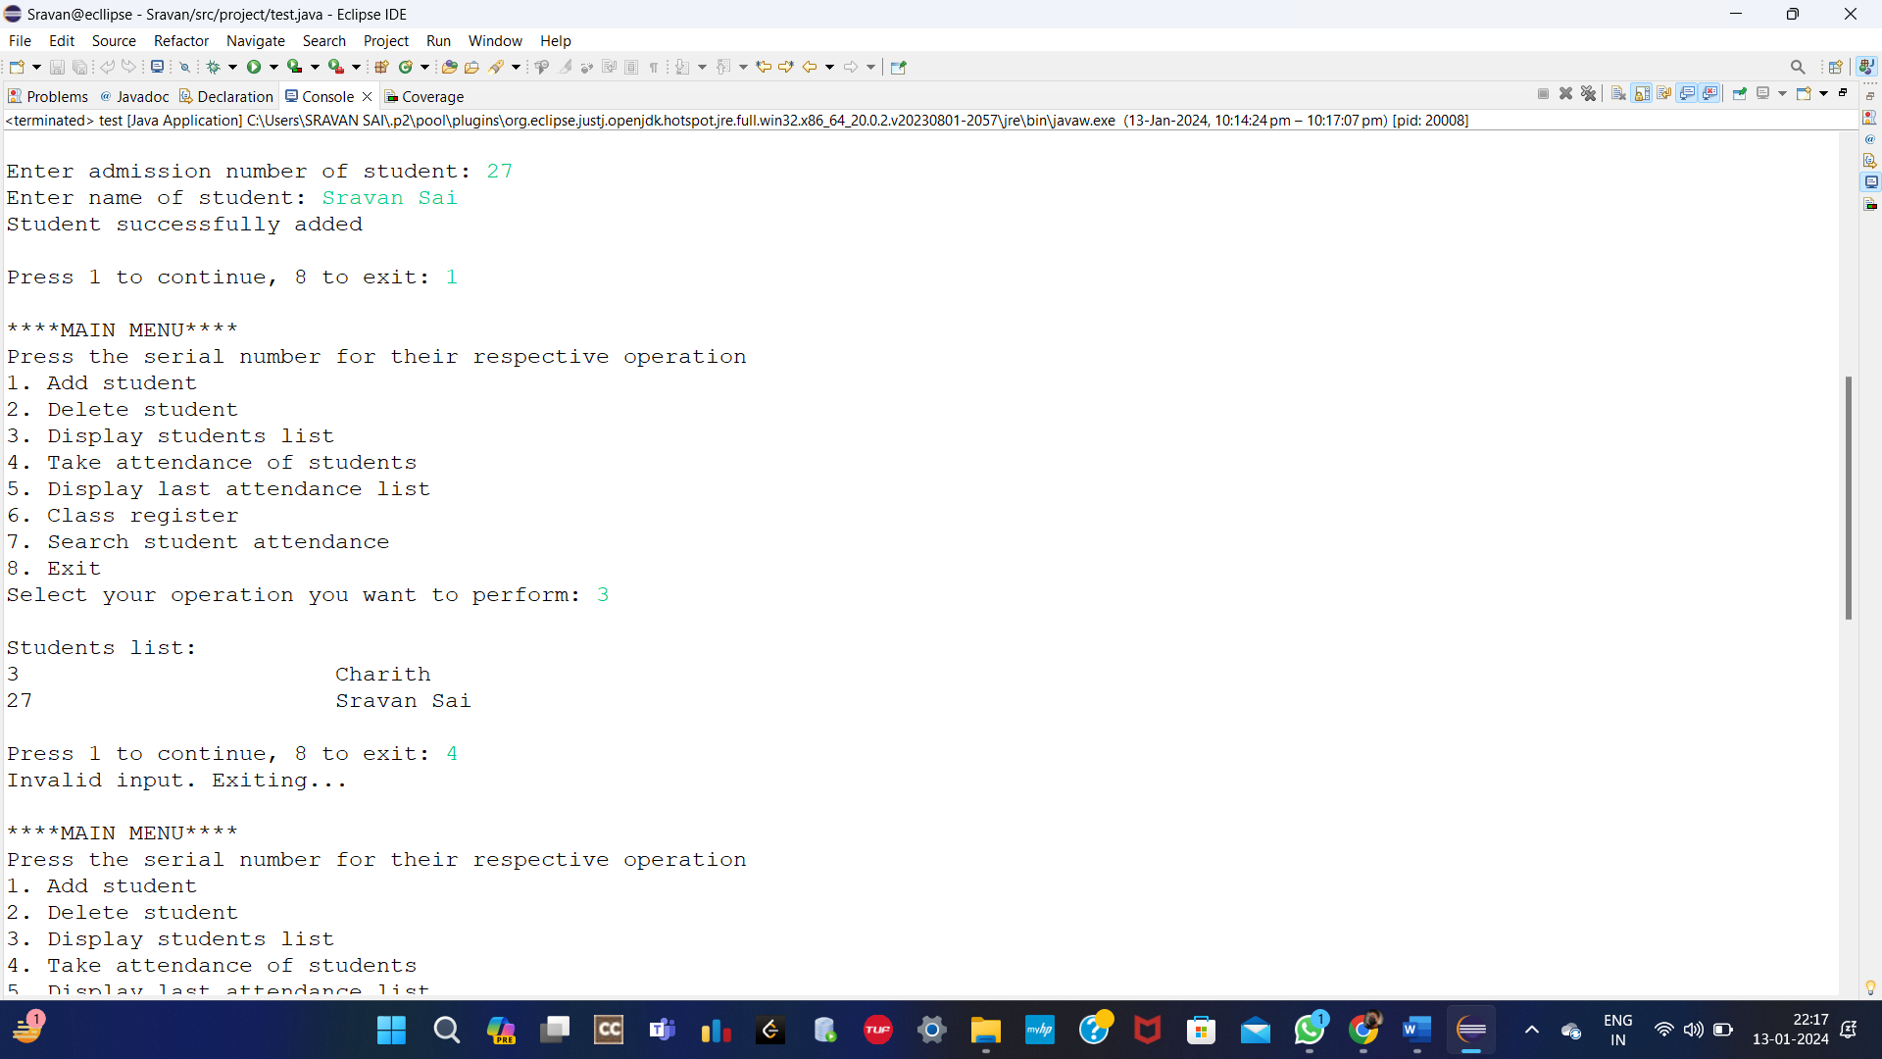

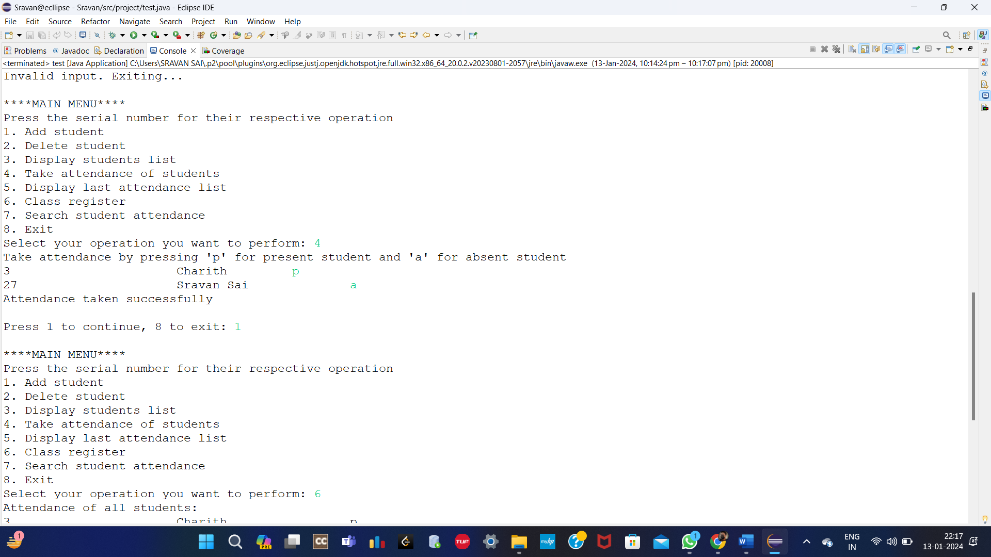

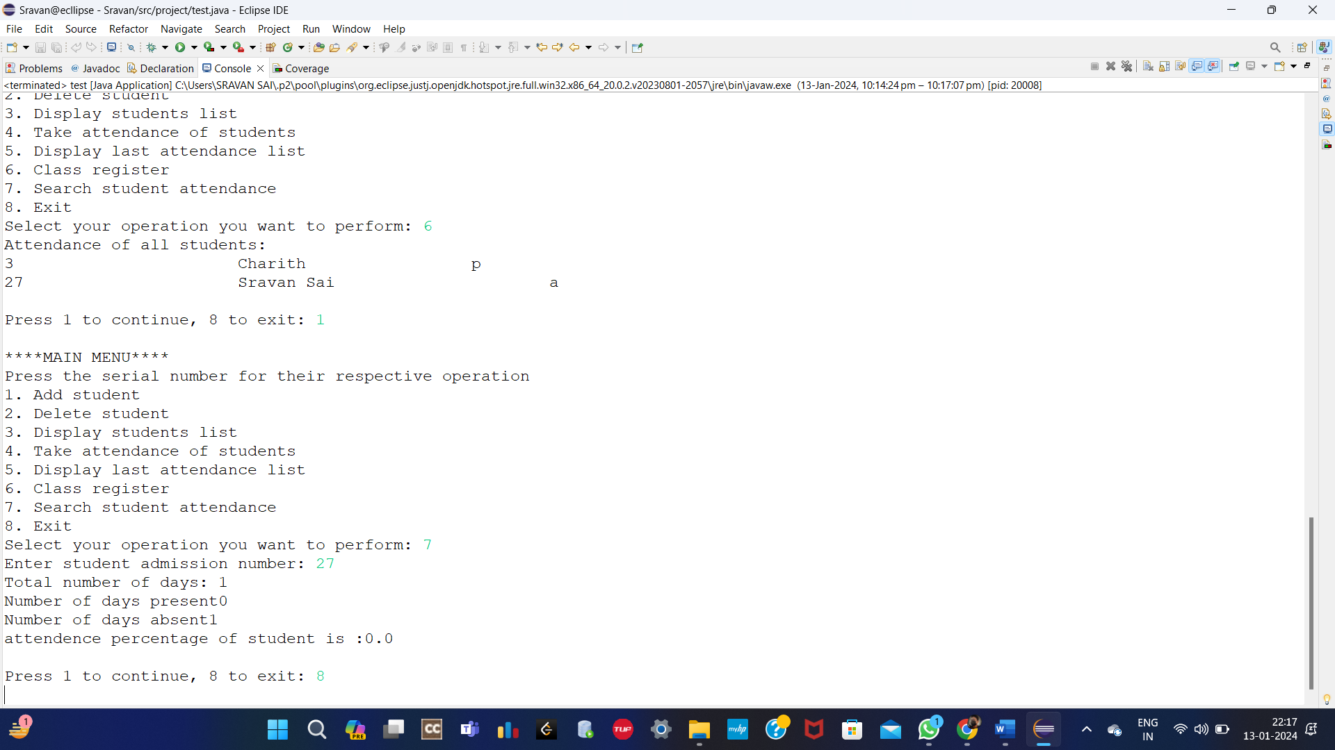

## CONCLUSION AND FUTURE ENHANCEMEMT

## 

8.1. CONCLUSION

In conclusion, a Student Attendance Management System (SAMS) emerges as a transformative tool in the educational landscape, addressing traditional challenges associated with manual attendance tracking. The merits of such a system are evident in its ability to streamline processes, enhance accuracy, and foster transparent communication among stakeholders. Real-time monitoring, comprehensive reporting, and analytics empower educators and administrators to make informed decisions, contributing to improved student engagement and academic outcomes.

The implementation of SAMS is not without its challenges. Initial hurdles may include resistance to change, technical glitches, and concerns related to privacy. Additionally, the dependence on technology introduces considerations for system reliability, network stability, and the ongoing cost of maintenance.

In essence, a judiciously implemented Student Attendance Management System, particularly one crafted with the capabilities of Java, offers a progressive and efficient solution for educational institutions. The continuous evolution of technology in education underscores the importance of embracing tools like SAMS to not only modernize administrative processes but also to contribute significantly to the overarching goals of fostering a conducive and effective learning environment. As institutions navigate the digital landscape, addressing challenges and maximizing the merits of a well-implemented SAMS is essential for realizing the full potential of automated attendance management in the educational sector.

8.2 FUTURE ENHANCEMENTS

This project is very flexible and efficient but however to make it even better we can enhance it by:

* Machine Learning for Predictive Analytics
* Facial Recognition Technology
* IoT Integration for Smart Classrooms
* Blockchain for Enhanced Security
* Biometric Authentication Enhancements

9. REFERENCES

1. Asoronye, Gaylord O., Goodluck I. Emereonye, and Ibiam A. Agha. "An Efficient Implementation for the Cryptanalysis of Caesar’s Cipher." The Melting Pot 5.2 (2019).

1. Ortzow, Kyle. "Original Code for Encrypting and Decrypting Caesar Ciphers." Available at SSRN 3694155 (2020)

1. Sravani, Jayanti. "A Study on some modified Classical Ciphers for Secure Crypto-System." Turkish Journal of Computer and Mathematics Education (TURCOMAT) 12.6 (2021): 5316-5319.

1. Z. Xie, M. Zhang, Y. Guo, Z. Li and H. Wang, "Modified Password Guessing Methods Based on TarGuess-I," Wireless Communications and Mobile Computing, pp. 1-2, 2020.

1. Das, R.; Tuithung, T., "A novel steganography method for image based on Huffman Encoding," Emerging Trends and Applications in Computer Science (NCETACS), 2012 3rd National Conference on , vol., no., pp.14,18, 30-31 March 2012