A CASE-STUDY BASED REPORT
ON
Network Intrusion Detection Using Random Forest and Deep Neural Networks
submitted in partial fulfilment of the requirements for the Course
MACHINE LEARNING
BACHELOR OF TECHNOLOGY
in
A.Y.: 2026-27
by
Name: Muvva Lohitha roll 2520030378
Name: Vedika Kulakarni roll 2520030350
Name: Charith Kanakamedala roll 2520030356
Under the Esteemed guidance of
Mr. G. Ravindra Babu
Assistant Professor, Dept. of CSE




INDEX
Abstract 3
Introduction 3
Background 3
Motivation for the Project 3
Overview of the Work Carried Out 4
Scope and Responsible-Use Statement 4
Problem Statement 4
Case-Study Scenario 4
Central Case-Study Question 5
Formal Problem Definition 5
Objectives that Guide the Study 5
Assumptions and Limitations 5
Dataset and Exploratory Data Analysis 6
About the Dataset 6
Purpose of EDA 7
Preparation Steps Actually Performed 7
EDA Exploration - Implementation 8
Summary of EDA Findings 10
Algorithm Selection and Implementation 11
Conclusion 16

Abstract
The Network Intrusion Detection Using Random Forest and Deep Neural Networks project develops a machine-learning-based system that classifies network connections as either normal or anomalous (intrusive). Network-traffic records are pre-processed, categorical attributes are encoded, numeric features are standardised, and two classifiers are trained and compared: a Random Forest, chosen for its reliable accuracy on tabular data with many features, and a Deep Neural Network (DNN), chosen for its ability to learn complex non-linear patterns.
Both models were trained on 20,153 connection records and evaluated on 5,039 unseen records drawn from the NSL-KDD training file (25,192 records, 41 features). On the held-out test set the Random Forest reached an accuracy of 99.80% (precision 99.67%, recall 99.96%, F1-score 0.9981), while the DNN reached 99.11% (precision 99.18%, recall 99.14%, F1-score 0.9916). Exploratory analysis shows that intrusions are characterised by half-open or rejected connection flags, high SYN-error rates, low service-consistency rates, and an absence of logged-in sessions, and the Random Forest feature importances confirm this. The study shows how an automated, risk-score-based approach can help security teams prioritise suspicious network activity, and discusses the limitations of drawing real-world conclusions from a single benchmark dataset.
Keywords: network intrusion detection, NSL-KDD, Random Forest, Deep Neural Network, anomaly detection, classification.

Introduction

Background
Modern computer networks are continuously exposed to threats such as denial-of-service (DoS) floods, port scanning and probing, unauthorised remote access, privilege escalation and malware communication. A Network Intrusion Detection System (NIDS) monitors network traffic and decides whether each connection is normal or potentially malicious. Traditional NIDS products rely largely on signature matching and hand-written rules, which work well for known attacks but struggle with new, modified or slowly evolving attack patterns.
Machine learning offers an alternative: instead of writing rules by hand, a model learns the statistical difference between normal and malicious behaviour from labelled examples. Each network connection can be described by a vector of measurable attributes, such as the protocol used, the number of bytes sent in each direction, how many connections were made to the same host in a short window, and what fraction of them ended in errors. A classifier trained on such vectors can then score new connections automatically and at scale.

Motivation for the Project
- Volume of traffic. A security team cannot manually inspect every connection; an automated model can score all of them and surface only the most suspicious.
- Evolving attacks. Learned models can generalise to variations of known attacks that fixed signatures miss.
- Choosing the right model. Ensemble tree methods and deep neural networks are both popular for intrusion detection, but it is not obvious which gives the better balance of accuracy, false alarms and interpretability. Comparing them on identical data, with an identical split and identical metrics, gives a fair answer.
- Cost of errors. In security, a missed attack (false negative) and a false alarm (false positive) have very different costs, so a model must be judged on precision and recall rather than accuracy alone.

Overview of the Work Carried Out
The work followed a standard supervised-learning pipeline, implemented in Python in a Jupyter/Google Colab notebook:
- Loaded the NSL-KDD training file (Train_data.csv) and inspected its structure, data types and missing values.
- Performed exploratory data analysis: class balance, protocol-wise behaviour, byte-count distributions and a feature correlation heat map.
- Pre-processed the data: label-encoded the categorical features (protocol_type, service, flag) and the target, made a stratified 80/20 train-test split and standardised the features.
- Trained a Random Forest classifier (200 trees) and a feed-forward Deep Neural Network (128-64-32-1 with dropout and early stopping).
- Evaluated both models using accuracy, precision, recall, F1-score, ROC-AUC, confusion matrices and ROC curves.
- Extracted Random Forest feature importances and produced per-connection risk scores to show how the model output could be used by an analyst.

Scope and Responsible-Use Statement
The scope of this case study is binary classification (normal versus anomaly) of connection-level records from a public benchmark dataset, carried out offline for academic purposes in the Machine Learning course. The records contain only aggregate connection statistics; they do not contain packet payloads, IP addresses or any personal information.
The models and results described here are a learning exercise and should not be deployed as the sole line of defence on a real network. Any real deployment would require training on current, locally representative traffic, monitoring for model drift, human review of alerts, and authorisation from the network owner. Intrusion-detection techniques must be used only to protect systems that the user is permitted to monitor, and never to surveil individuals.

Problem Statement

Case-Study Scenario
Consider the security operations team of a mid-sized university campus network. Every day the perimeter sensors log tens of thousands of connection records describing students, staff, servers and automated services. Hidden among these records are port scans, SYN floods, failed-login attempts and other hostile activity. The team has only a few analysts, so reviewing each connection by hand is impossible, and static rules generate either too many false alarms or too many misses. (This scenario is illustrative; the NSL-KDD dataset is used as the stand-in for the campus traffic.)
The team therefore asks for an automated classifier that reads each connection record, labels it normal or anomalous, and attaches a risk score so that analysts can start with the most dangerous connections first.

Central Case-Study Question
Can a Random Forest and a Deep Neural Network, trained only on connection-level features, reliably separate normal network connections from intrusions, and which of the two offers the better trade-off between detection rate (recall), false alarms (precision) and interpretability?

Formal Problem Definition
Let D = {(x_i, y_i)}, i = 1…N, be a labelled dataset of N = 25,192 network connections. Each x_i is a 41-dimensional feature vector (after encoding categorical attributes) and y_i ∈ {0, 1}, where 0 denotes a normal connection and 1 denotes an anomaly (intrusion). The task is to learn a function f: R^41 → [0, 1] that outputs the probability that a connection is an intrusion, and to classify the connection as an intrusion when f(x) ≥ 0.5. The function is learned from a training subset and judged on a disjoint test subset using accuracy, precision, recall, F1-score and ROC-AUC, with the anomaly class treated as the positive class. Two hypotheses f_RF (Random Forest) and f_DNN (Deep Neural Network) are learned and compared.

Objectives that Guide the Study
- To understand the structure and quality of the NSL-KDD data and identify which features differ most between normal and anomalous traffic.
- To build a clean, leakage-free pre-processing pipeline (encoding, stratified split, scaling fitted on training data only).
- To implement and train a Random Forest classifier and a Deep Neural Network for intrusion detection.
- To compare the models using accuracy, precision, recall, F1-score, ROC-AUC, confusion matrices and ROC curves.
- To identify the most influential features and relate them back to known attack behaviour.
- To demonstrate how model probabilities can be turned into a ranked list of suspicious connections for security analysts.

Assumptions and Limitations
Assumptions
- The labels (normal / anomaly) supplied with the dataset are correct.
- The records are independent and the random 80/20 split gives a test set that is statistically similar to the training set.
- Label-encoded categorical features are acceptable inputs for both models.
Limitations
- NSL-KDD is an older benchmark derived from 1990s-era traffic; modern attacks and encrypted traffic differ, so scores on this data are optimistic compared with live networks.
- The task is binary; the file used does not provide attack-type labels (DoS, Probe, R2L, U2R), so the study cannot report per-attack-family performance.
- Evaluation uses a single random split with one random seed (42); no cross-validation or extensive hyper-parameter search was performed.
- Label encoding imposes an arbitrary numeric order on nominal features such as service and flag. This is harmless for tree models but is a less natural input for the neural network; one-hot or embedding layers could improve it.
- Two columns (num_outbound_cmds and is_host_login) are constant in this file and carry no information; they were left in place for simplicity.

Dataset and Exploratory Data Analysis

About the Dataset
The dataset used is Train_data.csv, the NSL-KDD network-intrusion data (an improved version of the KDD Cup 1999 data, introduced by Tavallaee et al., 2009, with redundant records removed). The file contains 25,192 connection records. Each record has 41 input features and one label column, class, whose value is either normal or anomaly. The 41 features fall into four groups, summarised in Table 1.
Table 1: Feature groups in the dataset
Group | Count | Features
Basic connection features | 9 | duration, protocol_type, service, flag, src_bytes, dst_bytes, land, wrong_fragment, urgent
Content features | 13 | hot, num_failed_logins, logged_in, num_compromised, root_shell, su_attempted, num_root, num_file_creations, num_shells, num_access_files, num_outbound_cmds, is_host_login, is_guest_login
Time-based traffic features | 9 | count, srv_count, serror_rate, srv_serror_rate, rerror_rate, srv_rerror_rate, same_srv_rate, diff_srv_rate, srv_diff_host_rate
Host-based traffic features | 10 | dst_host_count, dst_host_srv_count, dst_host_same_srv_rate, dst_host_diff_srv_rate, dst_host_same_src_port_rate, dst_host_srv_diff_host_rate, dst_host_serror_rate, dst_host_srv_serror_rate, dst_host_rerror_rate, dst_host_srv_rerror_rate

Key facts about the data, as verified in the notebook, are given in Table 2.
Table 2: Dataset overview
Property | Value
Total records | 25,192
Columns | 42 (41 features + 1 label)
Column types | 23 integer, 15 float, 4 text (protocol_type, service, flag, class)
Missing values | 0
Duplicate rows | 0
Constant columns | 2 (num_outbound_cmds, is_host_login)
Categorical cardinality | 3 protocols, 66 services, 11 flags
Class: normal | 13,449 records (53.39%)
Class: anomaly | 11,743 records (46.61%)

Purpose of EDA
Exploratory Data Analysis (EDA) is carried out before modelling to check the data for quality problems, understand how the classes are distributed, and discover which features separate normal traffic from intrusions. It guides pre-processing choices (for example, whether the classes are balanced enough to avoid special handling, and whether heavily skewed features need scaling) and gives a baseline understanding against which the model results can later be sanity-checked.

Preparation Steps Actually Performed
- Loading and inspection. The CSV was read with pandas (shape 25,192 × 42) and df.info() confirmed the column types.
- Missing values. df.isnull().sum().sum() returned 0, so no imputation was needed. No duplicate rows were found.
- Encoding categorical features. protocol_type, service and flag were converted to integers with LabelEncoder.
- Encoding the target. class was encoded as normal = 0 and anomaly = 1.
- Feature/target split. X holds the 41 feature columns and y holds the label.
- Stratified train-test split. An 80/20 split (random_state = 42, stratify = y) produced 20,153 training and 5,039 test records with the same class ratio in both.
- Feature scaling. StandardScaler was fitted on the training set only and then applied to the test set, which prevents information from the test data leaking into training.
categorical_cols = ['protocol_type', 'service', 'flag']
for col in categorical_cols:
data[col] = LabelEncoder().fit_transform(data[col])
data['class'] = LabelEncoder().fit_transform(data['class']) # normal=0, anomaly=1

X_train, X_test, y_train, y_test = train_test_split(
X, y, test_size=0.2, random_state=42, stratify=y)
scaler = StandardScaler()
X_train_scaled = scaler.fit_transform(X_train) # fit on train only
X_test_scaled = scaler.transform(X_test)

EDA Exploration - Implementation
Four visual analyses were produced with Matplotlib and Seaborn.
1. Class distribution
sns.countplot(x='class', data=df, palette=['#2E86AB', '#E63946'])
print(df['class'].value_counts(normalize=True) * 100)
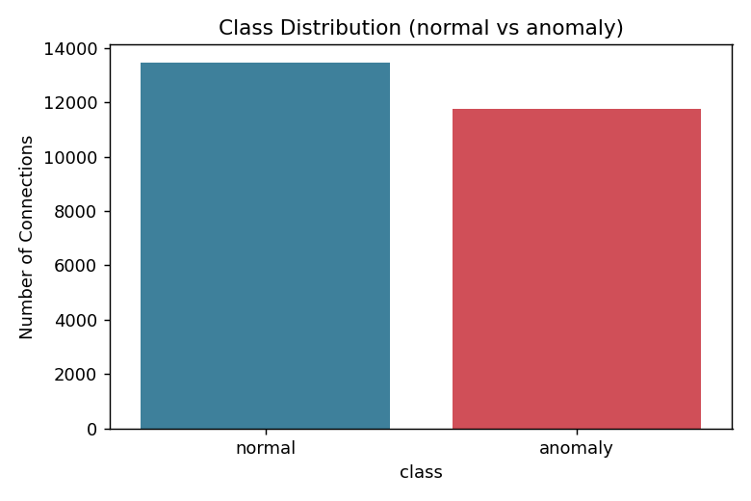
Figure 1: Class distribution (normal vs anomaly)
The classes are almost balanced: 53.39% normal and 46.61% anomaly. Because neither class dominates, plain accuracy is a meaningful metric here and no resampling or class weighting is needed.
2. Class count by protocol type
sns.countplot(x='protocol_type', hue='class', data=df)
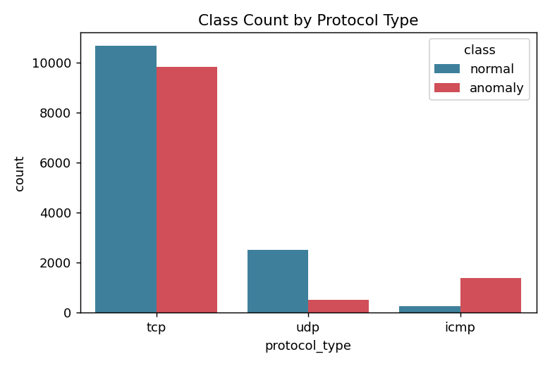
Figure 2: Class count by protocol type
TCP carries most of the traffic (20,526 records), with a near-even split between normal (10,681) and anomaly (9,845). ICMP is dominated by attacks: 1,394 of 1,655 ICMP records (84.2%) are anomalies, consistent with ping-sweep and ICMP-flood behaviour. UDP is mostly normal (2,507 of 3,011, or 83.3%).
3. Source-bytes distribution
sns.histplot(data=df, x='src_bytes', hue='class', bins=30, log_scale=(True, False))
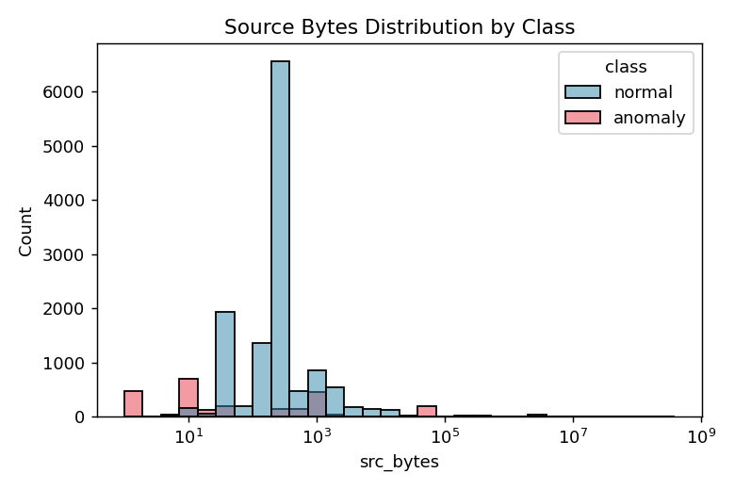
Figure 3: Source bytes distribution by class (log scale)
src_bytes is extremely right-skewed (hence the log axis). The median is 0 bytes for anomalies and 234 bytes for normal connections: many attack connections (for example SYN floods and scans) never send any data. The mean for anomalies (about 39,146) is nevertheless larger than for normal traffic (about 11,394) because a few attacks transfer very large volumes. This skew is why the features are standardised before modelling.
4. Correlation heat map
corr = df.select_dtypes(include=np.number).corr()
sns.heatmap(corr, cmap='coolwarm', xticklabels=False, yticklabels=False)
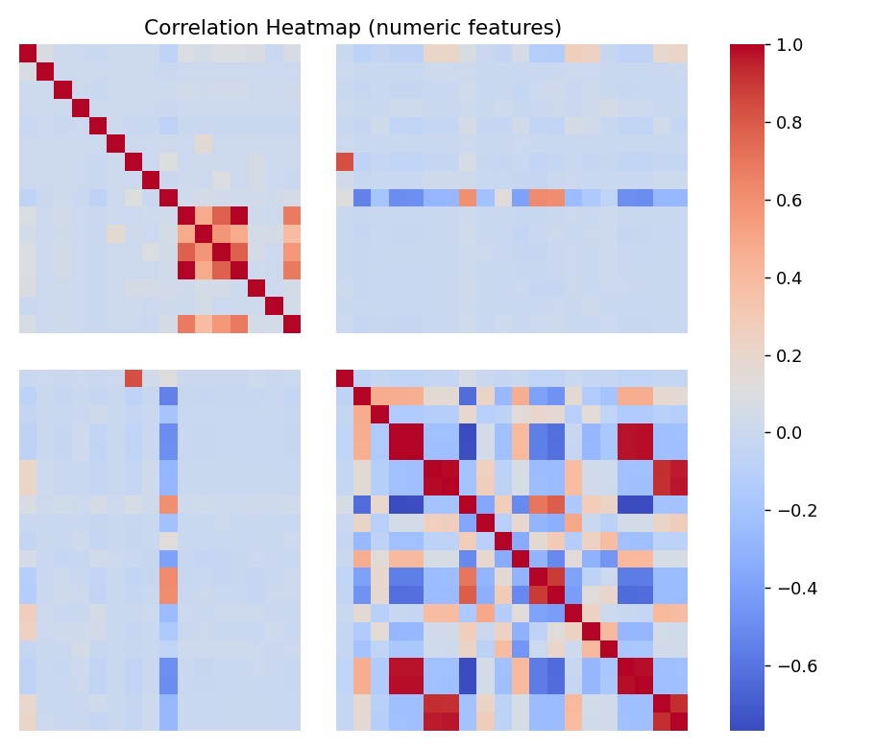
Figure 4: Correlation heat map of the numeric features
The heat map shows clear blocks of strongly correlated features, mainly the pairs and groups of error-rate features (serror_rate, srv_serror_rate, dst_host_serror_rate, dst_host_srv_serror_rate and the rerror counterparts) and the service-rate features. Such redundancy does not harm a Random Forest and is tolerated by the DNN, but it indicates that dimensionality reduction or feature selection could be explored in future work.

Summary of EDA Findings
Table 3 compares the average behaviour of normal and anomalous connections for the most telling features.
Table 3: Feature behaviour by class
Feature | Normal | Anomaly | Interpretation
src_bytes (median) | 234 | 0 | Attacks often send no data
serror_rate (mean) | 0.015 | 0.597 | Attacks cause many SYN errors (half-open connections)
same_srv_rate (mean) | 0.968 | 0.308 | Attacks touch many different services (scanning)
logged_in (mean) | 0.709 | 0.035 | Attacks rarely complete a login
count (mean) | 22.6 | 155.6 | Attacks make many connections in a short window
flag = S0 | 80 records | 6,929 records | S0 = SYN sent, no reply: 59% of all anomalies
flag = SF | 12,663 records | 2,310 records | SF = normal completion: 94% of normal traffic

- The data is clean (no missing values or duplicates) and the classes are nearly balanced.
- Intrusions are strongly characterised by abnormal connection flags (S0, REJ, RSTR), high SYN-error rates, high connection counts, low service consistency, zero payload and no logged-in session.
- ICMP traffic is highly suspicious in this dataset, while UDP is mostly benign.
- Several numeric features are heavily skewed, which justifies standardisation, and groups of features are highly correlated.
- Because the classes differ so clearly on several simple features, strong model performance is expected; the experiment tests how well each algorithm exploits these differences.

Algorithm Selection and Implementation

Why These Two Algorithms
Intrusion detection from connection records is a supervised binary-classification problem on mixed numeric and categorical tabular data with 41 features. Two algorithm families were selected to represent a classical and a deep-learning approach:
- Random Forest is an ensemble of many decision trees, each trained on a random sample of the records and a random subset of the features, whose votes are averaged. It handles many features, skewed values and non-linear interactions without much tuning, resists over-fitting, trains quickly, and provides feature importances that explain which traffic attributes drive its decisions.
- Deep Neural Network (DNN) is a fully connected feed-forward network that learns hierarchical non-linear combinations of the inputs. It can capture subtle feature interactions that tree splits may miss, at the cost of more tuning, a need for scaled inputs, and weaker interpretability.

Random Forest Implementation
Table 4: Random Forest configuration
Parameter | Value
n_estimators | 200 trees
Split criterion | Gini impurity (default)
max_depth | None (trees grown fully)
Input | Standardised 41-feature vectors
random_state | 42
n_jobs | -1 (all CPU cores)

rf = RandomForestClassifier(n_estimators=200, random_state=42, n_jobs=-1)
rf.fit(X_train_scaled, y_train)

rf_pred = rf.predict(X_test_scaled)
rf_proba = rf.predict_proba(X_test_scaled)[:, 1] # risk score 0-1

Deep Neural Network Implementation
The DNN has an input layer of 41 features, three hidden layers of 128, 64 and 32 ReLU units, and a single sigmoid output unit that gives the probability of an intrusion. Dropout (30%) after the first two hidden layers reduces over-fitting. The network has 15,745 trainable parameters. It is trained with the Adam optimiser and binary cross-entropy loss; 20% of the training data is held out for validation and EarlyStopping (patience = 5, restore_best_weights = True) halts training when the validation loss stops improving.
Table 5: DNN architecture
Layer | Output size | Activation | Parameters
Input | 41 | - | 0
Dense 1 | 128 | ReLU | 5,376
Dropout (0.3) | 128 | - | 0
Dense 2 | 64 | ReLU | 8,256
Dropout (0.3) | 64 | - | 0
Dense 3 | 32 | ReLU | 2,080
Output Dense | 1 | Sigmoid | 33
Total |  |  | 15,745

dnn = Sequential([
Dense(128, activation='relu', input_shape=(n_features,)), Dropout(0.3),
Dense(64, activation='relu'), Dropout(0.3),
Dense(32, activation='relu'),
Dense(1, activation='sigmoid')])
dnn.compile(optimizer='adam', loss='binary_crossentropy', metrics=['accuracy'])
early_stop = EarlyStopping(monitor='val_loss', patience=5, restore_best_weights=True)
history = dnn.fit(X_train_scaled, y_train, validation_split=0.2,
epochs=50, batch_size=64, callbacks=[early_stop])
Training ran for 13 epochs of a possible 50 before early stopping triggered, and the weights from epoch 8, where the validation loss was lowest, were restored. Figure 5 shows that training and validation accuracy rise together and level off near 99%, with no sign of serious over-fitting.
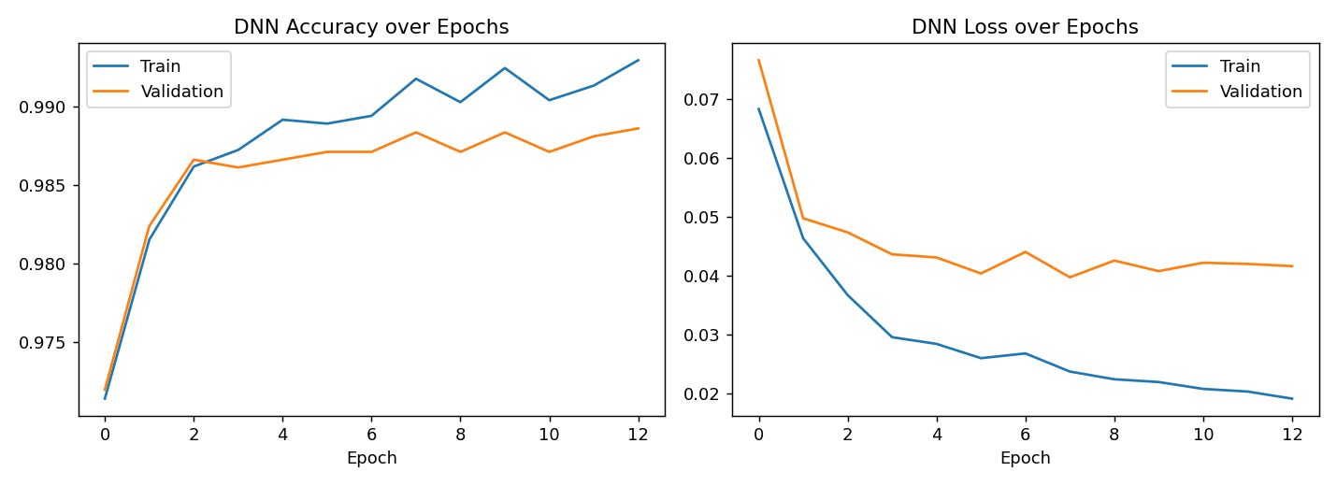
Figure 5: DNN accuracy and loss over epochs

Model Evaluation
The anomaly class is treated as the positive class. Precision is the share of connections flagged as intrusions that really were intrusions (it falls when there are false alarms); recall is the share of real intrusions that were caught (it falls when attacks are missed); F1-score is their harmonic mean; and ROC-AUC measures how well the risk score ranks intrusions above normal connections across all thresholds. Results on the 5,039 unseen test records are given in Table 6 and Figure 6.
Table 6: Test-set performance of both models
Model | Accuracy | Precision | Recall | F1-score | ROC-AUC
Random Forest | 0.9980 | 0.9967 | 0.9996 | 0.9981 | ≈ 1.0000
Deep Neural Network | 0.9911 | 0.9918 | 0.9914 | 0.9916 | 0.9996

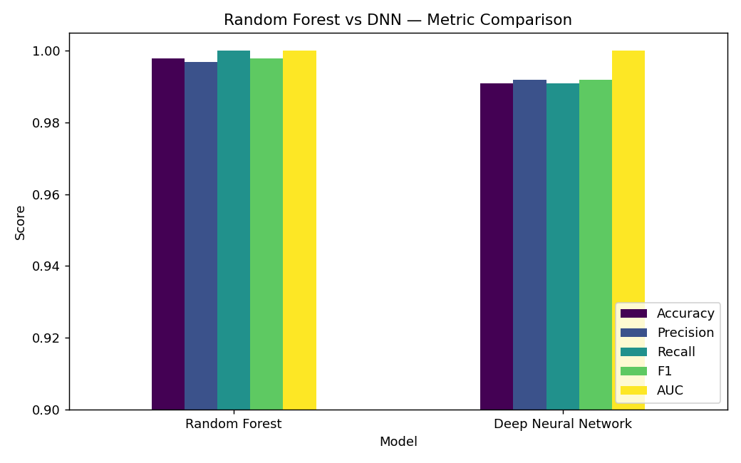
Figure 6: Random Forest vs DNN metric comparison (y-axis starts at 0.90)
Confusion matrices
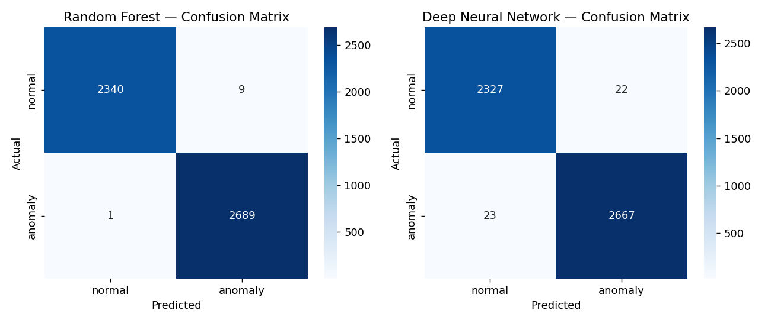
Figure 7: Confusion matrices (rows = actual, columns = predicted)
Table 7: Confusion-matrix counts on the 5,039 test records
Model | True normal (TN) | False alarm (FP) | Missed attack (FN) | True anomaly (TP)
Random Forest | 2340 | 9 | 1 | 2689
Deep Neural Network | 2327 | 22 | 23 | 2667

The Random Forest made only 10 errors in 5,039 records: 9 false alarms and 1 missed attack. The DNN made 45 errors (22 false alarms and 23 missed attacks). The RF is therefore better on both error types, and its recall of 99.96% is especially valuable in security, where a missed attack is the costlier mistake.
ROC curves
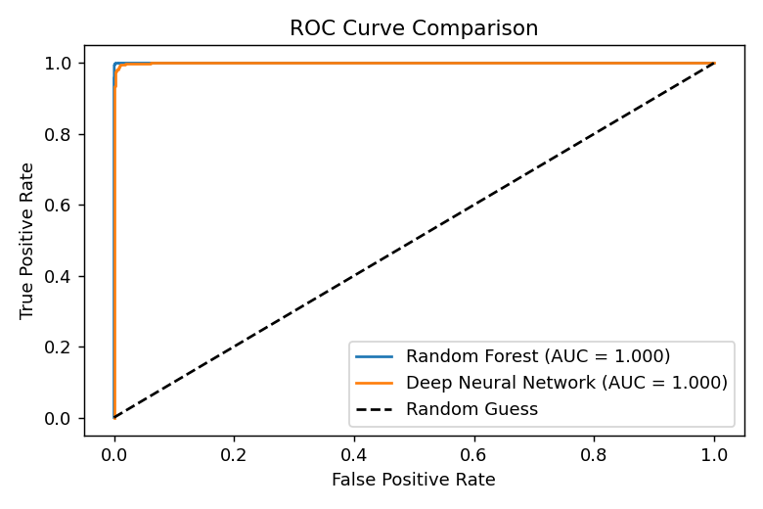
Figure 8: ROC curve comparison
Both curves hug the top-left corner, far above the random-guess diagonal. The Random Forest ranks intrusions above normal connections almost perfectly (AUC ≈ 1.000) and the DNN is very close (AUC = 0.9996).
Per-class classification report
Table 8: Classification report by class
Model | Class | Precision | Recall | F1-score | Support
Random Forest | normal | 0.9996 | 0.9962 | 0.9979 | 2349
Random Forest | anomaly | 0.9967 | 0.9996 | 0.9981 | 2690
Deep Neural Network | normal | 0.9902 | 0.9906 | 0.9904 | 2349
Deep Neural Network | anomaly | 0.9918 | 0.9914 | 0.9916 | 2690

Feature Importance
The Random Forest exposes which features it relied on most. The DNN has no equivalent native measure because it learns distributed combinations of inputs.
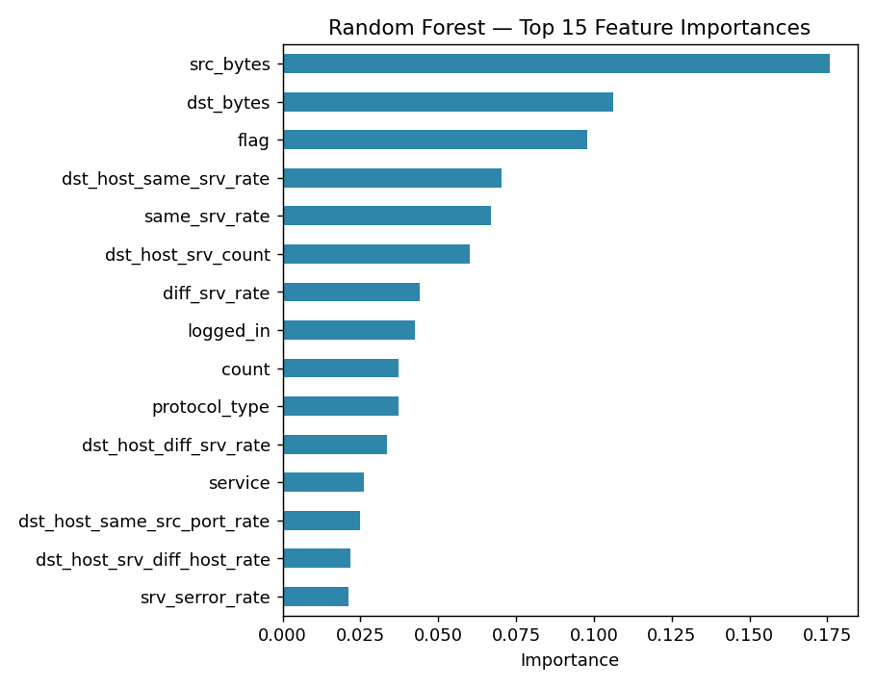
Figure 9: Random Forest top 15 feature importances
Table 9: Ten most important features (Random Forest)
Rank | Feature | Importance
1 | src_bytes | 0.1758
2 | dst_bytes | 0.1063
3 | flag | 0.0979
4 | dst_host_same_srv_rate | 0.0705
5 | same_srv_rate | 0.0668
6 | dst_host_srv_count | 0.0602
7 | diff_srv_rate | 0.0441
8 | logged_in | 0.0424
9 | count | 0.0372
10 | protocol_type | 0.0372

The top features, src_bytes, dst_bytes, flag, the same-service rates and logged_in, are exactly those that the EDA showed to differ between the classes. This agreement between the exploratory findings and the trained model gives confidence that the model is using sensible traffic characteristics rather than artefacts.

From Predictions to a Ranked Risk List
Using predict_proba(), every test connection receives a risk score between 0 (certainly normal) and 1 (certainly intrusion). Sorting by this score gives analysts a prioritised work list. Of the 2,698 connections that the Random Forest flagged as intrusions (risk score ≥ 0.5), 2,689 were genuine anomalies (a hit rate of 99.67%), so almost every alert would be worth an analyst’s time. The two models also agreed on 99.23% of all test connections, so records on which they disagree form a small, natural set for closer human review.
risk_table['RF_Risk_Score'] = rf_proba
risk_table['DNN_Risk_Score'] = dnn_proba
flagged = risk_table[risk_table['RF_Risk_Score'] >= 0.5].sort_values('RF_Risk_Score', ascending=False)

Discussion
- Random Forest was the stronger model on every metric: higher accuracy, precision, recall and F1, and fewer errors. For tabular data with mixed, skewed and label-encoded features, tree ensembles are well suited because they split on thresholds and are insensitive to the arbitrary numeric order given to categories.
- The DNN was competitive (99.11% accuracy) despite having less tuning, and it was balanced between its two error types. Better encoding (one-hot or embeddings), tuning of depth and learning rate, and longer regularised training could narrow the gap.
- Interpretability favours the Random Forest. Its importances can be explained to a security team and checked against domain knowledge.
- Caution on near-perfect scores. Such high scores partly reflect how cleanly NSL-KDD separates into classes and the fact that the test set comes from the same random split as the training set. Real-world performance on new traffic, new attack types and encrypted flows would almost certainly be lower, and should be tested on separate data such as the NSL-KDD test file, UNSW-NB15 or CICIDS2017.

Conclusion
This case study built and compared two machine-learning intrusion detectors, a Random Forest and a Deep Neural Network, on 25,192 NSL-KDD connection records. After checking data quality (no missing values or duplicates), exploring the data, encoding categorical attributes, making a stratified 80/20 split and scaling the features, both models were evaluated on 5,039 unseen records.
The answer to the central question is yes: both models separate normal traffic from intrusions reliably. The Random Forest achieved 99.80% accuracy with 99.96% recall (only one missed attack) and 99.67% precision, while the DNN achieved 99.11% accuracy with 99.14% recall and 99.18% precision. On this dataset the Random Forest offers the better trade-off between detection rate, false alarms and interpretability, and its feature importances (src_bytes, dst_bytes, flag, service-rate features) agree with the patterns found in the exploratory analysis: intrusions tend to be half-open or rejected connections with many requests, little or no data and no login.
The risk-score output shows how the system could support a real security team by ranking connections for investigation instead of producing only a yes/no label. The results must be interpreted with care because of the age of the dataset and the single train-test split.
Future work
- Evaluate on the separate NSL-KDD test file and on newer datasets (UNSW-NB15, CICIDS2017) to measure generalisation to unseen attacks.
- Extend the task to multi-class classification of attack families (DoS, Probe, R2L, U2R).
- Use k-fold cross-validation and hyper-parameter search; try one-hot encoding or embeddings for service and flag.
- Tune the decision threshold to match the security team’s tolerance for false alarms versus misses, and add explainability tools such as SHAP.
- Explore gradient-boosted trees and autoencoder-based anomaly detection, and a streaming deployment with drift monitoring.
Reference. M. Tavallaee, E. Bagheri, W. Lu and A. A. Ghorbani, “A detailed analysis of the KDD CUP 99 data set,” IEEE Symposium on Computational Intelligence for Security and Defense Applications (CISDA), 2009.
Signature of the Team members
______________________
Muvva Lohitha (2520030378)
______________________
Vedika Kulakarni (2520030350)
______________________
Charith Kanakamedala (2520030356)

