**Big Data Applications and its Analytics**

Student’s Name’s

Charitha Kammari

UCID: ck369

Ratna Deepika Cheedarla

UCID: rc645

Varunkumar Nachu

UCID:vn293

Institution Affiliate

**New Jersey Institute Of Technology**

Course Name

Introduction of Big Data

Instructors Name

Yajuan Li

**Abstract**

The Big Data term is a controversial topic that many writers and authors have been part of the argument depending on the application that is used in defining and differentiating the data and its analysis. This term has been authored preferably been an extensive data heave that would not have been handled through the traditional method of data handling or techniques. The big data field has been able to play an indispensable role in different fields where agriculture, data mining, education, finance and marketing. Analytics of Big data is a method where one would be able to look at the data and find a hidden pattern, relationship within the data and other data with importance in trying to enhance decision in relation to the data. With continued interest that is expanding due to the technological developments and many fields trying to use data increasing the data continuity and usage.

The open-source Apache Hadoop technology was developed in Java and is operated on a Linux operating foundation. This exploration's main goal is to demonstrate a practical, cost-free big data application solution in a distributed setting, along with its benefits and usage guidelines. Later on, it became necessary to conduct an analytical examination of fresh advancements in big data technologies. Among the world's most important problems is healthcare. Big data in healthcare refers to electronic health data collections that are linked to the well-being and treatment of patients. Data in the healthcare sector is expected to grow significantly over the next several years, beyond the managing capacity of healthcare associations.

**Big Data Applications and its Analytics**

**Introduction**

The term "Big Data" has lately become popular to describe a new paradigm for data exploitation. In the world of information technology, these new innovations frequently make their debut and receive a lot of media attention; yet, it may take some time to notice their unique selling feature. Volume (too vast), velocity (rapid arrival), unpredictability (quick changes), veracity (much turmoil), and variety (diversity) are only a few of the unique characteristics of big data, or BD. This Big Data is handled in constrained reckoning structures using conventional theories and practices. The diverse display styles seen in even the BD-supporting technologies eventually make it difficult to encourage the development of tools and applications that help incorporate data from many sources.

Large and diverse datasets share several distinct and significant characteristics that are similar to "Big Data." It is difficult to manage big datasets using the conventional frameworks for information preparation. Additionally, the "Big Data" highlights a number of uphill issues related to data storage, data movement, data visualization, data penetration, analysis of data, information protection, privacy of data breaches, and sharing. It is reasonable to consider the Big Data as a way to possibly grasp more knowledge sets, highlighting the limitations of habitual data structures. The Big Data model appears when data compute is either in motion or in take it easy mode; it compels data management to become a key component of the system engineering architecture. The Big Data Model essentially signifies a paradigm change in data infrastructures, moving away from large, perpendicularly mounted systems and toward parallel systems that combine to form an infinitely linked network of reserves. This shift from parallel-to-parallel causes a number of distinct issues in a number of different domains, including information delivery, information orchestrating, inactivity in maintaining consistency across diagrams, stack stabilization, and, on the one hand, process flaws and their interdependencies.

Conversely, the big information model incorporates the same shift but makes use of new devices to give the advances in data management. This action is being taken to align information scaling and negotiate codes and information across loosely connected assets. Analyzing vast volumes of data is one way to store and retrieve information in addition to producing new understanding about it. The assay was typically obtained on an uncontrolled portion of information in the past.

The term "Big Data" is used in a variety of circumstances and has a variety of characteristics. We must extend our understanding of the word to a certain degree in order to understand where ideology will support the big data model in an effective manner. "Big Data" refers to a collection of data with exceptional quality that, for a given problem domain, cannot be expertly handled using current/available/perceived/routine advancements and strategies with the specific goal of concentrating value at any given moment.

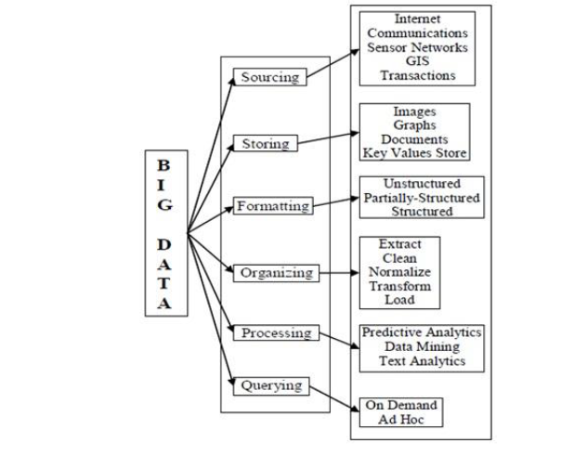

**Data Analytics**

Massive data sets with a variety of information types may be analyzed using the big data analytics technique. For instance, massive data sets can be used to uncover hidden relationships, advertising drift, customer preferences, and other useful business information. These measurable results might lead to effective marketing, additional revenue opportunities, more customer satisfaction, improved operational proficiency, an advantage over competing associations, and different business repayment. Big Data has become a central subject in many endeavors, research projects, educational initiatives, and society at large. This is due to the fact that the ability to produce, compile, transmit, prepare, and analyze extraordinary amounts of disparate information has practically broad applications and fundamentally alters how companies operate, how research ought to be conducted, and how people use and live with modern technology. Specialized businesses, such as automobile, finance, social insurance, or assembly, might greatly benefit from improved and expedited information research.

Big Data invention and study in information-driven research methodologies becomes increasingly commonplace, for example in the geosciences, cosmology, and biological sciences. Customers who use PDAs, web-based social networks, and online resources spend a growing amount of time and energy on the internet, generate enormous amounts of information, and are the target audience for tailored services, offers, and notifications. While many of the potential advances associated with large amounts of data remain in their early stages, there is tremendous promise provided that the many application-specific and mechanical challenges associated with managing and using big data are adequately addressed.

**Big Data Analytics in Health Informatics**

The application of computer programming is the primary distinction between big-data health analytics and classical health analysis. Under the old structure, big data analysis in the healthcare sector was dependent upon other industries. Because information technology produces useful results—its operating systems are operational and it can process data into standardized forms—many healthcare stockholders have faith in it. Managing the quickly expanding large healthcare data is a difficulty facing the healthcare sector today. Big data analytics is a developing topic that might offer the healthcare system insightful information. The vast majority of the enormous volumes of data produced by this system are kept in hard copies, as was already mentioned, and must thereafter be digitized. Big data may enable enhanced patient care, enhance medical outcomes, cut costs, and prevent wasteful spending all while enhancing healthcare delivery.

Big data analytics is now utilized to forecast a patient's age, present state of health, and the result of a heart operation depending on the decisions made by clinicians. In summary, big data's function in the healthcare industry is to handle healthcare data sets, which are complicated and challenging to handle with the tools available today for hardware, software, and administration. The amount of healthcare data is increasing, and payment policies are likewise evolving. As a result, in the healthcare industry, elements like performance-based compensation and intentional usage have become crucial. Over 150 terabytes of data were created in 2011 by healthcare organizations, all of which need to be effectively evaluated in order for the system to benefit from them at all. Data pertaining to healthcare is stored in EHRs in a number of ways. In the field of bioinformatics, where genetic sequencing generates terabytes of data, an abrupt growth in data pertaining to medical informatics has also been noted. Medical data may be interpreted using a range of analytical methods, which can subsequently be used to patient treatment.

The healthcare informatics industry is facing challenges in developing data processing algorithms due to the heterogeneous origins and formats of big data. Techniques that merge disparate data sources are in high demand. Large volumes of data from various datasets may be recognized for anomalies using a variety of conceptual techniques. The following frameworks are available for the analysis of medical data:

* **Healthcare and Predictive Analytics**: Although statistical analysis has been widely acknowledged as a prominent business intelligence technique for the past two years, its practical implications go much beyond the realm of business. Multimedia analytics and text analytics are two of the many techniques that make up big data analytics. Predictive analytics, which comprises statistical techniques like mining data and machine learning that look at past and present information to forecast the future, is one of the most important areas, nonetheless. Currently, predictive techniques are employed in hospital settings to identify patients who may be at readmission risk. Physicians using this data can make critical decisions about patient treatment.
* **Machine Learning Applications in Health Care:** Data Mining and Machine Learning have a similar notion in that they both scan data to find patterns. Machine learning uses the data to enhance the program's knowledge, as opposed to extracting it based on human expertise, as in data mining applications. Machine learning finds patterns in the data and then modifies the algorithm to make it work differently.
* **Electronic Health Records**: EHRs are the most popular use of big data in healthcare applications. Every patient has individual medical records that contain information on their symptoms, allergies, diagnoses, and outcomes of lab tests. Healthcare practitioners in the public and private sectors can access patient details through a secure information system. Physicians may enter fresh medical test findings and make modifications to the files at any time, eliminating the requirement for paper or redundant data.

**The Four V’s of Big Data in Healthcare**

The Four attributes that are necessary and related to the big data are the following; Volume, Velocity, Variety and veracity.

* **Volume**; This are the volume of data collected which is of huge data. With no particular threshold for the data volume, the term is used in respect towards the massive- data scale which had to be managed stored and traditional database and data processing that is used in analysis. The volume which is a generated data through modern IT and system of healthcare, there has been a growing concern that is driven on the reduced cost on storage of data and processes in architecture while needing the valuable insight within the essential business process, services and efficiency in consumers.
* **Velocity**: Velocity, or the rate at which data is gathered, is the main cause of the exponential increase of data. Data is being generated by healthcare systems faster and faster. The velocity of the creation of this data after processing necessitates a choice based on its output due to the amount and diversity of structured or unstructured data that has been collected.
* **Variety**: in data relates to its format, including text, audio, video, medical images, unstructured or structured data, and sensor data. Clinical data, or patient record data, is one type of structured data that just has to be gathered, stored, and analyzed by a specific device. Just 5% to 10% of medical information are structured.
* **Veracity**: The degree of certainty that the interpretation of the data is consistent is known as the veracity of the data. The degrees of trustworthiness and dependability of data differ amongst different data sources. Bigdata analytics results need to be reliable and error-free, however unsupervised algorithms for machine learning in the health care sector create decisions that automated devices employ based on potentially false or misleading data. The job of healthcare analytics is to glean insights from the information that will help clinicians treat patients while making the best choices.

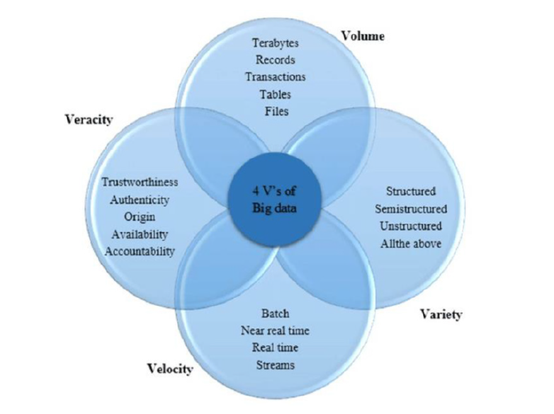

**Big Data-Related problems**

Utilizing medical data to its maximum potential is hampered by several issues. First off, data are frequently divided or compartmentalized in many healthcare organizations, particularly hospitals. The teams responsible for financial and operational oversight maintain and utilize administrative data, including cost data, reimbursements requests, and claims. The administrative functions of the health care industry use this information, but patient treatment and care procedures are typically not informed by it.

1. **Data Analytics**

Only by merging these datasets can data analytics pertaining to the best possible use of the hospital's resources and bettering patient outcomes be accomplished, fulfilling the second part of Gartner's definition: "cost-effective, innovative forms of data processing for improved understanding and decision making." In an effort to address this problem, a number of suppliers are putting a lot of effort into developing technologies like information warehouses and decision-making databases that let researchers and analysts mix information from sources that have historically been divided.

1. **Privacy**

Safeguarding patient privacy is a second major obstacle to fully utilizing big data in healthcare. One of the main objectives of many organizations is to share health care data, and groups like regional medical organizations were established with the express purpose of gathering health care data from various stakeholders, such as payers, providers, and governments. Covered businesses are required by the health care portability and accountability act to secure patient information. After de-identification, medical information may be shared, but it can be difficult to safeguard patients from both direct and indirect identifying while preserving the data's value.

1. **Computation**

The fact that analysis is frequently an additional use of the information is a significant barrier in healthcare information analytics that has to be recognized. Administrative data, for example, is mostly gathered in order to account for services provided and collect payment. The main purpose of collecting EHR data is to monitor clinical state, treatment outcomes, and patient development. The initial usage of the information must be identified as a potential restriction that might jeopardize the validity and reliability of any derived models when these data are subsequently utilized for assessing quality and outcomes.

1. **Unstructured Data**

The quantity of unstructured data presents perhaps the biggest obstacle to gathering and interpreting large amounts of health care data. Data that is saved and accessed in a relational database is referred to be structured or discrete data. Test results, scanned papers, photos, and notes on progress in the individual's electronic health record are examples of unstructured data in healthcare. While standards like the Clinical Document Building9 facilitate EHR data exchange and interoperability, the information contained in the designated areas is frequently unorganized speech. Unstructured data will probably be one of the most useful parts of the heath care big data landscape as free-text searching software tools advance and the processing of natural languages software is included into those capabilities.

**Solutions towards Application Problem**

Many of these issues inside and across providers may be resolved with full information and data governance procedures. Regulations governing data format, proper usage of data sources, and data fields are all part of a data governance program. Strict data governance guidelines assist the technical elements of mapping and merging data from several sources while ensuring that the subject matter or format of information is consistent. Programs for information governance deal with data processing, analysis, and protection. Information governance regulations will help data users decide what amount of information may be disclosed without jeopardizing the identification of patients, as well as whether or not another use of the information is appropriate.

For the team understanding it is important to improve the technology use which would be more convenient in the respect of data security and essentials. Keeping the prospects and storage position more permanent and secure would be a resolver of all the issues that comes with the data analytics in medical essence comparing technology advancements and updates.

**Conclusion**

Big data plays a major role in the field of healthcare informatics and has a considerable impact on the healthcare system particularly its four Vs in healthcare. In this article, we have presented an in-depth definition and a quick review of big information in general and in the healthcare system. Additionally, we suggested using a conceptual architecture to solve big data-driven healthcare problems using Hadoop-based terminologies. This would entail using big data produced by various medical data levels and developing techniques for analyzing the data and coming up with answers to medical queries.

Big data and healthcare analytics together can enable doctors to prescribe the right drugs for each patient, rather of just the ones that work for them, which can result in therapies that are successful for some individuals. Big data analytics is still in its infancy, and the issues it raises cannot be resolved with the tools and techniques available today. Big data may be thought of as large systems, which have many difficulties. Consequently, in order to address the problems facing the healthcare system, a significant amount of research in this area will be needed.

**References**

Chugh, S., Kumaram, S., & Sharma, D. K. (2021). Application of tools and techniques of big data analytics for healthcare system. *Applications of Big Data in Healthcare*, 69-84. <https://doi.org/10.1016/b978-0-12-820203-6.00010-2>

Isakki Alias Devi P. (2022). Big data, data mining, and data analytics in IoT-based healthcare applications. *Research Anthology on Big Data Analytics, Architectures, and Applications*, 1035-1053. <https://doi.org/10.4018/978-1-6684-3662-2.ch049>

Iyamu, T. (2022). A framework for selecting healthcare big data analytics tools. *Advancing Big Data Analytics for Healthcare Service Delivery*, 58-73. <https://doi.org/10.4324/9781003251064-5>

Kumar, S., & Singh, M. (2019). Big data analytics for healthcare industry: Impact, applications, and tools. *Big Data Mining and Analytics*, *2*(1), 48-57. <https://doi.org/10.26599/bdma.2018.9020031>

Management Association; Information Resources. (2021). *undefined*. IGI Global.

Morr, C. E., & Ali-Hassan, H. (2019). *Analytics in healthcare: A practical introduction*. Springer.

Mukhtar, W. F., & Abuelyaman, E. S. (2020). Opportunities and challenges of big data in healthcare. *Data Analytics in Medicine*, 1989-2001. <https://doi.org/10.4018/978-1-7998-1204-3.ch099>

Varatharajan, A., C., S., & Varatharajan, V. (2020). Big data analytics in the healthcare industry. *Big Data Analytics for Sustainable Computing*, 160-178. <https://doi.org/10.4018/978-1-5225-9750-6.ch010>