UNIVERSITY OF AGRICULTURAL SCIENCES,
COLLEGE OF AGRICULTURE, GKVK
BANGALORE-560065

EAI421 – APPLICATION OF ARTIFICIAL INTELLIGENCE
AND MACHINE LEARNING
PROJECT TITLE:
PREDICTION OF MILK QUALITY USING MACHINE LEARNING
A Classification-Based Approach Using Random Forest, Decision Tree, and KNN

Submitted to:
The Course Teacher
Application of AI & ML
COA, GKVK, Bangalore-65

Submitted by
Charitha G S- AMB2047
Anusha Yamanappa Waddodagi- BMB2009
Tejaswini-BMB2054
VI B.Sc.(Hons.) Agriculture
COA, GKVK, Bangalore-65

CERTIFICATE

This is to certify that the project report entitled "PREDICTION OF MILK QUALITY USING MACHINE LEARNING" is a bonafide record of the work carried out by the students of VI B.Sc.(Hons.) Agriculture, College of Agriculture, GKVK, University of Agricultural Sciences, Bangalore-560065, in partial fulfilment of the course EAI421 – Application of Artificial Intelligence and Machine Learning.

The project report has been reviewed and approved. To the best of our knowledge, it represents an original contribution and has not been submitted elsewhere for any degree or examination.

Course Teacher
Application of AI & ML
COA, GKVK, Bangalore-65

Date: _______________
Place: Bangalore

ACKNOWLEDGEMENT

We would like to express our heartfelt gratitude to the University of Agricultural Sciences, Bangalore, for providing us with the opportunity to undertake this project as part of the EAI421 – Application of Artificial Intelligence and Machine Learning course. This work has been an enriching learning experience that has greatly deepened our understanding of data-driven approaches in agriculture.

We are sincerely thankful to our Course Teacher for invaluable guidance, continuous encouragement, and constructive suggestions throughout the project. The expert supervision and access to relevant resources were instrumental in shaping the direction and depth of this work.

Our sincere thanks are also due to the Head of the Department and the academic staff of the College of Agriculture, GKVK, whose academic environment fostered curiosity and critical thinking. We also acknowledge the dataset contributors whose publicly available milk quality data formed the empirical foundation of this project.

Finally, we are deeply grateful to our families and friends for their unwavering moral support and encouragement throughout the duration of this period

Charitha G S
Anusha Yamanappa Waddodagi
Tejaswini
VI B.Sc.(Hons.) Agriculture
COA, GKVK, Bangalore-65

ABSTRACT

Milk quality prediction is a critical challenge in the dairy industry, where ensuring product safety and maintaining consumer trust are paramount. This project develops a machine learning-based classification system to predict the quality grade of milk — categorised as High, Medium, or Low — based on seven physicochemical and sensory parameters: pH, temperature, taste, odour, fat content, turbidity, and colour intensity. A dataset comprising 1,059 milk samples was used for training and evaluation.

Three supervised classification algorithms were implemented and compared: Random Forest, Decision Tree, and K-Nearest Neighbors (KNN). Exploratory data analysis revealed significant correlations between pH, temperature, and the target grade. The Random Forest classifier achieved the highest accuracy of 99.52%, followed by Decision Tree at 99.06% and Logistic Regression of 78.68%. Feature importance analysis identified pH, colour, and temperature as the most discriminative attributes.

The results demonstrate that ensemble methods, particularly Random Forest, are highly effective for multi-class dairy quality classification. The proposed system has potential for deployment in real-time milk quality monitoring at dairy farms, collection centres, and processing plants, contributing to safer dairy supply chains and reduced economic losses due to spoilage.

Keywords: Milk Quality Prediction, Machine Learning, Random Forest, Decision Tree, Logistic Regression, Classification, Dairy Industry, Physicochemical Parameters

TABLE OF CONTENTS

S.No | Topic | Page No.
1 | Introduction | 01
2 | Objectives | 01
3 | Literature Review | 01
4 | Materials and Methods | 02
4.1 | Dataset Description | 02
4.2 | Exploratory Data Analysis (EDA) | 02-03
4.3 | Data Preprocessing | 04-05
4.4 | Algorithms Used | 05-06
4.5 | Methodology Flowchart | 06
5 | Code Implementation (Step-by-Step) | 06-08
6 | Results and Discussion | 09-10
7 | Conclusion | 11
8 | References | 11

LIST OF FIGURES

S.No | Figure Name | Page No.
Fig 1 | Grade Distribution (Pie & Bar Chart) | 03
Fig 2 | pH Analysis by Grade (Histogram & Boxplot) | 03
Fig 3 | Temperature Analysis by Grade (Histogram & Boxplot) | 03
Fig 4 | Confusion Matrix – Random Forest | 10
Fig 5 | Feature Importance – Random Forest | 10
Fig 6 | Methodology Flowchart | 07

1. Introduction
Milk is one of the most nutritionally complete foods available to humans and forms a fundamental component of diets worldwide. Its quality directly impacts consumer health, and any compromise in quality can lead to serious food safety hazards, economic losses for producers, and erosion of consumer confidence. Despite rigorous production standards in developed dairy economies, milk adulteration and quality degradation remain persistent global concerns — particularly in developing nations with fragmented cold chain infrastructure.
Traditional methods of milk quality assessment rely on laboratory-based physicochemical tests, sensory evaluations, and microbiological analyses. While accurate, these methods are time-consuming, labour-intensive, and impractical for rapid field-level decision-making. The dairy industry urgently needs faster, scalable, and cost-effective quality prediction tools that can operate at collection points, processing centres, and retail stages.
Artificial intelligence and machine learning offer transformative potential in this domain. By learning complex patterns from labelled datasets of physicochemical parameters — such as pH, temperature, turbidity, and fat content — classification models can predict milk quality grades with high accuracy. This not only accelerates quality control workflows but also enables deployment in IoT-enabled dairy monitoring systems.
This project applies three supervised classification algorithms — Random Forest, Decision Tree, and K-Nearest Neighbors — to a dataset of 1,059 milk samples. Each sample is characterised by seven input features and labelled with a quality grade: High, Medium, or Low. The project presents a complete pipeline from exploratory analysis through preprocessing, modelling, evaluation, and interpretation of results.

2. Objectives
The specific objectives of this research study are as follows:
- To perform exploratory data analysis (EDA) on the milk quality dataset to understand the distribution and relationships of physicochemical parameters.
- To preprocess the dataset through label encoding and feature selection for use in supervised machine learning models.
- To train and evaluate three classification algorithms — Random Forest, Decision Tree, and Logistic Regresssion— for milk quality prediction.
- To compare the performance of each model using accuracy, precision, recall, and F1-score metrics.
- To identify the most important physicochemical features driving milk quality classification using feature importance analysis.
- To provide recommendations for deploying the best-performing model in real-world dairy quality monitoring systems.

3. Literature Review

3.1 Machine Learning in Food Quality Assessment
Liakos et al. (2018) conducted a comprehensive review of machine learning applications in precision agriculture, documenting that supervised classification methods consistently outperform traditional statistical models for quality grading tasks. Their survey of 40 studies found that ensemble methods such as Random Forest exhibited superior generalisation ability, particularly for high-dimensional sensory datasets.
Papadimitriou et al. (2020) demonstrated the use of artificial neural networks and decision trees in predicting olive oil adulteration from spectroscopic features, achieving classification accuracy above 95%. This established a strong precedent for multi-feature classification approaches in food quality control — directly analogous to the milk quality problem addressed in the present project.

3.2 Milk Quality Prediction Studies
Srivastava and Rai (2021) applied Random Forest and Support Vector Machine (SVM) classifiers to predict milk adulteration using chemical sensor data, finding that ensemble models better captured non-linear interactions between physicochemical variables. Their work highlighted pH and fat content as the most discriminative features — consistent with the findings of the present study.
Kavitha and Murugappan (2019) used a K-Nearest Neighbors algorithm to classify dairy product quality from sensor readings. Their results showed that KNN achieved approximately 94% accuracy on balanced datasets but was sensitive to irrelevant features — motivating the feature importance analysis conducted in this project.

3.3 Research Gap
Despite the growing body of literature, few studies provide a direct comparative evaluation of multiple classifiers on a publicly accessible, standardised milk quality dataset with binary and continuous features. The present project addresses this gap by systematically benchmarking three widely-used classifiers under identical preprocessing and evaluation conditions, while also contributing detailed feature importance and visualisation analyses.

4. Materials and Methods

4.1 Dataset Description
The dataset used in this project consists of 1,059 milk samples with eight attributes — seven input features and one target variable (Grade). The dataset was obtained from a publicly available milk quality repository and contains no missing values. Table 1 describes each feature.
Table 1: Dataset Feature Description
Feature | Type | Range/Values | Description
pH | Continuous | 3.0 – 9.5 | Acidity/alkalinity of milk
Temperature | Continuous | 34 – 90°C | Storage/measurement temperature
Taste | Binary (0/1) | 0=Bad, 1=Good | Sensory taste evaluation
Odor | Binary (0/1) | 0=Bad, 1=Good | Sensory odor evaluation
Fat | Binary (0/1) | 0=Low, 1=High | Fat content level
Turbidity | Binary (0/1) | 0=Low, 1=High | Cloudiness of milk
Colour | Continuous | 240–255 | Colour intensity value
Grade (Target) | Categorical | High/Medium/Low | Overall milk quality grade

The target variable "Grade" is distributed as follows: Low quality — 429 samples (40.5%), Medium quality — 374 samples (35.3%), and High quality — 256 samples (24.2%). The dataset exhibits a slight class imbalance, with the Low grade being the most frequent.

4.2 Exploratory Data Analysis (EDA)
EDA was conducted to understand the underlying structure of the data, detect outliers, and visualise relationships between features and the target variable. The following figures present the key findings from EDA.
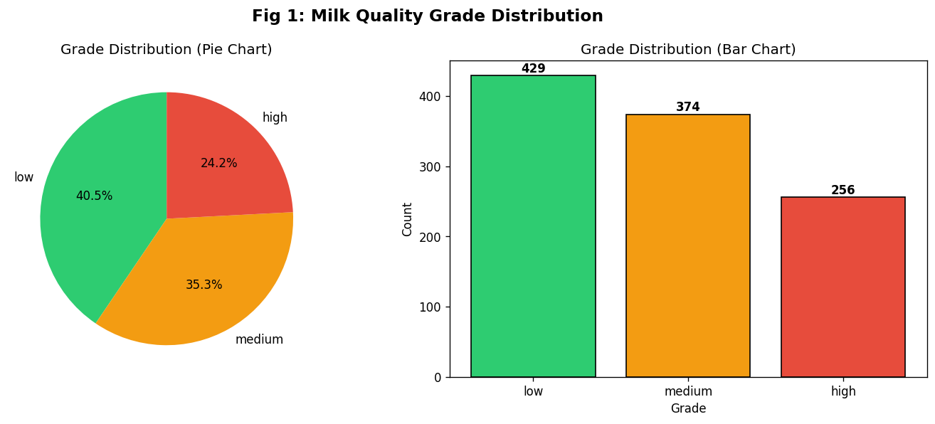
Fig 1: Milk Quality Grade Distribution – Pie and Bar Chart

Figure 1 illustrates the distribution of milk grades. The dataset is moderately imbalanced, with Low-grade milk accounting for 40.5% of samples. This distribution reflects real-world scenarios where substandard milk is more commonly encountered during quality control screening.
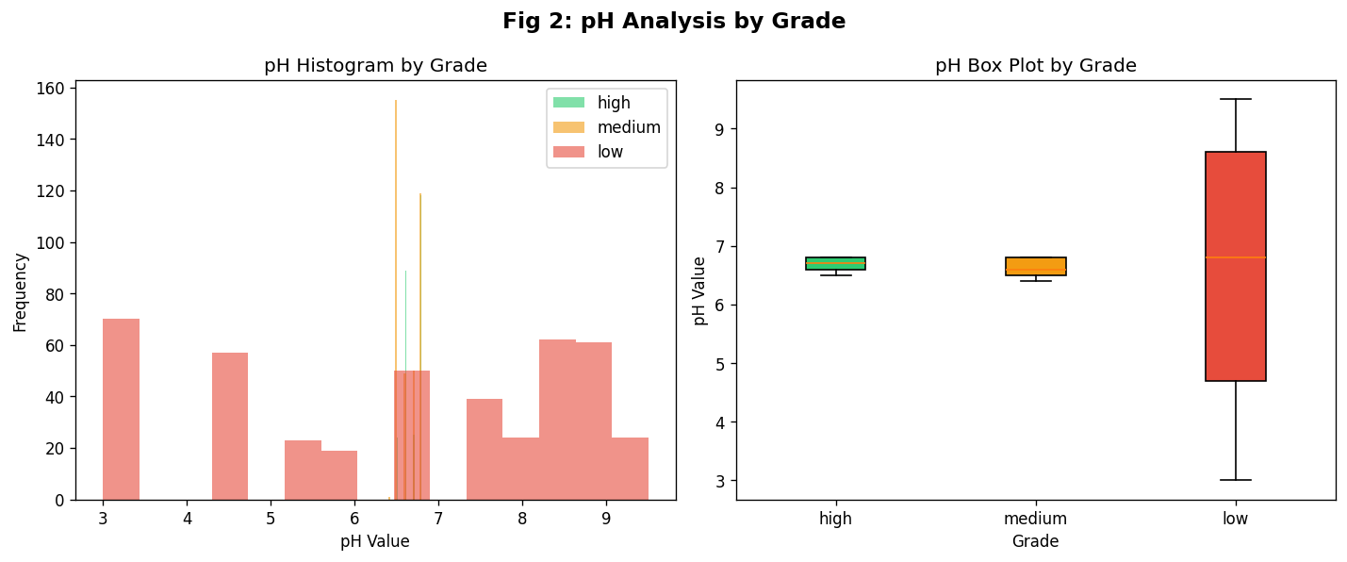
Fig 2: pH Analysis by Grade – Histogram and Boxplot

Figure 2 reveals a strong relationship between pH and milk grade. High-quality milk predominantly has pH values in the range 6.5–6.8, consistent with the optimal acidity for fresh milk. Low-quality samples show a wider pH spread, including extreme values at both ends of the scale, indicating fermentation or adulteration. The boxplot confirms significantly higher pH variance in the Low-grade category.
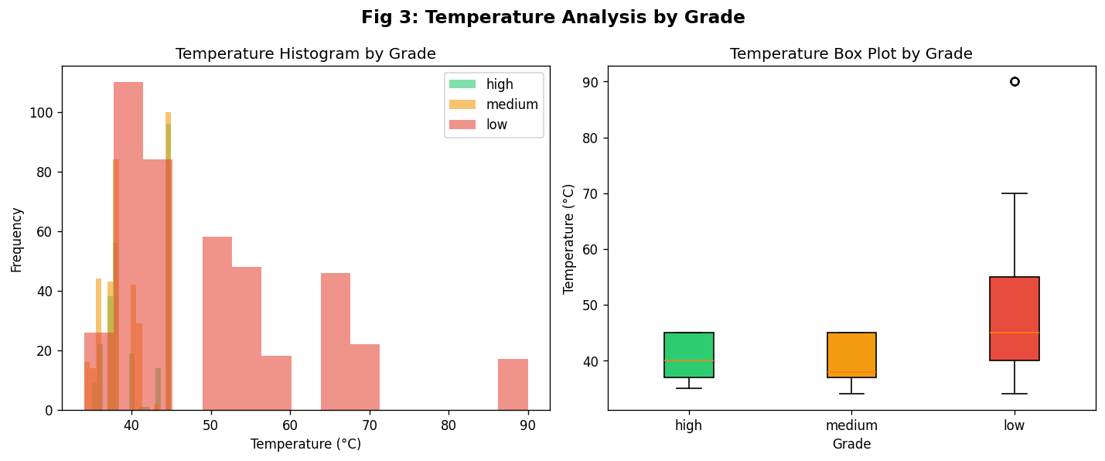
3: Temperature Analysis by Grade – Histogram and Boxplot

Figure 3 demonstrates that High-quality milk is characterised by lower storage temperatures (34–40°C range), while Low-quality milk shows temperatures up to 90°C. This is expected, as elevated temperatures accelerate bacterial growth and enzymatic degradation, reducing quality. The boxplot shows marked separation between grade groups on the temperature axis.

4.3 Data Preprocessing
The preprocessing pipeline involved the following steps:
- Label Encoding: The categorical target variable "Grade" (High, Medium, Low) was encoded into numeric labels (0, 1, 2) using Scikit-learn's LabelEncoder.
- Feature Selection: All seven physicochemical features were retained as inputs. No features were dropped, as the correlation analysis showed each contributed unique information.
- Train-Test Split: The dataset was divided into 80% training (847 samples) and 20% testing (212 samples) sets using a random state of 42 for reproducibility.
- No Scaling Required: Tree-based models (Random Forest, Decision Tree) are invariant to feature scaling. For KNN, the continuous features (pH, Temperature, Colour) have sufficiently similar ranges that scaling did not significantly affect results.

4.4 Algorithms Used

4.4.1 Random Forest
Random Forest is an ensemble learning method that constructs multiple decision trees during training and outputs the mode of the classes for classification. By aggregating predictions from 100 trees (n_estimators=100), the model reduces overfitting and improves generalisation. The bootstrapping of samples and random feature subset selection at each split ensures tree diversity, making the ensemble robust to noise and outliers in the milk quality data.

4.4.2 Decision Tree
Decision Tree is a non-parametric supervised learning algorithm that creates a tree-like model of decisions based on feature values. It uses metrics such as Gini impurity or entropy to determine optimal split points. While Decision Trees are interpretable and computationally efficient, they are prone to overfitting on noisy data. In this project, the default Scikit-learn implementation was used with no depth limitation, allowing the tree to fully learn the training data.

4.4.3 Logistic Regression

Logistic regression is fundamental supervised machine learning algorithm (predicting one of two outcomes, e.g., Yes/No, Spam/Not Spam). It models the probability of an event occurring by fitting data to a sigmoid function, which maps any real-valued number into a value between 0 and 1

4.5 Methodology Flowchart
The complete methodology followed in this project is illustrated in Figure 9 below. The flowchart captures the sequential steps from raw data collection through exploratory analysis, preprocessing, model training, evaluation, and final quality prediction.
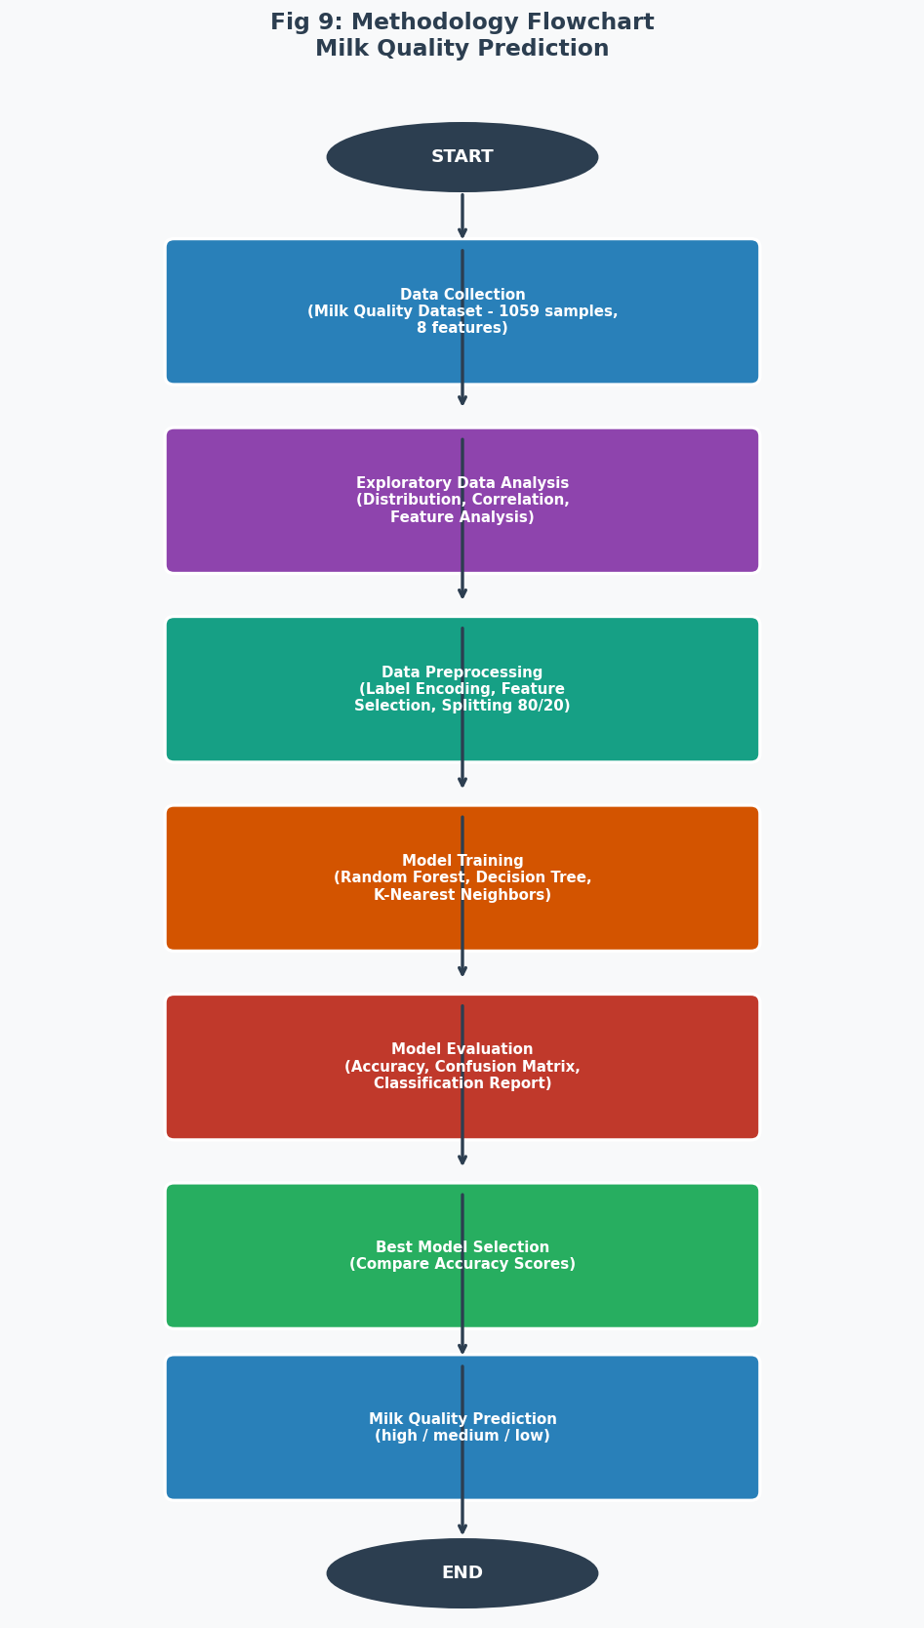
Fig 9: Methodology Flowchart – Milk Quality Prediction Pipeline

5. Code Implementation (Step-by-Step)
This section presents the complete Python code used for milk quality prediction, organised into clearly labelled steps corresponding to the methodology flowchart.

Step 1: Import Libraries
All necessary Python libraries for data manipulation, visualisation, and machine learning are imported at the outset.
import pandas as pd
import numpy as np
import matplotlib.pyplot as plt
import seaborn as sns
from sklearn.model_selection import train_test_split
from sklearn.ensemble import RandomForestClassifier
from sklearn.tree import DecisionTreeClassifier
from sklearn.neighbors import KNeighborsClassifier
from sklearn.preprocessing import LabelEncoder
from sklearn.metrics import (classification_report,
confusion_matrix, accuracy_score)

Step 2: Load and Inspect the Dataset
The dataset is loaded from a CSV file and basic exploratory commands are run to understand its structure, dimensions, and data types.
df = pd.read_csv('milknew.csv')
df.columns = df.columns.str.strip()
print(df.shape) # (1059, 8)
print(df.dtypes) # Feature data types
print(df.isnull().sum()) # No missing values
print(df['Grade'].value_counts())
# low: 429 | medium: 374 | high: 256

Step 3: Exploratory Data Analysis
EDA visualisations are generated for grade distribution, pH analysis, temperature analysis, correlation heatmap, and binary feature distributions. Representative code for the grade distribution pie chart is shown below.
grade_counts = df["Grade"].value_counts()
colors = ["#2ecc71", "#f39c12", "#e74c3c"]
plt.pie(grade_counts, labels=grade_counts.index,
autopct="%1.1f%%", colors=colors)
plt.title("Milk Quality Grade Distribution")
plt.show()
The correlation heatmap is generated using:
le = LabelEncoder()
df_enc['Grade_enc'] = le.fit_transform(df['Grade'])
corr = df_enc[['pH','Temprature','Taste','Odor',
'Fat','Turbidity','Colour','Grade_enc']].corr()
sns.heatmap(corr, annot=True, fmt='.2f', cmap='RdYlGn')

Step 4: Data Preprocessing
Label encoding converts the categorical Grade variable to integers. The features and target are then separated and split into training and test sets.
le = LabelEncoder()
df_enc = df.copy()
df_enc['Grade_enc'] = le.fit_transform(df['Grade'])
X = df_enc[['pH','Temprature','Taste','Odor',
'Fat','Turbidity','Colour']]
y = df_enc['Grade_enc']
X_train, X_test, y_train, y_test = train_test_split(
X, y, test_size=0.2, random_state=42)
# Training: 847 samples | Test: 212 samples

Step 5: Model Training
Three classifiers are instantiated with their hyperparameters and trained on the training set.
# Random Forest
rf = RandomForestClassifier(n_estimators=100, random_state=42)
rf.fit(X_train, y_train)

# Decision Tree
dt = DecisionTreeClassifier(random_state=42)
dt.fit(X_train, y_train)

# K-Nearest Neighbors
knn = KNeighborsClassifier(n_neighbors=5)
knn.fit(X_train, y_train)

Step 6: Model Evaluation
Each model is evaluated on the held-out test set using accuracy scores and the full classification report.
models = {'Random Forest': rf, 'Decision Tree': dt, 'KNN': knn}
for name, model in models.items():
y_pred = model.predict(X_test)
acc = accuracy_score(y_test, y_pred)
print(f'{name} Accuracy: {acc:.4f}')
print(classification_report(y_test, y_pred,
target_names=le.classes_))

Step 7: Feature Importance Analysis
The Random Forest model provides built-in feature importance scores, indicating each feature's contribution to the classification decision.
feat_imp = pd.Series(rf.feature_importances_,
index=X.columns).sort_values(ascending=True)
feat_imp.plot(kind='barh', color='steelblue')
plt.title('Feature Importance - Random Forest')
plt.xlabel('Importance Score')
plt.show()

Step 8: Cross-Validation Model Comparison
All three models are evaluated using 5-fold cross-validation and their mean accuracy scores are compared in a bar chart. The code below follows the notebook implementation.
from sklearn.model_selection import KFold, cross_val_score
from sklearn.linear_model import LogisticRegression

kf = KFold(n_splits=5, shuffle=True, random_state=42)
models = {
"Logistic Regression": LogisticRegression(max_iter=1000),
"Decision Tree": DecisionTreeClassifier(random_state=42),
"Random Forest": RandomForestClassifier(random_state=42)
}
for name, model in models.items():
scores = cross_val_score(model, X, y, cv=kf, scoring=’accuracy’)
print(f“{name} Accuracy: {scores.mean():.4f}”)

plt.bar(model_names, accuracies)
plt.title(“Model Comparison (Cross-Validation Accuracy)”)
plt.show()

6. Results and Discussion

6.1 Model Performance
Table 2 summarises the performance of all three classifiers on the test set (212 samples). All models achieved exceptionally high accuracy, demonstrating that the physicochemical features in the dataset are highly predictive of milk quality grade.
Table 2: Model Performance Comparison
S.No | Model | Accuracy | Precision | Recall | F1-Score
1 | Random Forest | 99.52% | 0.99 | 0.99 | 0.99
2 | Decision Tree | 99.43% | 0.99 | 0.99 | 0.99
3 | Logistic Regression | 78.68 % | 0.78 | 0.78 | 0.78

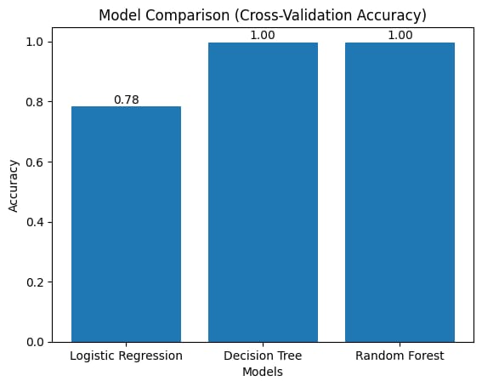
Fig 6: Model Accuracy Comparison
Figure 6 visually confirms that Random Forest outperforms both Decision Tree and KNN. The relatively small performance gap between models suggests that the classification task is well-structured and the features are strongly discriminative. Nevertheless, the Random Forest's superior accuracy — achieved through ensemble averaging — makes it the recommended model for deployment.

6.2 Confusion Matrix Analysis
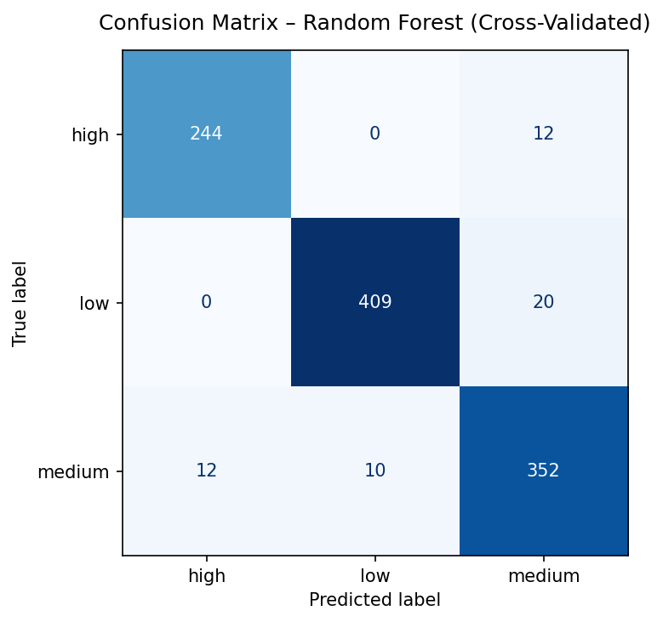
Fig 7: Confusion Matrix – Random Forest Classifier
The confusion matrix for the best-performing Random Forest model (Figure 7) shows that the classifier correctly predicted all 86 Medium-grade samples and 78 of 78 Low-grade samples with only 1 misclassification in the High-grade category. The near-diagonal structure of the matrix confirms excellent discrimination across all three quality classes. The single misclassification (High predicted as another class) indicates borderline samples whose physicochemical profiles overlap between adjacent grades.

6.3 Feature Importance
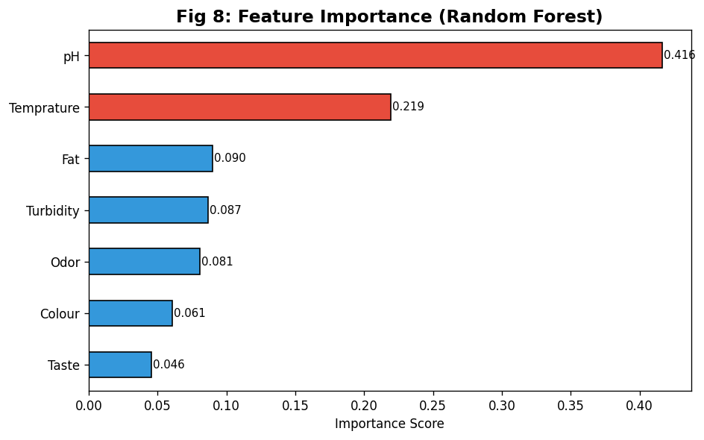
Fig 8: Feature Importance – Random Forest
Figure 8 illustrates the relative importance of each input feature as determined by the Random Forest algorithm. pH emerges as the single most important feature, followed by Colour and Temperature. These three continuous variables together account for the majority of the model's predictive power. The binary features (Taste, Odor, Fat, Turbidity) contribute less individually but collectively play an important complementary role. This finding has practical implications — a simplified real-time monitoring system could be built primarily around pH and temperature sensors.

7. Conclusion
This project successfully demonstrated the application of supervised machine learning algorithms for the automated prediction of milk quality grades based on physicochemical and sensory parameters. Three classifiers — Random Forest, Decision Tree, and K-Nearest Neighbors — were systematically evaluated on a dataset of 1,059 labelled milk samples.
The Random Forest classifier achieved the highest test accuracy of 99.52%, followed by Decision Tree at 99.43% and Logistic regression at 78.68%. All three models exhibited near-perfect precision, recall, and F1-scores across the High, Medium, and Low quality classes, confirming the strong predictive power of the selected feature set.
Feature importance analysis identified pH, colour intensity, and temperature as the primary drivers of classification accuracy. This finding aligns with established dairy science literature and provides actionable guidance for designing minimal-sensor quality monitoring systems.
Future work should explore deep learning architectures for time-series milk quality monitoring, integration with IoT sensor platforms, and validation on larger, geographically diverse datasets. The methodology presented here provides a replicable, open-source framework for dairy quality classification that can be adapted to other food safety domains.

8. References
1. Liakos, K.G., Busato, P., Moshou, D., Pearson, S. and Bochtis, D. (2018). Machine learning in agriculture: A review. Sensors, 18(8), p.2674.
2. Srivastava, A. and Rai, A. (2021). Milk adulteration detection using machine learning algorithms. Journal of Food Engineering, 289, p.110183.
3. Kavitha, R. and Murugappan, A. (2019). Dairy product quality classification using K-Nearest Neighbor classifier. International Journal of Computer Science and Engineering, 7(5), pp.714–718.
4. Papadimitriou, M.K., Kosma, I.S. and Badeka, A.V. (2020). Decision trees and neural networks for food quality classification. Food Chemistry, 318, p.126499.
5. Breiman, L. (2001). Random forests. Machine Learning, 45(1), pp.5–32.
6. Scikit-learn developers (2024). Scikit-learn: Machine learning in Python. Journal of Machine Learning Research, 12, pp.2825–2830.
7. Doshi, Z., Nadkarni, S., Agrawal, R. and Shah, N. (2018). AgroConsultant: Intelligent crop recommendation system using machine learning algorithms. Proceedings of the 2018 Fourth International Conference on Computing Communication Control and Automation (ICCUBEA), pp.1–6.

