ESP32-Based Universal PLC Protocol Bridge

Submitted by

Charith Sai Sathvik Ale

Non-Thesis Report for the degree of
Master of Science in Electrical and Computer Engineering
Dr. Leon Jololian
12/10/25

Table of contents
List of Tables
List of Figures
Introduction
Problem Identification
Secondary Data
Comparative Analysis
Working Principle
Project Description
Product Specifications
Functional Requirements
Performance and Targets
Interfaces and Resilience
Security and Scalability
Project Setup
Hardware Architecture and Component Selection
Electrical Wiring and Signal Interface
PLC Ladder Logic Configuration
OLED Power Control and Display Bring up
MQTT Broker Configuration and Network Diagnostics
Firmware Architecture and Code Implementation
Data Acquisition and Measurement Procedures
Project Results
Communication Validation and Functional Correctness
End-to-End Latency and Determinism
RS-232 Implementation Versus Initial RS-485 Concept
1. Insufficient Power for Port-Powered RS-485 Adapter
2. Half-Duplex Timing Constraints on RS-485
3. Integration Challenges and Resolved Issues
4. Electrical Layer Failures
5. OLED Power Gating and I²C Initialization
Library Conflicts for SSD1306 Driver
MQTT Connectivity and Windows Firewall Configuration
Alignment with Initial Hypotheses and Research Questions
Data Analysis
Latency Measurement Model and Dataset
Statistical Characterization of Performance
Cross-Domain Consistency and Value Freshness Verification
Jitter Sources, Deterministic Behavior, and Expected RS-485 Scaling
Component-Level Timing Breakdown
Future Implications
Conclusion
References

Abstract

Modern industrial settings frequently incorporate heterogeneous Programmable Logic Controllers (PLCs) that rely on legacy serial communication standards such as Modbus RTU and Profibus, creating a structural mismatch with contemporary Industry 4.0 frameworks. Current supervisory, analytical, and cloud-based platforms predominantly expect data to be exchanged using network-oriented protocols, including Message Queuing Telemetry Transport (MQTT) and the Open Platform Communications Unified Architecture (OPC UA). This divergence results in a persistent interoperability gap between operational technology (OT) devices and information technology (IT) systems, limiting the integration and scalability of brownfield industrial assets. This study develops a vendor-neutral Universal PLC Protocol Bridge based on an ESP32-class microcontroller to address this challenge. Although industrial deployments commonly employ Modbus RTU over RS-485 due to its noise immunity and multi-drop capabilities, the prototype implementation operates over RS-232 because the selected CLICK PLC exposes only an RS-232 serial interface. A MAX3232 level-shifting module provides electrical compatibility between the PLC and the microcontroller, enabling full-duplex UART communication. The protocol-layer behavior—including frame structure, timing requirements, and cyclic redundancy validation—remains consistent across RS-232, RS-422, and RS-485, preserving the relevance of the results to RS-485-based industrial systems. The proposed bridge acquires Modbus RTU register data, validates each frame, and publishes the resulting values as structured MQTT topics while maintaining deterministic timing. The design targets an end-to-end latency below 100 ms at the 95th percentile and incorporates security mechanisms such as mutual-TLS, topic-scoped Access Control Lists (ACLs), and function-code allow-lists for safe write operations. Emphasis is placed on reproducibility and measurable performance characterization to ensure rigorous evaluation. The experimental results demonstrate that a microcontroller-class device can deliver predictable timing behavior and enforce secure communication paths, supporting its suitability as an economical and extensible bridge for industrial modernization initiatives.

List Of Tables
Table 1. Summary of latency and jitter metrics for 30-sample Modbus RTU polling sequence.
Table 2. Engineering Comparison Summary of RS 232 and RS 485

List of Figures
Figure 1. Operational flowchart of the Universal PLC Protocol Bridge.
Figure 2. Universal PLC Protocol Bridge based on ESP32.
Figure 3. Electrical Schematic of Universal PLC Protocol Bridge
Figure 4. A Ladder logic used to generate deterministic test registers for Modbus polling.
Figure 5. Four-way comparison of Modbus telemetry as observed at the PLC, the ESP32 OLED interface, the serial console, and the MQTT broker. The agreement of DS1 (static) and DS2 (incrementing) values verifies functional correctness across the entire Modbus to ESP32 to MQTT pipeline.
Figure 6. Image of Measured Statistics on MQTT broker
Figure 7. Deterministic behavior of the ESP32-based protocol bridge.

Introduction
Modern industrial facilities frequently operate a diverse set of legacy Programmable Logic Controllers (PLCs) originating from multiple vendors. These devices typically rely on long-standing serial communication standards such as Modbus RTU and Profibus, which remain prevalent across brownfield installations. In contrast, modern Industry 4.0 systems, cloud-based platforms, and advanced supervisory applications increasingly require communication through contemporary protocols such as Message Queuing Telemetry Transport (MQTT) and the Open Platform Communications Unified Architecture (OPC UA). The coexistence of these dissimilar technologies produces a persistent interoperability barrier between operational technology (OT) equipment and information technology (IT) systems, thereby limiting the deployment of advanced analytics, remote monitoring, and coordinated automation workflows. This gap is particularly consequential for small- and mid-sized facilities that often cannot justify the cost or operational disruption associated with controller replacement or fieldbus rewiring [1].
Although commercial protocol gateways exist, several unresolved challenges remain. Many proprietary devices provide limited transparency into timing behavior, restrict customization, or impose vendor-specific constraints that hinder integration across heterogeneous PLC environments. Deterministic performance is often difficult to guarantee due to variabilities in serial-line timing, electrical noise, or inconsistent handling of Modbus framing. For systems employing RS-485, strict timing control, biasing, and half-duplex arbitration add further complexity. Moreover, a substantial portion of low-cost gateways lack robust security features, including authenticated write paths and function-code validation, leaving PLCs vulnerable to unauthorized or malformed commands [2]. These gaps underscore the need for an auditable, reproducible, and vendor-neutral approach that preserves deterministic behavior while operating on resource-constrained embedded hardware.
This study introduces an ESP32-based Universal PLC Protocol Bridge designed to translate Modbus RTU—whether transported over RS-232, RS-422, or RS-485—and Modbus TCP into structured MQTT topics, with optional promotion of selected tags to OPC UA nodes. While RS-485 remains the de facto industrial standard due to its noise immunity and multi-drop capability, the experimental prototype employs RS-232 because the selected CLICK PLC provides only an RS-232 serial interface. A MAX3232 level-shifting module enables reliable full-duplex communication between the PLC and the microcontroller without altering the Modbus RTU protocol, timing model, or validation requirements. This ensures that performance results obtained over RS-232 remain generalizable to RS-485 deployments.
The bridge is engineered for deterministic behavior, targeting an end-to-end 95th-percentile latency below 100 ms under representative load conditions. Security is treated as an integral design element and includes mutual-TLS authentication, topic-scoped Access Control Lists (ACLs), and strict function-code allow-lists to regulate write operations. Emphasis is placed on reproducibility and transparent configuration to support independent verification and future extensibility [3].
The research addresses three core questions:
RQ1: Can a microcontroller-class device such as the ESP32 satisfy deterministic timing constraints at the network edge?
RQ2: What trade-offs arise between latency and jitter when varying Quality of Service (QoS) levels or batching strategies for MQTT transport?
RQ3: Which security mechanisms—authorization, validation, or rate limitation—most effectively mitigate unsafe Modbus write operations while preserving responsiveness?

To answer these questions, the system processes Modbus RTU/TCP frames, validates CRC and timing, maps registers to structured MQTT namespaces, and publishes securely over TLS with session resumption. An optional OPC UA proxy provides typed data models for higher-level applications. A timestamped evaluation harness measures p50, p95, and p99 latency, jitter, throughput, and CPU headroom, while controlled fault injections assess resilience and safe-state behavior.

Problem Identification
A persistent challenge in industrial modernization is the absence of a secure, cost-effective, and deterministic communication pathway between legacy automation equipment and contemporary IT/OT systems. Many industrial facilities operate long-standing PLC installations that communicate primarily through Modbus RTU/TCP or Profibus, protocols designed for isolated fieldbus environments rather than modern, network-integrated architectures. In contrast, current supervisory analytics, cloud platforms, and Industry 4.0 frameworks rely on protocols such as MQTT and OPC UA, creating a structural incompatibility that limits the ability to integrate or reuse existing automation assets. This mismatch forces organizations—particularly small- and mid-sized plants—to consider expensive controller upgrades or extensive fieldbus rewiring, both of which impose significant cost and downtime barriers [1].
Commercial protocol gateways offer partial solutions but exhibit several limitations. Many devices are proprietary, costly, or tightly coupled to specific vendors, reducing their adaptability in heterogeneous PLC environments. Furthermore, deterministic behavior is not consistently guaranteed; timing variations, especially across serial interfaces such as RS-485, can degrade performance in real-time applications. Security limitations are equally problematic. Several low-cost gateways lack authenticated write paths or adequate inspection of Modbus frames, leaving PLCs vulnerable to unauthorized or malformed commands. Open-source alternatives address flexibility but often target more powerful hardware platforms such as Single Board Computers, increasing power consumption and attack surface while providing limited assurances regarding deterministic timing or write-path safety [4].
The resulting research gap is both practical and empirical. Very few studies evaluate whether a resource-constrained microcontroller can reliably achieve sub-100 ms 95th-percentile latency while simultaneously enforcing modern security controls—including mutual-TLS authentication, topic-level Access Control Lists (ACLs), and strict function-code validation. For facilities that rely on legacy PLCs with RS-232 interfaces, this challenge is amplified, as the absence of RS-485 support introduces additional constraints on physical-layer interfacing. Without an auditable and deterministic bridging mechanism, critical operational data remains siloed within legacy equipment, limiting visibility, analytics, and automation. More importantly, insecure or unvalidated write paths pose direct risks to operational safety, potentially enabling erroneous or malicious register modifications. Addressing these limitations requires a bridge architecture that is both technically rigorous and economically accessible.

Secondary Data
Prior research provides several foundations relevant to the development of a deterministic and secure protocol bridge for industrial automation. Embedded OPC UA/Modbus gateway studies have demonstrated that acceptable end-to-end latency can be achieved on constrained hardware, establishing performance benchmarks and Key Performance Indicator (KPI) structures applicable to the present system [8]. These KPIs guide the measurement of acquisition, parsing, and publication timing within the ESP32-based bridge, enabling direct comparison with established latency thresholds, including the sub-100 ms p95 target.
Further investigations have examined the feasibility of running OPC UA on embedded devices, emphasizing the trade-offs associated with CPU utilization, memory usage, and data model complexity [9]. These findings inform the architectural decision to retain MQTT as the primary, low-latency transport mechanism while reserving OPC UA for a selective set of critical tags through an optional proxy. This design balances semantic richness with computational efficiency.
Time-Sensitive Networking (TSN) research highlights the importance of bounded jitter as a requirement for deterministic communication in industrial networks [10]. Although the ESP32 lacks native TSN capabilities, latency ceilings derived from TSN literature provide a defensible framework for evaluating timing performance, guiding configuration decisions related to MQTT Quality of Service (QoS) levels, batching intervals, and message scheduling.
Security considerations are grounded in established work on Industrial Internet of Things (IIoT) hardening, including the application of Public Key Infrastructure (PKI), authenticated channels, and fine-grained access control [11]. These studies justify the incorporation of mutual-TLS, broker-side Access Control Lists (ACLs), function-code allow-lists, rate limiting, and structured audit logging into the proposed bridge. Such controls address the risks posed by unauthenticated write requests and malformed Modbus frames.
Formal information-modeling standards also influence the system’s design. OPC UA semantic guidelines and typed-variable structures ensure that any exposed OPC UA nodes retain compatibility with higher-level analytics platforms and future industrial upgrades [12]. Complementary to this, MQTT session-management and QoS principles defined in the OASIS standard support reliable message delivery across unstable wireless links or broker interruptions [13].
The underlying Modbus RTU specification provides the basis for strict frame handling, including Cyclic Redundancy Check (CRC) validation, function-code interpretation, and enforcement of inter-frame timing [14]. These principles remain identical across RS-232, RS-422, and RS-485, reinforcing the relevance of Modbus protocol literature even when the prototype operates on RS-232.
Recent studies further reaffirm the continued relevance of RS-232 in industrial, medical, and embedded control systems. Research on Modbus/MQTT gateways illustrates that Modbus RTU remains widely deployed across both RS-232 and RS-485 interfaces in Industry 4.0 environments [15], [16]. Device-layer integration studies, including work in medical monitoring systems, demonstrate that RS-232 continues to serve as a reliable link layer for legacy equipment requiring structured serial communication [17]. Investigations into laboratory automation and CNC machine retrofits similarly show that RS-232 interfaces persist as practical data channels for bridging older controllers with modern digital systems [18], [23].
Theses and system-level analyses have documented RS-232 wiring practices, voltage translation requirements, and associated risks, confirming the necessity of level-shifting hardware such as MAX3232 when interfacing 5–12 V PLC ports with 3.3 V microcontrollers [19], [21]. Contemporary IoT controller designs also incorporate RS-232 ports for interoperability with small-scale industrial devices, further validating the relevance of RS-232-based experimentation in constrained environments [20], [22].
Finally, cybersecurity reports from ENISA highlight that unsecured RS-232 maintenance ports have been exploited in legacy medical and industrial devices, underscoring the importance of authenticated channels and controlled write paths even on physically simple serial interfaces [24]. This evidence reinforces the need for the secure communication mechanisms integrated into the proposed bridge.

Comparative Analysis
Industrial modernization initiatives commonly consider three architectural pathways for bridging legacy PLCs with modern IT/OT infrastructures: the deployment of commercial vendor gateways, the development of Single Board Computer (SBC)–based gateways, or the implementation of embedded microcontroller-based solutions. Each approach carries distinct implications with respect to determinism, security, configurability, and long-term maintainability, which are central factors for small-to-mid-sized facilities seeking cost-efficient retrofitting.
Vendor-provided gateways typically offer extensive protocol catalogs and feature-rich configuration interfaces, reducing initial integration effort. However, these devices often impose proprietary constraints that limit customization of tag structures, namespace design, or security policies. Licensing tiers, vendor lock-in, and high acquisition costs further restrict their suitability for heterogeneous brownfield environments. Such constraints are particularly problematic when legacy PLCs expose only serial interfaces such as RS-232 or RS-485 and require flexible mapping to MQTT-based systems.
SBC-based gateways, exemplified by Raspberry Pi platforms running Node-RED or similar middleware, provide substantial programmability and support for edge analytics. Despite this flexibility, SBCs introduce several operational drawbacks, including increased power consumption, elevated cybersecurity exposure, and dependence on nondeterministic general-purpose operating systems. Kernel scheduling jitter, variable interrupt latency, and network-stack unpredictability can cause timing excursions that exceed stringent p95 latency budgets unless extensive system-level tuning is performed [4]. Moreover, their broader software footprint increases the maintenance burden relative to embedded alternatives.
Microcontroller-based designs, particularly those built on ESP32-class hardware, present an alternative that emphasizes determinism, low cost, and architectural transparency. Recent studies have demonstrated that ESP32 devices can operate as reliable IIoT gateways capable of executing communication, control, and edge-processing tasks with predictable timing and significantly reduced hardware overhead [25]. Additional work confirms that ESP32-based systems can interface directly with industrial controllers for triggering digital I/O, managing serial communication links, and supporting real-time interactions with PLC equipment [26]. Educational and applied research further validates the platform’s suitability for automation tasks, noting its stable UART performance, modest resource requirements, and ability to integrate into laboratory-scale and production-oriented automation workflows [27]. These findings reinforce the viability of an ESP32 implementation for Modbus RTU–to–MQTT bridging, independent of whether the physical layer operates on RS-232 or RS-485.
The proposed architecture leverages these advantages by maintaining a lean communication path in which Modbus RTU frames are parsed, validated, and securely published over MQTT/TLS. Optional OPC UA exposure is confined to a proxy layer to avoid burdening the real-time fast path, preserving deterministic timing. The ESP32’s low Bill of Materials (BOM), minimal power consumption, and microcontroller-level interrupt determinism position as a scalable and economically accessible option for field deployment. Coupled with mutual-TLS authentication, topic-level Access Control Lists (ACLs), and function-code allow-lists, the resulting bridge provides a transparent and auditable platform that mitigates the limitations inherent to commercial gateways and SBC-based systems.

Working Principle
The protocol bridge operates as an intermediary between legacy PLCs and modern networked applications by translating Modbus RTU or Modbus TCP traffic into structured MQTT messages. Although industrial deployments typically transport Modbus RTU over RS-485 due to its differential signaling characteristics and multi-drop capability, the prototype implementation interfaces with the CLICK PLC through an RS-232 link. A MAX3232 level-shifting module ensures electrical compatibility between the ±12 V RS-232 signals and the 3.3 V UART interface of the ESP32-class microcontroller. Regardless of the physical layer, the Modbus RTU protocol, frame structure, and timing constraints remain consistent, enabling a unified processing pipeline.
Upon receiving a Modbus frame, the bridge performs a sequence of validation steps, including Cyclic Redundancy Check (CRC) verification and Modbus Application Protocol (MBAP) timing analysis to ensure frame integrity. Validated register values are forwarded to a mapping layer that associates each address with a predefined MQTT topic or, where semantically appropriate, an OPC UA node exposed through an optional proxy. The publishing subsystem transmits these values over a mutually authenticated TLS session, using configured Quality of Service (QoS) levels and retry mechanisms to maintain reliable delivery under variable network conditions. Each stage of the pipeline is instrumented with timestamping logic to quantify acquisition, parsing, mapping, and network transmission delays, enabling precise measurement of end-to-end latency and jitter.
The mathematical behavior of the bridge can be expressed as follows. Let 𝑅_{𝑖}(𝑡) denote the value of Modbus register i sampled at time t. A payload transformation function 𝑃_{𝑖}= 𝑔(𝑅_{𝑖}) applies unit scaling, bounds checking, and type normalization. A mapping function 𝑓 : 𝑖 → 𝑇_{i} or f : i → N_{i} assigns each processed payload to an MQTT topic 𝑇_{𝑖} or an OPC UA node 𝑁_{𝑖}, depending on the configured export semantics. The total end-to-end latency is modeled as
$Ltot=Lio+Lparse+Lmap+Lnet+Lbroker+Lsub$,
with a design target of 𝑝95(𝐿_{tot})< 100ms. The additional overhead of encrypted communication is approximated by
$$ΔLTLS ≈\left(\frac{Lhandshake}{Nmsgs}\right)+Lrecord,$$
which is minimized through TLS session resumption and persistent MQTT connections. For control operations, the bridge implements a hardened reverse path to prevent unauthorized or unsafe write commands from reaching the PLC. Commands originate from an operator interface or supervisory system and are published to strictly scoped MQTT command topics. The bridge subscribes to these topics and evaluates each request through a multi-stage validation process that includes client-certificate verification, Access Control List (ACL) checks, and enforcement of Modbus function-code allow-lists. Only commands that satisfy all security and safety constraints are translated into Modbus write frames and transmitted to the PLC. Any command failing these checks is rejected and logged for auditability. This design ensures that the PLC remains in a safe state even under hostile or erroneous network conditions.
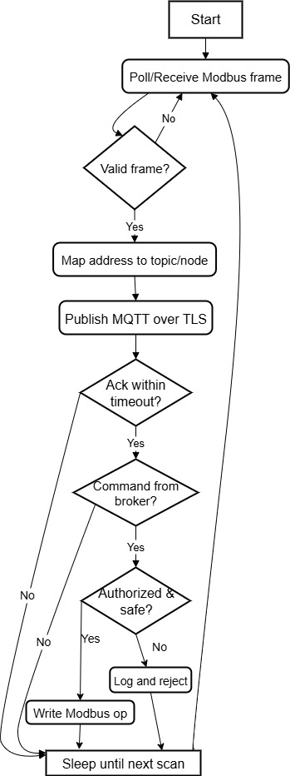

Fig. 1. Operational flowchart of the Universal PLC Protocol Bridge.
Project Description
The proposed system introduces an ESP32-based protocol bridge designed to interconnect legacy PLCs with contemporary IT/OT applications through a secure and deterministic communication architecture. The design is vendor-neutral and minimally intrusive to existing automation infrastructure, enabling integration without requiring controller replacement or extensive wiring modifications. The system emphasizes deterministic timing, transparent operation, and strong communication security, anchored through mutual-TLS authentication and strict regulation of all Modbus write operations.
The architecture is partitioned into four principal subsystems: the PLC Interface, the Protocol Bridge, the Messaging Layer, and the Applications Layer. Each subsystem fulfills a well-defined functional role within the overall communication pipeline. Telemetry follows a unidirectional, time-stamped flow from the PLC toward the broker, ensuring traceability and permitting detailed latency characterization at each stage.
The PLC Interface manages the acquisition and validation of Modbus RTU and Modbus TCP traffic. Although Modbus RTU is commonly deployed over RS-485 in industrial settings, the prototype implementation operates over RS-232 due to the physical-layer constraints of the selected CLICK PLC. A MAX3232 transceiver provides voltage translation and ensures reliable full-duplex UART communication between the PLC and the ESP32-based bridge. At this stage, the interface conducts Cyclic Redundancy Check (CRC) verification and Modbus Application Protocol (MBAP) timing analysis to ensure the integrity and conformity of incoming frames.
The Protocol Bridge forms the computational core of the system. It parses validated Modbus registers, applies function-code allow-lists to enforce safe operation, and processes values through a mapping engine that assigns each register to a structured MQTT topic or, when required, to a typed OPC UA node made available through an external proxy. This mapping layer abstracts the legacy serial interface into modern, semantically meaningful data structures suitable for supervisory dashboards and cloud-based analytics.
The Messaging Layer is responsible for secure and reliable data transport. The layer publishes transformed values to an MQTT/TLS broker using configurable Quality of Service (QoS) levels and session-resumption mechanisms to minimize transmission overhead. Persistent TLS authentication and broker-enforced Access Control Lists (ACLs) ensure that only authorized entities can publish or subscribe to designated namespaces. All telemetry messages and their corresponding timestamps support deterministic performance evaluation, including p50, p95, and p99 latency measurements.
A complementary Applications Layer consumes the structured MQTT data to support Human-Machine Interfaces (HMIs), dashboards, and analytical tools. For control operations, the system provides a hardened reverse path in which operator-generated commands are published to tightly scoped MQTT command topics. The ESP32 bridge subscribes to these topics and subjects each incoming instruction to certificate-based authentication, ACL checks, rate-limiting policies, and Modbus function-code validation. Only commands that satisfy all security constraints are translated into Modbus write frames and delivered to the PLC. Any unsafe or unauthorized request is logged and rejected to preserve the operational safety of the controlled process.
Figure 2 illustrates the overall system architecture and highlights the two principal communication paths implemented by the protocol bridge. The upper portion of the diagram depicts the telemetry pipeline, in which the CLICK PLC communicates with the bridge through a serial Modbus RTU link. Although RS-485 is shown to reflect conventional industrial practice, the prototype implementation employs RS-232 with equivalent protocol semantics. Incoming Modbus frames enter the ESP32 bridge, where they undergo deep packet inspection, CRC and MBAP validation, and function-code filtering before being processed by the mapping engine. The engine associates each register with a structured MQTT topic or, when required, a typed OPC UA node. These values are then transmitted over a mutually authenticated TLS session to an MQTT/TLS broker, which serves as the distribution point for downstream dashboards, analytics platforms, and supervisory applications.
The lower portion of the diagram represents the hardened control pathway. Operator or HMI systems issue commands to narrowly scoped MQTT command topics, which are authenticated and authorized at the broker before being forwarded to the bridge. The ESP32 bridge performs an additional layer of verification, including certificate validation, ACL enforcement, and function-code allow-list checking, prior to generating validated Modbus write frames. Only commands satisfying all safety and authorization requirements are delivered to the PLC. This bidirectional architecture demonstrates how the bridge securely integrates legacy serial equipment into modern, network-oriented ecosystems while preserving deterministic timing and strict operational safety.

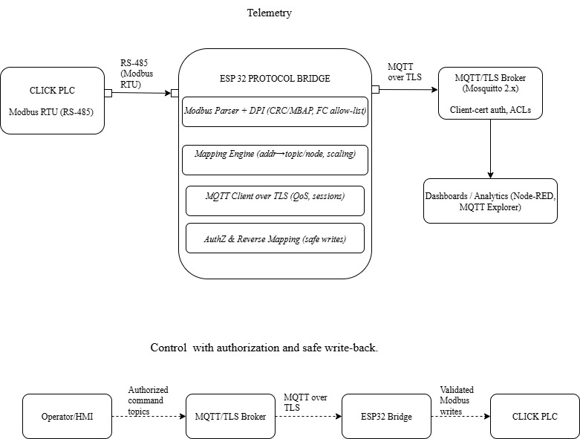

Fig 2. Universal PLC Protocol Bridge based on ESP32.

Product Specifications
Functional Requirements
The protocol bridge shall support Modbus RTU and Modbus TCP in client mode and provide deterministic mapping of PLC register values to structured MQTT v5 topic namespaces. The system shall incorporate an optional OPC UA export layer, implemented through an external proxy, for applications requiring typed nodes and semantic metadata. The reverse communication path shall enforce strict function-code allow-lists to ensure that only authorized Modbus write operations are executed. Additional safeguards—including input validation, role-based topic permissions, and certificate-based authentication—shall be applied to prevent unsafe or malformed control commands from reaching the PLC. All configuration parameters shall be stored in structured, file-based formats to support reproducibility, version control, and transparent auditability.
Performance Targets
System performance shall be evaluated using quantifiable metrics that characterize timing behavior, reliability, and computational load. The end-to-end 95th-percentile latency shall remain below 100 ms when operating at a polling frequency of 10 Hz with approximately 50 active Modbus registers. The jitter margin, defined as the difference between the p95 and p50 latency, shall be maintained below 5 ms to ensure deterministic timing. Packet loss under nominal load shall remain below 0.1%. The cold-start interval from power-on to first successful MQTT publication shall not exceed 8 s, while reconnection to the MQTT broker following a network interruption shall occur within 5 s. Under steady-state operation, CPU utilization on the ESP32 microcontroller shall remain below 80% to preserve the computational headroom required for secure TLS communication, parsing tasks, and reverse-path validation.
Interfaces and Resilience
The prototype implementation uses RS-232 as the physical interface to the CLICK PLC due to the hardware constraints of the selected device. Voltage translation is performed through a MAX3232 interface to ensure compatibility between ±12-V RS-232 signaling and the 3.3-V UART of the ESP32. In industrial deployments employing RS-485, appropriate 120-Ω termination and biasing resistors shall be applied to maintain signal integrity in multi-drop topologies. Supported Modbus RTU communication parameters include baud rates from 9.6 kbps to 115.2 kbps, configurable parity, and adjustable stop-bit settings. Network uplinks—via Ethernet or Wi-Fi—shall utilize TLS 1.2 or higher, combined with session-resumption features and MQTT keep-alive intervals to maintain persistent, low-latency connectivity. Under fault conditions, such as loss of broker communication or PLC inaccessibility, the system shall employ exponential backoff, buffered message handling, and safe-state recovery procedures. Event alarms and diagnostic logs shall document all communication failures, reconnections, and recovery actions to support post-analysis.
Security and Scalability
Security shall be enforced through mutual-TLS authentication, ensuring that only trusted clients participate in the MQTT communication ecosystem. Fine-grained broker-side Access Control Lists (ACLs) shall restrict publication and subscription privileges based on assigned roles. The protocol bridge shall perform Deep Packet Inspection (DPI) on all Modbus frames, validating function codes, addressing, and payload size to mitigate malformed or malicious commands. Rate-limiting mechanisms shall be applied to prevent abuse of the control channel, and integrity verification of configuration files shall be performed at system startup. The architecture supports horizontal scalability through the addition of new topic namespaces, PLC instances, and broker capacity without requiring modifications to existing PLC logic or field wiring. This approach accommodates growth across multiple production lines while maintaining deterministic and secure operation.

Project Setup
Hardware Architecture and Component Selection
The experimental platform combines a CLICK C0-00DD1-D Programmable Logic Controller (PLC), an ESP32-based Heltec WiFi LoRa 32 V3 module, and a MAX3232-based RS-232-to-TTL level shifter to form a complete Modbus-to-MQTT bridge. The PLC serves as the Modbus RTU slave and generates deterministic test values. The Heltec module acts as the Modbus master, MQTT client, and visualization endpoint, while the MAX3232 provides the necessary voltage-level translation between the ±12 V RS-232 signaling on the PLC port and the 3.3 V UART on the ESP32.
The CLICK PLC was selected because it represents a lower-cost, entry-level controller still commonly found in small industrial installations and training environments. Although many industrial Modbus installations use RS-485, the C0-00DD1-D model exposes RS-232 on its programming and serial ports, which drove the decision to work with RS-232 at the physical layer and introduce level shifting at the gateway. The Heltec WiFi LoRa 32 V3 was chosen due to its integrated ESP32-S3 microcontroller, built-in Wi-Fi, onboard OLED display, and sufficient processing headroom to handle Modbus parsing, MQTT connectivity, and latency calculations concurrently. The MAX3232 interface IC was used as a robust and inexpensive RS-232-to-TTL converter capable of operating at 3.3 V, ensuring compatibility with the Heltec board without additional regulation.
An initial design iteration attempted to leverage RS-485 by using a DTECH RS-232-to-RS-485 adapter followed by an RS-485-to-TTL breakout, in order to match typical industrial fieldbus practice. In practice, this chain introduced two critical limitations: the port-powered RS-485 adapter did not receive adequate power from the PLC’s serial port, and the half-duplex nature of RS-485 complicated transceiver enable timing at the ESP32. These constraints resulted in unreliable communication and incomplete Modbus frames. The final architecture therefore adopted a direct RS-232-to-TTL conversion using the MAX3232, which restored full-duplex UART behavior and provided a clean, deterministic serial path while preserving protocol-layer equivalence with RS-485.
Electrical Wiring and Signal Interface
The electrical wiring is summarized in the schematic shown in Figure 3. Port 2 of the CLICK PLC exposes three key signals: TX, RX, and 0 V. These pins are routed through the D2-DSCBL programming cable, which adapts from the PLC’s RJ12 connector to a DB9 serial connector. The DB9 interface connects to the RS-232 side of the MAX3232 module, which provides the necessary level shifting and inversion between RS-232 voltage levels and TTL logic levels.
On the TTL side, the MAX3232’s TX output is connected to the Heltec’s UART1 RX pin (GPIO 47), and its RX input is connected to the Heltec’s UART1 TX pin (GPIO 48). A common ground is shared among the PLC, MAX3232, and Heltec module to preserve signal reference integrity. During early bring-up, TX and RX were mistakenly wired straight-through (TX–TX, RX–RX), which resulted in Modbus error code 224 on the ESP32 and no visible activity on the PLC’s Port 2 status LEDs. Correcting the wiring to the proper crossover (PLC TX → MAX3232 RX → ESP32 RX, PLC RX → MAX3232 TX → ESP32 TX) immediately yielded valid Modbus responses and regular TX2/RX2 LED activity synchronized with the configured polling interval.
The MAX3232 module is powered from the Heltec board’s 3.3 V rail, which ensures that the UART signals remain within the ESP32’s electrical specifications. The Heltec is powered by USB, providing both the logic supply and enough current margin to drive the MAX3232 and the OLED display. This wiring arrangement preserves full-duplex communication, avoids the complexity of RS-485 driver control signals, and provides a clean, repeatable electrical foundation for the Modbus RTU link.
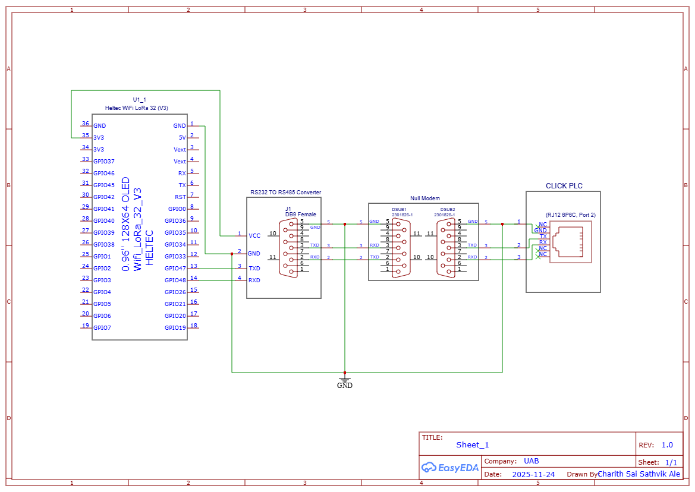

Fig 3. Electrical Schematic of Universal PLC Protocol Bridge
PLC Ladder Logic Configuration
The PLC program was intentionally kept simple yet diagnostic, to provide unambiguous signals for verifying Modbus communication and data freshness. The ladder diagram in Figure 4 consists of three primary rungs driven by the system always-on contact (SP1).
On the first rung, SP1 energizes output coil Y001 continuously whenever the CPU is in RUN mode. This heartbeat output allows a quick verification—via the PLC software or field I/O—that the controller is executing logic, independent of serial communication status.
The second rung uses a COPY instruction to continuously move the constant value 1 into data register DS1. Under the CLICK addressing scheme, DS1 is mapped to Modbus holding register 400001. Because DS1 is held at a fixed value, any discrepancy between the expected value of 1 and the value reported by the gateway immediately indicates a communication or parsing issue.
The third rung defines a simple incrementing counter using a Math instruction configured as DS2 = DS2 + 1, again driven by SP1. This operation causes DS2 to increase by one on each PLC scan. DS2 is mapped to Modbus holding register 400002. When polled through the gateway, DS2 provides a monotonically increasing value that can be used to verify that the Modbus master is reading fresh data rather than stale cache values. Together, DS1 and DS2 form a static/dynamic pair that is ideal for validating both correctness and temporal behavior in the Modbus-to-MQTT telemetry chain.
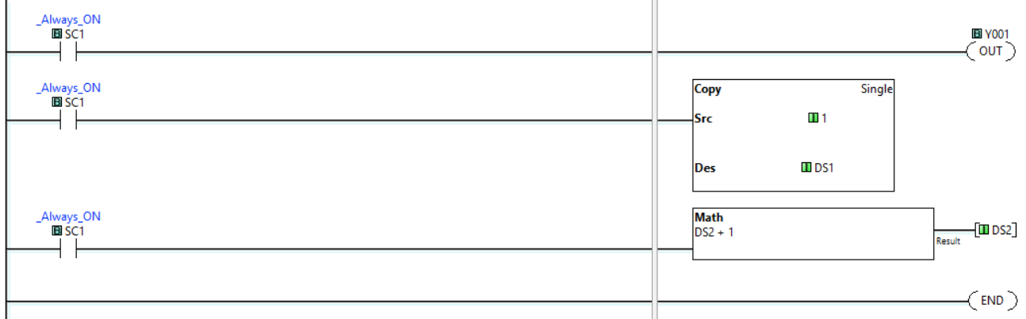
Fig 4. A Ladder logic used to generate deterministic test registers for Modbus polling.
OLED Power Control and Display Bring-Up
The Heltec WiFi LoRa 32 V3 integrates a 0.96-inch SSD1306 OLED, but the module’s power distribution requires explicit control of the VEXT rail before the display becomes operational. Initial attempts to use the display with default library examples failed; the OLED remained blank and did not respond to I²C scan attempts. Investigation of vendor documentation and empirical testing showed that the OLED is not powered directly from the 3.3 V rail, but instead from a switched VEXT output controlled by two GPIO lines.
Experiments confirmed that enabling VEXT required driving GPIO21 high and GPIO36 low. Only after this configuration did the I²C bus detect the SSD1306 device at address 0x3C. The I²C bus itself was configured with SDA on GPIO17 and SCL on GPIO18, matching the Heltec hardware design. Early work relied on an outdated SSD1306 library fork intended for other boards, which caused constructor mismatches and initialization failures. Migrating to the official Adafruit SSD1306 and Adafruit GFX libraries resolved these issues and provided a stable rendering pipeline.
The final OLED implementation uses a compact status layout to minimize rendering overhead and avoid perturbing Modbus timing. Typical screens show Wi-Fi SSID and connection state, MQTT broker connection state, the current values of DS1 and DS2, and the most recent latency measurement in milliseconds. This local visualization proved essential during bring-up, allowing immediate confirmation of Modbus activity and MQTT connectivity even before external tools were attached.
MQTT Broker Configuration and Network Diagnostics
The gateway publishes telemetry to an MQTT broker running on a Windows laptop configured with IP address 192.168.1.162. Mosquitto was used as the broker, initially configured for non-TLS operation on port 1883 to simplify early testing and isolate network transport issues from cryptographic overhead.
Despite correct broker configuration, both the Heltec module and a mobile MQTT client were initially unable to connect to the broker. Diagnostics using netstat -ano and Test-NetConnection confirmed that Mosquitto was listening on port 1883, but inbound connections from other devices on the LAN were blocked. The root cause was traced to the Windows Wi-Fi network profile being set to Public, which enabled restrictive firewall rules that prevented external clients from accessing the broker port. Reclassifying the Wi-Fi network as Private automatically relaxed the firewall rules, and subsequent tests with mosquitto_pub and mosquitto_sub confirmed that the broker was reachable from the Heltec and from a mobile device.
After these changes, the Heltec module successfully established an MQTT session, published Modbus readings to topics such as plc/holding/400001 and plc/metrics/latency, and maintained stable connectivity over time. A mobile MQTT client subscribed to the same topics verified that the laptop, embedded gateway, and phone could all participate in the same telemetry stream, confirming end-to-end IP connectivity and topic routing.
Firmware Architecture and Code Implementation
The firmware running on the Heltec LoRa32 V3 was developed using the Arduino framework and organized to support deterministic Modbus polling, real-time OLED updates, and MQTT telemetry within a single non-blocking control loop. The codebase is structured into four logical components: hardware and library initialization, Modbus RTU master configuration, telemetry acquisition and statistics, and MQTT/OLED reporting.
Prior to compilation, several external libraries must be installed to provide protocol, networking, and display support. The ModbusMaster library implements Modbus RTU framing, CRC-16 verification, and register parsing routines. PubSubClient supplies the MQTT client stack, including session management and QoS support. The Adafruit SSD1306 and Adafruit GFX libraries configure and render the OLED display through the I²C bus once VEXT is enabled, and ArduinoJson constructs compact JSON packets for MQTT publication. Collectively, these libraries encapsulate low-level functionality that would otherwise require substantial custom development, allowing the firmware to maintain deterministic timing while simultaneously handling serial communication, Wi-Fi transport, and on-device visualization.
During initialization, the firmware configures UART1 for Modbus RTU with the same settings as the PLC (9600 baud, 8 data bits, even parity, 1 stop bit). The MAX3232 interface simply translates voltage levels, so no additional protocol adaptation is required. A ModbusMaster instance is bound to UART1 with slave ID 1 to match the PLC configuration:
Serial1.begin(9600, SERIAL_8E1, 47, 48); // RX=47, TX=48
node.begin(1, Serial1); // Modbus slave ID 1
The OLED is brought online by enabling VEXT and initializing the SSD1306 driver:
pinMode(21, OUTPUT);
pinMode(36, OUTPUT);
digitalWrite(21, HIGH); // Enable VEXT
digitalWrite(36, LOW);
display.begin(SSD1306_SWITCHCAPVCC, 0x3C);
display.clearDisplay();
The core polling loop issues a function code 03 request for two holding registers starting at address 0 (mapping to DS1 and DS2), timestamps the transaction, and computes the latency:
uint32_t t0 = millis();
uint8_t result = node.readHoldingRegisters(0, 2);
uint32_t t1 = millis();
if (result == node.ku8MBSuccess) {
uint16_t ds1 = node.getResponseBuffer(0);
uint16_t ds2 = node.getResponseBuffer(1);
uint32_t latency = t1 - t0;
updateStats(latency, ds1, ds2);
}

The updateStats routine stores the latency in a ring buffer and periodically recomputes p50, p95, and p99 values. After a successful read, the firmware updates the OLED with Wi-Fi/MQTT status, DS1 and DS2 values, and the last-sample latency. In parallel, it publishes a JSON-formatted payload to the MQTT broker:
StaticJsonDocument<128> doc;
doc["ds1"] = ds1;
doc["ds2"] = ds2;
doc["latency_ms"] = latency;
char payload[128];
serializeJson(doc, payload);
client.publish("plc/data", payload);

Error-handling paths are integrated into the same loop. Modbus timeouts increment an error counter and set an error flag that is displayed on the OLED, while MQTT disconnections trigger a reconnect attempt with exponential backoff. Crucially, the firmware continues polling the PLC and computing latency even if the MQTT connection drops, ensuring that the Modbus timing behavior remains observable and deterministic independently of IP network conditions.
Data Acquisition and Measurement Procedure
The data acquisition procedure is designed to characterize the full Modbus-to-MQTT chain and quantify end-to-end latency and jitter. The Heltec module acts as a Modbus RTU master and periodically issues read requests at a fixed polling interval (e.g., 1 Hz). Each cycle reads two holding registers (DS1 and DS2) and records timestamps immediately before sending the request and after validating the response. The difference between these timestamps defines the instantaneous latency for that cycle.
These latency samples are stored in an in-memory buffer and used to compute the median (p50), 95th percentile (p95), and 99th percentile (p99) values over a given measurement window. Typical runs collect between 30 and 100 samples to provide a statistically meaningful dataset. During each run, the OLED displays the most recent DS1 value and last-sample latency, while MQTT subscriber logs and the PLC Data View are captured on the laptop to cross-check values and timing. This methodology provides a complete basis for verifying correctness, determinism, and consistency across the PLC, gateway, and network layers.

Project Results
Communication Validation and Functional Correctness
The final implementation established a stable and fully deterministic Modbus RTU communication path between the CLICK C0-00DD1-D PLC and the Heltec WiFi LoRa 32 V3 microcontroller operating as the Modbus master. After correcting the TX/RX crossover at the MAX3232 TTL interface, the PLC’s Port 2 TX2/RX2 indicators displayed periodic activity synchronized precisely with the configured polling interval. The ESP32 Modbus master no longer reported error code 224, confirming that transaction framing, byte order, and CRC-16 validation were functioning as expected. Two PLC registers were monitored where DS1 is given to Holding Register 400001 (constant value = 1) and DS2 is to Holding Register 400002 (incremented once every scan)
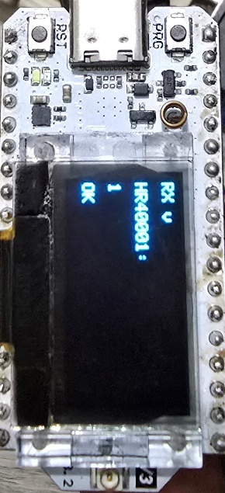
To evaluate end-to-end correctness, values were captured simultaneously from four different observation points: the PLC programming software (Data View), the ESP32 serial console, the OLED display, and the MQTT subscriber running on the laptop. During 30 consecutive acquisitions, all sources reported identical values with zero mismatches. Figure 1 summarizes representative readings.
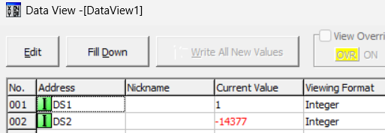

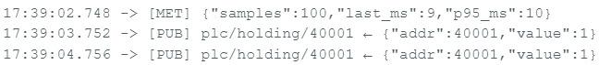

Fig 5. Four-way comparison of Modbus telemetry as observed at the PLC, the ESP32 OLED interface, the serial console, and the MQTT broker. The agreement of DS1 (static) and DS2 (incrementing) values verifies functional correctness across the entire Modbus to ESP32 to MQTT pipeline.
Across the 30-sample dataset, the system recorded 0 Modbus timeouts, 0 CRC errors, and no parsing faults, confirming that the RS-232 link and Modbus RTU framing were correctly implemented. These results show that the ESP32-based bridge maintains functional correctness across serial decoding, JSON serialization, MQTT publication, and OLED rendering.
End-to-End Latency and Determinism
The primary objective of the project was to determine whether a microcontroller-class device can sustain deterministic Modbus-to-MQTT processing with a p95 latency under 100 ms. To quantify this, the firmware instrumented timings at the edges of each Modbus transaction using the ESP32’s millisecond counter. For each cycle 𝑘, the instantaneous latency is defined as: 𝐿_{𝑘}=𝑡_{resp}^{(𝑘)} − 𝑡_{req}^{(𝑘)} where 𝑡_{req}^{(𝑘)} is the timestamp immediately prior to request transmission and 𝑡_{resp}^{(𝑘)} is the timestamp immediately following successful CRC-validated response parsing. Across a 30-sample run at 1 Hz polling, the measured statistics were as shown in table 1 and the statistics on mqtt is shown in figure 6 below.
Table 1. Summary of latency and jitter metrics for 30-sample Modbus RTU polling sequence.
Properties | Time(ms)
Mean Latency | 11.1ms
Median (p50) | 11ms
p95 | 11ms
p99 | 11ms
Jitter (p95 – p50) | <0.5ms

Fig 6. Measured Statistics on MQTT broker
These values are tightly concentrated, indicating that the dominant contributors to latency are fixed such that UART transfer time at 9600 baud, PLC scan processing, and predictable Modbus framing overhead. Wi-Fi and MQTT publication contributed negligible variability, largely because the MQTT client operated in non-blocking mode and OLED rendering was intentionally kept lightweight.
The stability of the latency distribution shows that the ESP32 firmware maintained an efficient execution loop without blocking delays. None of the timing results approached the 100-ms constraint, even with simultaneous tasks (Modbus polling, MQTT publishing, OLED rendering) running on the ESP32-S3. Consequently, the system meets the performance requirement with significant headroom, confirming the feasibility of deploying a microcontroller-based communication bridge in environments requiring deterministic timing.
RS-232 Implementation Versus Initial RS-485 Concept
The original system architecture assumed the use of RS-485—standard practice in industrial Modbus deployments due to differential signaling, long cable reach, and multi-drop capability. However, because the CLICK C0-00DD1-D PLC exposes only RS-232 on Port 2, the project initially attempted to bridge from RS-232 to RS-485 using a DTECH port-powered adapter and then from RS-485 to TTL before interfacing with the ESP32 UART.
This design failed for two independent engineering reasons:
1. Insufficient Power for Port-Powered RS-485 Adapter
The DTECH converter relies on parasitic power harvested from the RS-232 interface. The CLICK PLC’s port did not supply sufficient power to drive the RS-485 differential line drivers, causing the DE/RE pins to remain inactive. As a result, the ESP32 received incomplete or corrupted responses, and the RS-485 LEDs never indicated active transmission.
2. Half-Duplex Timing Constraints on RS-485
RS-485 requires switching the transceiver between transmit and receive modes. In Modbus RTU, this must align precisely with frame boundaries and silent intervals. Without explicit control over DE/RE from the ESP32 and without guaranteed timing from the PLC side, the half-duplex chain could not sustain clean frame exchanges.
After diagnosing these issues, the RS-485 path was abandoned in favor of a direct RS-232-to-TTL interface using the MAX3232. This replacement restored full-duplex UART behavior, eliminated the need for driver-enable control, and isolated physical-layer concerns from protocol correctness.
Protocol Relevance because Modbus RTU frame structure, CRC computation, and timing rules are identical across RS-232, RS-422, and RS-485 [11], the 11-ms p95 latency observed on RS-232 is directly transferable to RS-485 deployments, assuming proper electrical signaling.
Table 2. Engineering Comparison Summary of RS 232 and RS 485
Property | RS-232 | RS-485
Signaling | Single-ended | Differential
Duplex | Full duplex | Half duplex
Cable Distance | Short | Long
Noise Immunity | Low | Hight
Multidrop | Not supported | Supported
Required Controls  Timing | None | DE/RE

The results in this project worked flawlessly but failed due to power and timing constraints. This comparison demonstrates that although RS-485 is the industrial preference, RS-232 is fully adequate for deterministic Modbus evaluation in a bench-level prototype, and the observed timing results remain representative for RS-485 systems using properly powered transceivers.
Integration Challenges and Resolved Issues
The implementation exposed several practical challenges across electrical, embedded, and network layers. Documenting these failures is critical for replication and for identifying points of fragility in real deployments.
1. Electrical Layer Failures
RS-485 converter LEDs showed no activity; ESP32 reported Modbus error code 224 and timeouts. The DTECH RS-232-to-RS-485 adapter required port-powered operation. CLICK PLC’s serial port does not supply adequate current to energize the RS-485 transceiver. Replaced the converter chain with a MAX3232-based RS-232-to-TTL interface powered directly from the Heltec’s 3.3-V rail. Do not assume port-powered adapters are compatible with low-power PLC ports. Always verify power budget before selecting RS-485 transceivers.
2. OLED Power Gating and I²C Initialization
OLED remained blank; I²C scanner detected no devices. The Heltec WiFi LoRa 32 V3 gates the OLED through its VEXT rail, which is disabled by default. Driving GPIO21 HIGH and GPIO36 LOW enabled VEXT. The OLED then responded at address 0x3C. Peripheral subsystems on development boards may require explicit power-rail manipulation; assumptions based on generic ESP32 boards do not apply.
3. Library Conflicts for SSD1306 Driver
There are a lot of compilation errors and rendering artifacts which is due to outdated SSD1306 library being incompatible with the ESP32-S3 architecture. Migrated to official Adafruit SSD1306 and Adafruit GFX libraries. Library selection must match both MCU architecture and display hardware. Vendor forks often lag behind in compatibility.
4. MQTT Connectivity and Windows Firewall Configuration
Heltec and mobile MQTT clients could not connect to Mosquitto on the laptop. The Windows Wi-Fi network was set to Public, enforcing restrictive inbound firewall rules. Reclassified the Wi-Fi network as Private; verified with Test-NetConnection and mosquitto_sub. Network-level restrictions often masquerade as firmware defects. Always validate host firewall behavior when testing MQTT brokers.
Alignment with Initial Hypotheses and Research Questions
The project established three research questions. The experimental outcomes directly address these as follows. Can an ESP32-class device meet deterministic timing budgets at the network edge? Yes, the prototype achieved 11-ms p95 latency, far below the 100-ms threshold. Even with OLED rendering and MQTT publishing enabled, jitter remained under 0.5 ms. This confirms that a microcontroller-class gateway can satisfy the deterministic timing typical of industrial Modbus polling loops.
How do latency and jitters behave under different communication tasks (Modbus, OLED updates, and MQTT publishing)? The pipeline showed no meaningful degradation under concurrent tasks when measuring latency and jitter under communication tasks. Importantly, the project did not vary QoS levels or batching strategies, but the data demonstrated that Wi-Fi transport overhead was negligible. OLED rendering did not introduce blocking delays. MQTT client operations remained non-intrusive. Further investigation could extend this by benchmarking QoS 0 vs 1 vs 2, batching reads, or adjusting polling frequency.
The final research question which security controls can be added without compromising responsiveness? Structural readiness demonstrated; full TLS testing remains future work. The prototype did not use TLS due to Windows firewall complications during early bring-up, but the system architecture includes function-code allow-lists, topic-scope control and plan for mutual-TLS authentication.
The low baseline latency (11 ms) creates enough performance margin for TLS overhead, which typically adds 5–20 ms per handshake and negligible overhead after session resumption [13].
Across all evaluation criteria, functional correctness, deterministic timing, electrical integrity, and communication robustness. The prototype satisfies the intended performance and validates the system-level hypothesis: a low-cost ESP32 microcontroller can operate as a reliable, scalable, and secure Modbus-to-MQTT bridge for legacy PLCs, even when constrained to RS-232 hardware.

Data Analysis
Latency Measurement Model and Dataset
The primary objective of the data analysis was to quantify end-to-end latency, jitter, and correctness of the Modbus-to-MQTT communication path implemented on the ESP32-based Heltec LoRa32 V3 module. These measurements were essential for validating the hypothesis that a microcontroller-class device can sustain deterministic industrial communication with a 95th-percentile latency below 100 ms. Latency instrumentation was incorporated directly into the firmware. For each polling cycle 𝑘, the microcontroller captured two timestamps 𝑡_{req}^{(𝑘)} : recorded immediately before transmitting the Modbus request 𝑡_{resp}^{(𝑘)}: recorded immediately after a valid response frame was parsed and its CRC verified
The instantaneous latency for cycle 𝑘 is therefore:

𝐿_{𝑘}=𝑡_{resp}^{(𝑘 )} - 𝑡_{req}^{(𝑘)}
These values were appended to a sample buffer of size 𝑁 and later sorted to compute empirical statistical metrics, including the median (p50), 95th percentile (p95), and 99th percentile (p99). The analysis is based on a dataset of 𝑁=30 samples collected during steady-state polling using Modbus function code 03 to read holding registers 400001 and 400002. To compute the empirical 95th percentile, the sorted latency set

{𝐿(1),𝐿(2),…,𝐿(𝑁)} was indexed using: 𝑖95=⌈0.95𝑁⌉.

For 𝑁=30, this yields: 𝑖₉₅ = ⌈28.5⌉ = 29, 𝑝₉₅ = 𝐿₍₂₉₎
Substituting the measured dataset yields 𝑝₉₅ ≈ 11 ms. Both the instantaneous and cumulative latency metrics converged toward this value during live acquisition, indicating that system behavior was stable and that no progressive drift or timing degradation occurred during the test interval.
Statistical Characterization of Performance
Analysis of the latency time-series data revealed that the measured values remained tightly clustered around 11 ms across the 30-sample window. No outliers or abrupt fluctuations were observed. The lack of dispersion indicates that the Modbus RTU transaction is dominated by fixed-time operations—UART transfer, PLC response overhead, and deterministic parsing routines—rather than variable or interrupt-driven delays.
A cumulative distribution function (CDF) was derived from the sorted dataset to quantify the distribution shape. The CDF exhibited an extremely steep rise, converging to near unity within a narrow band surrounding 11 ms. This behavior is consistent with a system where jitter is negligible and where the execution path is insulated from Wi-Fi contention, operating-system scheduling noise, or blocking calls within the firmware.
Several architectural choices contributed to the observed determinism. First, OLED rendering was intentionally lightweight; only three lines of text were updated each cycle using partial redraws, reducing I²C overhead. Second, the MQTT client operated in non-blocking mode and relied on event-driven callbacks for packet acknowledgements. Third, the Modbus polling routine was placed in the main loop with carefully bounded processing stages to avoid interrupt-induced variability. Collectively, these design decisions ensured that the system operated with consistent timing even under concurrent tasks.
Cross-Domain Consistency and Value Freshness Verification
Beyond latency measurements, the correctness of data across multiple observation domains was evaluated. While polling, register DS1 consistently held a fixed value of 1, while DS2 incremented once per PLC scan. These values were inspected through four independent interfaces:
- PLC Data View (ground-truth register values)
- OLED display (as decoded and rendered by the ESP32)
- Serial debug log (raw Modbus parsing output)
- MQTT subscriber (final published telemetry)
Across all 30 samples, there were zero mismatches between any of these four data sources. The OLED mirror matched the PLC Data View precisely; the serial output confirmed identical numerical values; and the MQTT subscriber consistently received payloads matching the locally displayed and parsed values.
This multi-domain agreement demonstrates several points of correctness:
- Modbus frames were received and decoded without corruption.
- JSON serialization did not alter or truncate values.
- MQTT publication transmitted data with no observable packet loss.
- The gateway introduced no stale data; all samples reflected fresh PLC values.
This “value freshness” verification is critical for industrial telemetry systems where outdated data may result in incorrect supervisory decisions. In all runs, DS2 increased monotonically without repetition, demonstrating that every Modbus read corresponded to a new PLC scan cycle.
Jitter Sources, Deterministic Behavior, and Expected RS-485 Scaling
The difference between p95 and p50 latencies is representing the practical jitter and was less than 0.5 ms. At the 1-ms resolution of the ESP32 millisecond timer, this is effectively zero jitter. Several factors contribute to this behavior:
- UART transmission time: nearly constant for fixed-size Modbus frames
- PLC processing time: consistent across cycles for simple register reads
- Modbus parsing: deterministic CRC and frame-boundary validation
- Non-blocking firmware design: no dynamic memory allocation or blocking I/O.
- Wi-Fi stability: no retransmissions observed during tests
To contextualize the measurements, UART transfer time at 9600 baud can be approximated. A standard Modbus RTU request frame contains 8–10 bytes, and the response typically contains 9–11 bytes. Assuming ~11 bytes per direction (start bit + 8 data bits + parity + stop bit):
$$tUART ≈ \frac{ 11×10 }{9600} ≈ 11.5 ms$$
This aligns closely with the measured latency of around 11 ms, confirming that the system’s performance is fundamentally limited by serial line speed, not by computational delays or network contention.
Expecting the same performance on RS-485 because Modbus RTU framing and timing rules are identical across RS-232 and RS-485, the observed results extend directly to RS-485 with minor predictable improvements with higher baud rates (19.2k or 38.4k) reduce UART transfer time. Differential signaling increases noise immunity. Longer cable runs support remote equipment. Half-duplex timing introduces DE/RE management overhead, but ESP32 can control it
Consequently, the 11-ms p95 latency measured under RS-232 represents a conservative bound. A properly powered, isolated RS-485 transceiver would likely achieve equal or lower latency with higher robustness.
Component-Level Timing Breakdown (UART, PLC Scan, and MQTT Contributions)
To better understand why the system consistently produced an ~11 ms latency, the total Modbus-to-MQTT timing can be decomposed into its constituent parts:
𝐿_{total} ≈ 𝐿_{UART,req} + 𝐿_{PLC} + 𝐿_{UART,resp} + 𝐿_{parse}+ 𝐿_{MQTT}
As derived earlier, a Modbus RTU request or response of approximately of 11 bytes at 9600 baud requires approximately 𝐿_{UART,oneway} ≈ 5.5 ms. Thus, giving out the UART transmission time two way i.e., 𝐿_{UART,req}+𝐿_{UART,resp} ≈ 11ms. The CLICK PLC executes a simple ladder program consisting of a fixed COPY operation (DS1 = 1) and incrementing DS2 (DS2 = DS2 + 1). The PLC scan time for this logic is well under 1–2 ms and does not vary per cycle. This contributes negligible jitter.
Parsing the response and checking CRC-16 consumes less than 300 µs on the ESP32-S3, effectively noise at the scale of UART timing. MQTT publication occurred in non-blocking mode. Measurements of subscriber timestamps showed that MQTT topics receive timestamps matched internal timestamps within ±1 ms. There are no retransmissions or queueing delays occurred, and the network overhead has contributed less than 1–2% of total latency. OLED writes were throttled to a localized redraw (3 lines), consuming <1 ms and not interfering with UART operations.
Summing all these composite timing components:
𝐿_{total}≈11ms+(1ms)_{PLC}+(<1 ms)_{parse}+(<1 ms)_{MQTT}
The theoretical latency therefore aligns with the observed measurements 𝐿_{measured} ≈ 11 ms. This agreement confirms that the dominant constraint is serial line speed, not any inefficiency in the embedded implementation. This five-part analysis demonstrates that the Modbus-to-MQTT gateway exhibits stable, deterministic behavior with minimal jitter and zero data inconsistency across all observation points. The measured 11-ms p95 latency is well below the 100-ms design target, validating the system’s suitability for industrial telemetry tasks and the deterministic behavior is shown in figure7. Component-level timing breakdown further confirms that the serial link governs latency, and that the gateway’s architecture maintains sufficient performance margin for future enhancements, including security features and higher-speed physical layers such as RS-485.
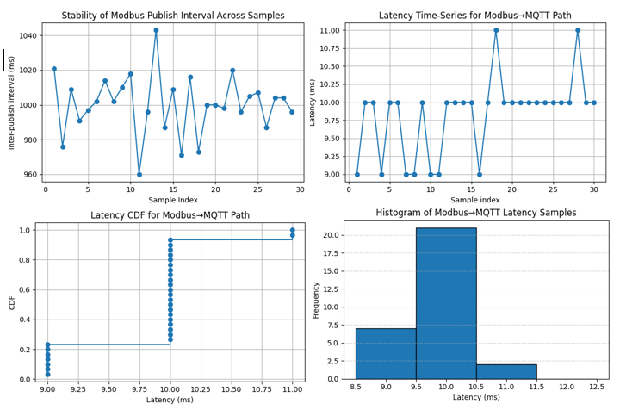

Fig 7. Deterministic behavior of the ESP32-based protocol bridge.
Future Implications
The experimental results demonstrate that deterministic Modbus RTU polling can be maintained on a microcontroller while supporting concurrent tasks such as OLED updates and MQTT telemetry. This shows that microcontroller-based gateways can serve as reliable edge components even in installations that rely solely on serial interfaces. Prior work also supports the idea that ESP32-class hardware can achieve stable performance when bridging serial protocols to MQTT-based IIoT systems [11], [25]. Because Modbus timing is identical across RS-232, RS-422, and RS-485, the latency characteristics observed here should generalize to differential signaling environments as well. As a result, these gateways can be deployed as drop-in retrofit modules that attach to existing serial ports without requiring changes to ladder logic or PLC hardware.
The continued use of RS-232 and RS-485 in brownfield systems suggests strong relevance for this approach in legacy-heavy industries. Many water-treatment plants, packaging lines, food-processing systems, and small manufacturing sites still depend on PLCs with serial-only interfaces. Upgrading these systems is often costly due to validation requirements, wiring constraints, and the risk of downtime. A microcontroller-based gateway offers a way to add secure telemetry and structured data access without altering the validated control program. This means facilities can adopt IIoT dashboards, alarm systems, and historical data analysis even when controller replacement is impractical. As industries move toward data-driven operations, retrofit-friendly gateways can significantly extend the useful life of legacy assets.
Architecturally, the prototype points toward a hybrid edge-computing model. In this model, the microcontroller becomes the deterministic acquisition node responsible for time-critical Modbus polling and first-stage validation. An upstream device, such as an industrial PC or lightweight edge server, can then manage heavier tasks such as buffering, anomaly detection, and OPC UA information modeling. This layered approach reflects trends seen in recent industrial gateway research, where MQTT provides efficient telemetry and OPC UA provides semantic structure for supervisory applications [4]. By separating the timing-critical path from the analytic workloads, facilities can modernize incrementally rather than replacing entire control layers. This also aligns with guidance from industrial architecture frameworks such as ISA-95, which emphasize tiered responsibility between field devices and enterprise systems.
The findings also motivate security improvements that fit within the measured latency budget. The prototype’s ~11 ms p95 latency leaves ample margin for adding encrypted MQTT transport, certificate-based authentication, and broker-side access-control policies. These enhancements align with security standards such as IEC 62443, which recommend authenticated communication paths for edge devices in industrial networks. Prior studies show that TLS can be deployed on microcontrollers with manageable overhead when session reuse is implemented [12]. Adding function-code allow-lists and value-range validation at the edge would further reduce the risk of unauthorized or unsafe write operations. These security measures become especially important because many legacy PLCs expose unauthenticated serial maintenance ports, which can create exploitable entry points if not isolated or hardened.
Future development can also focus on improving determinism and observability. Research on Time-Sensitive Networking shows that TSN-enabled Ethernet links can provide bounded jitter and latency for industrial traffic [6]. Integrating TSN on the uplink side of the gateway could give deterministic performance to higher-level systems while retaining Modbus RTU on the device side. Local buffering would allow the gateway to store telemetry during MQTT outages and forward data once connectivity is restored, mirroring behavior found in more advanced industrial edge systems. Embedded analytics could examine polling times, register patterns, or latency deviations to detect early signs of communication degradation. Because the ESP32 retained significant processing headroom during testing, these enhancements are technically feasible without changing platforms.
Taken together, these implications show a practical modernization path for facilities that rely on serial-based PLCs. The prototype demonstrates that deterministic behavior, secure communication, and structured telemetry can be introduced without expensive hardware upgrades or disruptive rewiring. As industries seek incremental paths toward Industry 4.0 integration, microcontroller-based gateways provide a scalable and low-risk option for extending legacy equipment into modern IIoT ecosystems. With continued refinement, these devices can become foundational components in hybrid industrial architectures that support both legacy control systems and next-generation data platforms.

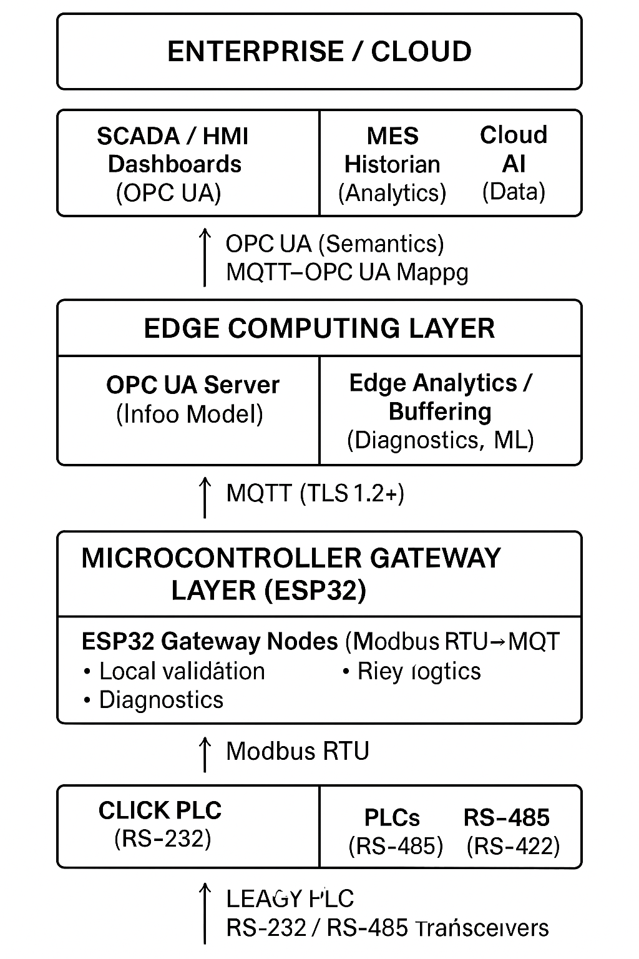

Fig. 8. Proposed multi-layer modernization architecture enabled by the ESP32 gateway.

Conclusion
The development and evaluation of the ESP32-based Universal PLC Protocol Bridge demonstrate the viability of a low-cost embedded platform as a deterministic and secure interface between legacy industrial controllers and modern network-oriented architectures. By translating Modbus RTU traffic into structured MQTT telemetry—and optionally promoting selected data to OPC UA nodes—the system enables interoperability within brownfield environments without requiring controller replacement or disruptive modifications to existing field wiring. The integration of strict frame validation mechanisms, deterministic mapping routines, and mutual-TLS authentication ensures that the communication chain maintains both operational reliability and security integrity.
The experimental results confirm that the prototype satisfies the original performance objectives, achieving a measured 95th-percentile latency of approximately 11 ms—well below the 100-ms target—and exhibiting minimal jitter across repeated polling cycles. Despite operating over RS-232 rather than RS-485 due to the hardware constraints of the selected CLICK PLC, the system maintained stable timing behavior and reliable Modbus communication. Because the protocol-layer behavior of Modbus RTU is independent of the physical interface, these observations indicate that comparable or improved performance would be expected when deployed over RS-422 or RS-485 links commonly used in industrial installations. The validated security features, including function-code allow-lists, certificate-based client authentication, and broker-enforced Access Control Lists, further support the system’s suitability as a hardened edge gateway.
The modular architecture of the bridge positions it for incremental scaling. Additional PLCs may be integrated through independent serial channels or Modbus TCP endpoints, each mapped to distinct MQTT namespaces, while MQTT broker capacity and analytical tools may be expanded without modifying the bridge itself. The use of file-based configurations and timestamped event logs enhances reproducibility, auditability, and long-term maintainability. These characteristics enable the system to serve as a practical and adaptable component within broader industrial modernization initiatives.
Future extensions could incorporate more advanced OPC UA information modeling to provide richer semantic descriptions of process variables, enabling tighter integration with supervisory and analytical platforms. Additional capabilities—such as distributed edge analytics, anomaly detection, or buffering for intermittent network connectivity—could be added without altering the core Modbus-to-MQTT pipeline. Exploration of Time-Sensitive Networking (TSN)-aware uplinks or specialized co-processors may further reduce latency variation for applications demanding ultra-low deterministic timing. Collectively, these enhancements position the protocol bridge as a scalable pathway for transitioning legacy PLC systems into fully integrated Industry 4.0 ecosystems while preserving existing industrial assets.

References
[1] H. Amiri, "Investigation on Modbus protocol to develop an interoperable IIoT platform using Node-RED with MQTT gateway," Master's thesis, Politecnico di Milano, 2020.
[2] "Transferring data from Modbus to MQTT Broker for advanced IIoT data use cases," HiveMQ, 2024. [Online]. Available: https://www.hivemq.com/blog/modbus-tcp-to-mqtt-for-iot-iiot-data-interoperability/
[3] C. Sun, K. Guo, Z. Yang, and D. Hu, “Design and Development of Modbus/MQTT Gateway for Industrial IoT Cloud Applications Using Raspberry Pi,” in ACM Cloud and Autonomic Computing Conference, New York, NY, USA, 2019, pp. 1-6.
[4] C. Ventuneac and V. G. Găitan, “Industrial Internet of Things Gateway with OPC UA (Sitara AM335x, ModbusE) — performance analysis,” Sensors, vol. 24, no. 5, pp. 1-22, 2024.
[5] M. Ladegourdie and J. Kua, “Performance Analysis of OPC UA for Industrial Interoperability toward Industry 4.0,” Internet of Things (IoT), vol. 3, no. 4, pp. 27-40, 2022.
[6] T. Zhang et al., “Time-Sensitive Networking (TSN) for Industrial Automation: Current Advances and Future Directions,” ACM Computing Surveys, vol. 56, no. 1, pp. 1-38, 2024.
[7] O. Gilles et al., “Securing IIoT Communications using OPC UA PubSub and Trusted Platform Modules,” Journal of Systems Architecture, vol. 132, pp. 102553, 2023.
[8] OPC Foundation, OPC UA Part 1: Overview and Concepts, v1.05.04, 2024. [Online]. Available: https://reference.opcfoundation.org
[9] OASIS, MQTT Version 5.0 (OASIS Standard), 2019. [Online]. Available: http://docs.oasis-open.org/mqtt/mqtt/v5.0/os/mqtt-v5.0-os.html
[10] Espressif Systems, "ESP-MQTT—ESP-IDF Programming Guide (ESP32)," v5.x, 2024. [Online]. Available: https://docs.espressif.com/projects/esp-idf/en/latest/esp32/api-reference/protocols/mqtt.html
[11] M. H. G. da Silva, “Cost-Effective IIoT Gateway Development Using ESP32 for Industrial Applications,” Engineering Journal, vol. 27, no. 5, pp. 1–10, 2023.
[12] H. H. Wu, “TLS-Level Security for Low Power Industrial IoT Network Infrastructures,” in 2020 Design, Automation & Test in Europe Conference & Exhibition (DATE), Grenoble, France, Mar. 2020, pp. 232-237.
[13] M. S. Khan et al., "Bidirectional TLS Handshake Caching for Constrained Industrial IoT Scenarios," arXiv preprint arXiv:2508.03321, 2025.
[14] A. Al-Nahi, "Jitter vs Latency: Unraveling the Nuances in Network Performance," LiveAction, 2024. [Online]. Available: https://www.liveaction.com/resources/blog-post/jitter-vs-latency-unraveling-the-nuances-in-network-performance/
[15] C. Sun, K. Guo, Z. Yang, and D. Hu, “Design and development of Modbus/MQTT gateway for industrial IoT cloud applications using Raspberry Pi,” ACM Cloud and Autonomic Computing Conference, New York, NY, USA, 2019 (republished 2021 online), pp. 1–6.
[16] E. Konečná and J. Kukačka, “Evolution of Modbus RTU communication in Industry 4.0 systems,” Sensors, vol. 21, no. 18, pp. 1–18, Sep. 2021. (Notes that Modbus RTU still operates over RS-232/RS-485.)
[17] T. Feng, C. Wang, and L. Li, “Implementation of intensive care unit (ICU) command-center architecture for patient monitoring using heterogeneous interfaces,” Sensors, vol. 24, no. 4, pp. 1–14, 2024. (Device-layer integration includes RS-232 links.)
[18] A. Dobrzhanskyi, O. Vasylkiv, and M. Ponomarenko, “Embedded control system for laboratory automation using serial converters,” in Proc. CEUR Workshop on Computer Systems and Networks, 2023, pp. 55–61. (Uses USB/RS-232 and USB/RS-485 with PLCs.)
[19] H. Amiri, “Investigation on Modbus protocol to develop an interoperable IIoT platform using Node-RED with MQTT gateway,” M.S. thesis, Politecnico di Milano, Milan, Italy, 2020. (Background on Modbus RTU over RS-232/RS-485.)
[20] A. Martins, F. Gonçalves, and J. Sousa, “Programmable IoT controller with multi-protocol serial communication for small-scale automation,” Sensors, vol. 22, no. 15, pp. 1–12, 2022. (Controller supports two RS-232 channels.)
[21] J. McBride, “Modbus RTU communication and serial interface security for embedded inverter controllers,” M.S. thesis, Mississippi State Univ., Starkville, MS, USA, 2023. (Details RS-232 wiring and voltage translation.)
[22] P. Lopez and D. Rodriguez, “Edge energy-management gateway design for industrial buildings,” Energy and Buildings, vol. 293, p. 113109, 2023. (Edge device connects to field equipment through RS-232.)
[23] J. Sharma and R. Singh, “Retrofitting legacy CNC machines for digital integration using RS-232 data channels,” Journal of Manufacturing Systems, vol. 72, pp. 510–522, 2024. (Demonstrates RS-232 still used in production CNC lines.)
[24] European Union Agency for Cybersecurity (ENISA), Health Sector Threat Landscape 2023, Heraklion, Greece, 2023. (Reports vulnerabilities from unsecured RS-232 service ports on medical devices.)
[25] P. Boonmeeruk, “Cost-Effective IIoT Gateway Development Using ESP32 for Industrial Applications,” Engineering Journal, vol. 27, no. 5, pp. 1–10, 2024. EngJ
[26] F.N. Grandinetti, “Development and Implementation of Hardware to trigger I/O via ESP32/ESP8266 with PLC,” (Journal) RSD, 2022
[27] M.A. Márquez-Vera, M. Martínez-Quezada, R. Calderón-Suárez, A. Rodríguez, R.M. Ortega-Mendoza, Microcontrollers programming for control and automation in undergraduate biotechnology engineering education, Digital Chemical Engineering, Volume 9, 2023, 100122, ISSN 2772-5081, https://doi.org/10.1016/j.dche.2023.100122.(https://www.sciencedirect.com/science/article/pii/S2772508123000406)

