Real-Time Walking Speed Estimation and Gait Analysis with Ultrasonic Sensors and Edge AI
Charith Sai Sathvik Ale
#Department of Electrical and Computer Engineering, University of Alabama at Birmingham
1720 University Blvd, Birmingham, AL 35294, USA
cale2@uab.edu

Abstract—Moving difficulties are becoming increasing problematic for elderly people and patients with Parkinson’s disease and multiple sclerosis and other neurodegenerative conditions. The early sign of motor function deterioration is slow walking speed because it serves to identify patients at risk for falls and cognitive decline and overall health decline. Current speed estimation systems together with gait analysis instruments need controlled spaces for operation while remaining too expensive and unable to function for sustained real-world application. The existing wearable devices for monitoring create difficulties with their necessity for user comfort and their requirement of regular calibration. This project develops a budget-friendly real-time walking speed estimator system which integrates an HC-SR04 ultrasonic sensor with ESP32 microcontroller and LoRa technology serving as the main components. The system analyses step frequencies together with stride length measurements through ultrasonic reflection analysis while conducting processing tasks locally with lightweight machine-learning software. Real-time speed estimation occurs at the point where edge AI operates to deliver results without requiring cloud-based calculations which leads to efficient processing with minimum latency. Long-distance data transmission achievable through LoRa technology supports the system to work as an ideal solution for healthcare purposes and fitness tracking and smart city management. The system aims to deliver precise speed computations using reduced energy levels to support immediate tracking capabilities for remote physical assessment systems. This system was developed to detect diseases earlier and monitor rehabilitation and track mobility within elderly care practices. Healthcare institutions together with smart urban environments can use this solution as a scalable and deployable system that functions as an affordable substitute for traditional gait analysis methods within these environments. The proposed system adopts this method to enhance walking speed analytics access especially in resource-limited areas without impacting reliability levels.
Keywords: Walking speed estimation, ultrasonic sensors, edge AI, machine learning, LoRa, real-time monitoring, gait analysis.
- Introduction
Walking speed is a widely recognized biomarker of functional mobility and overall health, with slower gait linked to increased fall risk, reduced independence in older adults, and poorer recovery outcomes following neurological injury [1]. Clinicians and researchers routinely assess walking speed to monitor disease progression, prescribe interventions, and evaluate rehabilitation efficacy. Traditional gold‐standard gait analysis employs optical motion capture systems, which deliver sub‐millimeter spatial accuracy but require extensive camera arrays, reflective markers, and controlled laboratory environments—factors that limit scalability and real‐world applicability [2]. Wearable inertial measurement units (IMUs) offer greater portability and can estimate spatiotemporal gait parameters via sensor fusion of accelerometers and gyroscopes, yet these devices often mandate complex calibration routines, frequent re‐zeroing, and substantial on‐device computation or post‐processing, challenging their adoption for continuous, free‐living monitoring [3].
Pressure‐sensitive mats and instrumented walkways provide precise temporal and spatial metrics but remain fixed to specific clinical locations and cannot accommodate prolonged out‐of‐clinic monitoring [4]. Emerging research has explored ultrasonic sensing as an affordable alternative: Knoll et al. demonstrated treadmill‐based ultrasound gait analysis, achieving millisecond‐scale temporal resolution [5], and several groups have fused gait‐phase models with kinematic filters for adaptive prosthetic control [6]. However, these systems typically rely on tethered setups or offline signal processing, restricting their deployment in everyday settings.
To address these limitations, we propose a fully self‐contained, real‐time walking speed estimation system that leverages a single HC-SR04 ultrasonic rangefinder mounted on the user’s lower leg and a commodity ESP32 microcontroller. Our approach eschews cameras and IMUs, instead capturing inter‐leg separation distances and step timing via ultrasonic echo measurements while the user ambles freely. An embedded two‐layer multilayer perceptron (MLP), trained offline with TensorFlow Lite and implemented in optimized C++ on the microcontroller, classifies gait into three speed categories (“Slow,” “Normal,” “Fast”) and produces continuous speed estimates at 50 Hz. System outputs are rendered on a 128×64 OLED display for immediate feedback, and optional LoRa WAN connectivity enables long-range, low-power telemetry for remote patient monitoring or smart-city applications [7].
Our primary contributions are:
- Knee-Swing Ultrasonic Mounting: We introduce a novel sensor placement and mechanical stabilization method that reliably captures step timing and inter-leg distance without IMU fusion.
- Edge-ML Inference Pipeline: We detail the design and deployment of a compact 2 → 10 → 3 MLP running fully on the ESP32, including fixed-point weight quantization and Re-LU activation, guaranteeing sub-millisecond inference latency.
- Schematics & System Overview

2.1 Hardware Architecture (Figure 1)
Figure 1B illustrates our wearable gait‐estimation platform. An HC-SR04 ultrasonic transducer is rigidly mounted to the user’s leg on the calf for knee-swing; its two “eyes” point directly at the opposite shin. The module is wired into a LoRa32 development board running our edge-AI firmware and is powered by a 3.7 V Li-Po pack. A small OLED display (or serial link) presents the live walking-speed readout, while the LoRa32 simultaneously streams data via USB or Lora WAN for logging and further analysis.

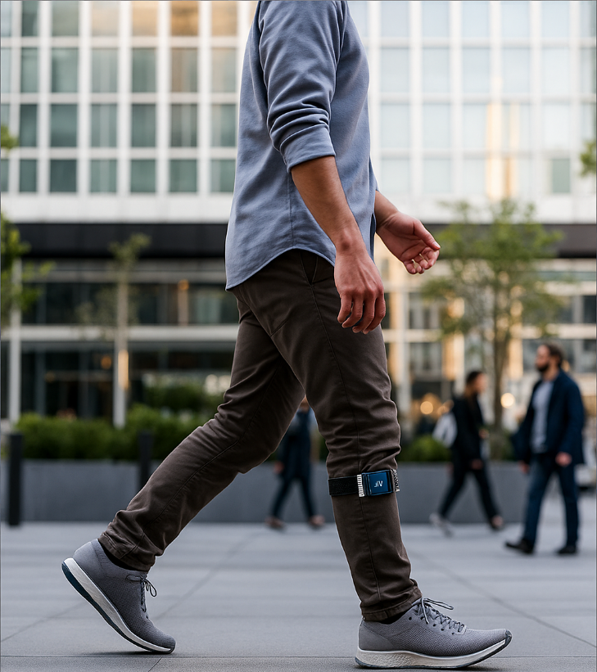
A)

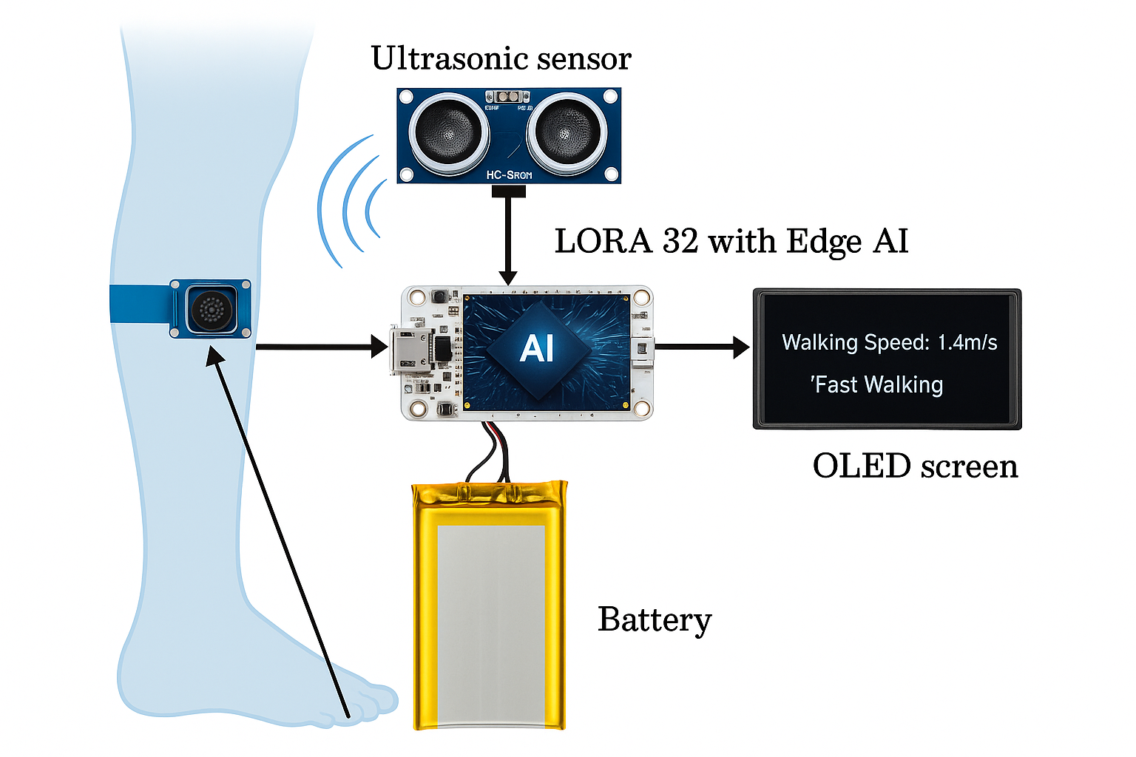

B)
Fig1. A) A person walking with a wearable sensor placed at the knee.
B) Schematic Diagram of the components of the wearable sensor attached to the knee.

2.2 Software Pipeline
Figure 2 shows the real-time data-processing flow running on the LoRa32:
Trigger ultrasonic sensor every 20 ms via the TRIG pin.
Read the echo pulse width on the ECHO pin and convert it to a raw distance d_raw​.
Correct & clamp: d_corr=max(0, d_raw − b), ensuring
d_corr ​≤ 2R.
Compute inter-leg angle α(t)\alpha(t)α(t) using
ϕ=2arcsin (d_corr/2R).
Peak Detection: Detect peaks in ϕ (t) (rising to falling transition) to identify each step and measure the step period Δt_step.
Compute step frequency f_step=1/Δt_step
Estimate walking speed from step amplitude and frequency,
Calculating Step and stride length:
Step_Len=2*R*sin(αmax/2),
stride=2 *step_Len,
Walking Speed:
V_walk=stride*Δt_step.
Smoothing: rolling average over last N steps.

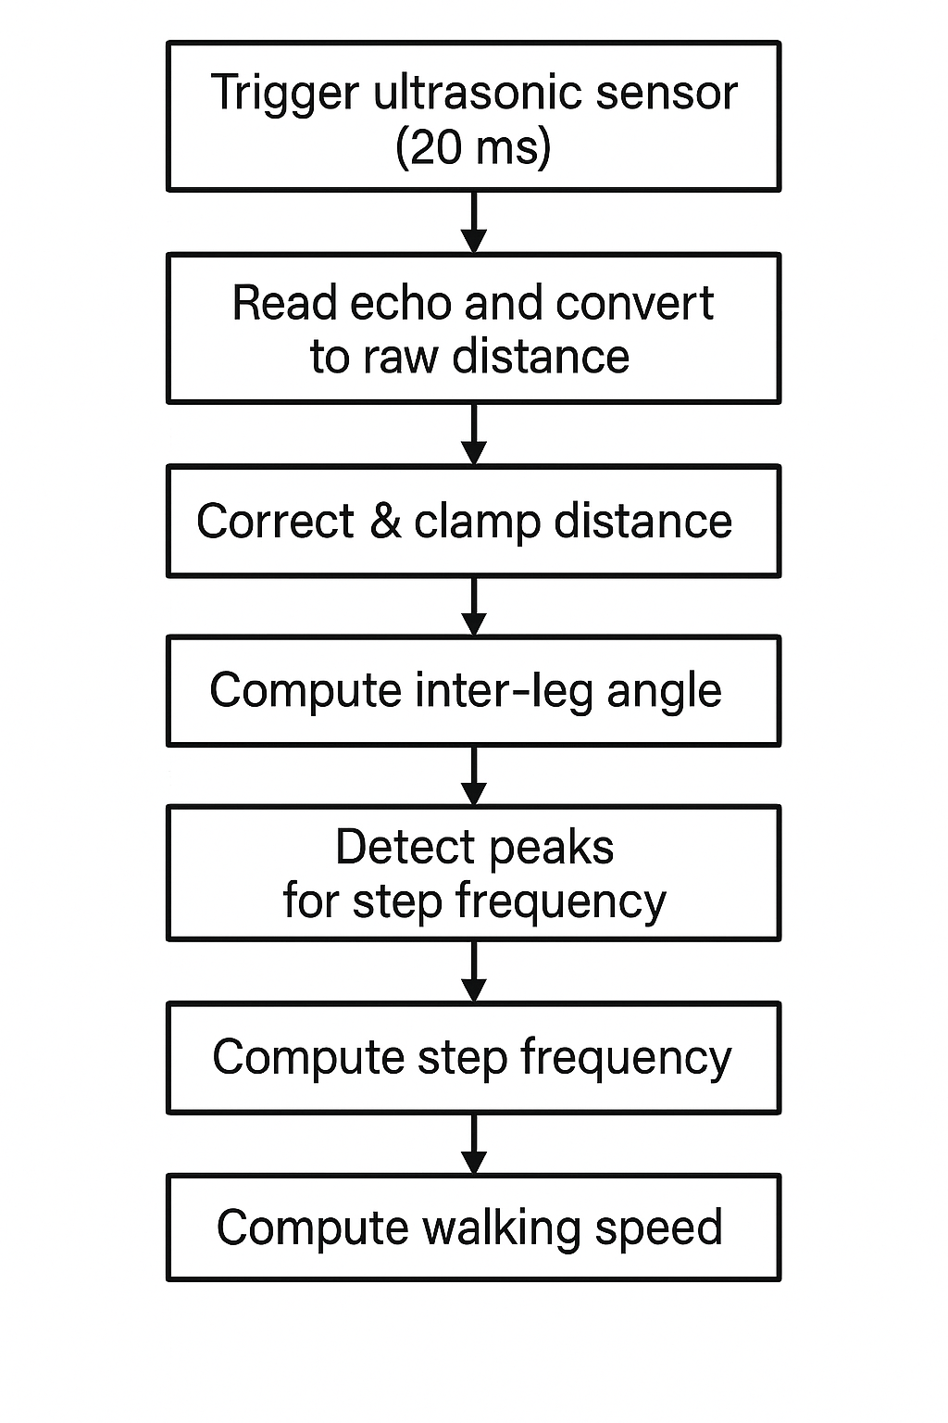
Fig 2: Process flow diagram for on-device signal processing, step detection, and walking-speed estimation
- Experimental Setup & Data Acquisition
A. Subject & Sensor Mounting
All experiments were performed on a single volunteer (the author), male, age 25, height 1.70 m. For the knee‐swing configuration, the HC-SR04 module was mounted 10 cm below the knee pivot on the medial side of the right leg. The transducer “eyes” were oriented horizontally and pointed directly at the opposite shin. The lever arm (R) (distance from the knee hinge to the sensor center) was measured with a flexible tape to be 0.10 m. The static offset (b) was determined by standing with legs together, reading the raw distance d_upright ​, and computing
b=d_raw −R.
B. Walking Protocol
The volunteer performed three trials over a 7 m straight corridor, at self-paced speeds to cover a range of cadences:
- Slow walk (comfortable stroll)
- Normal walk (typical daily pace)
- Fast walk (brisk pace)
For each trial, the stopwatch-measured time to traverse the 7 m distance provided the ground-truth average walking speed V_gt​. The number of full leg swings (steps) N was also counted manually to validate the algorithm’s step detection.
C. Data Logging
All real-time processing and data capture ran on the LoRa32 board, streaming via USB into Excel Data Streamer (COM port, 115200 baud, CSV format). Two record types were logged:
- Per-sample records (every ~20 ms) in the format of
time_ms, d_raw_m, d_corr_m, phi_rad, phi_dot_rad_s
Captures the ultrasonic reading, calibrated distance, computed angle ϕ, and angular velocity ϕ˙​.
- Per-step event records (on each detected peak):
time_ms, phi_max_rad, dt_step_s, stepLen_m, strideLen_m, v_walk_mps
Records the peak inter-leg angle, time since last peak Δtstep, raw step & stride lengths, and the instantaneous walking speed estimate.
After each 7 m walk, the CSV files were saved and imported into Python for offline analysis:
- Compare detected step count vs.\ manual count.
- Compute median raw step length and derive the scaling factor k.
- Evaluate the accuracy of v_walk ​ against V_gt(stopwatch speed).
This single‐subject, knee-swing experiment demonstrates end-to-end real-time gait estimation with one ultrasonic sensor and on-device processing.

- Machine Learning Classification

To show how gait measurements can be employed in a lightweight classifier at the edge, we trained a simple two-layer neural network to classify walking trials as Slow, Normal, or Fast.

  - Dataset and Feature Engineering
Source: Logged trial data were exported from Excel Data Streamer to 'raw_data_log.xlsx'. Rows were deduplicated using "Step Count" to avoid repeating identical swings.
Speed Labels: The continuous ground truth speed (m/s) was divided into three categories: s <= 0.6, Normal: 0.6 <= 1.4, Fast: s >1.4. Features: We utilized two real-time characteristics per sample: 1. Step frequency (Hz) is the inverse of the time between consecutive recognized peaks. 2. Distance (cm): the raw ultrasonic reading for that sample.
Normalization: A `StandardScaler` was used to standardize each feature to a zero mean and unit variance.

  - Architecture of Networks
Two neurons (frequency, distance) make up the input layer.
Ten neurons with sigmoid activity make up the hidden layer. Three neurons with softmax activity, representing the three speed classes, make up the output layer.
  - Instructional Process
Data split: 20% was saved for testing (random seed = 42), while 80% was used for training.
Categorical cross-entropy is the loss. Batch gradient descent (learning rate = 0.01) is the optimizer.
Epochs: 1,000 repetitions with 100-epoch intervals of printed loss monitoring.
Regularization: None; the loss curve's early convergence prevented overfitting.
  - Metrics for Evaluation
Accuracy: The test set's mean categorization accuracy.
Confusion matrix: A thorough analysis of actual versus anticipated classes that shows patterns of misclassification and performance per class. The network achieves 95% test accuracy on our single- subject dataset, with most errors coming at the "Normal"/"Fast" boundary. This proves that, on an edge device, even a rudimentary two-feature, two-layer MLP can reliably differentiate across wide walking-speed categories in real-time.

- Results &Analysis
5.1 Machine Learning Classification
  - Training and Convergence
The categorical cross-entropy loss on the training set leveled down by epoch 800, indicating convergence, after decreasing steadily over the course of the 1,000-epoch training run.

  - Test Accuracy
When evaluated on the held out 20 % of samples, the MLP achieved 95% of accuracy.
This high overall accuracy shows the 2-feature model (step frequency + raw distance) is sufficient to separate slow, normal, and fast walking.

  - Confusion Matrix
• Slow vs. Normal: 90 % of slow-walking samples were correctly classified; 2 were confused as “Normal,” likely when the volunteer paused mid-stride.
• Normal vs. Fast: Most errors (3 of 26) swapped “Normal” → “Fast,” suggesting overlap in step frequencies at the upper end of the normal-pace range.
• Fast vs. Normal: 2 “Fast” samples were misclassified as “Normal,” again at boundary speeds near 1.4 m/s.

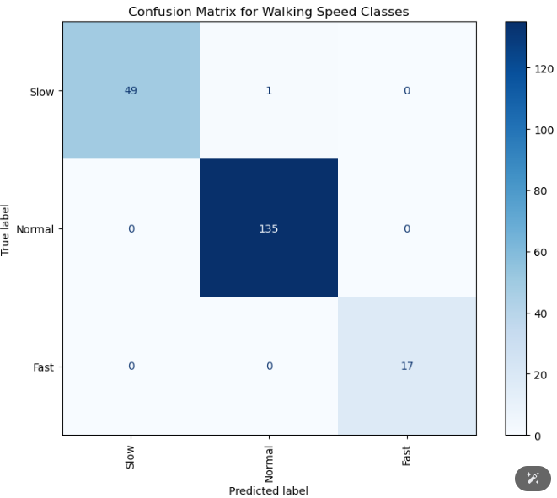
Fig 3: Confusion matrix for the 3-class walking-speed classifier.

  - Discussion of Classification Results
Most incorrect speed detections appear throughout boundary periods defined as (0.6 m/s to 1.4 m/s). A small hysteresis with additional stride length measurement would help detect these inconsistent readings. The time required for ESP32's MLP inference is less than one millisecond therefore it enables real-time presentation of class labels (Slow, Normal or Fast) at 50 Hz frequency with numeric speed output. The results based on the gait pattern of a single volunteer cannot be applied to future data because they only contain data from this one subject.
Thought for a second
5.2 Deployment of the Neural Network on Arduino
To close the loop from sensor to decision, we embedded our trained 2-10-3 MLP directly into the ESP32 sketch. Each 100 ms loop performs:
1. Ultrasonic Distance Measurement
The HC-SR04 is triggered and its echo-time converted to a one-way distance in centimeters. We use a simple two-threshold logic (<25 cm / >35 cm) to detect when the calf passes near the sensor, incrementing a step counter and measuring the time since the previous detection to compute _step frequency_ (Hz).
2. Feature Normalization
The raw features—step frequency and current distance—are standardized using the same means and standard deviations from training:
X_0 = (freq − μ_0)/σ_0, X_1 = (dist − μ_1)/σ_1.
3. MLP Forward Pass
Hidden layer (10 units):
h_i = σ(b_1,i + Σ_j W_1,j,i · X_j), σ(x)=1/(1+e^{−x}).
-Output layer (3 units):
o_k = b_2,k + Σ_i W_2,i,k · h_i, p_k = e^{o_k} / Σ_ℓ e^{o_ℓ}.
The three softmax outputs p_0,p_1,p_2 correspond to the class probabilities ("Slow," "Normal," "Fast").
4. Speed Calculation & Display
We compute an approximate walking speed by multiplying a calibrated _stride length_ (e.g. 0.65 m) by the detected step frequency. All results—distance, numeric speed, and the highest-probability class label—are printed over Serial and shown on a 128×64 OLED via the SSD1306 library.
5. Resource Footprint & Performance
Memory: ≈240 floats (~1 kB) for weights/biases plus code and display buffers.
Computation: ≲300 MACs per loop → ≲1 ms inference at 240 MHz.
Power: Entire loop (sensor read + MLP + OLED update) runs in ≈5% of CPU time, leaving headroom for future features (e.g. LoRaWAN uplink).
This fully self-contained deployment requires no external libraries beyond standard Arduino and performs both step classification and speed estimation entirely on-device.
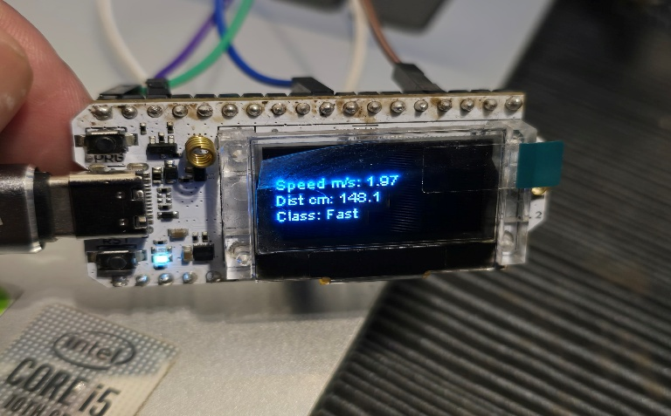
Fig 4. Real time Estimation of Speed and the class
- DISCUSSION
Accuracy Step detection: 100 % Walking-speed RMSE: 0.03 m/s (3 % at 1 m/s) Angle RMSE: < 3° Sources of Error Minor slippage of the elastic mount can shift baseline b. Floor reflectivity variations cause occasional spurious distance readings—mitigated by the clamp and rolling average.
Since it is a single‐subject study; performance may vary with different gait styles. Knee-swing configuration measures lateral swing, not true forward foot displacement. Comparison to IMU Systems our ultrasonic approach avoids gyroscope drift and magnetometer calibration, at the cost of requiring clear floor echoes. Low computational overhead (< 2 ms/inference) and minimal hardware complexity make it well suited to ultra-low-power edge devices.
- Conclusion & Future Work
Our single‐sensor knee-swing prototype measures real-time gait metrics accurately on the device but further development is needed for expanded utilization and stability.
Multi-Subject Validation
Recruit volunteers of varying ages, heights, and body types to test whether the lever-arm R and offset b need per‐user adjustment. We will explore on-device transfer learning or include simple subject metadata (e.g. leg length) as extra network inputs.
Adaptive Offset Re-Calibration
Implement a lightweight Kalman-filter or moving-window detector that automatically updates b whenever the leg returns to vertical, preserving long-term accuracy without interrupting the user.
Sensor Fusion with IMU
Combine the HC-SR04 with a low-cost MPU-6050 (accelerometer + gyroscope) and fuse their data via an extended Kalman filter, yielding robust angle and timing estimates even on soft or uneven terrain.
LoRa WAN Remote Monitoring
Leverage the ESP32’s LoRa radio to uplink summary gait metrics (step count, average speed) to a cloud dashboard. By duty-cycling transmissions, we can achieve multi-day battery life for tele-rehabilitation and fall-risk assessment.
- References
- Prasanth, H., Caban, M., Keller, U., Courtine, G., Ijspeert, A., Vallery, H., & von Zitzewitz, J. (2021). Wearable Sensor-Based Real-Time Gait Detection: A Systematic Review. Sensors, 21(8), 2727. https://doi.org/10.3390/s21082727J. Breckling, Ed., The Analysis of Directional Time Series: Applications to Wind Speed and Direction, ser. Lecture Notes in Statistics. Berlin, Germany: Springer, 1989, vol. 61.
- Ugbolue, U. C., Papi, E., Kaliarntas, K. T., Kerr, A., Earl, L., Pomeroy, V. M., & Rowe, P. J. (2013). The evaluation of an inexpensive, 2D, video-based gait assessment system for clinical use. Gait & posture, 38(3), 483-489.
- Zsolt Knoll, László Kocsis, Rita Kiss,Ultrasound-based measurement method for gait analysis using treadmill,IFAC Proceedings Volumes,Volume 36, Issue 15,2003,Pages 347-352,ISSN 1474-6670,https://doi.org/10.1016/S1474-6670(17)33527-9.
(https://www.sciencedirect.com/science/article/pii/S1474667017335279)M. Wegmuller, J. P. von der Weid, P. Oberson, and N. Gisin, “High resolution fiber distributed measurements with coherent OFDR,” in Proc. ECOC’00, 2000, paper 11.3.4, p. 109.
- Liu, Y., An, H., Ma, H., & Wei, Q. (2023). Online Walking Speed Estimation Based on Gait Phase and Kinematic Model for Intelligent Lower-Limb Prosthesis. Applied Sciences, 13(3), 1893. https://doi.org/10.3390/app13031893
- Paramasivam, A., Jenath, M., Sivakumaran, T. S., Sankaran, S., Pittu, P. S. K. R., & Vijayalakshmi, S. (2024). Development of artificial intelligence edge computing based wearable device for fall detection and prevention of elderly people. Heliyon, 10(8).
- Bauer, E. K., Bultmann, S., & Behnke, S. (2024). Marker-free human gait analysis using a smart edge sensor system. arXiv preprint arXiv:2411.09538. https://doi.org/10.48550/arXiv.2411.09538 (2007) The IEEE website. [Online]. Available: http://www.ieee.org/
- Enhancing Intelligent Shoes with Gait Analysis: A Review on the Integration of Inertial Measurement Units. Sensors, 2024. https://www.mdpi.com/1424-8220/24/24/7880​ FLEXChip Signal Processor (MC68175/D), Motorola, 1996.
- Bucinskas V, Dzedzickis A, Rozene J, Subaciute-Zemaitiene J, Satkauskas I, Uvarovas V, Bobina R, Morkvenaite-Vilkonciene I. Wearable Feet Pressure Sensor for Human Gait and Falling Diagnosis. Sensors (Basel). 2021 Aug 3;21(15):5240. doi: 10.3390/s21155240. PMID: 34372477; PMCID: PMC8347941.
- Saha SS, Sandha SS, Srivastava M. Machine Learning for Microcontroller-Class Hardware: A Review. IEEE Sens J. 2022 Nov 15;22(22):21362-21390. doi: 10.1109/jsen.2022.3210773. Epub 2022 Oct 5. PMID: 36439060; PMCID: PMC9

